Conveyor renderer inner workings on the surface.
The goal of the conveyor renderer was to combat the performance loss we got from upgrading the engine to 4.25.x that introduced a major change to the renderer.
For some unknown reason the removing of primitives got easily 4-5x as expensive then before. This is a problem because the conveyor belts items are updated every frame depending on their significance and visibility state of the belt.
Unreal’s instance system is built with them being “static” / “unchanging” in mind. Because of this when updating the transform data / removing or adding the instance component it calls a full re-init which reuploads all mesh data to the GPU and instance data. This must be done in a certain phase which slows down the Game-thread and the Render thread significantly.
To combat this problem the conveyor item’s locations and rotations (quaternions) are now stored in a dynamic float32 texture2D, one for location and one for rotation.
For every LOD there is a row in the texture so per entry there will be 3 rows and only the first 2 LOD’s will have rotation to reduce write time and vertex shader cost on distance.
texture resource example
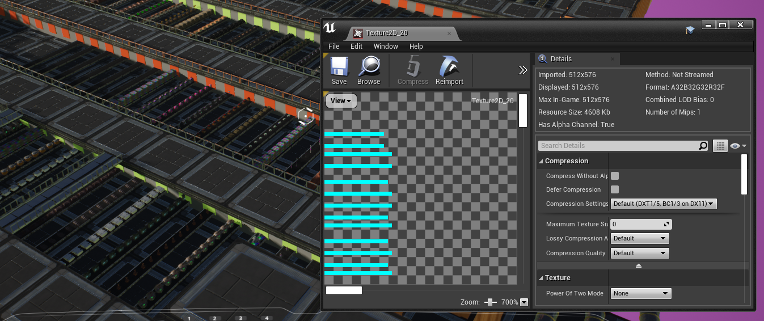
The instance components are in predetermined buckets, this way the system can hide certain instance clusters when they are irrelevant to the current frame and improve the component bounds calculations.
The instances use per instance custom data to read in the shader from which pixel it must sample its location & rotation.
Example of buckets, there are in this case 20 buckets of 32 instances, starting from row 0.
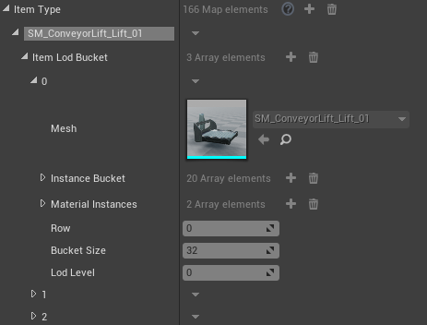
How to setup materials to make use of this system
The system tries to find the correct materials via the material instance assigned to the static mesh.
In the material instance there must a user asset data assigned with correct class: “FGConveyor Item User Data”
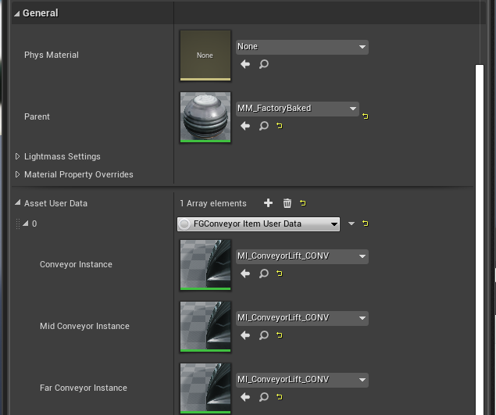
Materials used in Satisfactory that are common on conveyor belts will have the right implementation to be used with the new system.
For “Conveyor Instance” and “Mid Conveyor Instance”
bIsConveyorItem should be true and bUseRotation must be true
For Far Conveyor Instance bUseRotation must be false.
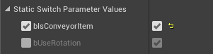
When no correct material assigned the system will use a fallback material which looks like this:
Example of item without implementation on conveyor belt.
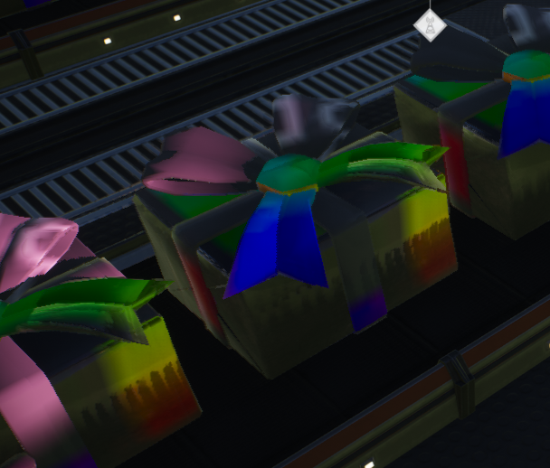
Known issues.
- Bucket generation can overshoot.
- Visibility flicker when switching from LOD levels.
- Initial frames can stutter a bit because of bucket generation there is currently no cap on how many can spawn in a single frame yet.

