16. Create an EC2 Instance with 8 GB Storage

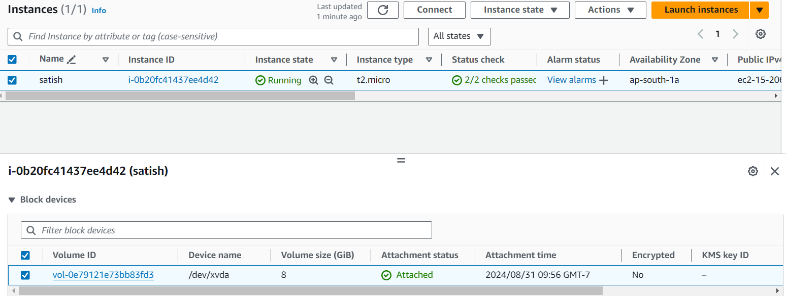

17. Create a Snapshot for the EC2 Instance's EBS Volume

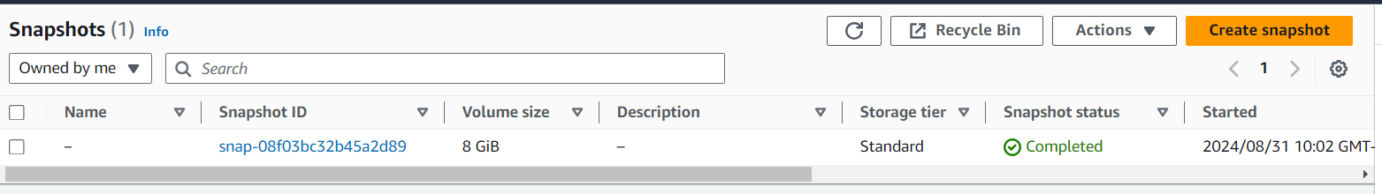

18. Extend Storage by an Additional 8 GB for the Running Instance

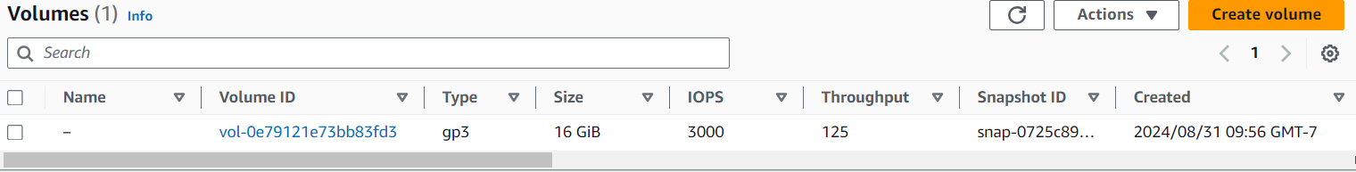

19. Delete the Snapshot Created Earlier

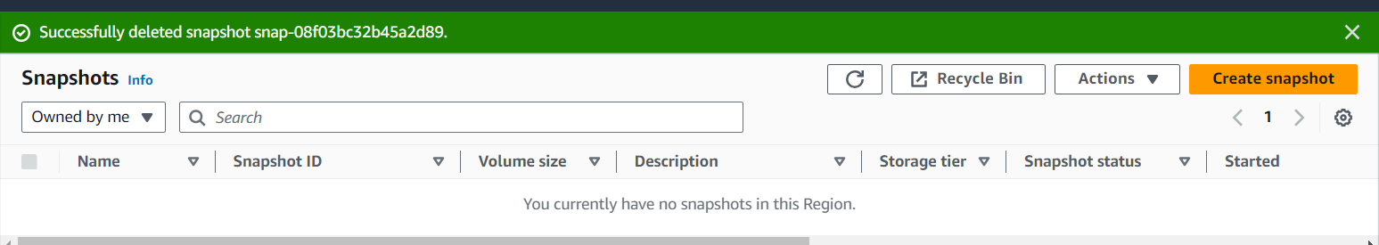

20. Instructions on How to Connect to an EC2 Instance if the PEM Key is Lost

1.Create a new EC2 instance.

2.Stop the original instance and detach the root volume.

3.Access the new instance. Detach and reattach the volume.

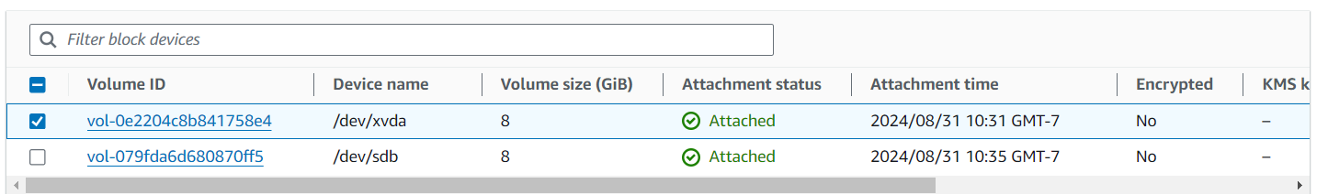

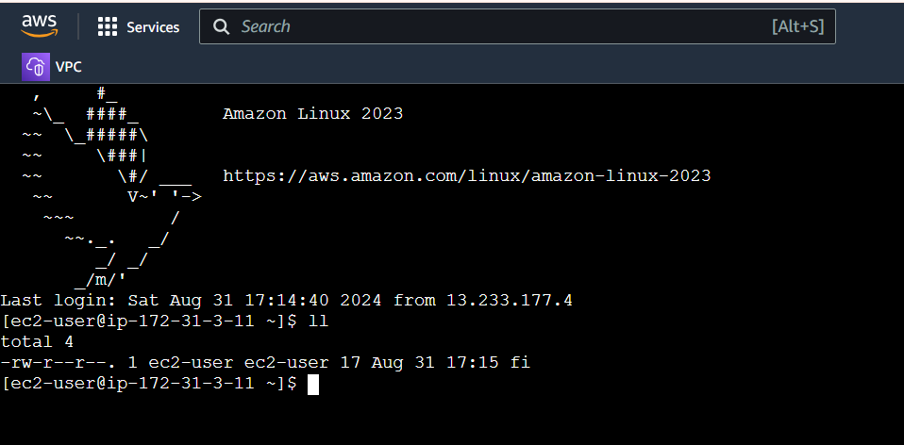

21. Create instance-1 in ap-south-1a with an 8GB volume

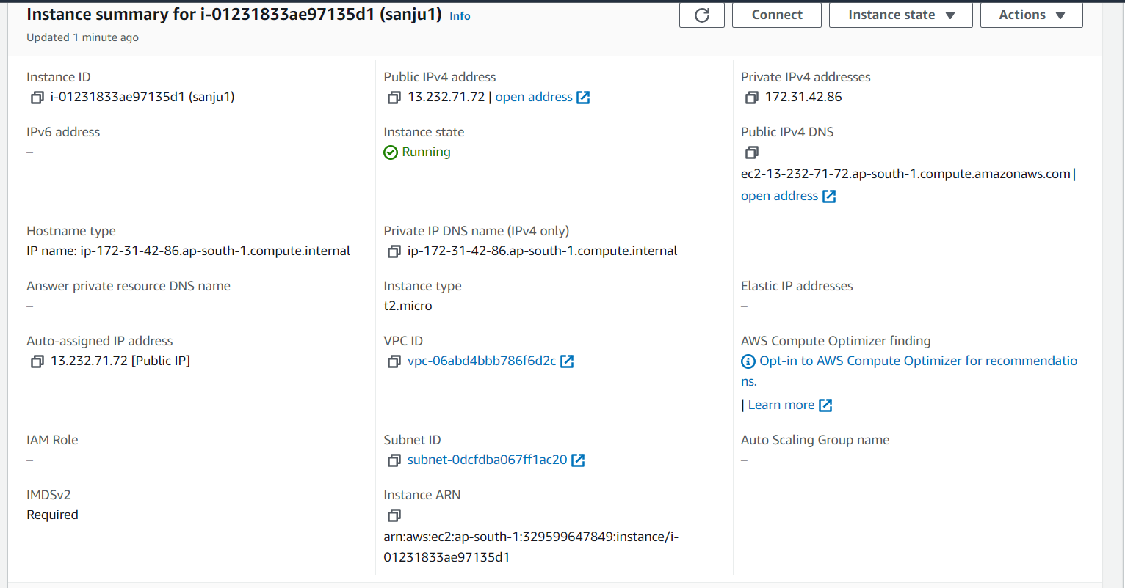

­­­­

22. Create instance-2 in ap-south-1b with an 8Gb volume

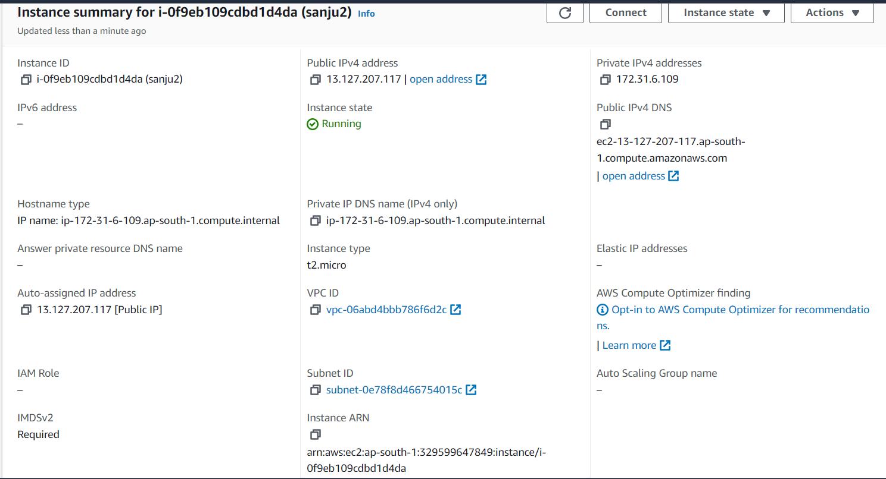

23.Stop and detach the EBS volume from instance-1 and attempt to attach it to instance-2. Determine if this is possible and under what conditions.

It is not possible to attach EBS volume of instance-1 to instance-2 during different availability zones. But it can be attached by using snapshot.

Create snapshot for the EBS volume of instance-1.

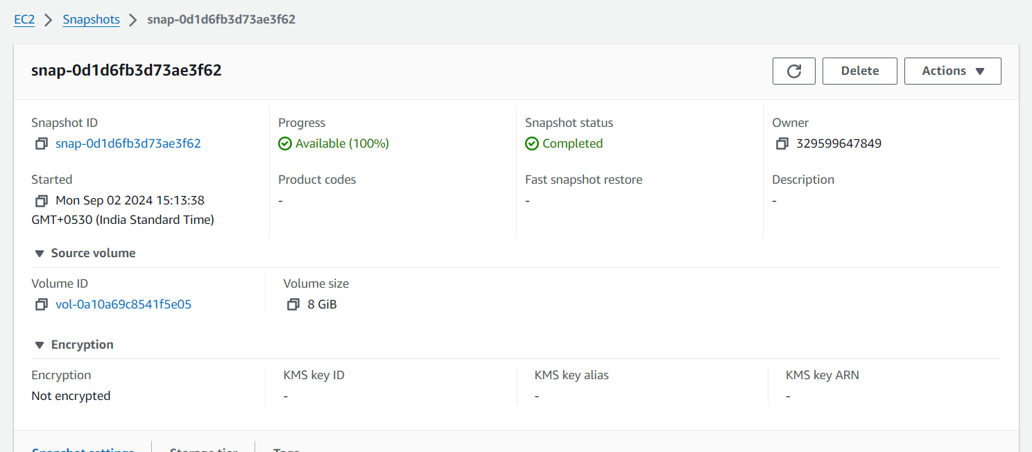

Detach and reattach the volume to the instance-2

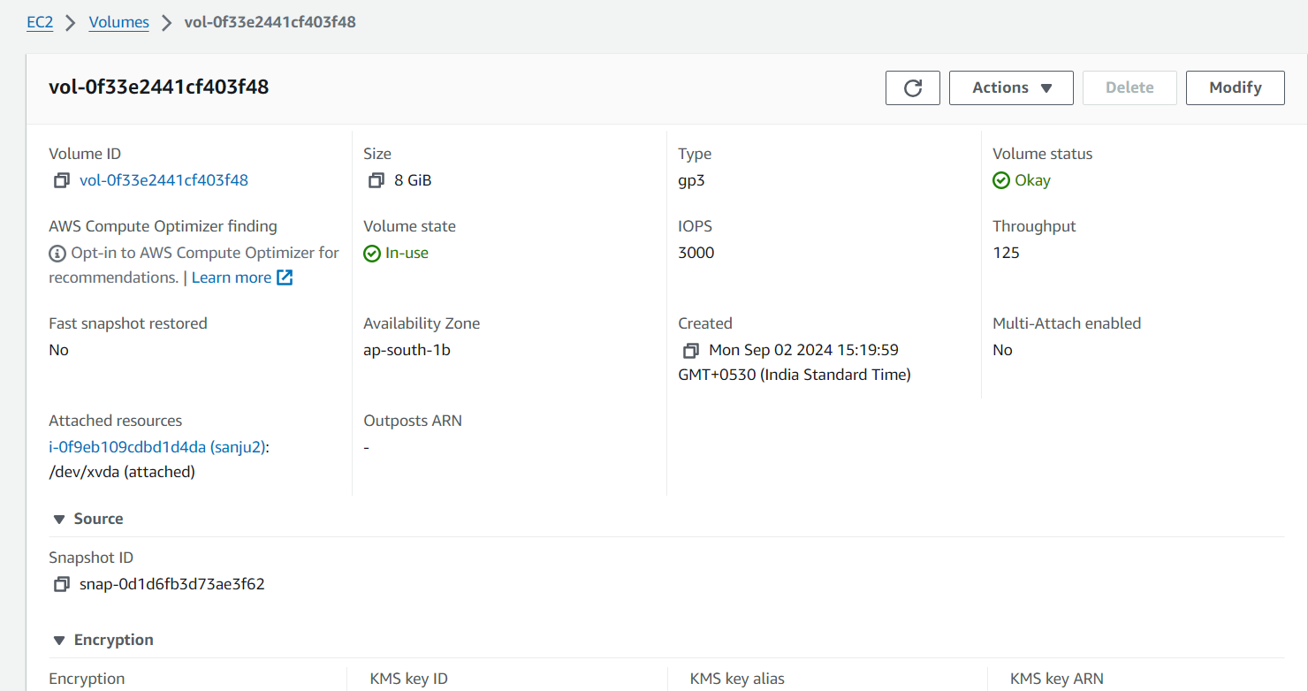

Attach the volume of the snapshot to the instance-2.

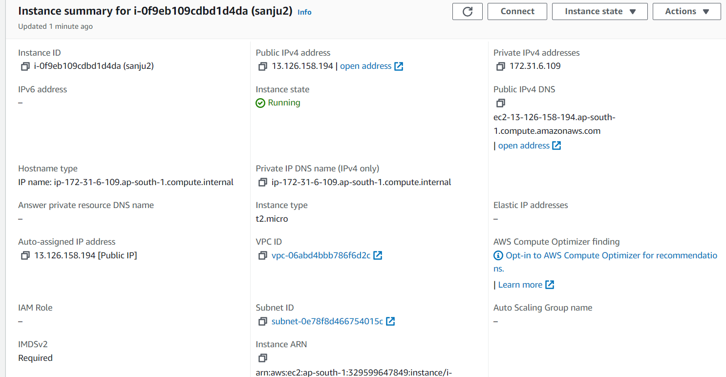

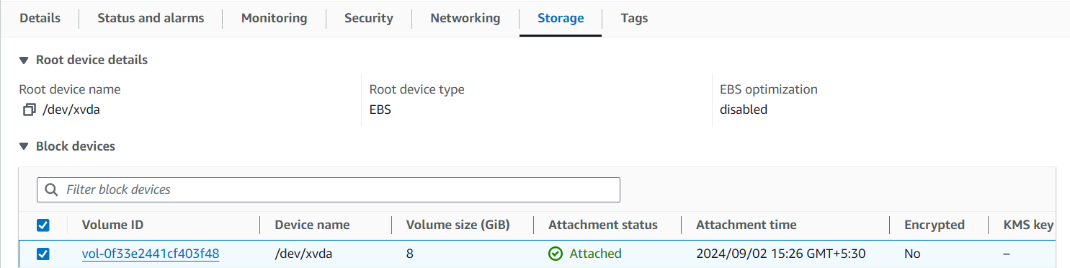

After attaching the volume to the instance-2, the files in the instance-1 are shown in instance-2.

