1.Create a repository:

1. Go to GitHub and create account.

2. Login to your GitHub account and click on new repository.

3. Enter repository name, description (optional) and select public or private option.

4. Click on create repository then repository is created in our GitHub account.

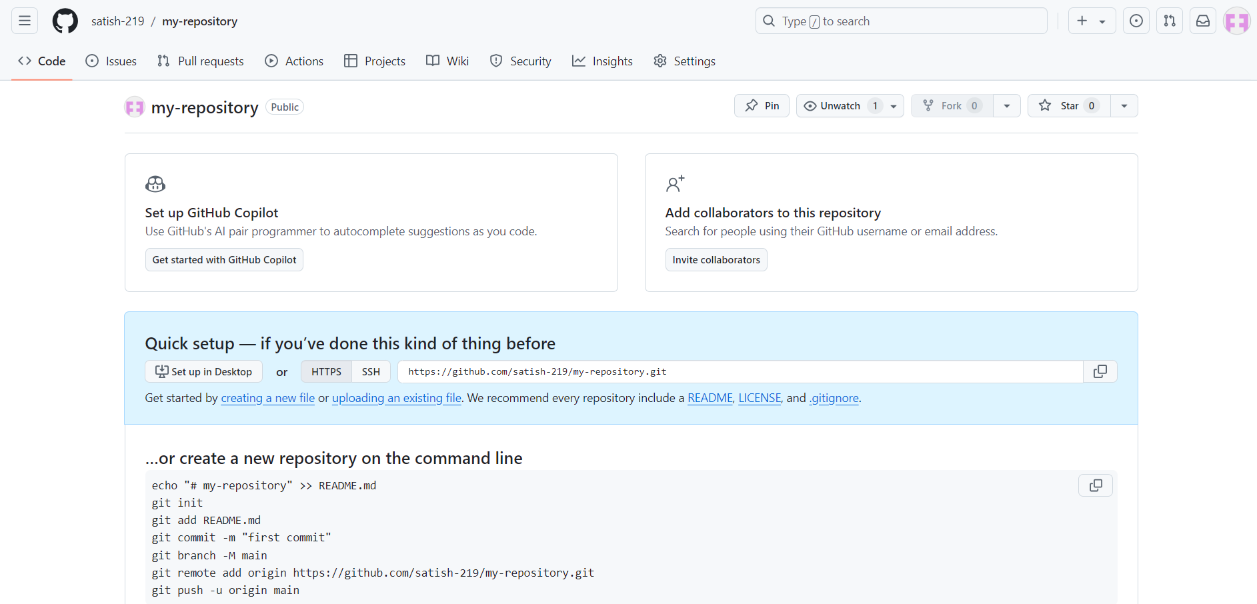

2. Create files and push to repository:

1.Open git on your local machine and initialize a git repository by using *git init* command.

2. Create a file using the command touch or create manually.

3. Add content to the file by using the command *vi filename* and save it.

4. Stage the files by using commands *git add* and commit changes by *git commit.*

5. Clone the repository and push the changes to the remote repository.

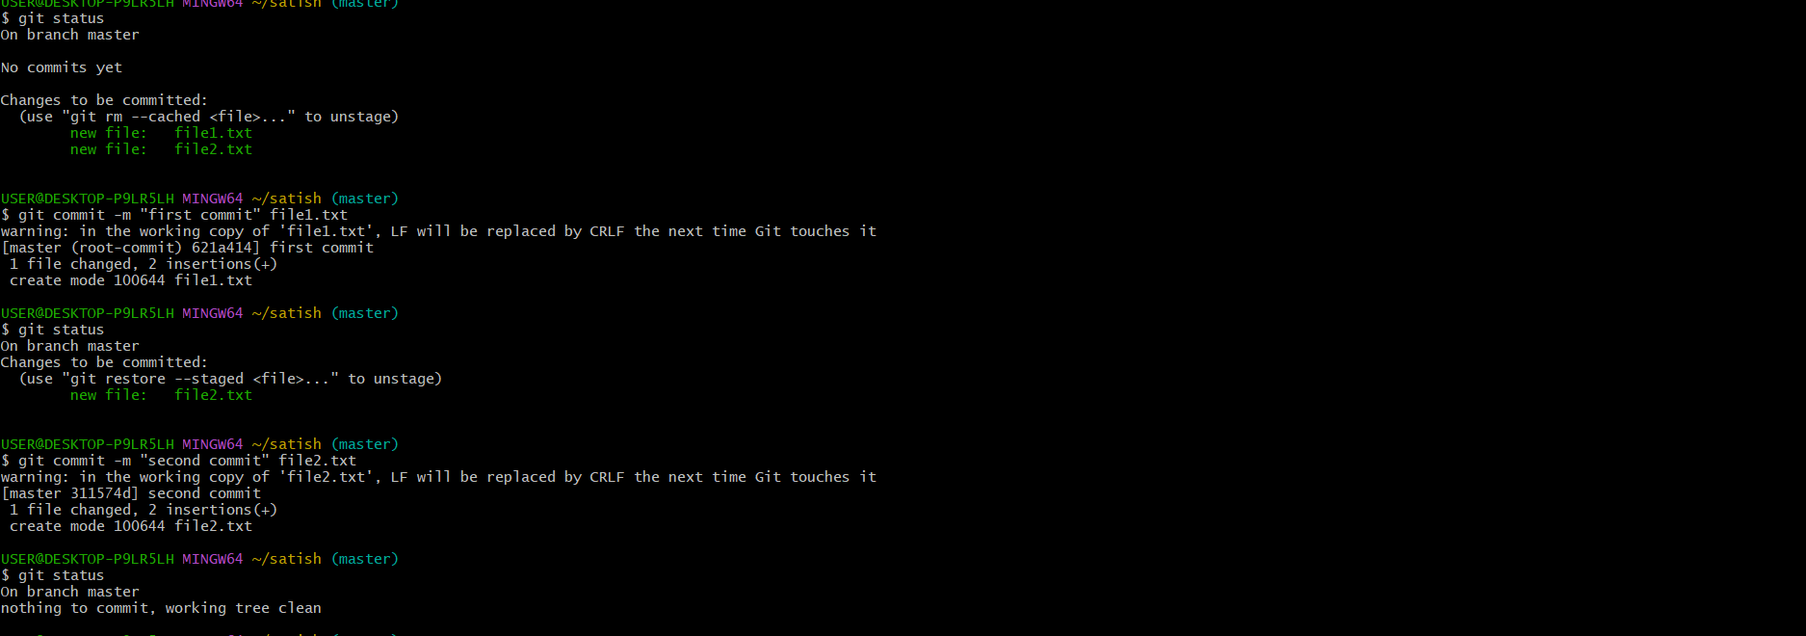

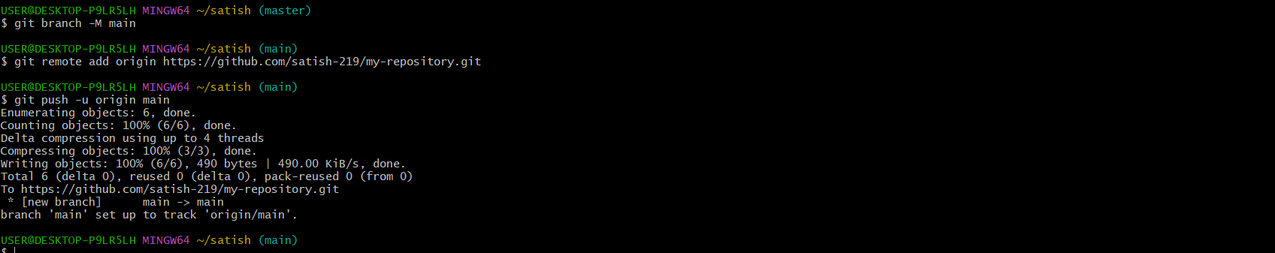

OUTPUT:

Files are pushed to the remote repository in your GitHub account.

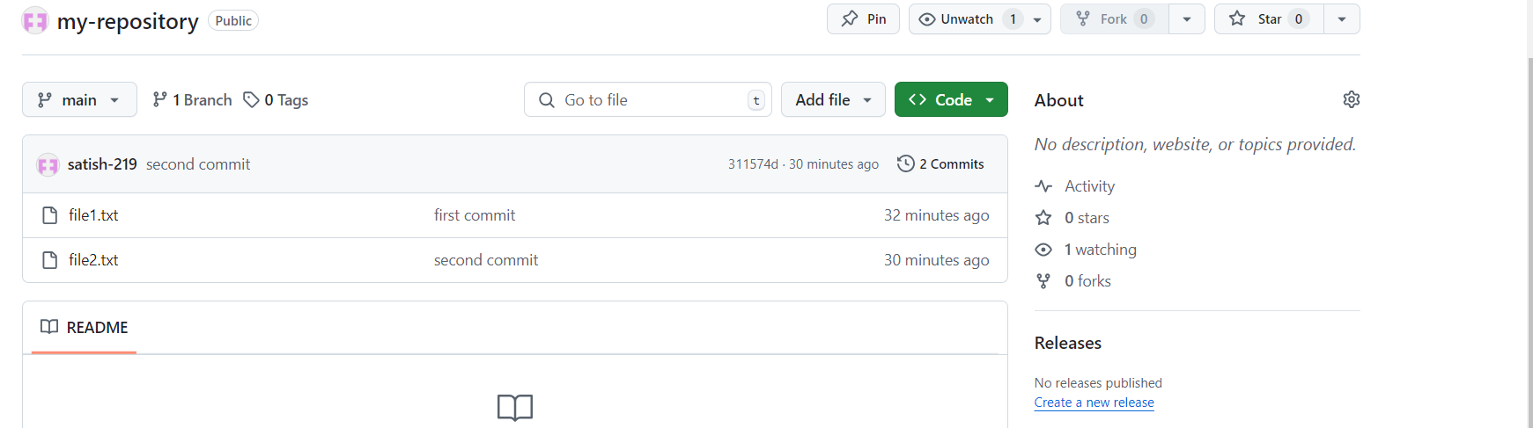

3. Create a new branch:

1. Create a new branch using the command *git branch < branch name >.*

2. Switch to the new branch by using command *git checkout < branch name >.*

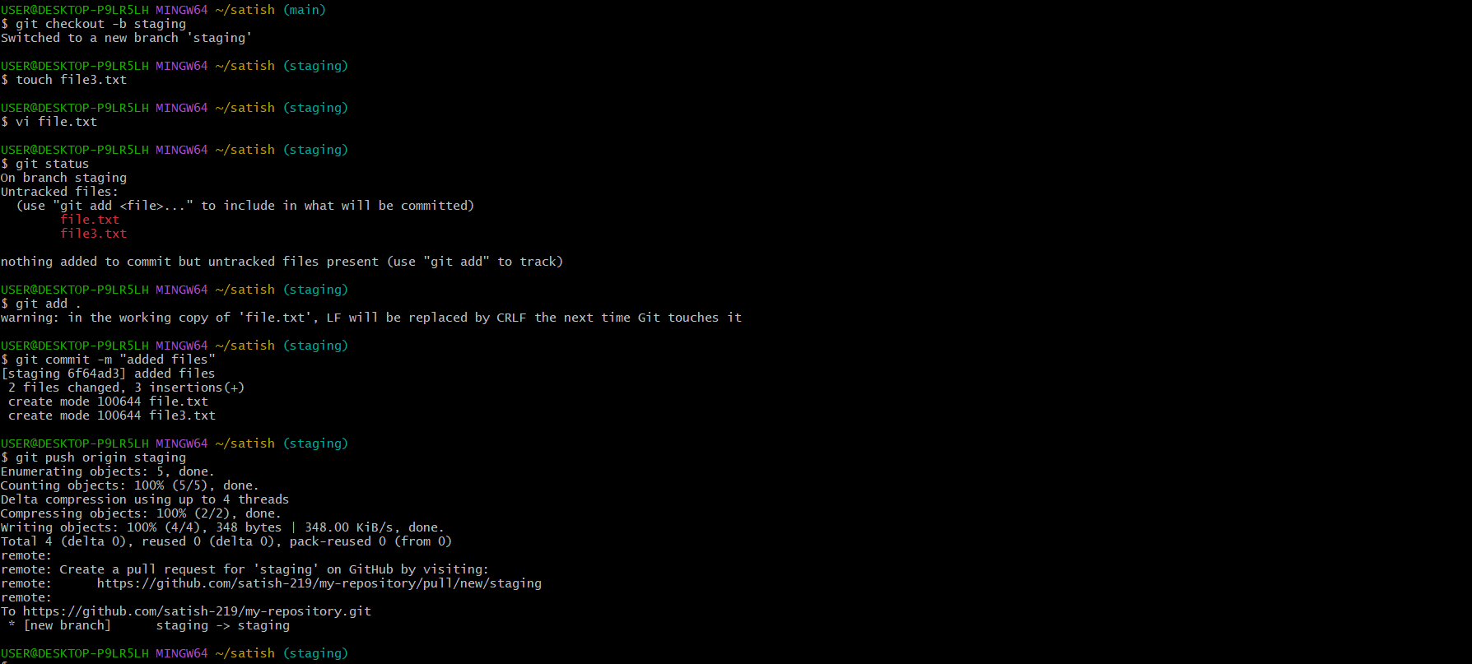

4. Add files to new branch and push back to git:

1. Create files using the command touch or create manually.

2. Add content to the file by using the command *vi filename* and save it.

3. Stage the files by using commands *git add* and commit changes by *git commit.*

4.Clone the repository from new branch and push the changes to the remote repository.

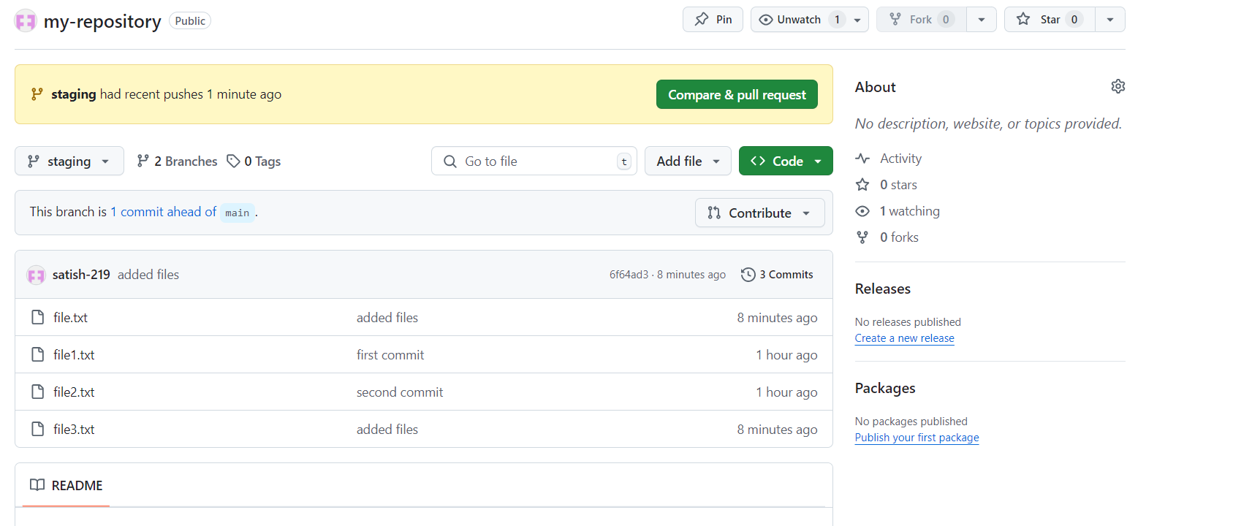

5. Create PR and merge with main branch:

1. Go to the repository on our GitHub account.

2. Create pull request from the new branch by clicking on create pull request option.

3. Add a tag and description for the pull request.

4. Merge pull request by clicking on merge pull request button.

5. Confirm by clicking on confirm merge button.

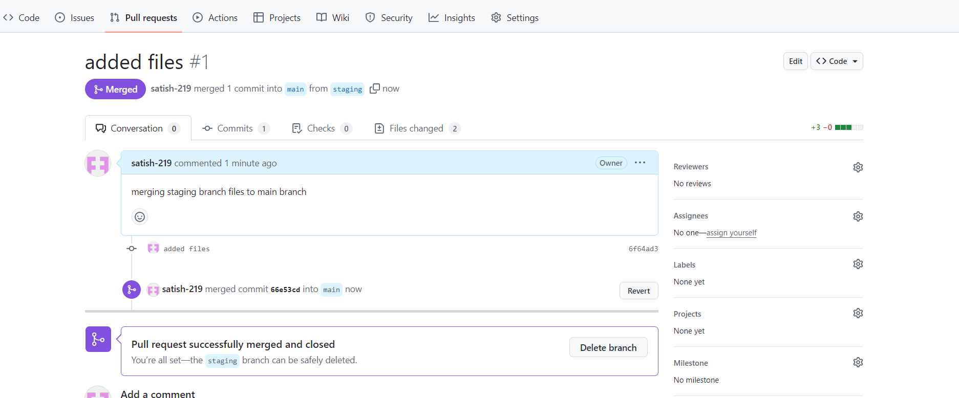

6. Create development branch and create 3 files, add 3 files, do commit, revert 1 file out of 3:

1. Create a new branch and switch to that branch by using git checkout command on git.

2. Create three files by using touch command.

3. Add some content to the three files by using any text editor.

4. Add all the 3 files to the staging area by using git add command.

5. Commit the changes to the new branch by using git commit command.

6. Revert one file out of the three files.

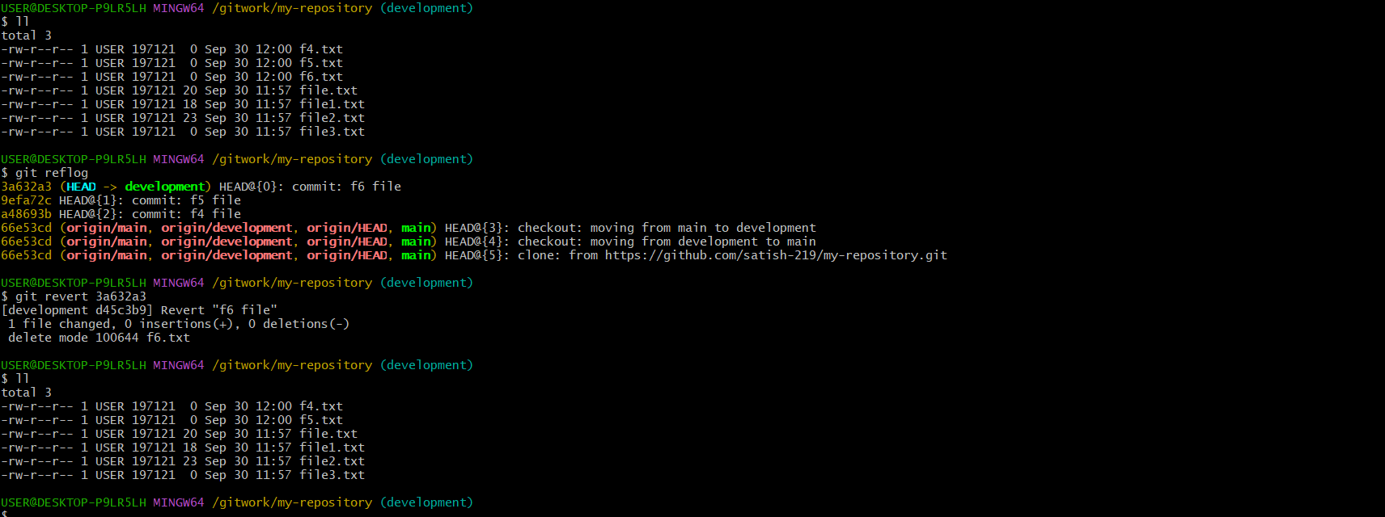

7. Create development branch and create 3 files, add 3 files, do commit do push and revert 1 file out of 3:

1. Create a new branch and switch to that branch by using git checkout command on git.

2. Create three files by using touch command.

3. Add some content to the three files by using any text editor.

4. Add all the 3 files to the staging area by using git add command.

5. Commit the changes to the new branch by using git commit command.

6. Push the files to the repository and revert one file out of the three files.

