**26) Create developers group**

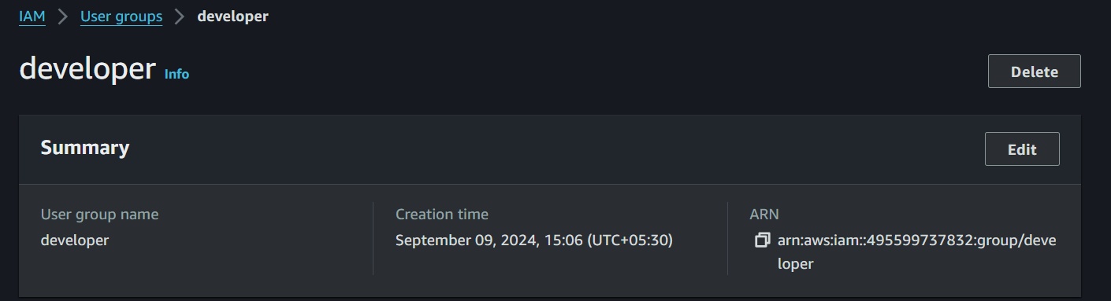

**27) create user-a with immediate change of password when login and add this user to developers group**

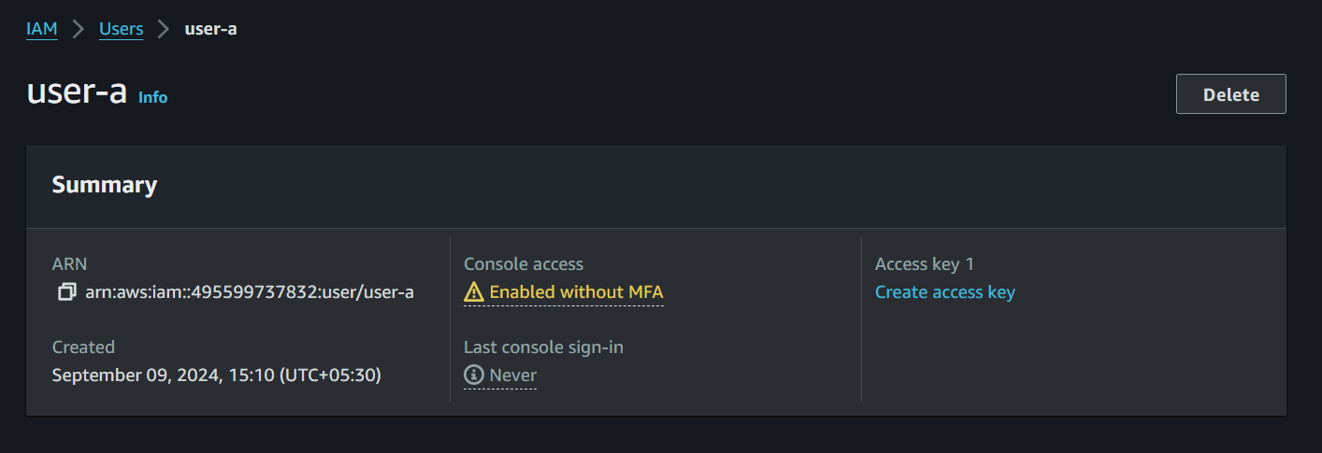

**User-a is added to the group developer**

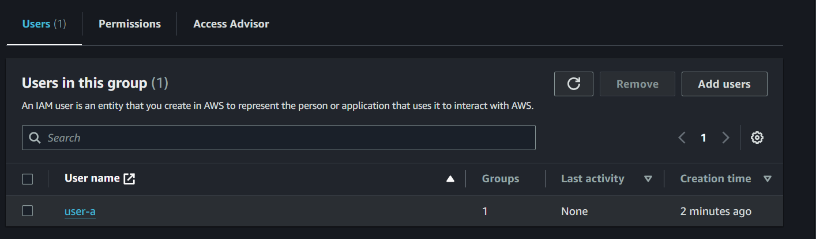

**When we trying to login with user-a it asking immediate change of password**

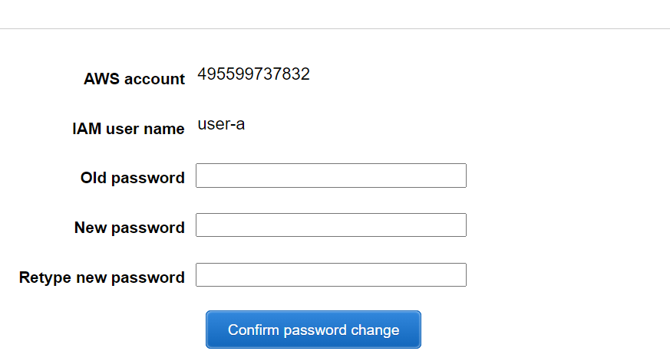

**28) Create a policy s3 readonly access and attach to develoeprs group**

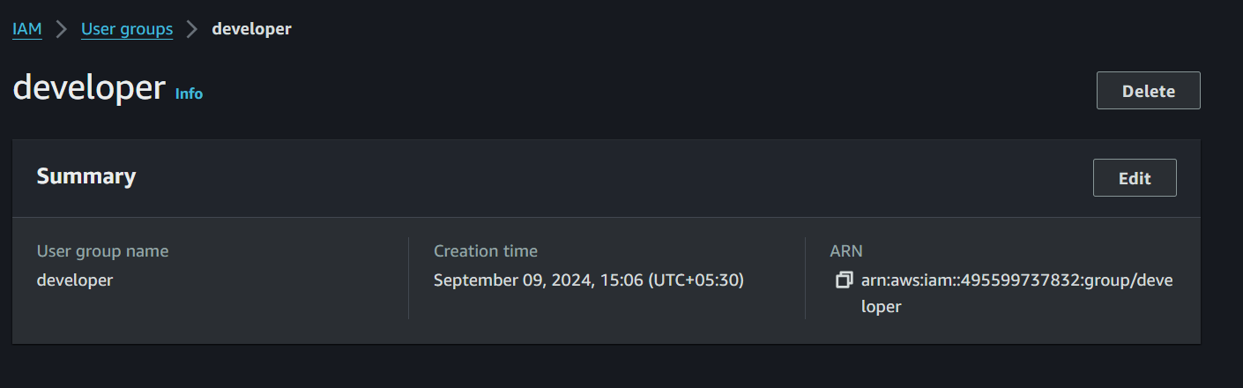

**Attached the s3 readonly access to the developer group**

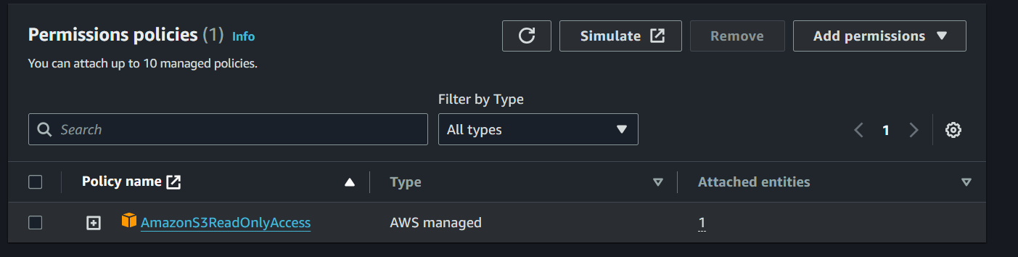

**29) login with usera and verify he has only s3 read-only access**

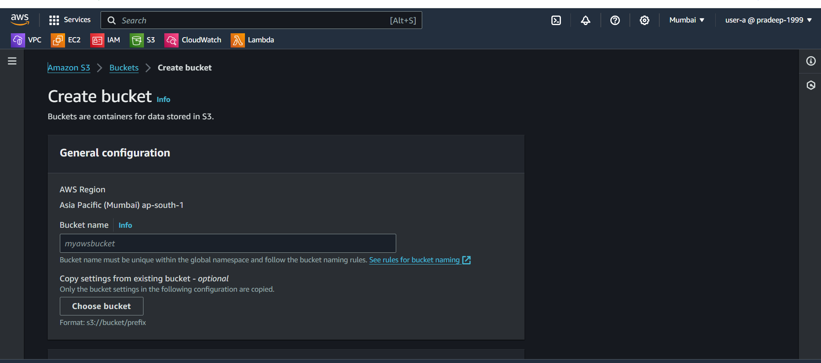

**30) Created the user-b**

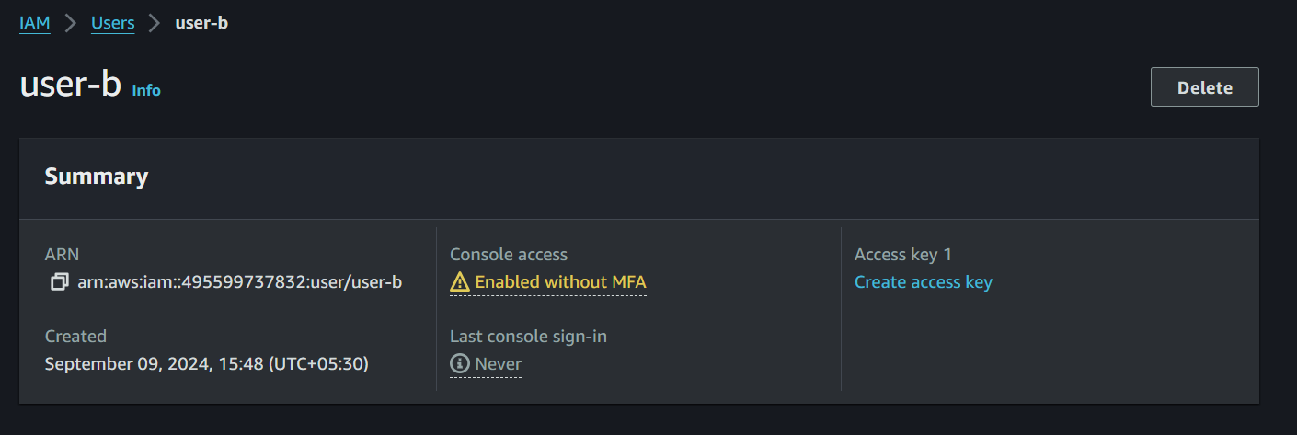

**31) Create ec2 full access and s3 full access policy and attached that policy to user-b**



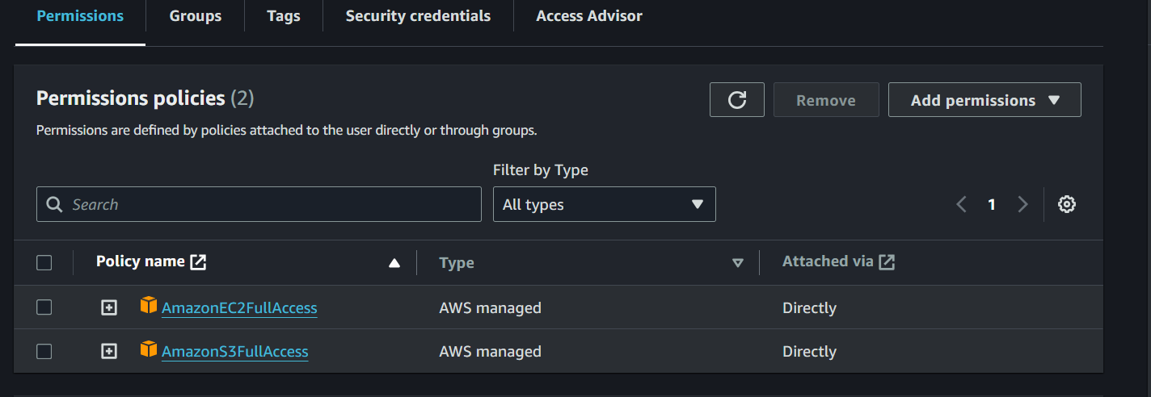

**32) verify user has ec2,s3 full aceess via console**

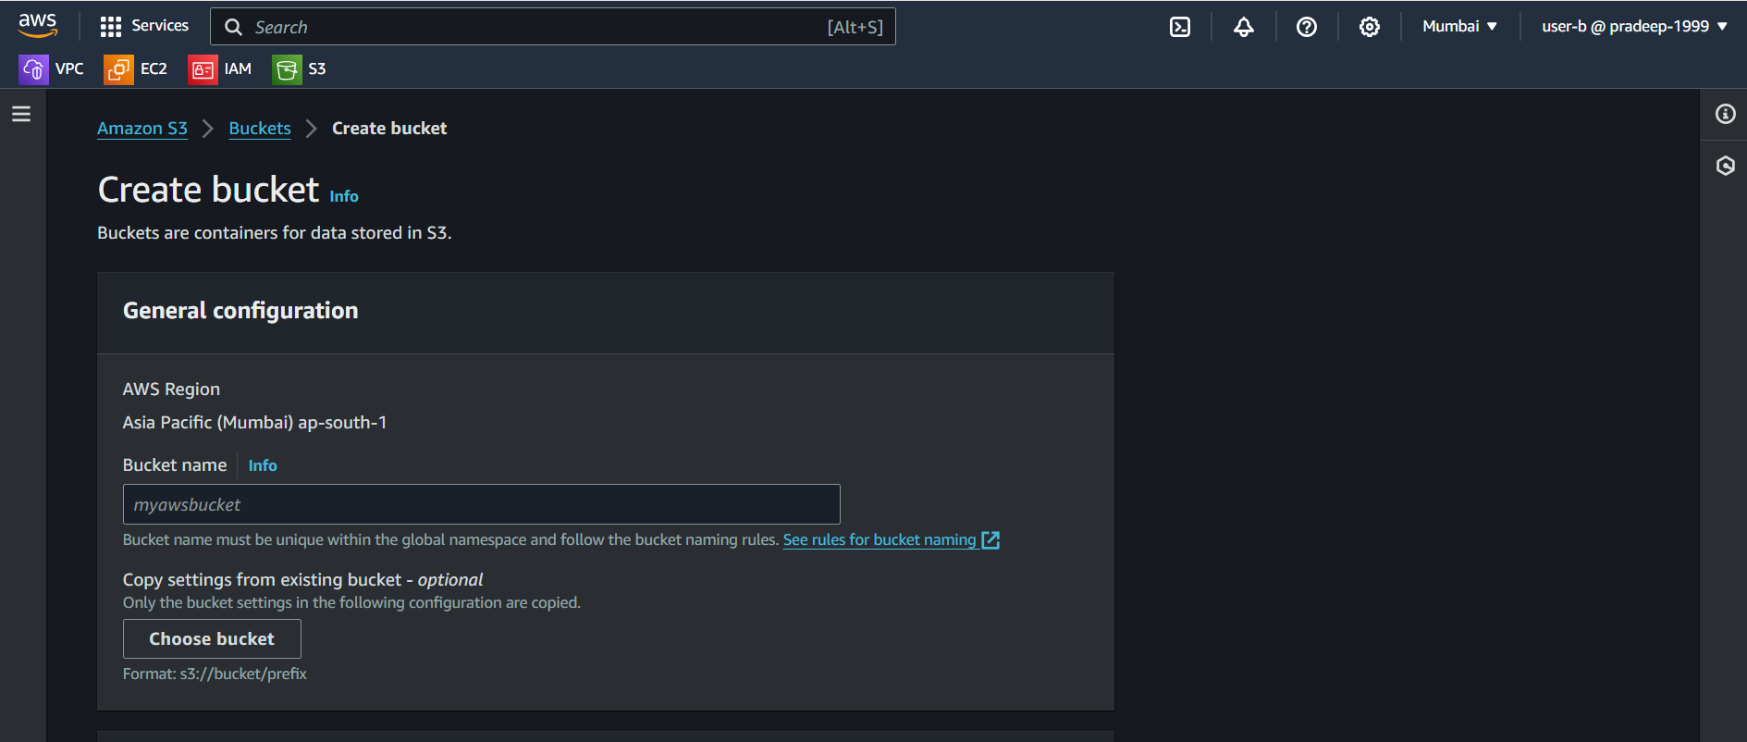

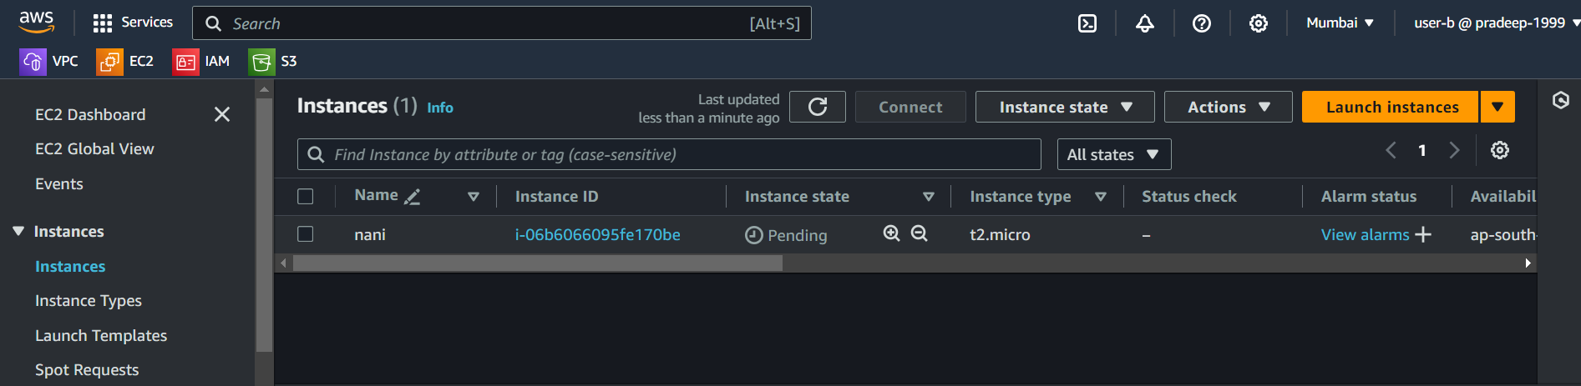

**33) create list-only s3+ec2 access for user-c. verify same from console (create using policy creater-ui)**

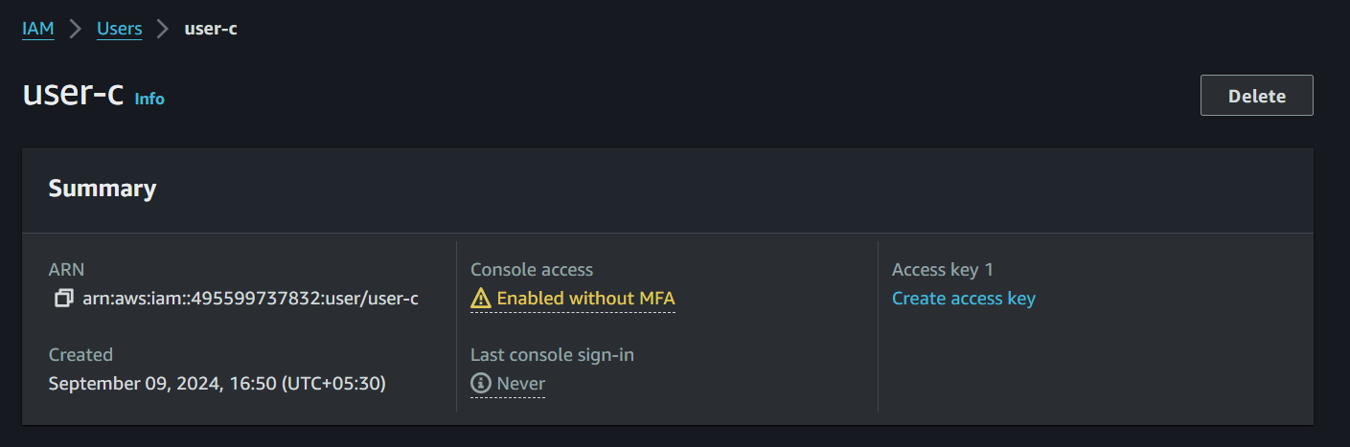

**Created the S3 and EC2 Policies and attached to the user-c**

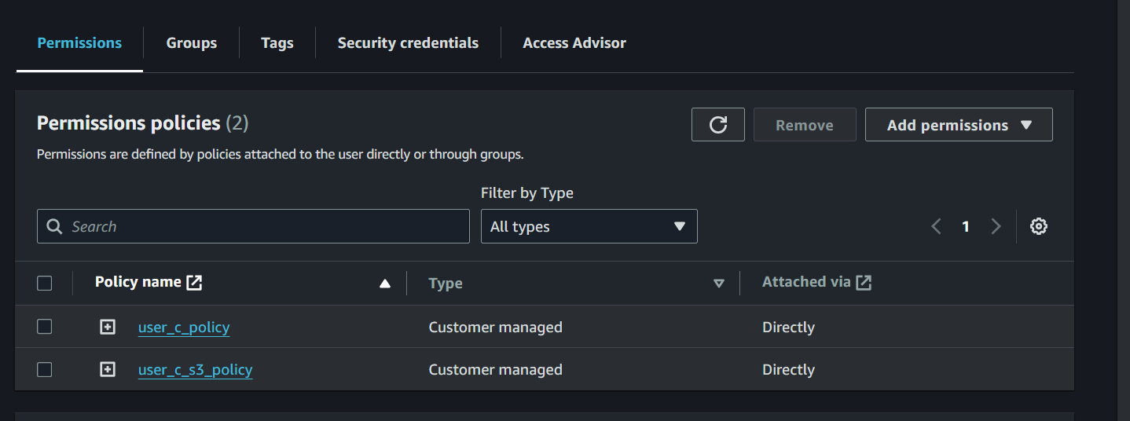

**Using user-c EC2-instance be accessed**

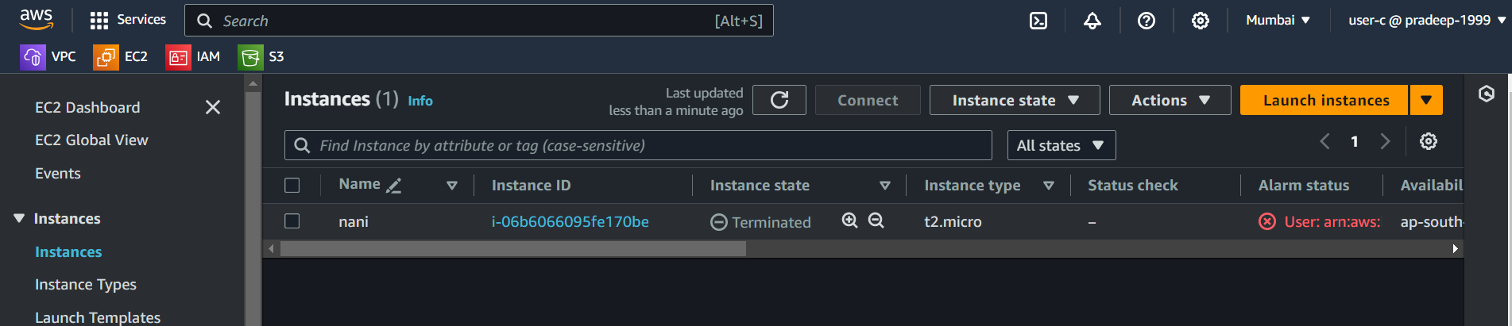

**Using user-c S3 service be accessed**

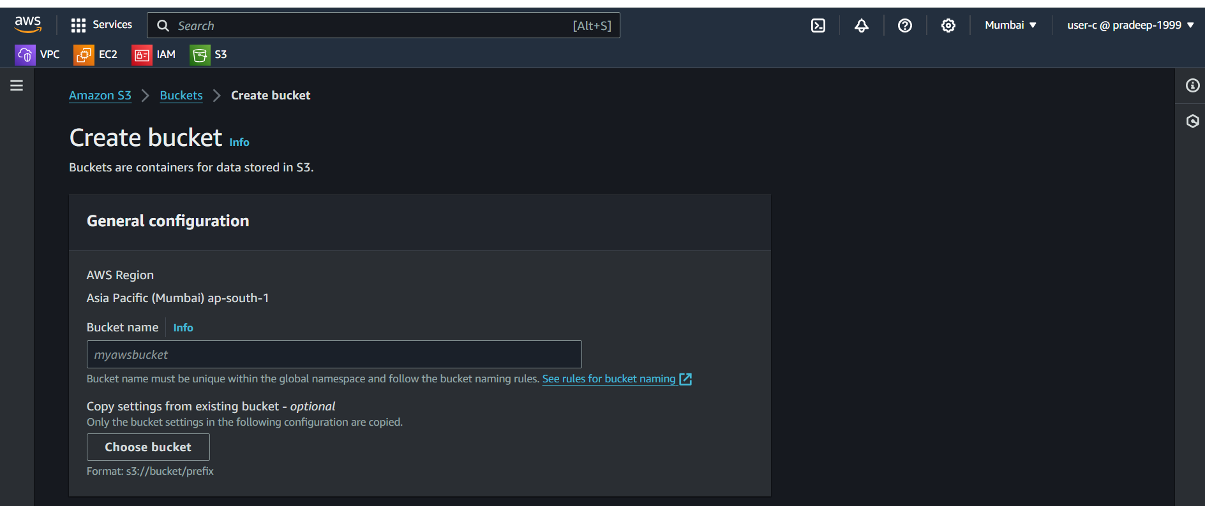

**34) create accesskey and secret keys and configure aws cli on windows local machine**

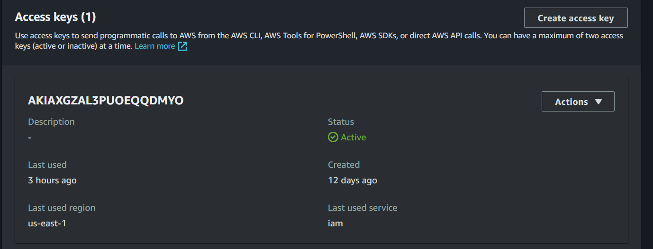

**35) run aws configure command it will ask for ur access/secret keys and then u will get access to your aws cloud from your local.**

Configured and the aws cli and created a S3-bucket

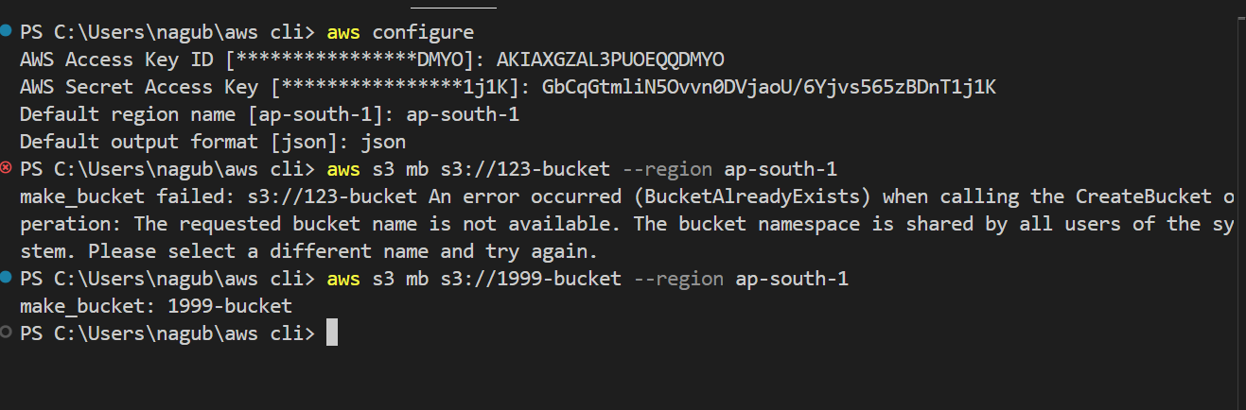

**36) create s3 bucket using aws cli**

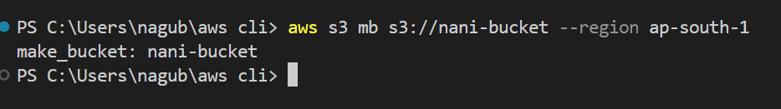

**37) create ec2 instance using aws cli**

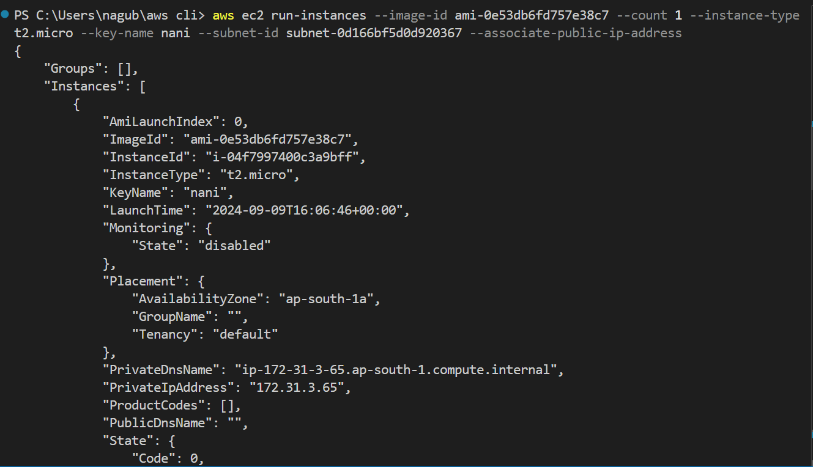

**38) create iam user using aws cli**

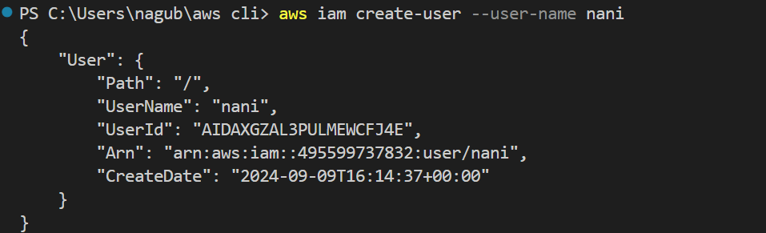

**39) create policy using aws cli**

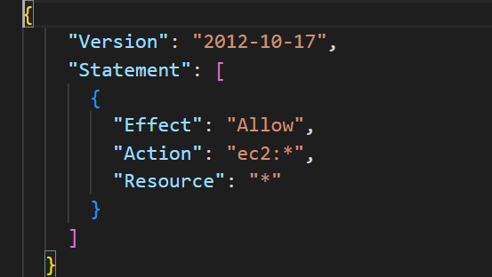

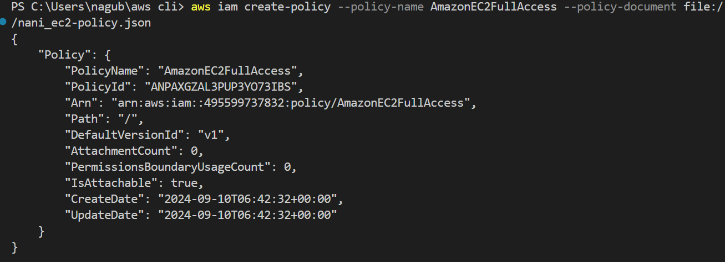

**40) attach policy to user using aws cli**

