36.Create bucket-1(ap-south-1) and upload files(t1,t2,t3) into it.

Created a bucket-1 in the region ap-south-1 and uploaded the files t1,t2 and t3 into the bucket.

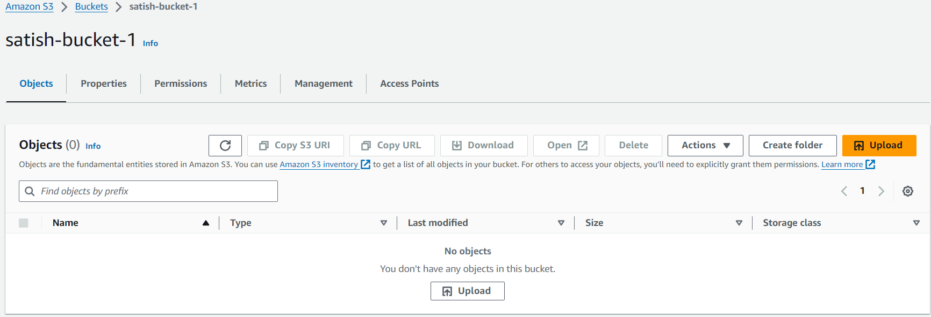

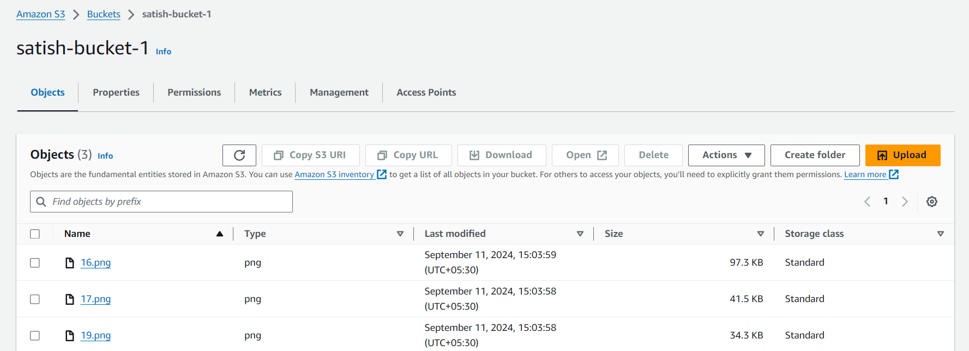

By using CLI:

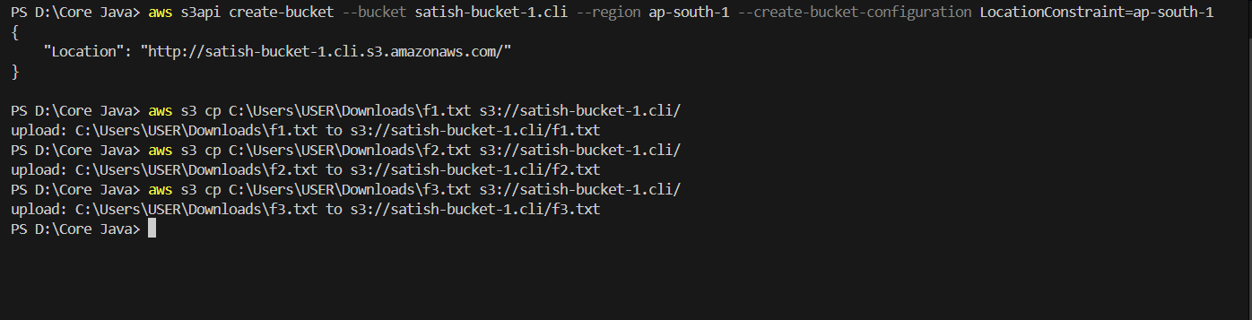

37. Create bucket-2(ap-souht-1) and upload files(t4,t5,t6) into it.

Created a second bucket in the region ap-south-1 and uploaded the files t4,t5 and t6 into the bucket -2.

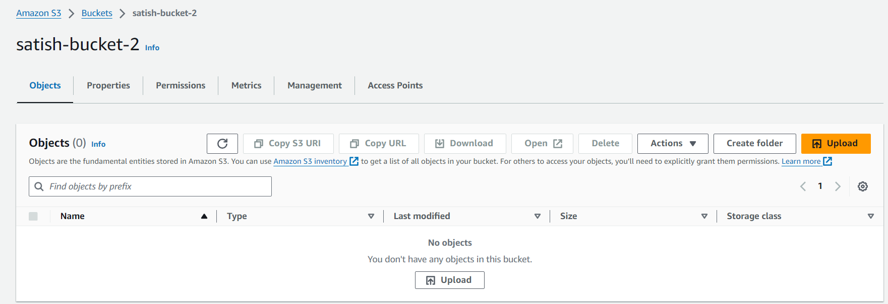

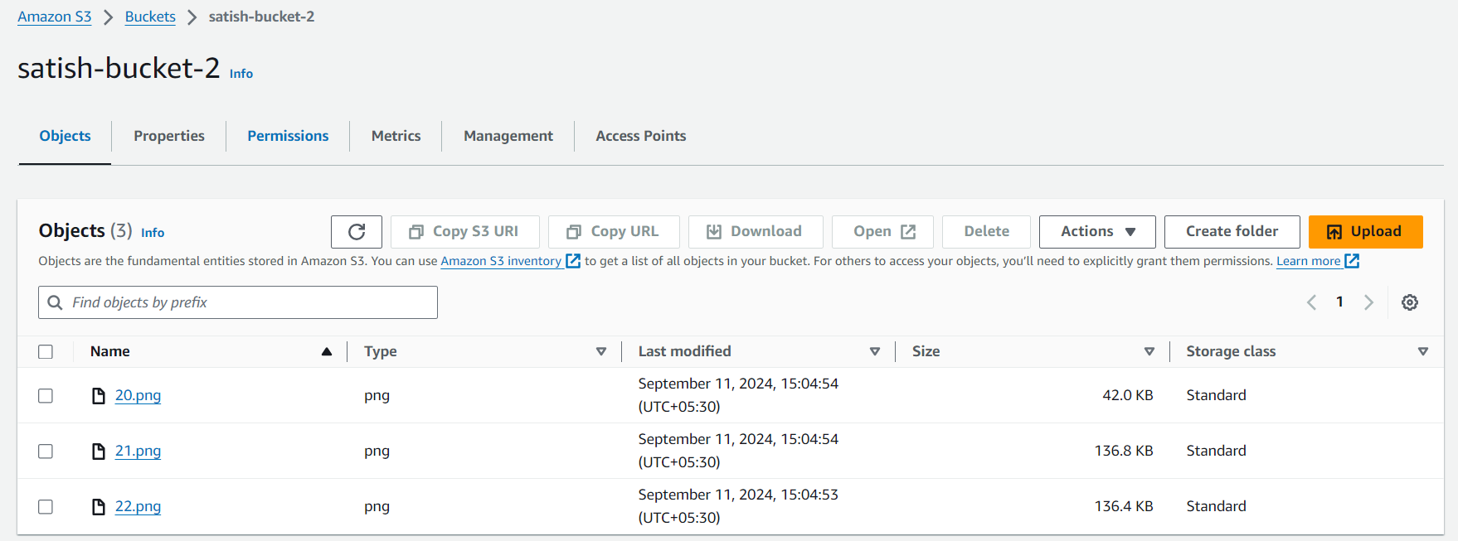

By using CLI:

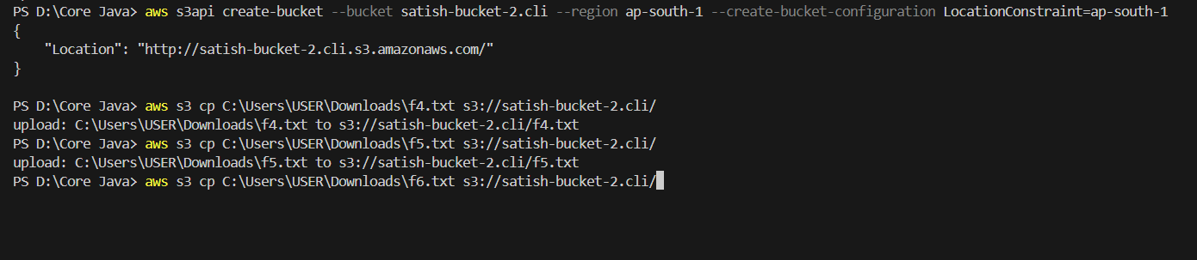

38.Copy files from bucket-1 to bucket-2. So that bucket-2 should have all 6 files.

Copied all the files from bucket-1 to bucket-2. The below image represents the copied files from the bucket-1.

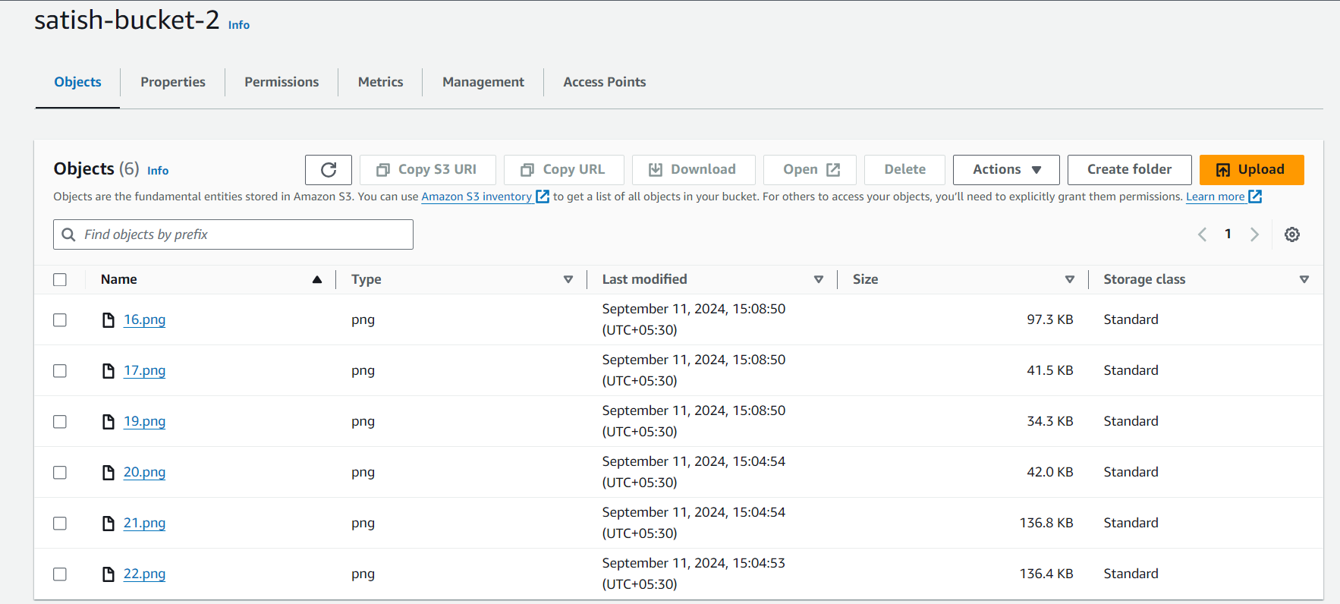

By using CLI:

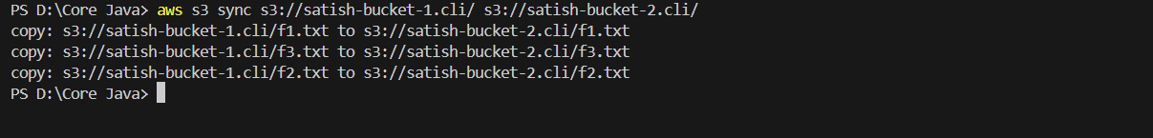

39. Create bucket-3(us-east-1) and upload files(t7,t8,t9)

Created a bucket-3 in the region us-east-1 and uploaded the files t7,t8 and t9 into the bucket-3.

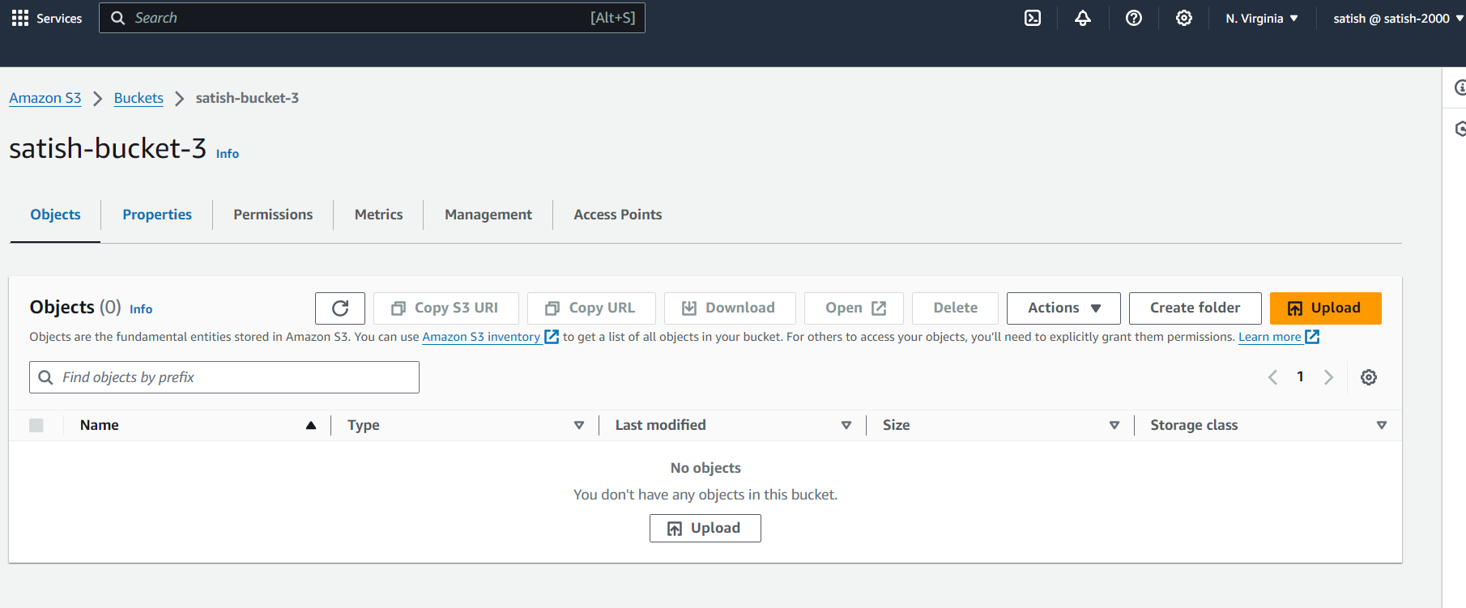

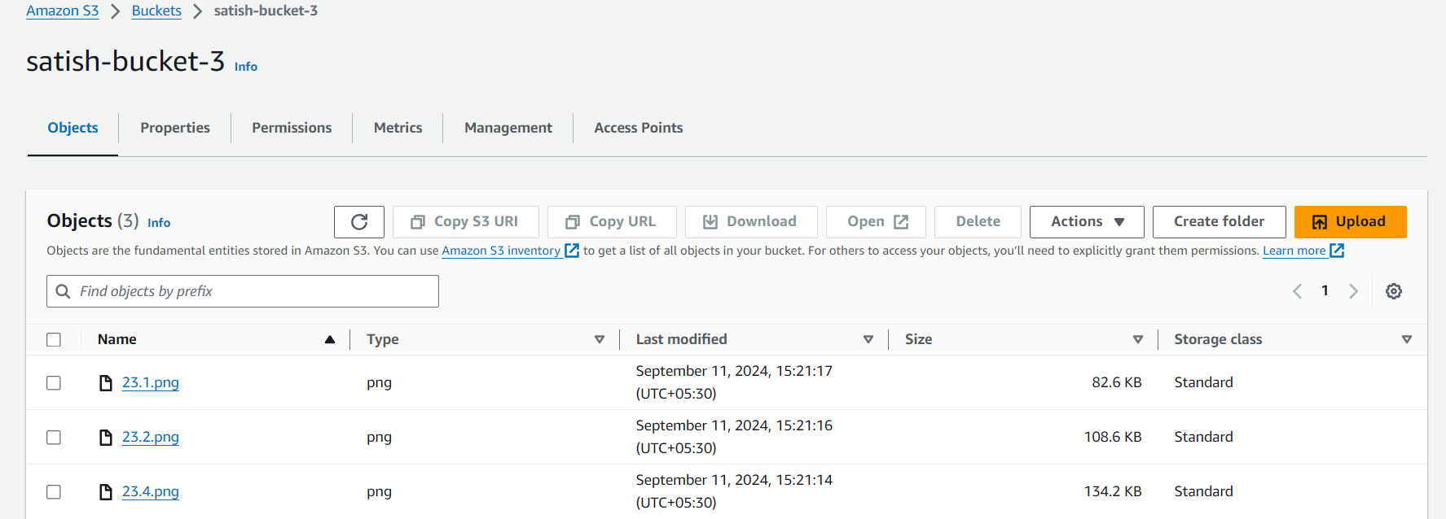

By using CLI:

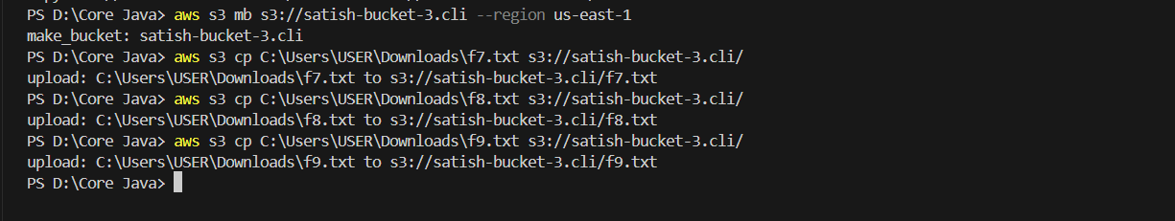

40. Copy files from bucket-1(ap-south-1) to bucket-3(us-east-1).

Copied all the files from bucket-1 in the region ap-south-1 to the bucket-3 in the region us-east-1.

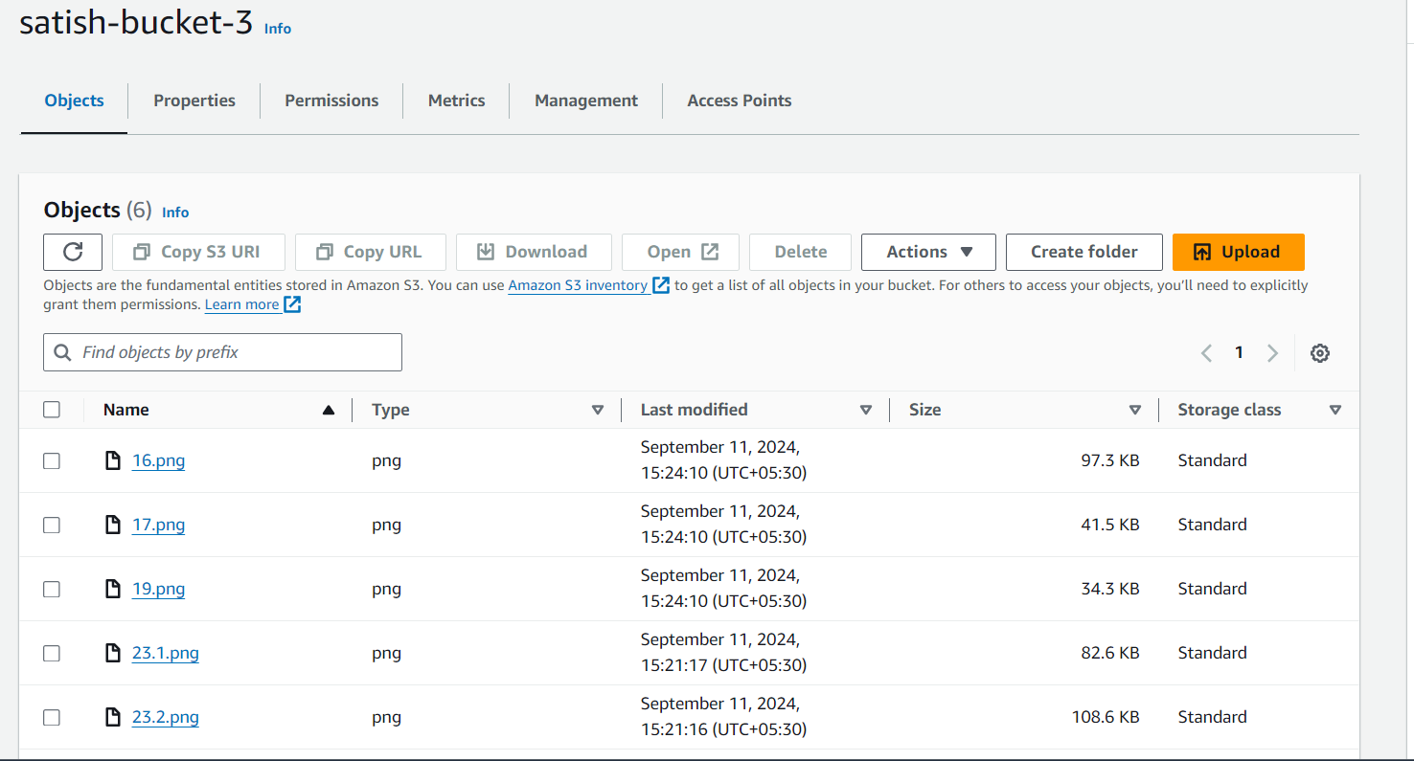

By using CLI:

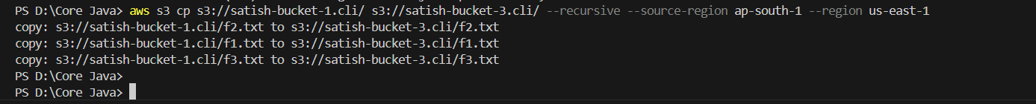

41. Make bucket-1 as static webhost and add proper policy and change bucket ACL's to get webpage

Made bucket-1 as a static webhost and added a policy to the bucket and changed the bucket ACL’s to get webpage. And a html file named game.html was uploaded into the bucket.

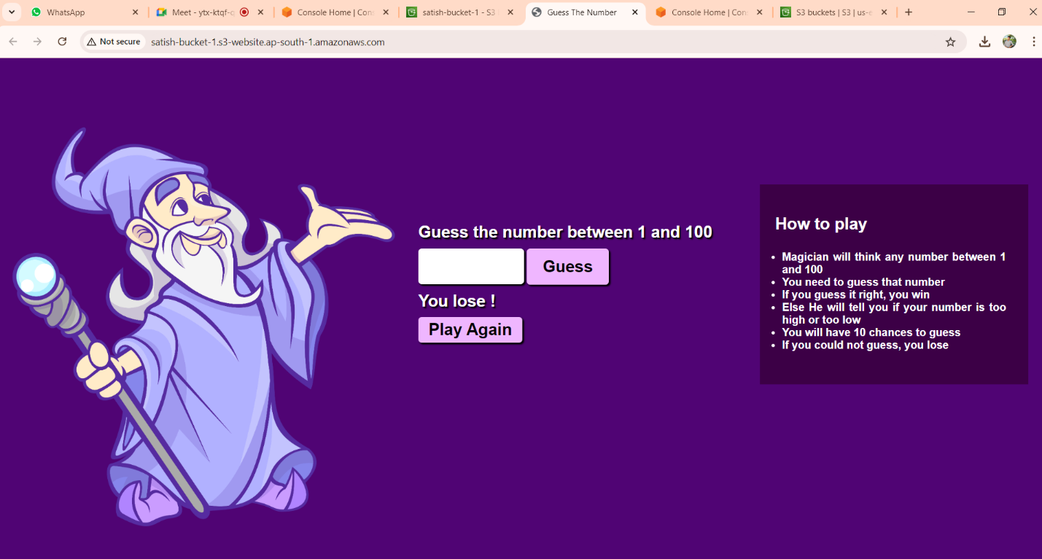

42. Create ec2 instance in private subnet. Then access bucket-2 from created ec2 instance which is in private subnet.

Created a ec2 instance in the private subnet through the console.

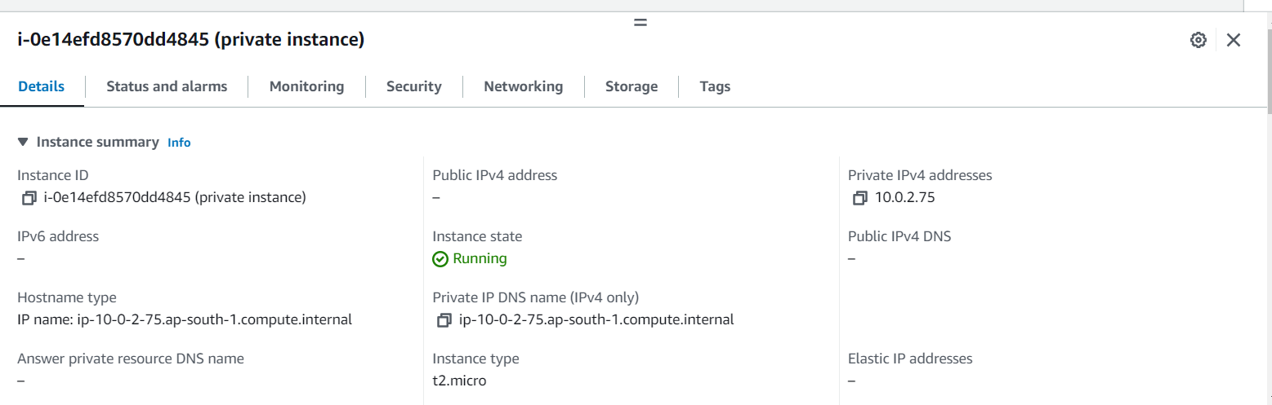

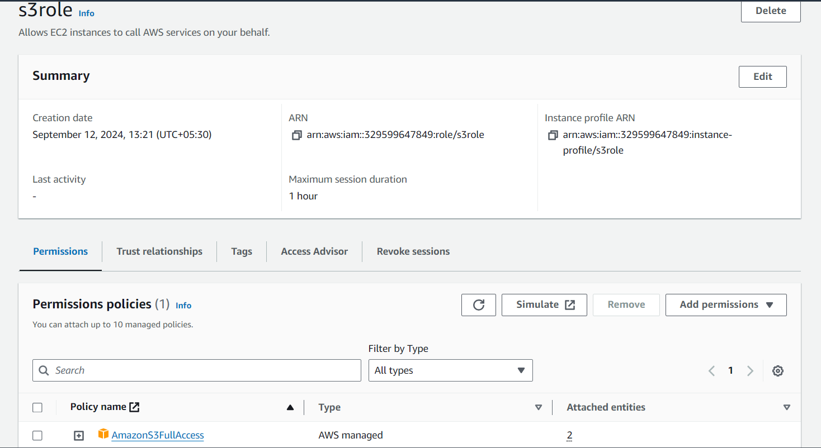

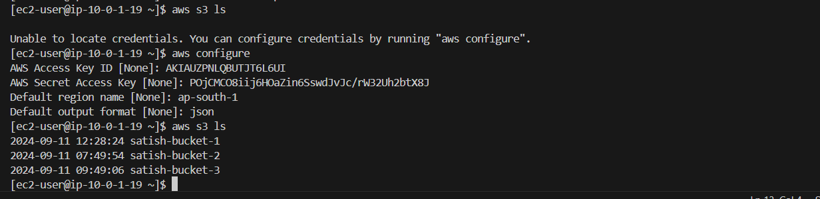

43.Block one IP address on bucket-2.

Blocked one IP address on bucket-2 using the bucket policy which will not allow that IP address to upload files into the bucket-2.

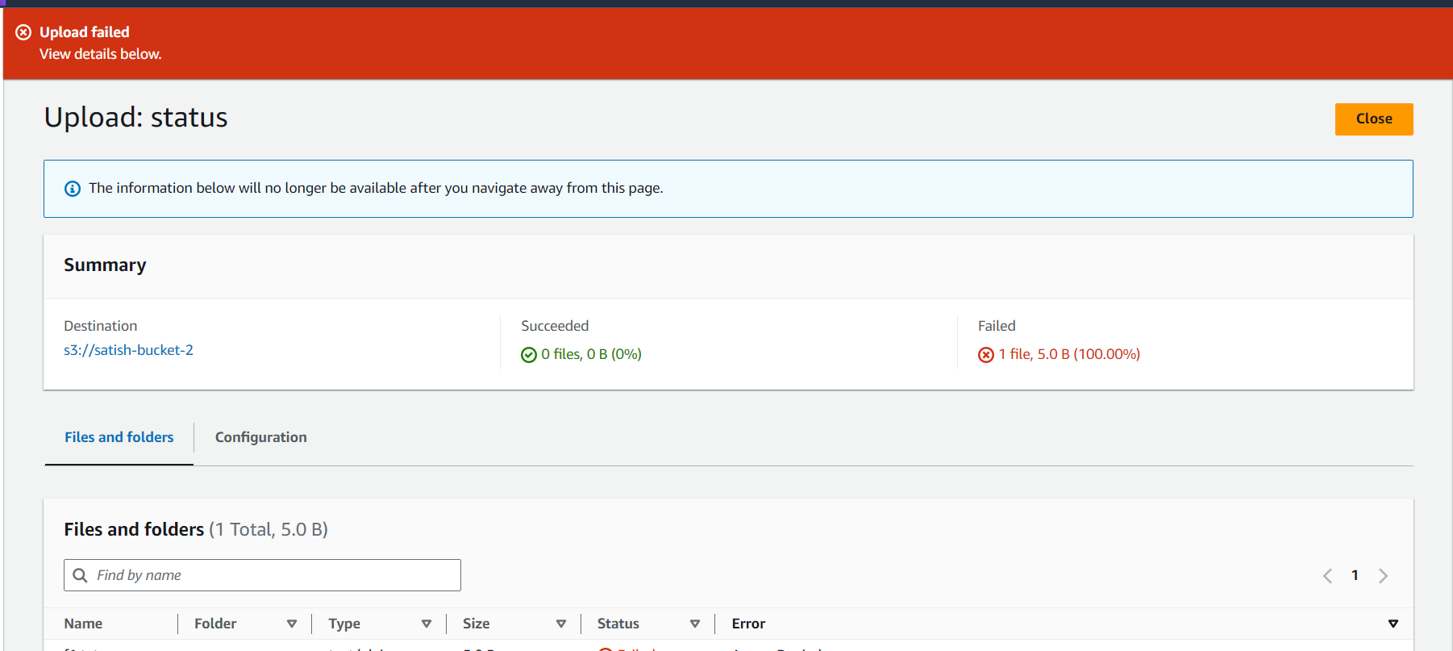

44. Allow only one IP address on bucket-3

Allowed only one IP address on bucket-3 which means only this allowed IP address can be able to upload the files into the bucket-3

