46. Create an alarm for a specific instance (e.g., monitoring a network load graph) and add it to an SNS topic to send email alerts.

1.Open CloudWatch in the AWS Management Console.

2. Go to Alarms in the CloudWatch Console and create alarm by choosing the metric that

reflects network load and define a threshold value for the alarm.

3. Create SNS topic and give email for the topic to send notifications.

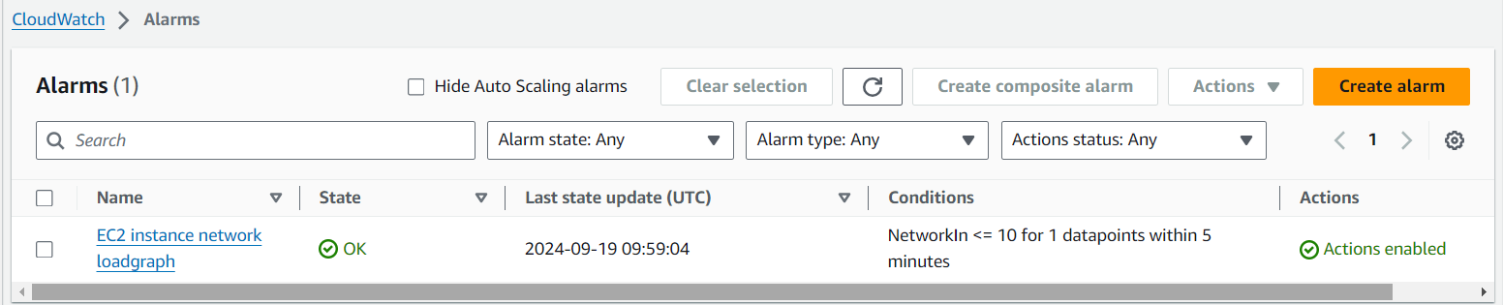

OUTPUT:

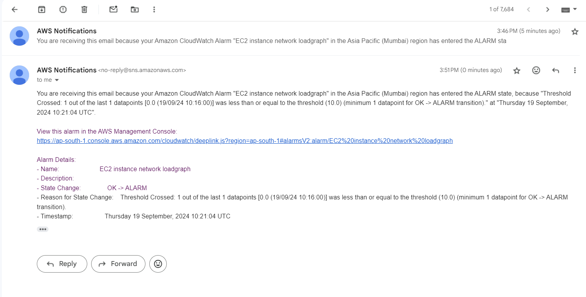

By using CLI:

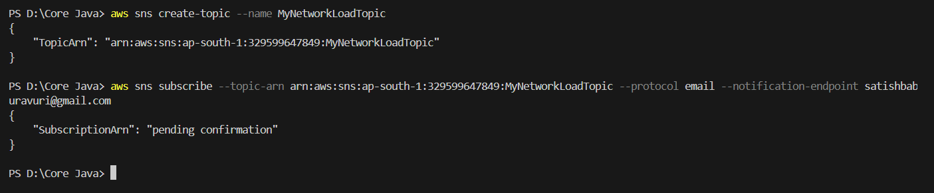

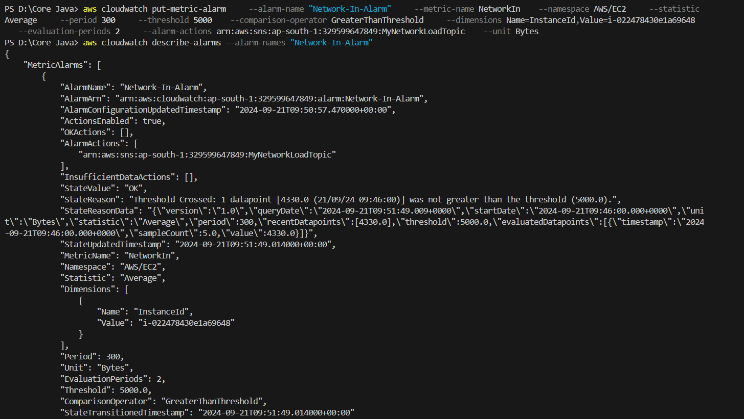

47. Create an SNS Topic and Add an Email Address for Notifications.

1. Open SNS in the AWS management console.

2. Create SNS topic by giving a specified name to the topic.

3. Add an email subscription by giving email in the protocol and enter the desired email address

for the notifications.

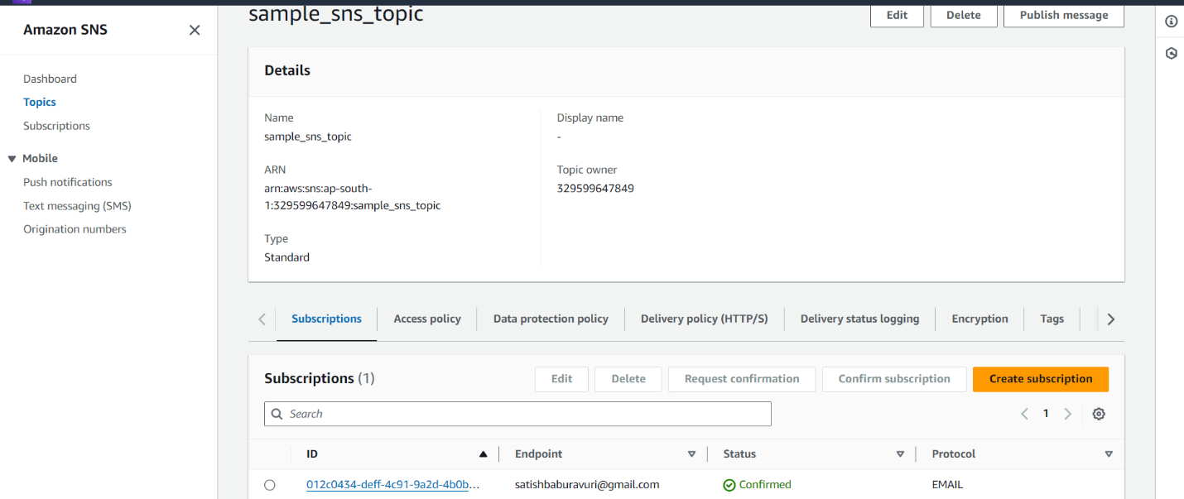

By using CLI:

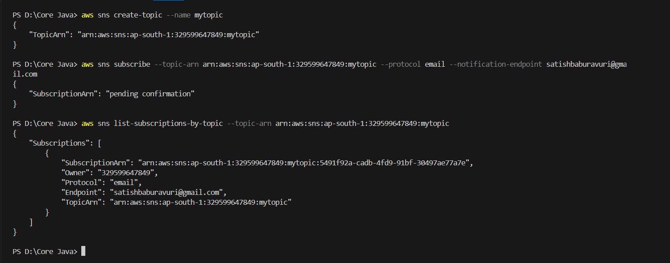

48. Create an SQS Queue and Subscribe It to the Previously Created SNS Topic.

1. Open SQS in the AWS management console.

2. Create an SQS queue by giving the specified name to the queue.

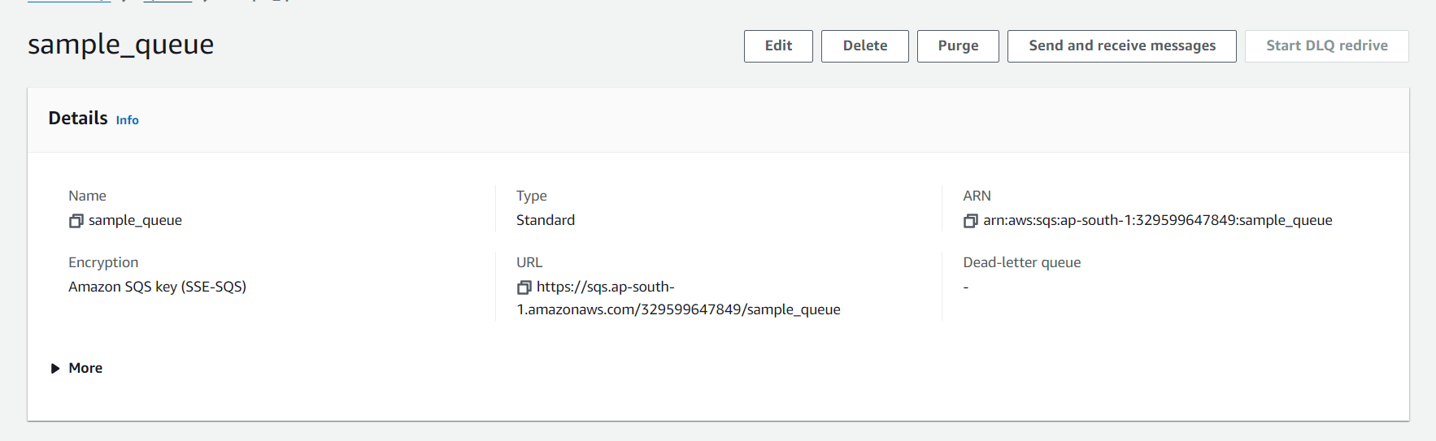

3. Go to the previously created SNS topic and subscribe SQS to the SNS topic by choosing

Protocol as SQS and in the endpoint give ARN of the SQS queue.

4. In SQS, go to the access policy and give a policy that allows SNS topic to send messages.

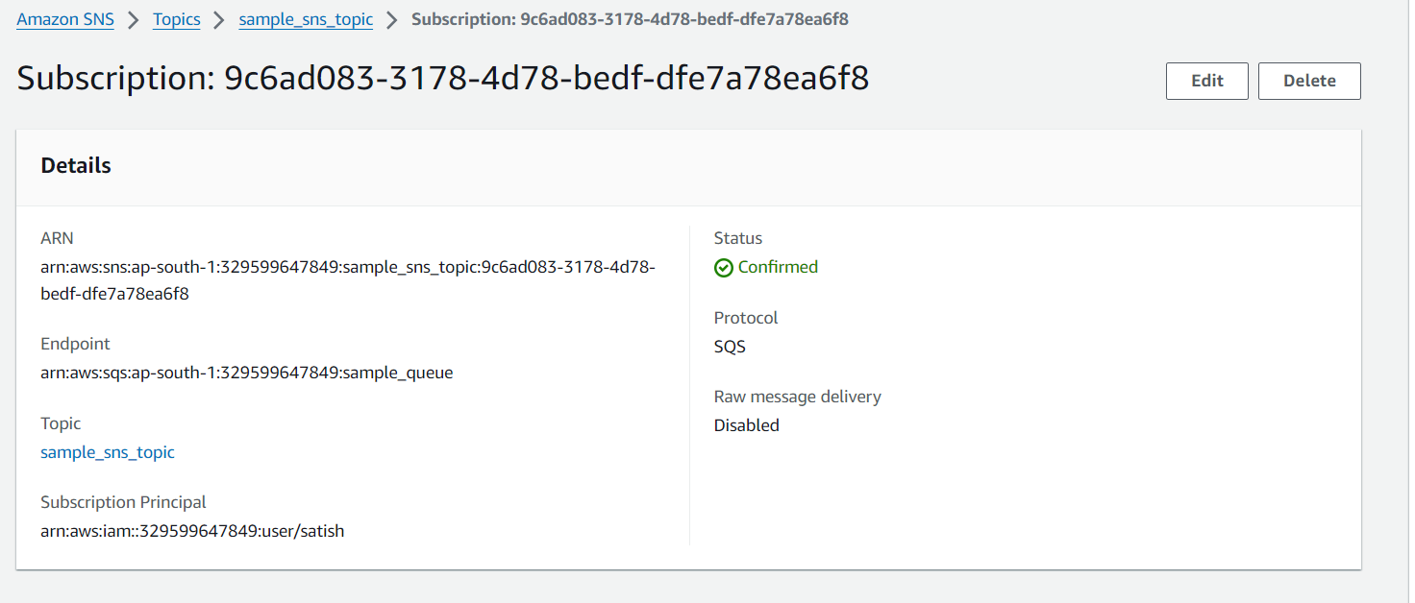

By using CLI:

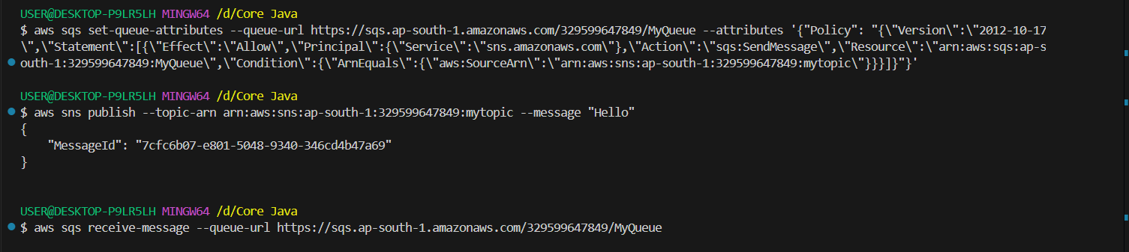

49. Verify if the Messages are Being Sent Correctly from SQS.

1. To verify send a test message to the queue. Open the previously created SNS topic and click

on publish message. Enter the message and publish it.

2. To check the message open SQS queue and select the send and receive messages to retrieve

message. Click on poll for messages and review the message.

