1. **Create VPC**

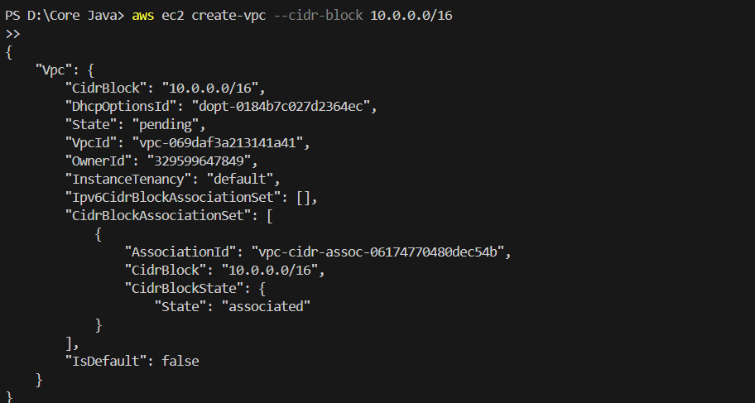

1. **Create Subnets (3 Public, 3 Private)**

**Public subnet 1:**

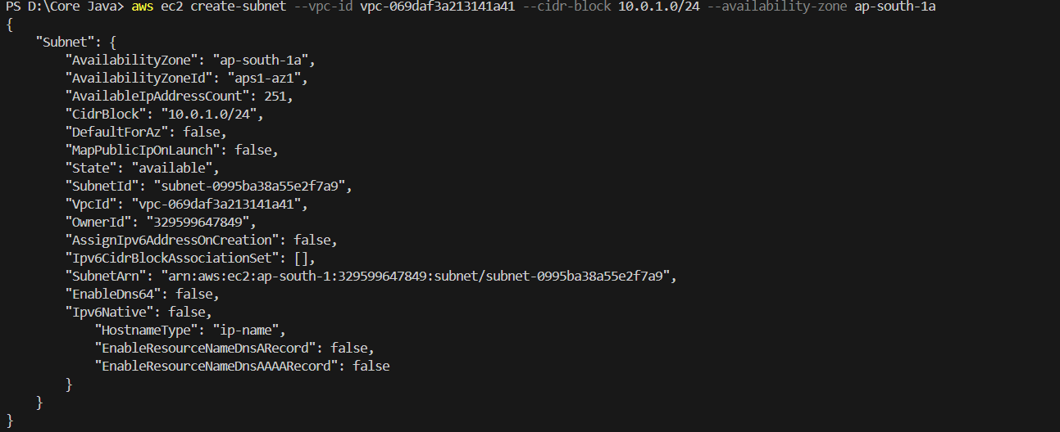

**Public subnet 2:**

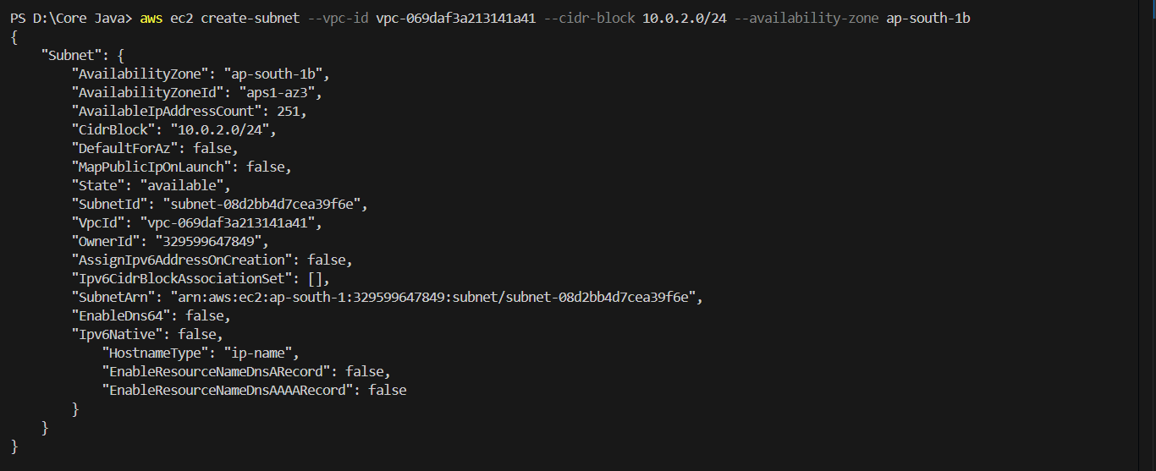

**Public subnet 3:**

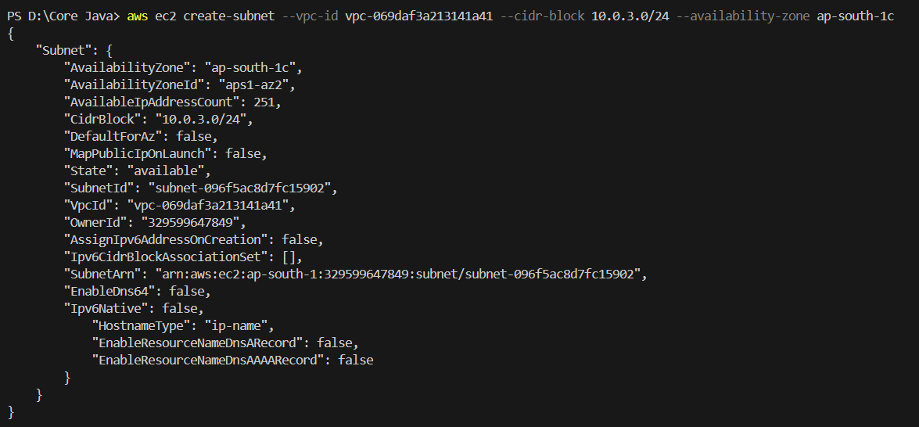

**Private subnet 1:**

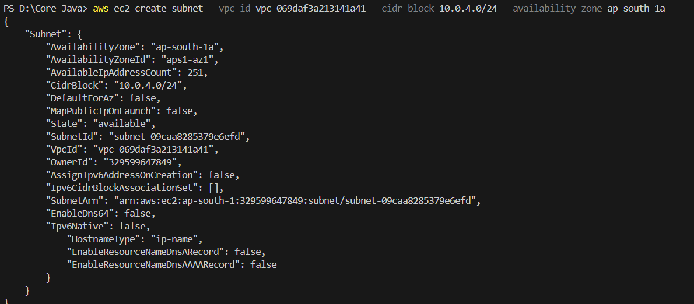

**Private subnet 2:**

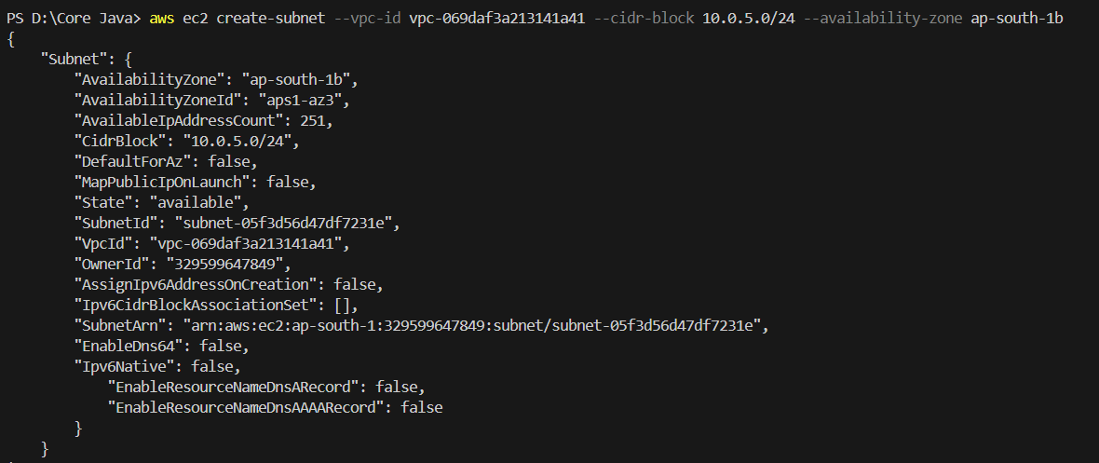

**Private subnet 3:**

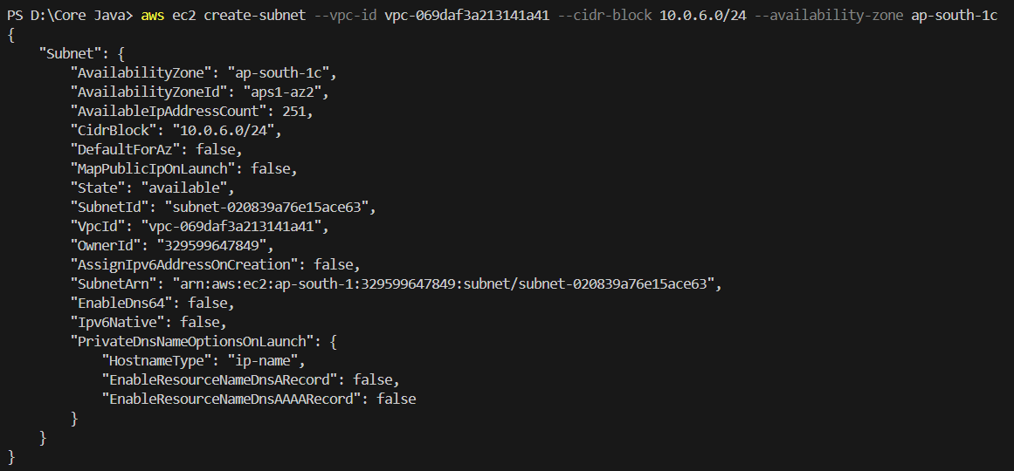

1. **Create Route Tables (Public and Private)**

**Public route table:**

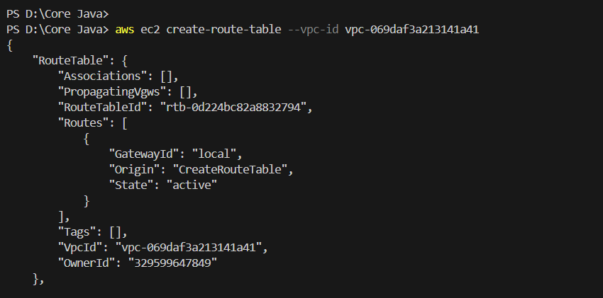

**Private route table:**

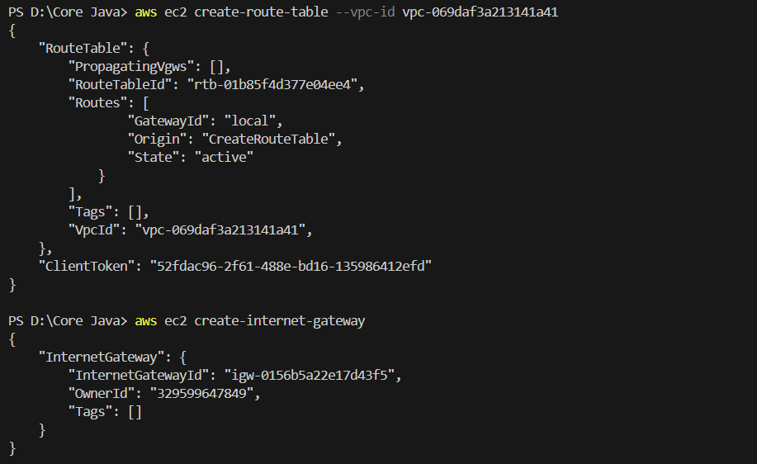

1. **Create an Internet Gateway (IGW)**

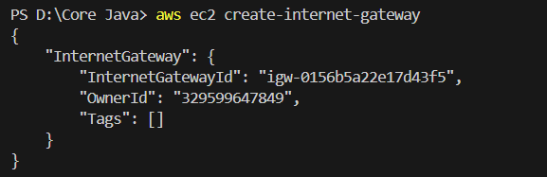

1. **Attach IGW to VPC**



1. **Add Route to Public Route Table (via IGW)**



1. **Associate Public Subnets with Public Route Table**

**Subnet 1:**

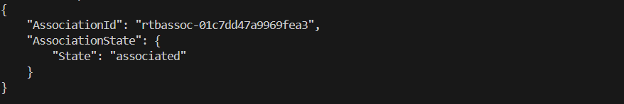

**Subnet 2:**

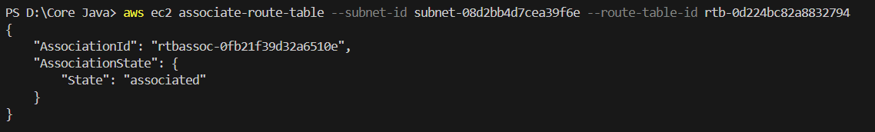

**Subnet 3:**

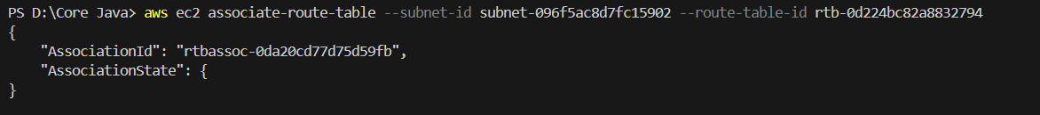

1. **Create NAT Gateway (NGW) with Elastic IP**

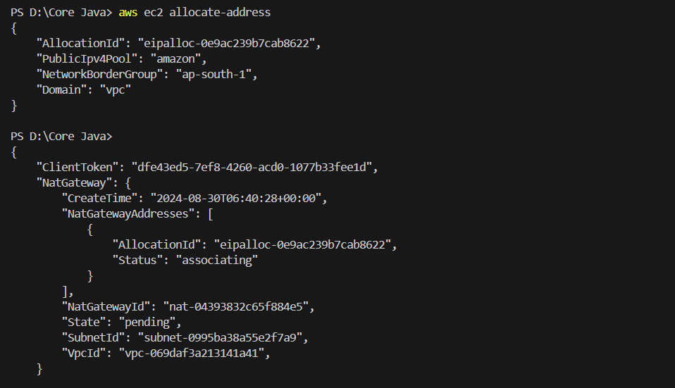

1. **Add Route to Private Route Table (via NGW)**



1. **Associate Private Subnets with Private Route Table**

**Subnet 1:**

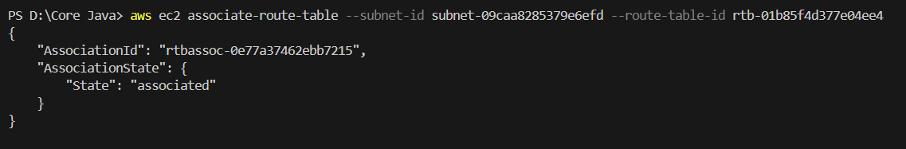

**Subnet 2:**

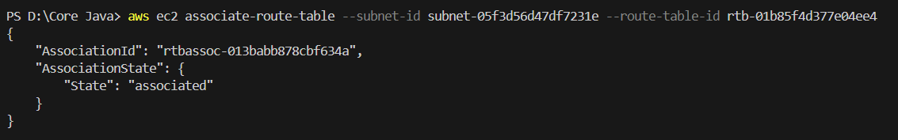

**Subnet 3:**

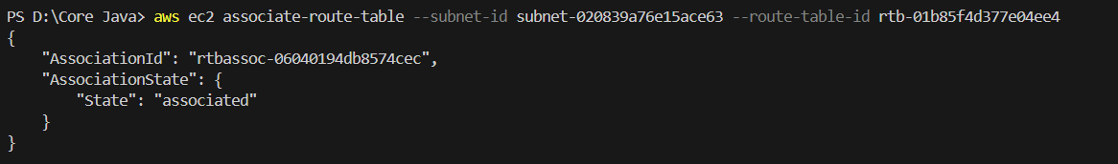

1. **Launch an EC2 Instance in Public Subnet**

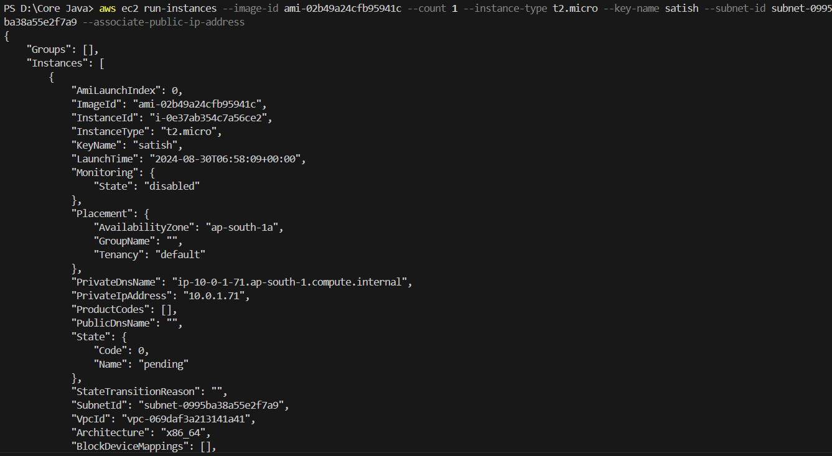

1. **Launch an EC2 Instance in Private Subnet**

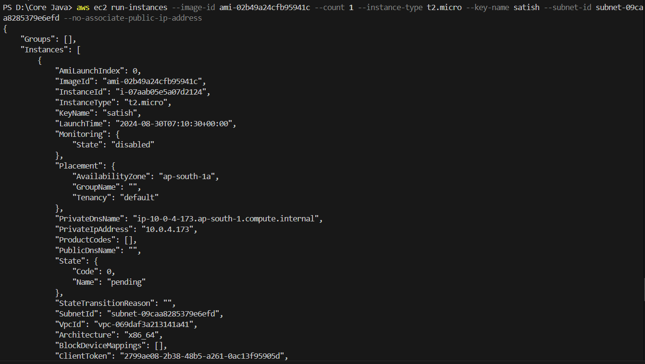

1. **Connect to EC2 Instance in Public Subnet**

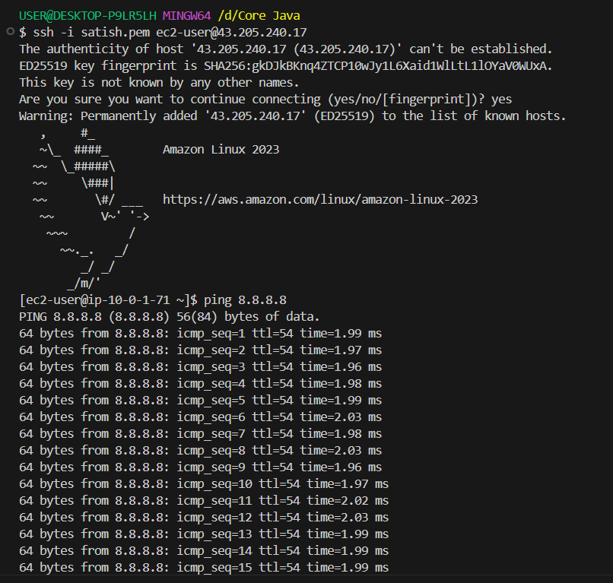

1. **Connect to EC2 Instance in Private Subnet**

1)First i connect to ec2-instance in public subnet using mobaxterm

2) upload the pem.file in mobaxterm.

3)and check the pem file is exists or not

4) select the private instance and click on connect and go to SSH client and

5)enter the command (ssh-i<Key Name>[.pemec2-user@<Private](mailto:.pemec2-user@%3cPrivate)InstancePrivateIP >) and

Add the SSH rule in the security group Click enter

6)and after we get denied permission.

7)After getting denied permission.enter a command( chmod 400 keyname.pem) is used for

Change the file permissions.

8)Now enter the ping 8.8.8.8 command to check whether it is working or not

15. **Stop Both EC2 Instances**