**1. Create VPC**

**Using AWS Management Console:**

1. Open the VPC Dashboard.
2. Click on "Create VPC."
3. Choose "VPC only" and give your VPC a name.
4. Specify an IPv4 CIDR block (e.g., 10.0.0.0/16).
5. Click on "Create VPC."

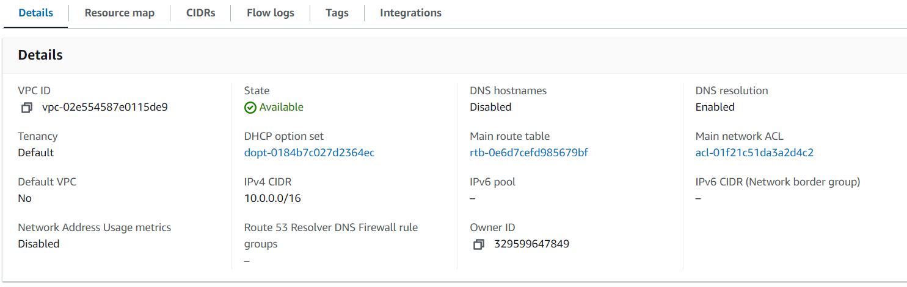

**2. Create 6 Subnets (3 Public, 3 Private)**

1. Go to "Subnets" under the VPC Dashboard.
2. Click on "Create Subnet."
3. Select your VPC, choose the Availability Zone, and specify a CIDR block for each subnet.
4. Create 3 public subnets (e.g., 10.0.1.0/24, 10.0.2.0/24, 10.0.3.0/24).
5. Create 3 private subnets (e.g., 10.0.4.0/24, 10.0.5.0/24, 10.0.6.0/24).

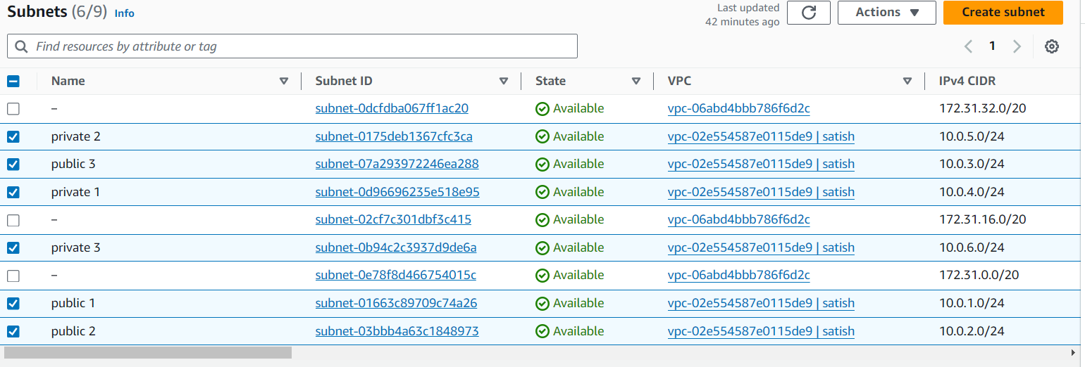

**3. Create Public and Private Route Tables**

1. Go to "Route Tables" under the VPC Dashboard.
2. Click "Create route table."
3. Create one route table for public subnets, and one for private subnets.

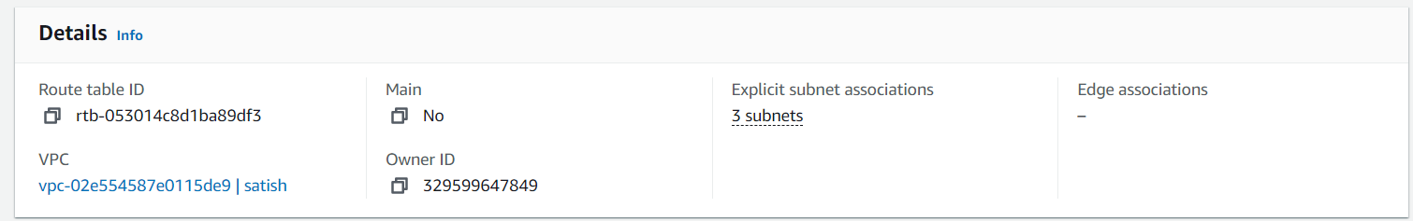

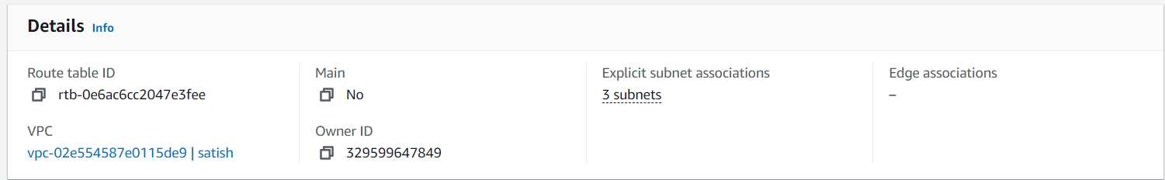

**4. Create an Internet Gateway (IGW)**

1. Go to "Internet Gateways" under the VPC Dashboard.
2. Click "Create internet gateway" and give it a name.

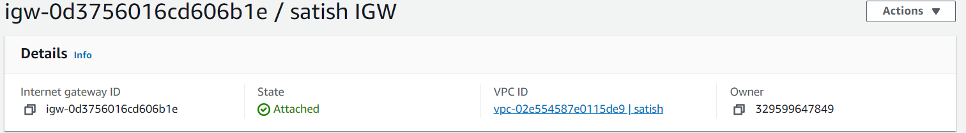

**5. Attach IGW to VPC**

1. Go to the "Internet Gateways" section.
2. Select your IGW, click "Actions," and choose "Attach to VPC."



**6. Add Route to Public Route Table (for IGW)**

1. Go to "Route Tables," select the public route table.
2. Click on "Routes" and "Edit routes."
3. Add a new route with destination 0.0.0.0/0 and target as the IGW.

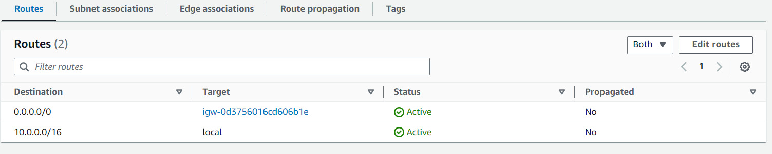

**7. Associate Public Subnets with Public Route Table**

1. In the "Route Tables" section, select your public route table.
2. Go to "Subnet Associations," and associate your 3 public subnets.

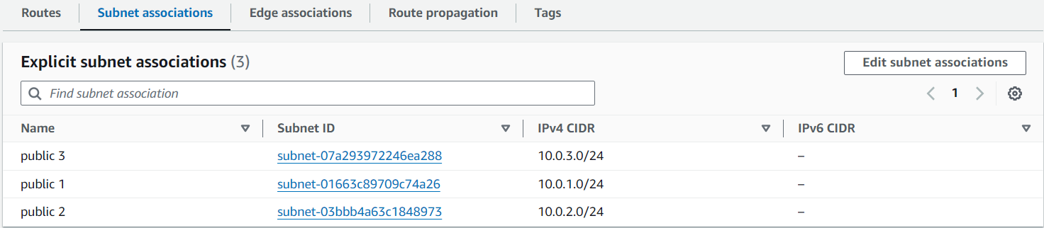

**8. Create NAT Gateway (NGW) with Elastic IP**

1. Go to "NAT Gateways" under the VPC Dashboard.
2. Click "Create NAT Gateway."
3. Select a public subnet, allocate an Elastic IP, and create the NAT gateway.

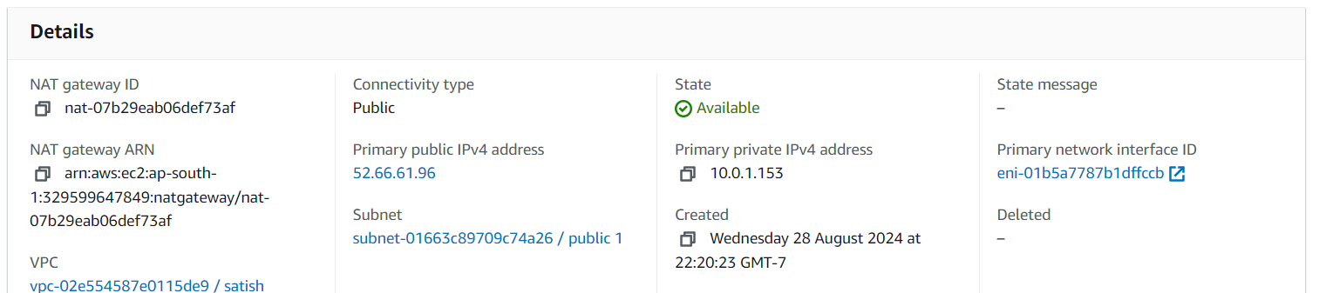

**9. Add Route to Private Route Table (for NGW)**

1. Go to "Route Tables," select the private route table.
2. Click "Routes" and "Edit routes."
3. Add a new route with destination 0.0.0.0/0 and target as the NAT Gateway.

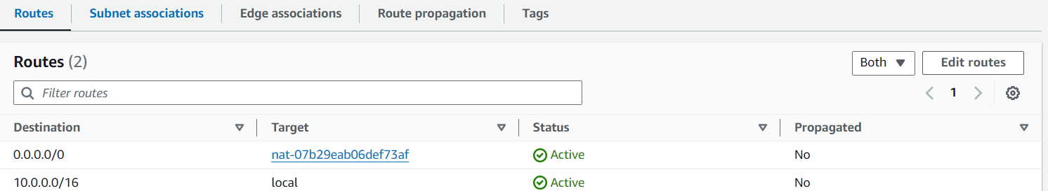

**10. Associate Private Subnets with Private Route Table**

1. In the "Route Tables" section, select your private route table.
2. Go to "Subnet Associations," and associate your 3 private subnets.

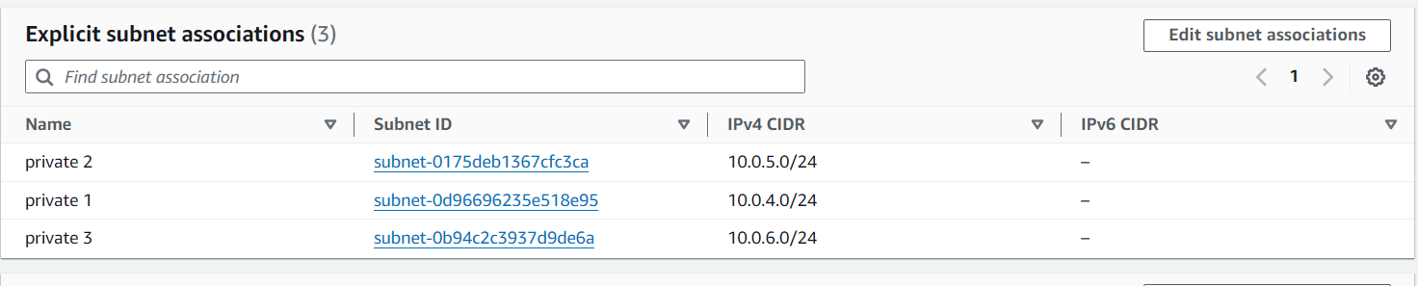

**11. Launch an EC2 Instance in Public Subnet**

1. Go to "EC2 Dashboard" and click "Launch Instance."
2. Choose an Amazon Machine Image (AMI) and instance type.
3. Under "Network," select the VPC and public subnet.
4. Configure security groups and other settings, then launch.

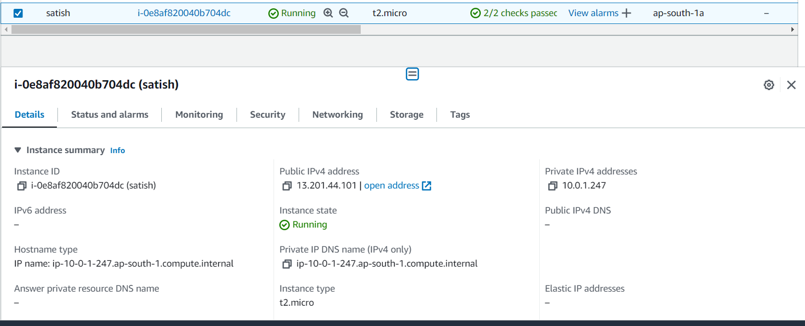

**12. Launch an EC2 Instance in Private Subnet**

1. Follow the same steps as above, but select a private subnet and do not associate a public IP.

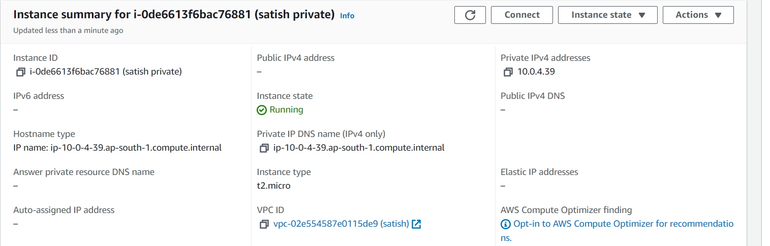

**13. Connect to EC2 Instance in Public Subnet**

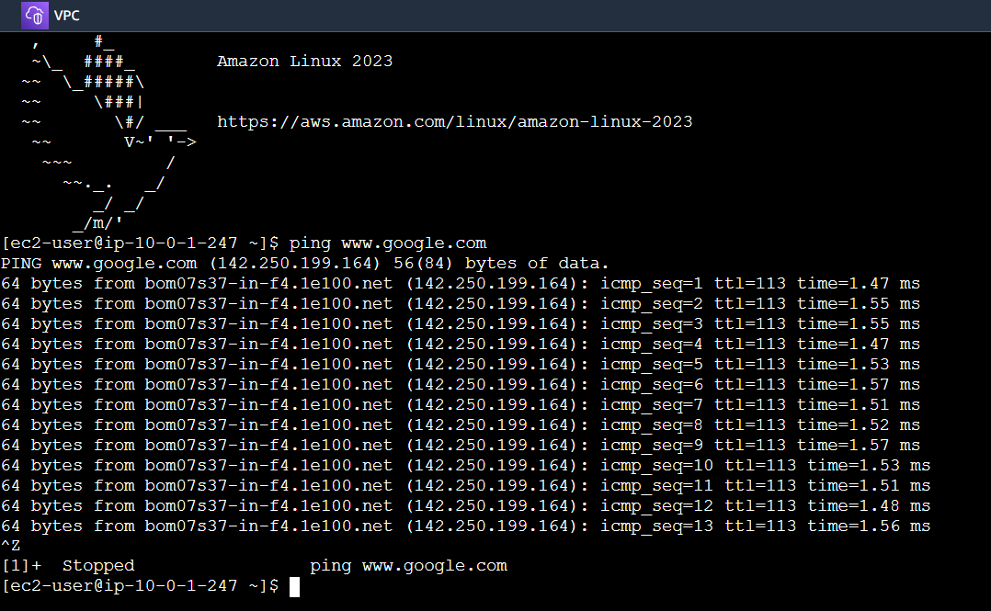

### 14. Connect to EC2 Instance in Private Subnet

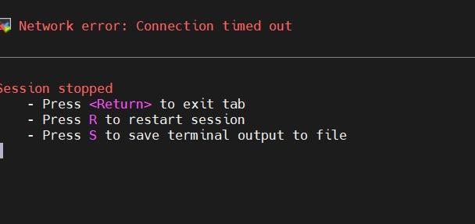

**15. Stop both EC2 instances**

1.Go to instances under the dashboard.

2.Select the instance and click.