NYC Taxi Trip Data Analysis Report
Comprehensive Analysis, Optimization, and Anomaly Detection

1. Report Objective
The primary objective of this report is to explore, analyze, and optimize a large-scale NYC Taxi Trip dataset. This analysis aims to extract meaningful commuter patterns, evaluate fare and distance metrics, detect systemic anomalies (such as billing errors or infinite fare calculations), and demonstrate the performance benefits of distributed computing for Big Data tasks.

2. Tools & Technologies Used
- Python: Core programming language used for the analysis.
- Dask: Utilized for distributed, out-of-core data processing to handle the large dataset efficiently.
- Pandas: Employed for underlying data manipulation and structuring.
- Matplotlib: Used for generating all visual distributions and scatter plots.
- Jupyter Notebook (VS Code): Interactive development environment used for writing and executing the code.

3. Dataset Details & Overview
The dataset, "taxi_trip_data.csv", is a high-volume record of taxi rides. Prior to modeling, the data underwent a crucial standardization phase:
- Schema Cleaning: Column names were stripped of whitespaces and converted to underscore formatting (e.g., 'fare amount' to 'fare_amount').
- Data Integrity: Missing values (NaNs) and duplicate records were fully expunged.
Post-cleaning, the dataset comprises exactly 9,392,429 valid trips. Key attributes include pickup/dropoff datetimes, vendor IDs, passenger counts, trip distances, and detailed fare breakdowns (base fare, tips, MTA taxes, surcharges, etc.).

4. Exploratory Data Analysis (EDA)

4.1 Passenger Count Demographics
Analysis of passenger counts reveals a dominant trend of single-occupancy rides, comprising over 6.6 million trips (approx. 70.5%). Notably, there is a data logging anomaly where 85,779 trips recorded exactly 0 passengers.
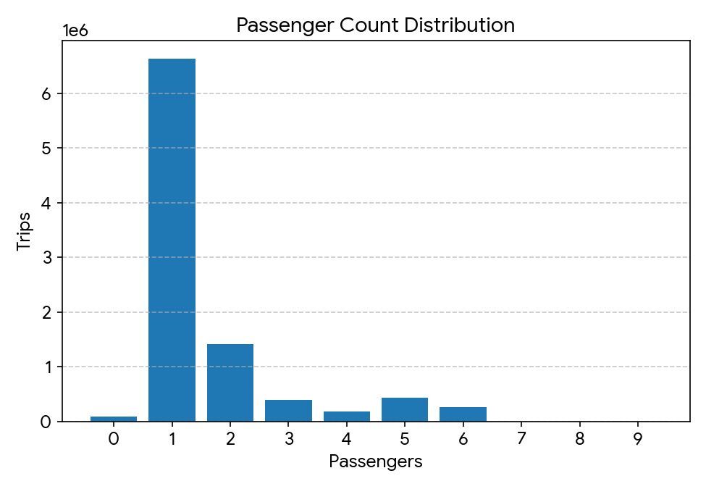
Passenger Count | Total Recorded Trips
0 | 85,779
1 | 6,629,109
2 | 1,417,209
3 | 392,020
4 | 183,577
5 | 430,615
6 | 253,624
7 | 196
8 | 160
9 | 140

4.2 Distance Mechanics
The dataset exhibits a mean trip distance of 8.84 units. The distribution of these distances is heavily right-skewed (log-normal shape), indicating that the vast majority of taxi trips are short, localized commutes, with long-haul journeys being exceedingly rare.
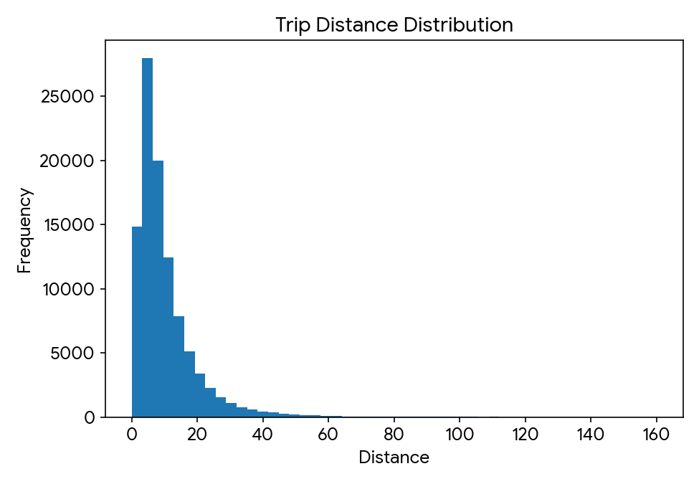

5. Outlier & Anomaly Detection

5.1 Extreme Fare Violations
By plotting the fare amount against trip distance, a severe systemic error was detected. A significant cluster of trips recorded near-zero distances but catastrophic fare charges. The average fare is $31.64, but the maximum fare peaked at $398,460.05.
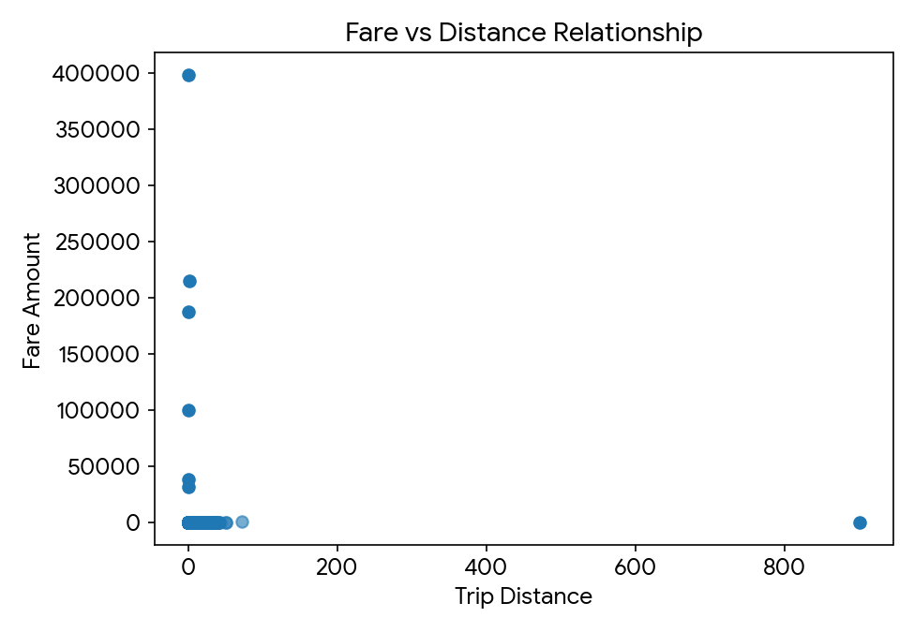
Vendor ID | Pickup Date | Distance | Fare Amount ($)
1 | 2018-07-17 | 0.0 | 398,460.05
1 | 2018-03-30 | 1.4 | 214,748.44
1 | 2018-11-22 | 0.3 | 187,436.46
1 | 2018-07-01 | 0.2 | 99,618.22
1 | 2018-12-21 | 0.0 | 38,301.78

5.2 The "Fare per KM" Metric Discrepancy
To further gauge efficiency, a 'fare_per_km' metric was computed. This exposed trips with highly inflated base fares for 0.0 distance, throwing infinite ('inf') calculation errors. These records must be isolated and removed before implementing predictive machine learning models.
Distance | Base Fare | Calculated Fare/KM
0.00 | $63.00 | inf
0.01 | $68.00 | $6,800.00
0.50 | $62.76 | $125.52
0.00 | $110.00 | inf

6. Big Data Optimization with Dask
Due to the size of the dataset (~9.4 million rows), Dask was utilized to parallelize the operations. During the execution phase, partition tuning was tested:
- Before Optimization: 22 partitions yielded a compute time of 36.16 seconds.
- After Repartitioning: Collapsing down to 8 partitions dropped the compute time to 31.40 seconds.
This ~13% increase in efficiency proves that balancing partition sizes with available compute cores significantly enhances processing speeds.

7. Major Findings & Conclusion
The analysis successfully navigated nearly 10 million taxi records to reveal several critical insights:
- Commuter Behavior: The majority of users ride alone, and journeys are strongly biased toward short distances (averaging 8.84 units).
- Data Quality Flaws: The dataset contains systemic recording errors, including "0-passenger" trips and highly unrealistic fare entries (reaching hundreds of thousands of dollars for 0-distance trips).
- Technological Efficacy: Employing Dask over standard Pandas allowed for seamless out-of-core computation, and fine-tuning partition architecture generated measurable reductions in processing time.
Moving forward, any predictive modeling or machine learning efforts on this dataset must involve a strict filtering pipeline to strip out the identified infinite 'fare_per_km' anomalies and negative/zero distance trips to ensure model accuracy.

