FINAL PROJECT REPORT
Sales Dashboard Development using Tableau

Prepared by: Satish Chandra Barick
B.Tech in Computer Science and Engineering
Centurion University of Technology and Management (CUTM)
Bhubaneswar, Odisha.

1. INTRODUCTION
In today’s data-driven world, organizations rely heavily on visual analytics to make informed decisions. This project focuses on developing a fully functional and interactive sales dashboard using Tableau to analyze and visualize business data.
The dashboard provides a comprehensive view of sales performance across different dimensions such as region, product category, payment method, customer type, and sales representatives. It helps stakeholders quickly understand trends, identify top performers, and detect areas needing improvement.

2. OBJECTIVE
The main objectives of this project are:
- To build an interactive dashboard using Tableau.
- To analyze sales data from multiple perspectives.
- To provide actionable insights for business decision-making.
- To visualize key performance indicators (KPIs) effectively.
- To enable dynamic filtering and user-driven exploration.

3. DATASET DESCRIPTION
The dataset used in this project includes the following fields:
- Sales Amount – Total revenue generated
- Quantity Sold – Number of units sold
- Unit Cost & Unit Price – Used for calculations
- Discount – Applied discount values
- Sale Date – Time dimension
- Region – East, West, North, South
- Product Category – Clothing, Electronics, Food, Furniture
- Customer Type – New and Returning
- Payment Method – Cash, Credit Card, Bank Transfer
- Sales Representative – Individual performers

4. TOOLS & TECHNOLOGIES USED
- Tableau Desktop – For data visualization and dashboard creation
- CSV Dataset – Source data
- Calculated Fields – For derived metrics
- Interactive Filters & Actions – For dynamic analysis

5. DASHBOARD COMPONENTS
The dashboard consists of multiple visual elements designed to provide a holistic view of the data.

5.1 KPI Cards
These KPIs provide a quick summary of overall business performance:
- Total Sales: ₹50,19,265.23
- Total Quantity: 25,355
- Average Discount: 0.1524

5.2 Sales Trend Line Chart
Displays monthly sales from Jan 2023 to Jan 2024. Helps identify seasonal patterns and fluctuations.
Insight: Sales show variation over time with peaks in certain months.
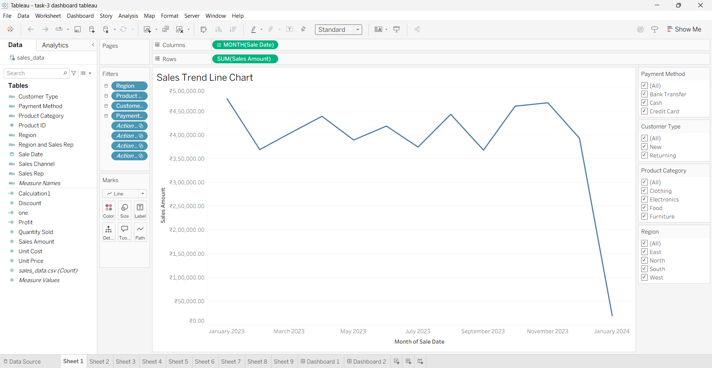

5.3 Region-Wise Sales (Bar Chart)
Compares sales across North, East, West, and South regions.
Insight: North region has the highest sales, while the South region has the lowest performance.
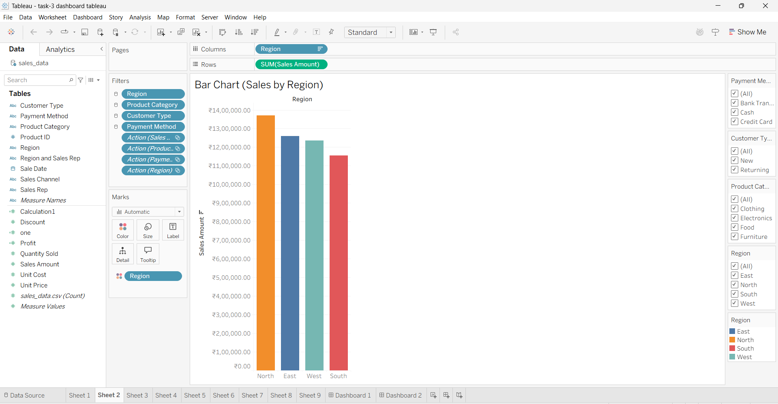

5.4 Treemap (Product Category)
Shows the distribution of sales across Clothing, Electronics, Food, and Furniture.
Insight: Certain categories clearly dominate revenue contribution.
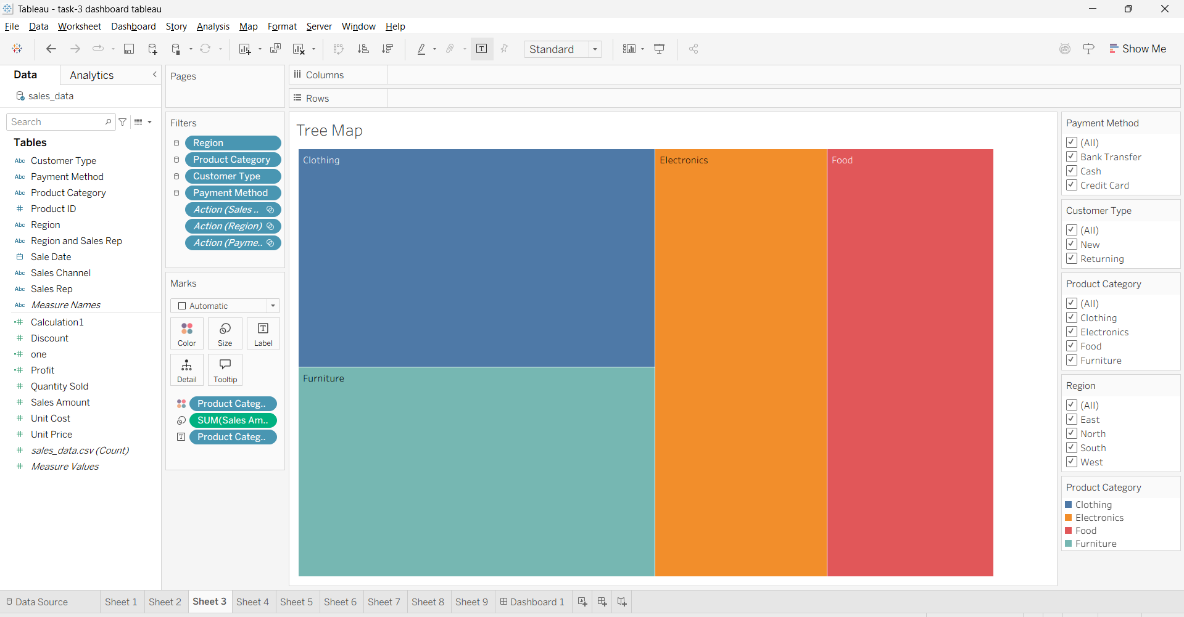

5.5 Pie Chart (Payment Method)
Displays usage across Bank Transfer, Cash, and Credit Card.
Insight: Payment usage is fairly distributed, with slight variations between methods.
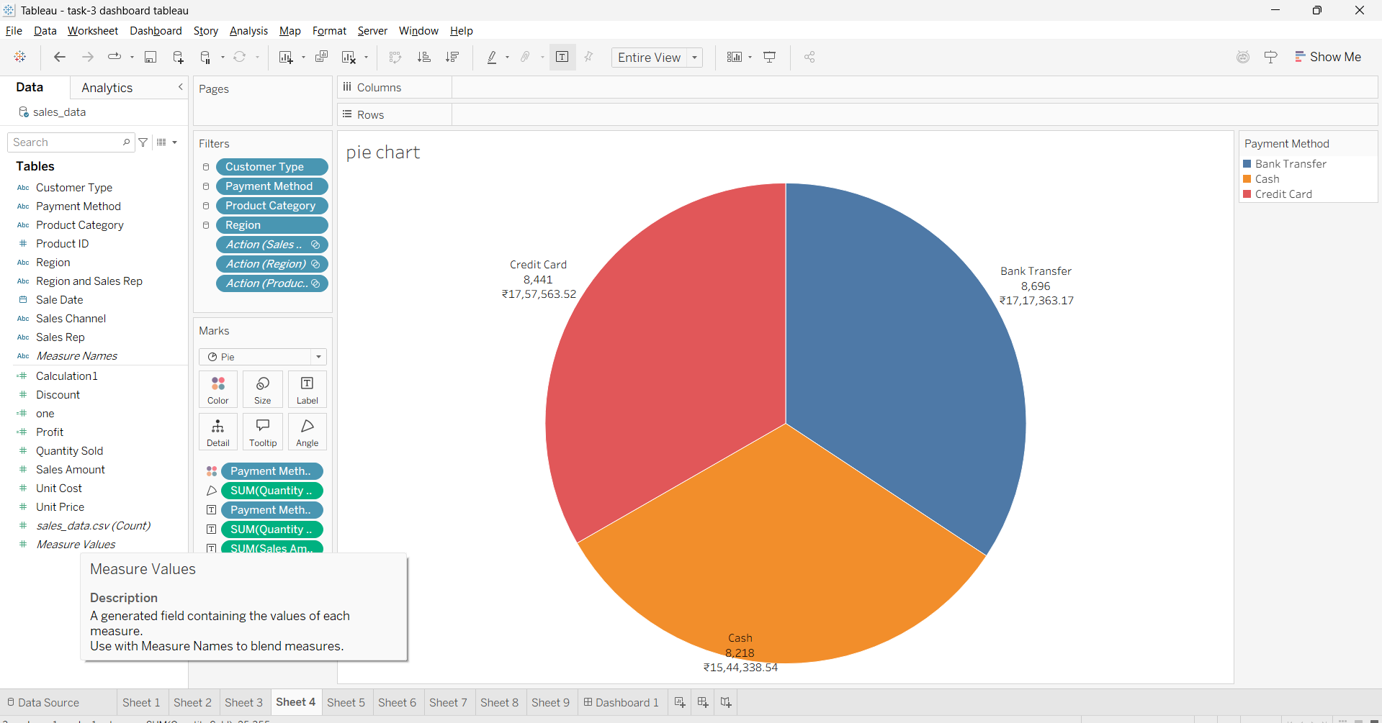

5.6 Top Performers Chart
Compares top sales representatives (David, Bob, Eve, Alice, Charlie).
Insight: Top sales reps contribute the major share of overall revenue.
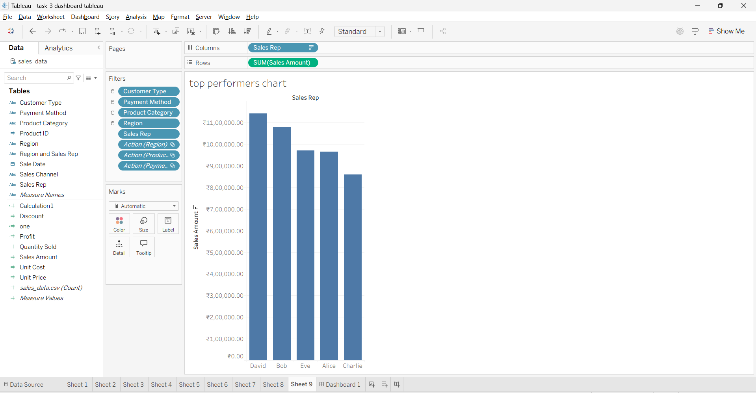

5.7 Color-Encoded Sales / Profit View
Uses a gradient color scale (Red → Green) to map profitability against sales volume.
Insight: Green indicates higher performance and profitability, whereas Red indicates lower performance.
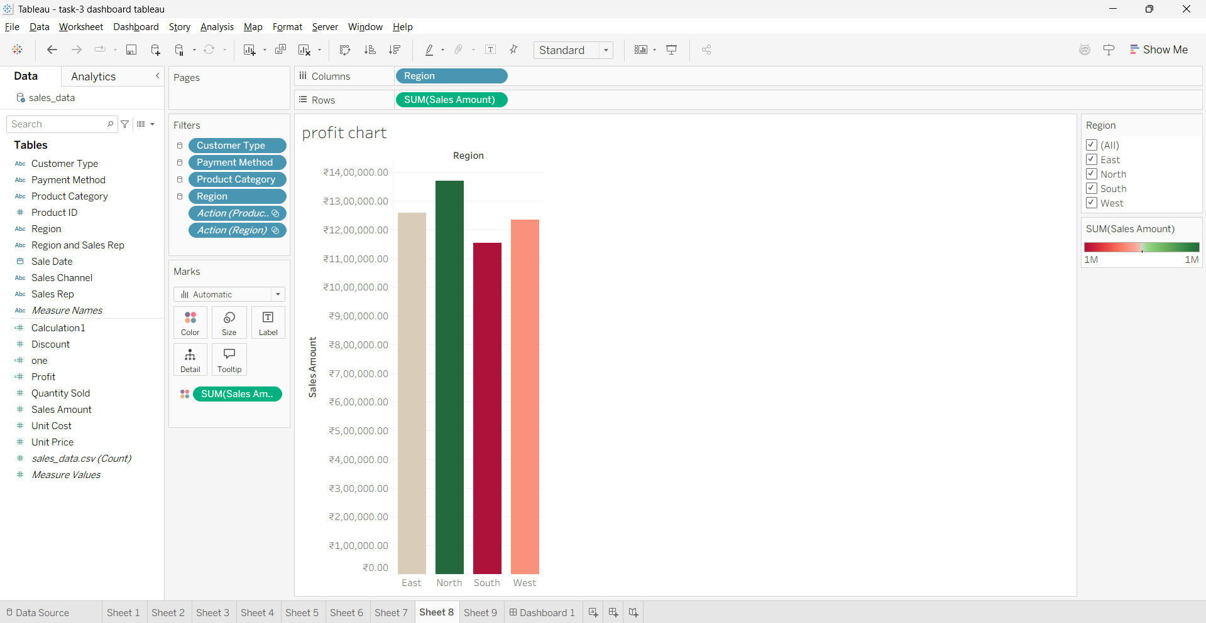

5.8 Full Dashboard Overview
A comprehensive, interactive view combining all the components listed above.
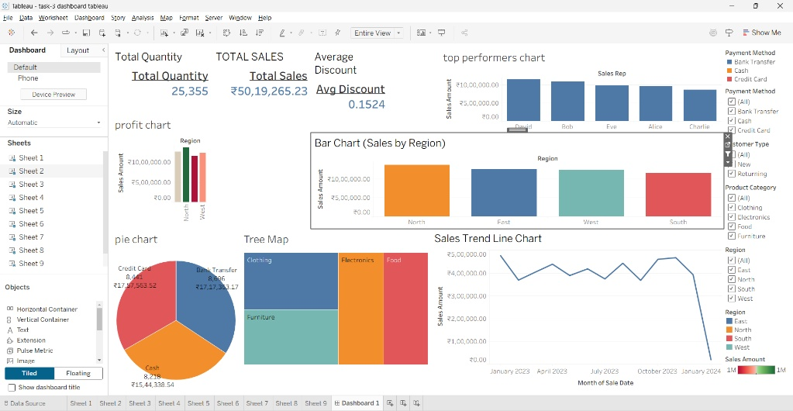

6. INTERACTIVITY FEATURES
- Filters: Configurable by Region, Product Category, Customer Type, and Payment Method.
- Dynamic Updates: All charts update simultaneously based on filter selection.
- User Interaction: Enables deep drill-down analysis for specific data points.

7. ACTIONABLE INSIGHTS
- North region is the top-performing region, whereas the South region requires targeted improvement strategies.
- Sales show consistent time-based fluctuations, indicating possible seasonal trends that can be leveraged for marketing.
- A select group of top sales representatives drives the majority of the revenue, highlighting the need for specialized incentives.
- Sales are well-distributed across multiple product categories, ensuring a diversified portfolio.
- Payment methods show no single dominant mode, meaning customer preferences vary widely.

8. ADVANTAGES OF THE DASHBOARD
- Easy to understand and visually appealing.
- Real-time filtering capabilities enhance exploration.
- Facilitates quick and accurate decision-making.
- Clearly identifies trends and performance gaps.
- Provides comprehensive business insights at a glance.

9. LIMITATIONS
- Analysis is constrained by the current dataset scope.
- Profitability analysis could be explored more deeply.
- Lacks forecasting or predictive analytics capabilities.
- Insights depend heavily on ongoing data quality and updates.

10. FUTURE IMPROVEMENTS
- Add forecasting models to predict future sales trends.
- Include a detailed profit margin analysis component.
- Develop customer segmentation insights for targeted marketing.
- Integrate real-time data sources for live tracking.
- Refine the UI/UX with advanced design principles.

11. CONCLUSION
This project successfully demonstrates the development of a fully functional Tableau dashboard with interactive features and meaningful insights. The dashboard enables users to analyze sales performance, compare regions and categories, identify top performers, and make informed business decisions. Overall, it fulfills the objective of delivering a data-driven, interactive, and insight-rich tool for stakeholders.

