Predictive Modeling & Survival Analysis
Comprehensive Analytical Report on Classification Methodologies

1. Executive Summary & Project Objective
The primary objective of this project is to construct, evaluate, and interpret predictive machine learning models designed to determine the likelihood of passenger survival based on historical maritime disaster data (the Titanic dataset). By rigorously analyzing demographic and socio-economic variables, the goal is to isolate the specific factors that contributed most significantly to a passenger's survival. Furthermore, this report compares the efficacy of an ensemble tree-based algorithm against a traditional linear statistical model to demonstrate the value of capturing non-linear relationships in complex datasets.
2. Technologies & Methodologies
This analytical pipeline was developed utilizing a modern, industry-standard Python data science stack. The following libraries and techniques were instrumental to the project:
Core Libraries:
• pandas & numpy: Employed for robust data ingestion, missing value treatment, matrix operations, and overall data frame structuring.
• matplotlib.pyplot & seaborn: Utilized for generating comprehensive statistical visualizations, confusion matrices, and diagnostic bar charts.
• scikit-learn (sklearn): The primary machine learning engine used for algorithmic model building, cross-validation, and performance evaluation.
Applied Machine Learning Techniques:
• Data Imputation: Mathematically filling missing 'Age' values with the population mean to preserve dataset integrity without introducing severe bias.
• Categorical Encoding: Mapping text-based demographic categories (e.g., gender) into binary numerical formats (0 and 1) to satisfy algorithmic constraints.
• Advanced Feature Selection: Applying SelectKBest (ANOVA F-value method) to mathematically isolate the most statistically significant predictive variables, thereby reducing dimensionality and noise.
• Algorithmic Benchmarking: Deploying and directly comparing a Random Forest Classifier (an ensemble method) against a Logistic Regression model.
3. Real-World Industry Applications
While this specific analysis utilizes historical disaster data, the underlying binary classification methodologies demonstrated here form the backbone of modern predictive analytics across multiple global industries:
• Healthcare & Triage: Predicting patient outcomes, hospital readmission rates, or the likelihood of a disease based on patient vitals and demographics.
• Financial Risk Management: Predicting loan defaults, credit card fraud, or subscriber churn (service cancellations) based on behavioral data.
• Insurance Underwriting: Calculating precise risk profiles by identifying which demographic features most heavily impact the likelihood of a future claim.
• Emergency Response Planning: Understanding how socio-economic factors and physical infrastructure impact survival dynamics to better allocate resources during natural disasters.
4. Data Preprocessing & Feature Engineering
A robust machine learning model requires highly curated data. The raw dataset consisted of 891 entries across 12 features. The analysis deliberately discarded noisy identifiers (such as names and ticket numbers) and focused on core quantifiable features: Survived, Pclass, Sex, Age, and Fare.
The 'Age' column contained 177 missing values (~20% of the dataset), which were imputed using the overall mean age. The 'Sex' variable was converted to a machine-readable format mapping 'male' to 0 and 'female' to 1. To optimize the model's performance, the SelectKBest algorithm was employed to filter out irrelevant data. Interestingly, the statistical selector discarded 'Age' entirely in favor of 'Pclass', 'Sex', and 'Fare'. This pivotal insight indicates that socio-economic status and gender carried a far heavier mathematical weight in determining survival than age alone.
5. Model Training & Performance Comparison
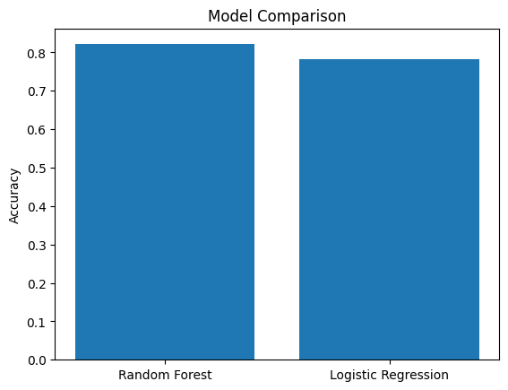
Two distinct machine learning architectures were trained on the optimized features using a standard 80/20 train-test split. This approach ensures the models are evaluated on unseen data, testing their true generalization capabilities.
As illustrated in Figure 1, the Random Forest model achieved an accuracy of 82.12%, outperforming the Logistic Regression model's 78.21% by a margin of nearly 4%. This performance gap is highly indicative of the dataset's nature: the relationship between survival and the features (Fare, Sex, Pclass) contains complex, non-linear patterns. The decision-tree-based ensemble method successfully captured these nuances, whereas the linear Logistic model fell short.

6. Visual Diagnostics & Error Analysis
Accuracy alone is often insufficient for a full evaluation. The models were subjected to deeper diagnostic visualization.
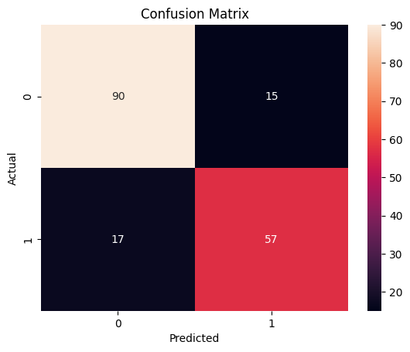
6.1 The Confusion Matrix

The heatmap above (Figure 2) visualizes the exact predictive breakdown of the Random Forest model on the 179 test samples. The model successfully identified 90 non-survivors (True Negatives) and 57 survivors (True Positives). Crucially, the error rates are relatively low and balanced: 15 false positives (predicting survival when the passenger perished) and 17 false negatives (predicting death when the passenger survived). This balance indicates a stable, reliable model.
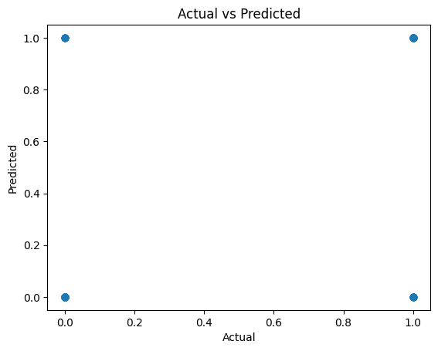
6.2 Actual vs Predicted Distribution

Figure 3 plots Actual values against Predicted values. Because this is a strict binary classification problem, all data points naturally cluster into four distinct coordinates on the grid. While this graph visually confirms that the model is outputting strict binary values (0 or 1), the severe overplotting of data points makes the previously discussed Confusion Matrix a far superior diagnostic tool for evaluating density and error rates.
7. Feature Importance: Drivers of Survival
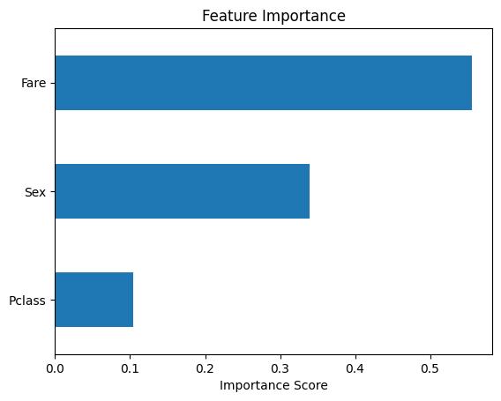
One of the greatest analytical advantages of the Random Forest algorithm is its innate ability to quantify exactly how much weight each feature carried during the decision-making process. This provides immense sociological insight into the disaster.
Based on Figure 4, we can draw the following critical conclusions:
1. Fare (Importance: ~0.55): Astonishingly, the price of the ticket was the single most dominant predictor, commanding over half of the model's decision weight. This stark socio-economic reality indicates that wealthier passengers had significantly better access to lifeboats and upper decks.
2. Sex (Importance: ~0.34): Gender was the second most vital feature, reflecting a strict adherence to the 'women and children first' maritime evacuation protocol.
3. Pclass (Importance: ~0.11): Passenger Class served as a supporting indicator of socio-economic status, further reinforcing the systemic disadvantages faced by third-class passengers.
8. Final Conclusion
This project successfully engineered a highly capable predictive system for passenger survival analysis. By systematically preprocessing the dataset, handling missing values, and extracting the most impactful variables via SelectKBest, the analysis quantitatively proved that survival during this historical event was not arbitrary; it was deeply correlated with socio-economic status and gender protocols.
Algorithmically, the Random Forest classifier proved its superiority over Logistic Regression by successfully navigating the non-linear boundaries of the data to achieve an 82.12% accuracy rate. Ultimately, the comprehensive methodologies demonstrated within this report—ranging from feature selection to ensemble modeling and confusion matrix evaluation—represent the fundamental backbone of modern predictive analytics applied across global industries today.

