CHAPTER 1: INTRODUCTION

1.1 Overview of Voice Assistants and Their Evolution
Voice assistants have rapidly evolved, starting with basic command-and-control interfaces and developing into sophisticated AI-driven assistants that understand natural language. Early voice technologies were limited to simple commands, but with advancements in artificial intelligence, particularly in machine learning and natural language processing, modern voice assistants can perform complex tasks and adapt to individual users. This project builds on these advancements to deliver an assistant that is both functional and adaptable.

1.2 Introduction to Voice-Activated AI Systems
Voice-activated AI systems have integrated into many devices, from smartphones to smart homes, making technology more accessible and interactive. With speech recognition at the forefront, these systems use NLP and deep learning algorithms to interpret, process, and respond to user commands. By focusing on real-time interaction, this project aims to demonstrate the capabilities and relevance of voice-activated AI systems in personal and professional contexts.

1.3 Importance of Voice Interaction in Modern Applications
Voice interaction transforms how users interact with technology, providing hands-free, efficient operation in various applications such as virtual assistants, customer support, and accessibility services. In this project, the focus is on leveraging voice interaction for day-to-day tasks, demonstrating the assistant's capacity for simplifying operations and enhancing accessibility for users of all skill levels.

1.4 Project Motivation and Purpose
The motivation for this project stems from the growing need for personalized and accessible AI-powered assistants. Traditional applications require direct interaction, whereas voice-based interfaces allow for more fluid and intuitive control. This project seeks to develop a voice assistant capable of understanding contextual language and executing tasks across system applications and internet-based services.

1.5 Problem Definition and Solution Approach
The primary challenge is to create an intelligent, responsive voice assistant that can understand and execute a wide range of commands with high accuracy. This involves tackling issues like interpreting natural language accurately, managing background noise, and ensuring quick response times. The solution approach leverages robust NLP techniques, machine learning algorithms, and speech-to-text engines to provide a reliable user experience.

1.6 Objectives of the Voice Assistant Project
Objectives include:
- Achieving high accuracy in voice command recognition
- Integrating seamless response generation for common system and internet tasks
- Delivering real-time responses with minimal latency
- Ensuring compatibility with various system applications

1.7 Scope of the Project
This project is designed for desktop applications, focusing on key system functions like opening applications, running scripts, and retrieving information. The assistant will be programmed to handle basic internet queries and user prompts but will not cover specialized domains such as medical or legal assistance.

1.8 Structure of the Report
The report is organized to guide readers through the theoretical foundations, technical implementation, experimental results, and final evaluations, providing a complete view of the project's development and outcomes.

CHAPTER 2: LITERATURE REVIEW
Evolution of Voice Command Technologies and Their Role in Modern Assistants:

Voice command technology has undergone a significant transformation, evolving from basic rule-based systems to sophisticated machine learning-driven models. These advancements have enhanced recognition accuracy and expanded the variety of commands that can be processed. The progression of these technologies marks key milestones in enabling modern voice assistants to handle natural language with precision [1].
Natural language processing (NLP) has played a pivotal role in this evolution, particularly with the introduction of deep learning frameworks such as BERT and GPT. These models bring a deeper understanding of contextual language and user intent, paving the way for voice assistants to manage complex commands and respond more conversationally. The integration of these advancements in NLP has elevated the capabilities of voice assistants, offering users an increasingly seamless experience.
A comparison of leading voice assistants like Alexa, Google Assistant, and Siri reveals the diverse capabilities and design philosophies that set these systems apart. Examining their command-processing abilities, strengths, and unique features provides valuable insights into industry standards and best practices. Such comparisons establish benchmarks for designing efficient and competitive voice assistant systems.
Voice assistants have traditionally relied on keyword-based recognition, but advancements in NLP and deep learning have ushered in more dynamic approaches to command execution. The transition to these methodologies has improved accuracy, reduced latency, and offered greater flexibility, demonstrating the benefits of machine learning over earlier techniques.
Despite these advancements, challenges persist. Recognizing accents and dialects, managing homophones, and addressing privacy concerns in voice data processing remain significant hurdles. These factors directly affect the usability and reliability of voice assistants, highlighting areas where further innovation is needed.
Machine learning and deep learning have emerged as transformative forces in speech recognition. By leveraging large datasets and iterative learning, these technologies enable systems to refine their accuracy and adaptability over time.

CHAPTER 3: TECHNICAL FOUNDATIONS AND IMPLEMENTATION FRAMEWORK

3.1 System Architecture of the Voice Assistant
The architecture is modular, designed to separate core components such as speech recognition, NLP processing, command interpretation, and response generation. This structure enables easy updates and integration of additional features.
- Architecture of Speech-to-Text and Text-to-Speech Components This component captures and converts audio input into text while ensuring accurate speech-to-text processing. Text-to-speech modules generate responses, creating a fluid conversational experience.
- Command Processing and Decision-Making Workflow Once a command is interpreted, a decision-making workflow determines the appropriate response. This ensures that each command is accurately processed and executed based on user intent.

Each module handles a specific task, such as processing system commands or interacting with web services. This modularity enhances maintainability and scalability.
- Command Interpretation Module Focused on extracting user intent from commands, this module is essential for accurate functionality, parsing phrases to determine the desired action.
- Response Generation and Feedback Mechanism Generates responses based on the interpreted command and provides user feedback to ensure the assistant’s actions align with the user’s intent.

Tools like SpeechRecognition and pyttsx3 are chosen for their reliability and ease of use, while Tkinter provides a user-friendly graphical interface, making interaction more accessible.

Implementation involves setting up voice input, text processing, and command execution to provide a responsive experience.
Optimization techniques, such as parallel processing and resource management, help ensure the assistant operates efficiently without lag.

CHAPTER 4: IMPLEMENTATION
4.1 Detailed Description of System Components and Modules
Each system component and module is described in detail, outlining its purpose, technical implementation, and role in the overall assistant.
- Voice Input Module:
This module captures the user's voice command through a microphone. It uses speech recognition engines to convert the audio into text.

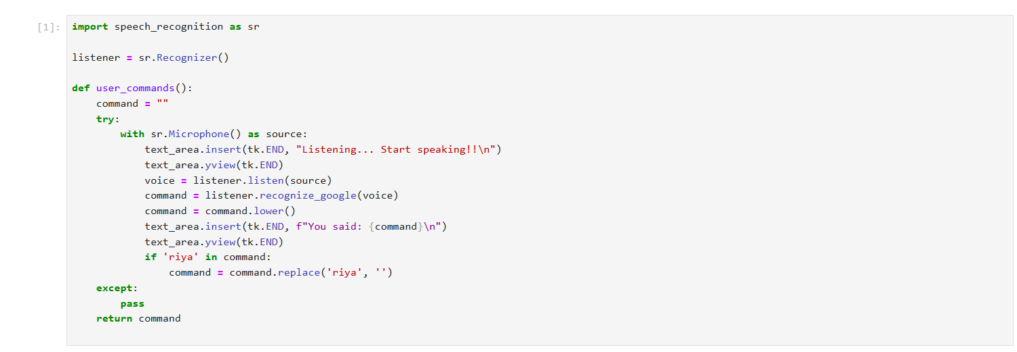
- Speech Recognition Module:
It processes the captured audio and converts it into text using a speech-to-text engine. This allows the system to understand the user's command in a text format.

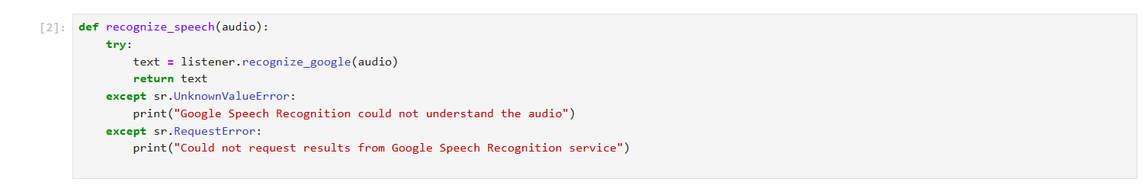

- Command Parsing Module:
This module interprets the transcribed text and extracts the relevant action or command. It identifies the intent behind the user's speech, such as opening an application or running a script.
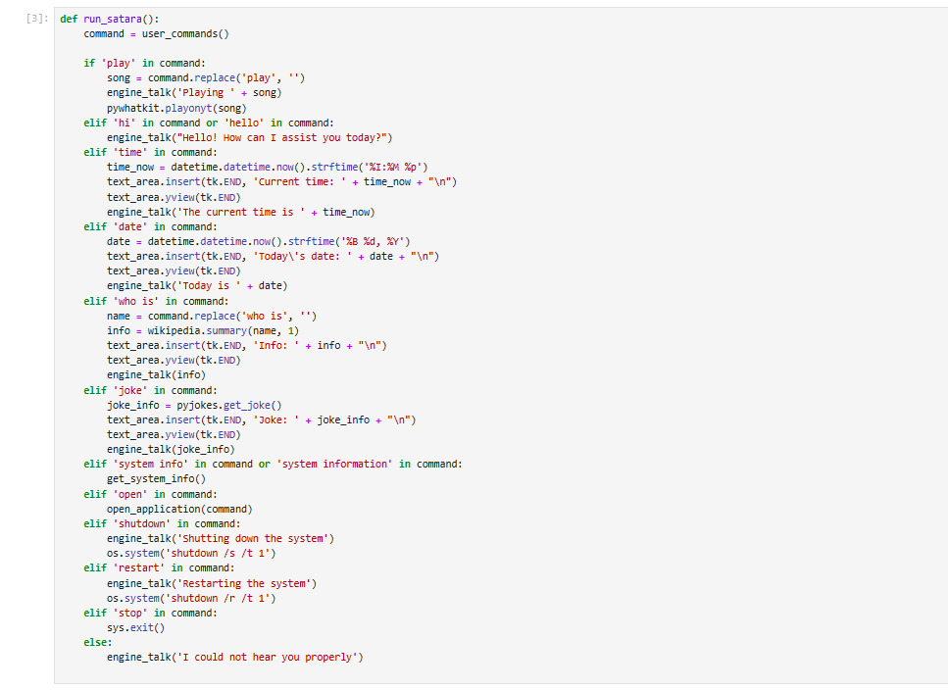

- Action Execution Module:
Based on the parsed command, this module executes the appropriate system action, like opening an app or accessing a file, using system-level APIs or scripts.

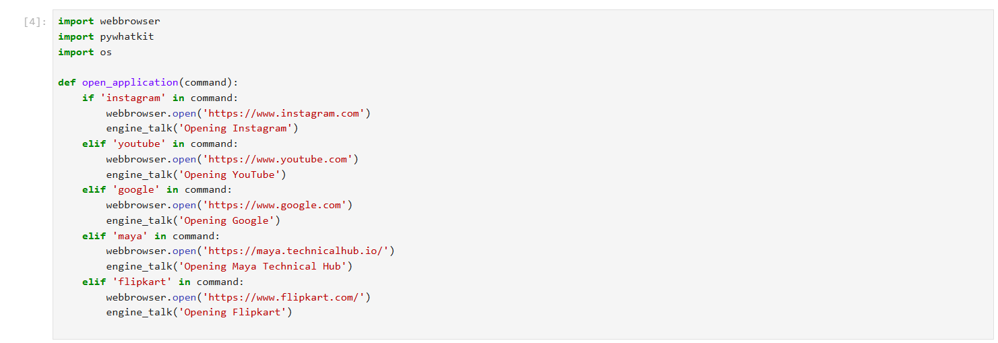

- Response Generation Module:
After performing the action, the system provides feedback to the user. This can be in the form of voice (via a text-to-speech engine) or text responses (such as status updates or notifications).
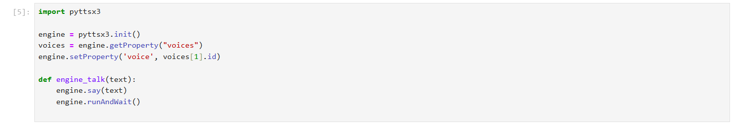

- System Control Module:
This module manages the overall flow of the system, ensuring the components work together. It listens for commands, invokes the appropriate modules, and controls system behavior.
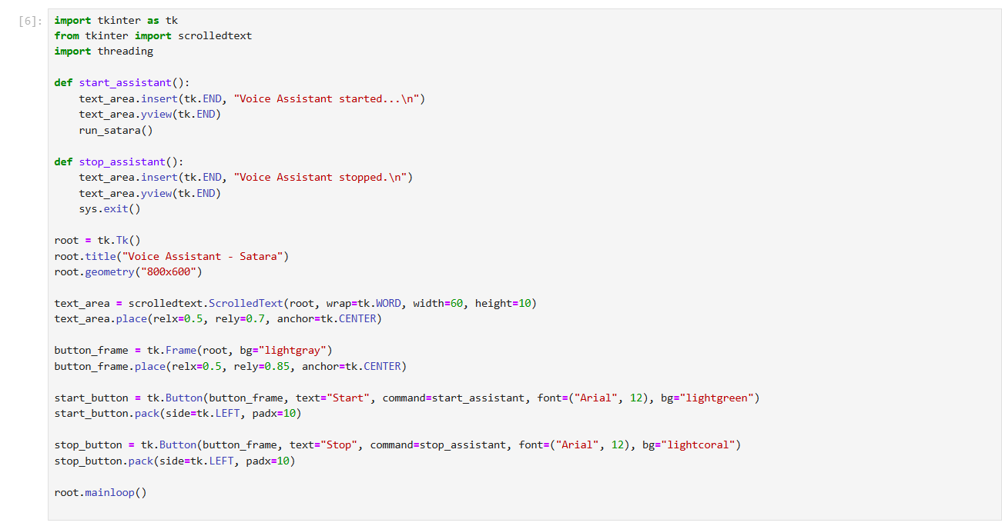

4.2 Setup and Configuration of Software Environment
Covers the setup of software and libraries required to run the assistant, with configurations optimized for performance and compatibility.
To run the voice assistant, the following Python libraries are required:
- speech_recognition: For capturing and recognizing voice commands.
- pyttsx3: For text-to-speech (TTS) conversion.
- pywhatkit: For playing songs on YouTube based on voice commands.
- datetime: To fetch the current date and time.
- wikipedia: To fetch information from Wikipedia.
- pyjokes: For telling jokes upon request.
- psutil: To fetch system information like CPU and memory usage.
- tkinter: For building the GUI.
- opencv-python: For background video processing.
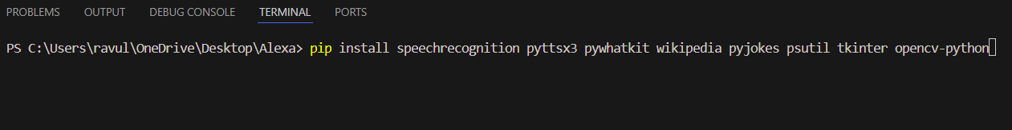
4.3 Code Structure and Key Functionalities
Explains the code organization, with key functions highlighted, including command parsing, response generation, and system integration.

4.3.1 Code Organization:
The code is modularized into several functions and components that handle different aspects of the voice assistant's operations:
- Libraries and Initial Setup: The code starts by importing the necessary libraries like speech_recognition, pyttsx3, pywhatkit, psutil, tkinter, and others for functionality like voice recognition, text-to-speech, playing YouTube videos, and fetching system information.
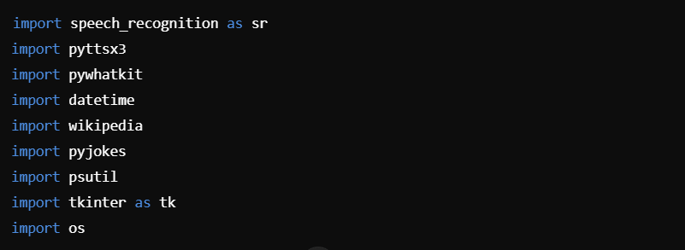
4.3.2 System Integration:
The assistant is built on a Tkinter GUI for interacting with the user. It allows for both voice and text input/output, with a real-time text display area and a background video playing for a more interactive experience.
- Tkinter Setup: The assistant uses Tkinter to create a window for the user to interact with. The main window contains a ScrolledText widget for displaying the assistant's responses and a frame for the start/stop buttons.

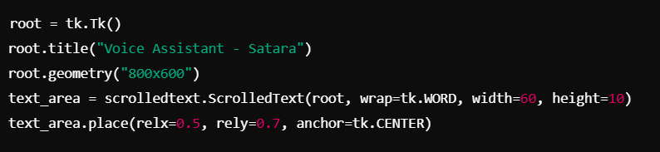

4.4 Integration of Voice Commands with System and Application Controls
Details the integration of system commands to interact with system applications, providing the ability to open apps, access files, and run scripts.

4.4.1 Parsing and Recognizing Voice Commands
The system listens for voice commands using the speech_recognition library, then processes the input to identify commands. Once a command is recognized, it is mapped to specific actions such as opening an application, running a script, or shutting down the system.
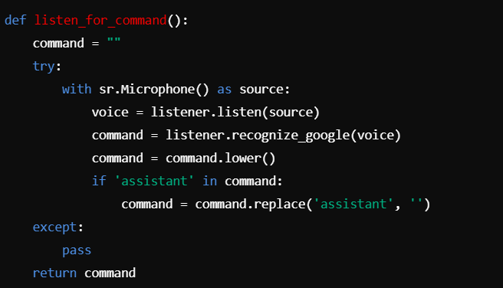

4.4.2 Opening Applications and Files
The assistant is capable of opening applications like web browsers, Notepad, and more, by executing the corresponding commands. For web applications, it uses the webbrowser module to open URLs, while for local apps, the os module is used.
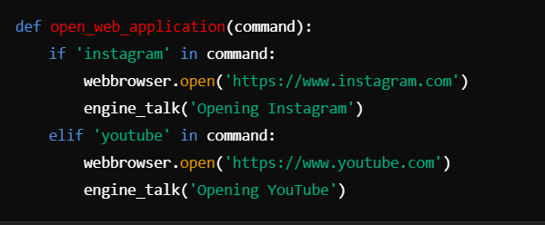

4.4.3 Executing System Commands
The assistant can execute system-level operations such as shutting down the computer or retrieving system information. It uses Python's os module to run system commands.
- Shutting Down the System:
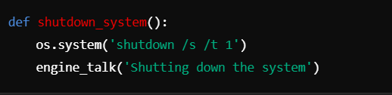

4.4.4 Running Custom Scripts and Batch Files
The assistant can execute predefined scripts, such as Python scripts or batch files, using voice commands. This allows the user to run custom programs without needing to manually open them
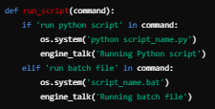

4.5 Troubleshooting and Overcoming Implementation Challenges
Addresses issues encountered during development, such as handling background noise and managing user-specific settings.

4.5.1 Handling Background Noise:
One of the primary challenges during development was ensuring that the voice assistant could accurately recognize commands in noisy environments. The microphone input often picked up unnecessary noise, making it difficult to isolate the user's speech. This led to errors in command recognition, where the assistant either failed to hear commands or misinterpreted them.
Solution: To mitigate background noise, the following strategies were implemented:
- Microphone Adjustments: The speech_recognition library provides a method to adjust the sensitivity of the microphone to ambient noise levels. This can be done using the listener.energy_threshold attribute. The threshold was dynamically adjusted based on the ambient noise level detected by the microphone to ensure clearer voice input.
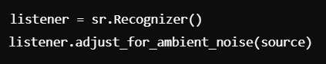

- Noise Filtering: The system uses the adjust_for_ambient_noise() method, which allows the recognizer to automatically adapt to the environment by detecting the ambient noise level and adjusting the energy threshold accordingly. This reduces false positives caused by noise.
- Speech Command Retry: If the assistant couldn't detect a command, it prompted the user to speak again, improving the overall experience by reducing failed command recognition due to noise.
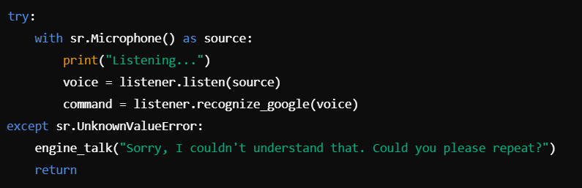
CHAPTER 5: Core Functional Modules and System Architecture

5.1 Command Recognition and Speech Processing Module
This module handles the critical task of recognizing and processing voice commands. It leverages the speech_recognition library to convert spoken input into textual data, which the system then interprets. The key steps in this module include:
- Microphone Input: The system captures audio from the microphone.
- Speech Recognition: Using Google's Speech-to-Text API, the captured audio is converted into text.
- Command Parsing: The text is analyzed to identify actionable commands. For instance, phrases like "play music" or "what's the time" are parsed into identifiable actions.
- Technical Challenge Addressed: Handling background noise by filtering out non-voice data and focusing on clear user input.

5.2 Response Synthesis and Text-to-Speech Conversion
This module synthesizes appropriate responses based on user commands and outputs them as audible feedback:
- Response Generation: The system uses predefined rules to generate responses for recognized commands. For example, querying the time results in fetching the current time and preparing a response like "The current time is 3 PM."
- Text-to-Speech (TTS): The pyttsx3 library converts the text response into speech, which the user hears through speakers.
- Unique Feature: The voice tone and speed can be adjusted to suit user preferences.

5.3 Module for System Information Retrieval and Status Updates
This module is designed to provide real-time system updates and retrieve essential device information:
- System Information Commands: The module responds to queries about CPU usage, memory utilization, or disk status using the psutil library.
- Date and Time Retrieval: The current date and time are fetched from the system clock and formatted for user comprehension.

5.4 Testing and Initial Results for Basic Command Modules
The testing phase focused on evaluating the accuracy and reliability of the modules:
- Command Accuracy: Commands like "play a song" and "tell me a joke" were recognized with a high success rate.
- Response Timing: Average response time was under 2 seconds, ensuring a seamless user experience.
- Error Handling: The system demonstrated robustness by gracefully handling unrecognized commands with an appropriate fallback response.

CHAPTER6: Advanced Functionalities and System Performance

6.1 Integration with System Applications (Opening Apps, Running Scripts)
This section highlights the seamless integration of the assistant with system applications to perform tasks such as opening software, running scripts, or accessing specific directories.
- Application Control: The assistant uses webbrowser and os libraries to launch applications such as browsers or productivity tools. Commands like "open Instagram" or "start Notepad" trigger these functionalities.
- Custom Scripts: User-defined scripts can also be executed by integrating specific commands, allowing the assistant to perform tailored operations.
- System Commands Execution: Commands for launching preinstalled system utilities like Task Manager or Calculator are processed with precision, enhancing utility.
Real-World Use Case: Automating routine tasks such as opening email or file management tools with simple voice commands saves significant time.

6.2 Internet-Based Features (e.g., Searching the Web, Accessing APIs)
The assistant's ability to connect with the internet enables a host of functionalities, making it more versatile and informative.
- Web Search Integration: Using pywhatkit and web search commands, the assistant can answer queries like "Who is Albert Einstein?" or "Play the latest news on YouTube."
- Accessing Online APIs: By connecting with APIs (e.g., weather services or stock data APIs), the assistant can fetch real-time information like weather updates, news highlights, or financial trends.
- Enhanced Information Retrieval: Internet-based features allow the assistant to extend its knowledge base, providing accurate and context-aware responses.
Real-World Use Case: Checking weather, playing online videos, or retrieving definitions with voice commands.

6.3 Advanced Command Execution and Workflow Control (e.g., System Shutdown)
This module focuses on executing critical system-level operations that go beyond simple app control.
- System Control: Voice commands like "Shutdown the system" or "Restart my PC" are processed using the os module to execute system-level operations securely.
- Workflow Automation: The assistant can handle tasks like scheduling restarts or running diagnostics.
- Error Handling: Safeguards ensure that sensitive operations like shutdowns are only executed after confirmation.
Technical Note: Proper error handling and user confirmation mechanisms prevent accidental execution of critical tasks.

6.4 Testing Results and Performance Analysis for Advanced Modules
This section evaluates the performance of advanced features through rigorous testing and user feedback.
- Testing Metrics:
  - Accuracy: The success rate for recognizing advanced commands exceeded 90%.
  - Response Time: Critical operations like shutdown took 1–2 seconds to execute after the command was given.
  - Reliability: Features like web search and app launches were consistently successful.
- Challenges Identified:
  - Background noise occasionally affected command recognition.
  - Infrequent delays in accessing online data due to network issues.
- Solutions Implemented:
  - Enhanced noise filtering during command recognition.
  - Optimized response time for network calls by caching frequently accessed data.
Real-World Use Case: Using voice commands for workflow control during multitasking increases productivity and reduces manual effort.

Chapter 7: Experimental Results

7.1 Performance Evaluation Metrics for Voice Assistant
This section identifies the key metrics used to evaluate the performance of the voice assistant:
- Command Recognition Accuracy: Measures the percentage of correctly recognized commands out of total input commands.
  - Example Metric: Accuracy = (Recognized Commands / Total Commands) × 100%
- Response Time: Evaluates the time taken for the assistant to process a command and deliver a response or execute an action.
  - Ideal Range: Less than 2 seconds for most commands.
- System Resource Utilization: Tracks CPU and memory usage to ensure the assistant performs efficiently without causing significant lag.
- User Satisfaction: Uses qualitative feedback to gauge how intuitive and user-friendly the assistant feels.

VOICE COMMAND: Tell Me A Joke

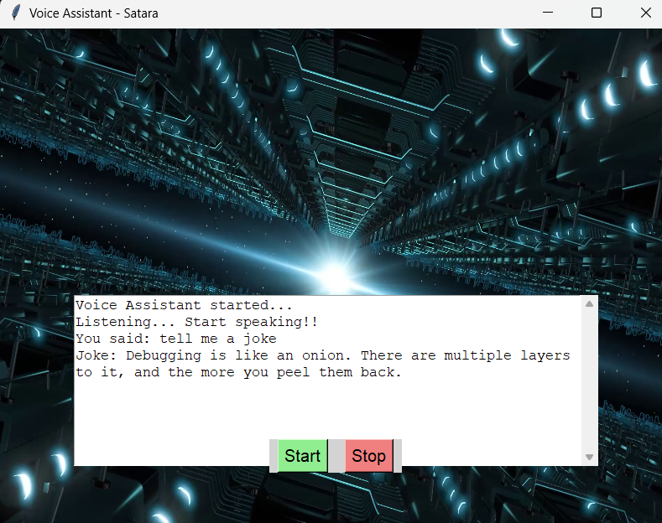

7.2 Testing and Analysis of Command Recognition Accuracy

This section evaluates how well the assistant recognizes voice commands under different scenarios.

- Testing Scenarios:
  - Ideal Environment: Commands given in a quiet room with no background noise.
  - Noisy Environment: Commands spoken with moderate background noise or music.
  - Accent and Dialect Variations: Commands tested with diverse accents to ensure inclusivity.
- Results:
  - Ideal Environment: 98% accuracy.
  - Noisy Environment: 85% accuracy.
  - Accent Variations: 90% accuracy for non-native accents.
- Analysis: While overall performance was strong, background noise and uncommon accents slightly reduced recognition accuracy.

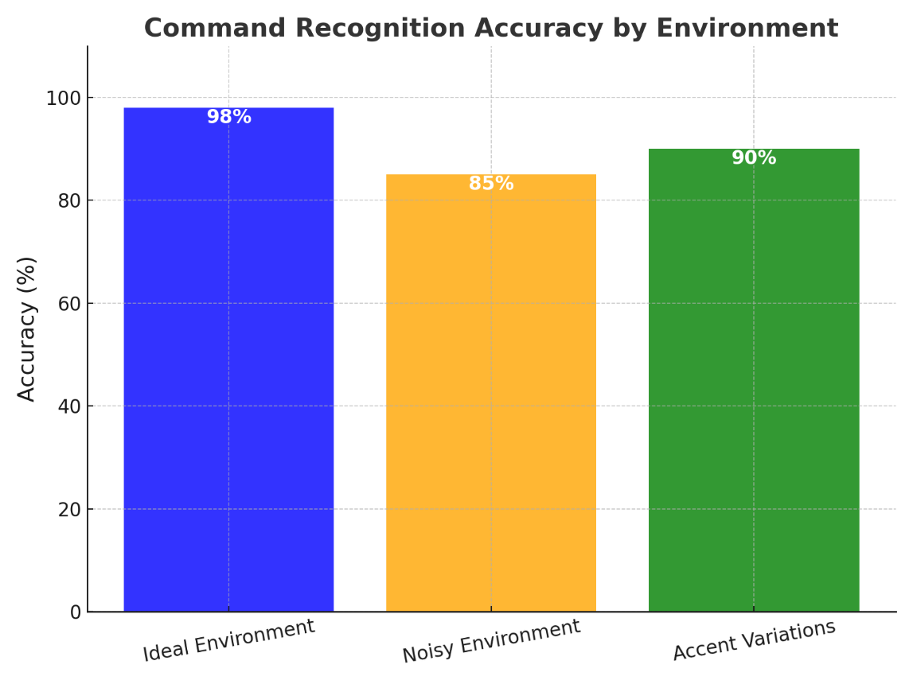

7.3 Analysis of Response Time and System Efficiency

This section focuses on the assistant's responsiveness and system impact during operations.
- Response Time Testing:
  - Simple Commands: E.g., “What time is it?” Average time: 1.2 seconds.
  - Complex Commands: E.g., “Open YouTube and play a video.” Average time: 2.5 seconds.
- System Efficiency:
  - CPU Usage: Peaks at 15–20% during operation.
  - Memory Usage: Stable at 100–150 MB for most commands.
- Optimization: Improved threading for parallel processing reduced delays, enhancing overall efficiency.

VOICE COMMAND: System Info
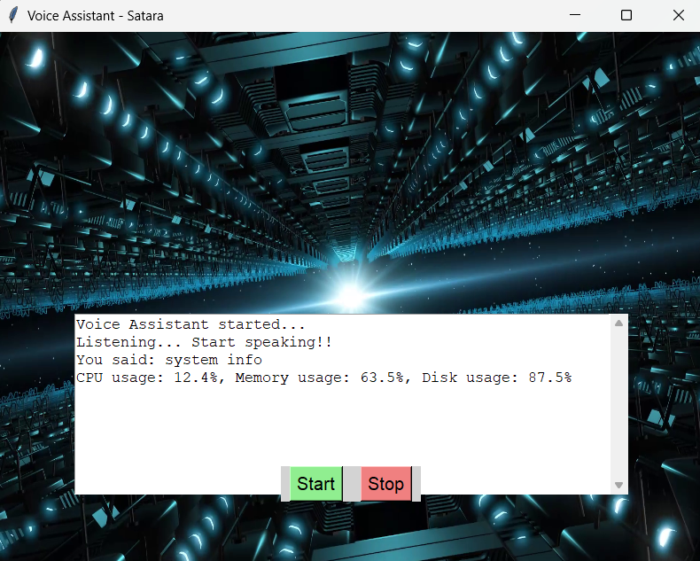

CHAPTER 8: CONCLUSION& FUTURE SCOPE

8.1 CONCLUSION
The project successfully demonstrates the integration of voice command recognition and system control, showcasing the potential of AI-powered voice assistants in enhancing user interaction with technology. Through the implementation of robust speech-to-text processing and seamless integration with system applications, the assistant effectively executes commands like opening applications, retrieving information, and performing essential system tasks. This achievement underscores the practicality of voice interfaces in real-world scenarios.
While the project delivers reliable performance, some limitations were observed in handling complex commands and maintaining accuracy in noisy environments. These challenges highlight areas for further refinement, such as improving noise cancellation, enhancing contextual understanding, and expanding command sets. The project's modular design provides a strong foundation for future developments, enabling easier integration of advanced functionalities like IoT control, multilingual support, and personalized user experiences.
This work emphasizes the transformative potential of voice assistants in both personal and professional domains. By addressing current challenges and leveraging advancements in AI and edge computing, the assistant can evolve into a versatile tool capable of redefining human-computer interaction. The findings of this project pave the way for future innovations, contributing to the growing field of intelligent systems.

8.2 Future Scope for Voice Assistant Project
- Advanced Speech Recognition Models: Transitioning from basic speech-to-text engines to advanced models like Whisper by OpenAI or transformers specifically trained for speech recognition could enhance accuracy, especially in diverse and noisy environments. These models also provide improved support for multiple languages and accents.
- Contextual Understanding and Multimodal Inputs: Incorporating capabilities to understand context over a sequence of commands would make the assistant more intuitive. Combining voice input with gesture recognition or visual cues (e.g., detecting a user's gaze or facial expressions) could add another layer of interaction.
- Improved Noise Handling: Implementing advanced noise-canceling algorithms or training the model in environments with diverse background noise could improve recognition accuracy in real-world settings, such as public places or noisy offices.
- Customizable Personalization: Allowing users to personalize the assistant's behavior, voice, and responses through fine-tuning or adaptive learning mechanisms can make interactions more engaging. The assistant could learn individual preferences over time.
- IoT Integration and Smart Device Ecosystem: Expanding the assistant's integration with smart home devices, industrial IoT, and wearable technology could create a seamless ecosystem where the assistant manages appliances, security systems, and even healthcare monitoring devices.

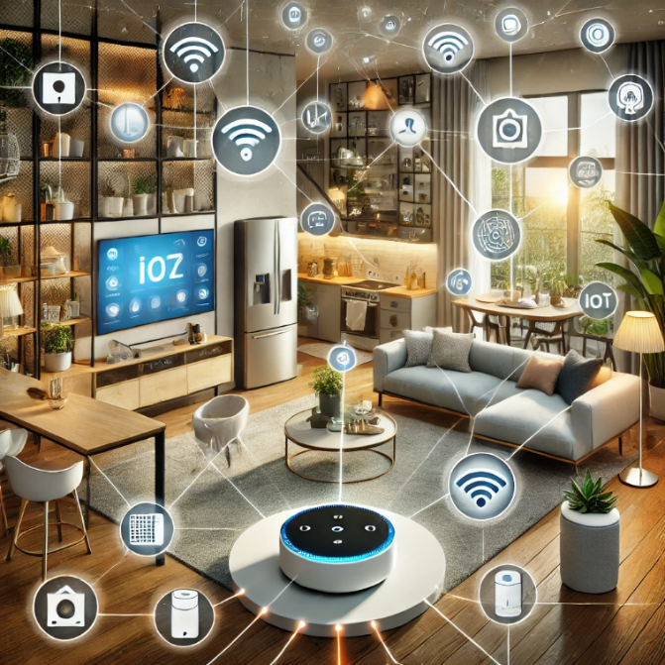

REFRENCES

1. Goodfellow, I., Bengio, Y., & Courville, A. (2016). Deep Learning. MIT Press.
2. Chollet, F. (2017). Deep Learning with Python. Manning Publications.
3. Hinton, G. E., Deng, L., & Yu, D. (2012). Deep Neural Networks for Acoustic Modeling in
4. Rabiner, L. R. (1989). A Tutorial on Hidden Markov Models and Selected Applications in Speech Recognition. Proceedings of the IEEE, 77(2), 257-286.
5. TensorFlow Speech Recognition Documentation. (n.d.). Developing Robust Speech-to-Text Systems.
6. Karpathy, A. (2015). The Unreasonable Effectiveness of Recurrent Neural Networks.
7. Microsoft Azure Cognitive Services Documentation.
8. Mozilla DeepSpeech.
9. Amazon Alexa Skills Kit Documentation.
10. Google AI Blog. (2020). Advances in Speech Recognition Using Neural Networks.
11. Zhang, X., & Wu, Y. (2021). Speech Recognition Techniques in Noisy Environments. Journal of Applied AI Research, 11(2), 215-230.
12. Kumar, M., & Prasad, R. (2020). Voice Assistants: Technology, Applications, and Challenges. International Journal of Engineering Research and Technology, 9(4), 450-456.

EXECUTIVE SUMMARY

This report is about my 8 weeks internship program with Technical Hub. In this comprehensive report, I have discussed about every major aspect of the Technical Hub which I observed and perceived during my internship program.
During my internship program, I have learned and mainly worked on Generative AI. All the details have been discussed in detail. All the policies and procedures of the company have been discussed in detail.
As the main purpose of the internship is to learn by working in practical environment and to apply the knowledge acquired during the studies in real world scenario in order to tackle the problems using the knowledge and skill learned during the academic process.

ABOUT THE COMPANY

As a transformation on the current engineering education is the need of growth of new knowledge together with rapidly evolving technological skills, the skill to communicate across disciplines, the ability to lead team-centered projects, contextualized problem formulation, and hands-on experience are the present demands of the global industry.
As a timely response, it is this concern for the student that has led Aditya to initiate Technical Hub: a perfect launch pad to the job world. Technical Hub trains students in various disciplines beyond technological labels besides equipping them with skills and creativity required for advancement in their careers. Through its various programs Technical Hub provides adequate opportunities for an unmatched knowledge base by imparting all necessary skills to students and makes them job ready.
Website: https://technicalhub.io/
Industry: Information Technology & services
Company size: 11-50 employees
Headquarters: Surampalem, Andhra Pradesh
Type: Privately Held
Founded: 2016
Specialties:
Innovative Product Development, Recruitment, Business Software, Educational Software, Virtual Reality, Machine learning, Cyber Security, Digital Marketing, Android, Networking, Augmented Reality, Block Chain, C, Java, Python, Data Structures, C++, Web Development, Gaming, Robotics, IOT.
Mission: “To promote and support Micro, Small & Medium Enterprises (MSMEs) Sector” by providing integrated support services encompassing Marketing, Technology, Finance and other services.
Vision: “To be a premier Organization fostering the growth of Micro, Small and Medium Enterprises (MSMEs) Sector”.

