ACCENTURE
1. Explain the OOP's in C#.
2. Differentiate between string and StringBuilder in C#, providing a real-time example of when to use each.

String
The string is immutable, Immutable means if you create a string object then you cannot modify it and It always creates a new object of string type in memory.
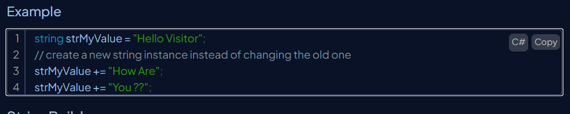
StringBuilder
StringBuilder is mutable, which means if create a string builder object then you can perform any operation like insert, replace, or append without creating a new instance every time. it will update the string in one place in memory and doesn't create new space in memory.
It will not create a new modified instance of the current string object but do the modifications in the existing string object.
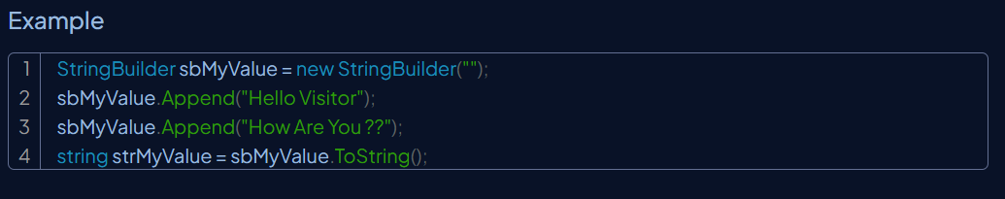
Feature | String | StringBuilder
Mutability | Immutable (cannot be changed after creation) | Mutable (can be changed without creating new objects)
Performance | Slower for frequent modifications | Faster for frequent modifications
Memory Usage | Creates a new object for each modification | Modifies the same object, reducing memory overhead
Use Case | Use for small or infrequently modified strings | Use for large or frequently modified strings

3. Compare and contrast Array and ArrayList in C#.
Basis | Array | ArrayList
Definition | An array is a data structure used to store multiple elements of the same type under a single variable name. | store objects of any data type.
Static/ Dynamic | Array is static in size. | ArrayList is dynamic in size.
Resizable | An array is a fixed-length data structure. | ArrayList is a variable-length data structure. It can be resized itself when needed.
Performance | It performs fast in comparison to ArrayList because of fixed size. | The resize operation in ArrayList slows down the performance.
Type-Safety | We cannot use generics along with array because it is not a convertible type of array. | ArrayList allows us to store only generic/ type, that's why it is type-safe.
Single/ Multi-Dimensional | can be multi-dimensional. | always single-dimensional.

4. Elaborate on the significance and usage of common C# keywords (e.g., var, static, this, base, async, etc.).

5. What is the difference between the const and readonly keywords in C#?
Interview Line: Both are used to assign values
"const means the value is set during compile time and stays the same every time the program runs.
readonly is assigned once, usually in a constructor, and is fixed for the lifetime of the object."
🧷 const – Constant value at compile time
- Value never changes
- Must be assigned when declared
- Value is fixed at compile time
- Used for values like PI, TaxRate, etc.
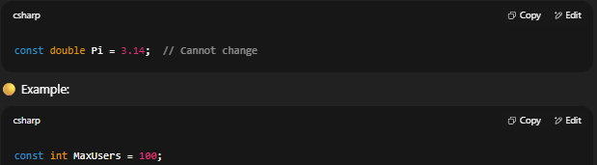
You can’t change MaxUsers anywhere in your code.

🔒 readonly – Value fixed at runtime
- Value can be set in constructor
- Cannot change after object is created
- Used when value is known only at runtime
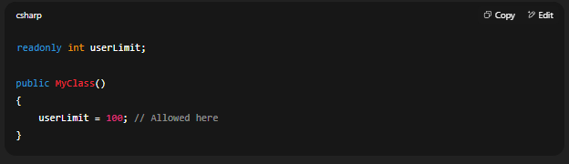

6. Explain the SOLID principles of object-oriented design.

7. Differentiate between the .NET Framework and .NET Core.

The main difference is that .NET Core is cross-platform and open-source, while .NET Framework is Windows-only and closed-source.
- NET Core is cross-platform, while .NET Framework is Windows-only
- .NET Core is open-source, while .NET Framework is closed-source
- .NET Core is modular, allowing developers to include only the necessary libraries, while .NET Framework is monolithic
- NET Core is optimized for cloud-based applications, while .NET Framework is more suited for desktop applications

8. What is the default access modifier when defining a function within an interface in C#?

9. Explain the differences between an interface and an abstract class in C#.

Abstract Class:
• Can have method implementations and fields.
• Supports access modifiers (e.g., public, protected).
• Inherits using "extends" in C#.
• Single inheritance (one abstract class can be inherited).
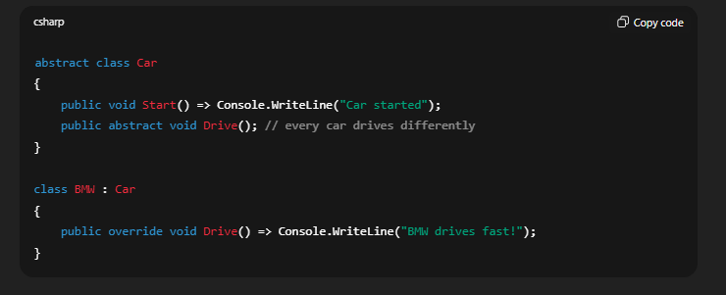
Interface:
• Cannot have fields; methods are abstract by default.
• No access modifiers, methods are public by default.
• Implements using "implements" in C#.m
• Supports multiple inheritance (can implement multiple interfaces).
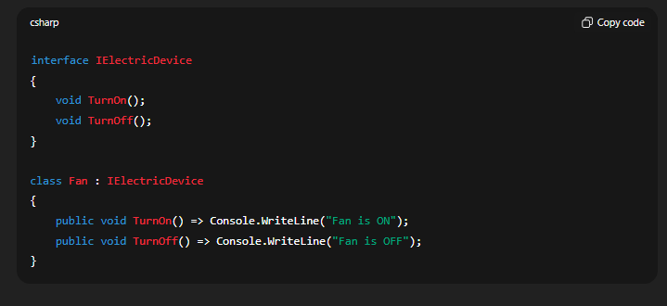
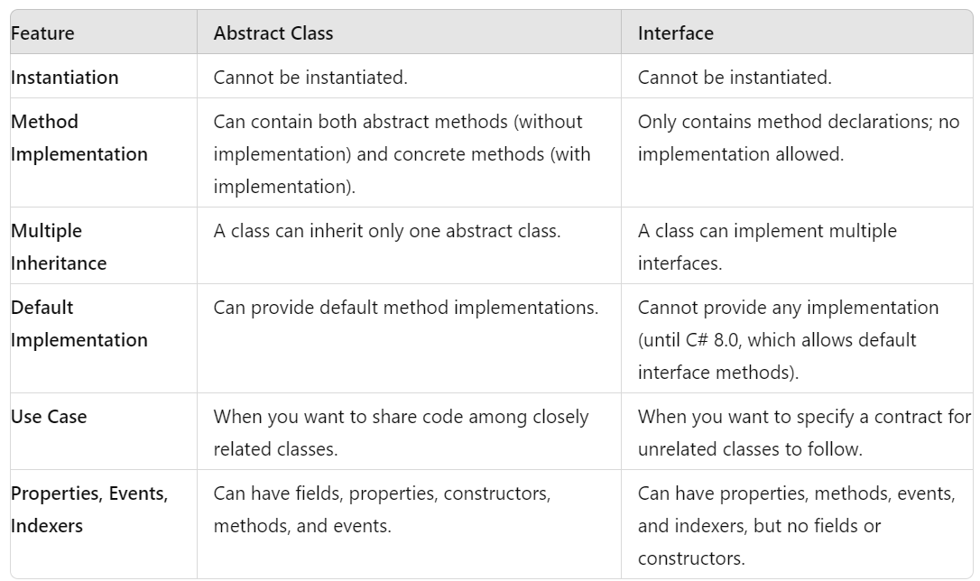

ASP.NET Core – Architecture and Development

1. What is ASP.NET Core, and what are its primary advantages?

2. How are static files served in an ASP.NET Core application, and where are they typically located in the project structure?

• Static files are served via Static File Middleware (app.UseStaticFiles()).
• By default, they live in the wwwroot folder of the project.
Examples: HTML, CSS, JS, images, PDFs, etc.
• You can configure additional folders if needed.

Security Notes
- Only files in wwwroot (or explicitly mapped folders) are publicly accessible.
- Sensitive files (e.g., .cs, .json, .csproj) are not served unless you explicitly configure it.

3. Explain the concept of middleware in ASP.NET Core, and provide an example of implementing custom middleware.
A middleware a component that is assembled into an application pipeline executed on EVERY REQUEST in the ASP.NET Core application.
We can set up the middleware in ASP.NET using the CONFIGURE method of our STARTUP class.
delegates based on a request's URL path.
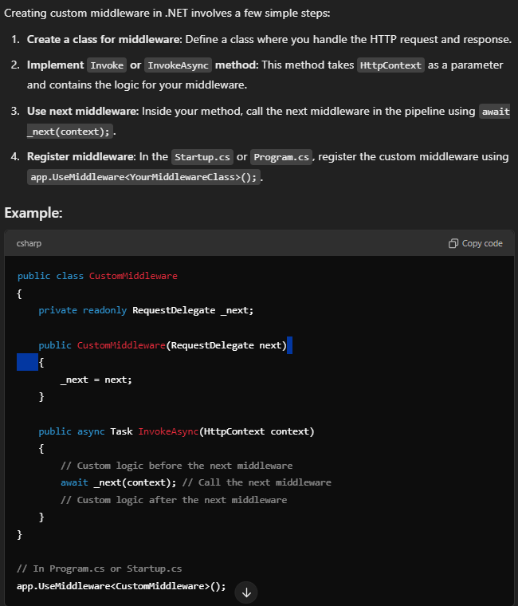

What is Run(), Use() and Map() method?
Use method will execute next middleware or line in sequence.
Run method will TERMINATE the chain.
No other middleware method will run after this.
Should be placed at the end of any pipeline.
The Map extension method is used to match request

4. Why is Cross-Origin Resource Sharing (CORS) used in ASP.NET Core applications?

CORS (Cross-Origin Resource Sharing) is a browser security feature that controls how a web page can request resources (like APIs) from a different domain than the one it was loaded from.
- By default, browsers block cross-origin requests for security.
- CORS allows the server to specify (using special HTTP headers) which domains are allowed to access its resources.
CORS Setup
To set up the CORS we need to go with the foll999999999999999owing steps:-
Install Nuget package: Microsoft.AspNetCore.Cors.
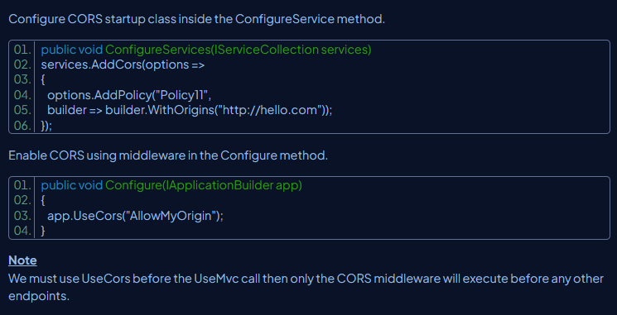
To enable CORS there are three ways to do so:
- Middleware using a named policy or default policy.
- Using endpoint routing.
- Using [EnableCors] attribute.

5. Describe the exception handling mechanisms in ASP.NET Core.

6. Explain the difference between throw and throw ex in C# exception handling.
throw
👉 Re-throws the original exception while keeping the original stack trace (where the error really happened).
throw ex
👉 Re-throws the same exception object but resets the stack trace.
👉 Bad practice ❌ (you lose the real origin of error).

7. What is a RESTful API, and why is it a popular choice for web service development?

8. Discuss the common return types used in ASP.NET Core Web API actions.

3q 9. Describe how JSON serialization and deserialization work in .NET Core, and list common .NET types mapped to JSON.
Serialization in C# is the process of converting an object into a format like JSON or XML so it can be saved or transmitted. It’s useful for data transfer between applications, storing data, and working with APIs.
or
Serialization is the process of converting a .NET object into a JSON string.
Deserialization is the process of converting a JSON string back into a .NET object.
✅ System.Text.Json

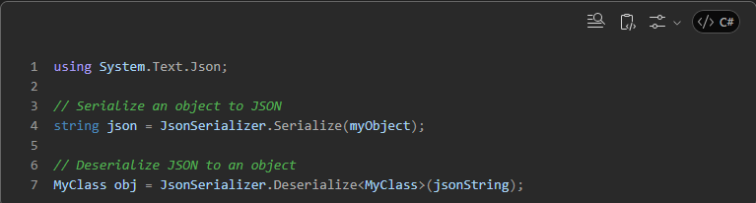

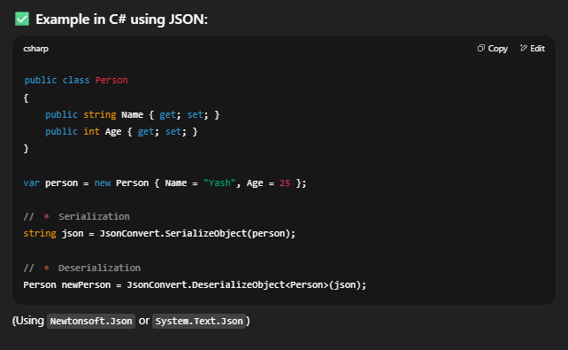
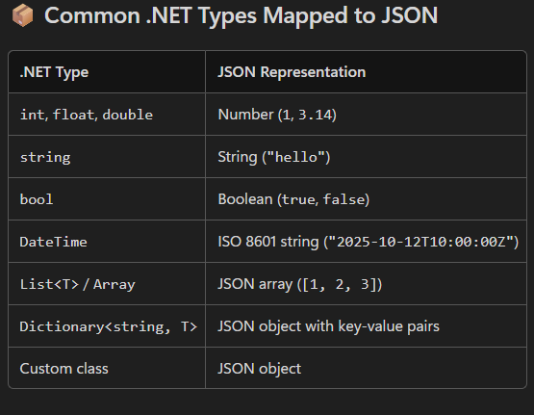

10. Between a GET and a POST request, which is generally considered more secure, and why?

👉 POST is generally considered more secure than GET, but with some clarifications:
GET
- Data is sent in the URL query string (e.g., /login?username=yash&password=123).
- Sensitive data (passwords, tokens, etc.) can be:
  - Logged in browser history
  - Saved in server logs
  - Cached by proxies
- Max URL length restrictions can cut off data.
POST
- Data is sent in the request body, not in the URL.
- Not logged in browser history or server logs by default.
- Supports larger payloads (useful for form submissions or file uploads).
⚠️ Important Note:
Neither GET nor POST is truly secure on its own, because:
- Both can be intercepted without HTTPS.
- The difference is mainly about exposure in logs/history.
✅ Best Practice: Always use HTTPS to encrypt data, and prefer POST for sensitive operations (e.g., login, form submission, updates).

11. What is the purpose of the appsettings.json file in a .NET Core application (formerly web.config in older ASP.NET versions)?

The appsettings.json file is used to store configuration settings for a .NET Core application.
It is used to store application settings in a structured, readable format — typically in JSON. These settings can include:
- ✅ Connection strings
- ✅ Logging configuration
- ✅ API keys or secrets
- ✅ Custom application settings
- ✅ Environment-specific values

12. Why is DbContext used in Entity Framework Core for data access?
DbContext in EF Core is the main class used for database access.
It manages the connection,
tracks entity changes,
translates LINQ queries into SQL, and saves data back to the database.
In short, it’s bridge between your C# classes and the database.

13. What is an Object-Relational Mapper (ORM), and why is it beneficial in .NET development?

14. Explain the differences and appropriate use cases for IEnumerable and IQueryable in C#.
Differences
IEnumerable
IEnumerable exists in the System.Collections namespace.
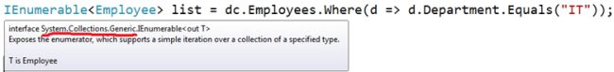
IEnumerable is suitable for querying data from in-memory collections like List, Array and so on.
While querying data from the database, IEnumerable executes "select query" on the server-side, loads data in-memory on the client-side and then filters the data.
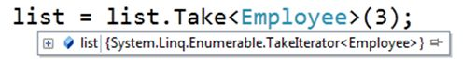
IEnumerable is beneficial for LINQ to Object and LINQ to XML queries.
IQueryable
IQueryable exists in the System.Linq Namespace.
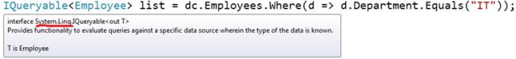
IQueryable is suitable for querying data from out-memory (like remote database, service) collections.
While querying data from a database, IQueryable executes a "select query" on server-side with all filters.
IQueryable is beneficial for LINQ to SQL queries.

#Deloitte interview questions for both .NET Core Full Stack Developer Posistion.

is Async programming and why is it used?
Async programming lets the application perform tasks like file or API access without blocking the main thread. It keeps the app fast and responsive, especially for I/O-bound operations, and is implemented using async and await in C#.

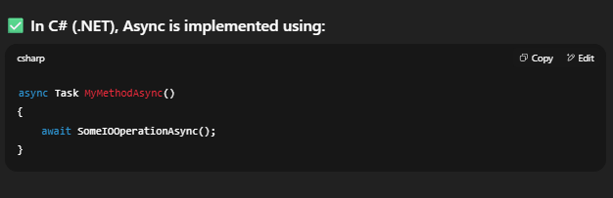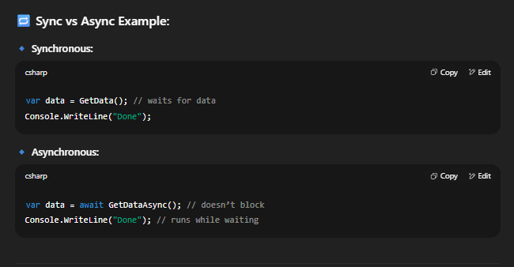

2. What is the difference between IEnumerable and IQueryable?

3. What is Serialization and why is it used in C#?

4. Explain middleware and how can we create custom middleware in .NET Core?

5. What is the difference between throw and throw ex?
throw preserves the original stack trace, while throw ex resets it — so throw is better for debugging.
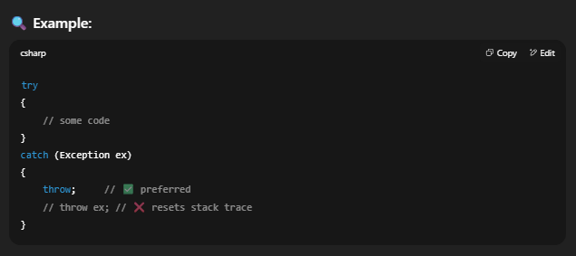

6. What is an extension method in C#?

An extension method allows you to add new methods to an existing class without modifying its source code or creating a subclass.
🧠 Key Points:
• Defined in a static class.
• The method is static, with the this keyword before the first parameter.
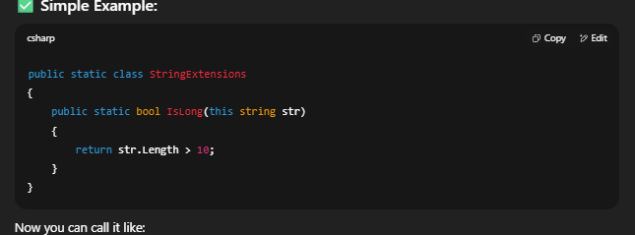

7. What design patterns are you using in your current project?

8. I have the following API function, what error will it throw?
[HttpGet]

[HttpPut]
public void GetAllUsers() {}
In ASP.NET Web API (or ASP.NET Core), you cannot apply multiple HTTP method attributes (like [HttpGet] and [HttpPut]) to the same action method.
The framework will throw an InvalidOperationException at runtime

9. What is the difference between PUT and POST?

PUT – Full Update
- Purpose: Replaces the entire resource with the new data.
- Idempotent: Yes — sending the same request multiple times has the same effect.
- Use Case: When you want to replace all fields of a resource.
PATCH – Partial Update
- Purpose: Updates only the specified fields of a resource.
- Idempotent: Yes (in most implementations).
- Use Case: When you want to modify only a few fields without affecting the rest.

#LTIMindtree .NET Angular Full Stack Developer Interview

Asp .Net

1. What is the difference between .NET Core and .NET Framework?

2. How does dependency injection work in ASP.NET Core?

3. What is the difference between IActionResult and ActionResult<T>?
In ASP.NET Core MVC, both IActionResult and ActionResult<T> are used to define what a controller action returns.
IActionResult
- It’s an interface that represents any kind of result returned from a controller action.
- You can return different types of results like ViewResult, JsonResult, RedirectResult, etc.
- Offers flexibility when your action might return different result types.
ActionResult<T>
- Introduced in ASP.NET Core, it's a generic class that combines the benefits of IActionResult and strongly typed return values.
- Typically used in Web APIs to return both data (like JSON) and HTTP status codes.
- Makes your API responses more predictable and type-safe.
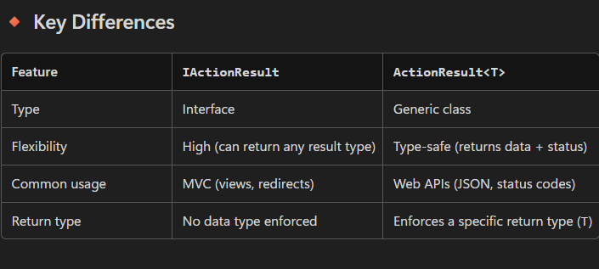

4. How do you implement Web API versioning in .NET Core?
API versioning in .NET Core (or any web framework) is a technique used to manage changes and updates to your API over time without breaking existing clients.

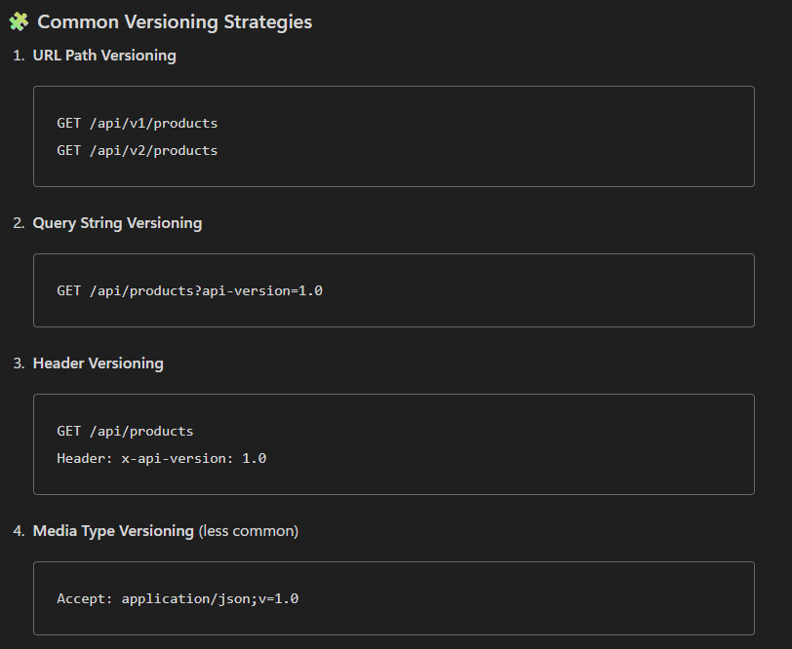

Microsoft.AspNetCore.Mvc.Versioning package

✅ Benefits
- Backward compatibility for older clients
- Clear evolution path for your API(You can improve your API without breaking anything.)
- Better maintainability and testing

5. Explain the middleware pipeline order in .NET Core.
In ASP.NET Core, middleware components are executed in the order they are added in Program.cs or Startup.cs, forming a pipeline that handles each request.
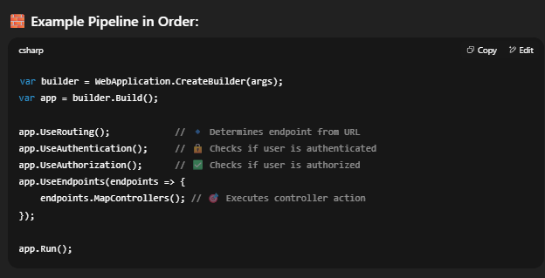
Why Order Matters?
- If UseAuthorization() is before UseAuthentication(), it fails because user identity isn't checked yet.
- UseRouting() must come before endpoint-related logic.
- Custom middleware logic should also be placed correctly based on whether it should run before or after something else.

6. What’s the use of AsNoTracking in Entity Framework Core?
AsNoTracking() in EF Core is used for read-only queries to improve performance by disabling change tracking.
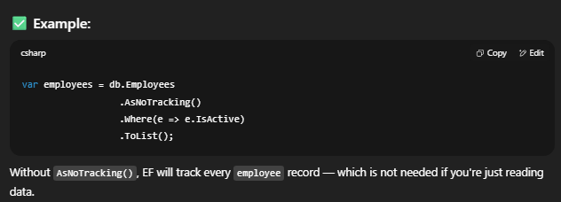
🧠 When to use it?
Use Case | Use AsNoTracking()?
Read-only data (reports, APIs)

7. How would you implement soft delete in EF Core?

Soft Delete means marking a record as deleted (e.g., setting IsDeleted = true) instead of actually removing it from the database.
Add an IsDeleted Property
1. Add an IsDeleted Property
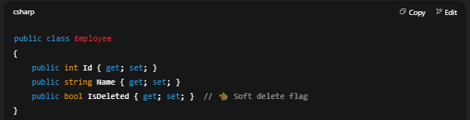
2. Apply Global Query Filter
So that EF automatically ignores soft-deleted records.
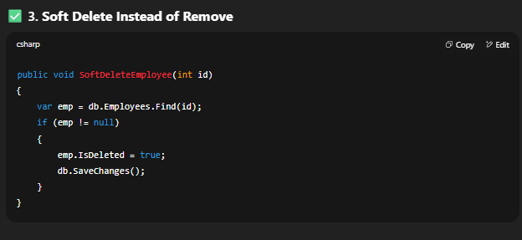

8. Write a LINQ query to replace all negative values in a column with the column’s max value.

9. How do you optimize a slow SQL stored procedure?
• Use indexes on columns used in WHERE, JOIN, or ORDER BY.
• **Avoid SELECT *** — only get the columns you need.
• Use proper joins — avoid unnecessary or nested joins.
• Filter early — use WHERE to reduce data as soon as possible.
• Avoid cursors and loops — use set-based queries instead.

10. Explain different SQL isolation levels.

#Infosys .NET Full Stack Developer role
🔹 .NET Framework / .NET Core / ASP.NET Core

1. What is the difference between a value type and a reference type in .NET?
- Value Types:
  - Stored in the stack.
  - Hold the actual data.
  - Examples: int, float, char, struct, enum.
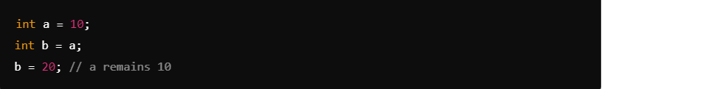
- Reference Types:
  - Stored in the heap.
  - Hold a reference to the actual data.
  - Examples: class, interface, delegate, object, string.

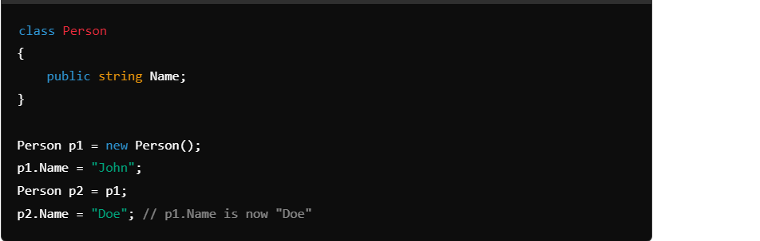

Explain the role of the Garbage Collector in .NET Framework.
The Garbage Collector in .NET manages memory automatically. It allocates memory for objects, reclaims memory from unused objects, prevents memory leaks, and compacts the heap to optimize performance. It uses generations (0, 1, 2) to efficiently manage short- and long-lived objects.
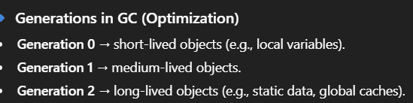

3. What are the different types of assemblies in .NET?

In .NET, assemblies are the building blocks of applications — they are compiled code libraries used for deployment, versioning, and security. Assemblies contain metadata, IL (Intermediate Language) code, and resources.
Type | Purpose | Stored Where? | Shared?
Private | Used by one app | App folder | ❌ No
Shared | Used by multiple apps | GAC (in .NET Framework) | ✅ Yes
Satellite | Localization (language resources) | Culture-specific folders | ❌ No
Dynamic | Created at runtime | In memory (or saved) | ❌ No

4. How does the AppDomain work in .NET and when is it used?

5. What are the key differences between .NET Framework and .NET Core?

6. What is Middleware in ASP.NET Core and how does it work?

7. How is Dependency Injection implemented in ASP.NET Core?

8. What is the purpose of the appsettings.json file?
The appsettings.json file in ASP.NET Core is used to store configuration settings for your application in a structured, easy-to-read format.
- ✅ Database connection strings
- ✅ API keys or secrets
- ✅ Logging configuration
- ✅ Custom application settings
- ✅ Environment-specific values

9. What is the life cycle of an ASP.NET MVC request?

10. What is the difference between TempData, ViewData, and ViewBag?

✅ ViewData
Passes data from controller to view.
Works only for current request.
Uses key-value pairs.
Requires casting.

✅ ViewBag
Also passes data to view.
Works only for current request.
Easier to use (no casting).
Dynamic type.

✅ TempData
Passes data between requests (like after redirect).
Works for one redirect only.
Stores data in session or cookies.
Good for success/error messages.

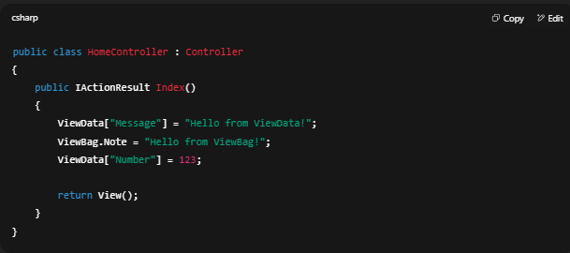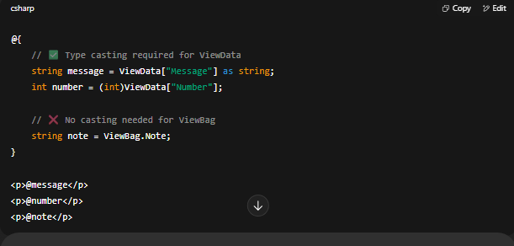

11. How do you implement security in an MVC application?

11a. What is AntiForgeryToken?
It’s a security feature in ASP.NET MVC/.NET Core used to protect against Cross-Site Request Forgery (CSRF) attacks.
How it Works
- use @Html.AntiForgeryToken() in your form in Razor View.
- ASP.NET generates a hidden form field with a unique token and a matching cookie token.
- When the form is submitted, both tokens are sent to the server.
- On the server side, the [ValidateAntiForgeryToken] attribute checks if the tokens don’t match, the request is rejected.
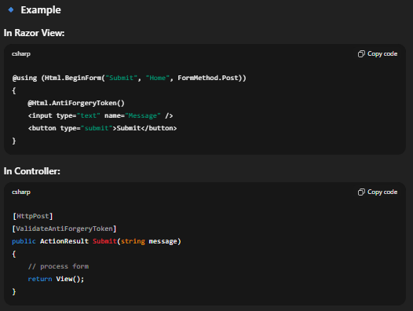

12. What is a partial view and when should it be used?
A partial view is a reusable view component in ASP.NET Core used to render a part of a view (like a header, footer, or form section).

✅ When to Use?
When you want to reuse UI code across multiple views.
To split complex views into smaller, manageable parts.
To dynamically load content using AJAX.
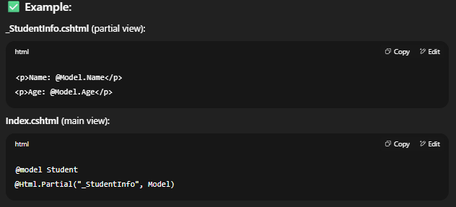

C# delegates In C#, a delegate is a pointer to a method. Delegate method is the most ideal way to pass method as parameter There are two types of delegates in C#, singlecast delegates and multiplecast delegates. - Singlecast delegate: Singlecast delegate points to a single method at a time. The delegate is assigned to a single method at a time. They are derived from System.Delegate class. - Multicast Delegate: When a delegate is wrapped with more than one method, that is known as a multicast delegate. ienum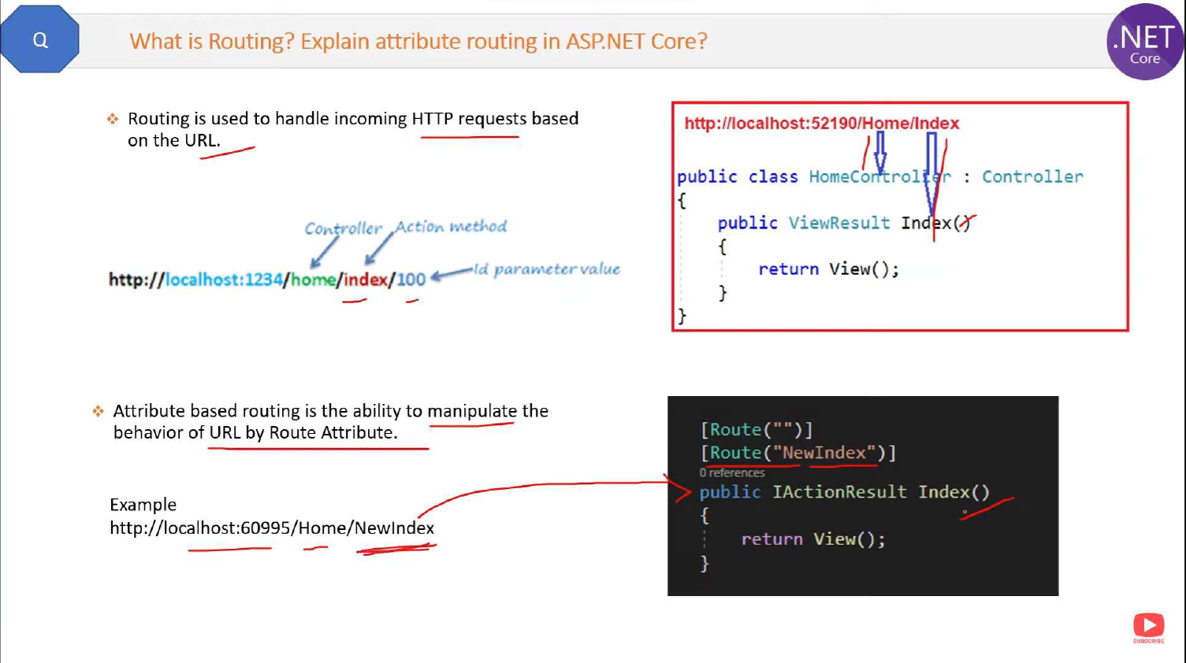 - Configuration: Route templates are specified directly on controller and action methods using attributes (e.g., [Route("api/products/{id}")]). Routing is the process of directing the HTTP requests to the right controller. The middleware makes this decision based on the URL. This is known as convention-based routing. Attribute-based Routing is an alternative to convention-based routing. We use C# attributes in the controller classes and the methods internally in this type of routing. The Attribute-based Routing method specifies metadata that tells ASP.NET Core when to call a method. What is Rate Limiting in API ? And how to implement it ? Rate limiting is a technique used to control the number of requests a user/client can make to an API in a given time period. It helps prevent abuse, reduces server load, and protects against DDoS attacks. 🔒 Why Rate Limiting? - Prevents overuse/misuse of your APIs. - reduces server load - Enhances security and protects from bots or brute-force attacks. 📝 Summary Step Description 1 Install AspNetCoreRateLimit NuGet 2 Configure limits in appsettings.json 3 Register services and middleware in Program.cs 4 Done! Clients now get rate-limited ⚙️ How to Implement Rate Limiting in .NET Core999 ✅ Using Middleware with AspNetCoreRateLimit Package Step-by-step: 1. Install NuGet Packages 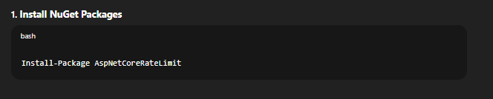 2. Add Configuration in appsettings.json 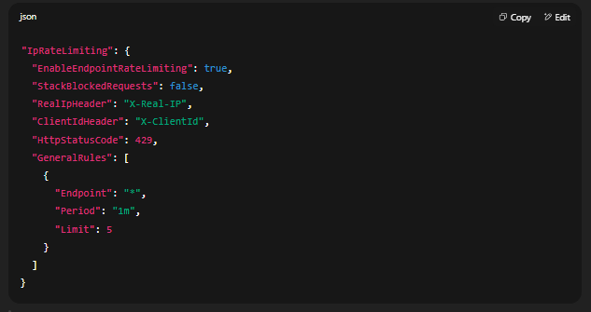🔹 This allows 5 requests per minute per IP to all endpoints. 3. Configure Services in Program.cs or Startup.cs 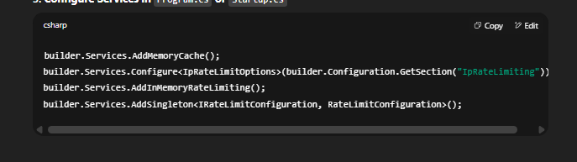 4. Use Middleware 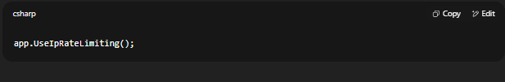 🧪 Test It If a client sends more than 5 requests per minute, they’ll receive: 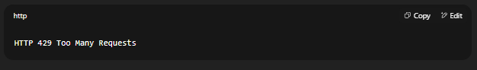 How to explain about JWT authentication in Asp.net core - JWT (JSON Web Token) is a compact, stateless token used for authentication and authorization. How it works (Flow in ASP.NET Core) - User logs in with username/password. - If valid, the server generates a JWT token (signed with a secret key). - The client (browser, mobile, Postman) stores the token (usually in localStorage or sessionStorage). - For every API request, the client sends the token in the Authorization header as: - Authorization: Bearer <token> - Middleware in ASP.NET Core validates the token. - If valid → request continues, else → 401 Unauthorized. "In ASP.NET Core, I’ve implemented JWT authentication for securing APIs. When a user logs in, the API generates a signed JWT token containing user claims and roles. The client stores this token and sends it in the Authorization header for each request. The middleware validates the token using the secret key before allowing access. This approach is stateless and scalable, and I’ve also worked with role-based claims to restrict access to certain APIs." - It contains 3 parts: Header, Payload, Signature. - It’s widely used in APIs because it avoids server-side session storage. 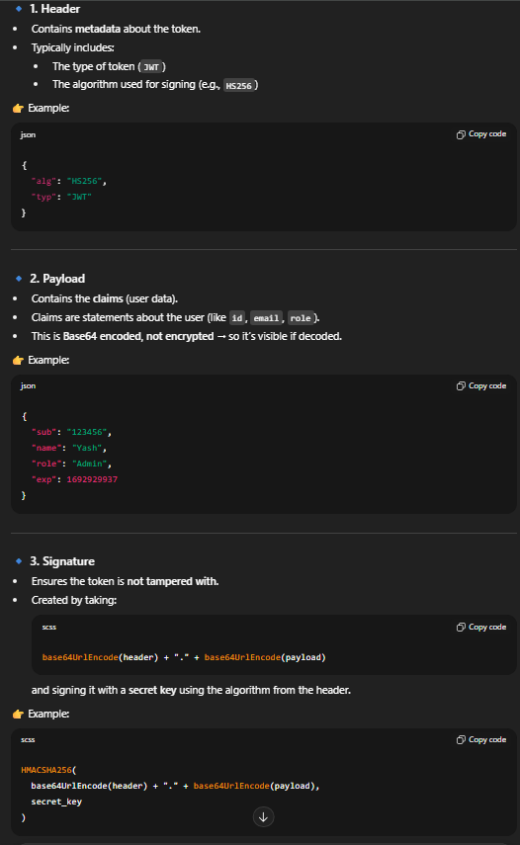 What is rest api and soap api ? SOAP API (Simple Object Access Protocol) - A strict, (standardized )protocol way for applications for exchanging structured data in web services.Uses XML format for requests and responses. - Runs typically over HTTP, but can also use SMTP, TCP, etc. - Requires strict contract (WSDL – Web Services Description Language). - More heavyweight (verbose XML, strict rules). - Has built-in standards for security (WS-Security), transactions, etc. REST API (Representational State Transfer) - An architectural style (not a strict protocol). - Uses simple HTTP methods like GET, POST, PUT, DELETE. - Can return data in JSON, XML, or other formats (JSON is most common). - No strict contract like WSDL; more lightweight and flexible. - Designed for scalability, simplicity, performance. - More Lightweight. Explain ref vs out in C# ? Both are used to pass parameters by reference, but: - ref → variable must be initialized before passing to the method. Then method can change and modify the value. Example :- So, if we change x inside the method, the original variable (from the caller) also changes. We have a static method named Add which takes an integer parameter x by reference using ref. Since it is passed by reference, any changes made to x inside the method will directly affect the original variable that was passed in. - out → variable doesn’t need initialization, but must be set inside the method. Example :- This is a static method named SetValue which takes an integer parameter y by reference using out. Since it is passed with out, the variable does not need to be initialized before calling the method. The method must assign a value to y, and that value will be directly stored in the original variable that was passed in. 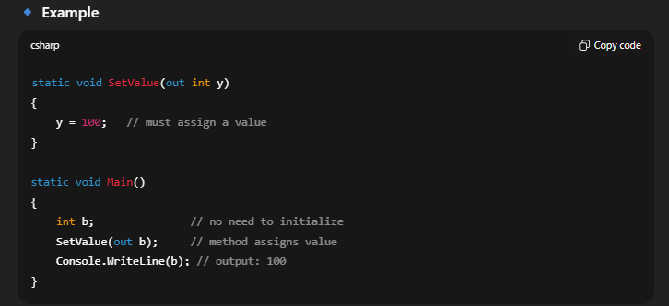 THREAD VS TASK 🔹 Thread A Thread is like a worker that runs a part of your program. You can have many threads working at the same time. Imagine you own a restaurant. - You hire one cook (thread) to prepare dishes. - If you want 5 dishes cooked at the same time, you must hire and manage 5 cooks yourself. - You also need to tell each cook when to start, stop, or take a break. 👉 Threads = you directly manage workers yourself (more effort). 🔹 Task A Task is like a smart worker built on top of threads. It is easier to use, manages itself, and works well with async/await. - You just say: “I need 5 dishes.” - The manager automatically assigns the work to available cooks (threads). - You don’t worry about who is free, when they work, or how they take breaks. 👉 Tasks = manager that uses workers (threads) smartly for you. What is async/await? - async and await are used in C# to write asynchronous code in an easy-to-read way. - They allow your program to do other work while waiting (e.g., calling an API, reading a file, or database query). - Instead of blocking the main thread, the program continues, and when the task is ready, it resumes. 🔹 Model Binding - Definition (easy): Model Binding automatically maps data from HTTP requests (Form, Query string, Route, Body) to your C# model or parameters. - If the request sends { "Id": 1, "Name": "Yash" }, ASP.NET Core automatically fills the Student object. Validation - Definition (easy): Validation checks if the incoming data is correct and valid before saving or processing. - We use Data Annotations or custom logic. [Required], [Range] What is Parallel Programming? - Definition (easy words): Running multiple tasks at the same time to make your program faster. Key Classes/Methods in C# - Parallel.For → loop runs in parallel - Parallel.ForEach → foreach loop runs in parallel - Task → run methods asynchronously struct and class Struct - Value type → stored in stack - Lightweight, used for small data - Cannot have inheritance (but can implement interfaces) - Default constructor cannot have parameters Class - Reference type → stored in heap - Can have inheritance, polymorphism, etc. - Can have constructors with parameters Find VS FirstOrDefault Find - Used on List<T> - Returns the first element that matches the condition. - If nothing found → returns default value (null for reference types). FirstOrDefault ~ - Part of LINQ (System.Linq) - Works on any IEnumerable, not just List - Returns first element matching the condition, or default value if none found IConfiguration and IOptions 1. IConfiguration - Represents the entire configuration of the application. - Reads data from appsettings.json, environment variables, command line, etc. - Provides key-value pairs directly. 2. IOptions<T> - Used for strongly-typed configuration - Bind a section of config to a C# class - Makes code cleaner and safer What is Global Exception Handling? Is a way to handle all unexpected exceptions. Instead of writing try-catch everywhere, we handle all exceptions in one central place (globally). 👉 Makes the app more clean, secure, and maintainable. Using UseExceptionHandler Middleware 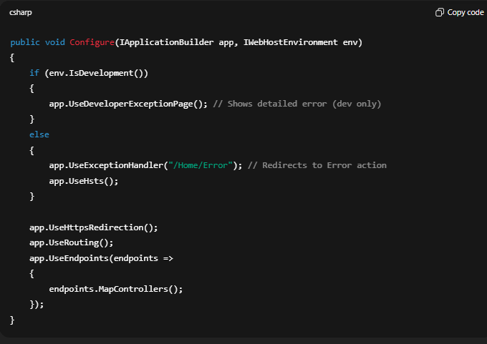 What is Logging? 👉 Logging is used to keep track of what’s happening in an application. It helps developers debug issues 👉 Helps in debugging, monitoring, and troubleshooting. ASP.NET Core provides a built-in ILogger interface with different log levels ASP.NET Core supports different log levels: - Trace → Very detailed logs (used for debugging) - Debug → Debugging info (less detailed than Trace) - Information → General events (app started, user login, etc.) - Warning → Something unusual but not breaking - Error → Something failed but app still runs - Critical → Serious failure, app might crash 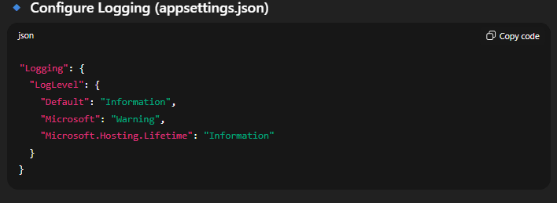 🔹 Providers (Where logs are stored) - Console - Debug window - File (using third-party like Serilog, NLog) - Database - Cloud (e.g., Azure App Insights, AWS CloudWatch) Configure Services and Configure Method ConfigureServices focuses on registering services and setting up dependency injection, while Configure configures the HTTP request pipeline, including middleware. ConfigureServices: Purpose: Registers services including database contexts, authentication, and other dependencies. This is where you set up dependency injection. Parameter: Takes an IServiceCollection as input, which is used to register the services. Execution: Called first when the application starts. Configure: Purpose: Configures the HTTP request pipeline, including middleware like routing, static files, and authentication. This determines how the application handles HTTP requests. Parameter: Takes IApplicationBuilder and IWebHostEnvironment as input. Execution: Called after ConfigureServices when the application starts. difference between middleware pipeline and filter pipeline Middleware Pipeline ✅ What It Is: - Works on the entire HTTP requests and responses. - Configured in Startup.cs (or Program.cs in minimal hosting model). - Runs before MVC routing and controller execution. 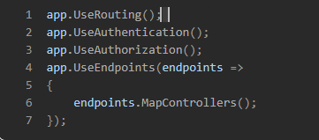 Filter Pipeline ✅ What It Is: - A set of components that run within the MVC framework, around controller actions. - Filters are specific to controllers and actions. 📌 Types of Filters: - Authorization Filters – Run first, check permissions. - Resource Filters – Run before model binding. - Action Filters – Run before and after action methods. - Exception Filters – Handle unhandled exceptions. - Result Filters – Run before and after the result (e.g., view rendering). 