**Our department**

* Neurology change to General Surgery
* Department of Emergency Medicine & General Practice --- make both in one
* Delete Development Department or make it Ophthalmology



* Delete Urology
* Delete Nephrology
* Delete Endocrinology
* Delete Plastic Surgery & Burn

**Add new department**

Forensic Medicine

Radiology & Imaging

Pathology

Microbiology

Biochemistry

Anesthesiology

Pharmacology

24/7 Emergency Service

Regular OPD

8:00AM – 3:00PM

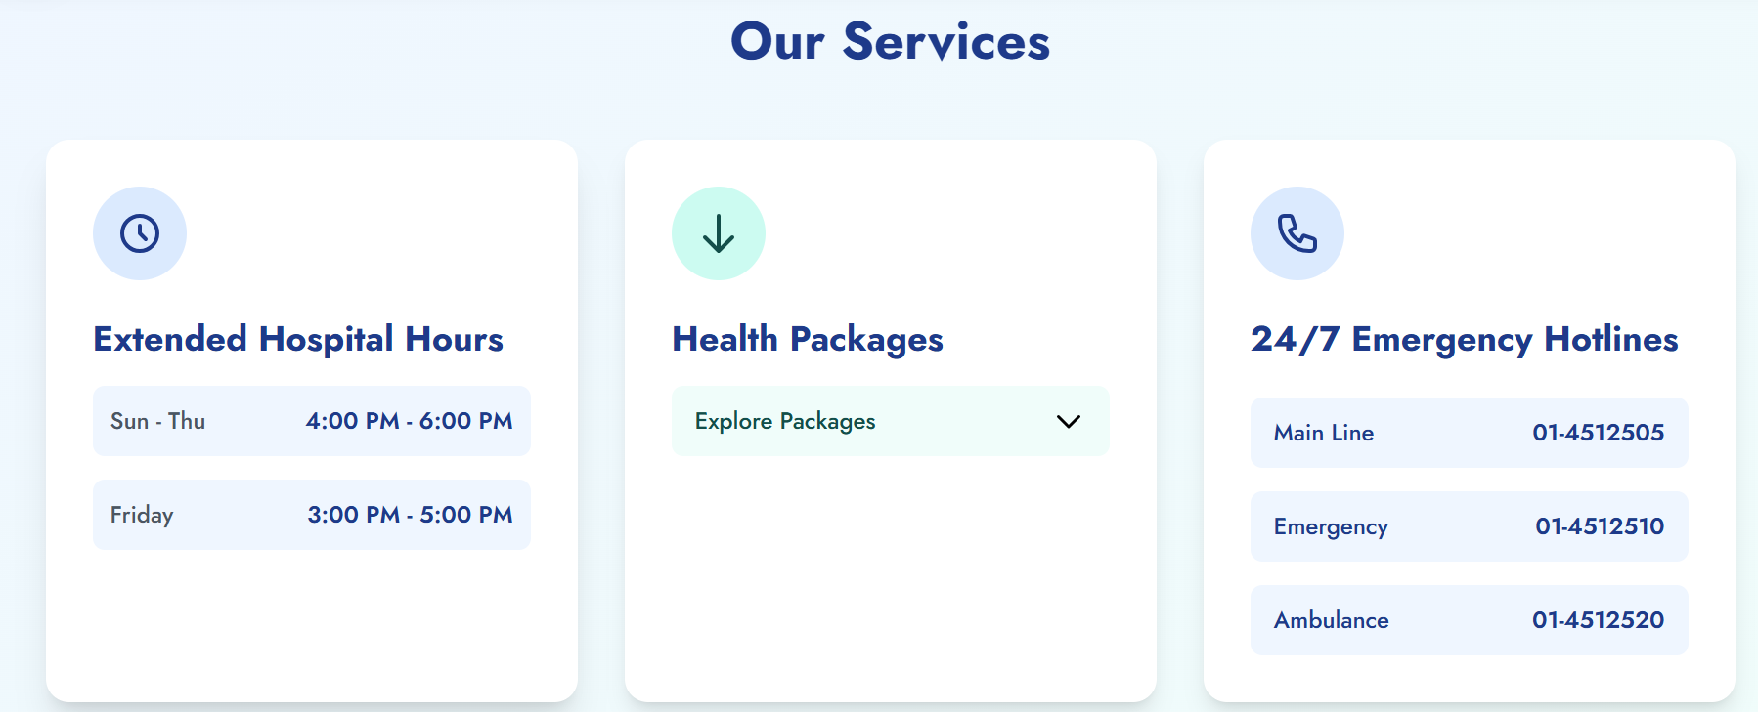

Laboratory Services

Biochemistry

Pathology

Microbiology

While clicking on any department its showing this internal Medicine page or instead write under construction instead of showing this

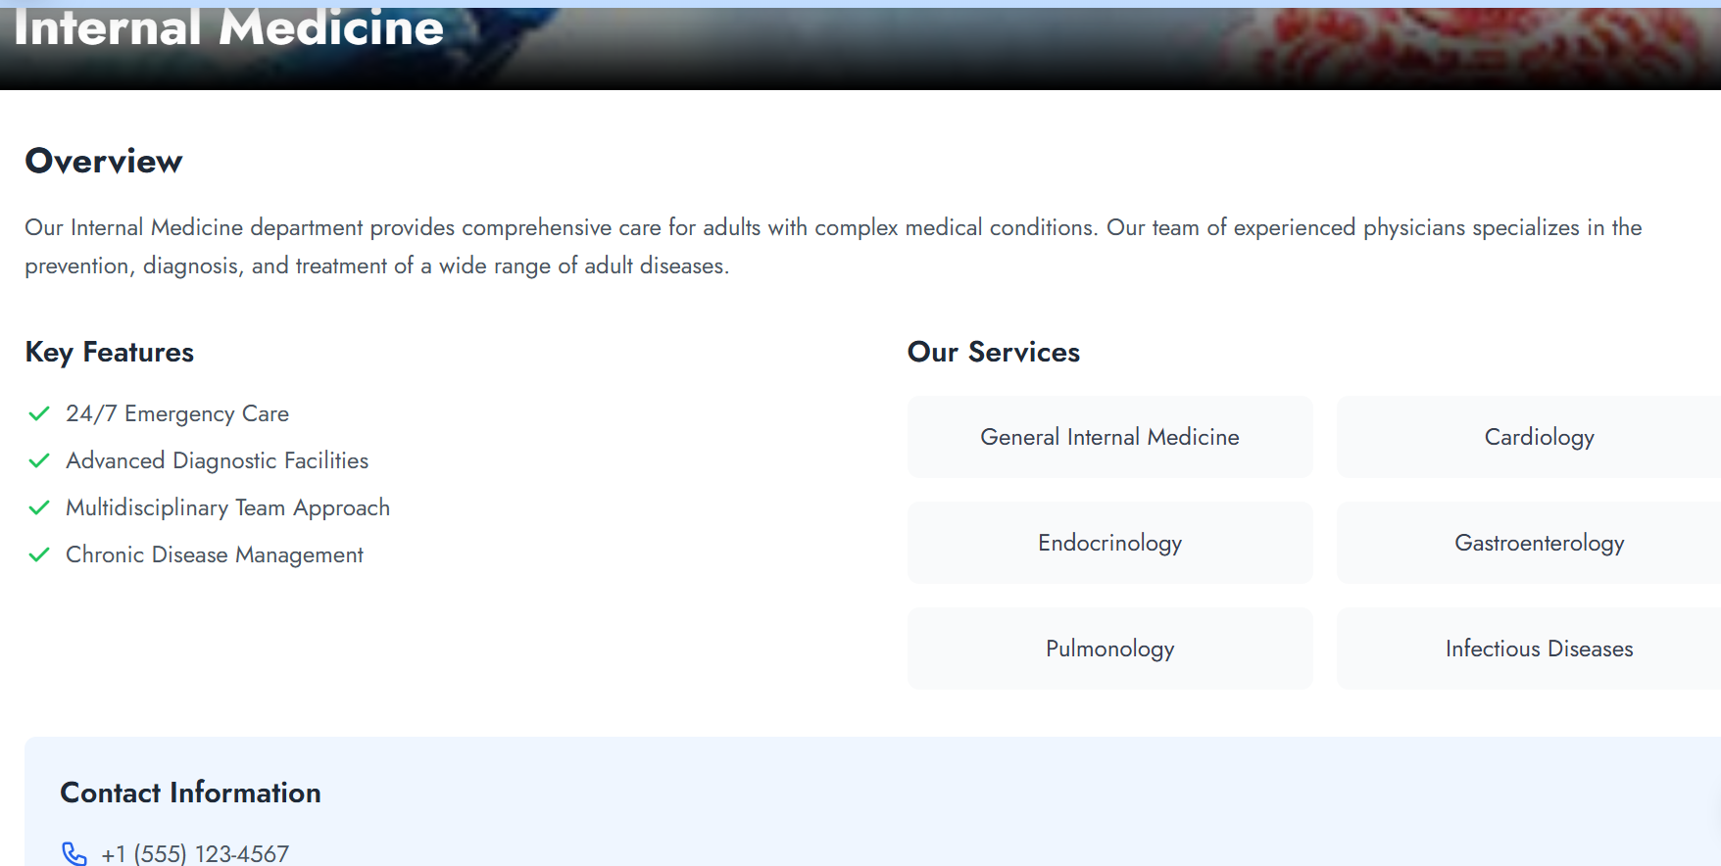

Delete this information & Write

041-590867, 041-590868

[mihs@mihs.edu.np/](mailto:mihs@mihs.edu.np/) info@mihs.edu.no

Hide this Endocrinology & Pulmunology