Google Analytics

- Login to your google analytics account.
- Create a “New Profile” from Profile tab
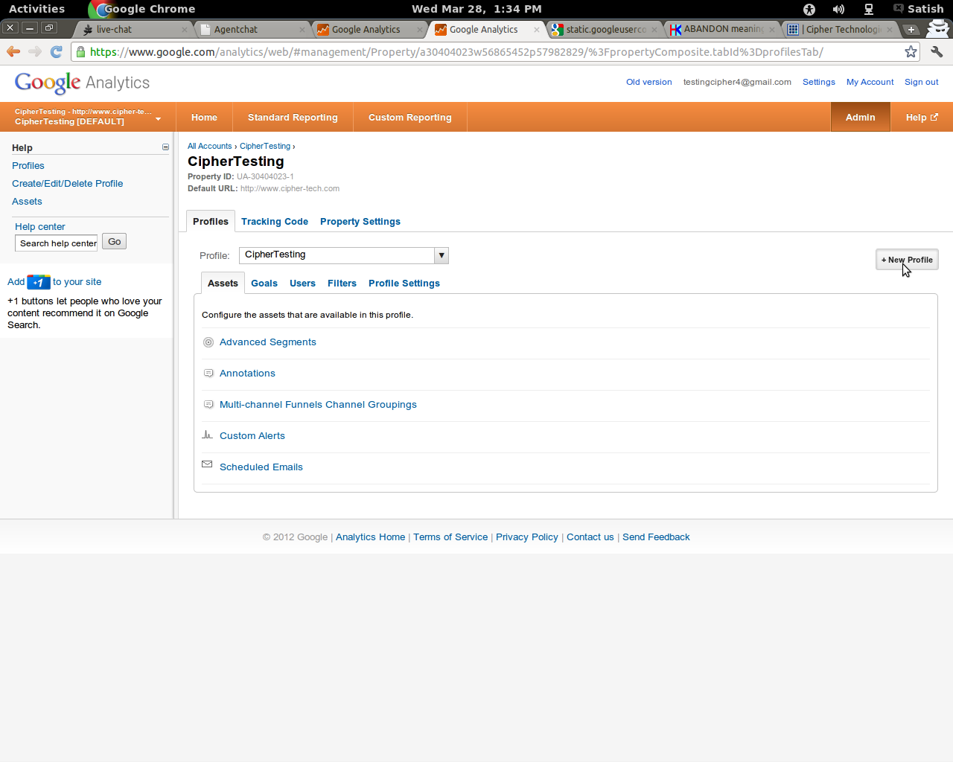

- Select “Tracking Code” tab on “Profile” page
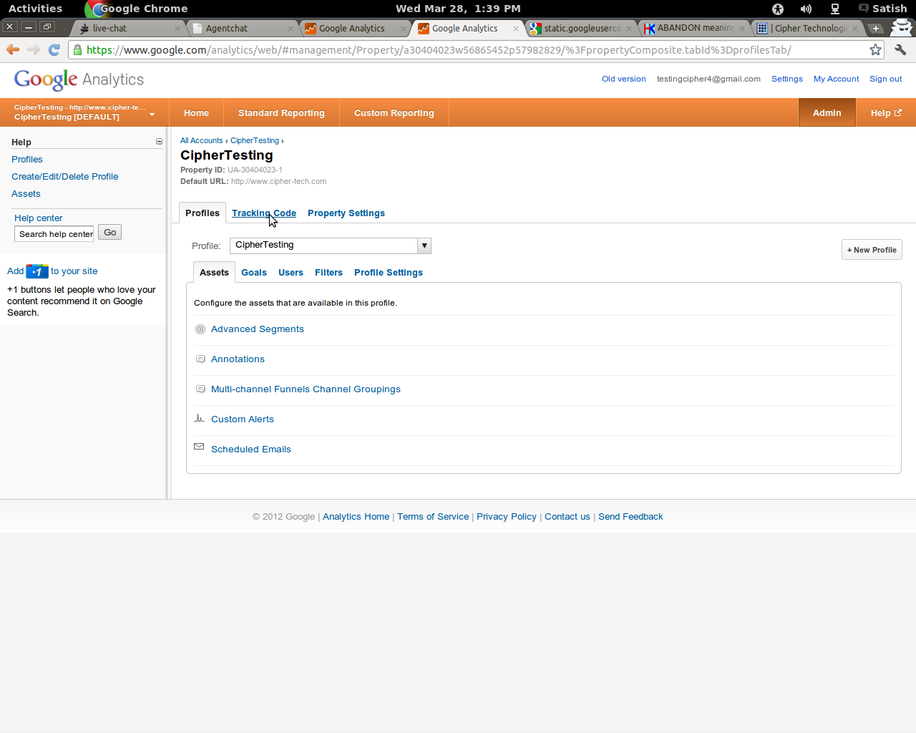

- Go to “Advance” tab in “Tracking Code”

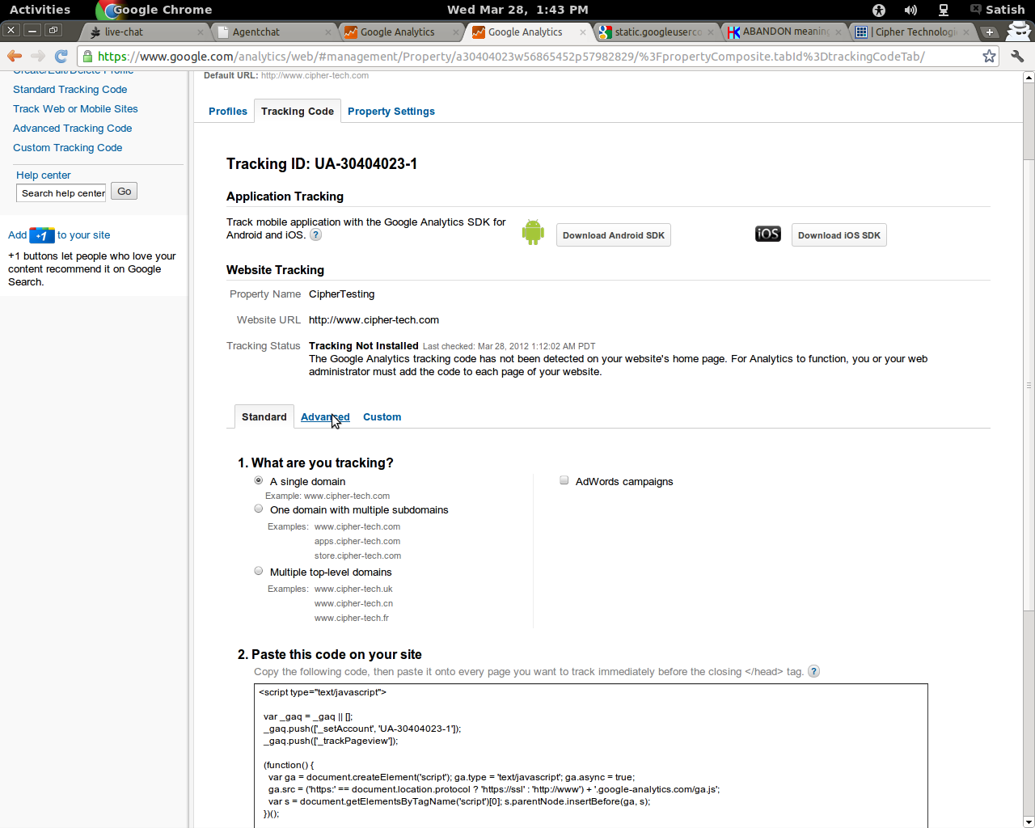

- Select a “I want to track dynamic content” option from right pannel
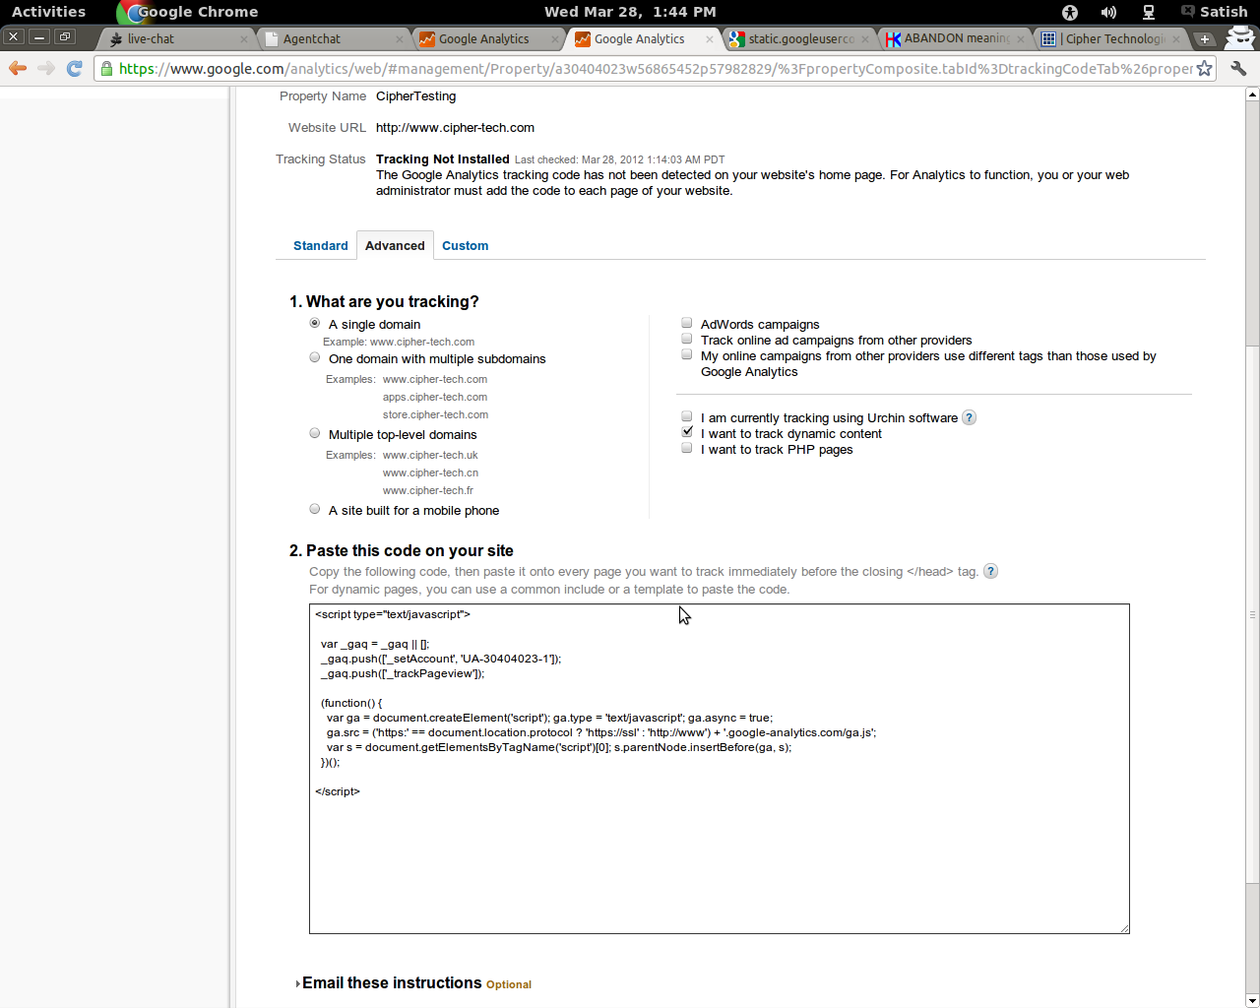

- Copy and paste the shown code into your layout file.
(For dynamic pages, you can use a common include or a template to paste the code.)

