Answer 1

Using ps -e | grep ‘systemd’ command to search for the systemd process

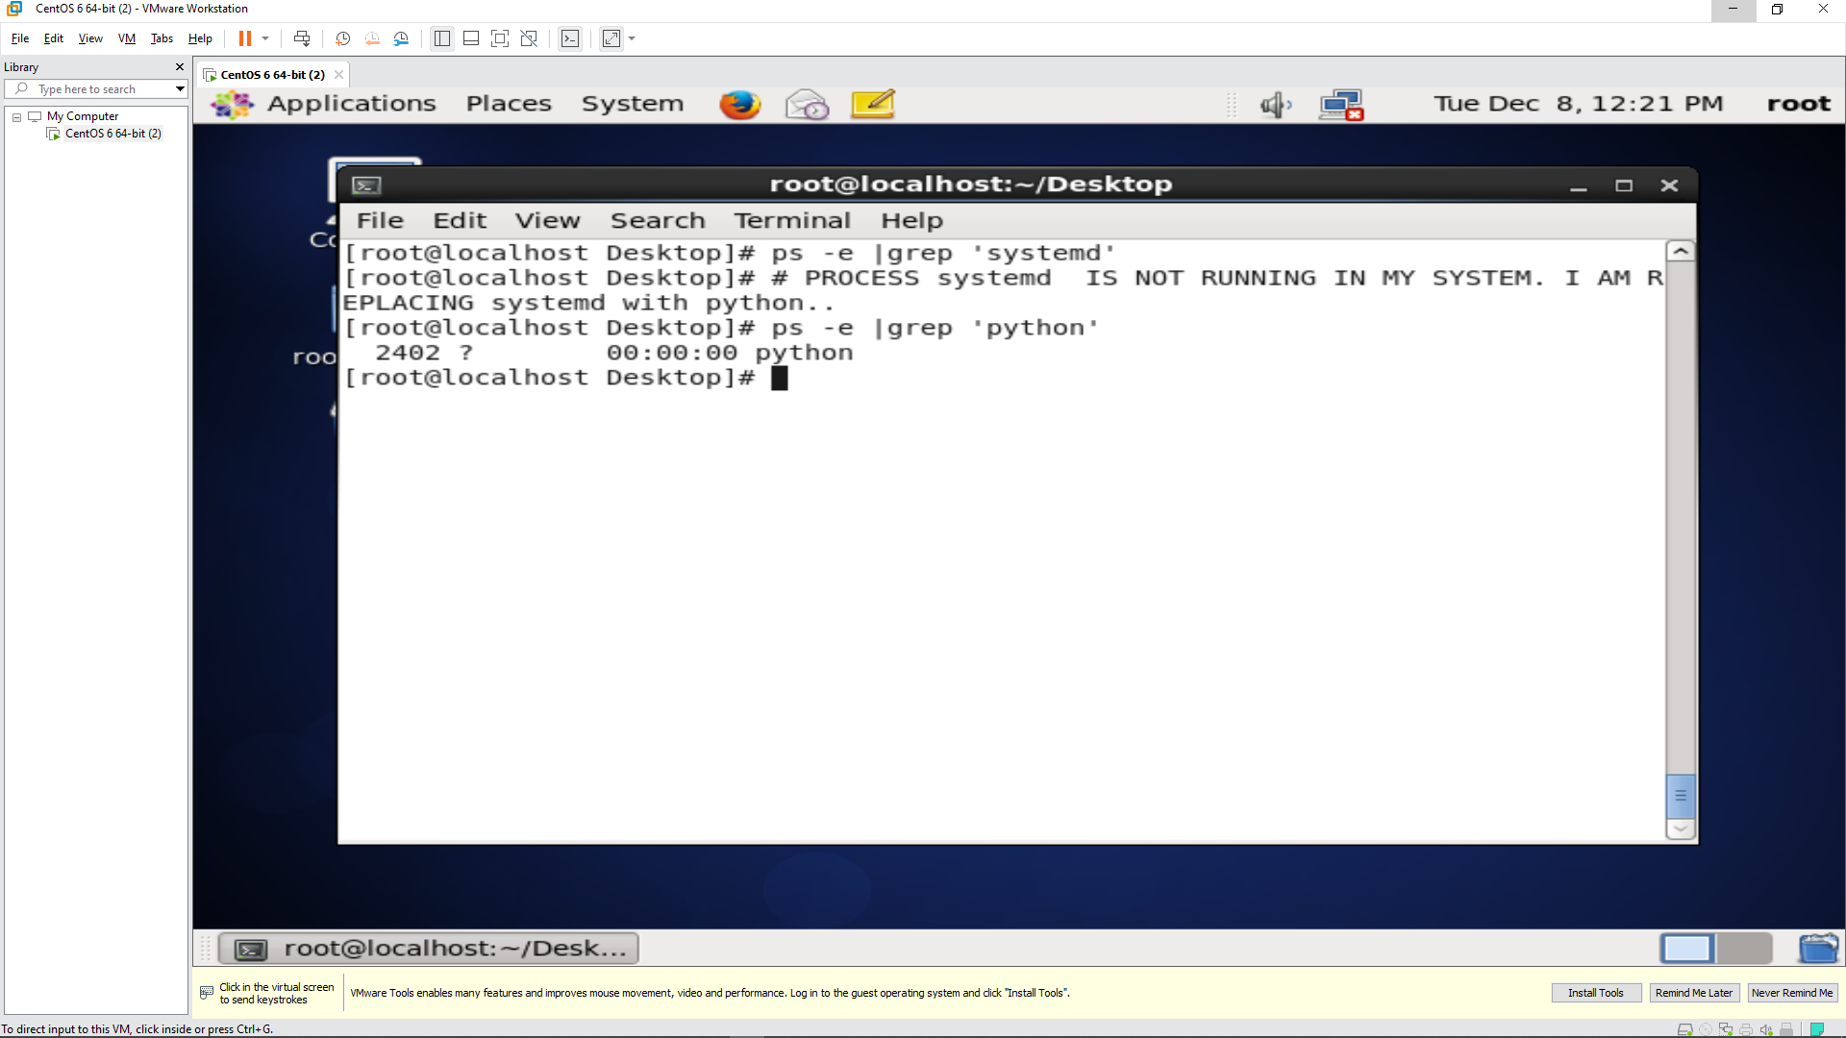

Answer 2

Using tty command to find the terminal name.

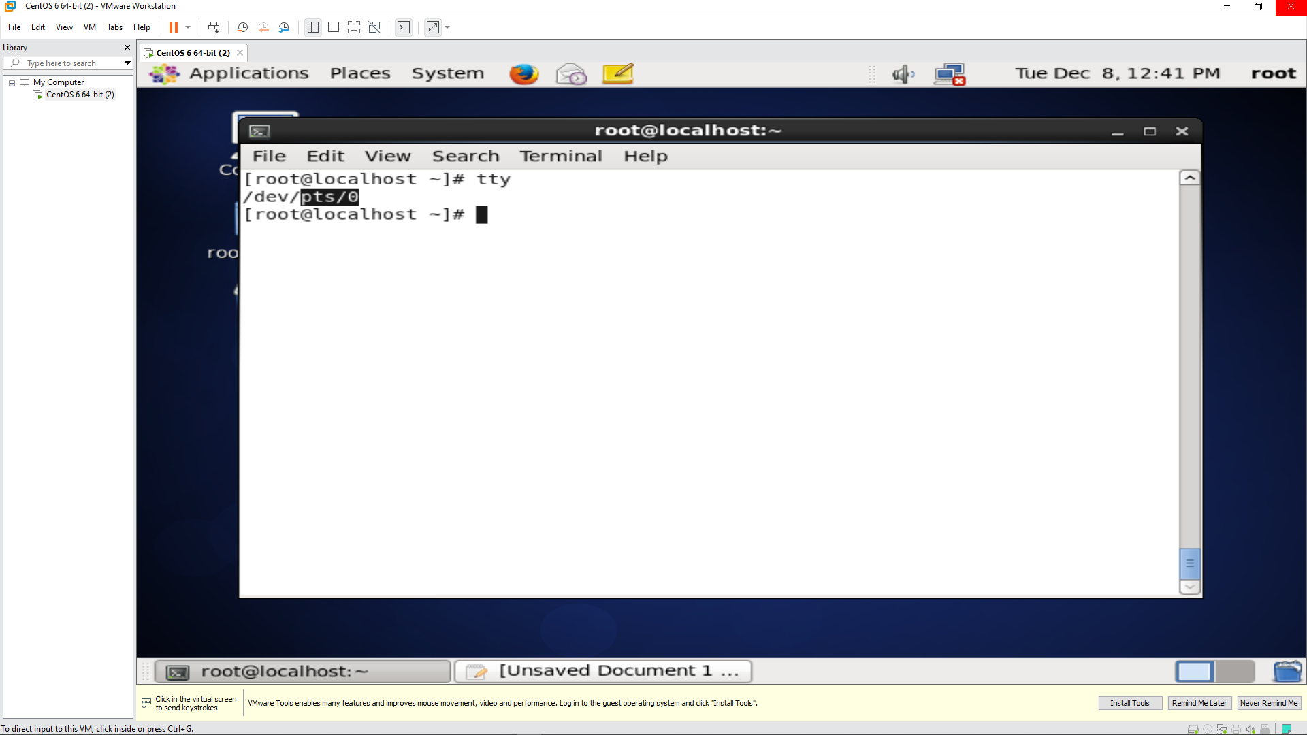

Using ps -t command to search all the process running from pts/0 terminal

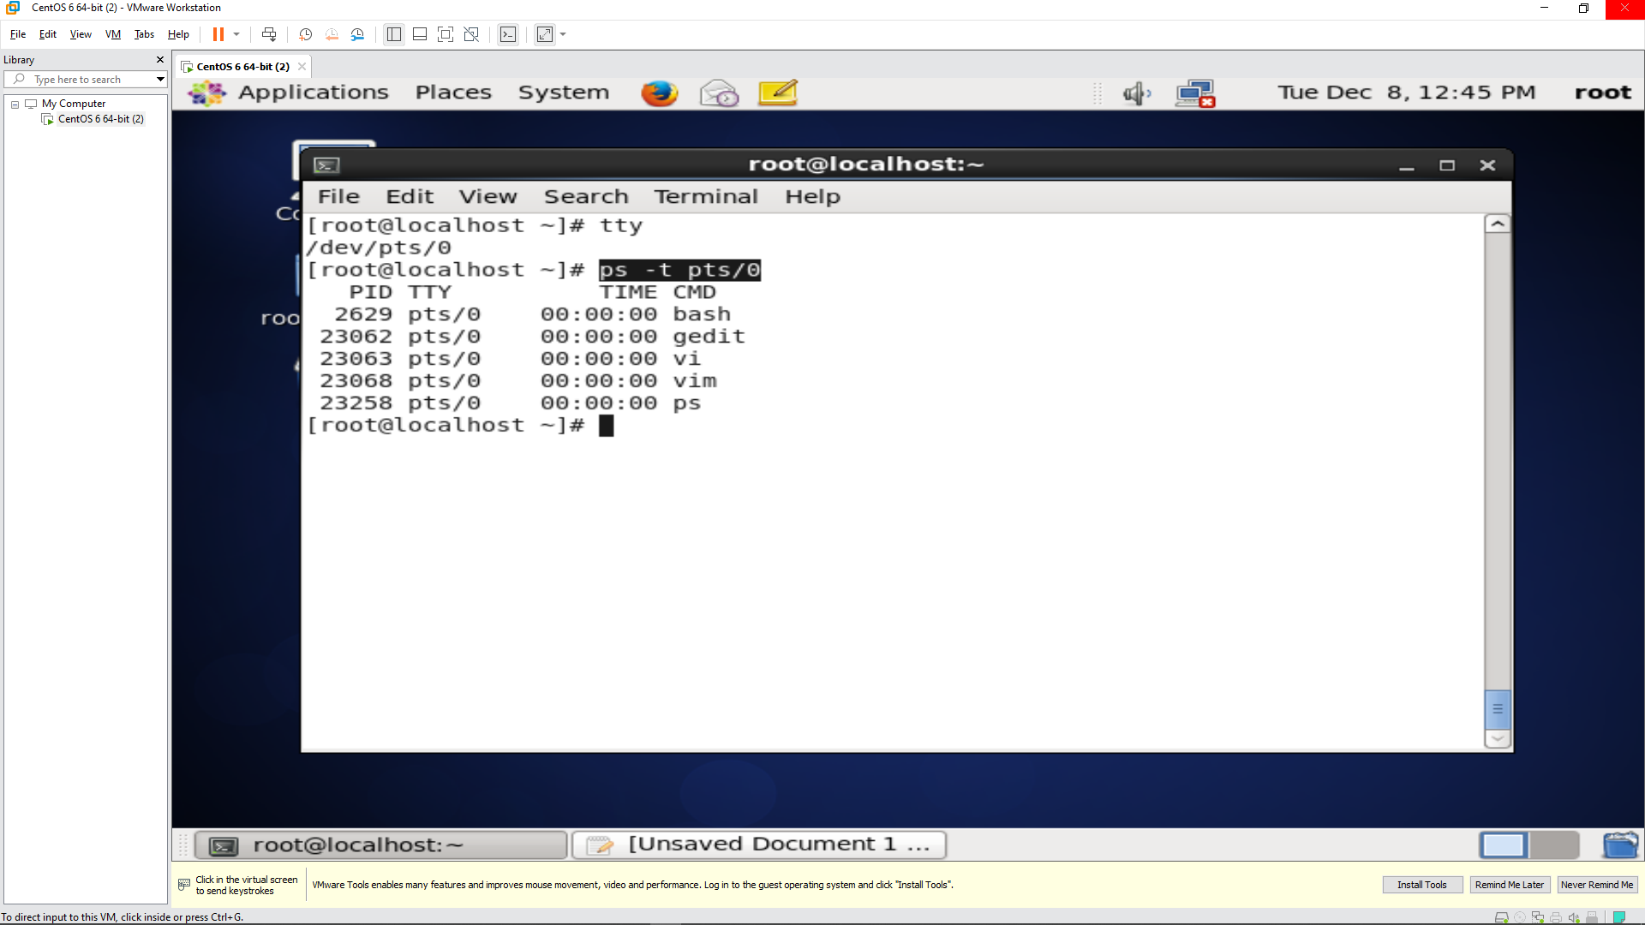

Answer 3

Noting the process id of the shell terminal from the previous command

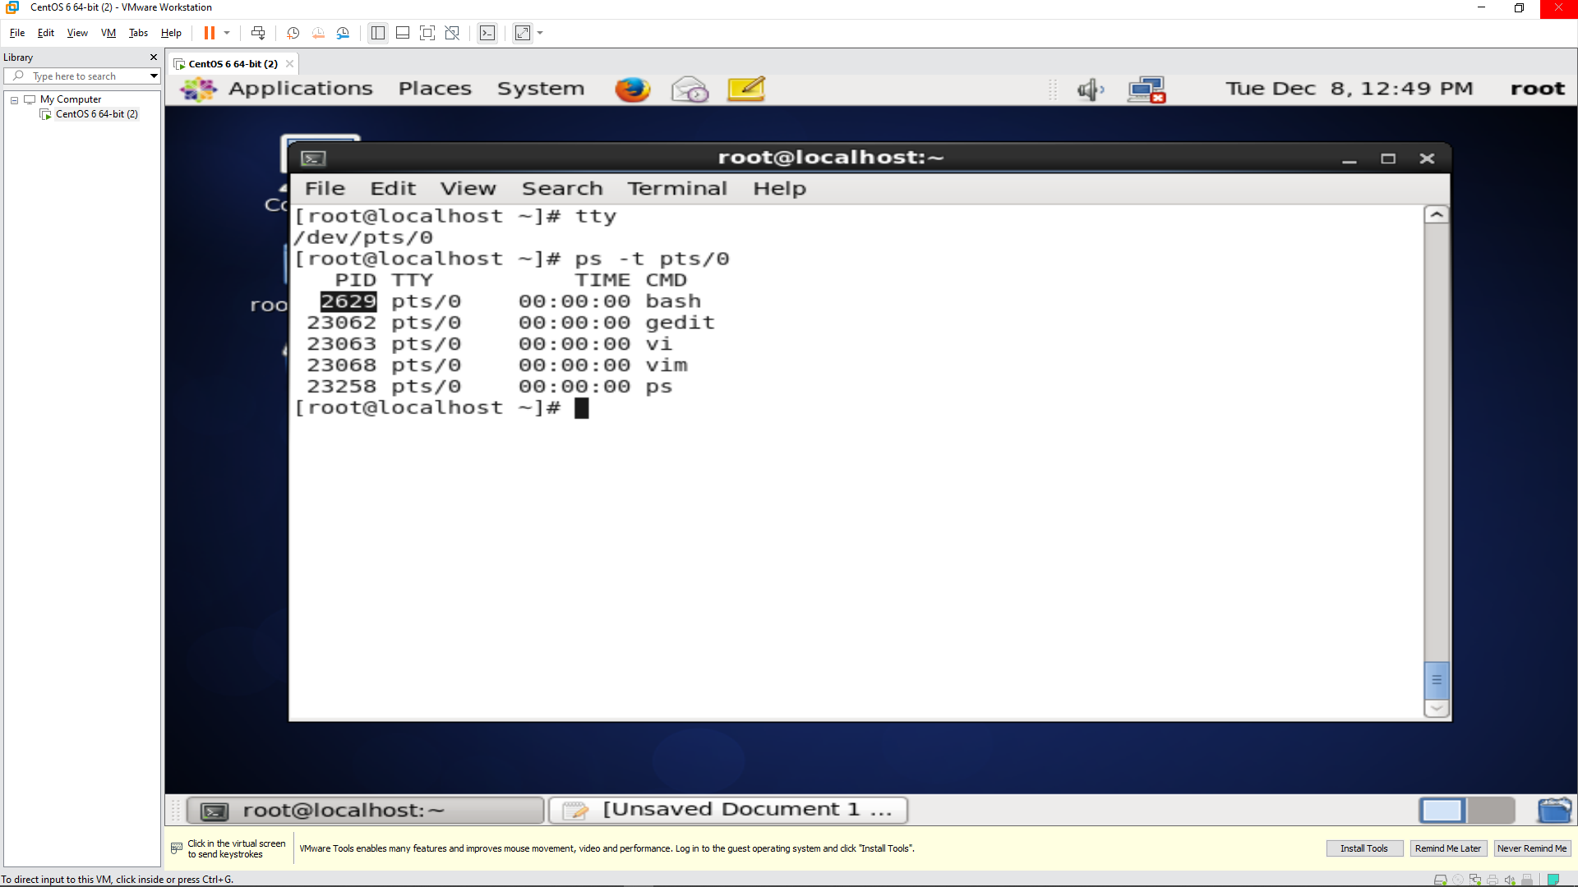

Using the ps -ef | grep command to get the parent id of the bash terminal

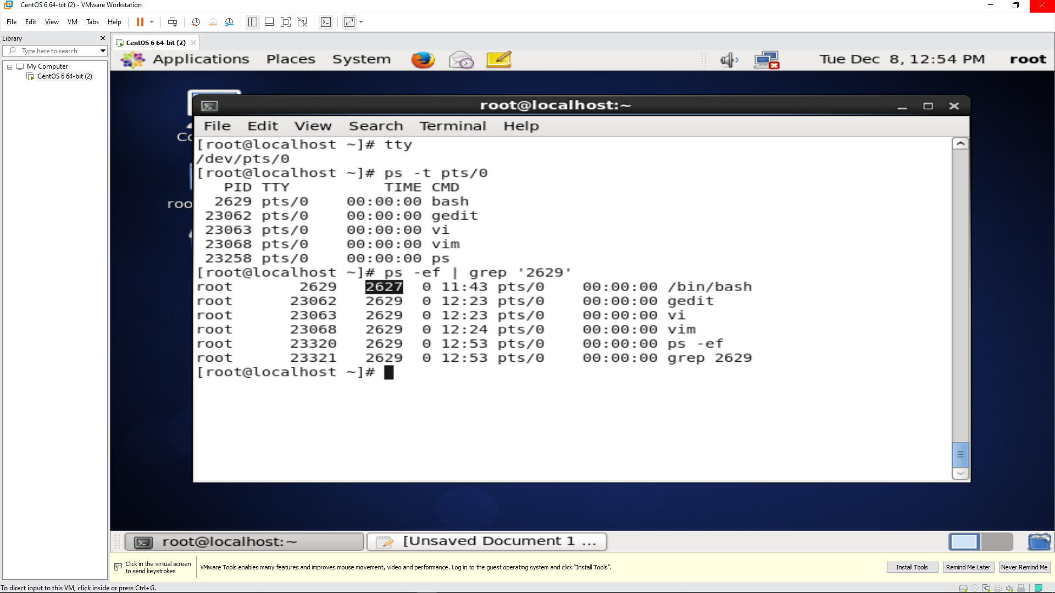

Answer 4

Using sleep 123 & command to start 3 instances of “sleep 123” as background processes.

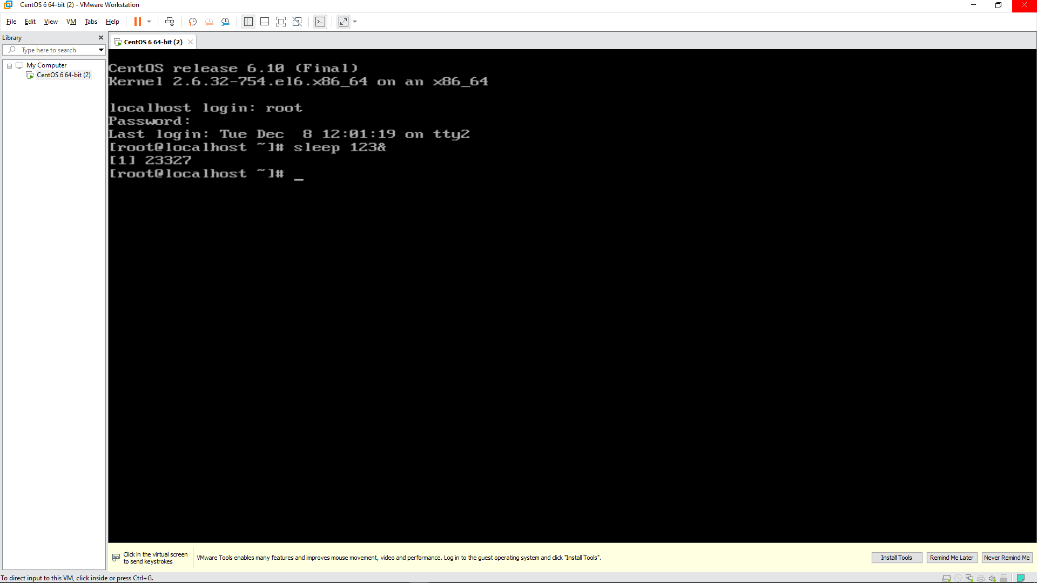

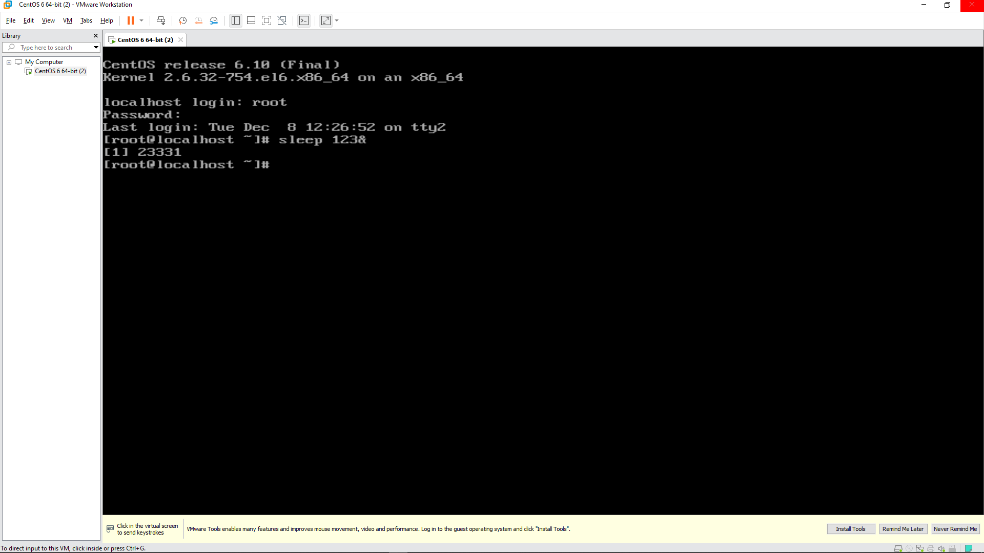

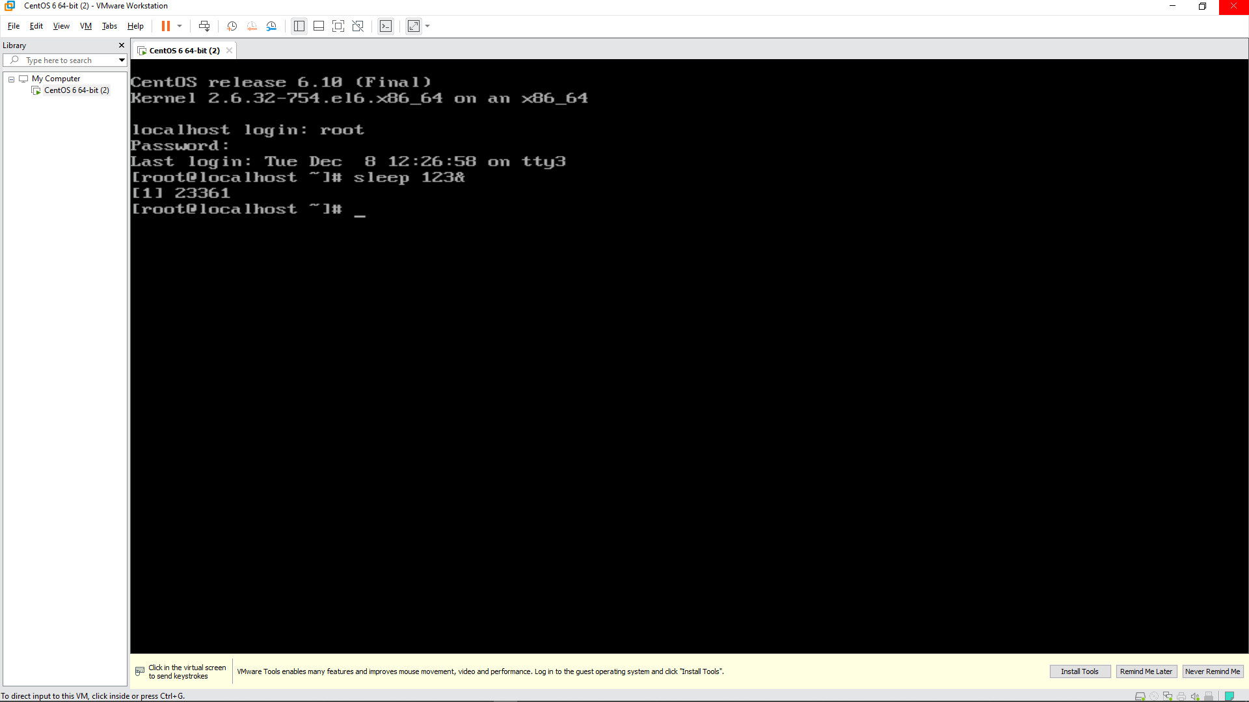

Answer 5

Using the ps -e |grep ‘sleep’ command to check and note the process id’s of all sleep processes.

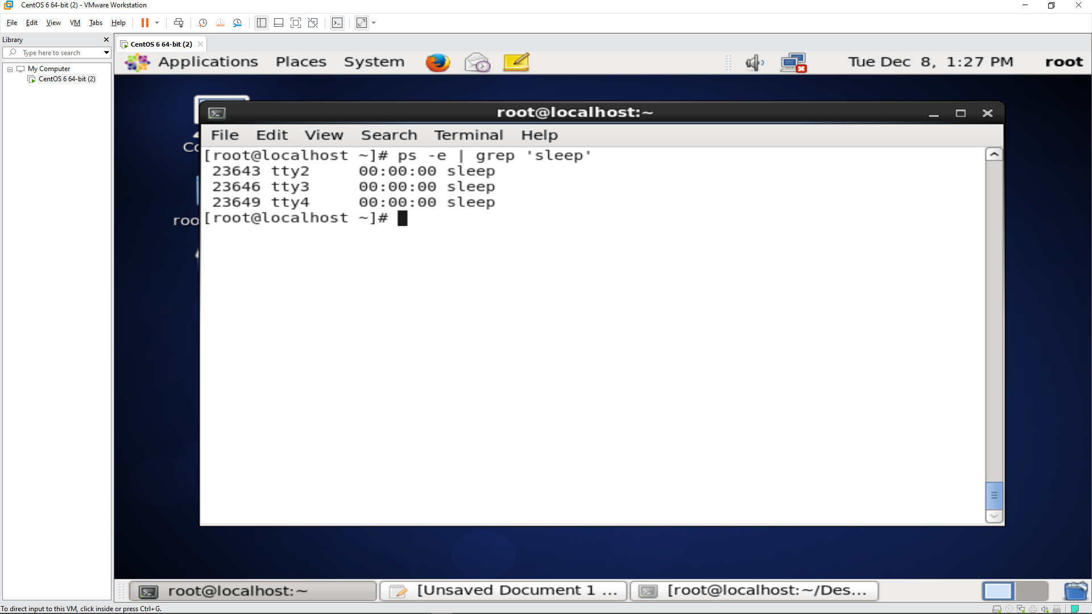

Answer 6

Using top -p 23643 -p 23646 -p 23649 command to display all the sleep processes in top.

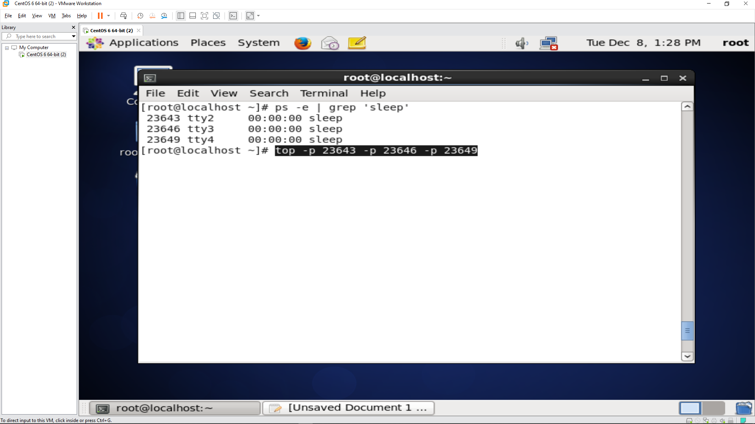

Output of top -p 23643 -p 23646 -p 23649 command

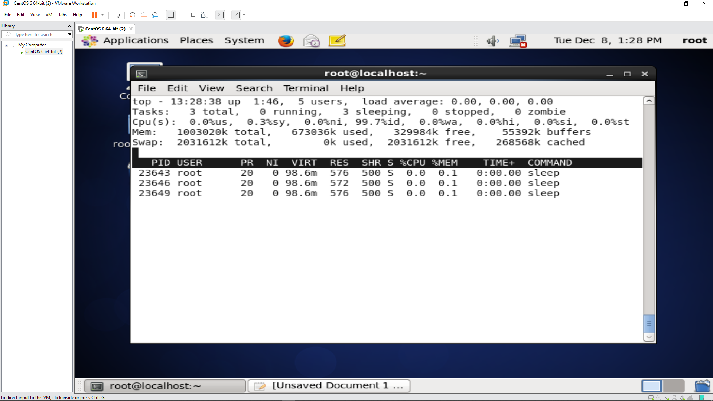

Quitting the Top by pressing q

