Projrct Name:
Secure Cloud File Sharing System with Data Mining & Intrusion Detection
Objective:
- User can securely upload/download files.
- Protect data using DataEncryption(AES).
- Detect suspiciousactivity by analyzing user behaviour,
System Arcitecture
: 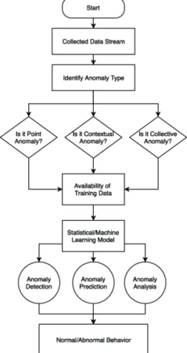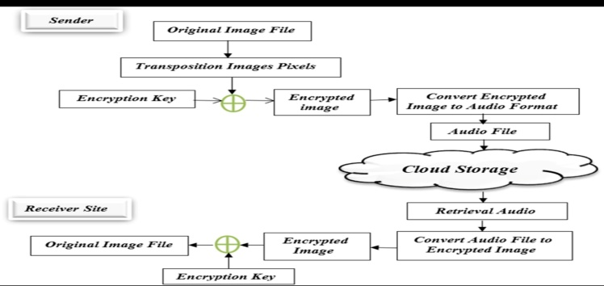
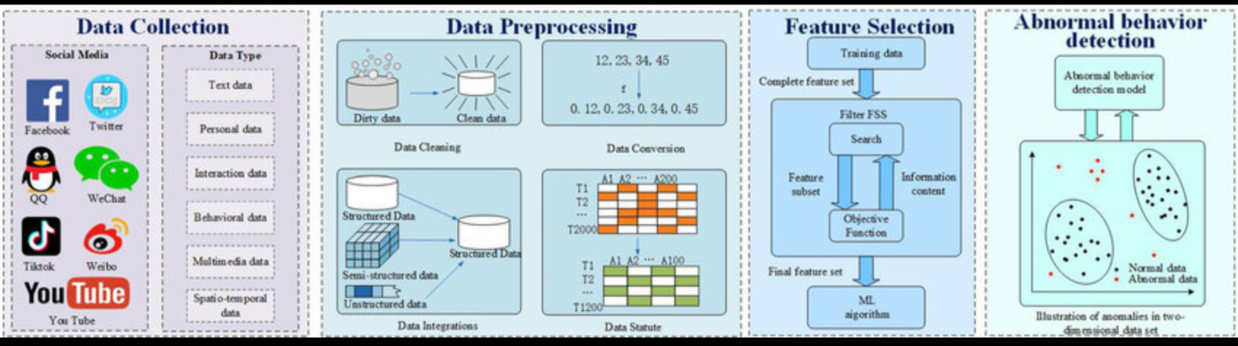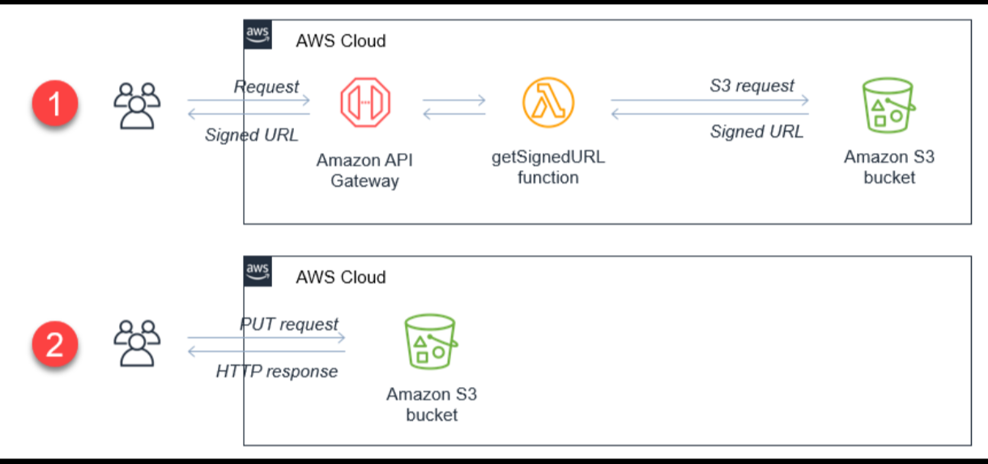

Required Technogies:
- Backend – Python(Flask)
- Database – SQLite
- Cloud – AWS S3
- Encryption – AES
- Frontend – HTML + CSS + javascript
- Data Mining – Python

Folder structure:
project/
│── app.py
│── database.db
│── templates/
│ ├── login.html
│ ├── register.html
│ ├── dashboard.html
│── static/
│ ├── style.css
│── uploads/
│── utils/
│ ├── encryption.py
│ ├── anomaly.py

Step 1 : pip install –r Requirements.txt

