Abstract

the platform Arduino with a number of sensors standard can be used as components of an electronic system for acquiring measures and controls. This presents design of a low-cost and effective solar charge controller. This system includes several elements such as the solar panel converter DC/DC, battery, circuit MPPT using Microcontroller, sensors, and the MPPT algorithm. The MPPT (Maximum Power Point Tracker) algorithm has been implemented using an Arduino Nano with the preferred program. The voltage and current of the Panel are taken where the program implemented will work and using this algorithm that MPP will be reached. This paper provides details on the solar charge control device at the maximum power point. The results include the change of the duty cycle with the change in load and thus mean the variation of the buck converter output voltage and current controlled by the MPPT algorithm.

Introduction

Global demand for energy is rapidly evolving and natural energy resources such as uranium, petroleum, and gas decreased due to a great diffusion and development of the industry in recent years. The increase in energy costs and environmental constraints are pushing for the development of technological solutions allowing better control of the resources and the exploitation of the renewable energies in specific photovoltaic energy. Photovoltaic energy is a clean and renewable energy resource. Moreover, solar panels are a silent energy producer because there is absolutely no noise when converting sunlight into electricity. In order to exploit solar energy to power the DC loads and to store electricity, a solar charge controller is needed to monitor the State of charge of the batteries and protect them from overcharging and full discharge (deep discharge). This monitoring and this permanent protection help to extend significantly the performance and life of the batteries. This controller is used in many areas such as systems not connected to the electric network, ensure the autonomy of an embedded system, monitor solar installations. This paper includes an MPPT circuit in order to extract the maximum power from the solar panel using DC /DC Converter.

**Proposed system**

The block diagram shown in figure 1 represents the complete system. It contains a solar panel, DC-DC buck converter, Arduino Nano, battery, and Loads. The solar panel is used to generate the current and voltage from which the voltage will be converted by a DC-DC converter. After calculating the power from the data transmitted by the current and voltage sensors, we use perturb and observe algorithm to reach the maximum power point. To maximize a photovoltaic (PV) system's output power, continuously tracking the maximum power point (MPP) of the system is necessary. The MPP depends on irradiance conditions, the panel's temperature, and the load connected. Maximum power point tracking (MPPT) algorithms provide the theoretical means to achieve the MPP of solar panels; these algorithms can be realized in many different forms of hardware and software. PV systems that lack MPPT rarely operate at the most efficient, MPP. This is why the rated power of the solar panel is almost never realized when connecting a load. The goal of this project will rapidly develop, construct, and test a working solution to the MPP problem with a limited budget.

**Block Diagram**

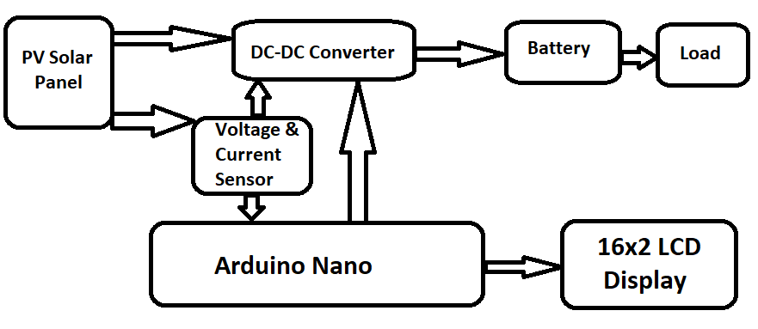

**Advantages**

* MPPT method can extract maximum available power from the PV module.
* This can increase the tracking efficiency.
* If your energy use is greatest in the winter (typical in most homes) and you have cold winter weather, then you can gain a substantial boost in energy when you need it the most
* Simple feedback structure

**Disadvantages**

* High cost compare to other implementation

**Application**

* Home
* Industry
* Can be used for battery charging or portable charging source

**References**

[1]. W. Makni, N. Ben hadj, H.Samet, R.Neji, Design simulation and realization of solar battery charge controller using Arduino Uno, a 17th international conference on Sciences and Techniques of Automatic control & computer engineering- STA'2016, Sousse, Tunisia, December 19-21, 2016.

[2]. ON Semiconductor, LC Selection Guide for the DC-DC Synchronous Buck Converter, AND9135/D.

[3]. N K. M’Sirdi, B. Nehme, M. Abarkan, A. Rabhi, The Best MPPT Algorithms by VSAS approach for Renewable Energy Sources (RES), conference paper EFEA 2014, PARIS.

[4]. M. Pathare, V. Shetty, Designing and Implementation of Maximum Power Point Tracking(MPPT) Solar Charge Controller, 2017 International Conference on Nascent Technologies in the Engineering Field (ICNTE-2017).

[5]. N. Barua, A. Dutta, S. Chakma, Implementation of Cost-effective MPPT Solar Photovoltaic System Based on the Comparison between Incremental Conductance and P&O Algorithm, 2016 IEEE International WIE Conference on Electrical and Computer Engineering (WIECON-ECE) 19-21 December 2016, India.

[6]. A. Chandwani, A. Kothari, Design, Simulation and Implementation of Maximum Power Point Tracking (MPPT) for solar based Renewable Systems, 2016 International Conference on Electrical Power and Energy Systems (ICEPES). Dec 14-16, 2016.

[7]. T. Kaur, J. Gambhir, S. Kumar, Arduino Based Solar Powered Battery Charging System for Rural SHS, Power Electronics (IICPE), 7th 2016 India International Conference.