**KL University**



**Department of Computer ScienceEngineering**

**Course code -15CS2007**

**Database Systems**

**II B.Tech – 2ndSemester**

**Academic Year2016-2017**

**Project Based Lab**

**ON**

**JOY HOST EVENT MANAGEMENT FRIM**

**Submitted by**

**Batch No: 19**

|  |  |  |
| --- | --- | --- |
| Student ID | Student Name | Department |
| 150030960 | V.Satish kumar | C.S.E |

**K L University**

**DEPARTMENT OF COMPUTER SCIENCE ENGINEERING**

**(DST-FIST Sponsored Department)**



**CERTIFICATE**

This is to certify that the course based project entitled **“JOY HOST EVENT MANAGEMENT FRIM”** is a bonafide workdone byV.Satish kumar **(150030960)** in partial fulfilment of the requirement for the award of degree in **BACHELOR OF TECHNOLOGY** in **Computer Science Engineering** during the academic year **2016-2017.**

**Faculty in Charge Head of the Department**

**M.V.B.T.Santhi Prof. Srikanth Vemuru**

**DEPARTMENT OF COMPUTER SCIENCE ENGINEERING**

**(DST-FIST Sponsored Department)**



**DECLARATION**

We hereby declare that this project based lab report entitled **“JOY HOST EVENT MANAGEMENT FRIM”** has been prepared by us in partial fulfilment of the requirement for the award of degree “**BACHELOR OF TECHNOLOGY in COMPUTER SCIENCE ENGINEERING**” during the academic year 2016-2017.

We also declare that this project based lab report is of our own effort and it has not been submitted to any other university for the award of any degree.

**Date:12/04/17**

**Place: K L University**

|  |  |
| --- | --- |
| **Name** | **Student ID** |
| **V.Satish Kumar** | **150030960** |

**ACKNOWLEDGMENTS**

Our sincere thanks to**Dr. J. Anand Chandulal**in the Lab for his outstanding support throughout the project for the successful completion of the work.

My sincere thanks to **MR. A.Satya Kalyan**Course coordinator of Data base system for helping us in the completion of our project based laboratory.

We express our gratitude to **V.SRIKANTH** Head of the Department for Computer Science and Engineering for providing us with adequate facilities, ways and means by which we are able to complete this term paper work.

We would like to place on record the deep sense of gratitude to the honourable Vice Chancellor, K L University for providing the necessary facilities to carry the concluded term paper work.

Last but not the least, we thank all Teaching and Non-Teaching Staff of our department and especially my classmates and my friends for their support in the completion of our project work.

Finally, it is pleased to acknowledge the indebtedness to all those who devoted themselves directly or indirectly to make this project report success.

**PROJECT ASSOCIATES**

|  |  |
| --- | --- |
| **Name** | **Student ID** |
| **V.Satish kumar** | **150030960** |

Table of Contents

**CONTENTS PAGE NO**

ABSTRACT 06

INTRODUCTION 07

PROJECT DISCRIPTION 08

LIST OF ENTITES AND ATTRIBUTES 09

ER-DIAGRAM 13

CREATION AND INSERTION OF MYSQL QUERIES 14

QUERIES 18

CONCLUSION 20

# Abstract

Joy Host Event Management firm(JHEM) has currently 10 branches spread across the two Telugu speaking states of Andhra Pradesh and Telangana. The firm specializes in hosting movie related events, new year celebrations in corporate firms, political events, conferences etc. They cater to both personal and corporate events. Details of each event organized by the firm are recorded. An event is associated with a branch of JHEM. The date, the venue and the type of event are recorded. JHEM assigns an Event Manager for each event and entrusts him/her the responsibility of conduct of the whole event. An Event manager can simultaneously take up multiple events. For each event staff are allocated who cater to various departments of an event. For example, separate staff are allocated to take care of electrical aspects; separate staff for food and catering; staff for hospitality; staff for stage management etc. One among these staff will be the head of department in that event.

JHEM also helps the clients obtain on their behalf all relevant permissions from Government and local bodies for a smooth and successful conduct of an event. Based on the branch location, the permission costs must be recorded and data must be maintained on how these costs have increased/decreased over the years. The branch manager is held responsible to obtain all these permissions in writing. The branch manager is supported by office staff who usually look after the administrative affairs of JHEM.

JHEM has approached you to develop an online management system. Some of their

requirements may be ambiguous and need a face-to-face discussion. They wish you to create

an initial design of how their firm’s data is stored and retrieved. They also wish to clear all

the ambiguities in their meeting after the initial design has been drafted. They want the design

to be robust and easily extendable to meet the demands of rapid growth in the business.

# IntroductioN

  Database is an organized collection of data. The data is typically organized to model aspects of reality in a way that supports processes requiring information. A DBMS makes it possible for end users to create, read, update and delete data in a database. The DBMS essentially serves as an interface between the database and end users or application programs, ensuring that data is consistently organized and remains easily accessible. The DBMS manages three important things: the data, the database engine that allows data to be accessed, locked and modified and the database schema, which defines the database’s logical structure. These three foundational elements help provide concurrency, security, data integrity and uniform administration procedures. The DBMS can offer both logical and physical data independence. That means it can protect users and applications from needing to know where data is stored or having to be concerned about changes to the physical structure of data.

So, our aim isto develop an online management system. Some of their requirements may be ambiguous and need a face-to-face discussion. They wish you to create an initial design of how their firm’s data is stored and retrieved. They also wish to clear all the ambiguities in their meeting after the initial design has been drafted. They want the design to be robust and easily extendable to meet the demands of rapid growth in the business.

# PROJECT DESCRIPTION

Joy Host Event Management firm(JHEM) has currently 10 branches spread across the two Telugu speaking states of Andhra Pradesh and Telangana. The firm specializes in hosting movie related events, new year celebrations in corporate firms, political events, conferences etc. They cater to both personal and corporate events. As the organization is growing they wish to setup an online management system for their internal usage. For personal events, they wish to record the client’s details such as the name, contact number, contact address and email id. For corporate events, they wish to record the name of the organization, the contact person and their contact details.

Details of each event organized by the firm are recorded. An event is associated with a branch of JHEM. The date, the venue and the type of event are recorded. JHEM assigns an Event Manager for each event and entrusts him/her the responsibility of conduct of the whole event. An Event manager can simultaneously take up multiple events. For each event staff are allocated who cater to various departments of an event. For example, separate staff are allocated to take care of electrical aspects; separate staff for food and catering; staff for hospitality; staff for stage management etc. One among these staff will be the head of department in that event.

JHEM also undertakes publicity of events organized by them using several modes. The print publicity, web publicity, multimedia based publicity are few modes. The cost incurred in an event by JHEM for these modes is also recorded in the database. A publicity specialist is hired by JHEM for each of these events. JHEM maintains a separate list of publicity specialists whom their hire from outside. Each publicity specialist charges an amount based on the type of the event and the number of days spent on the publicity of the event.

JHEM has approached you to develop an online management system. Some of their requirements may be ambiguous and need a face-to-face discussion. They wish you to create an initial design of how their firm’s data is stored and retrieved. They also wish to clear all the ambiguities in their meeting after the initial design has been drafted. They want the design to be robust and easily extendable to meet the demands of rapid growth in the business.

# List of Entities & Attributes

**List of entities:**

1. Client details
2. Manager
3. Department
4. Events
5. Branch
6. Staff details
7. Publicity

**List of attributes:**

1. Client details

* Cid
* Cname
* Cphno
* Caddr
* Cemail

1. Manager

* Managerid
* Manager name
* Contact_no
* Address

1. Department

* Dept-id
* Dept name
* Dept work

1. Events

* Event_id
* Event_name
* Event Venue
* Event date
* Event time

1. Branch

* Branch id
* Branch name
* Ph_no
* Address

1. Staff Details

* Staff Id
* Staff name
* Staff contact_no
* Address

1. Publicity

* Publicity id
* Publicity name
* Publicity cost

**List of relationships:**

* A Company/ Manager works for a company

Name of the relation: works

Cardinality: A:C=N:1

* A client wants to conduct an event

Name of the relation: conducts

Cardinality: C: E :M= N:N:1

* A Manager will store all the details of client, events, dept

Name of the relation: Records

Cardinality: C:E:D:M=N:N:N:1

* A branch will manages the dept and the whole event

Name of the relation: Manages

Cardinality: B:D:E=1:1:1

* A dept will store all the details of the staff

Name of the relation: holds

Cardinality: D:S=1:N

* A company will publish the event

Name of the relation: Publishs

Cardinality: M:P=1:N

**SCHEMA DIAGRAM:-**

**1.Branch**

|  |  |  |  |
| --- | --- | --- | --- |
| **bid** | **Bname** | **bcon_no** | **baddr** |

**2.manager**

|  |  |  |
| --- | --- | --- |
| **mid** | **mname** | **maddr** |

**3.Client details**

|  |  |  |  |  |  |
| --- | --- | --- | --- | --- | --- |
| Cid | Cname | C_conum | Caddr | Cemail | mid |

**4.Publicity**

|  |  |  |  |  |
| --- | --- | --- | --- | --- |
| pid | Mid | Publicity_type | pcost | No_of_days |

**5.Event**

|  |  |  |  |  |
| --- | --- | --- | --- | --- |
| eid | cid | evenue | etime | edate |

6.Dept

|  |  |  |
| --- | --- | --- |
| did | dname | dwork |

7.staff_details

|  |  |  |  |  |
| --- | --- | --- | --- | --- |
| sid | Sname | S_conum | saddrr | did |

# ER Diagram (Conceptual Model)

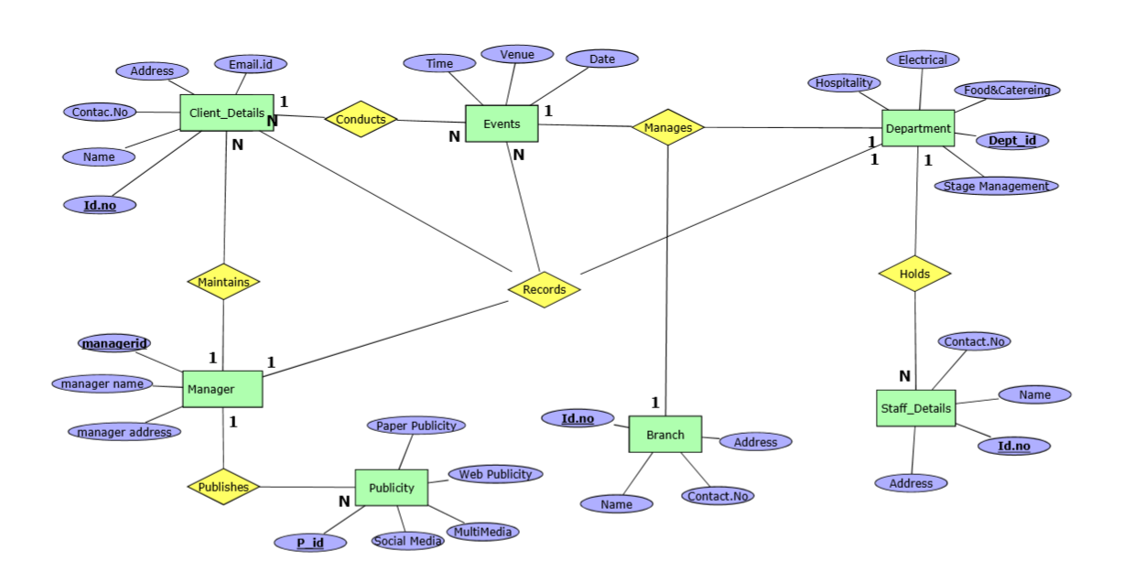

# **Create & Insert** SQL **Queries**

**Branch:**

create table branch(bid int,bname varchar(20),bcon_noint,baddr varchar(30),primary key(bid));

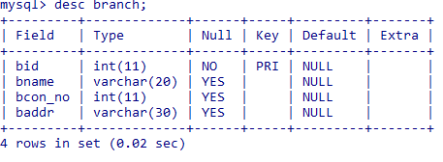

**Manager:**

create table manager(mid int,mname varchar(30),maddr varchar(30),primary key(mid));

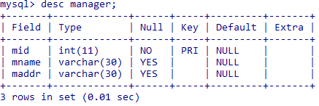

**Client details:**

create table client_details(cidint,cname varchar(20),c_conumint,caddrr varchar(30),cemail varchar(30),mid int,primary key(cid,mid),foreign key(mid) references manager(mid));

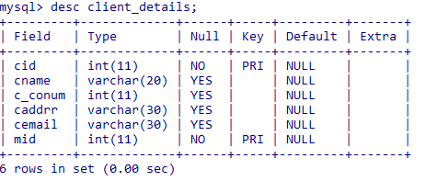

**Publicity:**

Create table publicity(pid int,mid int,Publicity_type varchar(20),pcost int,no_of_days int,primary key(pid,mid),foreign key(mid) references manager(mid));

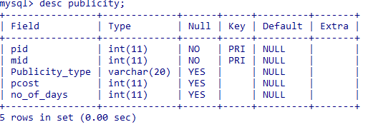

**Event:**

Create table event(eid int,cid int,evenue varchar(30),etime time,edate date,primary key(eid,cid),foreign key(cid) references client_details(cid));

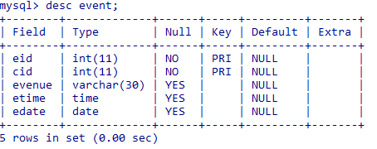

**Dept:**

Create table dept(did int,dname varchar(30),dwork varchar(30),primary key(did));

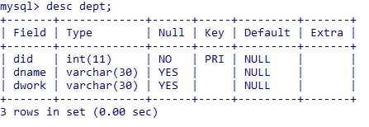

**Staff details:**

create table staff_details(sidint,sname varchar(30),s_conumint,saddrr varchar(25),did int,primary key(sid,did),foreign key(did) references dept(did));

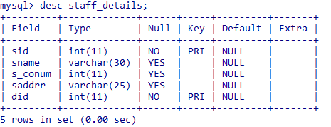

**event_dept_branch:**

create table event_dept_branch(eidint,bidint ,did int,primary key(eid,bid,did),foreign key(eid) references event(eid),foreign key(bid) references branch(bid),foreign key(did) references dept(did));

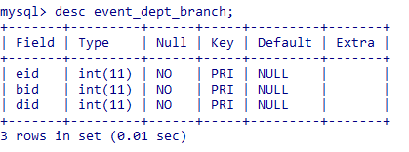

**INSERTION:**

**Branch:**

insert into branch values(100,'vijayawada',951571997,'benz circle');

insert into branch values(101,'hyderabad',951579135,'film city');

insert into branch values(102,'chennai',903045895,'T nagar');

insert into branch values(103,'delhi',953645895,'red hills');

insert into branch values(104,'banglore',95364545,'beside kemp fort');

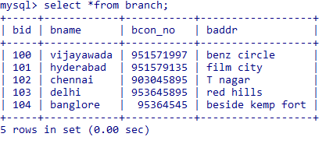

**Manager:**

insert into manager values(200,'vikram','dhilshuknagar');

insert into manager values(201,'Ajay','Nizampet-hyd');

insert into manager values(202,'Arjun','beside osmania-hyd');

insert into manager values(203,'Charan','Bandar road-vij');

insert into manager values(204,'Aditya','R.R.Road-Elu');

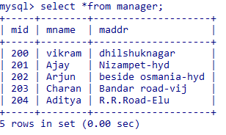

**Client_details:**

insert into client_details values(300,'raghu',978461321,'itanagar','raghu@gmail',200);

insert into client_detailsvalues(301,'ram',978465321,'alex road','ram@gmail',200);

insert into client_detailsvalues(302,'ravi',965465321,'pathan road','ravi@gmail',201);

insert into client_detailsvalues(

303,'robert',915325321,'blueappleroad','rober@gmail',202);

Insert into client_detailsvalues(

304,'revanth',956132321,'greenappleroad','revanth@gmail',203);

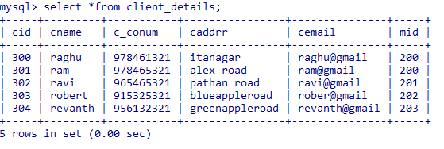

**Publicity:**

insert into publicity values(400,200,'paper_publicity',50000,10);

insert into publicity values(401,201,'web_publicity',40000,7);

insert into publicity values(402,202,'multi_media',45500,8);

insert into publicity values(403,203,'social_media',25000,6);

insert into publicity values(404,204,'others',35000,5);

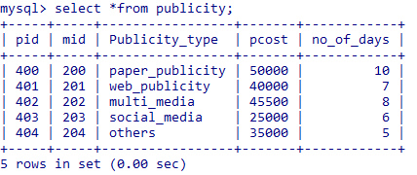

**Event:**

insert into event values(500,300,'hyderabad','20:06:55','2017-04-08');

insert into event values(501,301,'vijayawada','21:10:55','2017-06-08');

insert into event values(502,302,'mumbai','11:11:55','2016-05-28');

insert into event values(503,303,'Delhi','12:00:00','2017-07-20');

insert into event values(504,304,'Goa','22:02:04','2016-11-21');

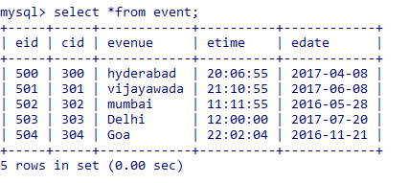

**Dept:**

insert into dept values(600,'electrical','connections');

insert into dept values(601,'management','managing');

insert into dept values(602,'Food&drinks','supplying');

insert into dept values(603,'decoration','decorating');

insert into dept values(604,'transpot','transporting');

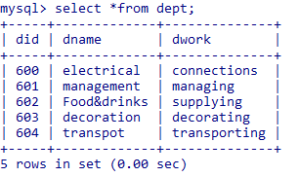

**Staff_Details:**

insert into staff_details values(700,'akhil',952236852,'beside tajmahal',600);

insert into staff_details values(701,'prasad',995456852,'beside charminar',601);

insert into staff_details values(702,'praveen',995521222,'beside burjkhalifa',602);

insert into staff_details values(703,'rahul',900361222,'beside KLU',603);

insert into staff_details values(704,'sowmitri',995621222,'beside MGRoad',604);

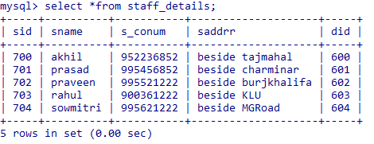

**Event_dept_branch:**

insert into event_dept_branch values(500,100,600);

insert into event_dept_branch values(501,101,601);

insert into event_dept_branch values(502,102,602);

insert into event_dept_branch values(503,103,603);

insert into event_dept_branch values(504,104,604);

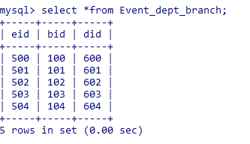

# Queries:

1. print the names of departments under branch=’101’.

select d.dname,b.bname from event_dept_branch edp inner join dept d inner join branch b where edp.did=d.did and edp.bid=101 and b.bid=101;

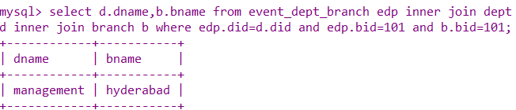

1. print the names of departments and their branches that conduct events

select d.dname,b.bname from event_dept_branch edp inner join dept d inner join branch b where edp.did=d.did and edp.bid=b.bid;

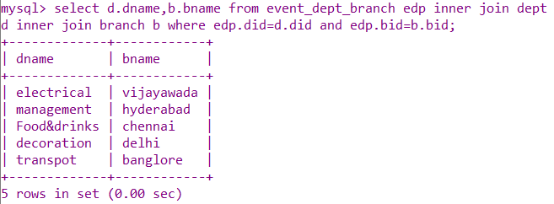

1. Print all the department and their works respectively

select dname,dwork from dept order by did;

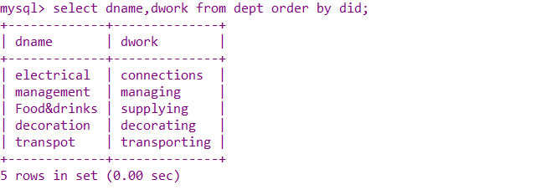

1. Print the staff details where name=’akhil’;

 select s_conum from staff_details where sname='akhil';

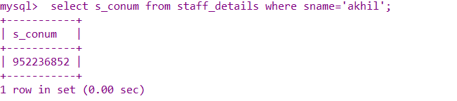

1. Display all types of publicities where no.of days are more than 5

select * from publicity having no_of_days>5;

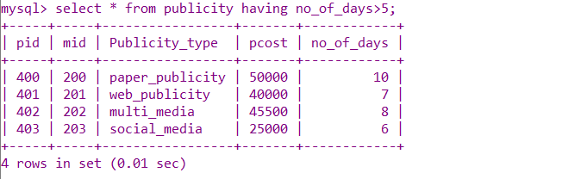

1. print all staff details whose name starts with 'p'

select * from staff_details where sname LIKE 'P%';

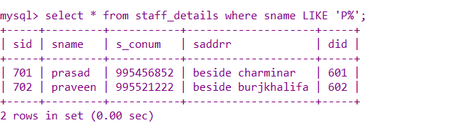

1. print total cost that publicity takes

select sum(pcost) from publicity;

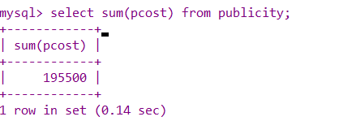

8.Display the evenue and branch name where eid=502

select evenue,bname from branch b,event e,event_dept_branch edp where edp.bid=b.bid and e.eid=edp.eid;

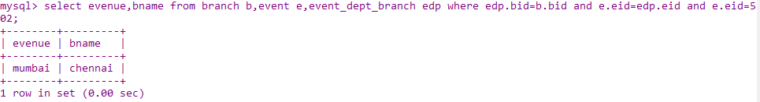

# Conclusion

The online data base of JOY HOST EVENT MANAGEMENT FRIM is created and it will be very useful to store the data of the events and client who wants to conduct the events. Apart from the event management the database also stores the information of the corporate supporters who were supported for the event to conduct successfully in.The database will make it very easy to retrieve information and update the existing data.

Some of their requirements may be ambiguous and need a face-to-face discussion. They wish you to create an initial design of how their firm’s data is stored and retrieved. They also wish to clear all the ambiguities in their meeting after the initial design has been drafted. They want the design to be robust and easily extendable to meet the demands of rapid growth in the business.