Clustering in Domain Mode in Multiple machines:

Master Node: 192.168.1.202 (DC)

Slave node1: 192.168.1.2 (HC1)
Slave node2: 192.168.1.20 (HC2)

NOTE:

In domain mode, generally Server groups created in Domain.xml and servers are created in host.xml.

Step-1: Installing jboss in all machines:

# cd opt/Jboss7

# unzip jboss-eap-7.0.0.zip

Now extracted folder created in the same location with the name jboss-eap-7.0.

Step-2:

On the DC, edit /opt/jboss-eap-7-Master/domain/configuration/host.xml and set its host name as follows: (the name should be unique in the whole domain)

<host name="masterOne" xmlns="urn:jboss:domain:4.1">

Do not confuse this name with the actual hostname of the machine.

Step-3:

On HC1, edit /opt/jboss-eap-7-Slave/domain/configuration/host.xml and set its host name like follows: (the name should be unique in the whole domain)

<host xmlns="urn:jboss:domain:4.1" name="slavenode1">

Step-4:

Tell it where the DC is - here we need to use the actual hostname of the DC. ( Means, host recognizes where is the master domain-controller is located, whether local/ remote).

<domain-controller>
<remote host="192.168.1.202" port="9999" security-realm="ManagementRealm"/>
</domain-controller>

NOTE:

To share single user for multiple host-slave controllers use the below way :

<domain-controller>
<remote host="YourMasterHostName" port="9999" security-realm="ManagementRealm" username="jbossuser"/>
</domain-controller>

Step-5:

For Specifying user in the above domain-controller tag, in the host-slaves, first we need to
Creating user in master node and pass those user user’s secret key into slave machines.

## Creating user in Master node:

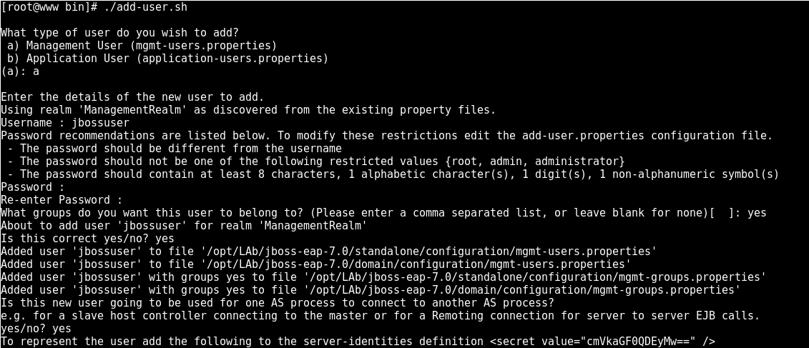

Here we found secret key value, we need to add this secret-key value into all slave nodes (HC1 and HC2) for communicating between master and slave jboss nodes, for that follow the below step.

Step-6:

On HC1 and HC2 edit /opt/jboss-eap-7-Slave/domain/configuration/host.xml and add the <server-identity> and the <secret value="..."> which was generated in step 5 as follows:

# cd /opt/Jboss7/jboss-eap-7.0/domain/configuration

# vim host.xml (add the below content under the security-realm).

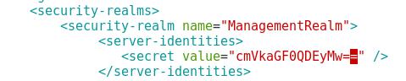

Step-7:

Start the DC with the script in /opt/jboss-eap-7-Master/bin as below.

NOTE:

Make sure that there are no firewall restrictions so that YourMasterHostName:9999 is accessible from remote Hcs.

Syntax:

./domain.sh -b YourMasterHostName -bmanagement YourMasterHostName

Example:

./domain.sh -b 192.168.1.202 -bmanagement 192.168.1.202

NOTE:

If we want to specify management bind address in master’s servers host.xml file as like below

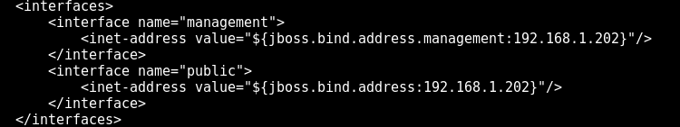

Step-8

Start the HC1and HC2 with the script in /opt/jboss-eap-7-Slave/bin as below:

HC1:

Syntax:

./domain.sh -Djboss.domain.master.address=YourMasterHostName -b SlaveHostName -bmanagement SlaveHostName

Example:

./domain.sh -Djboss.domain.master.address=192.168.1.202 -b 192.168.1.2 -bmanagement 192.168.1.2

NOTE:

If we want to specify the management ip address into HC1 and HC2 host.xml file as given below
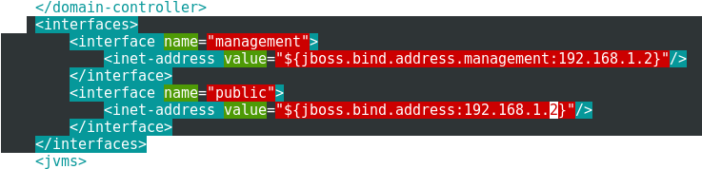

Step-9:

Need to mention master’s and slavenodes hostname and IPs into both /etc/hosts file as like below

# vim /etc/hosts

192.168.1.2 jboss.node.com
192.168.1.202 www.ajay.com
192.168.1.20 brms.local

Step-10:

After that we just the start servers using above commands, we get confirmation in master-node as like below, and start all the master and slave nodes accordingly.

NOTE:

For our reference we just follow: https://access.redhat.com/solutions/218053

NOTE:

you can access the admin console with master IP:9990 port-offset

http://192.168.1.202:9990/console

give username and password, opens the admin console as like below:

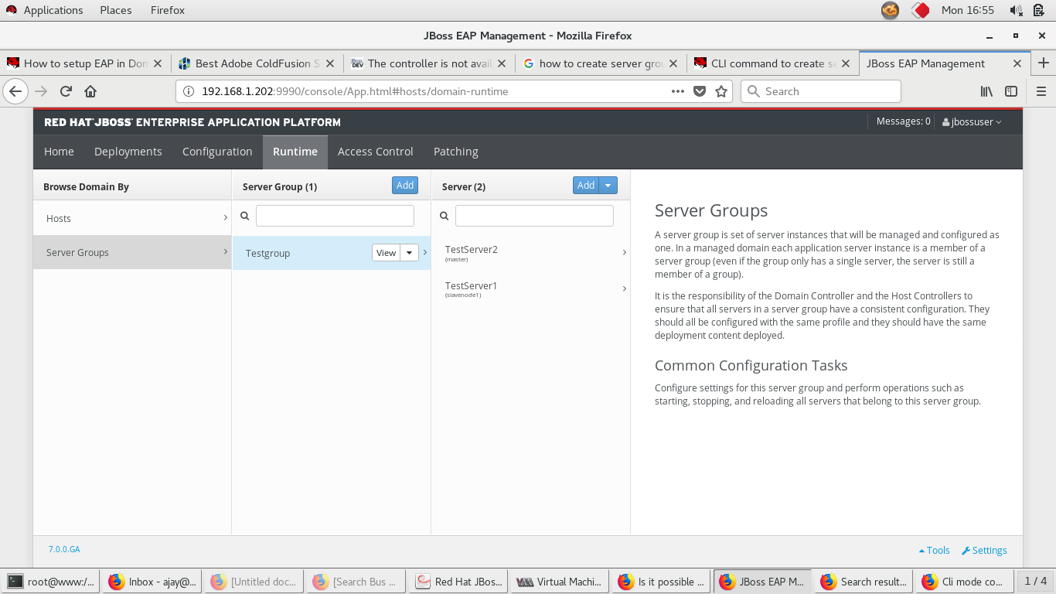
Fig: Server-Groups—Servers in side of the server-group.

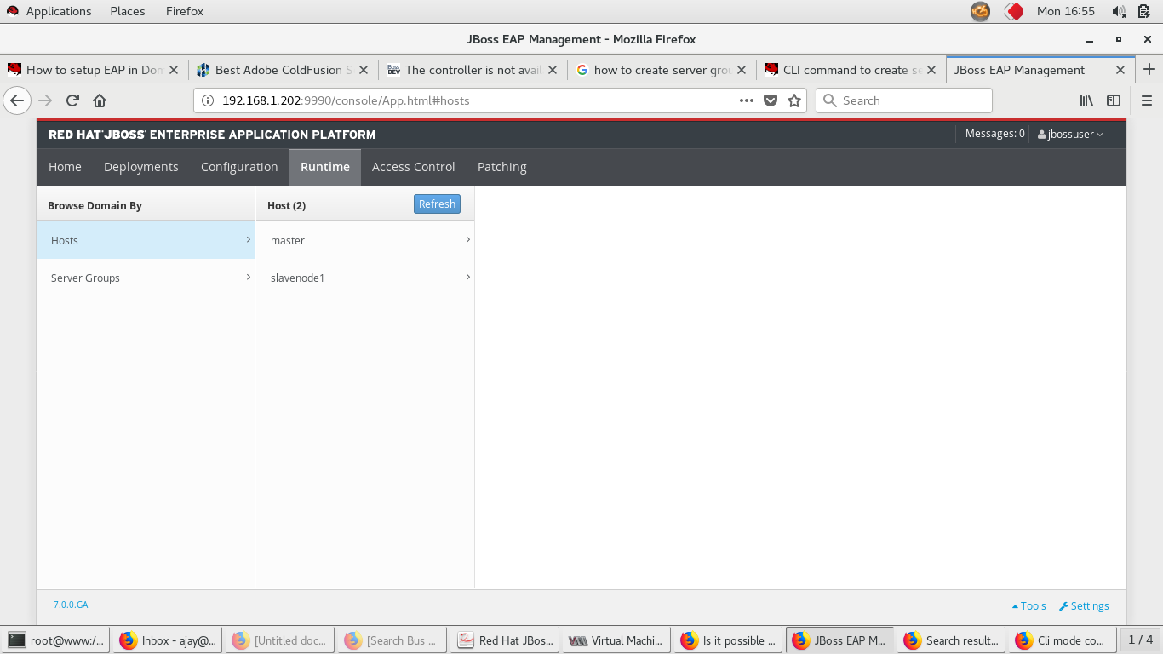
Fig: Slave servers list, master is master-server acts as host as well, slavenode1 is slave server from remote machine.

