Data Source Configuration in Jboss EAP7: Using PostgreSQL:

Generally, we want to to do data source configuration with Jboss EAP, first we need to install database.

Installation of PostgreSQL in Linux:

Step-1: Download below postgresql softwares from the postgresql site.

----- postgresql-9.5.5-1-linux-x64.run (This is the exact software of postgres)
----- postgresql-42.0.0.jar ( this is the connector jar).

Step-2:

Change the permissions to the 755 for postgresql-9.5.5-1-linux-x64.run.

Step-3:

For installing software, run the software as like below.

# ./ postgresql-9.5.5-1-linux-x64.run

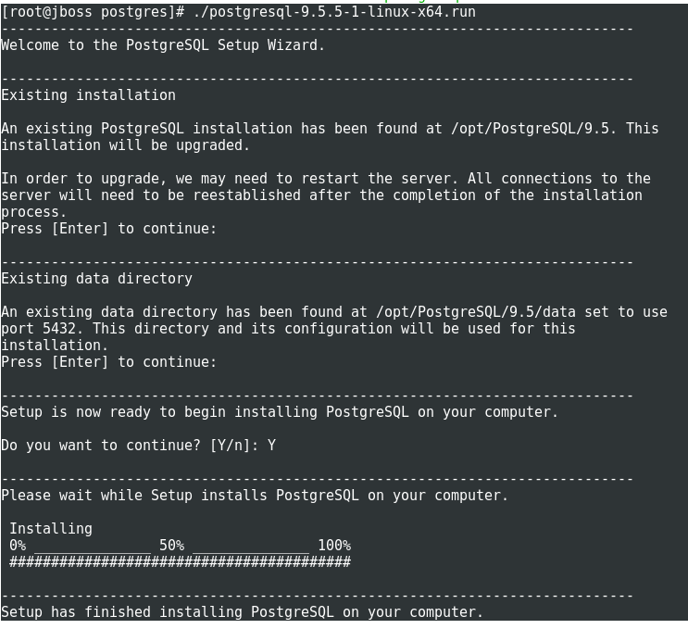

Step-4:

NOTE:
By default postgres user is created with default password “postgres”.

Connect with postgres user, then go to bin directory and connect to postgresql.

# su postgres

bash-4.2$ cd /opt/PostgreSQL/9.5/bin

bash-4.2$ ./psql
Password: postgres
psql.bin (9.5.5)
Type "help" for help.

postgres=#

Step-5: Create a database, here i am creating example database.

postgres=# create database test;
CREATE DATABASE

postgres=# \l
List of databases
Name | Owner | Encoding | Collate | Ctype | Access privileges
-----------+----------+----------+-------------+-------------+-----------------------
postgres | postgres | UTF8 | en_IN.UTF-8 | en_IN.UTF-8 |
template0 | postgres | UTF8 | en_IN.UTF-8 | en_IN.UTF-8 | =c/postgres +
| | | | | postgres=CTc/postgres
template1 | postgres | UTF8 | en_IN.UTF-8 | en_IN.UTF-8 | =c/postgres +
| | | | | postgres=CTc/postgres
test | postgres | UTF8 | en_IN.UTF-8 | en_IN.UTF-8 |
(4 rows)

Step-6: Connect to the created database as like below.

postgres=# \c test;
You are now connected to database "test" as user "postgres".

Configuring Data source in Jboss EAP7:

Step-1: Create a new module in the following location.

For PostgreSQL : jboss-eap-6.0/modules/org/postgresql/
For mysql : jboss-eap-6.0/modules/com/mysql/
For that, we need to create directory structure.

# cd JBOSS_HOME/modules

# mkdir -p /org/postgresql/

Step-2: Download the corresponding JDBC driver for database.

Step-3: Create a main directory in the directory created for the database:

# cd JBOSS_HOME/modules/org/postgresql/main

Step-4

Create module.xml file and add the below content into that module.xml file.

# cd JBOSS_HOME/modules/org/postgresql/main

# touch module.xml

# vim module.xml

<?xml version="1.0" encoding="UTF-8"?>
<module xmlns="urn:jboss:module:1.0" name="org.postgresql">
<resources>
<resource-root path="/opt/postgres/postgresql-42.0.0.jar"/>
</resources>
<dependencies><module name="javax.api"/></dependencies>
</module>

Step-5:

Copy the postgresql-42.0.0.jar into the /opt/postgres/ directory

Step-6:Start the Jboss and database servers.

# cd JBOSS_HOME/bin

DO the following changes in the Jboss configuration file.

# vim standalone-ha.xml (you can use any your required configuration file).

<datasource jndi-name="java:jboss/datasources/postgresDS" pool-name="postgresDS" enabled="true" use-ccm="true">
<connection-url>jdbc:postgresql://localhost:5432/test</connection-url>
<driver-class>org.postgresql.Driver</driver-class>
<driver>postgresql</driver>
<pool>
<min-pool-size>2</min-pool-size>
<max-pool-size>20</max-pool-size>
<prefill>true</prefill>
</pool>
<security>
<user-name>postgres</user-name>
<password>postgres</password>
</security>
</datasource>

<drivers>

<driver name="postgresql" module="org.postgresql">
<xa-datasource-class>org.postgresql.Driver</xa-datasource-class>
</driver>

Step-7:

Start the Jboss and database servers.

# cd JBOSS_HOME/bin

# ./standalone.sh c standaloneha.xml &

Step-8:

Please find the below message in the log file.

WFLYJCA0001: Bound data source [java:jboss/datasources/postgresDS]

Step-9:

Check the Test Connection from the browser.

For that, first we need to login into the jboss admin console with the below URL.

http://192.168.1.2:9990/console/

Click on TestConnection
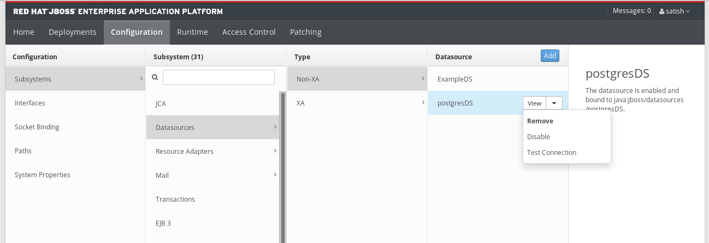

If TestConnection is successful getting below:

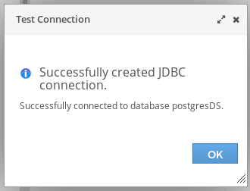

NOTE:

If you want to connect the remote database to jboss EAP, in the database level, you must do the following changes.

1. Connect to the PostgreSQL server,
2. add the following line in the file: /opt/PostgreSQL/9.5/data/postgresql.conf

listen_addresses = '*'

3. Add the following lines in the /opt/PostgreSQL/9.5/data/pg_hba.conf

host all all 192.168.122.2/32 md5
host all all 192.168.1.201/32 trust
host all all 192.168.1.2/32 trust

4. After that restart the database server and check the connection in jboss side from admin console or CLI.

CLI MODE:

# cd JBOSS_HOME/bin
# ./jboss-cli.sh --connect controller=192.168.1.2:9990

[standalone@192.168.1.2:9990 /] /subsystem=datasources/data-source=postgresDS:test-connection-in-pool
{
"outcome" => "success",
"result" => [true]
}

In Domain Mode:

/host=$Host_Controller_Name/server=$Server_Name/subsystem=datasources/data-source=DataSource_JNDI_Name:test-connection-in-pool
{
"outcome" => "success",
"result" => [true]
}

