SSL Configuration in JBOSS – Self-Signed Certificate:

Step-1: Create a self-signed certificate with the help of keytool command as like below.

# cd /opt/Jboss7/jboss-eap-7.0/standalone/configuration

# keytool -genkey -alias server -keystore keystore.jks -keyalg RSA -keysize 1024 -validity 365

(After entering this command, asking the below questions, example given here below along answer)

Enter keystore password: redhat@123
Re-enter new password: redhat@123
What is your first and last name?
[Unknown]: jboss.node.com (Domain name of the server)
What is the name of your organizational unit?
[Unknown]: IT
What is the name of your organization?
[Unknown]: TLS
What is the name of your City or Locality?
[Unknown]: Mumbai
What is the name of your State or Province?
[Unknown]: MH
What is the two-letter country code for this unit?
[Unknown]: IN
Is CN=jboss.node.com, OU=IT, O=TLS, L=Mumbai, ST=MH, C=IN correct?
[no]: yes

Enter key password for <server>
(RETURN if same as keystore password):

Certificate file keystore.jks is created in the same location. If you have created this certificate in any other location, need to copy that certificate into standalone/domain configuration directory.

Step-2: After done first step, now add the configuration part in the respective profile .xml file.

# vim standalone.xml

(a). Creating one new security realm with suitable keystore and optional truststore.
<security-realm name="CertificateRealm">
<server-identities>
<ssl>
<keystore path="/opt/Jboss7/jboss-eap-7.0/standalone/configuration/keystore.jks" keystore-password="redhat@123" alias="server"/>
</ssl>
</server-identities>
</security-realm>

(b). Reference above security realm from undertow subsystem's https listener.

<https-listener name="https" secure="true" enabled-protocols="TLSv1.1,TLSv1.2" security-realm="CertificateRealm" socket-binding="https"/>

Step-3: Start the Jboss eap server, with bind IP option as like below.

# cd /opt/Jboss7/jboss-eap-7.0/bin

# ./standalone.sh – b 192.168.122.20 &

Step-4: Access the application, with https and by default ssl port 9443.

https://192.168.122.20:9443/counter

Step-5: need to hide the 9443 port from browser, change the https port from 9443 to 443 in the standalone.xml configuration file as like below.

<socket-binding name="https" port="${jboss.https.port:443}"/>

Step-6: Now restart the server, and check without giving any port, accessing the application.

https://192.168.122.20/counter

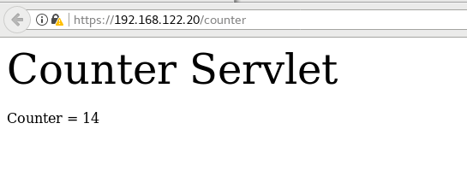

NOTE: FYR folllow,

https://access.redhat.com/solutions/2051083

