Task 1
#Sub Queries:- Sub Query means nested query within other sql query using where clause , It is used to return data that used by main query.
#Sql Joins:- Join Clause is used to combine rows from two or more table based on related column.
#From Clause:- is used to list the table and also used to perform join operation.
#Joint:- A join clause is used to combine Rows from two or more tables based on arelated column between them.

Task 2
Write queries which demonstrate inner join which uses more than two tables.
1-> Created Table
create table student(s_id int,s_name varchar(20),primary key(s_id));
create table marks(school_id int primary key, s_id int,score int, status varchar(20));
create table details(address_city varchar(20), email_ID varchar(20),school_id int, accomplishments varchar(50));
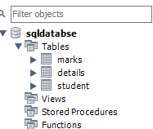

2-> Value Insertion
insert into student values(1, 'Jack'),(2, 'Rithvik'),(3, 'Jaspreet'),(4, 'Praveen'),(6, 'Suraj');
insert into marks values(1004, 1, 23, 'fail'),(1008, 6, 95, 'pass'),(1012, 2, 97, 'pass'),(1016, 7, 67, 'pass'),(1020, 3, 100, 'pass'),(1025, 8, 73, 'pass'),(1030, 4, 88, 'pass'),(1035, 9, 13, 'fail'),(1040, 5, 16, 'fail'),(1050, 10, 53, 'pass');
insert into details values('Banglore', 'jsingh@geeks.com', 1020, 'ACM ICPC selected'),('Hyderabad', 'praveen@geeks.com',1030, 'Geek of the month'),('Delhi','rithvik@geeks.com', 1012, 'IOI finalist'),('Chennai', 'om@geeks.com',1111, 'Geek of the year'),('Banglore', ' suraj@geeks.com',1008, 'IMO finalist'),('Mumbai','sasukeh@geeks.com',2211, 'Made a robot'),('Ahmedabad', 'itachi@geeks.com',1172, 'Code Jam finalist'),('Jaipur','kumar@geeks.com',1972, 'KVPY finalist');
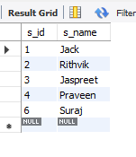
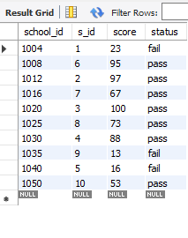
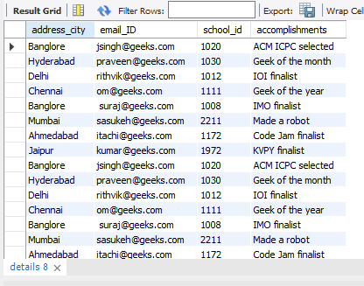
3->Inner Join:-
select student.s_name, marks.status,details.accomplishments from student inner join marks on student.s_id=marks.s_id inner join details on details.school_id=marks.school_id;
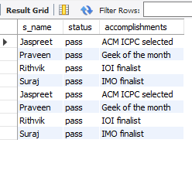

4-> Left Join:-
select student.s_name, marks.status,details.accomplishments from student left join marks on student.s_id=marks.s_id left join details on details.school_id=marks.school_id;
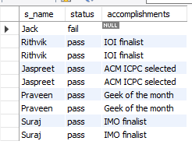
5-> Right Join:-
select student.s_name, marks.status,details.accomplishments from student right join marks on student.s_id=marks.s_id left join details on details.school_id=marks.school_id;
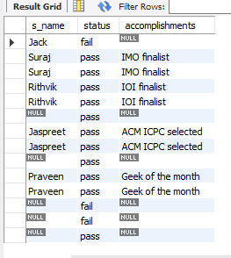

6->Write queries which demonstrate sub queries.
select * from details where address_city in (select address_city from details where address_city="Ahmedabad");
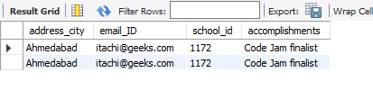

Diagram:-
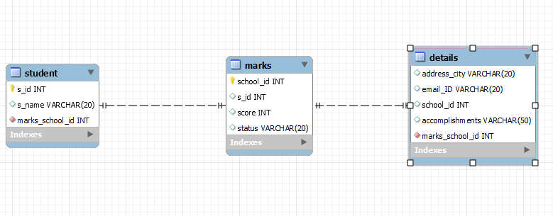
Date-> There is many inbuilt fuction to get date and timestamp insql and date and yimestamp is vey important when dealing with database, many time the date or time format create problem so it’s necessary to give the same format in input to date data type.
Ex:- select now();
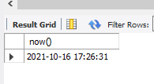

create table time(date date);
insert into time values( curdate());
select * from time;
