Task 1
Go through the concept on Order by clause and store procedures.
Order By:- Order By clause is used to arrange the the data in accending and descending order on give columns.
Ex;-
Select *
From student
Order by dept_name;

Store Procedure:- are created to perform one or more DML operations on Database. It is nothing but the group of SQL statements that accepts some input in the form of parameters and performs some task and may or may not returns a value.
Syntax:-
CREATE or REPLACE PROCEDURE name(parameters)
IS
variables;
BEGIN
//statements;
END;

- IN:
This is the Default Parameter for the procedure. It always receives the values from calling program.
- OUT:
This parameter always sends the values to the calling program.
- IN OUT:
This parameter performs both the operations. It Receives value from as well as sends the values to the calling program.

Task 2
Write a store procedure to calculate the total marks of each student.
DELIMITER //

CREATE PROCEDURE GetTotal()
BEGIN
SELECT student.SID, student.SName, ( marks.Maths + marks.Science + marks.English)
AS total
FROM student
Inner Join marks
on student.SID=marks.SID ;

END
//
DELIMITER ;

call GetTotal();
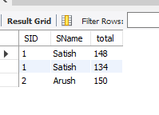

Task 3
Write a query which displays the list of students in ascending order based on there name along with the highestto lowest marks scored in different subject by each student
SELECT student.SID, student.SName, marks.Maths, marks.Science , marks.English
AS total
FROM student Inner Join marks on student.SID=marks.SID
Order by student.SName,marks.Maths desc,marks.Science desc,marks.English desc;
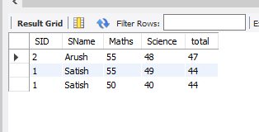

Task 4
Add constrains in such a way that if a primary key realted record is deleted then the correponding record containing the foreign key should be deleted.
Alter table student
Add Constraint Foreign Key (SID) references marks(SID)
On Delete Cascade;
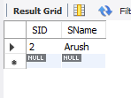

Task 5
Add constrains in such away that if a primary key realted record is delected then the correponding record containing the foreign key should be updated

Alter table student
Add Constraint Foreign Key (SID) references marks(SID)
On Update Cascade;

