Task 1
Go through the concept on Group by,Having clause,Union, group by v/s distinct.
- Group By : -
- The GROUP BY statement groups rows that have the same values into summary rows, like "find the number of customers in each country".
- The GROUP BY statement is often used with aggregate functions (COUNT(), MAX(), MIN(), SUM(), AVG()) to group the result-set by one or more columns.
Ex:-
Select count(school_id),address_city
From details
Group by address_city;
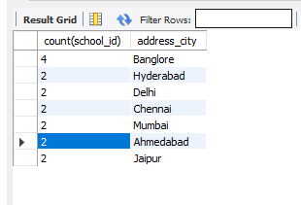
- Having :-
- The HAVING clause was added to SQL because the WHERE keyword cannot be used with aggregate functions.
Ex:-
SELECT address_city
FROM details
group by address_city
HAVING COUNT(address_city) >0 ;
- Union:- The UNION operator is used to combine the result-set of two or more SELECT statements.
- Every SELECT statement within UNION must have the same number of columns
- The columns must also have similar data types
- The columns in every SELECT statement must also be in the same order
Ex:-
SELECT name FROM Customer
UNION
SELECT s_name FROM student;


Task 2
Write a query to demonstrate the use of group by.

The SQL GROUP BY Statement
The GROUP BY statement groups rows that have the same values into summary rows, like "find the number of customers in each country".
The GROUP BY statement is often used with aggregate functions (COUNT(), MAX(), MIN(), SUM(), AVG()) to group the result-set by one or more columns.
Ex:- 1
SELECT COUNT(CustomerID), Country
FROM Customers
GROUP BY Country;
Ex-2
SELECT COUNT(CustomerID), Country
FROM Customers
GROUP BY Country
ORDER BY COUNT(CustomerID) DESC;
Ex-3
SELECT Shippers.ShipperName, COUNT(Orders.OrderID) AS NumberOfOrders FROM Orders
LEFT JOIN Shippers ON Orders.ShipperID = Shippers.ShipperID
GROUP BY ShipperName;

Task 3
Find the second highest marks scored by each student along with the student and subject name [Tables: student,subject,marks];

Task 4
Write a query to demonstrate the use of having clause along with aggregate functions.
Having:- The SQL HAVING clause is used in combination with the GROUP BY clause to restrict the groups of returned rows to only those whose the condition is TRUE.
SELECT emp_name,dept, SUM(emp_salary) AS "Total Ctc"
FROM employye
group by dept
HAVING SUM(emp_salary) > 1000;
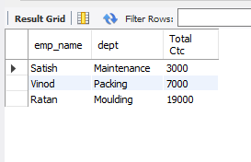

Task 5
Write two queries which help us to compare and understand the concept of distinct and group by.
Ex:- Group By
Select emp_name
From employye
Group by dept;
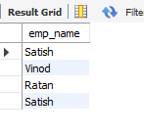
Ex:- Distinct : -
Select Distinct emp_name
From employye
Group by dept ;
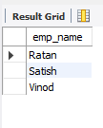

Task 6
Write Query which includes union keyword
Ex:- Union
SELECT name FROM Customer
UNION
SELECT s_name FROM student;

Task 7
Write a single query which includes group by, having,where ,from ,select,union and order by.
select emp_name
from employye
where emp_salary>1000
group by dept
having sum(emp_salary)<10000
order by emp_name ;


