**Objective:**

1. **Pushing docker images to our private repository (Nexus) through Jenkins pipeline.**
2. **Rolling back to previous versions of our application through Jenkins pipeline, by using images which are stored in Nexus.**

**Steps:**

Install Ubuntu Server 18.04 LTS (HVM), SSD Volume Type - ami-04bde106886a53080 (64-bit x86) / ami-04f6f742e1d9012e3 (64-bit Arm) – t2.medium

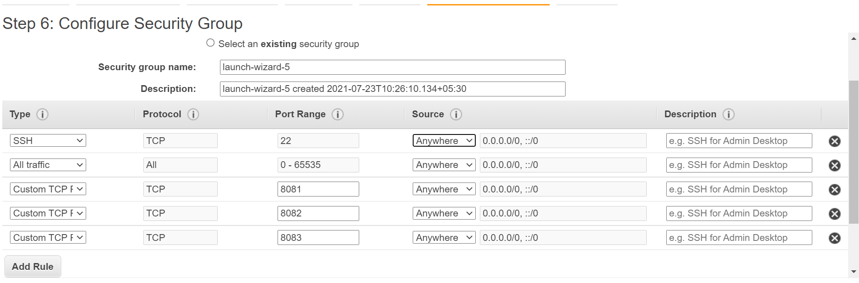

Allow port numbers 8081 to 8083.

Login to server as ubuntu user.

Sudo apt-get update

Install java: sudo apt install openjdk-8-jre-headless

move to folder cd /opt

then go to link

https://help.sonatype.com/repomanager3/download

copy : <https://download.sonatype.com/nexus/3/latest-unix.tar.gz>

sudo wget <https://download.sonatype.com/nexus/3/latest-unix.tar.gz>

sudo tar -xf latest-unix.tar.gz

//rename the nexus

sudo mv nexus-3.32.0-03/ nexus

**Add user nexus**

sudo adduser nexus

password : nexus

And keep on enter for following fields.

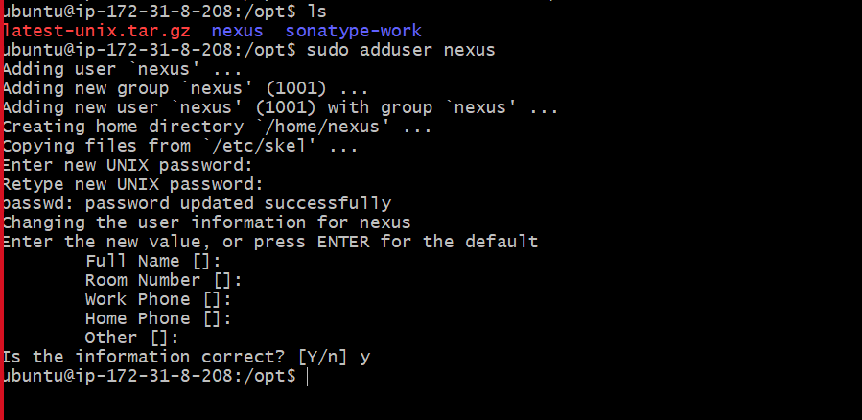

**Edit root permission**

sudo visudo

nexus ALL=(ALL) NOPASSWD: ALL

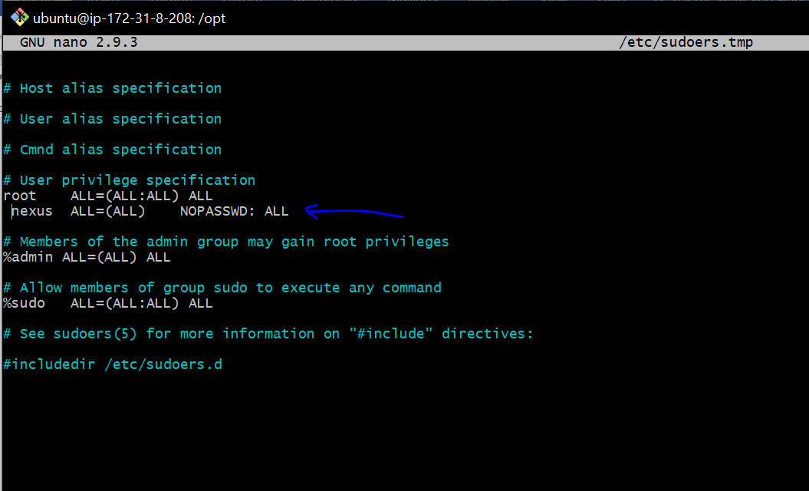

Run -> sudo chown -R nexus:nexus nexus sonatype-work

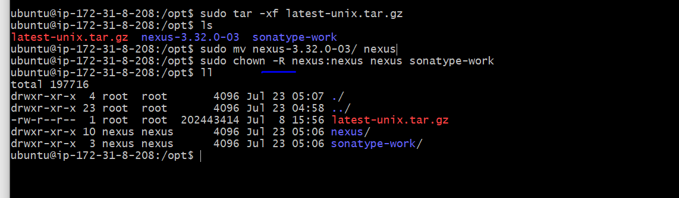

sudo vim /opt/nexus/bin/nexus.rc

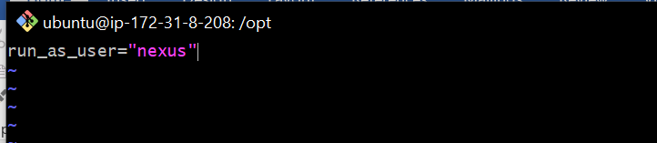

sudo ln -s /opt/nexus/bin/nexus /etc/init.d/nexus

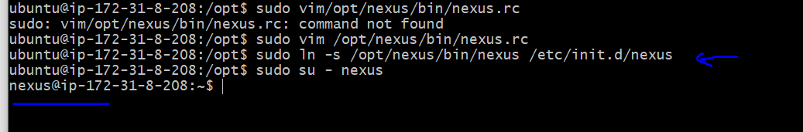

Nexus start

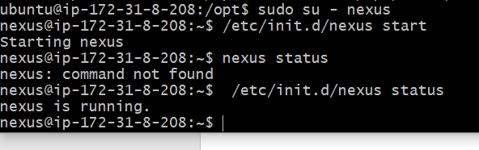

sudo netstat -plnt

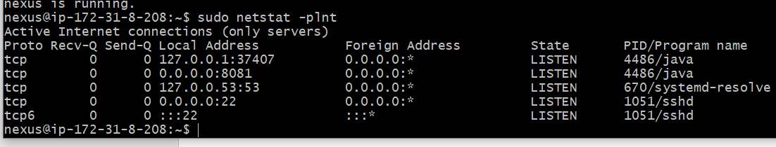

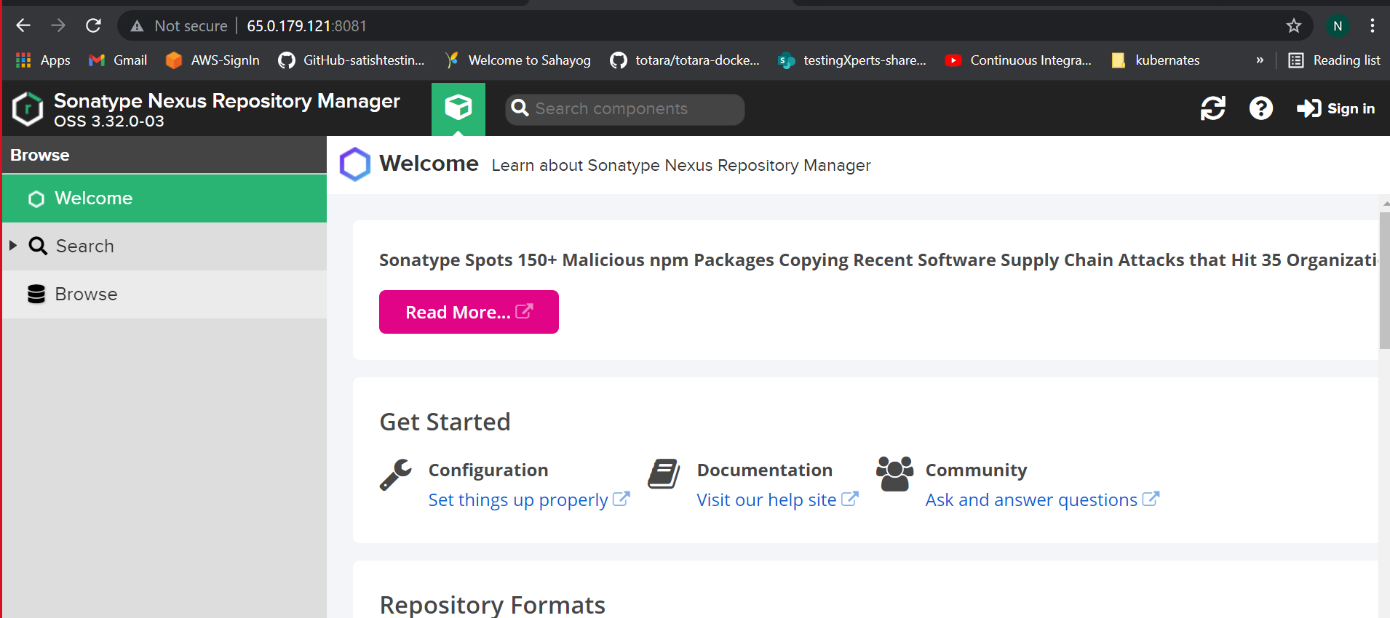

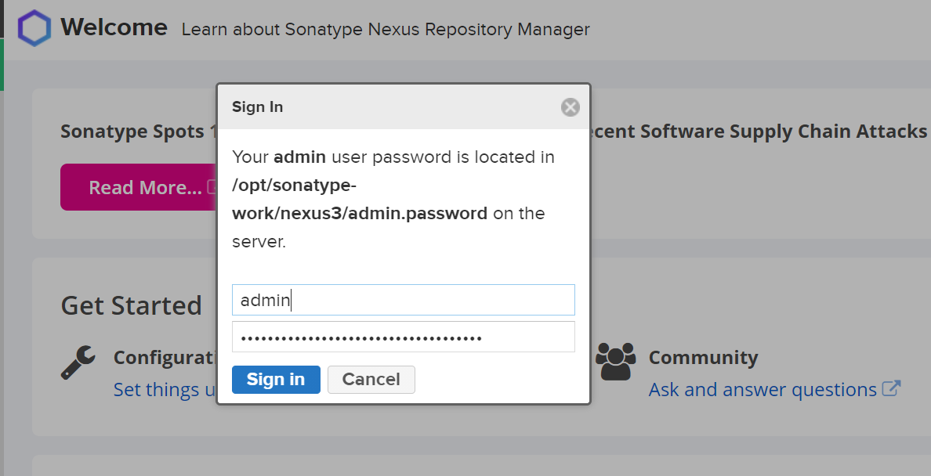

After successful login : create a docker repository

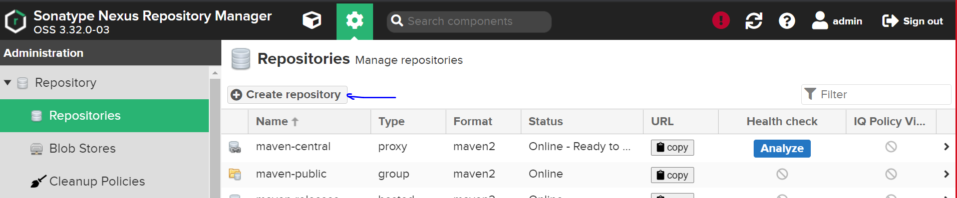

Nexus configuration in Jenkins server

1.docker to be installed

2. docker composes to be installed

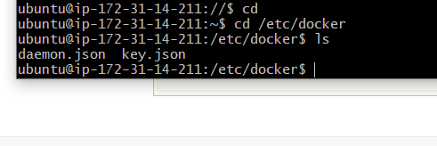

Create daemon.json file

In insecure registries add nexus ip with following port numbers

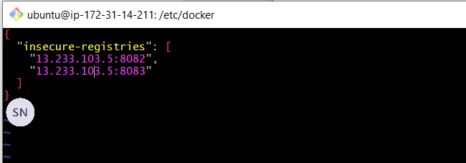

Service docker stop and start

Try docker login (with your nexus ip)

sudo docker login -u admin -p admin 15.206.187.134:8083

**After pipeline build:**

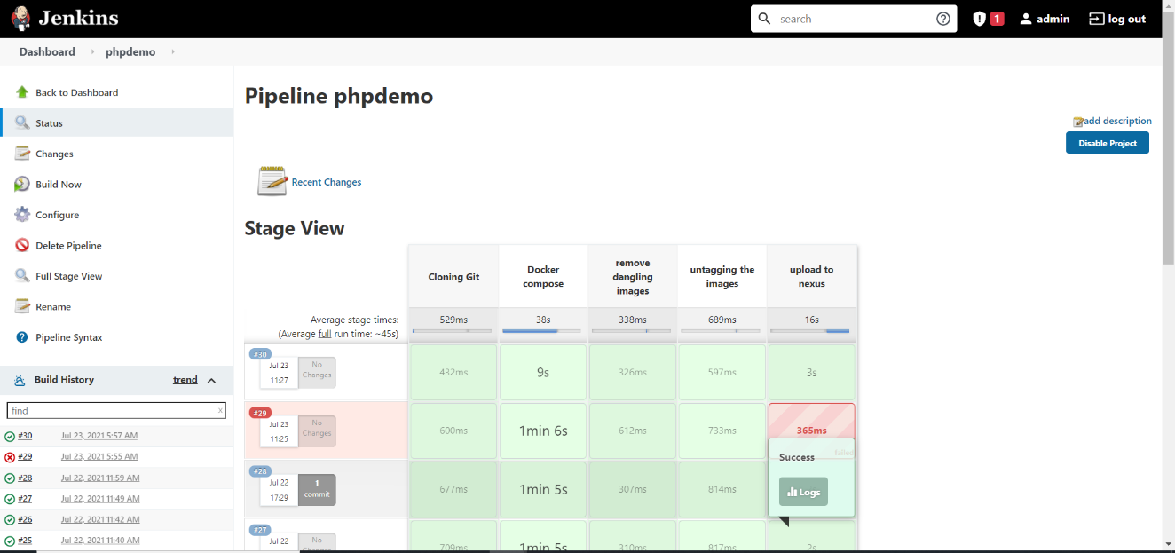

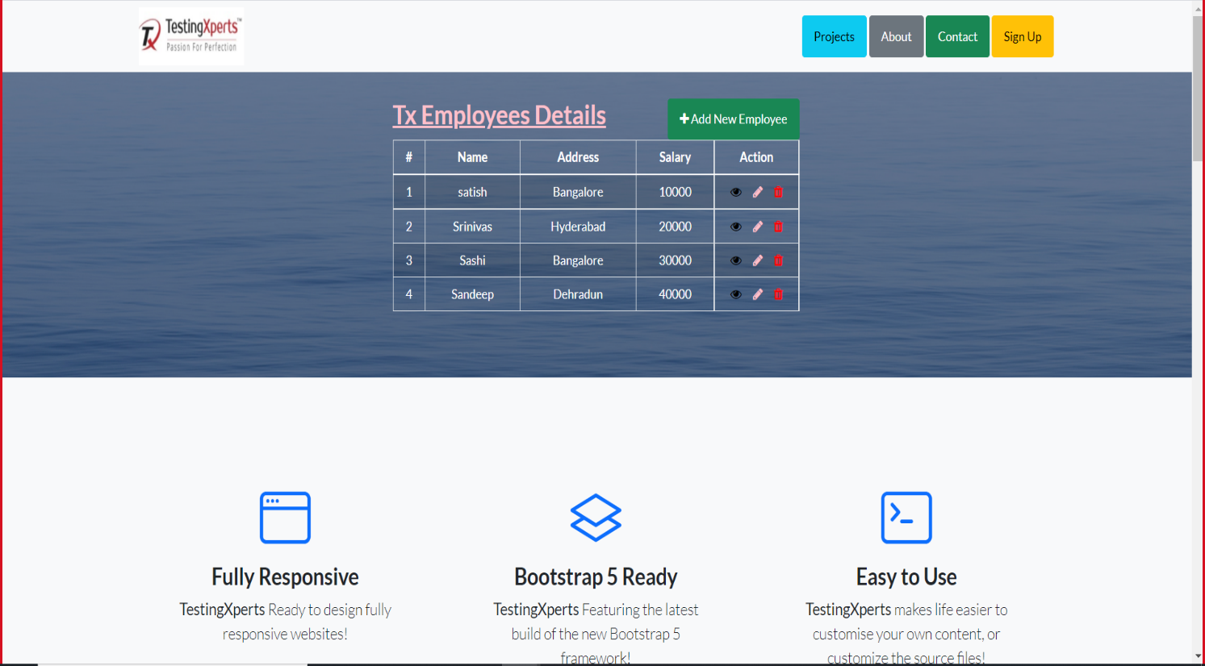

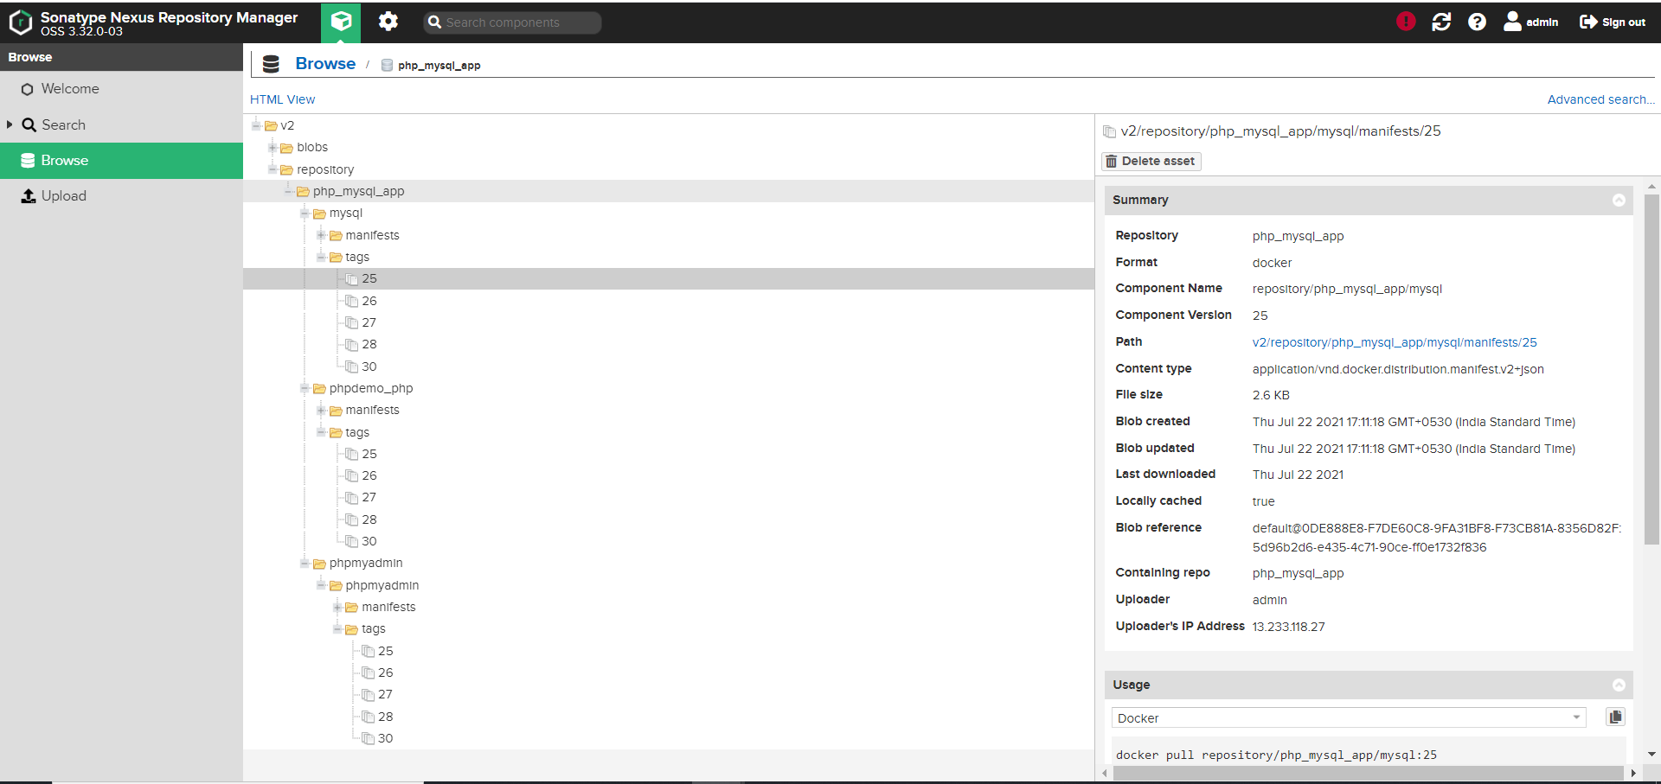

**Rolling back to previous version with previous builds:**

