**VMware Installation:**

1. Go to link:

<https://www.vmware.com/in/products/workstation-player/workstation-player-evaluation.html>

and download the file as per your system.

**VMware workstation player is non-licensed version. VMware workstation pro is licensed one.**

1. After downloading the file install it in your system at desired location.
2. Restart your system.

**Install OS on VMware:**

**For ubuntu**

1. Download the iso image from ubuntu official website or go to link

<https://ubuntu.com/download/desktop>

download the file.

1. Open VMware workstation player.
2. Click on ‘Create a New Virtual Machine’.

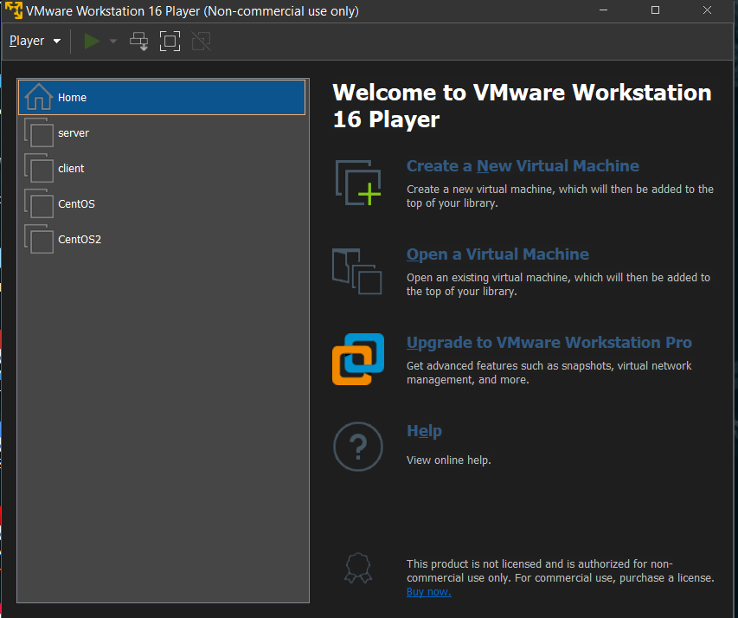

1. Click on installer disc image and browse to the iso file location and choose that file.

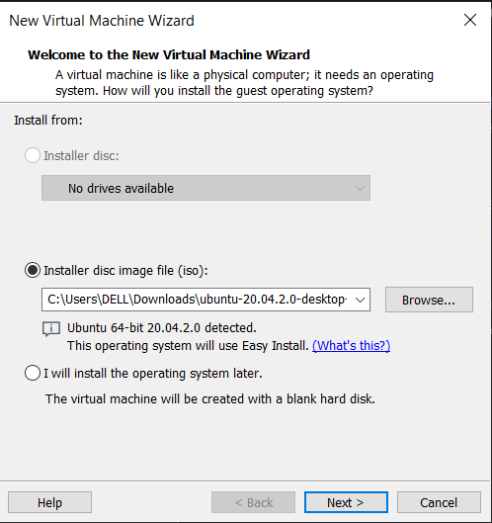

1. Click next and enter required details.

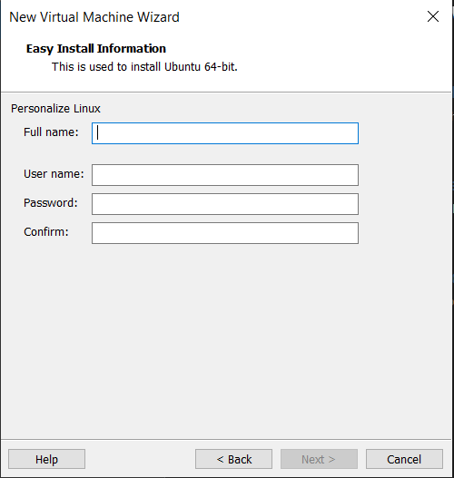

1. Click next and give your virtual machine a name and browse to the location where you want to store it.

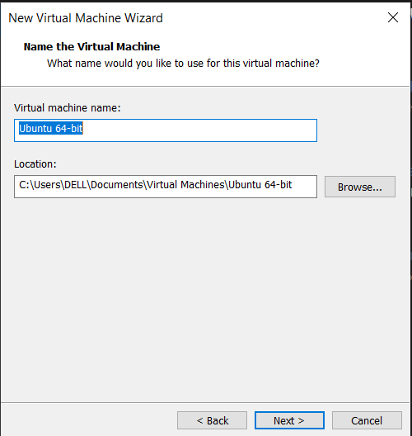

1. Enter the maximum disk size for your machine as per your requirement and click next.
2. Click on finish. Your virtual machine is created it will take some time to turn on.

**We can create vm of any os, we just need to download the iso image from its official site.**