1. XML Input File

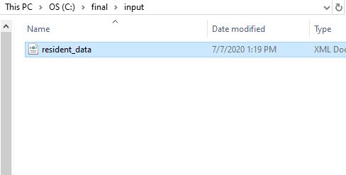

1. XML To Excel Application

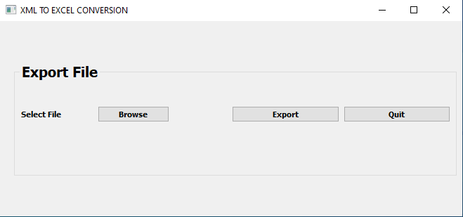

1. Click On Browse Button And Select “ Input Folder “ Where XML File Located. And Click on Select Folder.

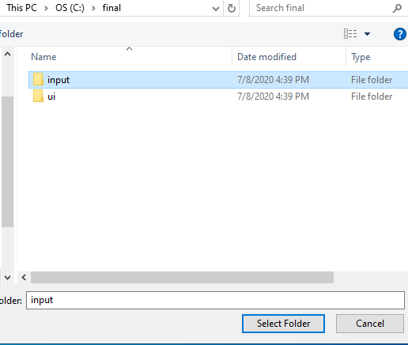

1. After Click On “ Export “ Button, Task Completed. File Conversion Done.

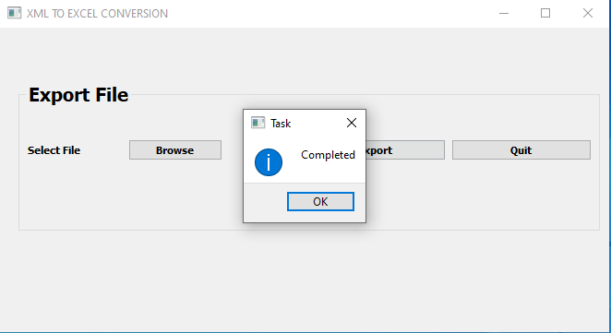

1. “ Output Folder“ Created. Where Excel file created.

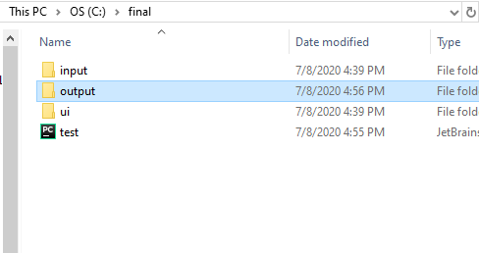

1. Excel File Created.

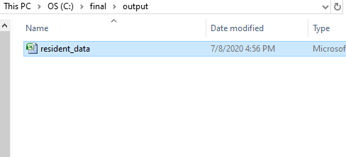

1. Output of Excel File:

