BIRD SPECIES IDENTIFICATION USING IMAGES
A Industrial/Practical Training project report

Submitted to the Faculty of Engineering of
JAWAHARLAL NEHRU TECHNOLOGICAL UNIVERSITY KAKINADA,
KAKINADA

In partial fulfillment of the requirements for the award of the Degree of

BACHELOR OF TECHNOLOGY
In
COMPUTER SCIENCE AND ENGINEERING

By

N.CHINMAI Md.NASREEN
(16481A05F7) (16481A05D3)

M.SHABBIR ALI P.SATISH
(16481A05C8) (17485A0528)



DEPARTMENT OF COMPUTER SCIENCE AND ENGINEERING

GUDLAVALLERUENGINEERINGCOLLEGE
(An Autonomous Institute with Permanent Affiliation to JNTUK, Kakinada)
SESHADRIRAOKNOWLEDGEVILLAGE
GUDLAVALLERU – 521356
ANDHRA PRADESH
2019-2020

GUDLAVALLERU ENGINEERING COLLEGE
(An Autonomous Institute with Permanent affiliation to JNTUK, Kakinada)

SESHADRIRAO KNOWLEDGE VILLAGE::GUDLAVALLERU

DEPARTMENT OF
COMPUTER SCIENCE AND ENGINEERING


certificate

This is to certify that the Industrial/Practical Training project Report entitled
“BIRD SPECIES IDENTIFICATION USING IMAGES” is a bonafide record of work carried out by N.CHINMAI, Md.NASREEN, M.SHABBIR ALI and P.SATISH in partial fulfillment of the requirements for the award of the degree of Bachelor of Technology in Computer Science and Engineering of Jawaharlal Nehru Technological University Kakinada, Kakinada during the academic year 2019-2020.

SK.SALMA BEGUM
(Industrial/Practical Training Coordinator)


INTERNSHIP REPORT APPROVAL FORM

May 24, 2019

With immense pleasure, this is to approve that the students of Gudlavalleru Engineering College i.e,

NUTULAPATI CHINMAI(16481A05F4),
MOHAMMAD NASREEN(16481A05D3),
MEER SHABBIR ALI(16481A05C8) and
P SATISH(17485A0528)

successfully completed their Project and Project Report on “Bird Species Identification Using Images” under our guidance.
We are highly impressed with the work that they have done and commend them on their quick grasping skills. They have shown good intent to learn and have put the knowledge gained into application in the from of this project. We appreciate the hard work and commitment shown by them.
We, hereby approve that this document is completely checked and accepted by Smart Bridge Technical Team. Its been an absolute pleasure to educate and mentor these students. We hope that this document will also serve as a Letter of Recommendation, to whomsoever applied.

We wish them success in all future endeavors and a great career ahead.

Mahankali Surya Tej
AI and IOT Developer

ACKNOWLEDGEMENT

The satisfaction that accompanies the successful completion of any task would be incomplete without the mention of people who made it possible and whose constant guidance and encouragements crown all the efforts with success.

We feel elated to express our floral gratitude and sincere thanks to Dr.S.Narayana, Head of the Department, Computer Science and Engineering for his encouragements all the way during analysis of the project. His annotations, insinuations and criticisms are the key behind the successful completion of the project work.

We would like to take this opportunity to thank our beloved principal Dr.P.Ravindra Babu for providing a great support for us in completing our project and giving us the opportunity for doing project.

We would like to take this opportunity to thank Smart Bridge Educational Services PVT Ltd. for providing this training program and support for us in completing our project.

Our Special thanks to the faculty of our department and programmers of our computer lab. Finally, we thank our family members, non-teaching staff, attendants and our friends, who had directly or indirectly helped and supported us in completing our project in time.

Team members
N.Chinmai (16481A05F4)
Md.Nasreen (16481A05D3)
M.ShabbirAli (16481A05C8)
P.Satish (17485A0528)

ABSTRACT

Currently, there are over 70,000 bird species in india. Then how to study these precious bird resources for the sake of protection is a matter that cannot be ignored. But in the first place,a simple and effective way to identify the species is much needed so that scientific and rational measures of protection can be developed regarding the features of bird species. So far, there have been various ways of species identification such as DNA bar coding, bird audio analysis and traditional morphology-based description to be applied in the different scenarios, each having prons and cons. This paper attempts to design and adopt the bird species identification system based on image feature analysis. By establishing the database of standard images features for bird species and using the algorithm of similarity comparison, this system is proved to achieve good results in practice.

INDEX
TITLE PAGE NO
ABSTRACT
CHAPTER 1: INTRODUCTION 1
1.1 Introduction 1 1.2 Objectives of Research 1
1.3 Problem Statement 1
2.Review of Literature 2
3.Data Collection 2
4.Methodology 3
4.1 Exploratory Data Analysis 4
5 Findings and Suggestions 6
6 References 8
7 conclusion 8

Bird Species Identification using Images
1.Introduction:
1.1. Introduction:
Identification of bird species is a challenging task often resulting in ambiguous labels. Even professional bird watchers sometimes disagree on the species given an image of a bird. It is a difficult problem that pushes the limits of the visual abilities for both humans and computers. Although different bird species share the same basic set of parts, different bird species can vary dramatically in shape and appearance. Intraclass variance is high due to variation in lighting and background and extreme variation in pose. Our project aims to employ the power of machine learning to help amateur bird watchers identify bird species from the images they capture.

1.2. Objectives of Research:
The main objective of the project is to identify the species of the birds by analyzing an image .Some of the experts like ornithologists couldn’t identify species of the bird correctly by looking at an image. Although bird classification can be done manually by domain experts, with growing amounts of data, this rapidly becomes a tedious and time-consuming process. So by this model we can identify the species of the birds accurately and in less time.

1.3. Problem Statement :
Identifying a bird can be a challenge, even for experienced birders. And if you're new to using field guides, it can be daunting to figure out where to even begin searching in the hundreds of pages of species .By some features like size, shape and color birds can be classified .By using CNN we can classify the species of the birds.

2. Review of Literature:
In particular, it was discovered that ecologists monitor them to determine the factors causing population fluctuation and to help in conserving and managing threatened and endangered species. The various surveys used in counting bird species including data collection techniques were succinctly reviewed. It was established that a small but growing number of researchers have studied the use of computer vision for monitoring species of birds.
This chapter evaluates reports of studies found in literature that are related to monitoring and classification of species. In particular, it focuses on reviewing birds techniques used for these species are often similar, and motion features which this research seeks to investigate for classification of birds. First techniques which perform classification using single images were explored. This was done by reviewing them separately as those that are used for classification of bird species and those for other species specifically bats.
3. Data Collection:
For the project, we will be using the dataset that includes 200 categories of bird species, 11,788 total number of images, and other information such as labeled visible bird parts, binary attributes, and bounding boxes surrounding the birds. The authors also include a recommended test and training set split of the data. From these 200 categories we are taking 3 basic categories and performs the test .
Input data for the identification system consist of digital images and parameters from the radar. All images for training the CNN are of wild birds in flight and they have been taken manually at the test location. There are also constraints concerning the area where the images have to be taken. Here, the area refers to the air space in the vicinity of the pilot wind turbine. We have used the wind turbine swept area as a suitable altitude level constraint for taking the images, because birds flying below or above the swept area are not in danger.

The bird species used in this dataset are:
- Black_footed_Albatross
- Groove_billed_Ani
- Brewer_Blackbird
- Red_bellied_Woodpecker

4. Methodology:
Convolution neural network algorithm is a multilayer perceptron that is the special design for identification of two-dimensional image information. Always has more layers: input layer, convolution layer, sample layer and output layer. In addition, in a deep network architecture the convolution layer and sample layer can have multiple. CNN is not as restricted Boltzmann machine, need to be before and after the layer of neurons in the adjacent layer for all connections, convolution neural network algorithms, each neuron don't need to do feel global image, just feel the local area of the image. In addition, each neuron parameter is set to the same, namely, the sharing of weights, namely each neuron with the same convolution kernels to de-convolution image.

The key technology of CNN is the local receptive field, sharing of weights, sub sampling by time or space, so as to extract feature and reduce the size of the training parameters. The advantage of CNN algorithm is that to avoid the explicit feature extraction, and implicitly to learn from the training data .The same neuron weights on the surface of the feature mapping, thus network can learn parallel ,and reduce the complexity of the network Adopting sub sampling structure by time
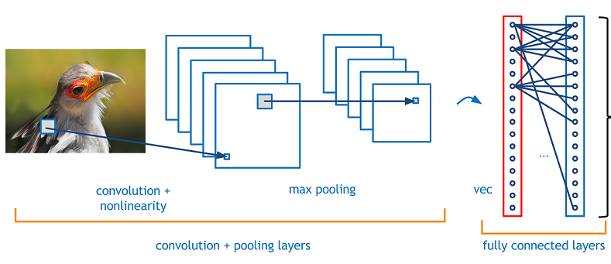

robustness, scale and deformation displacement .Input information and network topology can be a very good match, It has unique advantages in image processing. The Convolution Neural Network involves these steps
Convolution Layer:
The convolutional layer is the core building block of a CNN. The convolution layer comprises of set of independent feature detectors. Each Feature map is independently convolved with the images.
Pooling Layer:
Pooling layer function is to progressively reduce the spatial size of the representation to reduce the amount of parameters and computation in the network.Pooling layer operates on each feature map independently.The approaches used in pooling are:

- Max Pooling
- Mean Pooling
- Sum Pooling
Fully Connected Layer:
Neurons in the fully connected layer have full connections to all activationsin the previous layer.In this the output obtained from maxpooling is converted to one dimensional array and that should be the input layer and the process continues same as ANN model.
4.1.Exploratory Data Analysis:
4.1.1. Train Dataset:

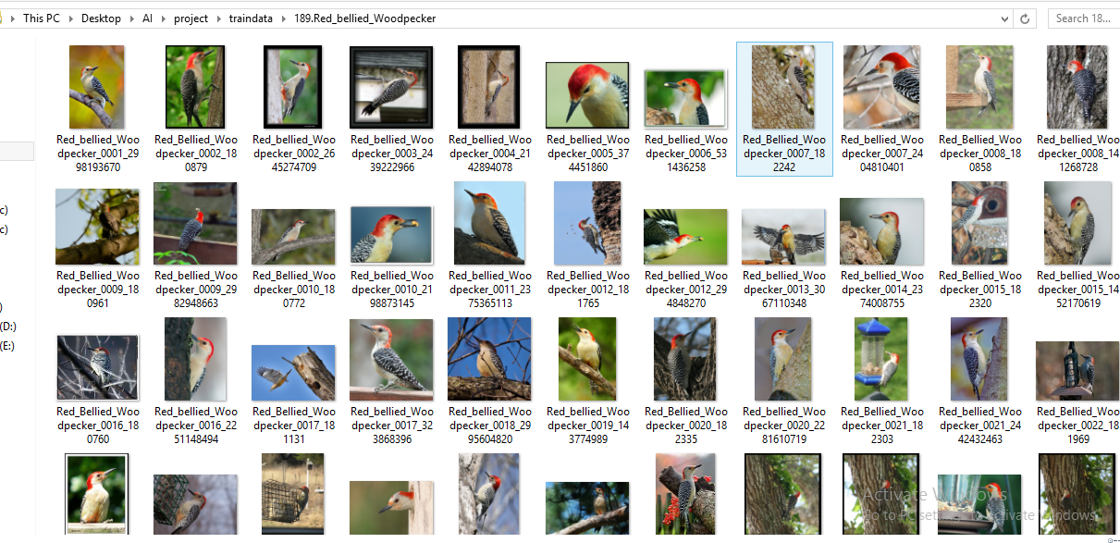

Test Dataset:
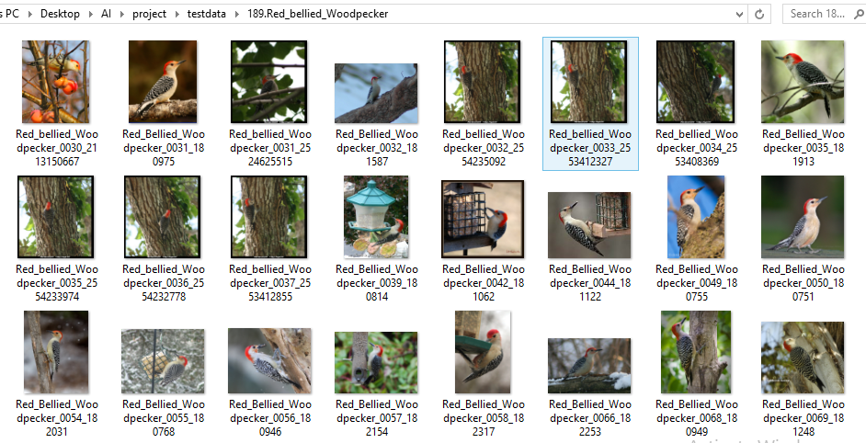

5. Findings and Suggestions :
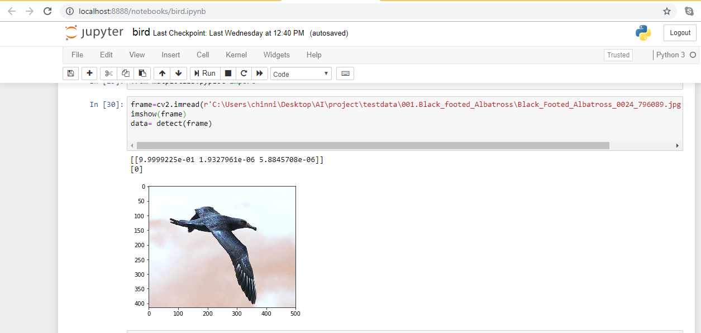
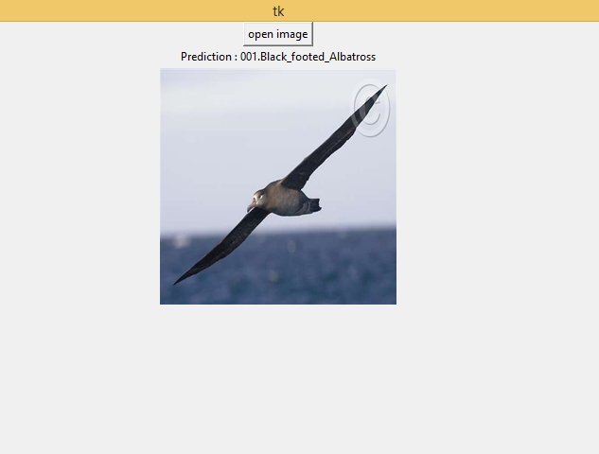

Prediction for the given image using GUI
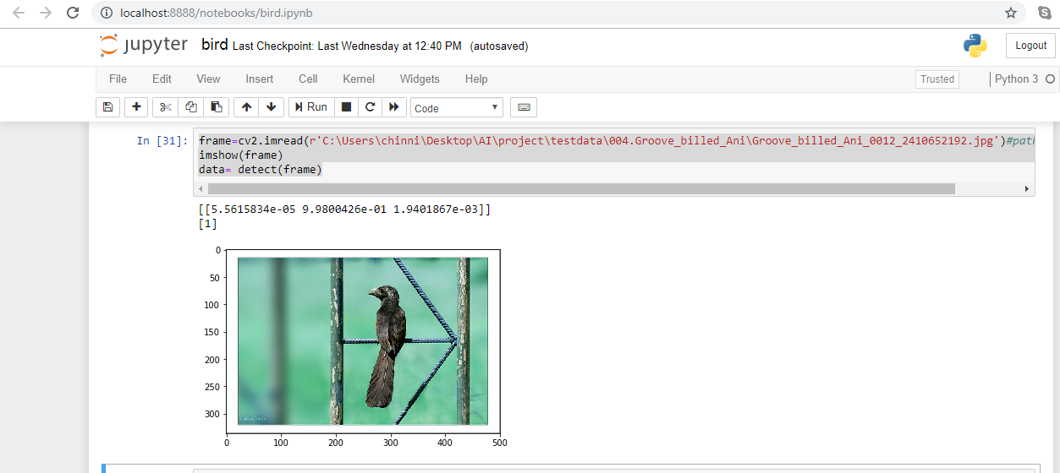

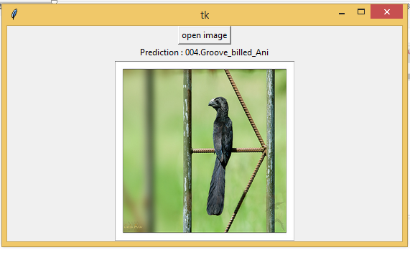

Prediction for the given image using GUI

6. References:
- https://www.visualdata.io/

- https://www.kaggle.com/datasets/bird-classification/

6. Conclusion :

Firstly, deep residual neural networks can be used to classify bird species based on acoustical data. Secondly, multiple-width frequency delta data augmentation cannot be used to increase classification accuracy when compared to raw spectral data, but the accuracy is close to the state-of-the-art and has an advantage over raw spectral data when computational resources are limited. We provided insights into our attempt of large-scale bird classification using various convolutional neural networks. After we conducted numerous experiments to identify the best techniques of dataset augmentation, training methods and network architectures, our best submission to the achieved a 0.605 score of ranking second of all submissions.

