**Udacity AIND – Isolation Heuristics Analysis**

**Custom Score 1:**

My best custom score gets the current player’s and opponent’s legal moves and squares. Then the function returns the difference between the two values.

**Custom Score 2:**

This custom score function returns the difference between the number of legal moves of both players. The number of legal moves for opponent have a weight of 2 while the current player moves have a weight of 1.

**Custom Score3:**

This custom score function returns the number of legal moves of the player.

**Result:**

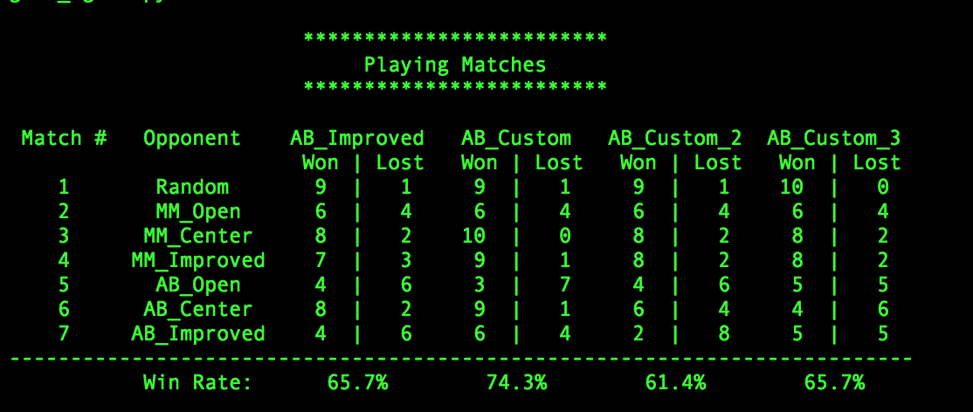

After testing the custom score functions, it was clear that the AB_Custom method consistently had higher win rates then the other functions. There were test runs where the AB_Custom had a win rate of above 70%. I believe squaring the number of legal moves for each player emphasized nodes with a higher number of moves as possible winning nodes. For AB_Custom_2 where the opponent number of legal moves had a weight of 2 performed worse than both AB_Improved and AB_Custom_3. This shows that increasing the weight of the opponents moves doesn’t result in more win. An improvement for this could be to make the current players number of legal moves have a weight of 2 while the opponent has a weight of 1.