Execute all the templates shown in the video.
Integrate Terraform in Jenkins using the Terraform plugin.

Terraform Hands-on — Short Steps
1. Create directory
mkdir terraform-provider
cd terraform-provider
2. Create local.tf
resource "local_file" "pet" {
filename = "/tmp/pets.txt"
content = "we love pets!"
}
3. Run commands
terraform init 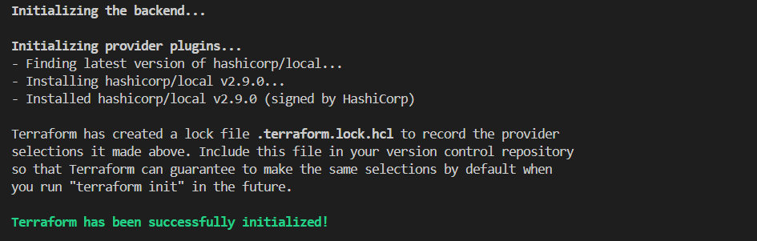
terraform validate 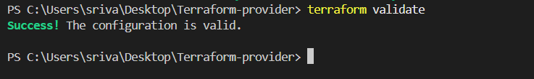
terraform fmt
terraform plan 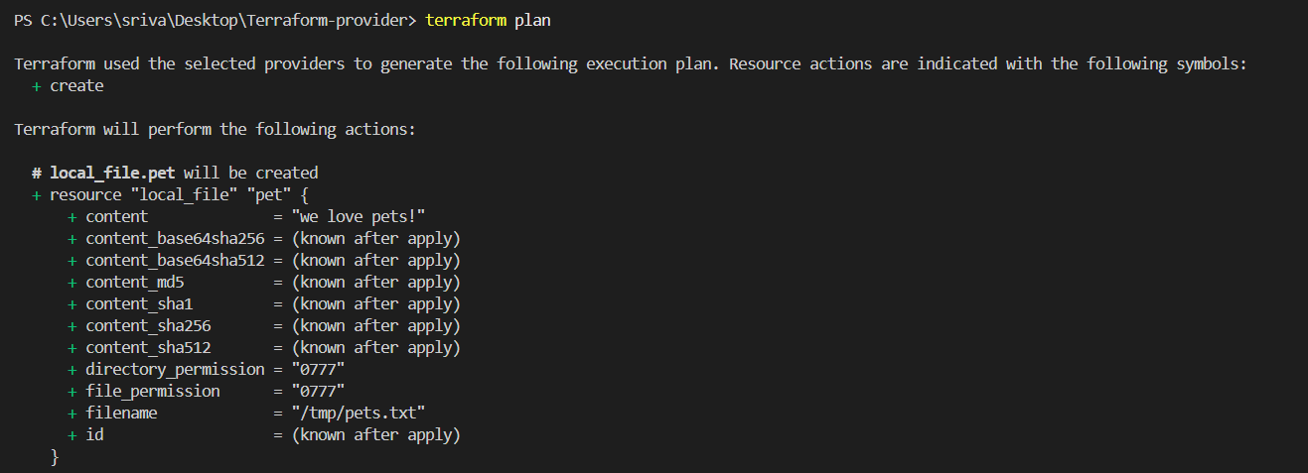
terraform apply 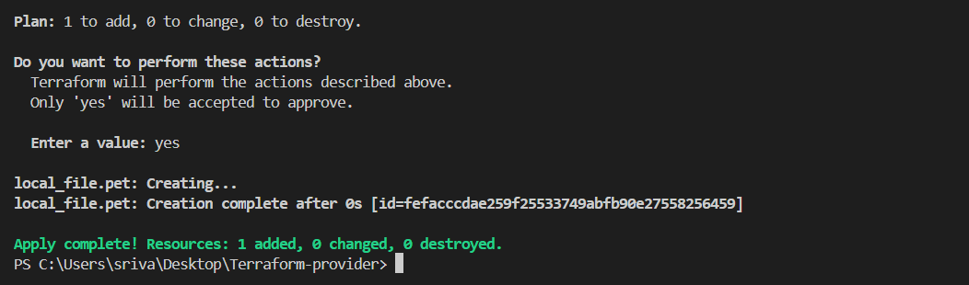
Type yes.
4. Verify
cat /tmp/pets.txt
terraform show 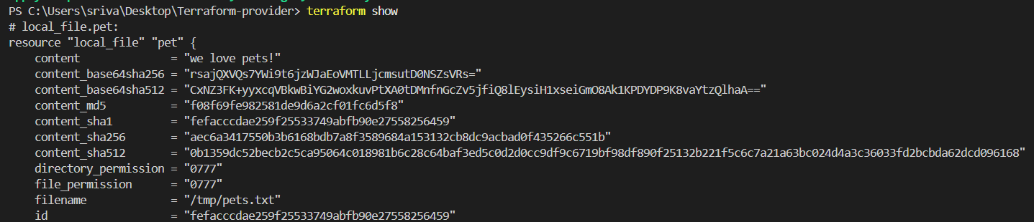
terraform state list
5. Delete
terraform destroy 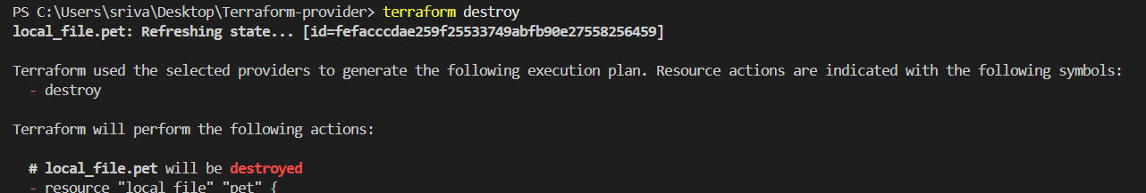

Next Topics
Do each topic separately:
6. Multiple Providers
resource "random_pet" "mypet" {
prefix = "MR"
separator = "."
length = 1
}
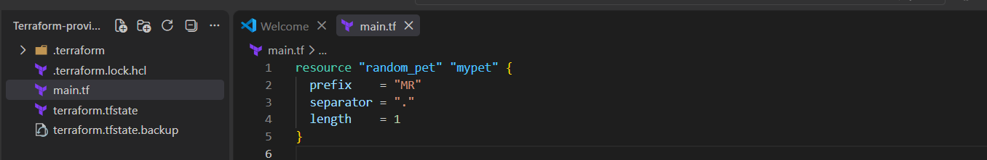
terraform init
terraform apply 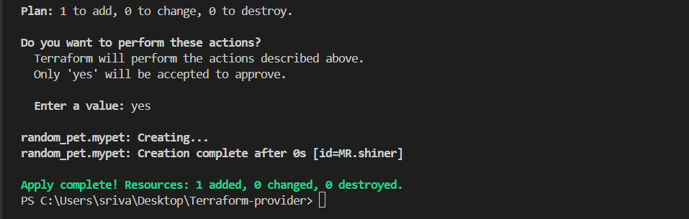

7. Variables
Create: variables.tf 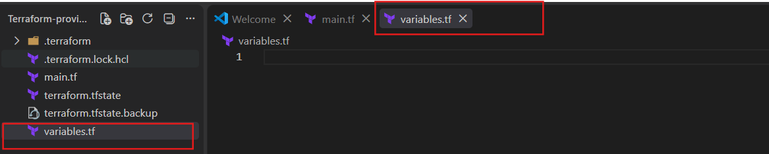
variable "filename" {
type = string
default = "/tmp/pets.txt"
}
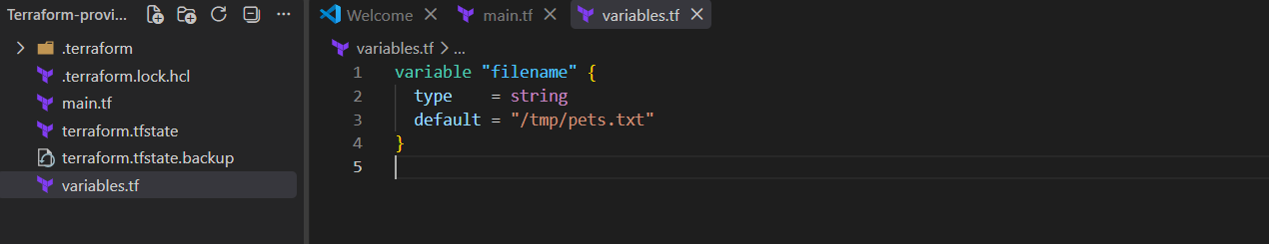
Use:
filename = var.filename 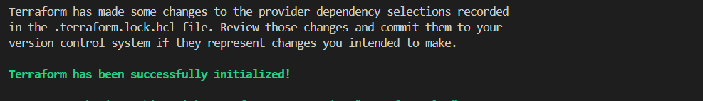

terraform fmt
terraform validate
terraform plan 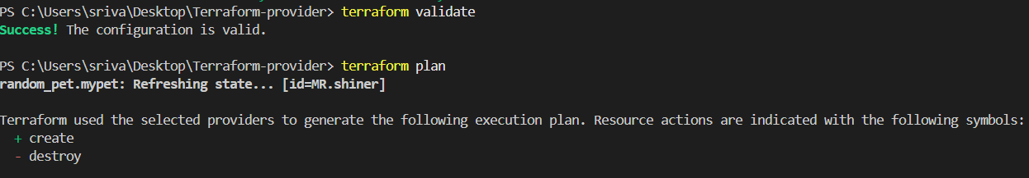
terraform apply 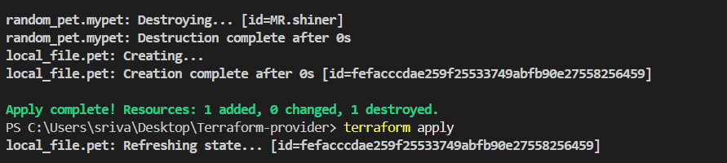

8. Attribute Reference
content = "My pet is ${random_pet.mypet.id}"

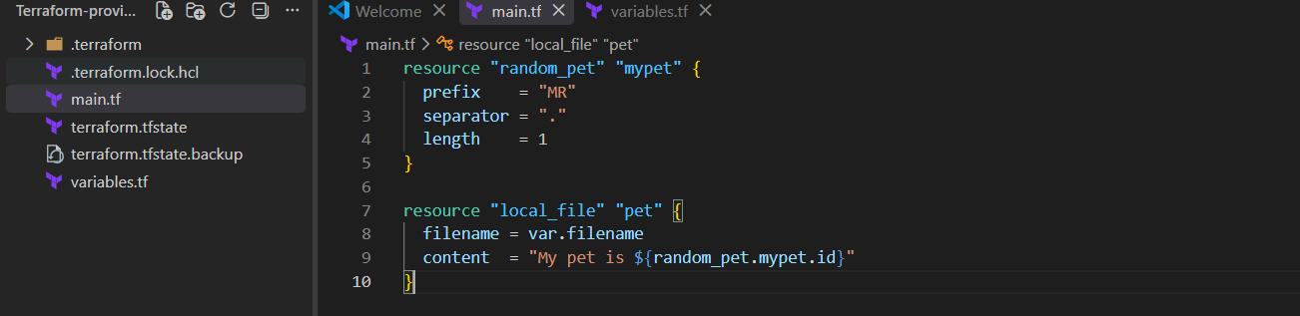
Step 2: Initialize
terraform init
Step 3: Apply
terraform plan
terraform apply 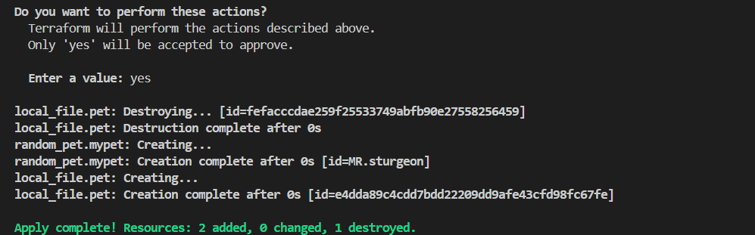
Step 4: Check
cat /tmp/pets.txt

9. Dependency
depends_on = [random_pet.mypet] 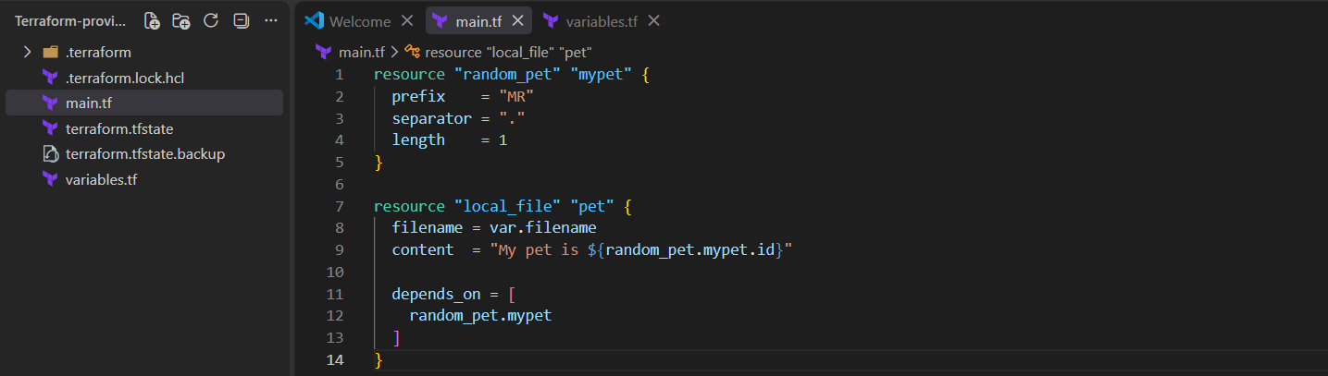
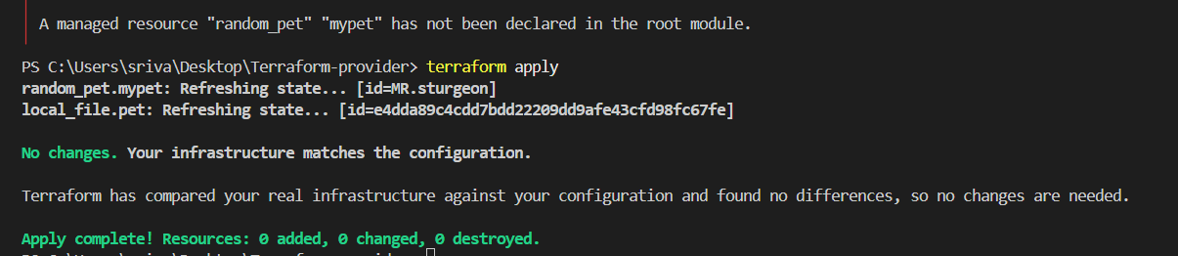

10. Output
Create outputs.tf:
output "pet_name" {
value = random_pet.mypet.id
}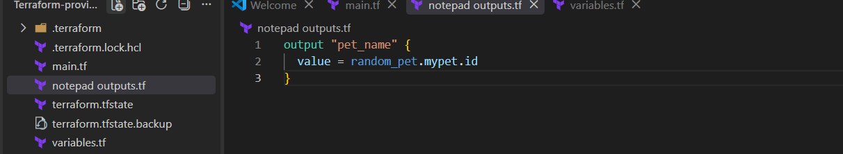
Run Terraform
terraform fmt
terraform validate 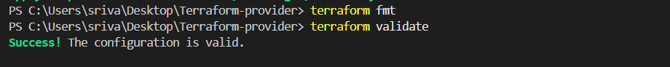
terraform plan 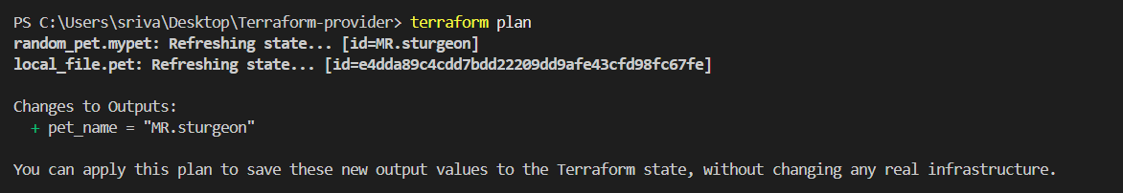
terraform apply 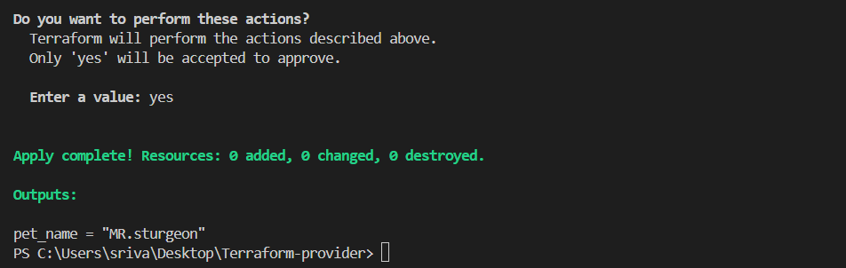

terraform output

11. State
terraform state list
terraform state show local_file.pet
terraform show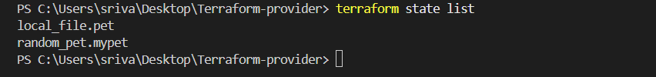 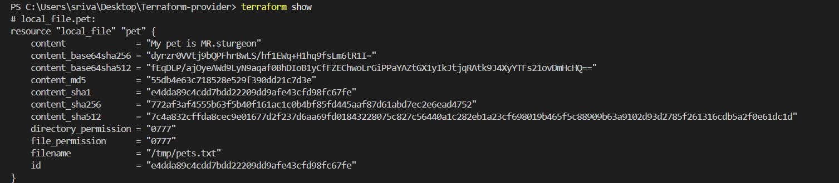

12. Lifecycle
Step 1: Update main.tf
For practice, use:
resource "local_file" "pet" {
filename = var.filename
content = "My pet is ${random_pet.mypet.id}"

lifecycle {
create_before_destroy = true
}
}
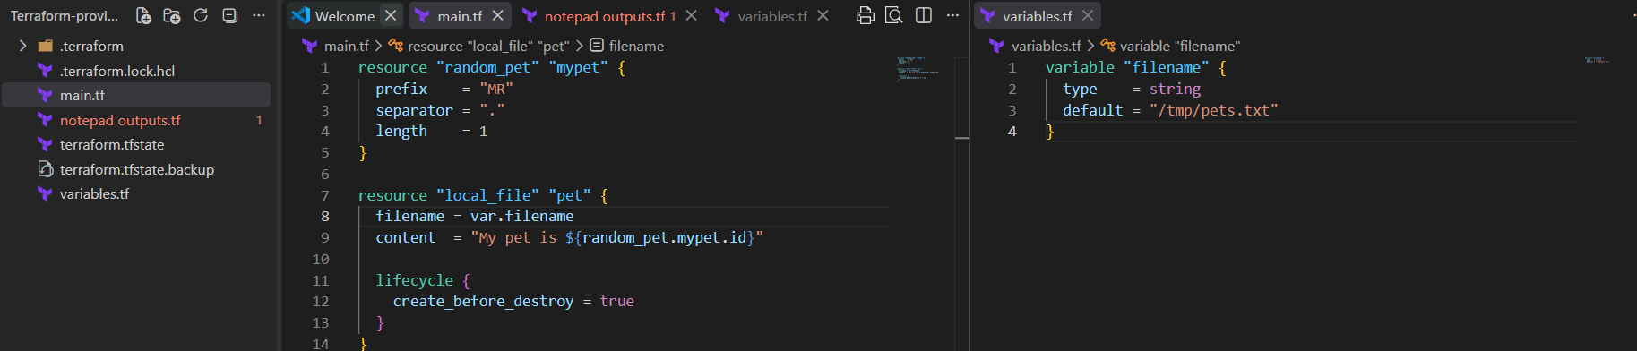
Step 2: Run
terraform fmt
terraform validate
terraform plan 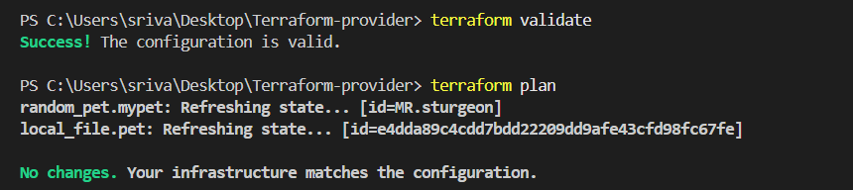
terraform apply 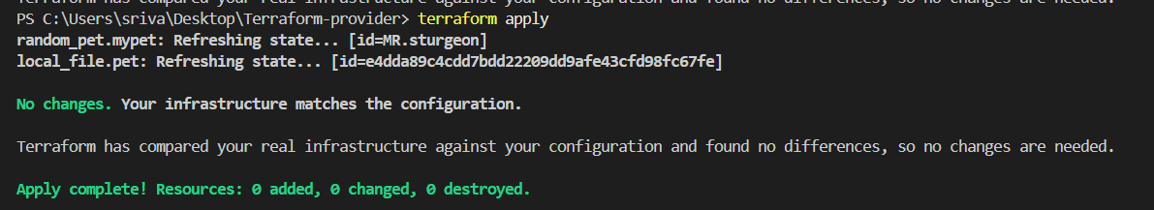

15. For_each
for_each = toset(var.filename)
Use:
filename = each.value
Final order to practice
Local → Random → Variables → Variable Types → tfvars → Attribute Reference → Dependencies → Output → State → Lifecycle → Data Source → Count → For_each.

Integrate Terraform in Jenkins using the Terraform plugin.

1. Install Terraform plugin
Go to:
Jenkins → Manage Jenkins → Plugins → Available plugins
Search:
Terraform
Install Terraform plugin. 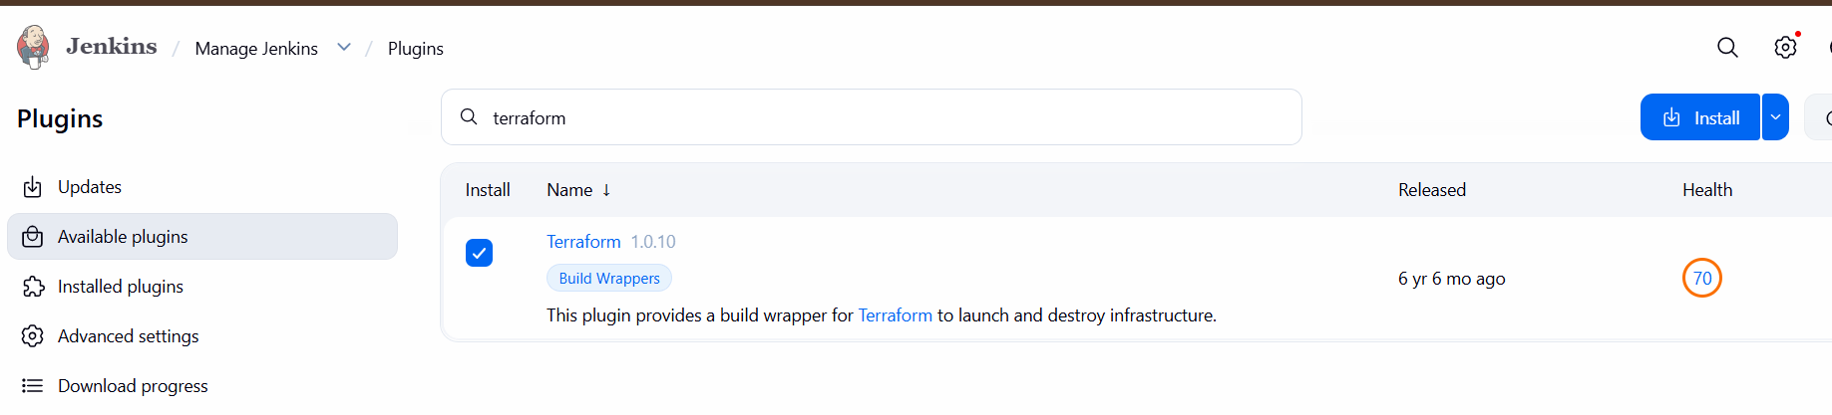

2. Configure Terraform
Go to:
Jenkins → Manage Jenkins → Tools
Find Terraform installations → Add Terraform.
Example:
Name: Terraform
Version: 1.16.1
Save. 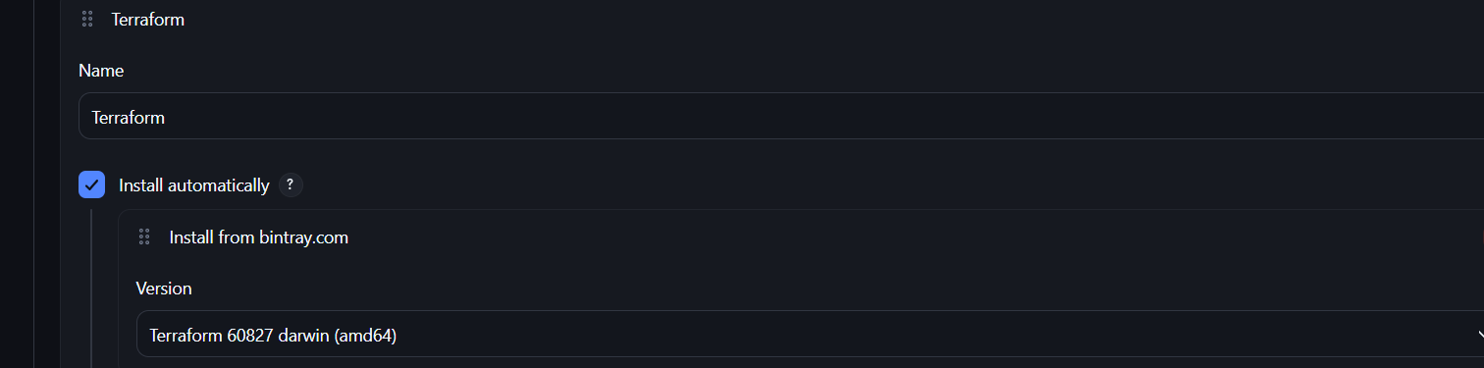

3. Create Jenkins Pipeline
Go to:
Jenkins Dashboard → New Item
Select:
Pipeline
Give name:
terraform-demo
Click OK. 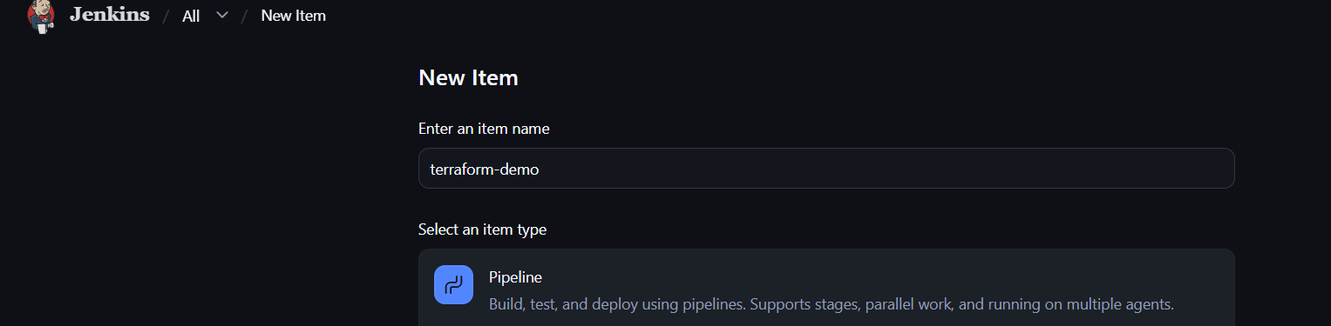

4. Add Pipeline
Go to Pipeline → Definition → Pipeline script.
Use:
pipeline {
agent any

stages {

stage('Terraform Init') {
steps {
sh 'terraform init'
}
}

stage('Terraform Validate') {
steps {
sh 'terraform validate'
}
}

stage('Terraform Plan') {
steps {
sh 'terraform plan'
}
}

stage('Terraform Apply') {
steps {
sh 'terraform apply -auto-approve'
}
}
}
}
Click Save. 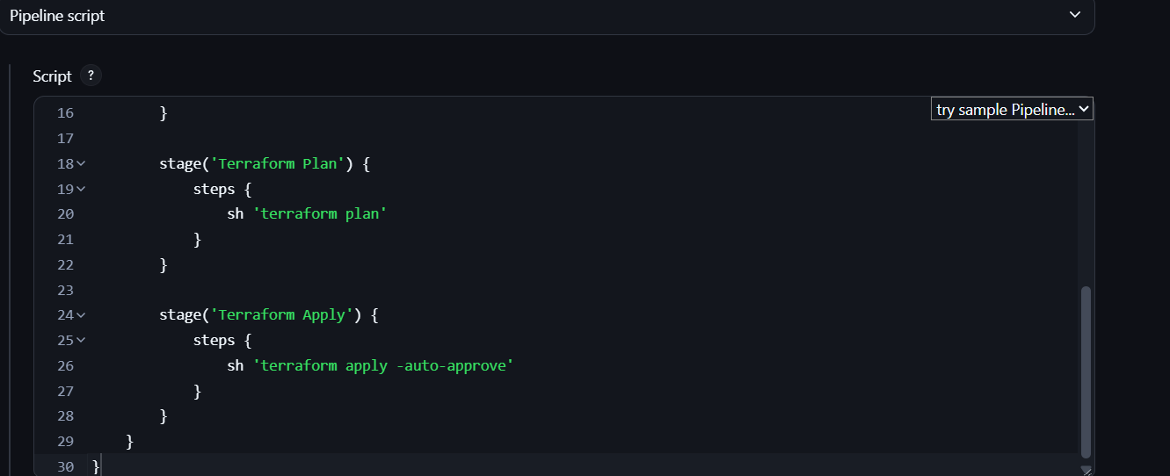

5. Run
Click:
Build Now
Jenkins will execute:
Jenkins
↓
terraform init
↓
terraform validate
↓
terraform plan
↓
terraform apply 