- Watch the Terraform-03 video.
- Execute the script shown in the video.
Step 1: Create a folder
Terraform-provider
Step 2: Create two files
main.tf
variables.tf
Step 3: Add resources in main.tf
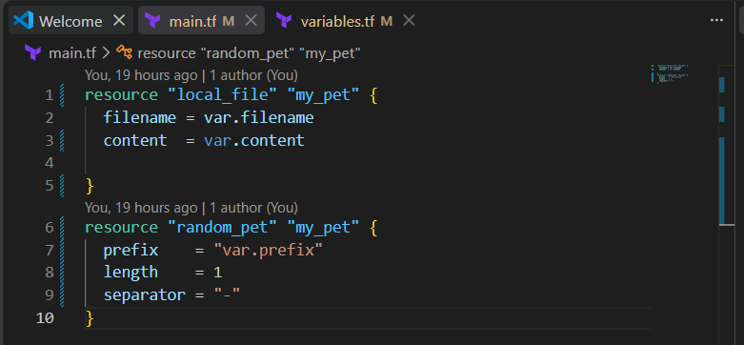
Step 4: Add variables in variables.tf
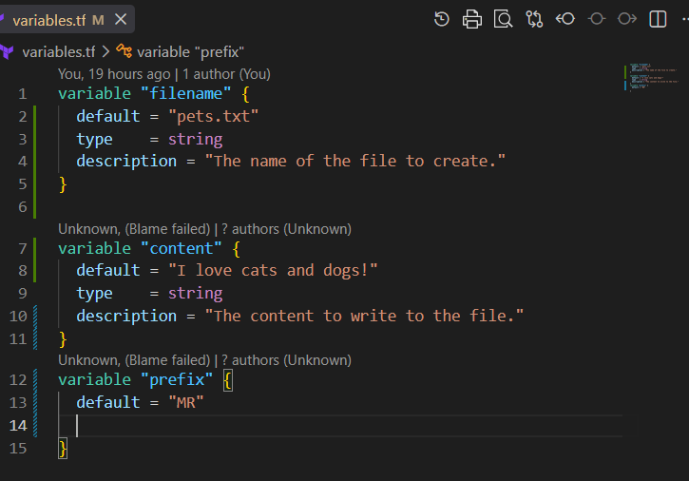

Step 5: Initialize Terraform
terraform init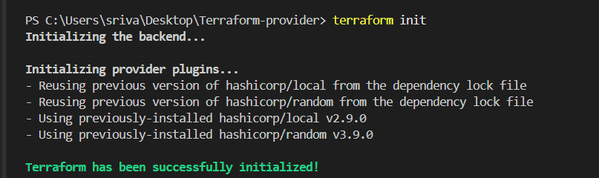Step 6: Validate configuration
terraform validate 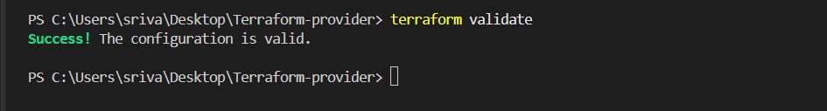
Step 7: Check execution plan
terraform plan 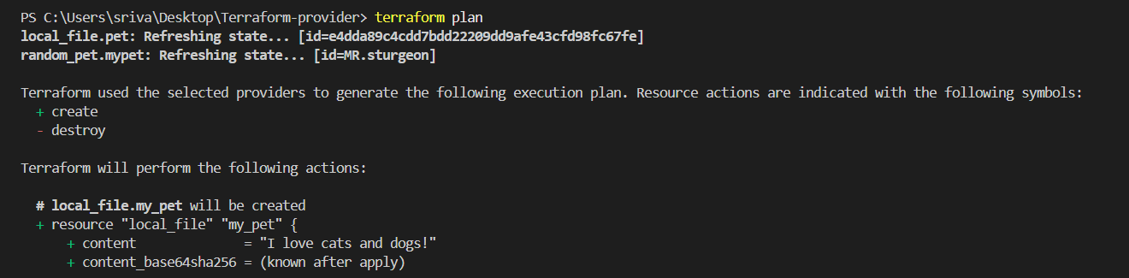
Step 8: Create resources
terraform apply 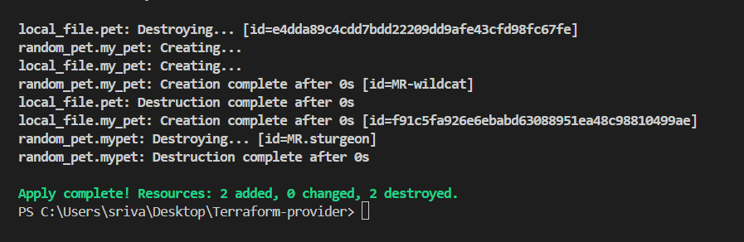

Interactive Variables — Hands-on
Step 1: Create variables.tf
variable "filename" {
}

variable "content" {
}

variable "prefix" {
} 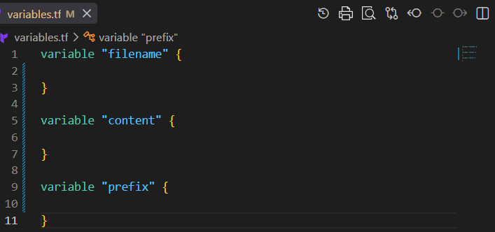
Step 2: Create main.tf
resource "local_file" "my_pet" {
filename = var.filename
content = var.content
}

resource "random_pet" "my_pet" {
prefix = var.prefix
length = 1
separator = "-"
}
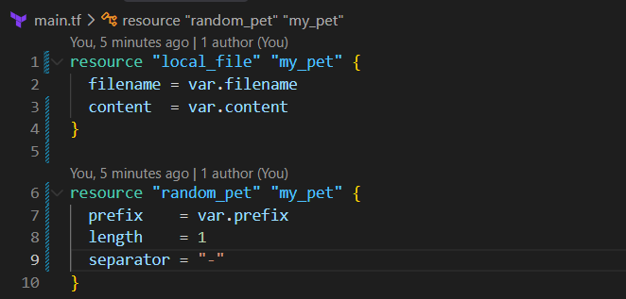
Step 3: Initialize
terraform init 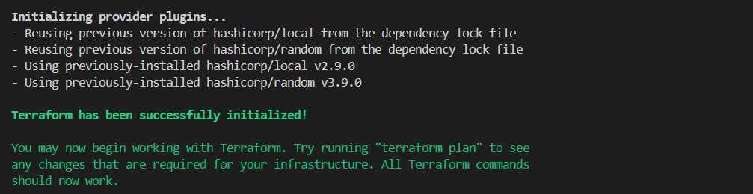
Step 4: Validate
terraform validate
Step 5: Apply
terraform apply
Terraform will ask:
var.filename
Enter a value:

var.content
Enter a value:

var.prefix
Enter a value:
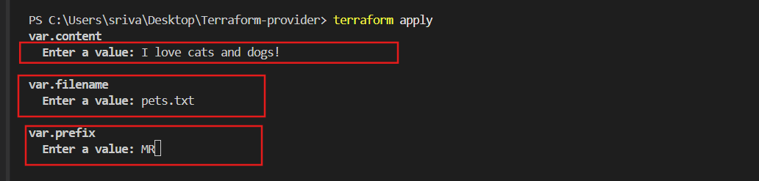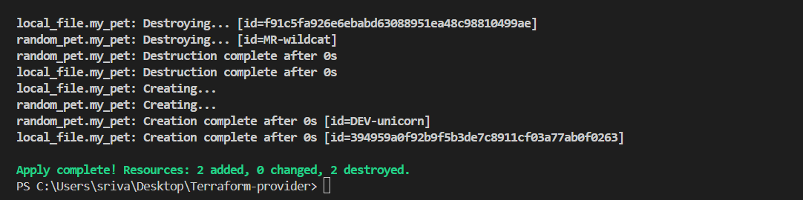
Enter your values and Terraform will create the resources.

Command-Line Flags — Terraform Variables
Step 1: variables.tf
variable "filename" {
}

variable "content" {
}

variable "prefix" {
} 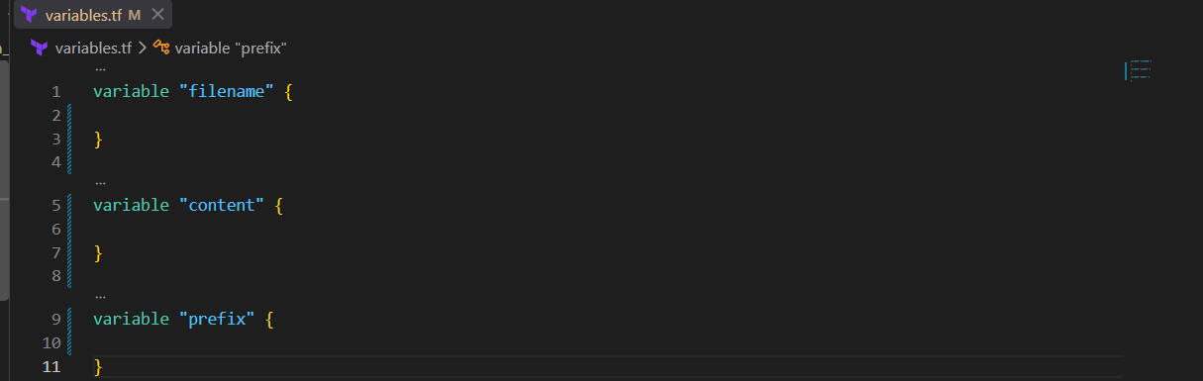
Step 2: main.tf
resource "local_file" "my_pet" {
filename = var.filename
content = var.content
}

resource "random_pet" "my_pet" {
prefix = var.prefix
length = 1
separator = "-"
} 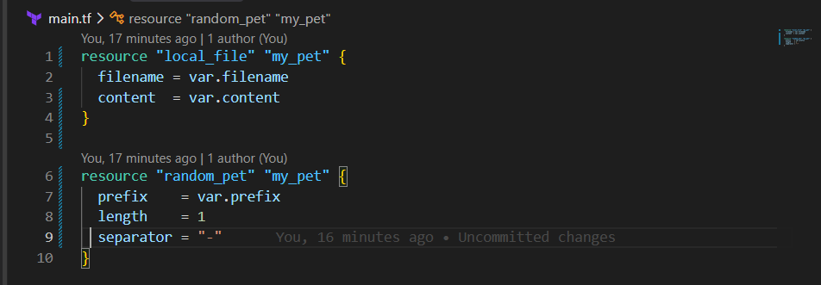
Step 3: Initialize
terraform init 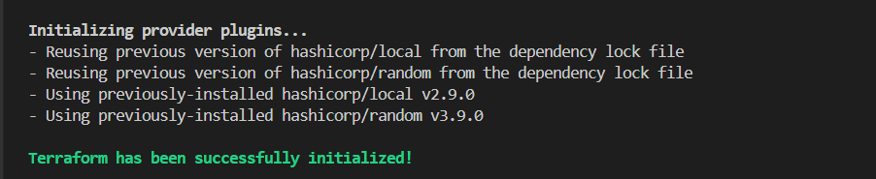
Step 4: Validate
terraform validate

Step 5: Pass values using command-line flags
terraform apply -var="filename=animals.txt" -var="content=I love elephants!" -var="prefix=DEV"
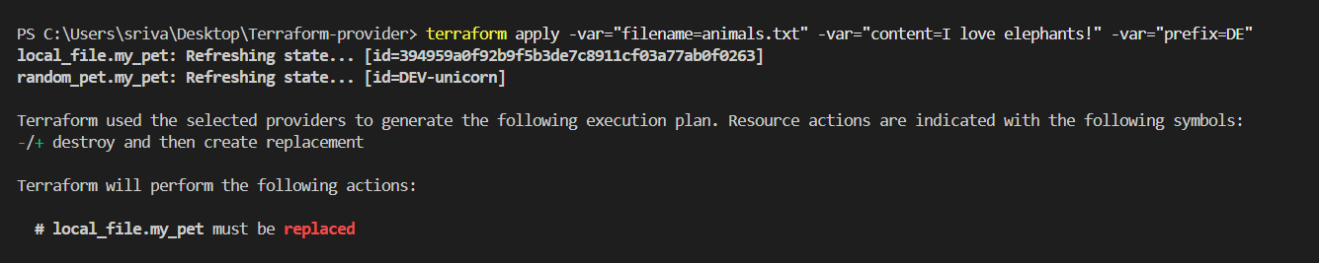
Step 6: Verify
Terraform creates:
animals.txt
with:
I love elephants! 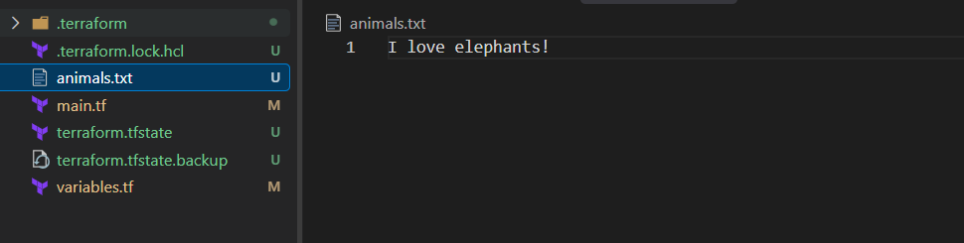
Key point: -var allows you to provide variable values directly from the command line.

Environment Variables
Your notes have a small typo: Terraform environment variables must start with TF_VAR_, not TF_val_.
Step 1: variables.tf
variable "filename" {
}

variable "content" {
}

variable "prefix" {
}
Step 2: main.tf
resource "local_file" "my_pet" {
filename = var.filename
content = var.content
}

resource "random_pet" "my_pet" {
prefix = var.prefix
length = 1
separator = "-"
}
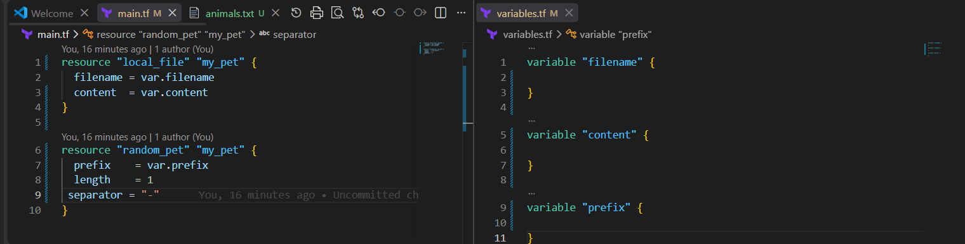
Step 3: Set variables in PowerShell
Set-Item -Path Env:TF_VAR_filename -Value "world.txt"
Set-Item -Path Env:TF_VAR_content -Value "lorpa"
Set-Item -Path Env:TF_VAR_prefix -Value "miss" 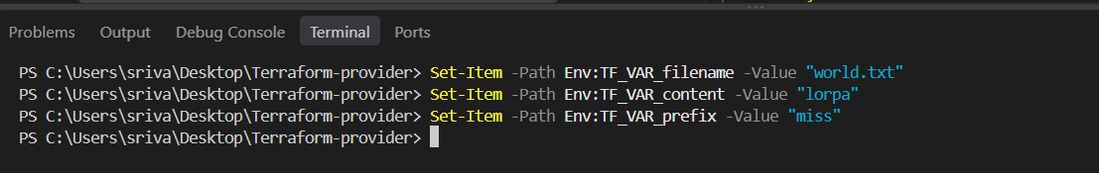
Step 4: Verify
$env:TF_VAR_filename
$env:TF_VAR_content
$env:TF_VAR_prefix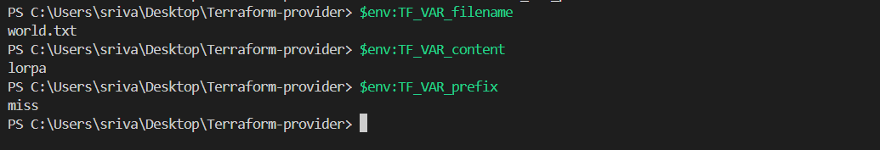
Step 5: Apply
terraform apply
Terraform automatically takes:
TF_VAR_filename → var.filename
TF_VAR_content → var.content
TF_VAR_prefix → var.prefix
To change the values
Set-Item -Path Env:TF_VAR_filename -Value "w/d.txt"
Set-Item -Path Env:TF_VAR_content -Value "lorpa"
Set-Item -Path Env:TF_VAR_prefix -Value "miss"
Then:
terraform apply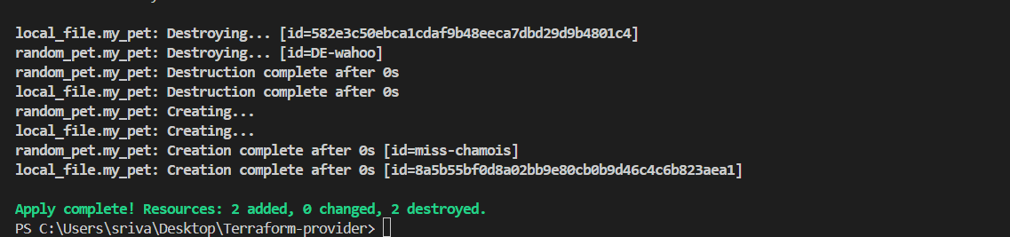

Variable Precedence
Use case: If you define a default value in variables.tf and also provide a TF_VAR_... environment variable, Terraform will use the environment variable value because it has higher precedence than the variable's default.
To prove the environment variable is overriding default
Terraform Variable Precedence
- Environment variable — TF_VAR_name
- terraform.tfvars
- *.auto.tfvars
- -var / -var-file

Step 1 — variables.tf
Create/update variables.tf:
variable "filename" {
default = "pets.txt"
}

variable "content" {
default = "I love cats"
}

variable "prefix" {
default = "DEV"
}
Here, you have defined variables + default values.

Step 2 — main.tf
resource "local_file" "my_pet" {
filename = var.filename
content = var.content
}

resource "random_pet" "my_pet" {
prefix = var.prefix
length = 1
separator = "-"
}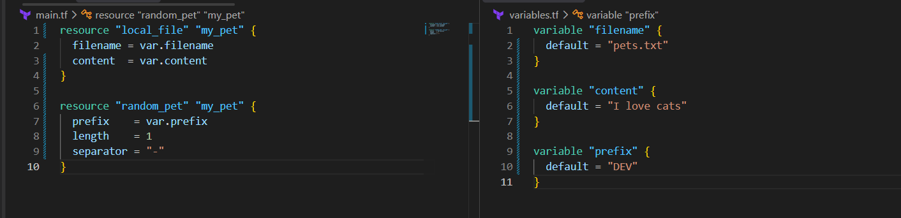

Step 3 — Open VS Code Terminal
Go to:
Terminal → New Terminal
You should see:
PS C:\Users\sriva\Desktop\Terraform-provider>

Step 4 — Pass different values using Environment Variables
Set-Item -Path Env:TF_VAR_filename -Value "world.txt"
Set-Item -Path Env:TF_VAR_content -Value "lorpa"
Set-Item -Path Env:TF_VAR_prefix -Value "miss" 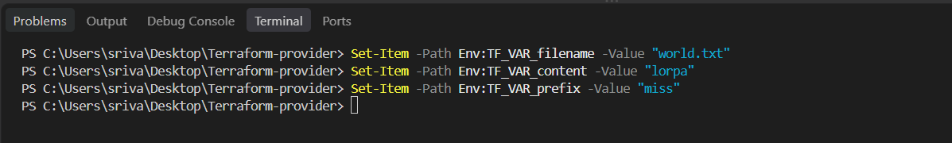 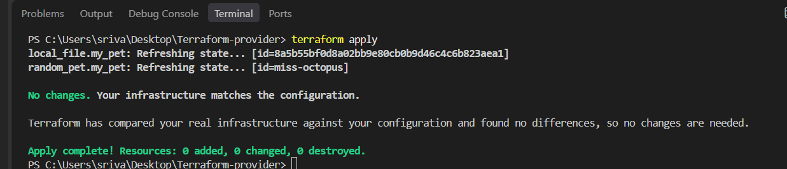

Step 5 — Verify Environment Variables
$env:TF_VAR_filename
$env:TF_VAR_content
$env:TF_VAR_prefix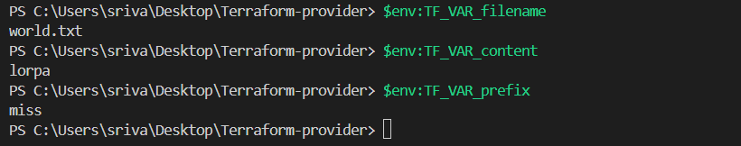

Step 6 — Run Terraform
terraform apply
Terraform will use the environment variable values, not the defaults from variables.tf.
So:
variables.tf Environment Variable
------------------------------------------------
pets.txt → world.txt
I love cats → lorpa
DEV → miss
Step 7 — Change the Environment Variable
For example:
Set-Item -Path Env:TF_VAR_filename -Value "new.txt"
Set-Item -Path Env:TF_VAR_content -Value "Hello Terraform"
Set-Item -Path Env:TF_VAR_prefix -Value "MR"
Then:
terraform apply
Terraform will detect the changes and update the resources.
Key point: default in variables.tf is the fallback value. TF_VAR_* environment variables override the default. 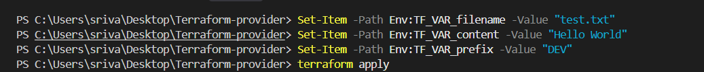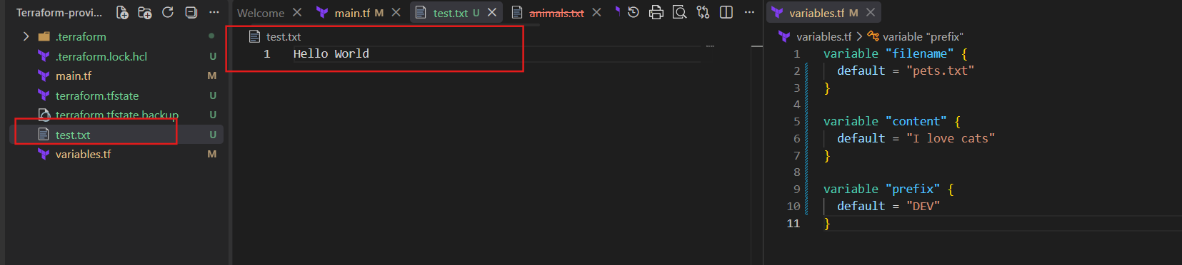

Terraform Resource Dependency
Step 1: Open your Terraform folder in VS Code
Open your existing folder:
C:\Users\sriva\Desktop\Terraform-provider

Step 2: Create main.tf
Use this:
resource "random_pet" "my_pet" {
prefix = "DEV"
length = 1
}

resource "local_file" "my_file" {
filename = "pet.txt"
content = random_pet.my_pet.id
}
Here:
random_pet.my_pet.id
is the resource reference.
It means: Get the id value from random_pet.my_pet and put it inside pet.txt. 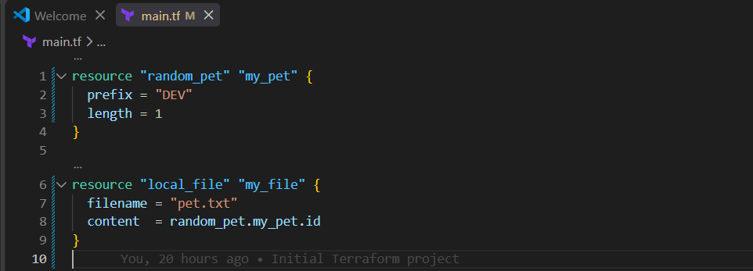

Step 3: Initialize Terraform
In VS Code terminal:
terraform init

Step 4: Check the plan
terraform plan
Terraform understands that:
random_pet → local_file
because local_file references random_pet.

Step 5: Apply
terraform apply
yes 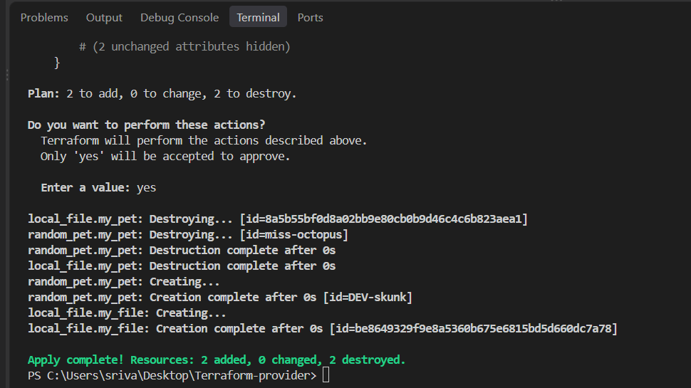

Step 6: Check the generated file
You will see:
pet.txt
DEV-skunk
The value comes from:
random_pet.my_pet.id 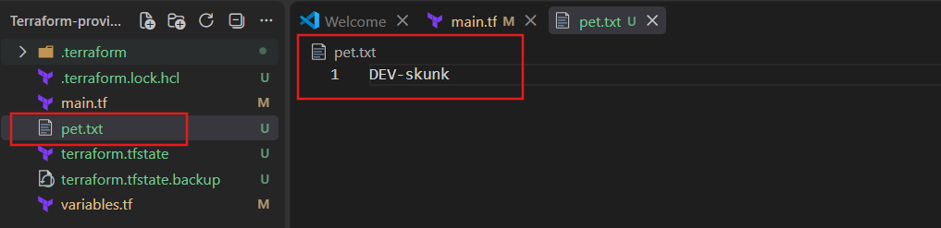

Step 7: Understand the dependency
Terraform creates:
random_pet.my_pet
↓
↓ reference
↓
local_file.my_file
So Terraform automatically knows:
Create random_pet first, then create local_file.
This is called an implicit dependency.

Step 8: Try Explicit Dependency
Change main.tf to: 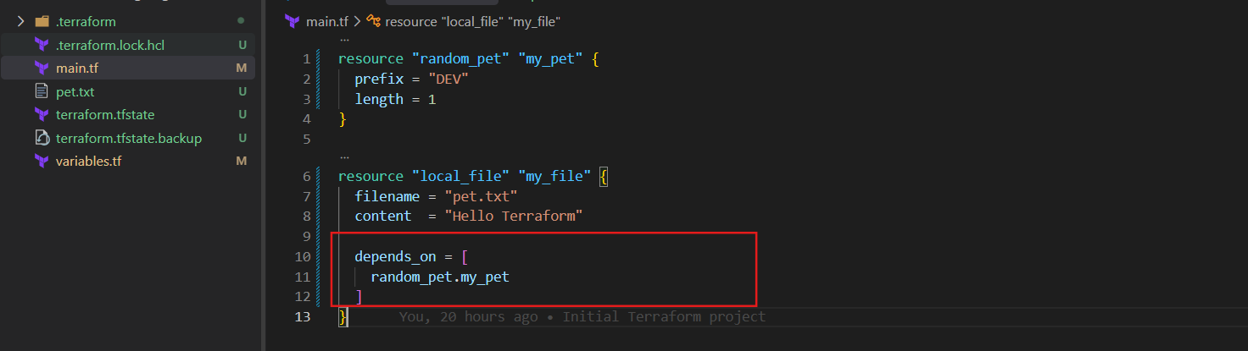
Now there is no resource reference in content.
But:
depends_on = [random_pet.my_pet]
manually tells Terraform:
Create random_pet.my_pet before local_file.my_file.

Step 9: Apply again
terraform plan
terraform apply 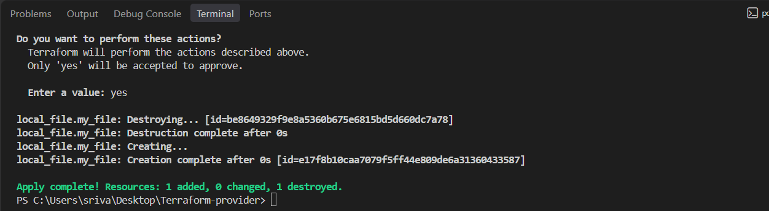

Terraform Output Variables
An output variable is used to display or expose a value after Terraform creates a resource.
For example, after creating a random pet, we can display its name.

Step 1: Keep your main.tf
resource "random_pet" "my_pet" {
prefix = "DEV"
length = 1
}
Step 2: Create outputs.tf
output "pet_name" {
value = random_pet.my_pet.id
}
Here:
random_pet.my_pet.id
is the resource reference. 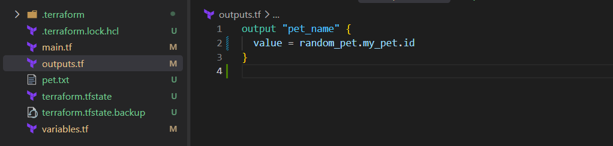

Step 3: Run Terraform
terraform init 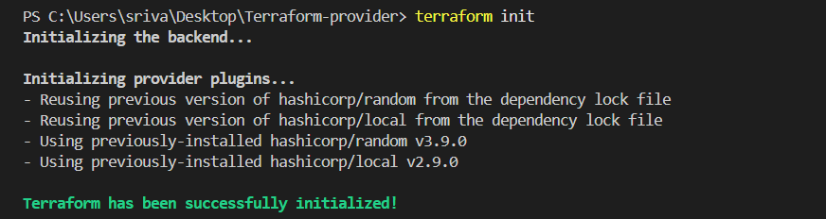
terraform apply
Enter:
yes 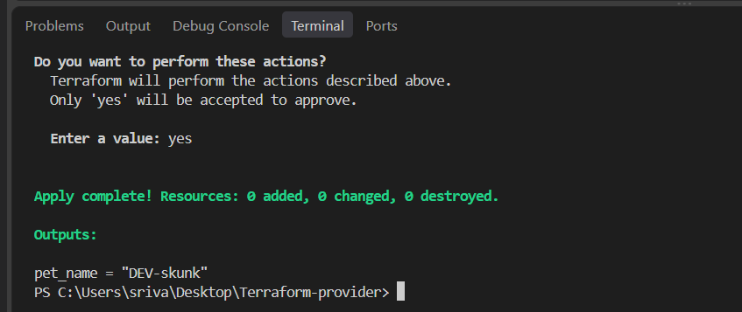

Step 4: Check the output
You should see something like:
Outputs:
pet_name = "DEV-Skunk"

Step 5: Display output anytime
After terraform apply, run:
terraform output
Or only the specific output:
terraform output pet_name
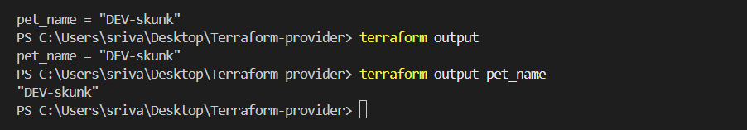

Simple interview definition
Output variable is used to display or expose values generated by Terraform resources.
Flow:
Resource
↓
random_pet.my_pet.id
↓
output "pet_name"
↓
terraform output
Important: output is different from an input variable.
- variable → gives values to Terraform
- output → gives values from Terraform

- Integrate Terraform in Jenkins using the Terraform plugin.
- Jenkins → Manage Jenkins → Plugins
  - Search Terraform
  - Install Terraform Plugin.
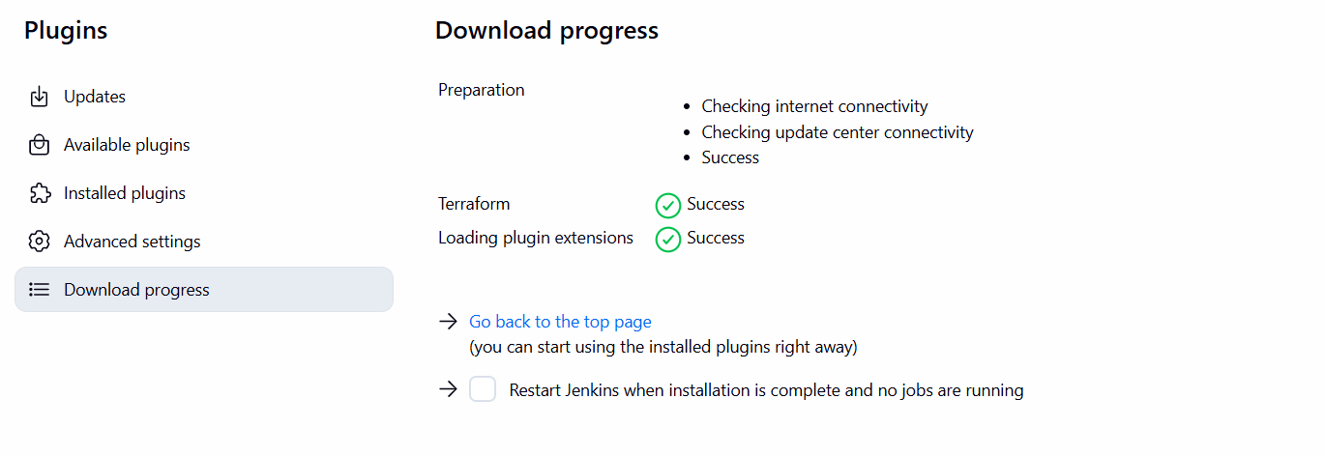
- Manage Jenkins → Tools
  - Find Terraform installations
  - Click Add Terraform
  - Name: terraform
  - Select Terraform version / auto-install
  - Save
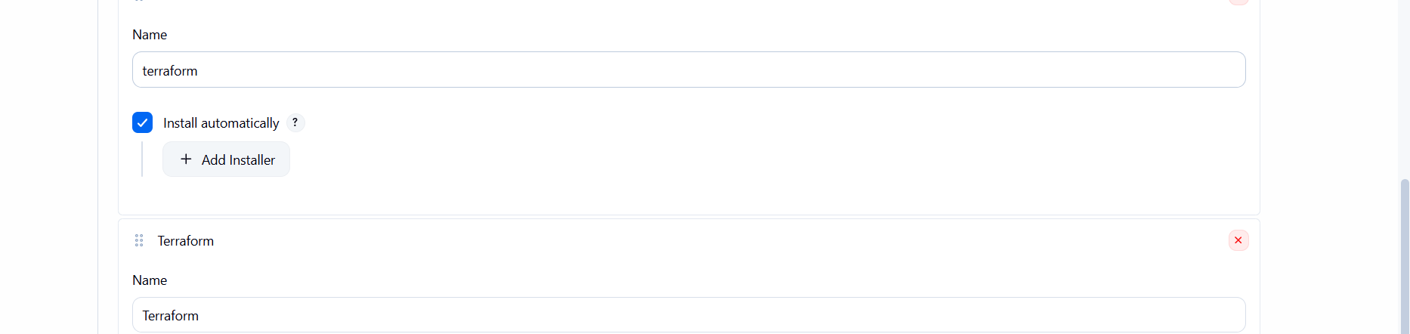
- Create Jenkins Pipeline
  - New Item → Terraform-jenkins pipeline
  - Select Pipeline
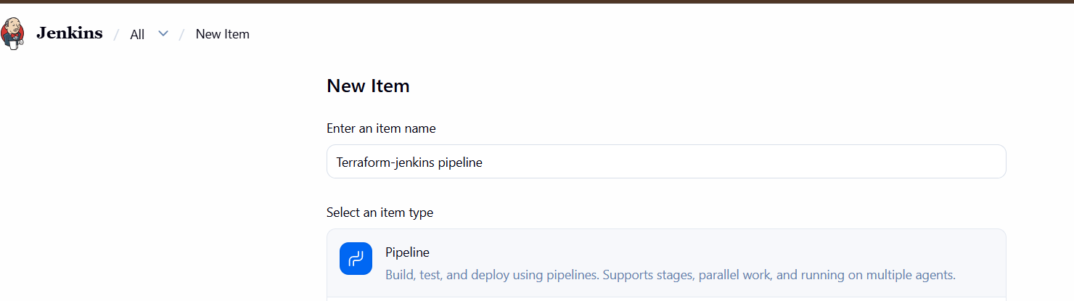
- Add this Jenkinsfile:
pipeline {
agent any

environment {
TF_HOME = tool name: 'terraform',
type: 'org.jenkinsci.plugins.terraform.TerraformInstallation'
PATH = "${TF_HOME}:${env.PATH}"
}

stages {
stage('Checkout') {
steps {
checkout scm
}
}

stage('Terraform Init') {
steps {
sh 'terraform init'
}
}

stage('Terraform Validate') {
steps {
sh 'terraform validate'
}
}

stage('Terraform Plan') {
steps {
sh 'terraform plan'
}
}
}
}
- Connect GitHub
  - Pipeline → Pipeline script from SCM
  - SCM: Git
  - Add your GitHub repository
  - Branch: main
  - Script Path: Jenkinsfile
- Build Now → check Console Output.
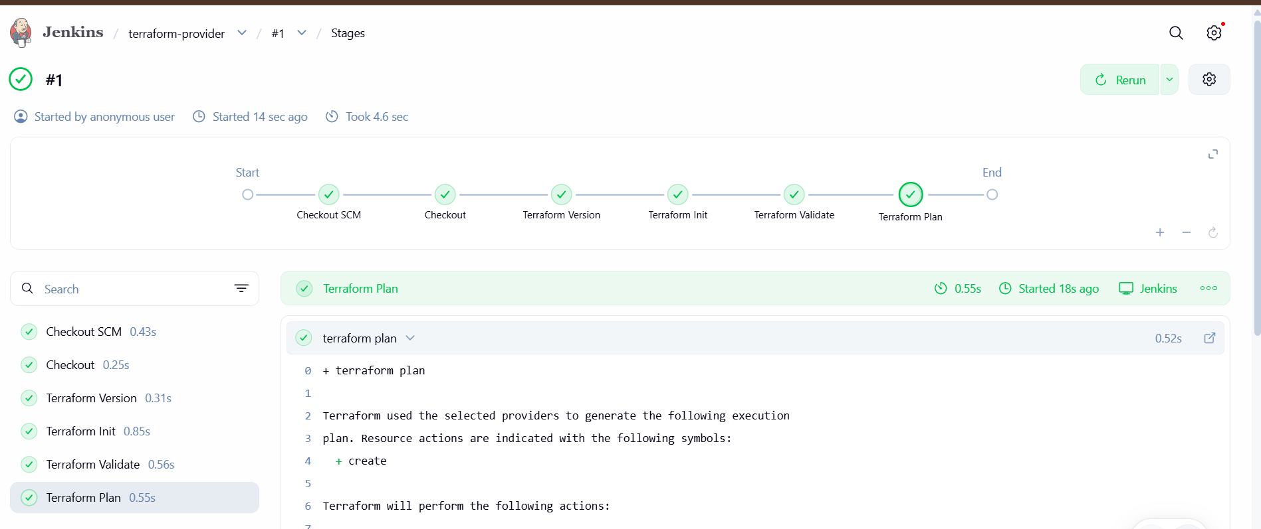
Flow
GitHub → Jenkins → Terraform Plugin → Terraform → AWS
Jenkins Terraform Plugin and Terraform AWS Provider are different things. terraform init downloads the AWS provider automatically.

- Create one Jenkins job using Maven Project for the code below with two stages:
- Stage 1:Git clone
- Stage 2:Maven CompilationCode:https://github.com/betawins/java-Working-app.git
1. Create Jenkins Job
Jenkins → New Item
Name:
java-working-app
Select:
Maven project
Click OK. Jenkins supports a dedicated Maven project type.
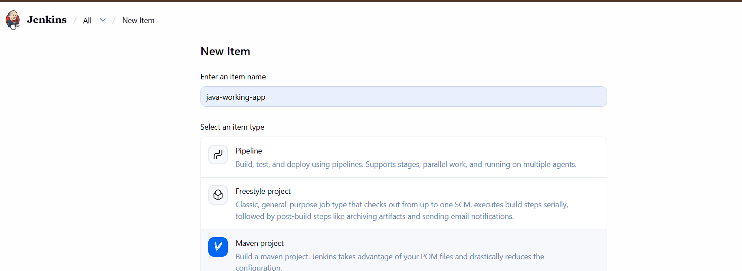
2. Stage 1 — Git Clone
In Source Code Management:
Select:
Git
Repository URL:
https://github.com/betawins/java-Working-app.git
Branch:
*/main
If the repository is public, you don't need credentials.
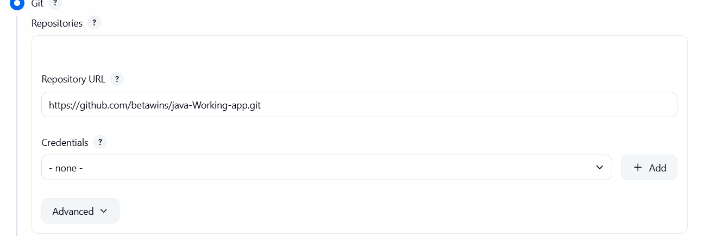
3. Stage 2 — Maven Compilation
Find Build section.
In Goals and options, enter:
clean compile
That's it. Maven will compile the Java project using its pom.xml.
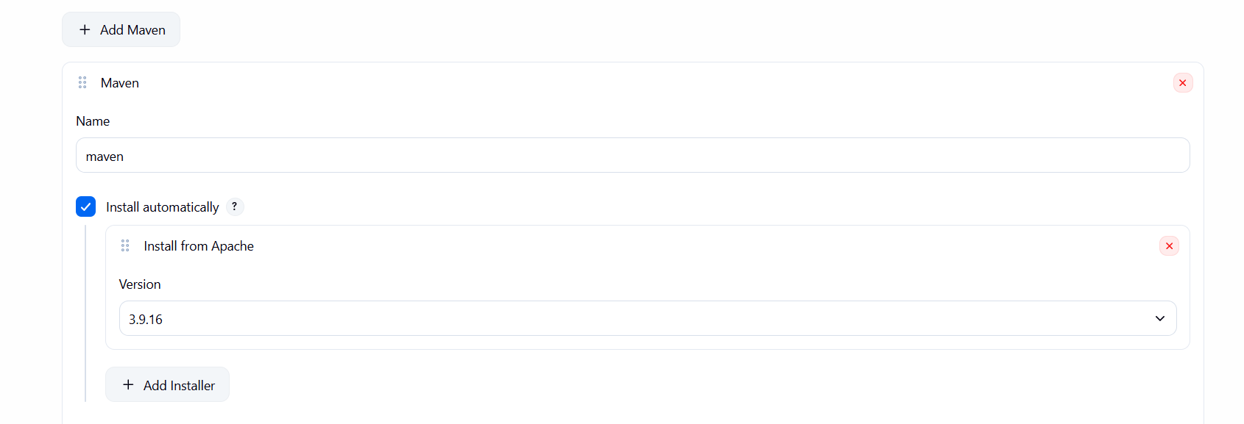
4. Save and Build
Click:
Save → Build Now
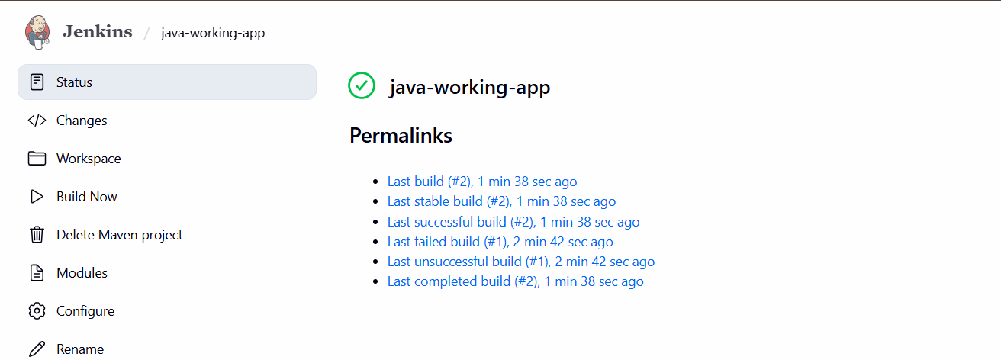
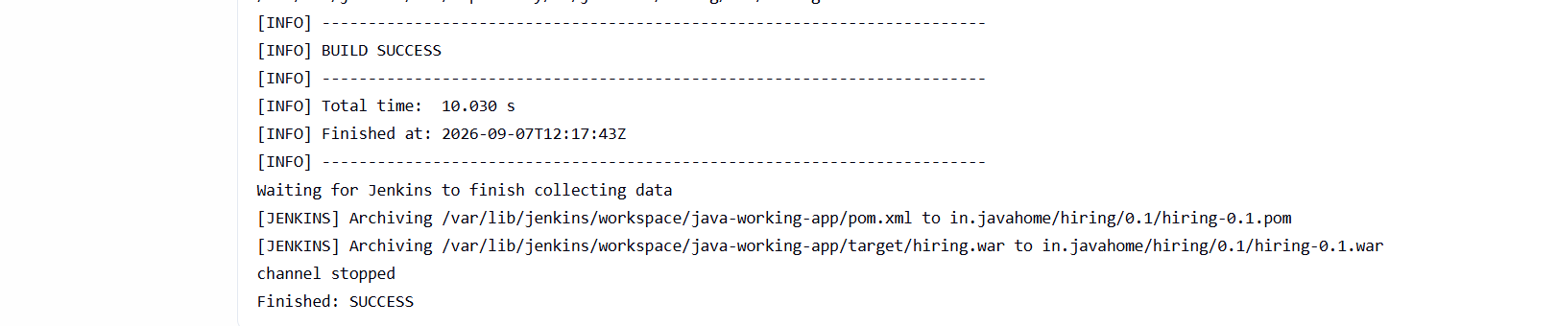
Then:
Build #1 → Console Output
You should see:
Git clone
↓
Downloading Maven dependencies
↓
mvn clean compile
↓
BUILD SUCCESS
So your two stages are effectively:
Stage 1: Git Clone
↓
Stage 2: Maven Compilation
↓
SUCCESS
For this particular requirement, you do not need a Jenkinsfile because you're specifically creating a Maven Project job.

- Use the same code and create a parameterized job in Jenkins with:
- Stage 1:Git clone
- Stage 2:Maven CompilationCode:https://github.com/betawins/java-Working-app.git
Jenkins job will have:
- Stage 1 — Git Clone
- Stage 2 — Maven Compilation
Git repository:
https://github.com/betawins/java-Working-app.git

Step 1: Create Jenkins Job
Go to Jenkins:
Dashboard → New Item
Enter:
java-working-app
Select:
Pipeline
Click OK. 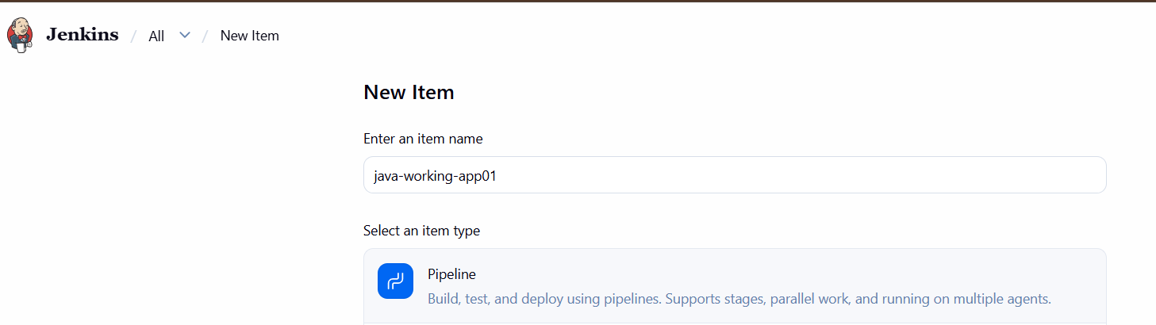

Step 2: Make it Parameterized
In the job:
Configure → General
Check:
☑ This project is parameterized
Click:
Add Parameter → Choice Parameter
Use:
Name: BRANCH
Choices:
Main
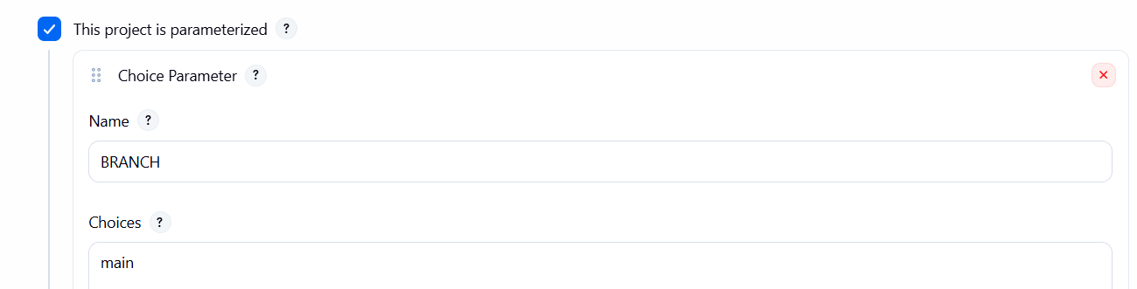

Step 3: Add Pipeline
Go to:
Pipeline → Definition
Select:
Pipeline script
Paste this:
pipeline {
agent any

parameters {
choice(
name: 'BRANCH',
choices: ['main', 'master'],
description: 'Select Git branch'
)
}

stages {

stage('Git Clone') {
steps {
git branch: "${params.BRANCH}",
url: 'https://github.com/betawins/java-Working-app.git'
}
}

stage('Maven Compilation') {
steps {
sh 'mvn clean compile'
}
}
}
}
Click:
Save 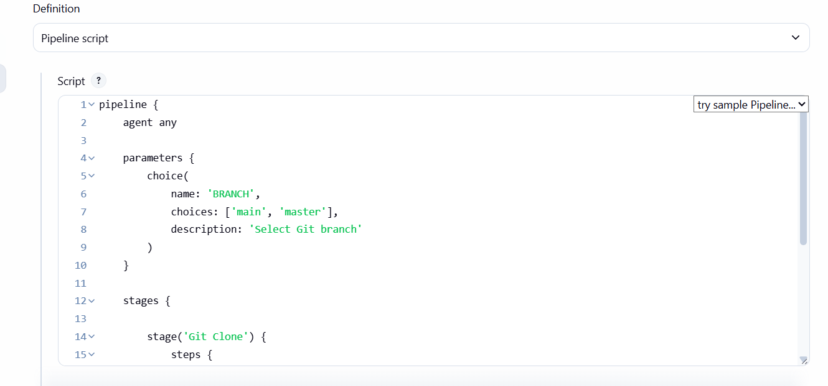

Step 4: Run the Job
Click:
Build with Parameters
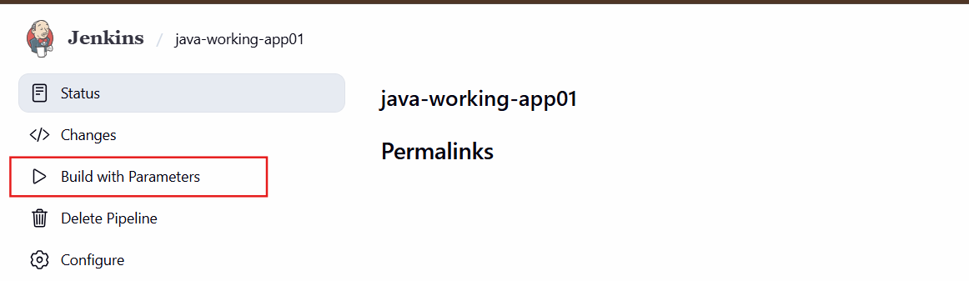
You will see:
BRANCH
[main ▼]
Select:
main
Click:
Build 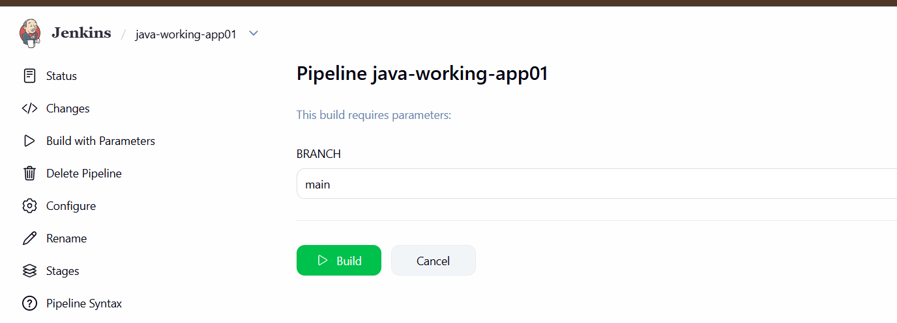

Step 5: Check Console Output
Go to:
Build #1 → Console Output
mvn clean compile
...
BUILD SUCCESS
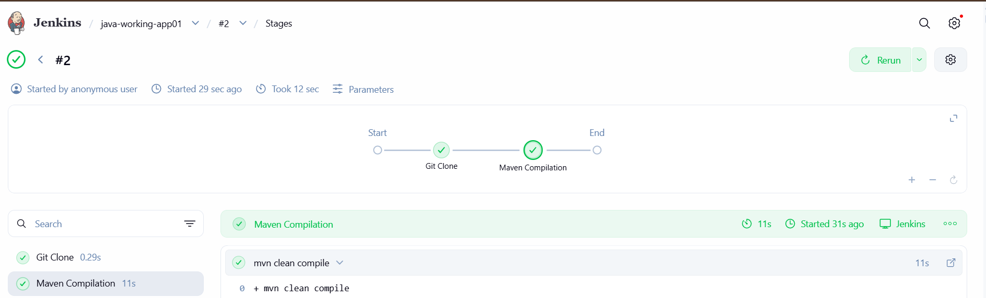

- What are the global variables in Jenkins?
In Jenkins, global variables are variables that are available throughout the Jenkins Pipeline.
Common Jenkins global variables
Variable | Meaning | Example
env | Environment variables | env.BUILD_NUMBER
params | Build parameters | params.BRANCH
currentBuild | Current build information | currentBuild.result
JOB_NAME | Jenkins job name | echo "${JOB_NAME}"
BUILD_NUMBER | Current build number | echo "${BUILD_NUMBER}"
BUILD_ID | Current build ID | echo "${BUILD_ID}"
BUILD_URL | URL of the build | echo "${BUILD_URL}"
WORKSPACE | Workspace directory | echo "${WORKSPACE}"
NODE_NAME | Jenkins agent/node name | echo "${NODE_NAME}"

Task: Jenkins Global Variables
We will use these 3 variables:
env.BUILD_NUMBER
env.JOB_NAME
env.WORKSPACE
Step 1 — Open your Jenkins job
Go to:
Jenkins → java-working-app01 → Configure → Pipeline
Replace your current Pipeline script with:
pipeline {
agent any

stages {

stage('Git Clone') {
steps {
git branch: 'main',
url: 'https://github.com/betawins/java-Working-app.git'
}
}

stage('Show Jenkins Variables') {
steps {
echo "Job Name : ${env.JOB_NAME}"
echo "Build Number : ${env.BUILD_NUMBER}"
echo "Workspace : ${env.WORKSPACE}"
echo "Node Name : ${env.NODE_NAME}"
}
}

stage('Maven Compilation') {
steps {
sh 'mvn clean compile'
}
}
}
}
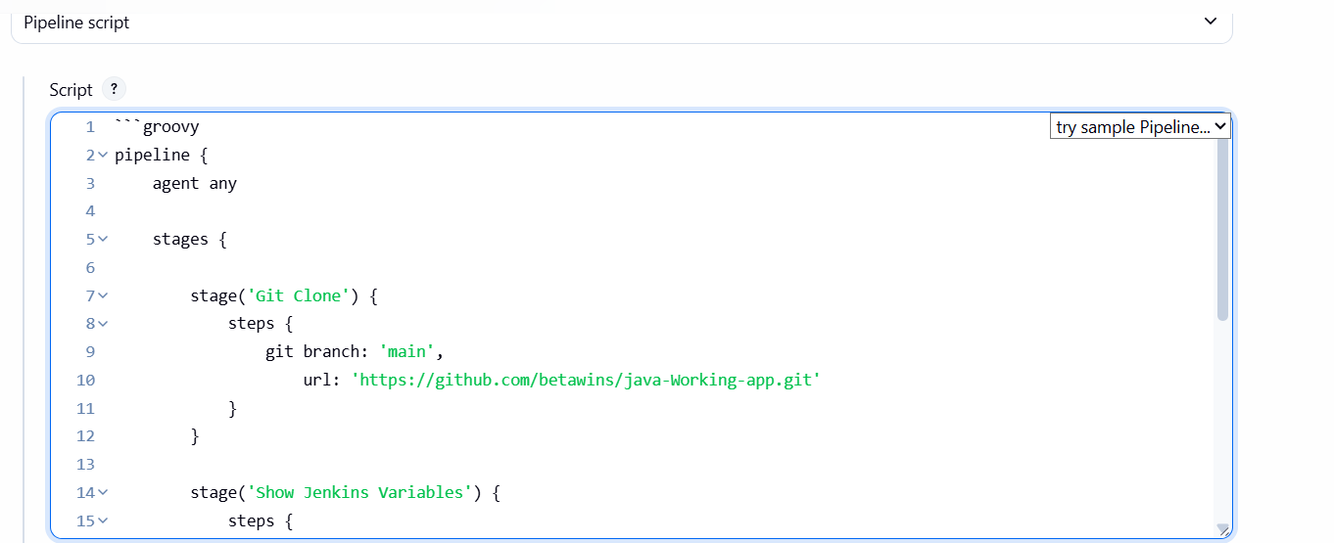
Step 2 — Save and Build
Click:
Save → Build Now
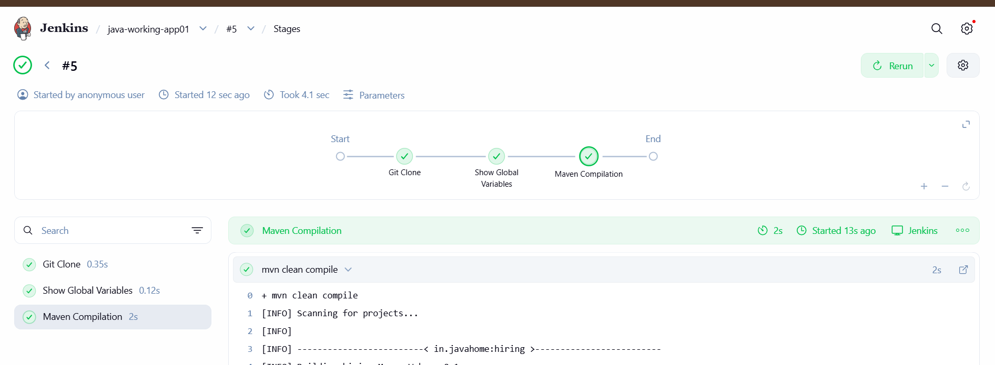
Step 3 — Check Console Output
You should see something similar to:
Job Name : java-working-app01
Build Number : 1
Workspace : /var/lib/jenkins/workspace/java-working-app01
Node Name : built-in

