Ansible-03 tasks:
- Write a single ansible playbook which will install apache and nginx. Note: Playbook should not be hardcoded and pass the variables from different file.
Step:1 create playbook directory
mkdir playbook
cd playbook 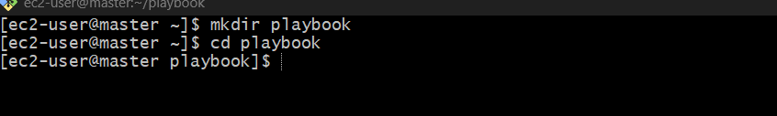
Step:2 create yaml files
Vi install.yaml
Vi variable.yaml 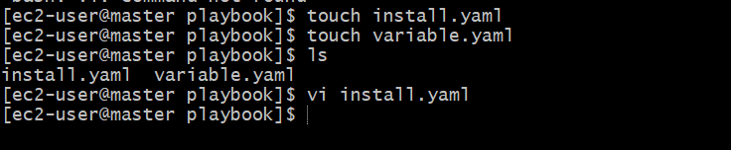
Step:3 write yaml file install and varaible.yaml
variable.yaml
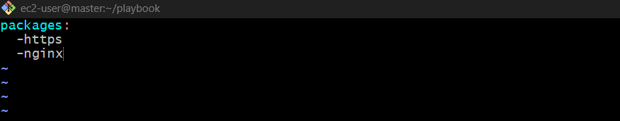

Install.yaml

---
- hosts: all
become: yes
vars_files:
- variables.yml

tasks:
- name: Install Apache
yum:
name: "{{ apache }}"
state: present

- name: Install Nginx
yum:
name: "{{ nginx }}"
state: present 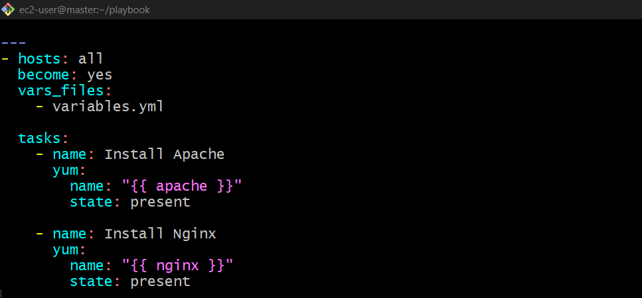

- Ansible playbook to create 10 different directories with minimal code and directory names should be passed as variables.
1. Purpose
To automate the creation of 10 directories on remote servers using a single Ansible playbook.
2. Objective
- Pass directory names through a separate variables file.
- Use a loop to create multiple directories.
- Reduce repetitive code and simplify automation.
3. Step 1: Create a project directory
On the Ansible control node, run:
mkdir directory_lab
cd directory_lab
4. Step 2: Create the variables file
Create vars.yml:
vi vars.yml
Add the directory names:
directories:
- dir1
- dir2
- dir3
- dir4
- dir5
- dir6
- dir7
- dir8
- dir9
- dir10 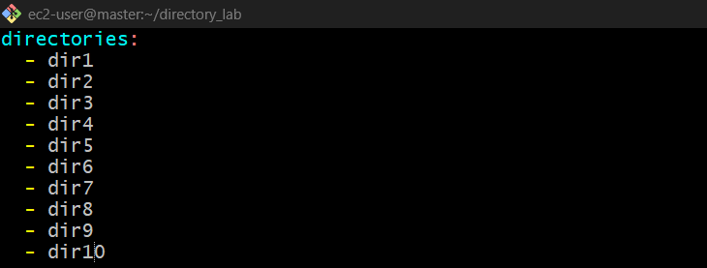

Create the inventory file
The inventory file is missing or invalid. Create it:
vi inventory
Add your target server's private IP address:
[servers]
172.31.x.x 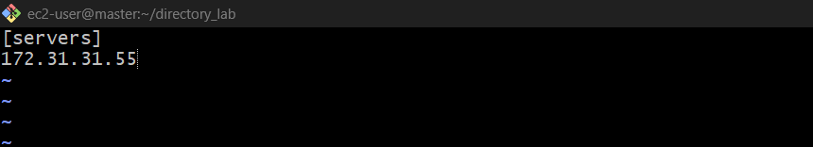
Step 3: Check the playbook
cat create_dirs.yml
5. Step 3: Create the Ansible playbook
Create create_dirs.yml:
vi create_dirs.yml
Add this playbook:
---
- name: Create 10 directories
hosts: all
become: yes

vars_files:
- vars.yml

tasks:
- name: Create directories
ansible.builtin.file:
path: "/tmp/{{ item }}"
state: directory
loop: "{{ directories }}"
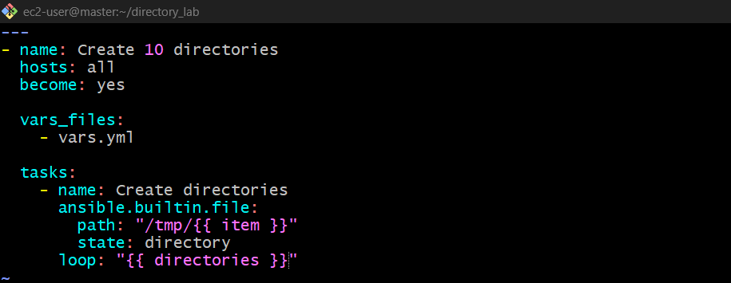

6. Step 4: Run the playbook
Make sure your inventory file contains the target server details, then run:
ansible-playbook -i inventory create_dirs.yml 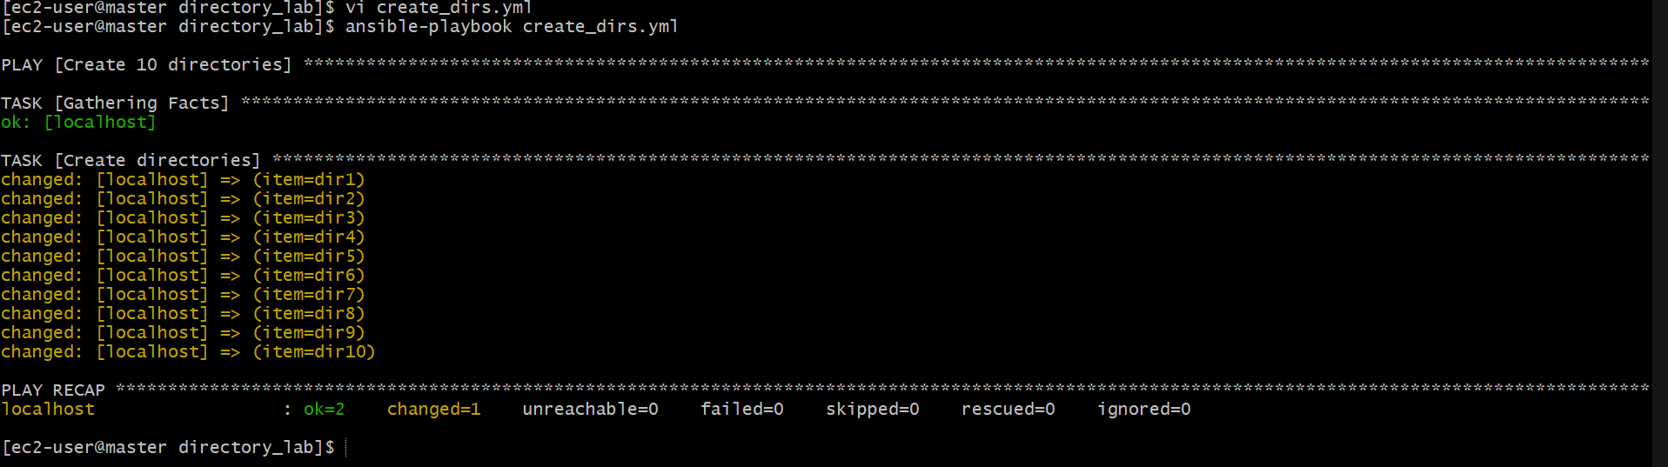
7. Step 5: Verify the directories
Log in to the target server and run:
ls -d /tmp/dir*
8. Result
Successfully created 10 directories using a single Ansible task, a loop, and a separate variables file.
Key concept: vars.yml stores the directory names, vars_files loads them, and loop processes each directory name one by one.

- Ansible playbook to copy ssh-keygen from master to worker nodes. Note:
a) Provision new 3 ec2 machines, one master and two worker nodes.
b) Create common user called ansadm and provide sudo priviliges on 3 ec2 instances.
c) Create ssh-keygen in master and your playbook should copy the keygen making it password less authentication.

1. Purpose
To configure passwordless SSH authentication between an Ansible master and two worker nodes using a common user, ansadm.
2. Objective
- Provision 3 EC2 instances: 1 master and 2 workers.
- Create the ansadm user on all 3 instances.
- Provide ansadm with sudo privileges.
- Generate an SSH key pair on the master.
- Use an Ansible playbook to copy the master's public key to both workers.
- Verify passwordless SSH authentication.
3. Architecture
Ansible Master
User: ansadm
Generates SSH key pair and runs playbook
Worker 1
User: ansadm
Receives public key
Worker 2
User: ansadm
Receives public key
4. Step 1: Provision 3 EC2 instances
Create three EC2 instances using Amazon Linux. For example:
Instance | Role | Example private IP
EC2-1 | Master | 172.31.31.55
EC2-2 | Worker 1 | 172.31.31.60
EC2-3 | Worker 2 | 172.31.31.65

These IPs are examples; use the actual private IPs from your EC2 console.
Ensure the instances can communicate over the VPC network and SSH port 22 is
allowed from the master to both workers.
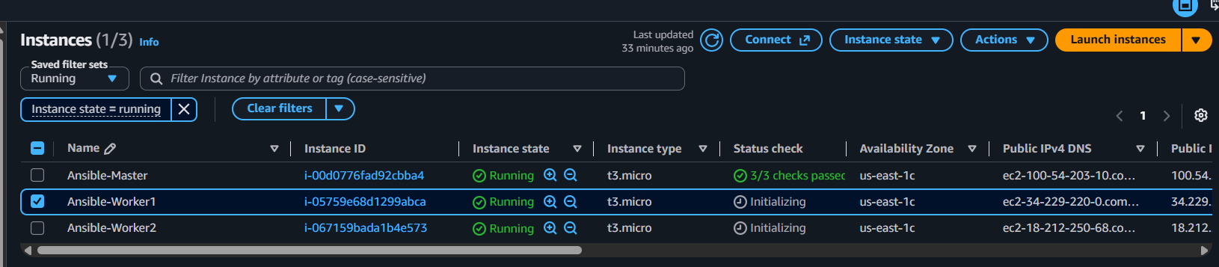

5. Step 2: Create ansadm user on all 3 instances
Log in to each instance using your existing EC2 SSH access. Run these commands on the master, worker 1, and worker 2:
sudo useradd -m ansadm
sudo usermod -aG wheel ansadm
echo 'ansadm ALL=(ALL) NOPASSWD: ALL' | sudo tee /etc/sudoers.d/ansadm
sudo chmod 440 /etc/sudoers.d/ansadm
Verify:
id ansadm
sudo -l -U ansadm
Master
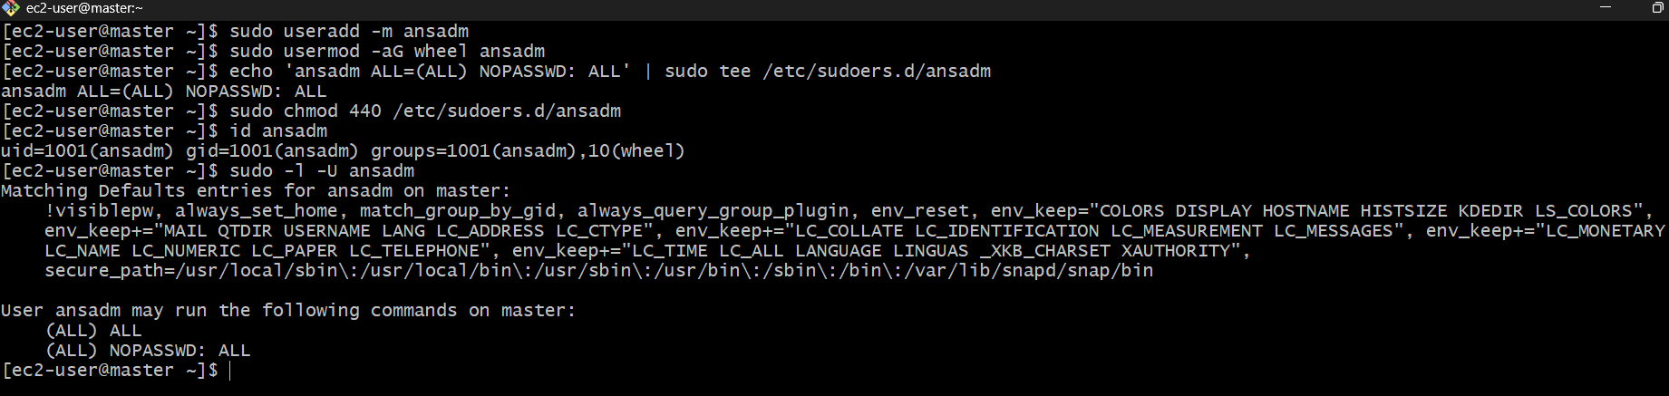
Worker-01 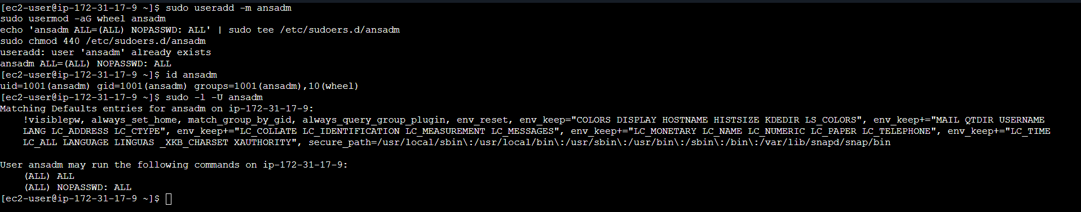

Worker-02
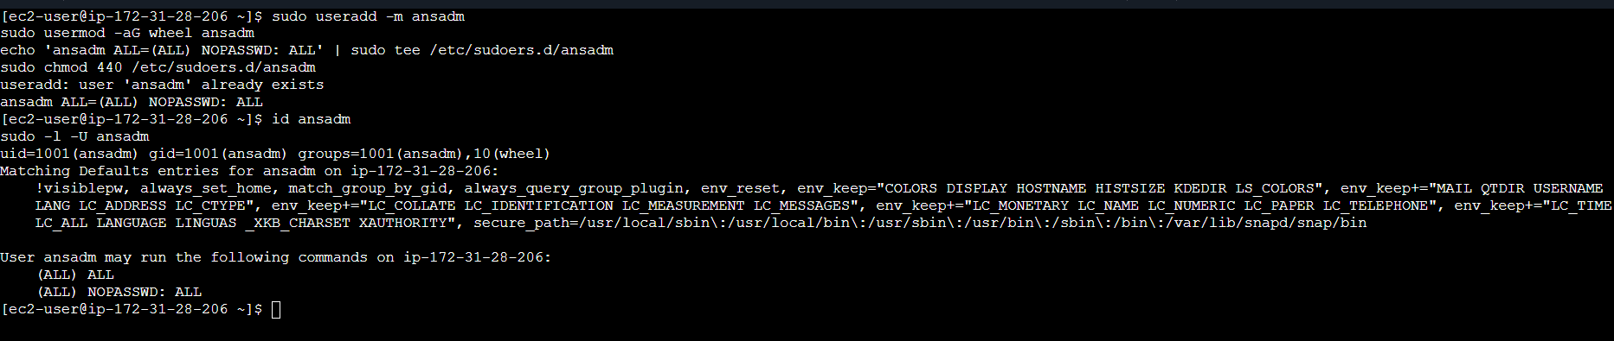

6. Step 3: Install Ansible on the master
On the master, check whether Ansible is installed:
ansible --version
If it is already installed, continue to the next step. 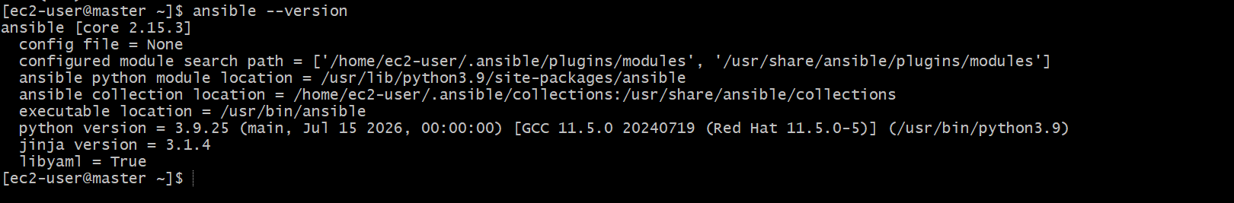
7. Step 4: Generate an SSH key on the master
Switch to the ansadm user on the master:
sudo -iu ansadm
Generate the key pair without a passphrase:
ssh-keygen -t rsa -b 4096 -N "" -f ~/.ssh/id_rsa
Verify the keys:
ls -l ~/.ssh/
You should see:
- id_rsa — private key; never share this file.
- id_rsa.pub — public key; this is the key to copy to the workers.
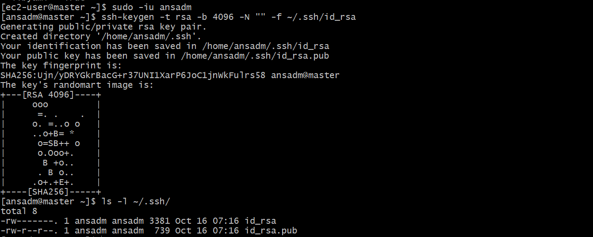
Exit back to ec2-user:
exit
Make the public key available to the account running Ansible:
sudo cp /home/ansadm/.ssh/id_rsa.pub /home/ec2-user/ansadm_id_rsa.pub
sudo chown ec2-user:ec2-user /home/ec2-user/ansadm_id_rsa.pub
8. Step 5: Create the project directory
mkdir ssh-key-lab
cd ssh-key-lab
vi inventory
vi copy_key.yml
9. Step 6: Configure the inventory
Create the inventory file:
vi inventory
Add your two worker private IPs:
[workers]
worker1 ansible_host=172.31.31.60
worker2 ansible_host=172.31.31.65

[workers:vars]
ansible_user=ec2-user
ansible_become=true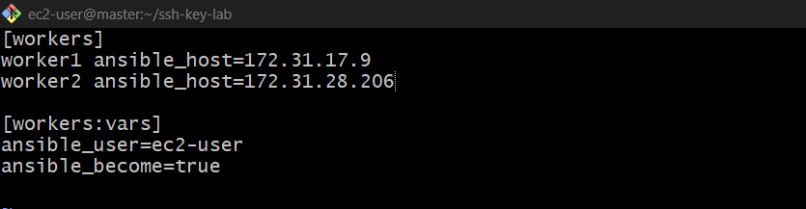
Ansible will initially connect using ec2-user and your existing EC2 .pem key. This allows it to install the ansadm public key on the workers.
10. Step 7: Create the Ansible playbook
Create the file:
vi copy_key.yml
Paste this code:
---
- name: Copy SSH public key to workers
hosts: workers
become: yes

tasks:
- name: Copy public key to ansadm
ansible.posix.authorized_key:
user: ansadm
state: present
key: "{{ lookup('file', '/home/ec2-user/ansadm_id_rsa.pub') }}"
This playbook adds the master's public key to each worker's /home/ansadm/.ssh/authorized_keys.
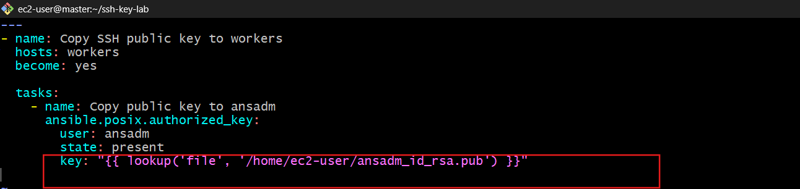
11. Step 8: Run the playbook
Use the path to the EC2 .pem key that currently lets you connect to the workers:
ansible-playbook -i inventory copy_key.yml --private-key /home/ec2-user/linux-key.pem
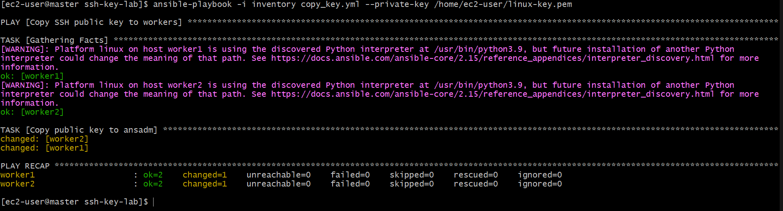
Replace /path/to/your-key.pem with your real key path.
Expected result: both workers show ok or changed, with no failures.
12. Step 9: Test passwordless authentication
From the master, run:
sudo -u ansadm ssh -i /home/ansadm/.ssh/id_rsa ansadm@172.31.31.60
Then test worker 2:
sudo -u ansadm ssh -i /home/ansadm/.ssh/id_rsa ansadm@172.31.31.65
Replace the example IPs with your actual worker IPs.
The first connection may ask you to confirm the host fingerprint; type yes. After that, authentication should work without asking for the ansadm user's password or an SSH-key passphrase.

13. Expected result
- Three EC2 instances have the ansadm user.
- ansadm has sudo privileges on all three instances.
- The master has an SSH key pair.
- Both workers trust the master's public key.
- Passwordless SSH works from the master to both workers.

- Ansible playbook to inject ansible vault variables.
Step 1: Create an Ansible Vault file
On your master EC2, run:
cd ~/ssh-key-lab
ansible-vault create secrets.yml
Enter a Vault password. In the editor, add:
db_username: admin
db_password: MySecurePassword123
Save and exit. Ansible encrypts the file so the secrets are not stored as plain text.
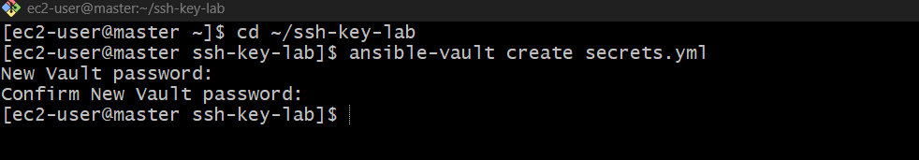
secrets.yml — encrypted variables only
Create it with:
ansible-vault create secrets.yml

Step 2: Create the playbook
vi vault_demo.yml
Paste this YAML:
---
- name: Inject Ansible Vault variables
hosts: workers
become: yes

vars_files:
- secrets.yml

tasks:
- name: Display database username
ansible.builtin.debug:
msg: "Database username is {{ db_username }}"

- name: Verify password variable is loaded
ansible.builtin.debug:
msg: "Database password variable loaded successfully"
Save and exit with Esc, :wq, and Enter.
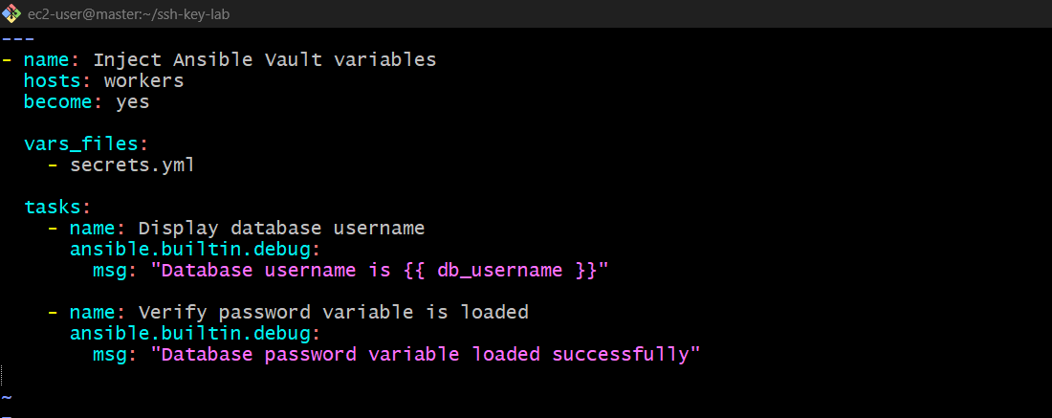
Step 3: Run the playbook
ansible-playbook -i inventory vault_demo.yml --ask-vault-pass
Enter the Vault password you created in Step 1. 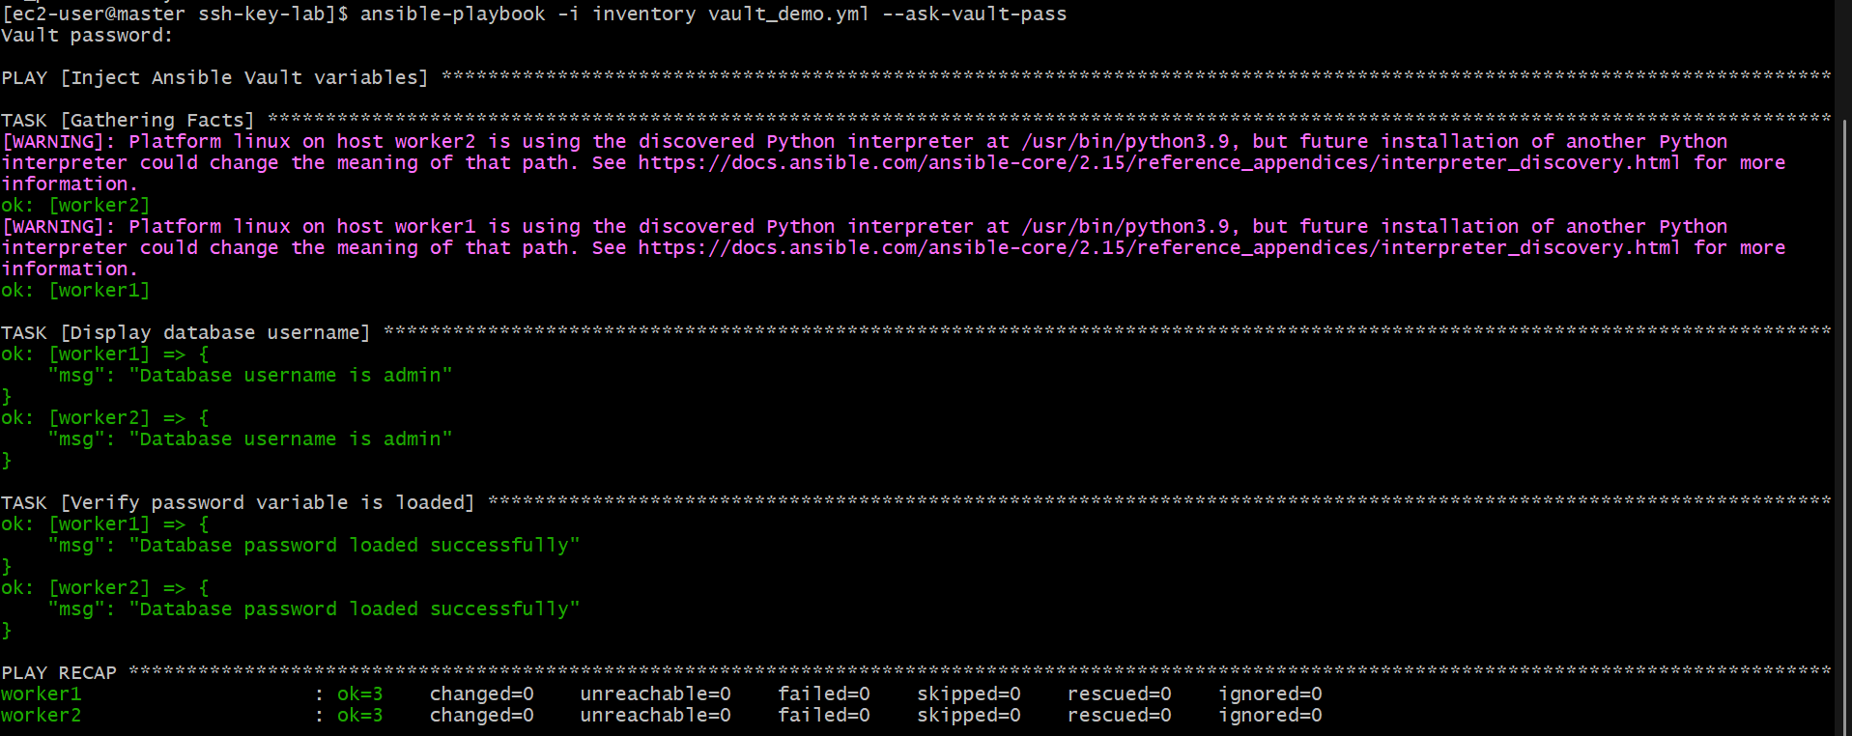
Step 4: Expected output
Command : ansible-playbook -i inventory vault_demo.yml --ask-vault-pass
TASK [Display database username]
ok: [worker1] => {
"msg": "Database username is admin"
}
ok: [worker2] => {
"msg": "Database username is admin"
}

TASK [Verify password variable is loaded]
ok: [worker1] => {
"msg": "Database password variable loaded successfully"
}
ok: [worker2] => {
"msg": "Database password variable loaded successfully"
}
The exact formatting may differ. The password itself is not printed. 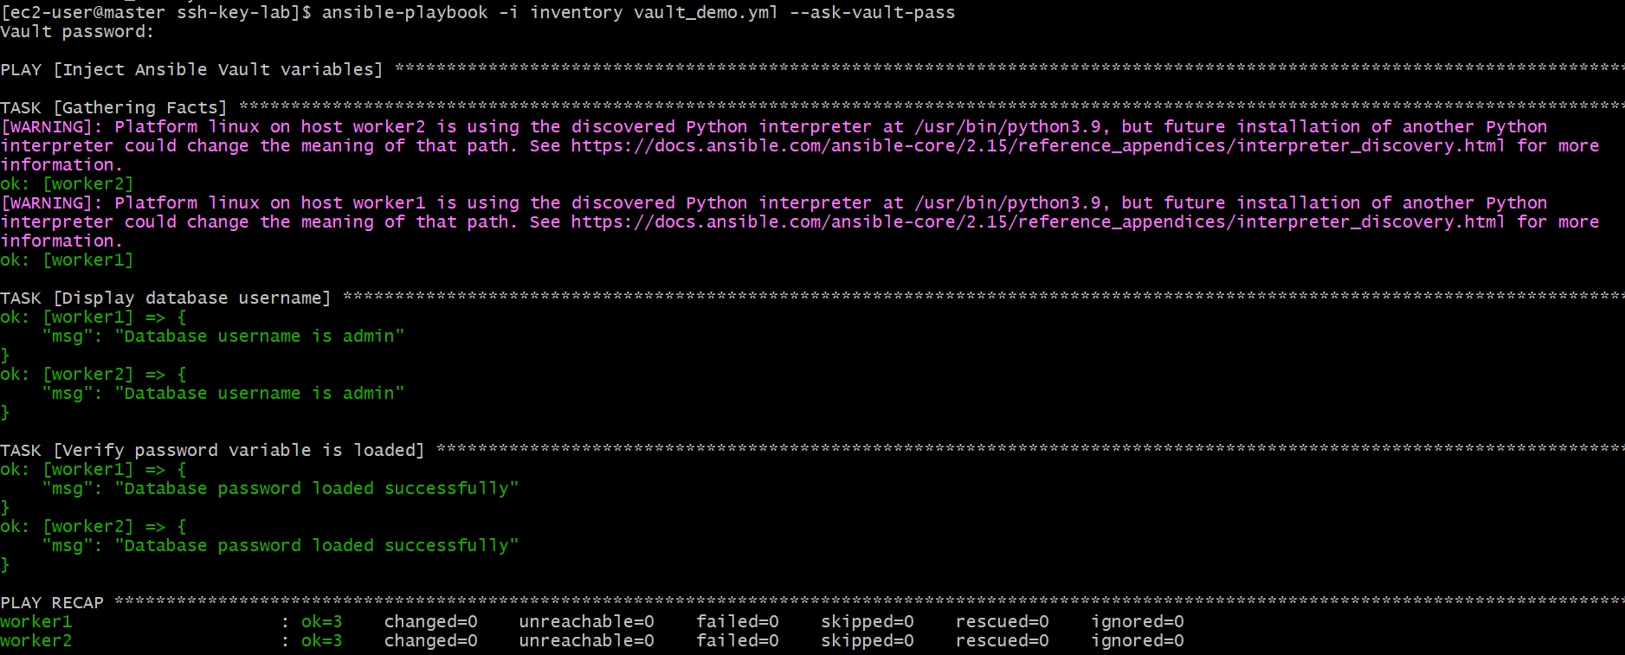
Step 5: Verify the Vault file is encrypted
cat secrets.yml 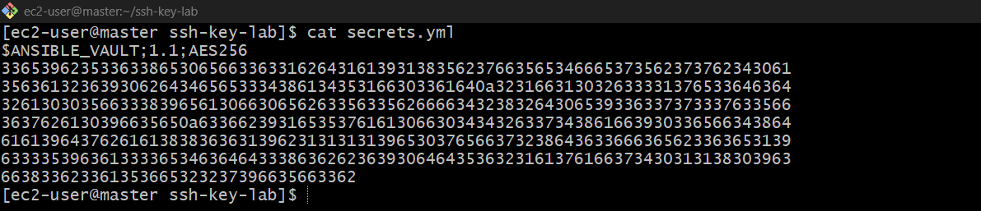
It should start with something like:
$ANSIBLE_VAULT;1.1;AES256
How it works:
- ansible-vault create secrets.yml — creates an encrypted file.
- vars_files — loads the Vault variables into the playbook.
- --ask-vault-pass — prompts for the password to decrypt the file.
- {{ db_username }} — accesses a variable stored in the Vault.

