Terraform-05
37-Terraform-StateLocks_S3_DynamoDB_TF_Provisioners_Commands.
1). Watch the Terraform-05 video.
2). Execute the script shown in the video.
Terraform State — Purpose
Definition
Terraform state is a file that keeps track of the infrastructure/resources Terraform manages.
By default, Terraform stores it in:
terraform.tfstate
Why do we need state?
Terraform uses the state file to:
- Track resources created by Terraform.
- Compare actual infrastructure with Terraform configuration.
- Know what needs to be created, changed, or destroyed.
- Store resource IDs such as EC2 instance IDs, VPC IDs, etc.
- Maintain dependencies between resources.
Hands -on
1. Create folder
mkdir terraform-s3
cd terraform-s3
2. Create terraform-s3-dynamodb.tf
resource "aws_s3_bucket" "s3_bucket" {
bucket = "s3backend"
acl = "private"
}
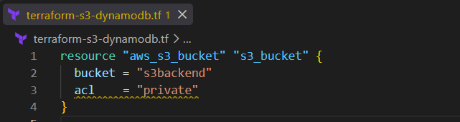
3. Run commands
terraform init 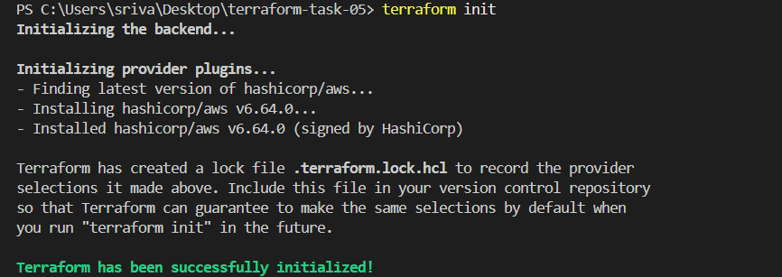
terraform validate
terraform plan
terraform apply
Enter:
yes 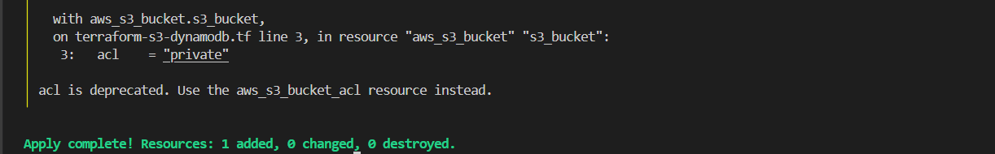
4. Verify
terraform state list
Expected:
aws_s3_bucket.mybucket
Purpose: Terraform creates and manages the S3 bucket as infrastructure.
Create DynamoDB using Terraform
1. Create folder
mkdir terraform-dynamodb
cd terraform-dynamodb
2. Create dynamodb.tf
resource "aws_dynamodb_table" "dynamodb-terraform-state_lock" {
name = "terraform-state-lock-dynamodb"
hash_key = " LockID "
read_capacity = 20
write_capacity = 20
attribute {
name = "LockID"
type = "S"
}
}
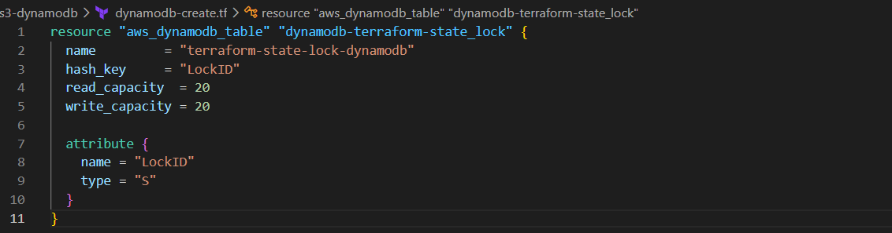
3. Run Terraform
terraform init 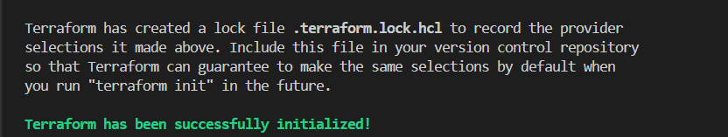
terraform validate
terraform plan
terraform apply
Enter:
yes 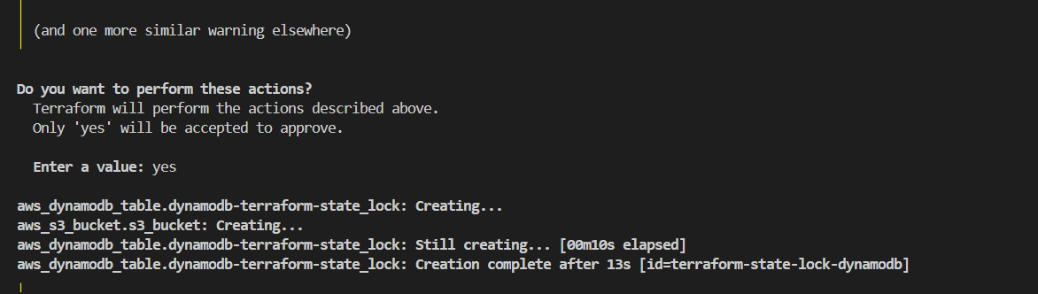
4. Verify
terraform state list
Expected:
aws_dynamodb_table.lock 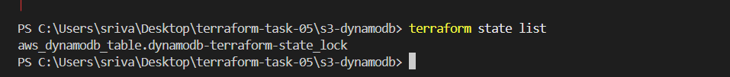
Also verify in AWS Console → DynamoDB → Tables.

S3 as backend for terraform .tfstate file
Hand-on
Step 1 — Keep your S3 bucket
You already have:
resource "aws_s3_bucket" "s3_bucket" {
bucket = "s3backend1470-satish-2026"

tags = {
Name = "terraform-state"
}
} 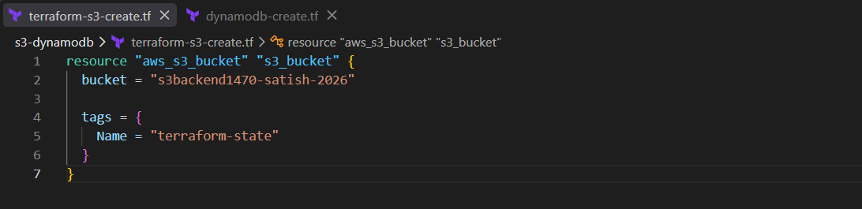
Step 2 — Create a separate backend configuration
Create a new file:
backend.tf
Put:
terraform {
backend "s3" {
bucket = "s3backend1470-satish-2026"
key = "terraform.tfstate"
region = "us-east-1"
use_lockfile = true
}
} 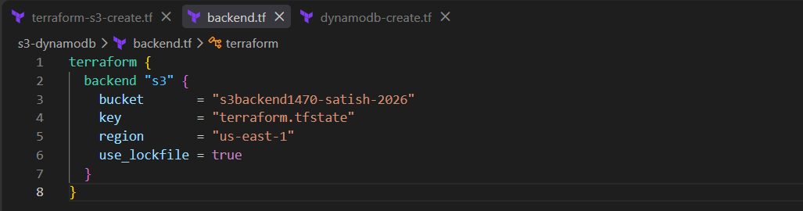
Step 3 — Initialize
Run:
terraform init
If you see:
Do you want to copy existing state to the new backend?
type:
yes 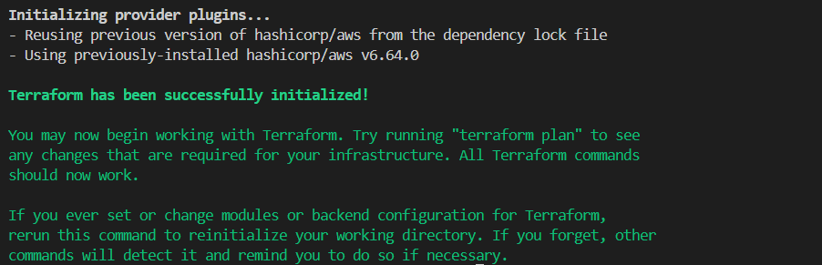
Step 4 — Verify
Run:
terraform state list 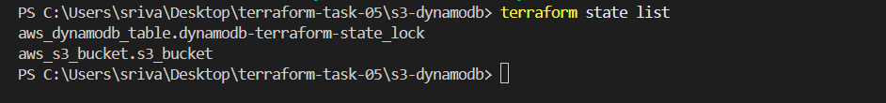
Then go to:
AWS Console → S3 → s3backend1470-satish-2026 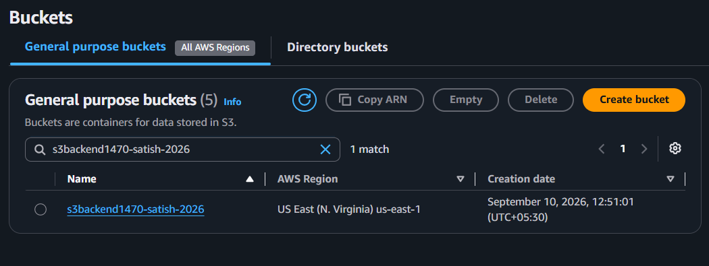

To intentionally create the “Inconsistent dependency lock file” error, use this exact lab.
Step 1 — Create a test folder
mkdir C:\Users\sriva\Desktop\terraform-lock-error
cd C:\Users\sriva\Desktop\terraform-lock-error
Step 2 — Create main.tf
terraform {
required_providers {
aws = {
source = "hashicorp/aws"
version = "6.64.0"
}
}
}

provider "aws" {
region = "us-east-1"
} 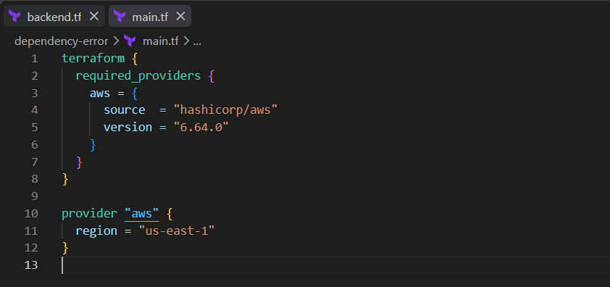

Step 3 — Create the lock file
terraform init
Now you have:
.terraform\
.terraform.lock.hcl 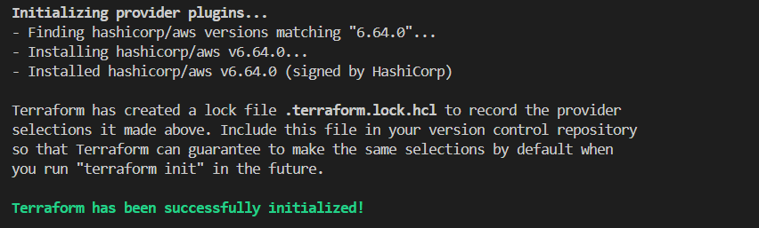
Step 4 — Change the required version
Open main.tf and change:
version = "6.64.0"
to:
version = "6.63.0" 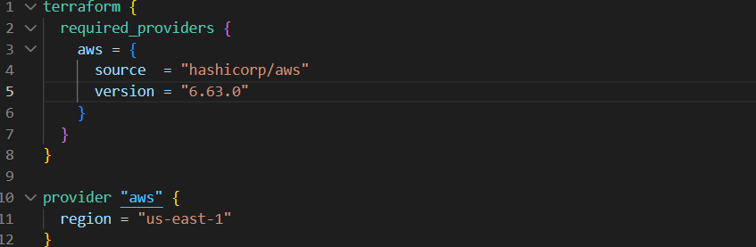
Do NOT run terraform init yet.
Step 5 — Run terraform plan
terraform plan 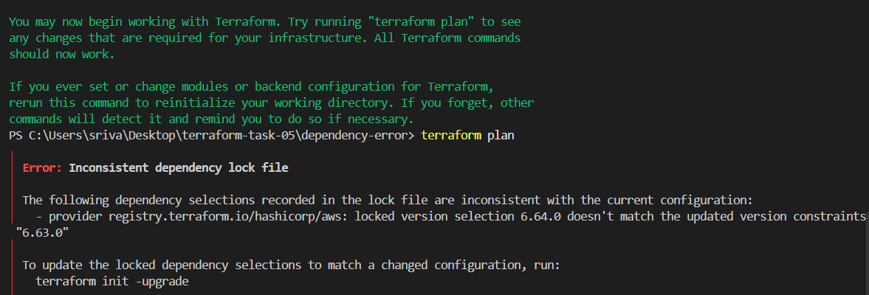
You should get an error similar to:
Inconsistent dependency lock file
Why did the error happen?
Your lock file says:
AWS provider → 6.64.0
But main.tf now requires:
AWS provider → 6.63.0
So Terraform says:
The dependency lock file is inconsistent with the current configuration.
Step 6 — Fix it
Run:
terraform init -upgrade 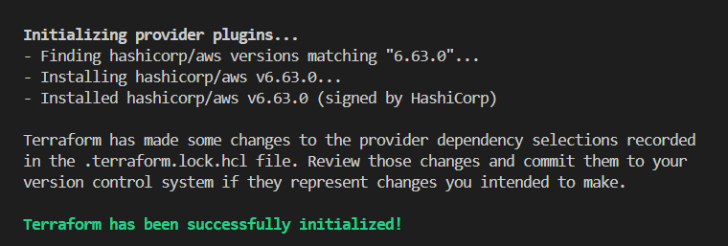
Then:
terraform validate
terraform plan
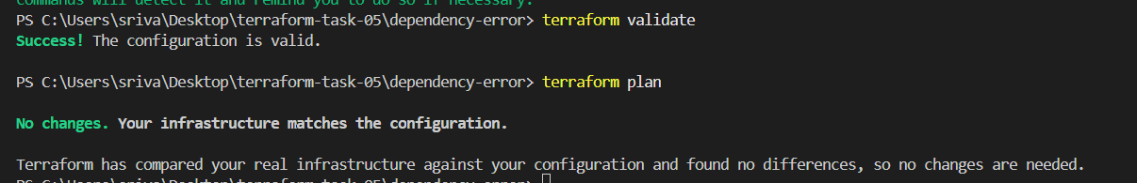
Now Terraform updates the dependency selection and the error should be gone.
Terraform Provisioner – Hands-on
- Local Provisioner (local-exec)
- Remote Provisioner (remote-exec)
1. Local Provisioner — local-exec
Step 1: Create folder
cd C:\Users\sriva\Desktop\terraform-task-05
mkdir provisioner-local
cd provisioner-local
code . 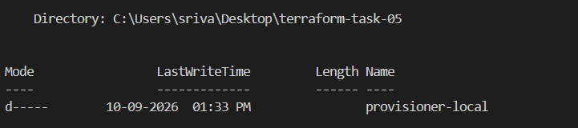
Step 2: Create main.tf
resource "local_file" "example" {
filename = "hello.txt"
content = "Terraform local provisioner"

provisioner "local-exec" {
command = "echo File created successfully"
}
} 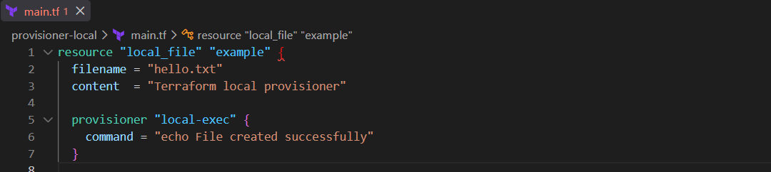
Step 3: Run
terraform init 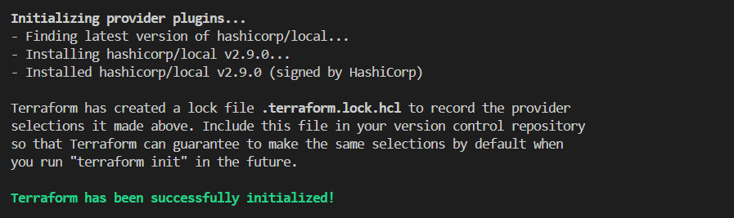
terraform apply
Type:
yes 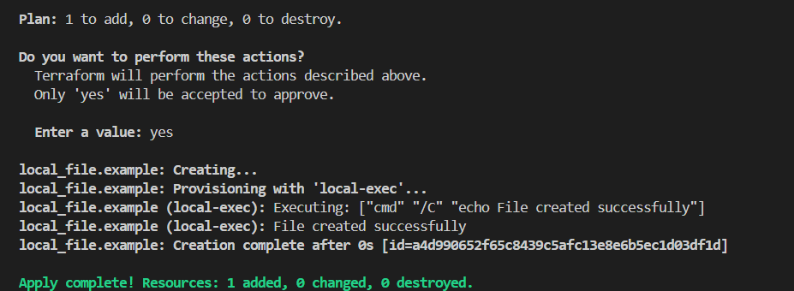

Verify
dir
type hello.txt 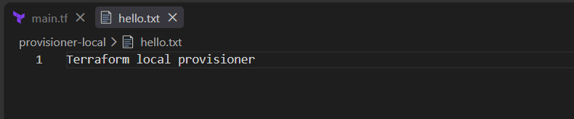
Purpose: local-exec runs a command on the machine where Terraform is running.

2. Remote Provisioner — remote-exec
This example creates an EC2 and executes commands inside the EC2.
Step 1: Create folder
cd C:\Users\sriva\Desktop\terraform-task-05
mkdir provisioner-remote
cd provisioner-remote 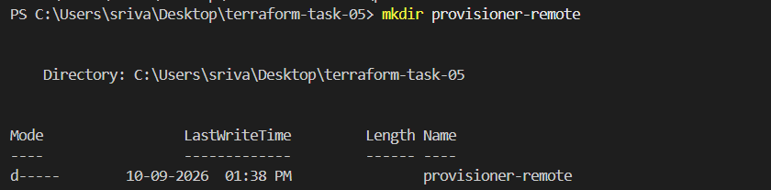
code .
Step 2: main.tf
Use your own AMI, subnet, key pair and security group:
provider "aws" {
region = "ap-south-1"
}

resource "aws_instance" "web" {
ami = "YOUR_AMI_ID"
instance_type = "t2.micro"
key_name = "YOUR_KEY_NAME"

subnet_id = "YOUR_SUBNET_ID"

vpc_security_group_ids = ["YOUR_SG_ID"]

provisioner "remote-exec" {
inline = [
"sudo yum install -y httpd",
"sudo systemctl start httpd",
"sudo systemctl enable httpd",
"echo 'Hello from remote provisioner' | sudo tee /var/www/html/index.html"
]
}

connection {
type = "ssh"
user = "ec2-user"
private_key = file("C:/path/to/your-key.pem")
host = self.public_ip
}
}
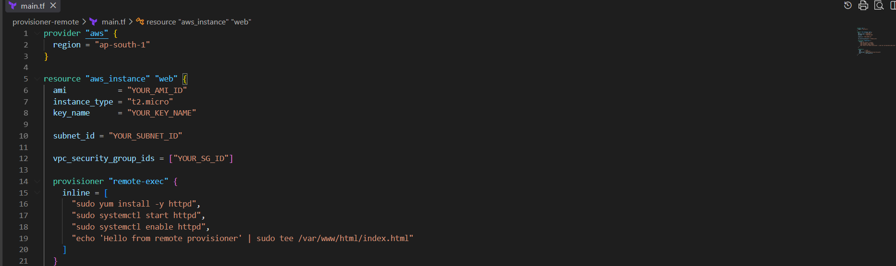
Step 3: Run
terraform init 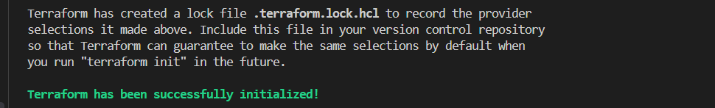
terraform plan
terraform apply
Type:
yes 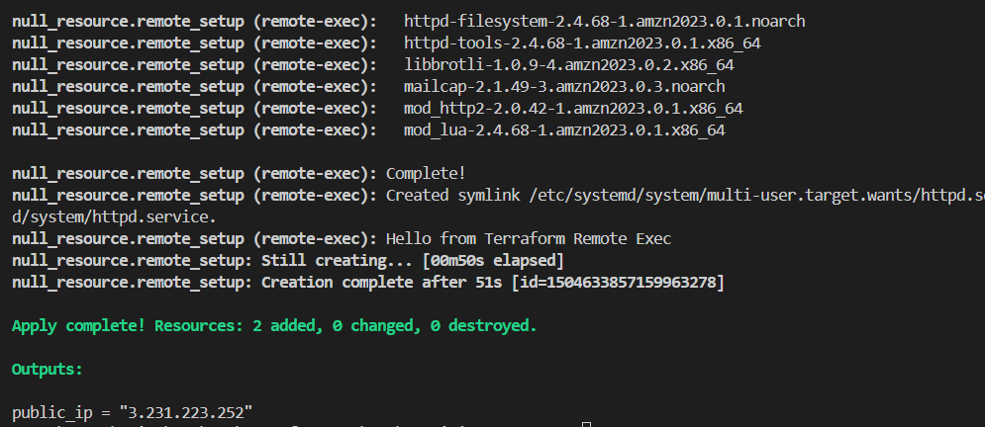
Verify
Get the EC2 public IP:
terraform output
or:
aws ec2 describe-instances
Then open:
http://EC2_PUBLIC_IP 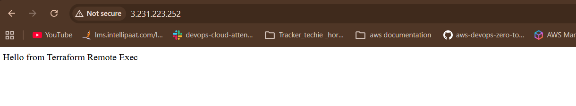
Provisioner | Runs where?
local-exec | Terraform machine
remote-exec | Remote resource/EC2
Remember: Provisioners are generally a last resort in Terraform; prefer native Terraform resources, cloud-init/user-data, or configuration-management tools when possible.
3). Create one EC2 instance with httpd installed using a Terraform script.
Task 3 — Create EC2 with HTTPD using Terraform
1. Create a folder
mkdir terraform-ec2-httpd
cd terraform-ec2-httpd
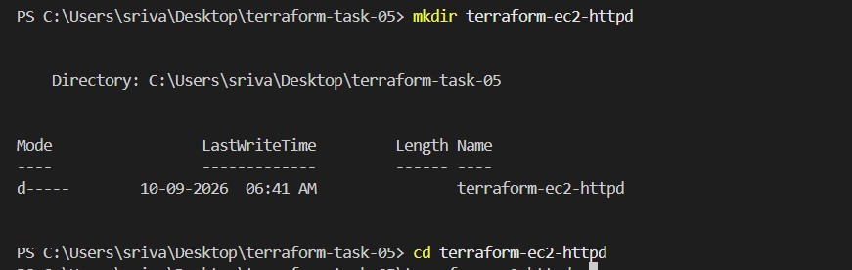
Create:
main.tf

2. Add Terraform code
main.tf
terraform {
required_providers {
aws = {
source = "hashicorp/aws"
}
}
}

provider "aws" {
region = "ap-south-1"
}

resource "aws_instance" "web" {
ami = "ami-090d68841c2a28756"
instance_type = "t2.micro"

user_data = <<-EOF
#!/bin/bash
dnf update -y
dnf install -y httpd
systemctl start httpd
systemctl enable httpd
echo "Hello from Terraform HTTPD Server" > /var/www/html/index.html
EOF

tags = {
Name = "terraform-httpd"
}
} 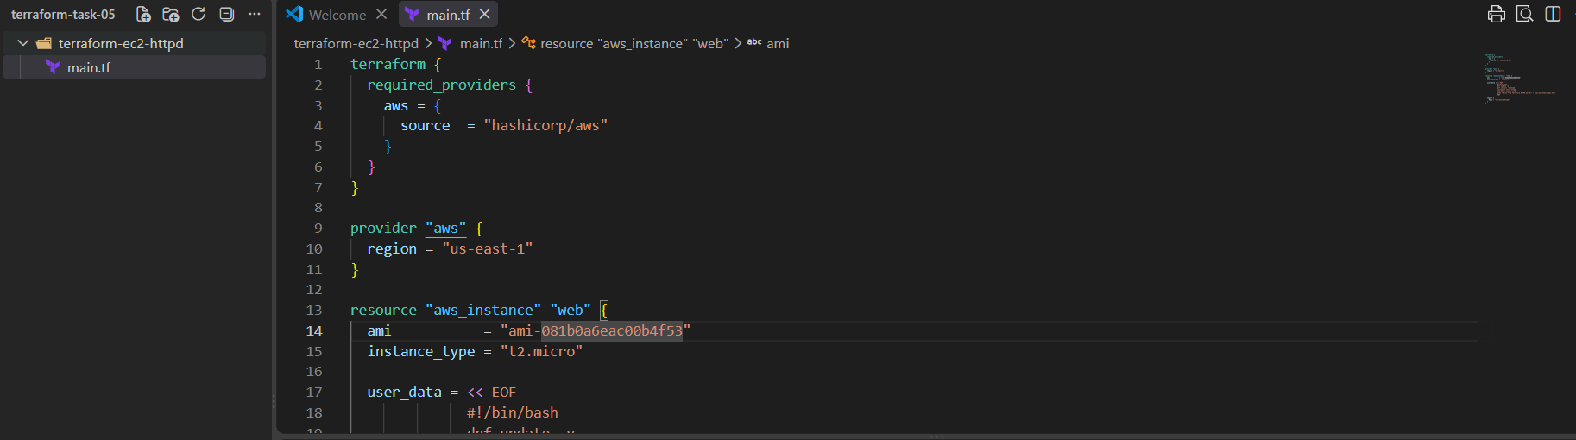
Important: Make sure the AMI belongs to us-east-1 and is still valid in your AWS account. If necessary, replace it with the current Amazon Linux 2023 AMI ID.

3. Initialize Terraform
terraform init
You should see something similar to:
Terraform has been successfully initialized! 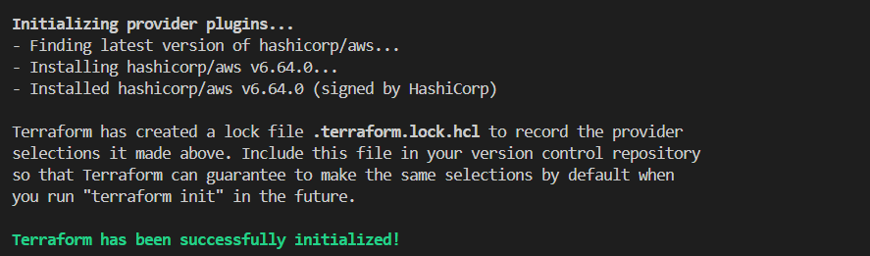

4. Check the configuration
terraform validate 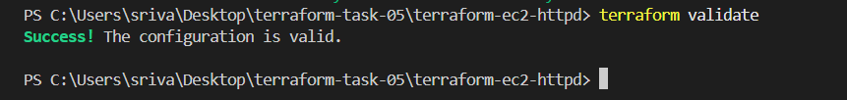

5. Create execution plan
terraform plan
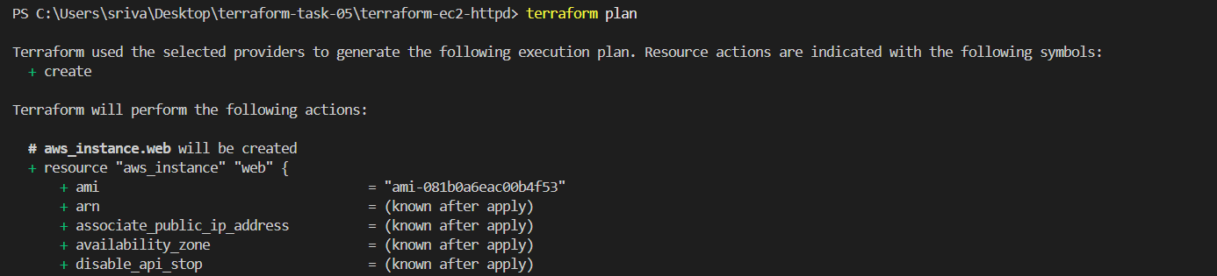

6. Create EC2
terraform apply
Enter:
yes
Terraform creates the EC2 instance. 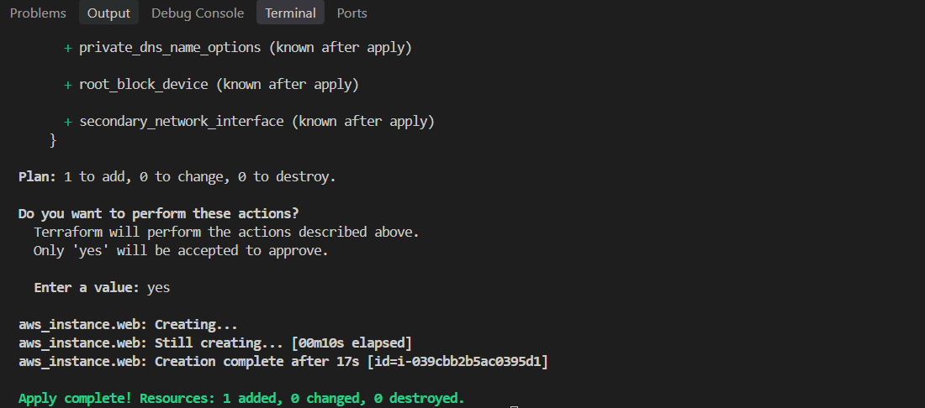

7. Verify EC2
terraform show
You can also check: 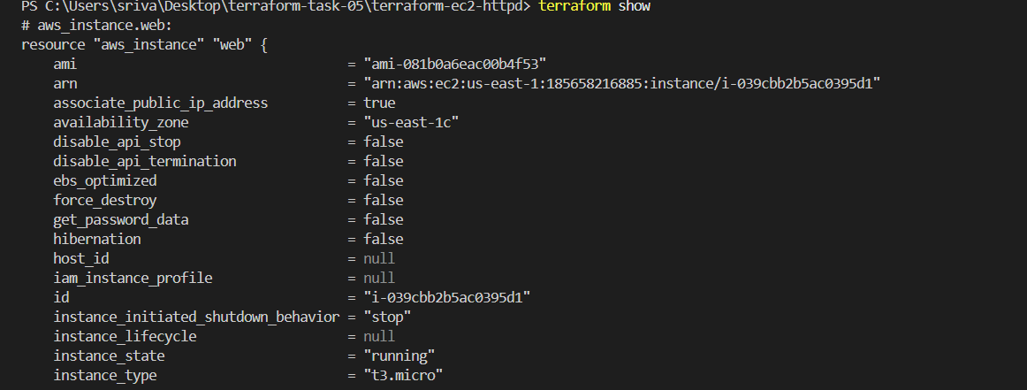
AWS Console → EC2 → Instances
Look for:
terraform-httpd
1. Add this to output.tf
output "user_data" {
value = aws_instance.web.user_data
}
2. Run
terraform apply
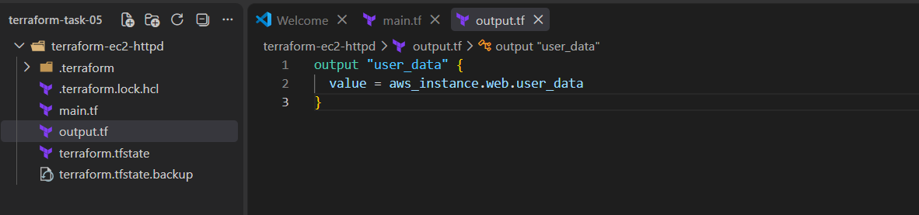

4). Set up S3 as backend for task 3.

1. Your folder
terraform-ec2-httpd/
├── main.tf
├── backend.tf
└── terraform.tfstate
2. First create S3 bucket
In main.tf, temporarily add:
resource "aws_s3_bucket" "terraform_state" {
bucket = "satish-terraform-state-2026-12345"

tags = {
Name = "Terraform State"
}
} 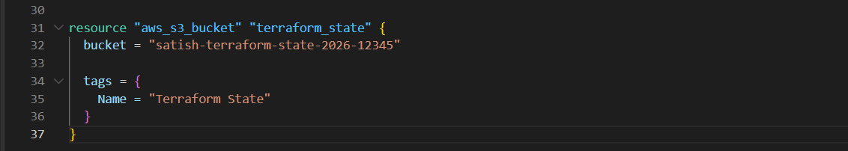
terraform init 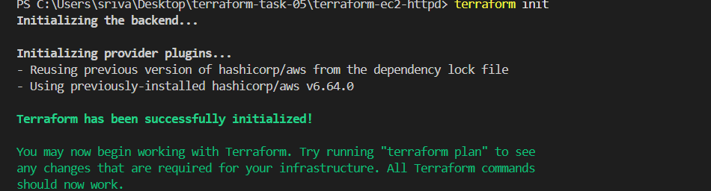
terraform apply
Enter:
Yes
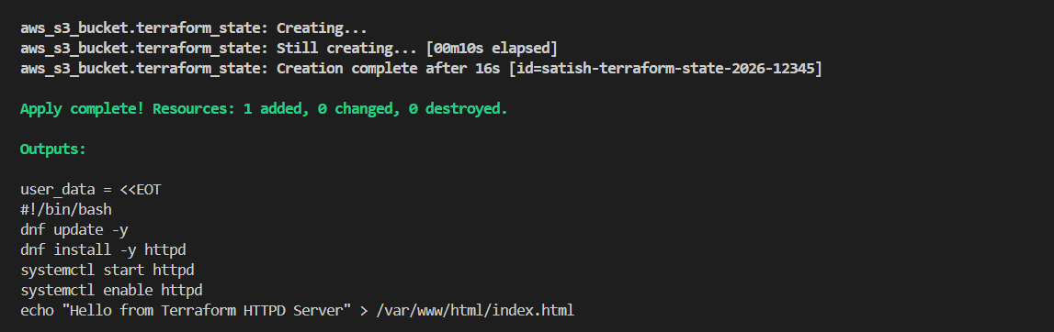
Verify:
aws s3 ls
3. Now configure backend
Create backend.tf:
terraform {
backend "s3" {
bucket = "satish-terraform-state-2026-12345"
key = "terraform-ec2-httpd/terraform.tfstate"
region = "ap-south-1"
}
} 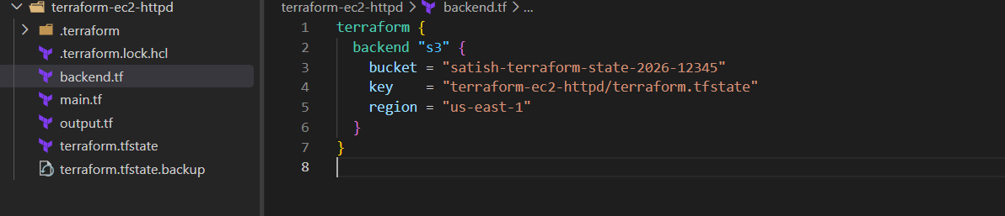

Terraform init
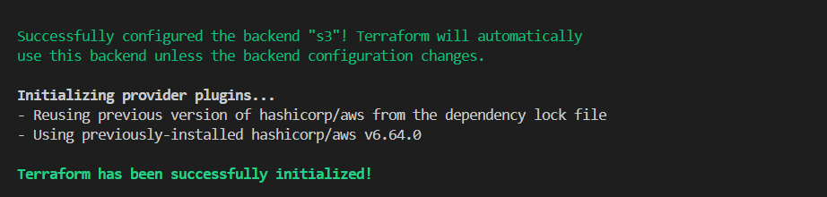

terraform state list 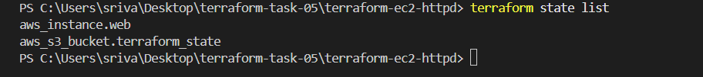
4. Important: remove S3 resource from main.tf
After the bucket is created, remove this:
resource "aws_s3_bucket" "terraform_state" {
...
}
Why? Because the bucket is now being used as the backend, and you don't want the same backend bucket managed by the state it stores.
5. Initialize backend
terraform init
When Terraform asks to migrate the existing state:
yes
6. Verify
terraform state list
And:
aws s3 ls s3://satish-terraform-state-2026-12345/terraform-ec2-httpd/
You should see:
terraform.tfstate
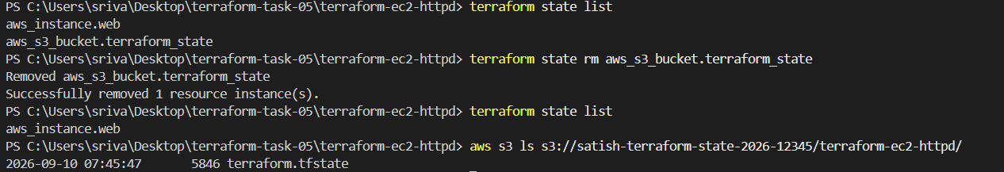

5). Set up DynamoDB locking for task 3.
Step 1 — Create DynamoDB table
Create a new file:
dynamodb.tf
Add:
resource "aws_dynamodb_table" "terraform_lock" {
name = "terraform-lock"
billing_mode = "PAY_PER_REQUEST"
hash_key = "LockID"

attribute {
name = "LockID"
type = "S"
}
} 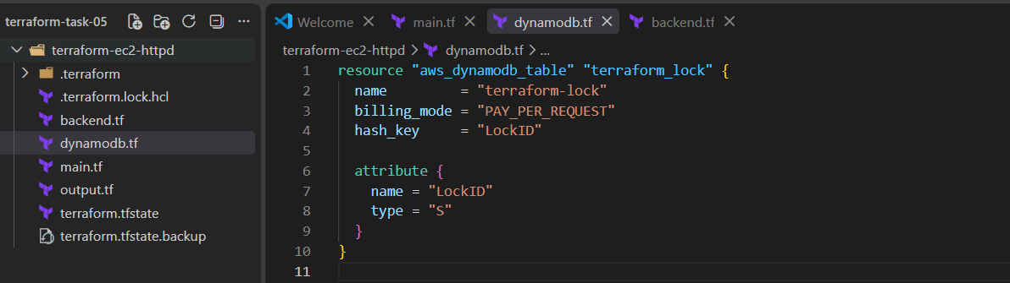

Step 2 — Create the table
Run:
terraform init 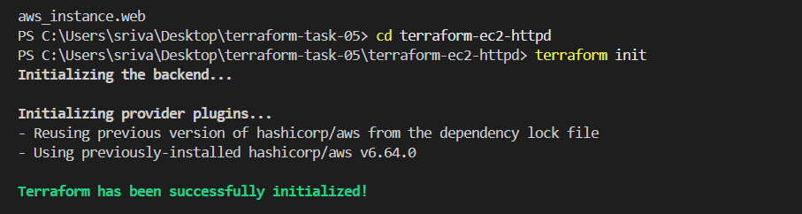
terraform plan 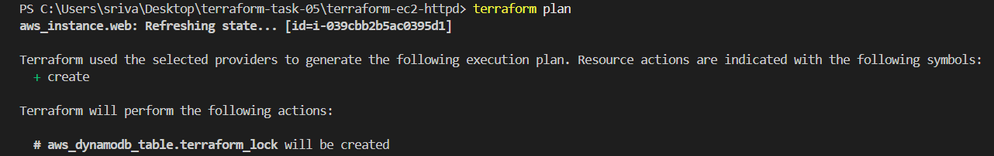
terraform apply
Enter:
Yes
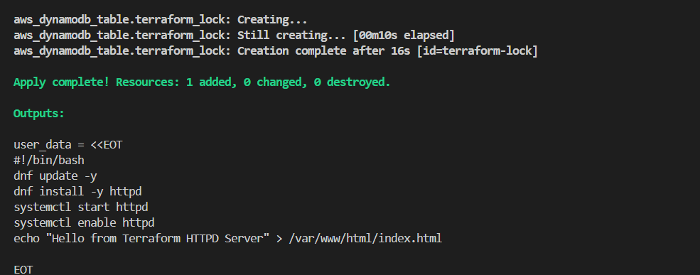
Step 3 — Verify DynamoDB
Run:
aws dynamodb describe-table --table-name terraform-lock --region us-east-1
You should see:
"TableName": "terraform-lock"
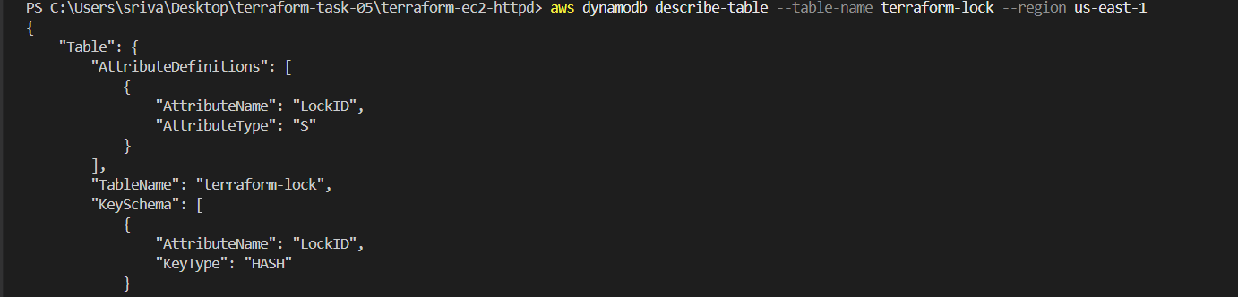
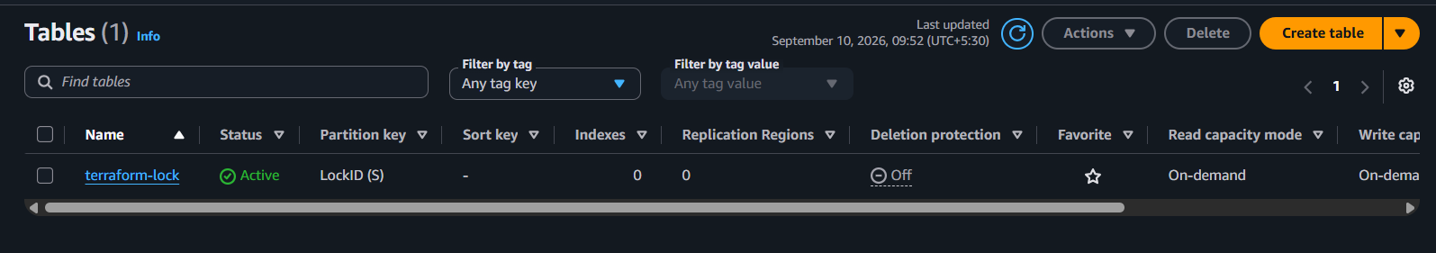
Step 4 — Configure backend
Your current backend.tf is:
terraform {
backend "s3" {
bucket = "satish-terraform-state-2026-12345"
key = "terraform-ec2-httpd/terraform.tfstate"
region = "us-east-1"
}
} 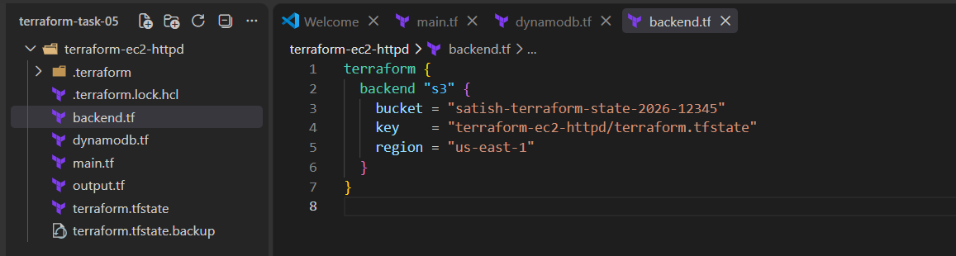
For the DynamoDB assignment, it would traditionally become:
terraform {
backend "s3" {
bucket = "satish-terraform-state-2026-12345"
key = "terraform-ec2-httpd/terraform.tfstate"
region = "us-east-1"
dynamodb_table = "terraform-lock"
}
}
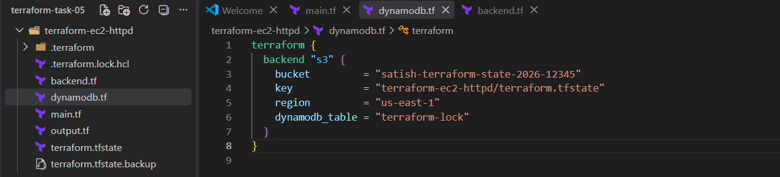
Then run:
terraform init -reconfigure 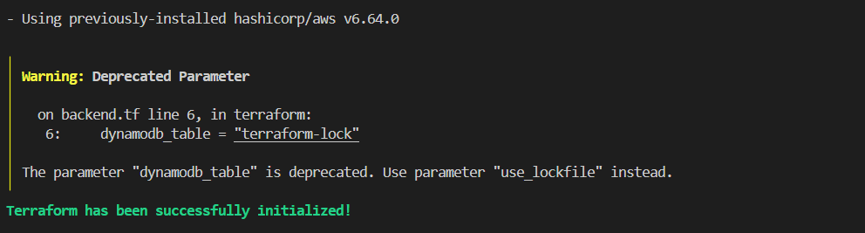
Step 5 — Verify
Run:
terraform plan 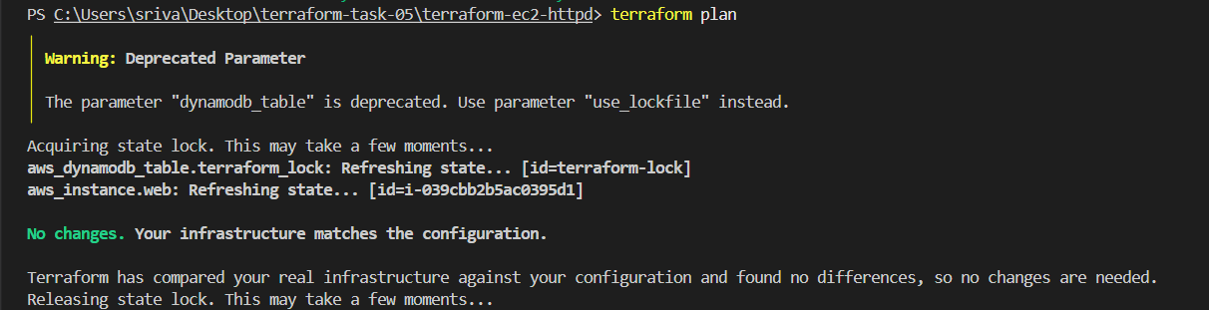
The important concept is:
Terraform
│
├── EC2
│
├── State ──────► S3
│
└── Lock ───────► DynamoDB
S3 = stores Terraform state
DynamoDB = prevents two Terraform operations from modifying state at the same time
DynamoDB state locking is successfully configured and verified. Terraform acquires the lock before accessing the state and releases it after the operation.

