Ansible-02 tasks
- Watch ansible-02 video and write down notes.
- Install httpd using ansible playbook, use handlers,notifiers.
Step 1: Go to your Ansible project directory
On the master server, run:
cd /home/ec2-user/ssh-key-lab
Step 2: Create the playbook
vi install_httpd.yml
Press i and paste this YAML:

---
- name: Install and start httpd
hosts: workers
become: yes

tasks:
- name: Install httpd
ansible.builtin.dnf:
name: httpd
state: present
notify: Restart httpd

- name: Start httpd service
ansible.builtin.service:
name: httpd
state: started
enabled: yes

handlers:
- name: Restart httpd
ansible.builtin.service:
name: httpd
state: restarted
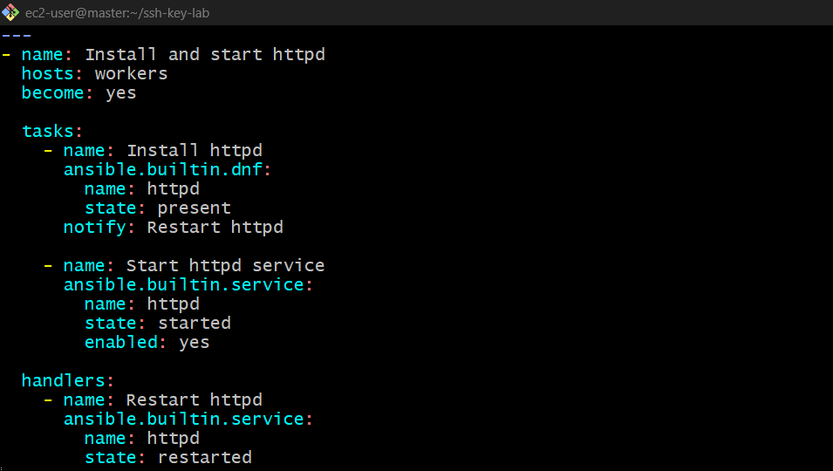
Save and exit: press Esc, type :wq, and press Enter.
Step 3: Check the playbook syntax
ansible-playbook -i inventory install_httpd.yml --syntax-check

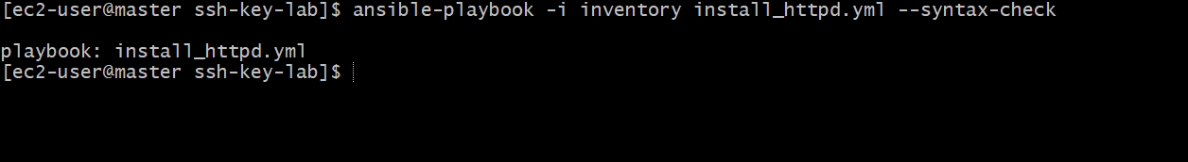
Step 4: Execute the playbook
ansible-playbook -i inventory install_httpd.yml
Ansible will install HTTPD on both worker1 and worker2, start the service, and enable it at boot. 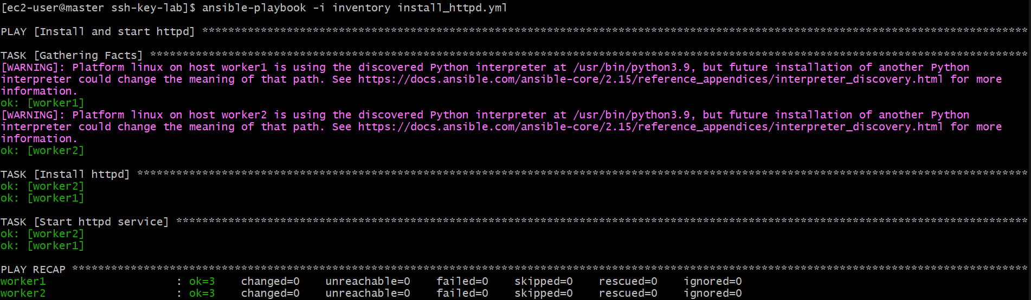
Step 5: Verify HTTPD is running
ansible workers -i inventory -b -m command -a "systemctl is-active httpd"
Expected output:
worker1 | SUCCESS | rc=0 >>
active

worker2 | SUCCESS | rc=0 >>
active 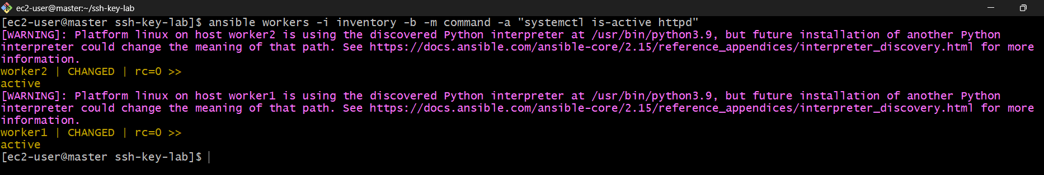
Step 6: Understand handler and notify
- Task: Installs HTTPD.
- Notify: Calls the Restart httpd handler when the installation task reports a change.
- Handler: Restarts HTTPD at the end of the play if notified.
Important: The handler runs only when notified. If HTTPD is already installed, the installation task may report no change, so the handler may not run.

- Write a ansible playbook to install apache tomcat.
We will install Java and Apache Tomcat on both worker servers using an Ansible playbook.
Step 1: Go to the project directory
On the master server:
cd /home/ec2-user/ssh-key-lab
Step 2: Create the playbook
vi install_tomcat.yml
Press i and paste this YAML:

---
- name: Install Apache Tomcat
hosts: workers
become: yes

tasks:
- name: Install Java
ansible.builtin.dnf:
name: java-21-amazon-corretto
state: present

- name: Install Tomcat
ansible.builtin.dnf:
name: tomcat
state: present

- name: Start Tomcat service
ansible.builtin.service:
name: tomcat
state: started
enabled: yes
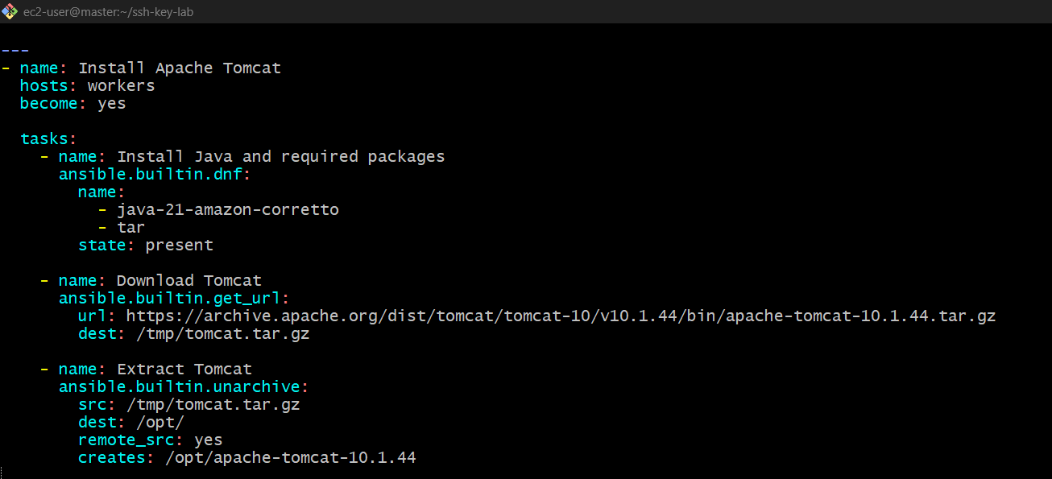
Save and exit: press Esc, type :wq, and press Enter.
Step 3: Check syntax
ansible-playbook -i inventory install_tomcat.yml --syntax-check 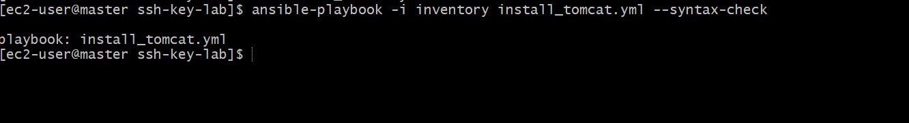
Step 4: Run the playbook
ansible-playbook -i inventory install_tomcat.yml
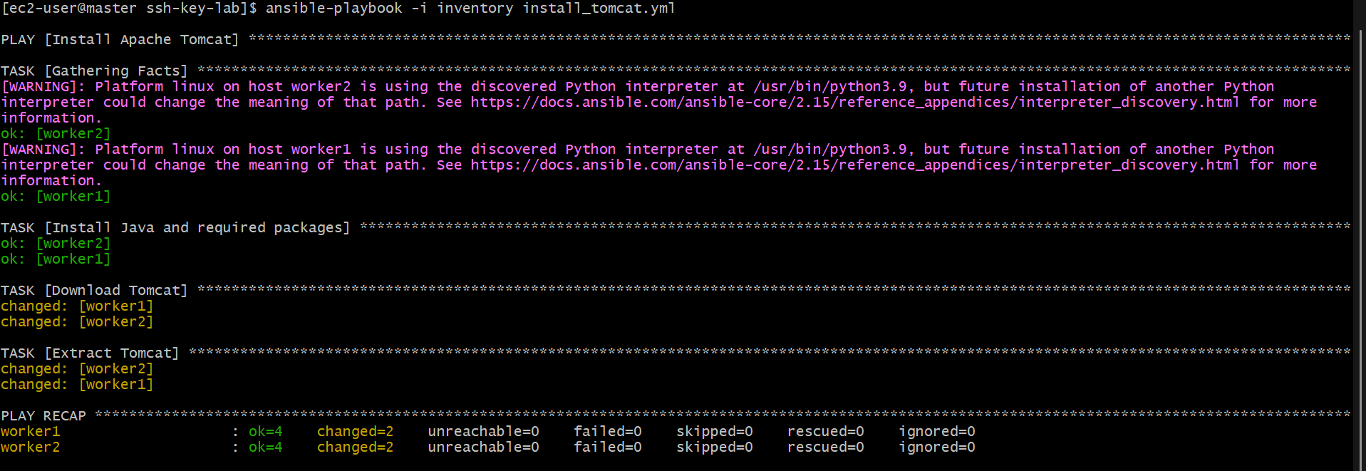
Step 5: Verify Tomcat
ansible workers -i inventory -b -m command -a "systemctl is-active tomcat"
Expected output:
worker1 | SUCCESS | rc=0 >>
active

worker2 | SUCCESS | rc=0 >>
active
Important: This playbook assumes your worker servers use Amazon Linux 2023 repositories that provide the tomcat package. If the package is unavailable, the playbook will fail; the installation method will need to be adjusted for your OS and Tomcat version. 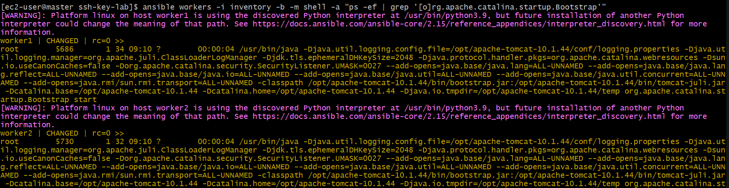

- Write a ansible playbook to provision one ec2 on aws.
We will use Ansible to create one EC2 instance in AWS.
Step 1: Install required AWS libraries
Run this on your Ansible master:
sudo dnf install python3-pip -y
pip3 install boto3 botocore
Make sure the AWS CLI is configured with credentials that have permission to create EC2 instances: 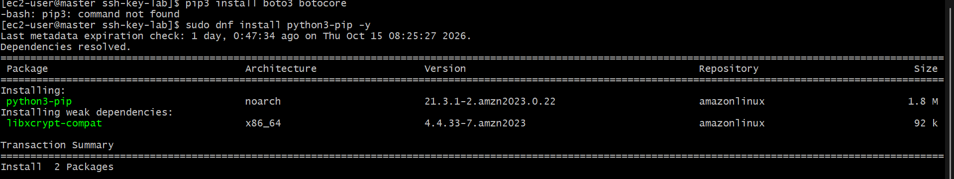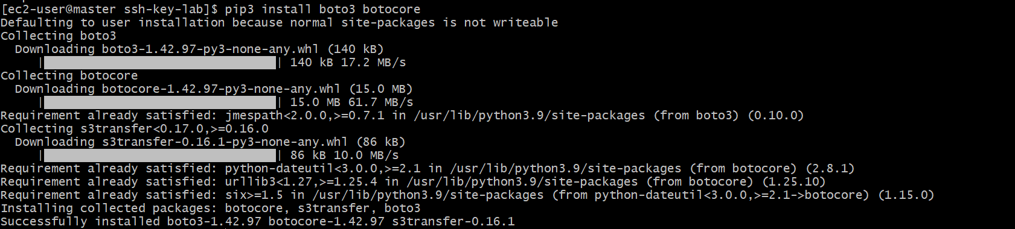
aws configure
Enter your AWS Access Key, Secret Key, and region (for example, us-east-1).
Step 2: Install the AWS Ansible collection
ansible-galaxy collection install amazon.aws
Step 3: Create the playbook
vi create_ec2.yml
Paste this simple YAML:

---
- name: Create one EC2 instance
hosts: localhost
connection: local
gather_facts: no

tasks:
- name: Launch EC2 instance
amazon.aws.ec2_instance:
name: Ansible-EC2
region: us-east-1
image_id: ami-xxxxxxxxxxxxxxxxx
instance_type: t3.micro
key_name: YOUR_KEY_PAIR
security_group: default
network_interfaces:
- assign_public_ip: true
count: 1
state: present
Replace ami-xxxxxxxxxxxxxxxxx with a valid AMI ID from your AWS region and YOUR_KEY_PAIR with your existing EC2 key pair name. 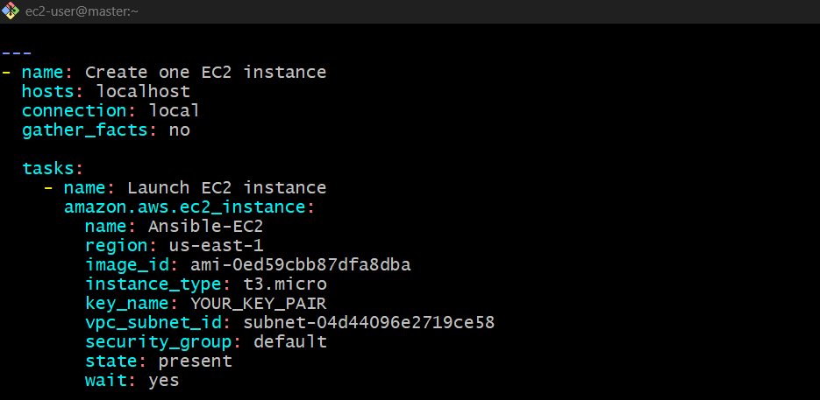
Step 4: Run the playbook
ansible-playbook create_ec2.yml 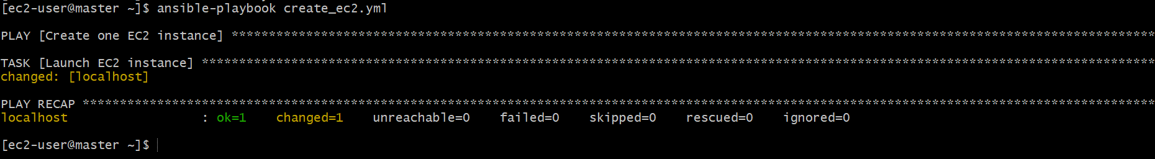
Step 5: Verify the instance
aws ec2 describe-instances --region us-east-1 --query "Reservations[].Instances[].[InstanceId,State.Name,InstanceType]" --output table
You should see the newly created EC2 instance and its state.

- Write a ansible playbook to copy one file from node-1 to node-2.
Ansible's copy module copies files from the master to a worker. To copy directly from node-1 to node-2, use fetch to retrieve the file to the master, then copy to send it to node-2.
Step 1: Create the playbook on the master
cd /home/ec2-user/ssh-key-lab
vi copy_file.yml
Paste this simple YAML:

---
- name: Copy file from node-1 to node-2
hosts: worker1
become: yes

tasks:
- name: Fetch file from node-1 to master
ansible.builtin.fetch:
src: /tmp/test.txt
dest: /tmp/
flat: yes

- name: Copy file from master to node-2
hosts: worker2
become: yes

tasks:
- name: Copy file to node-2
ansible.builtin.copy:
src: /tmp/test.txt
dest: /tmp/test.txt
mode: "0644"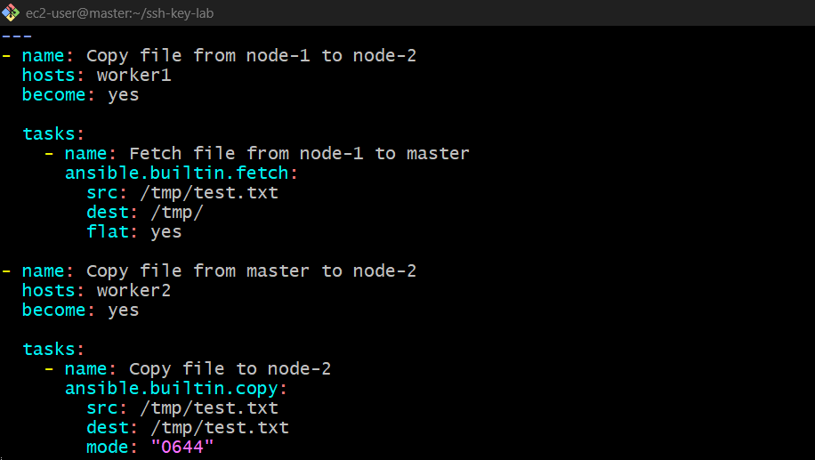
Step 2: Create a test file on node-1
ansible worker1 -i inventory -b -m copy -a "content='Hello from node-1' dest=/tmp/test.txt" 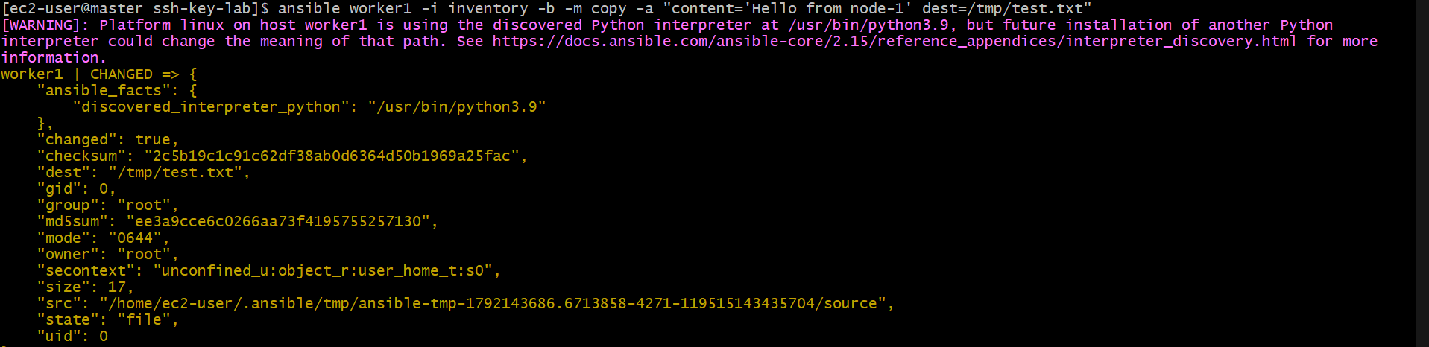
Step 3: Run the playbook
ansible-playbook -i inventory copy_file.yml
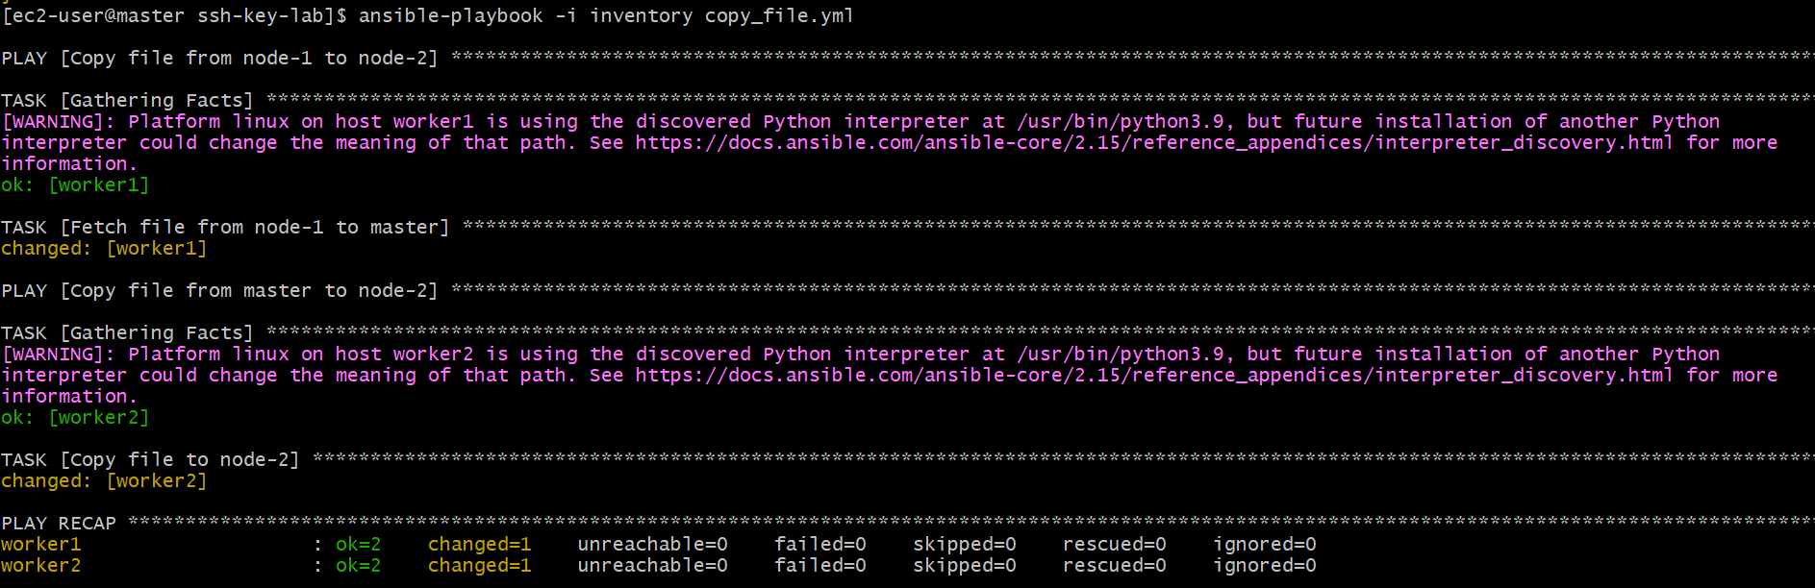
Step 4: Verify on node-2
ansible worker2 -i inventory -b -m command -a "cat /tmp/test.txt"
Expected output:
Hello from node-1
How it works: Node-1 → Ansible master → Node-2.

- Write a ansible playbook to create different files with different names using single playbook.
1. Create create_files.yml
---
- name: Create multiple files
hosts: workers
become: yes

tasks:
- name: Create files
ansible.builtin.file:
path: "/tmp/{{ item }}"
state: touch
mode: "0644"
loop:
- file1.txt
- file2.txt
- file3.txt 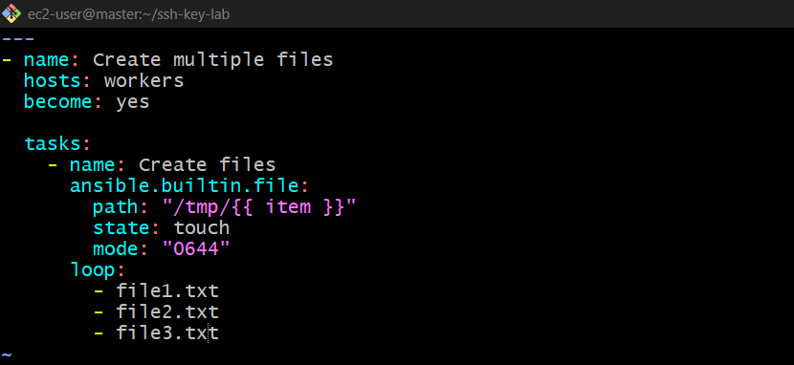
2. Run the playbook
ansible-playbook -i inventory files.yaml 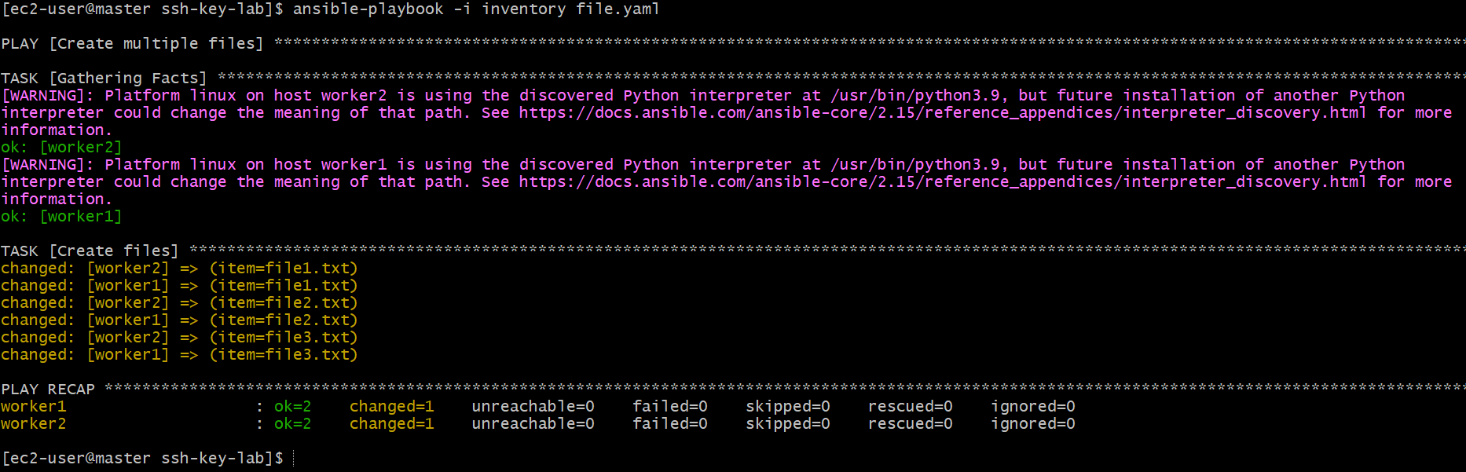
3. Verify the files
ansible workers -i inventory -b -m shell -a "ls -l /tmp/file*.txt"
Expected result: file1.txt, file2.txt, and file3.txt will be created in /tmp/ on both worker1 and worker2.
Key point: loop lets you create multiple files using a single task. 