Ansible-01 tasks
- Watch ansible-01 video and write down notes.
- Setup one master and two worker nodes in ansible.
1. Purpose
The purpose of this lab is to set up an Ansible control node (master) and two managed nodes (workers) so that you can manage multiple Linux servers from one machine.
2. Objective
By the end of this lab, you will be able to:
- Install Ansible on the master node.
- Configure SSH connectivity from master to both workers.
- Add worker IP addresses to the Ansible inventory.
- Test connectivity using Ansible ping.
- Execute commands on both workers from the master.

Step 1: Create 3 EC2 instances
Create three Ubuntu instances in AWS.
Instance | Role
Ansible-Master | Control node
Ansible-Worker1 | Managed node
Ansible-Worker2 | Managed node
Allow SSH (port 22) between the master and workers. Note all three private IP addresses. 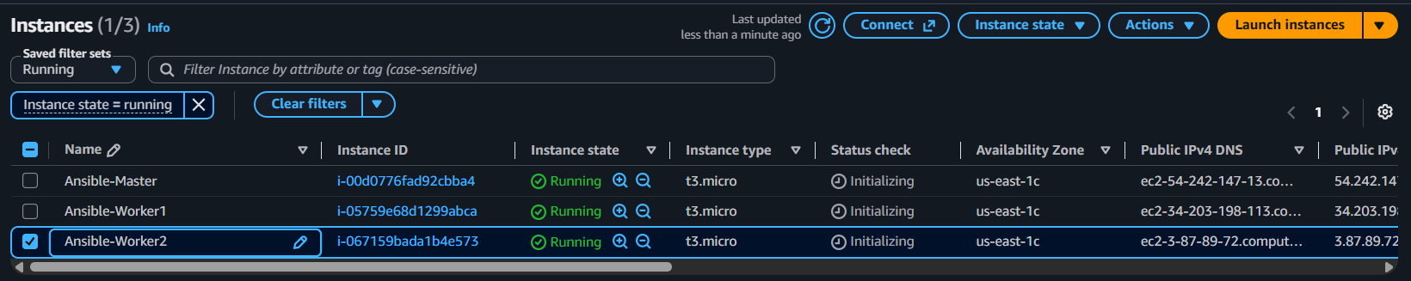
Step 2: Install Ansible on the master
Connect to the master and run:
sudo yum update
sudo yum install ansible -y 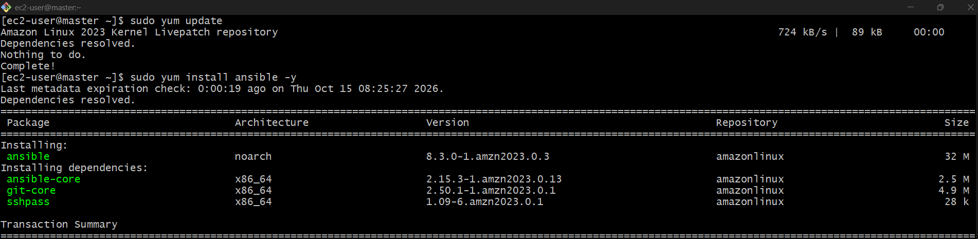
ansible --version 
Step 3: Configure SSH from master to workers
On the master, generate a key:
ssh-keygen 
Press Enter to accept the defaults.
Display the public key:
cat ~/.ssh/id_rsa.pub
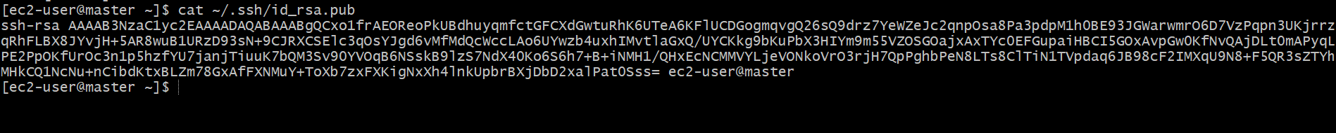
Copy the output.
On each worker, log in and run:
mkdir -p ~/.ssh
chmod 700 ~/.ssh
nano ~/.ssh/authorized_keys
Ansible-worker-01
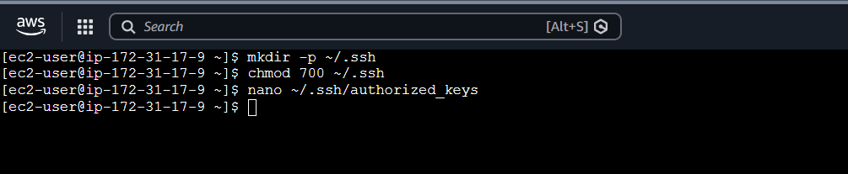
Paste the master's public key into the file, save it, and run:
chmod 600 ~/.ssh/authorized_keys
Ansible-worker-02

Step 4: Test SSH connections
From the master, run:
ssh ubuntu@WORKER1_PRIVATE_IP
Then test Worker 2:
ssh ubuntu@WORKER2_PRIVATE_IP 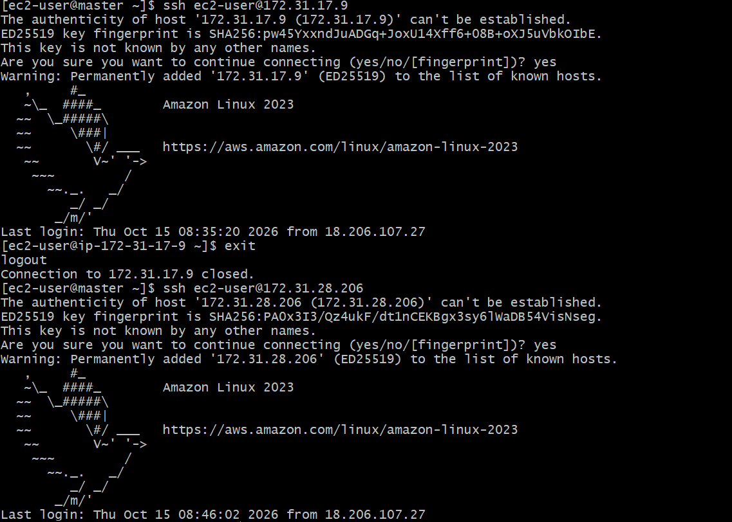
Replace the placeholders with the actual private IP addresses. Exit each SSH session before proceeding.
Step 5: Configure the inventory file
On the master:
sudo nano /etc/ansible/hosts
Add this configuration, replacing the example IPs:
[workers]
worker1 ansible_host=172.31.10.11
worker2 ansible_host=172.31.10.12

[workers:vars]
ansible_user=ubuntu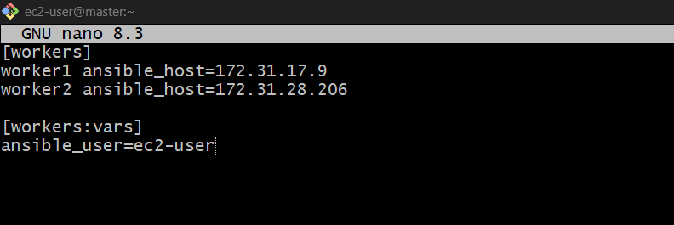
Save and exit.
Step 6: Verify the inventory
ansible-inventory --list
You should see both workers listed. 
Step 7: Test Ansible connectivity
ansible workers -m ping
Expected result:
worker1 | SUCCESS => {
"ping": "pong"
}
worker2 | SUCCESS => {
"ping": "pong"
} 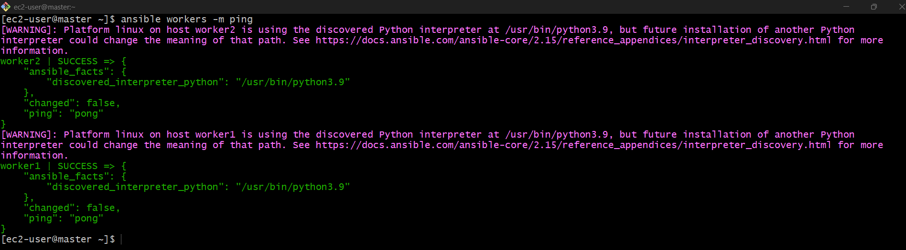
Step 8: Run a command on both workers
ansible workers -m command -a "hostname"
Ansible should display the hostname of each worker. 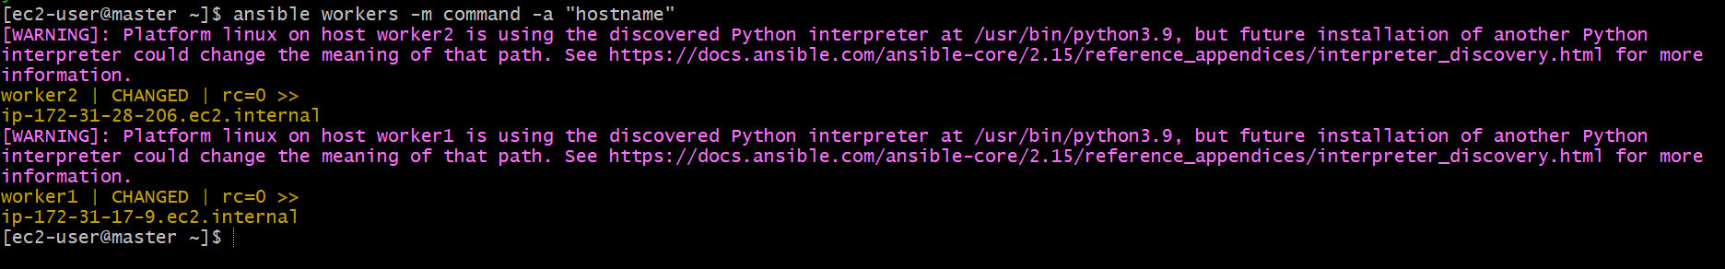
Final result
- Master: Ansible installed and configured.
- Worker 1: Connected through SSH.
- Worker 2: Connected through SSH.
- Verification: Ansible successfully executes commands on both workers.
Important: Complete Steps 1–3 first. If SSH does not work, fix SSH access before proceeding to the inventory and Ansible ping steps.

- Execute the adhoc command shared in #dvps-cloud-documents-12 Channel.
1. Check connectivity between slaves
Purpose: To verify that the Ansible controller can communicate with the managed nodes.
Use case: Before executing automation tasks, confirm that all worker servers are reachable.
ansible all -m ping
ansible all -m ping -i ansible_hosts 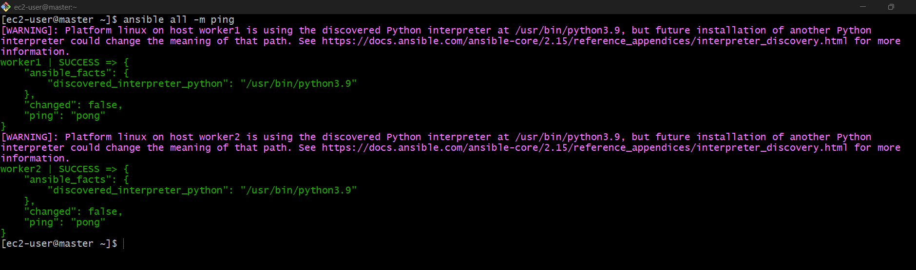
2. Gather facts of slave machines
Purpose: To collect system information such as hostname, IP address, operating system, CPU, and memory.
Use case: To check server configurations before deploying an application.
ansible all -m setup 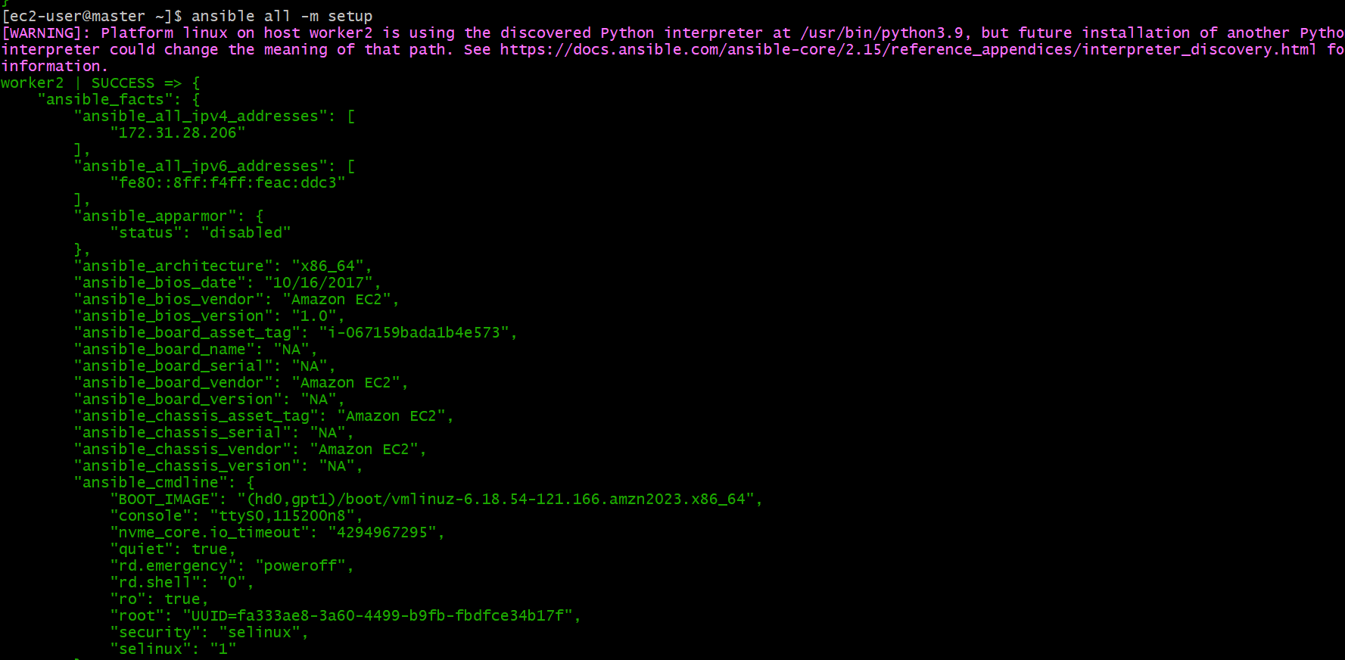
Tip: -i specifies the inventory file to use when running Ansible with a particular inventory.
3. Connect using username and password
# What if you do not have SSH key-based? How to pass username and password?
Purpose: To authenticate to managed nodes using an SSH username and password instead of an SSH key.
Use case: When password-based SSH authentication is enabled on the managed nodes.
ansible all -m ping --user=ansadm --ask-pass
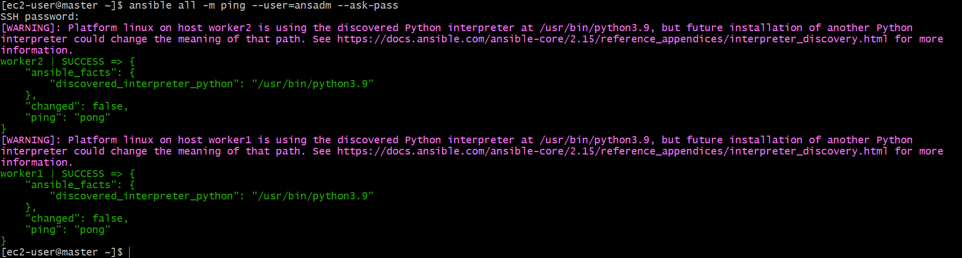
4. Check uptime of slave machines
Purpose: To check how long each server has been running since its last reboot.
Use case: To investigate server restarts and monitor system availability.
ansible all -a uptime 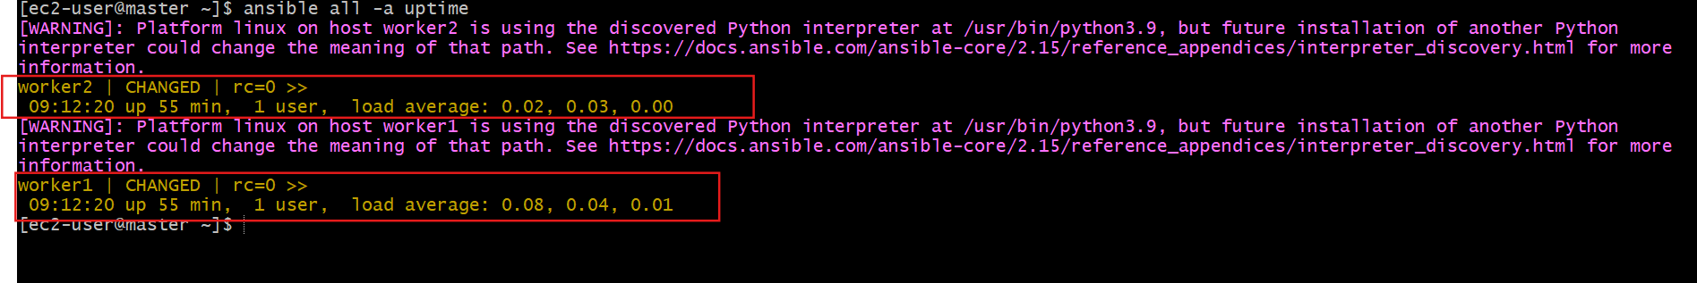
5. Check free memory or memory usage
Purpose: To display used and available RAM on managed nodes.
Use case: To troubleshoot high memory usage and application performance issues.
ansible all -a "free -m"
Tip: -m specifies the Ansible module, while -a supplies arguments to that module. If -m is omitted, Ansible uses the command module by default. 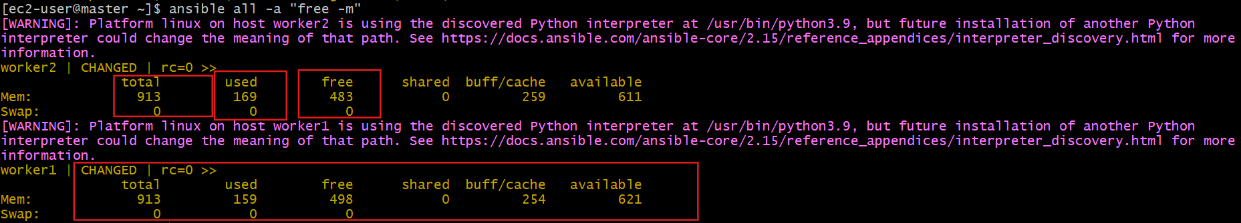
6. Execute a command as root using sudo
Purpose: To run a command with elevated privileges on managed nodes.
Use case: To access protected system information or perform administrative tasks.
ansible all -m shell -a "cat /etc/passwd|grep -i ansadm" -s --ask-sudo-pass
Note: -s and --ask-sudo-pass are legacy options and may not work with modern Ansible versions. 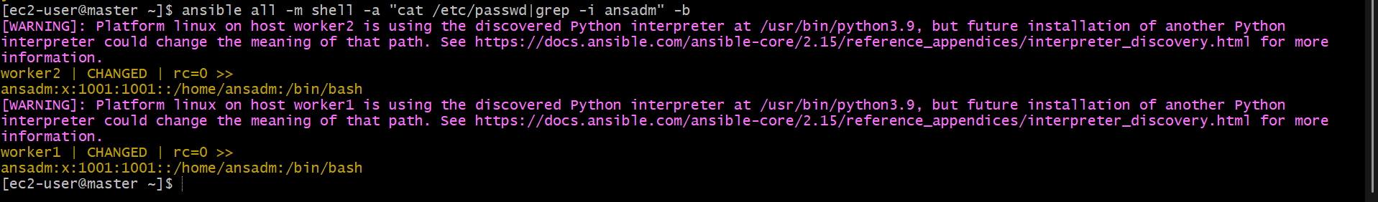
7. Execute a command using the become module
Purpose: To run commands with elevated privileges, usually as root.
Use case: To search for a particular user account in the system account file.
ansible all -m shell -a "cat /etc/passwd|grep -i ansadm" -b -K
Tips:
- -b enables privilege escalation (become).
- -K prompts for the become/sudo password.
- By default, become normally switches to root.
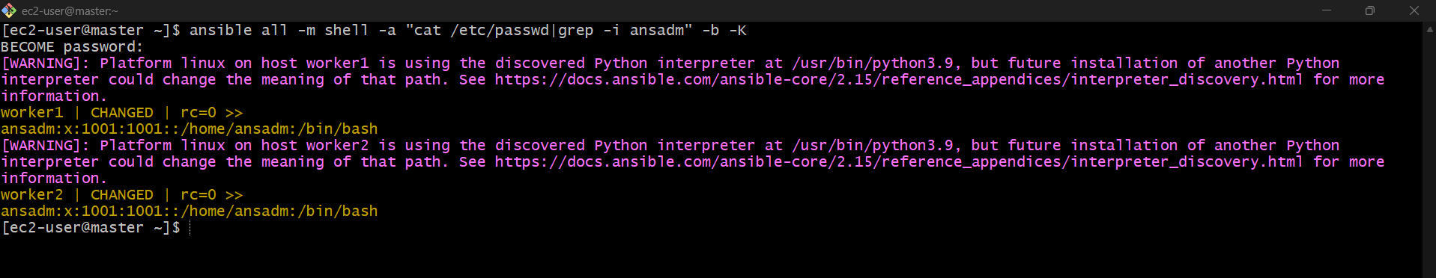

8. Execute a command as a different user
Purpose: To perform an operation using a specified user's privileges.
Use case: To create a directory for an application or service account.
ansible all -m file -a "path=/home/ansadm/test state=directory mode=0755" -b --become-user=ansadm 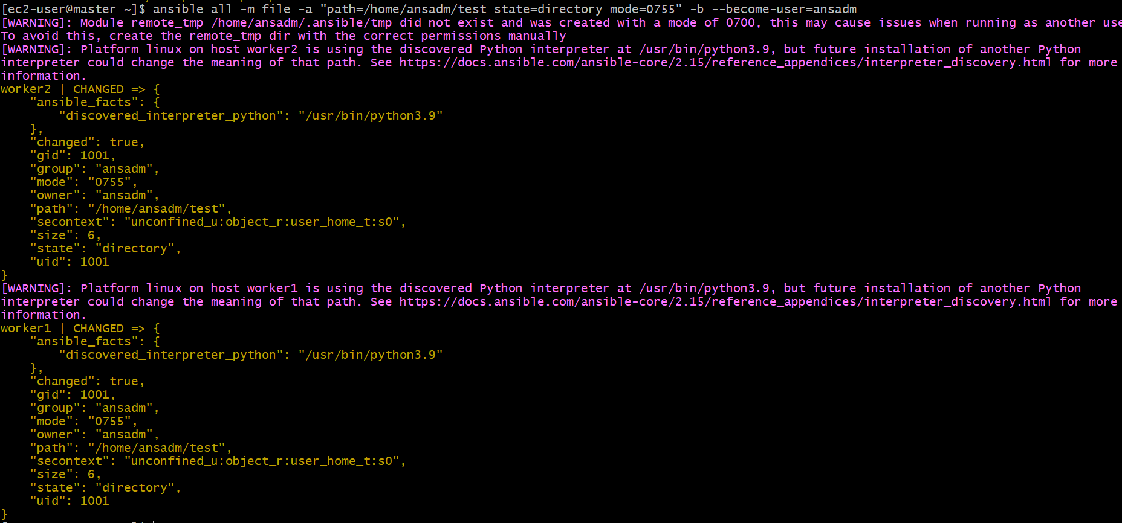
9. Create a Linux user group
Purpose: To create a group if it does not already exist.
Use case: To manage permissions for users who need access to shared application files.
ansible all -s -m group -a "name=test state=present" -b -K 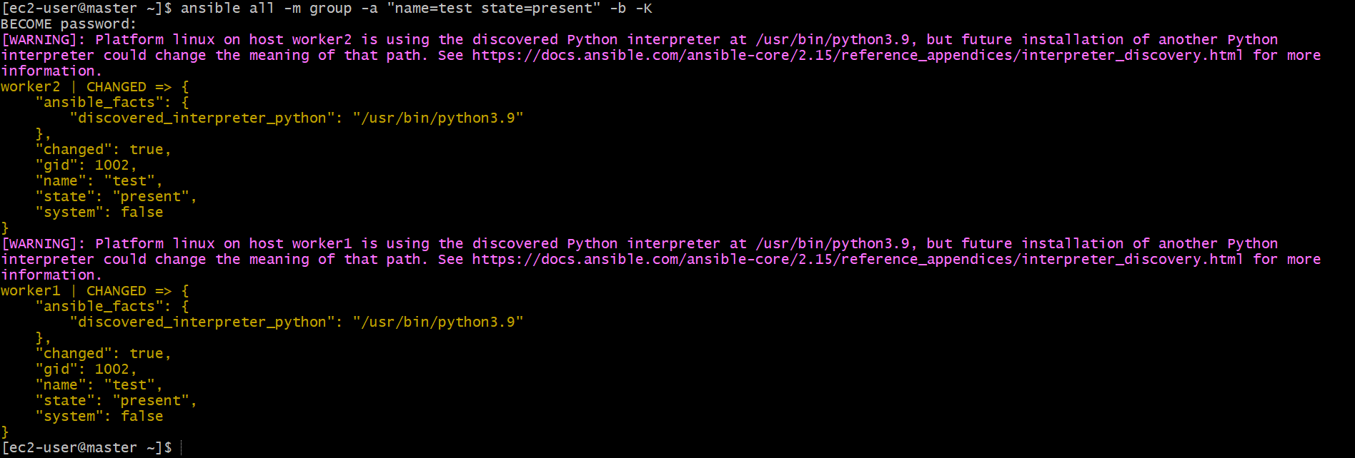

10. Create a file with 755 permission
Purpose: To create an empty file and assign the specified permissions.
Use case: To create a file for an application or script.
ansible all -m file -a "path=/home/asnadm/testfile state=touch mode=0755" 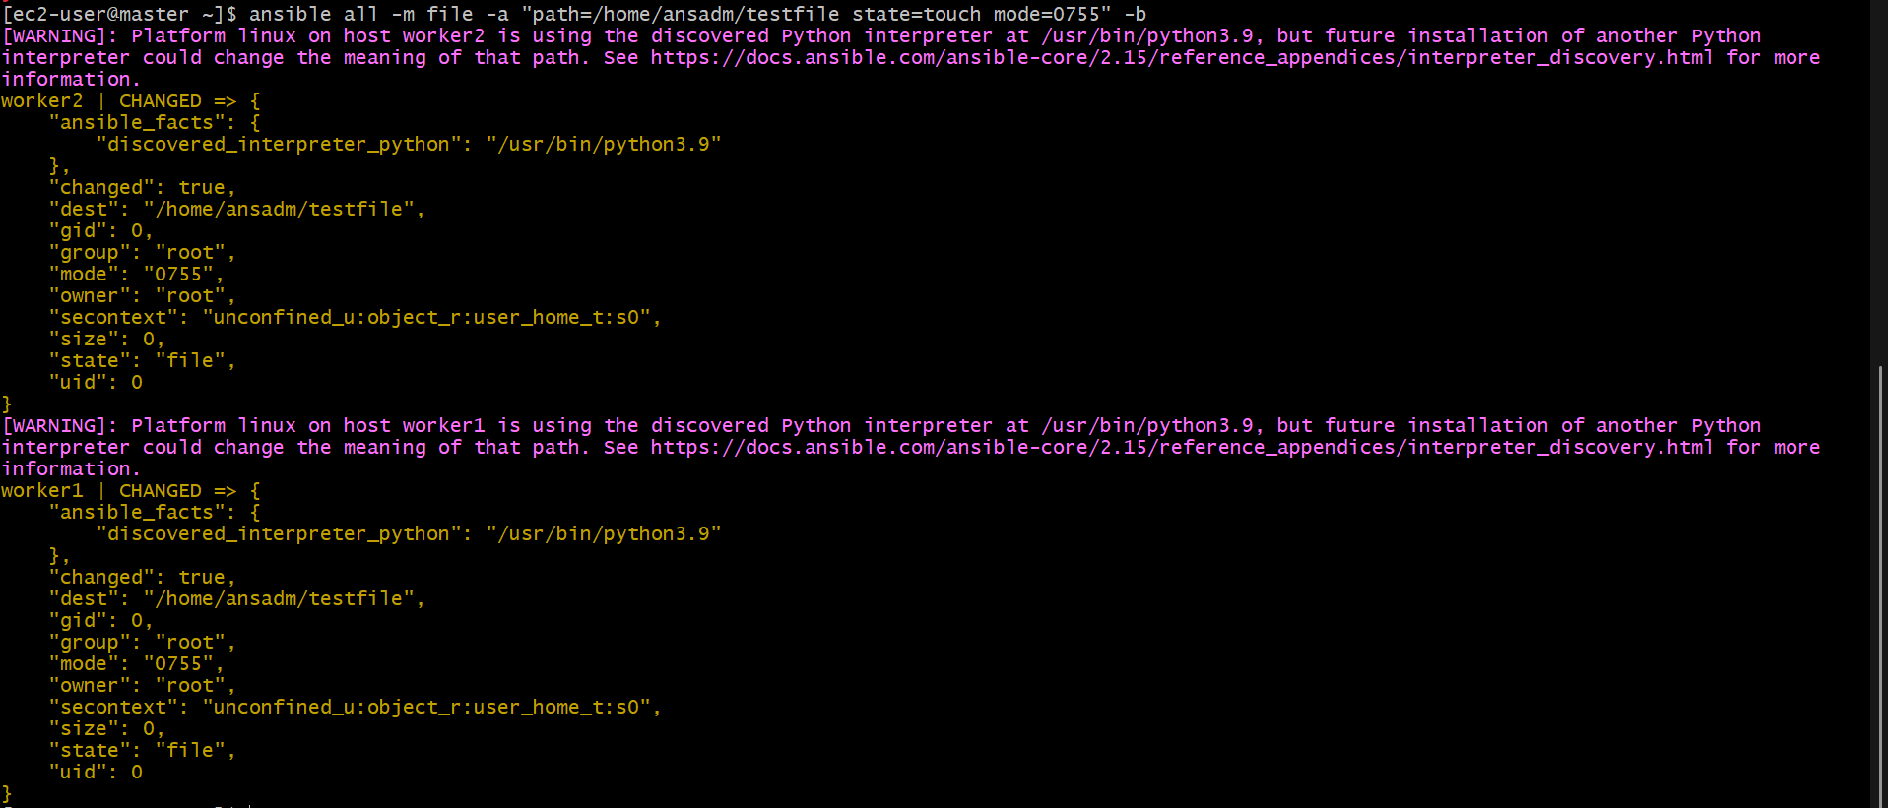
11. Change ownership of a file
Purpose: To change the owner and group of a file or directory.
Use case: To give an application the correct ownership of its files.
User
ansible all -m user -a "name=weblogic state=present" -b 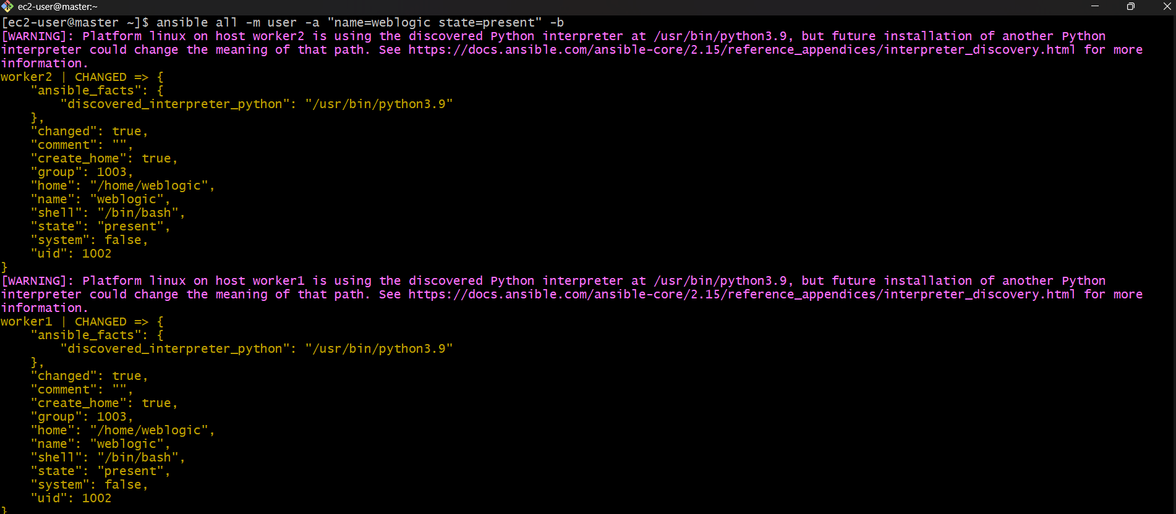
Group
ansible all -m group -a "name=weblogic state=present" -b 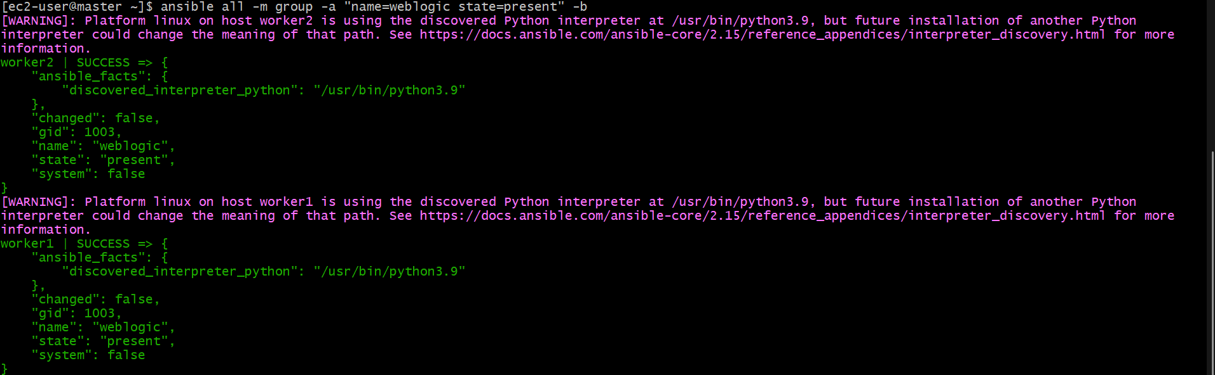
File
ansible all -m file -a "path=/home/ansadm group=weblogic owner=weblogic" -b 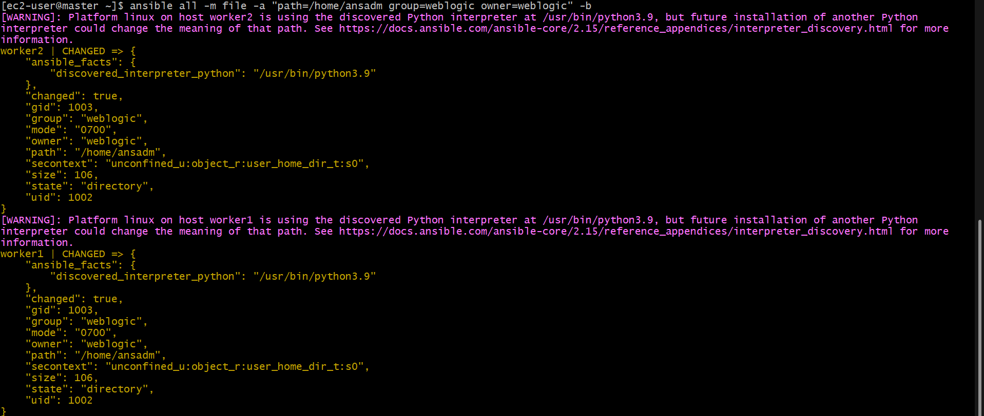

12. Install a package using the yum module
Purpose: To install software on multiple managed nodes.
Use case: To install Apache HTTP Server on managed servers.
ansible all -m yum -a "name=httpd state=installed" 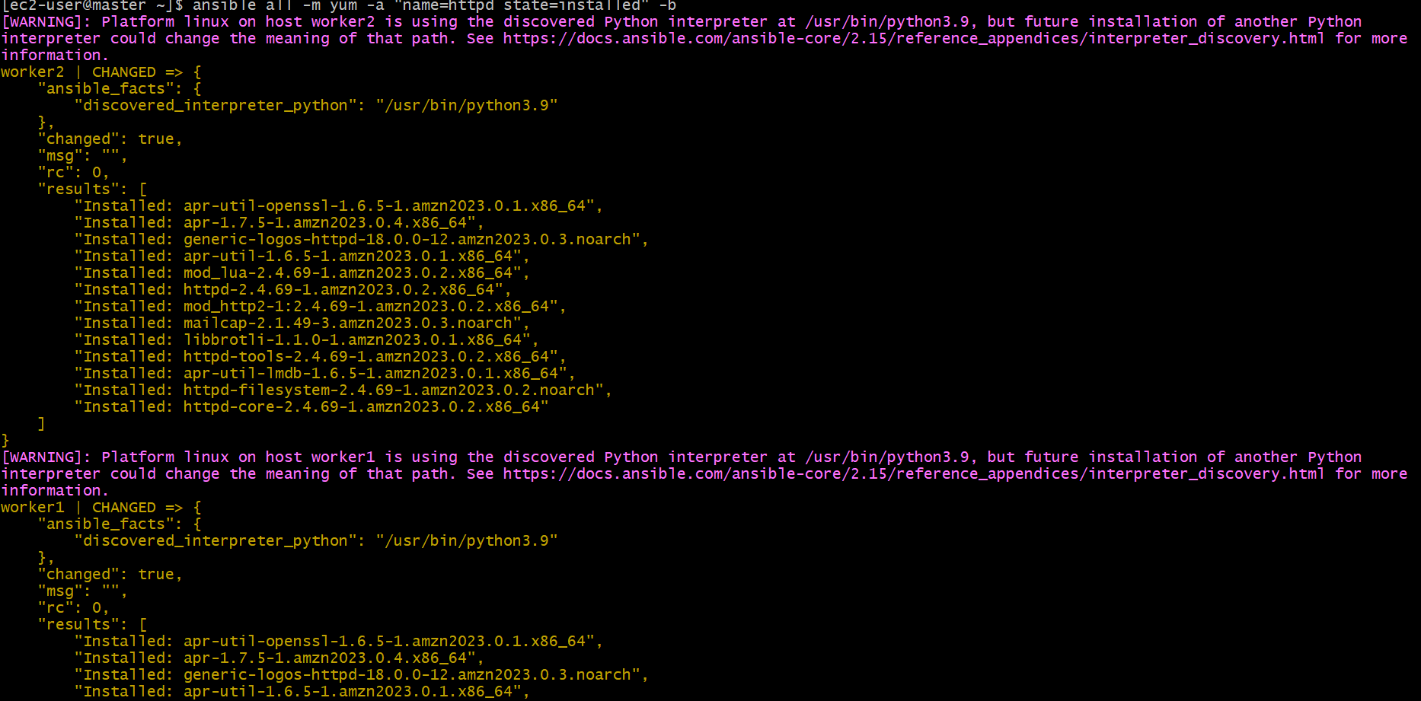
13. Start or stop a service
Purpose: To control a service remotely and configure whether it starts automatically at boot.
Use case: To start Apache after installation or stop it during maintenance.
To start:
ansible all -m service -a "name=httpd state=started enabled=yes" 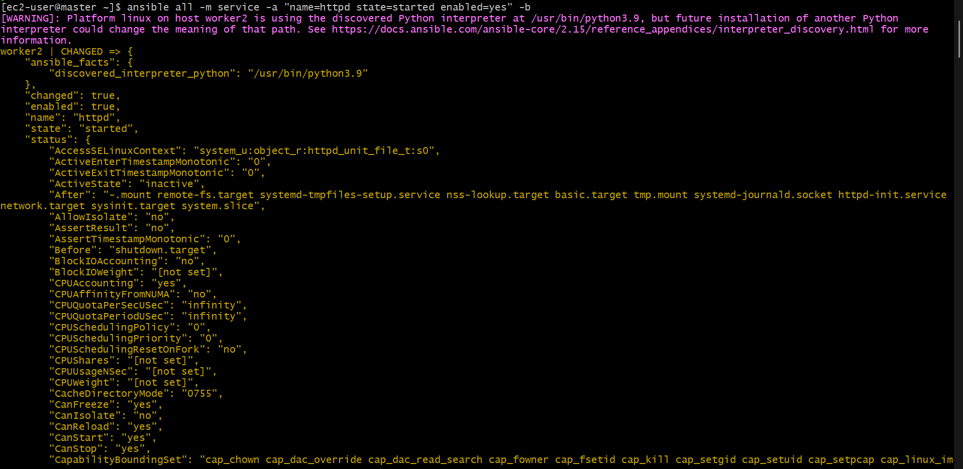
To stop:
ansible all -m service -a "name=httpd state=stopped enabled=yes"
