Create a image from running container.
Step 1: Identify the Running Container
docker ps
Purpose: Find the container name or container ID from which you want to create the image.
Step 2: Create an Image from the Container
docker commit <container-name> <image-name>:<tag>
Purpose: Creates a new Docker image from the current state of the running container.
Step 3: Verify the Image
docker images
Purpose: Confirms that the new image has been created successfully.
Process
Running Container → docker commit → New Docker Image
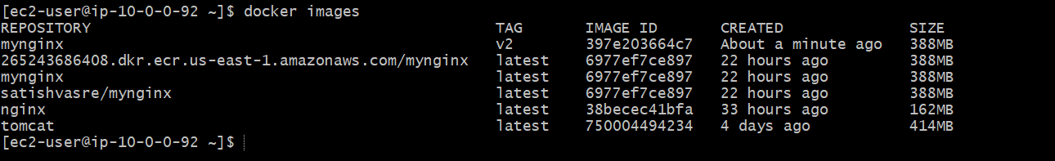

Copy image from local machine to docker server and load the image.
Step 1: Open Docker Desktop
Open Docker Desktop on your Windows machine.
Wait until Docker Desktop shows that the Docker Engine is running.
Verify from Git Bash: docker version
Explanation: Confirms that both Docker Client and Docker Server (Engine) are running.

Step 2: Check Docker Context
docker context ls
Make sure desktop-linux is selected:
desktop-linux *
Explanation: Ensures your local Docker CLI is connected to Docker Desktop's Linux engine.

Step 3: Pull the Nginx Image
docker pull nginx:latest
Explanation: Downloads the Nginx image from Docker Hub to your local Docker. 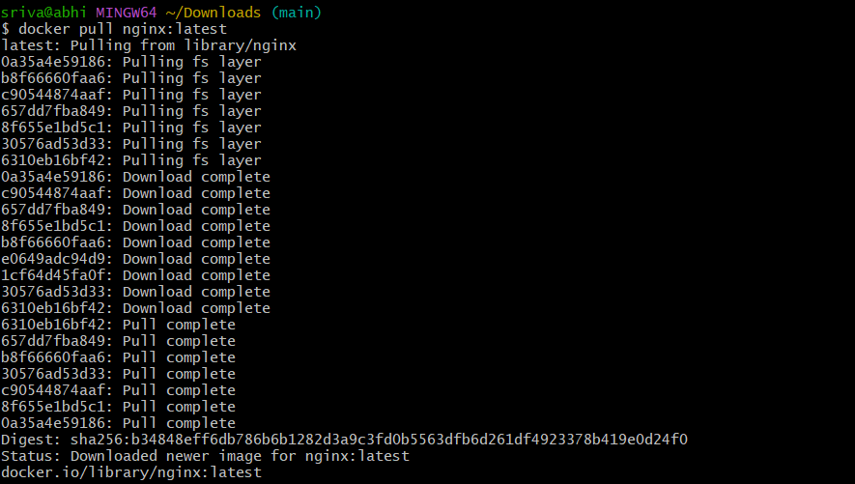

Step 4: Verify the Image
docker images
Explanation: Confirms that nginx:latest is available on your local machine. 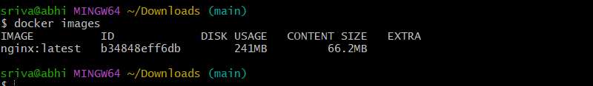

Step 5: Save the Image as a TAR File
docker save -o nginx.tar nginx:latest
Explanation: Converts the Docker image into a portable .tar archive.

Step 6: Verify the TAR File
ls -lh nginx.tar
Explanation: Confirms that the image archive was created successfully. 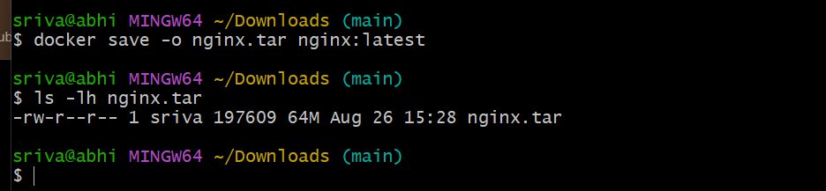

Step 7: Verify the SSH Key
Make sure your private key is available in the current directory:
ls -lh linux-testing.pem
Explanation: The key is required to connect to the EC2 Docker server. 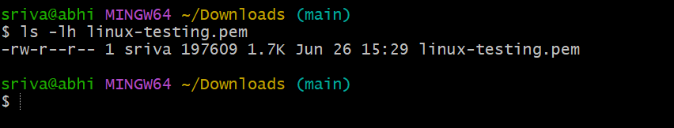

Step 8: Copy the Image to the Docker Server
Run this command from your local Git Bash:
scp -i linux-testing.pem nginx.tar ec2-user@34.205.131.107:/home/ec2-user/
Explanation: Copies the nginx.tar file from your local machine to the EC2 server. 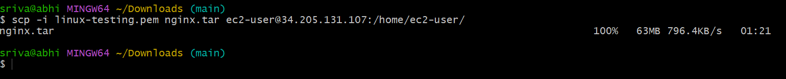

Step 9: Connect to the Docker Server
ssh -i linux-testing.pem ec2-user@34.205.131.107
Explanation: Establishes an SSH connection to the EC2 Docker server. 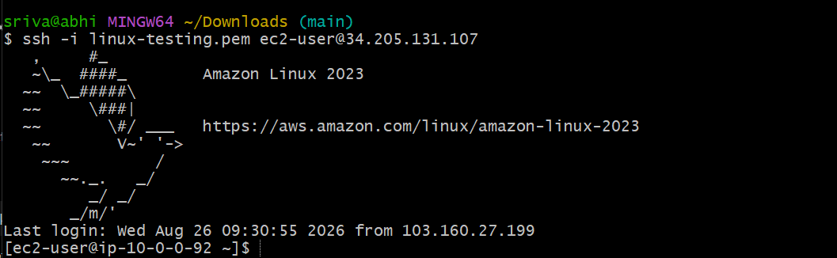

Step 10: Verify the TAR File on the Server
ls -lh nginx.tar
Explanation: Confirms that the image file was successfully transferred. 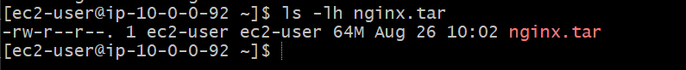

Step 11: Load the Image into Docker
docker load -i nginx.tar
Explanation: Loads the Docker image from the TAR archive into the server's local Docker image repository.

Step 12: Verify the Image
docker images
Explanation: Confirms that nginx:latest is now available on the Docker server.
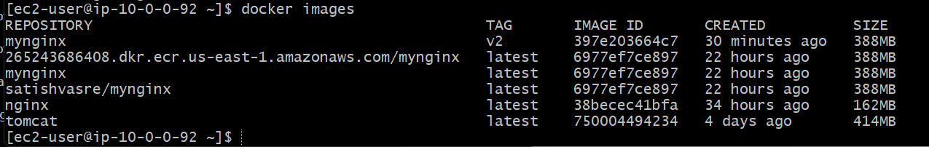

Create Docker image using alpine and customize with tomcat.
Note: Alpine uses musl instead of glibc, so Tomcat needs a compatible Java runtime. For a simple lab exercise, use an Alpine Java image as the base.
Step 1: Create a Dockerfile
However, because Tomcat version URLs change, a cleaner approach is to use a specific version.
Recommended simple lab approach
Create Docker file:
mkdir alpine-tomcat
cd alpine-tomcat
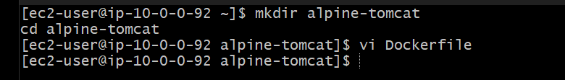
vi Dockerfile
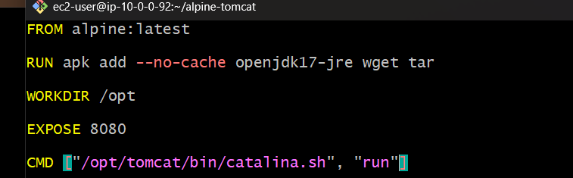

Step 2: Build the Image
docker build -t alpine-tomcat:v1 .
Explanation: Builds a custom Docker image using Alpine Linux with Java and Tomcat installed. 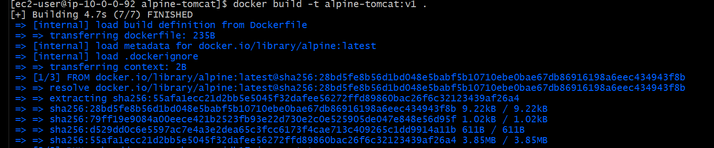
Step 3: Verify
docker images
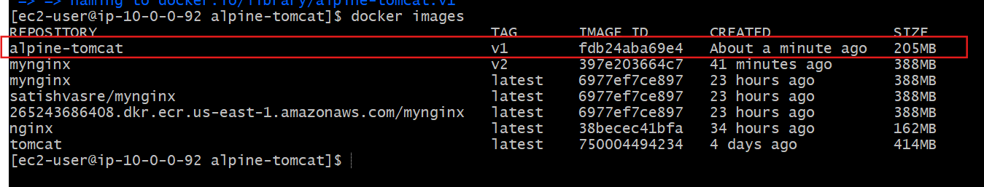
Step 4: Run the Container
docker run -d --name tomcat-alpine -p 8080:8080 alpine-tomcat:v1
Explanation: Starts Tomcat and maps container port 8080 to host port 8080.
Step 5: Verify
docker ps
Then open:
http://<SERVER-IP>:8080
Flow
Alpine → Install Java → Install Tomcat → Build Image → Run Container → Access Tomcat 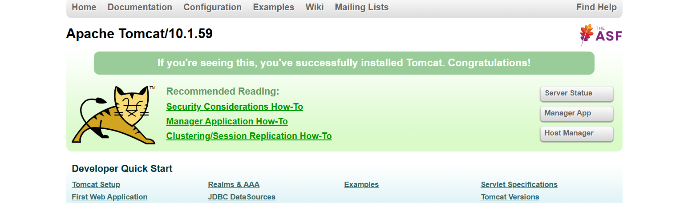

Create single stage and multi stage docker file using this source code:https://github.com/betawins/multi-stage-example.git
1. Clone the source code
On your EC2 server:
git clone https://github.com/betawins/multi-stage-example.git
cd multi-stage-example
Verify:
ls
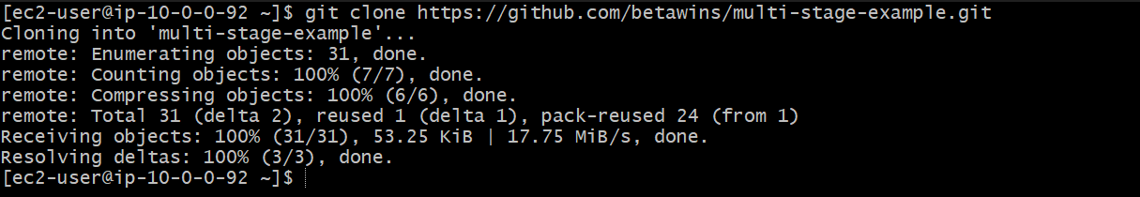
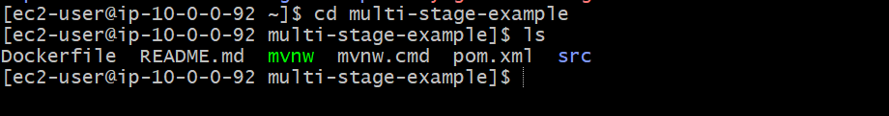

Single-Stage Dockerfile
Create a separate file:
vi Dockerfile.single
Add: 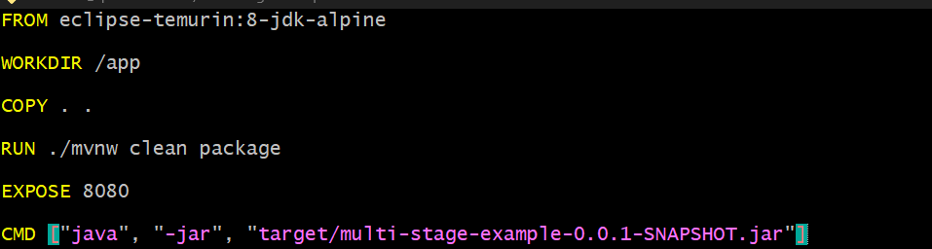
Build
docker build -t single-stage:v1 -f Dockerfile.single .
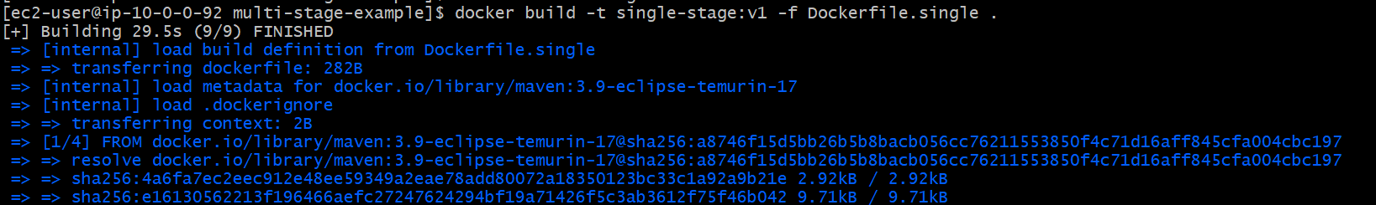
Run
docker run -d --name single-stage -p 8081:8080 single-stage:v1
Verify
docker ps
Single stage: Build tools + source code + JAR + Java runtime are all present in the final image.
Open Browser: http://34.205.131.107:8081/
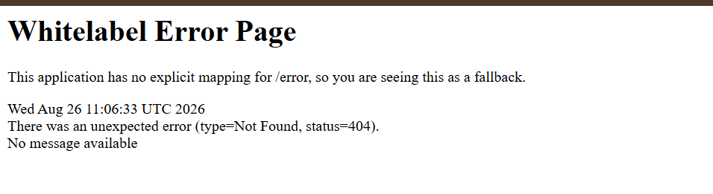

Multi-Stage Dockerfile
Create:
vi Dockerfile.multi
Add: 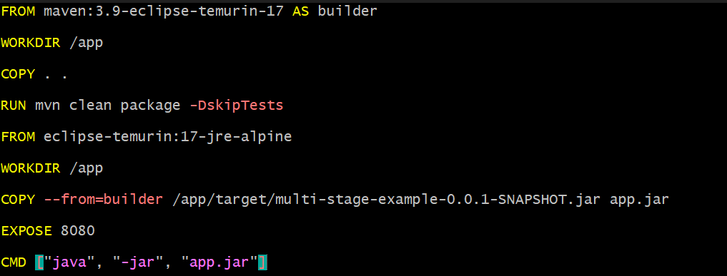
Multi-stage builds use separate build and runtime stages, then copy only the required application artifact into the final image.
Build
docker build -t multi-stage:v1 -f Dockerfile.multi .
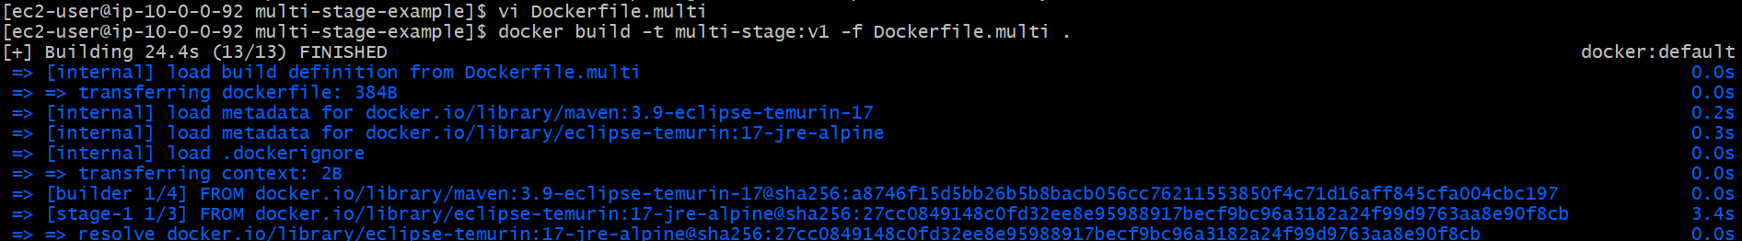
Run
docker run -d --name multi-stage -p 8082:8080 multi-stage:v1
Verify
docker ps
Compare images
docker images
You can compare:
single-stage:v1
multi-stage:v1
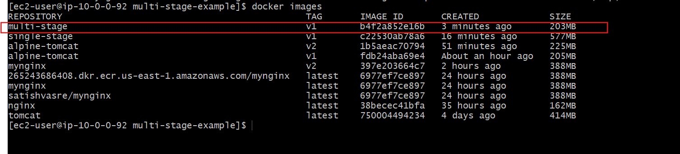

Install docker compose and execute sample application.
1. Check Docker
docker --version
2. Install Docker Compose
sudo curl -SL https://github.com/docker/compose/releases/latest/download/docker-compose-linux-x86_64 -o /usr/local/bin/docker-compose
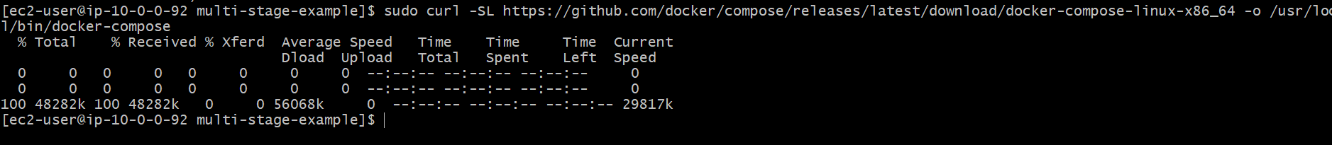
Give execute permission:
sudo chmod +x /usr/local/bin/docker-compose
3. Verify
docker-compose --version
You should see:
Docker Compose version ...

4. Clone a sample application
git clone https://github.com/docker/getting-started-app.git
cd getting-started-app 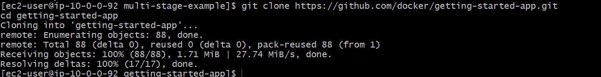
5. Create docker-compose.yml
vi docker-compose.yml
Add: 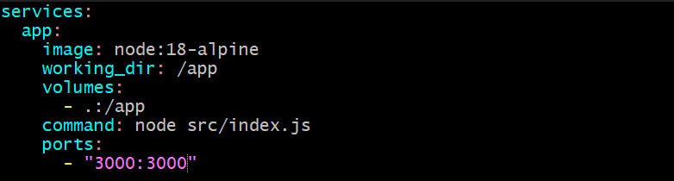
6. Start the application
docker-compose up -d
7. Check containers
docker-compose ps
8. Access the application
Open:
http://<EC2-PUBLIC-IP>:3000 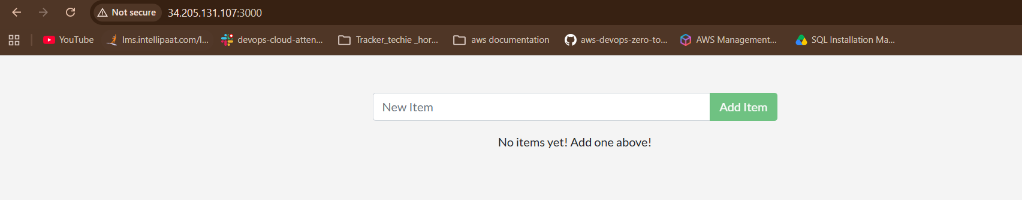
Make sure port 3000 is allowed in the EC2 Security Group.

Short flow
Install Docker Compose
↓
Create docker-compose.yml
↓
docker-compose up -d
↓
Application starts
↓
Access using EC2-IP:3000
Note: Modern Docker Compose is usually run as docker compose (with a space), rather than the older docker-compose command. If your Docker installation already supports it, docker compose version is the preferred check.

Implement solution to scan images when pushed to docker registry.
Purpose: To identify security vulnerabilities in Docker images and prevent vulnerable images from being pushed to the Docker registry or deployed to production.
1. Go to project
cd ~/multi-stage-example
Purpose: Navigate to the application directory.
2. Check Dockerfile
cat Dockerfile.multi
Purpose: Verify the Dockerfile before building.
Use eclipse-temurin instead of the unavailable openjdk:8-jdk-alpine. 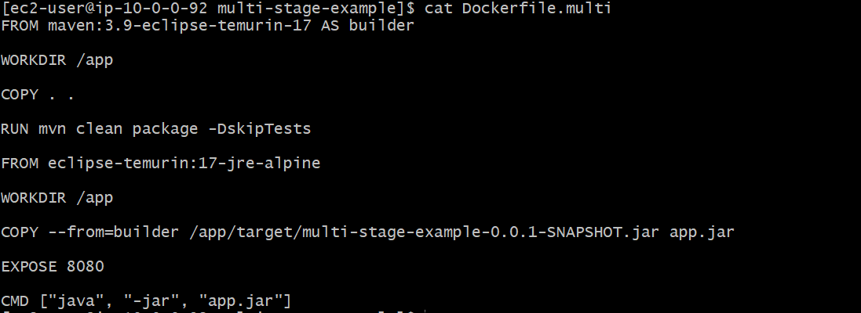
3. Build image
docker build -t myapp:v1 -f Dockerfile.multi .
Purpose: Create the Docker image.
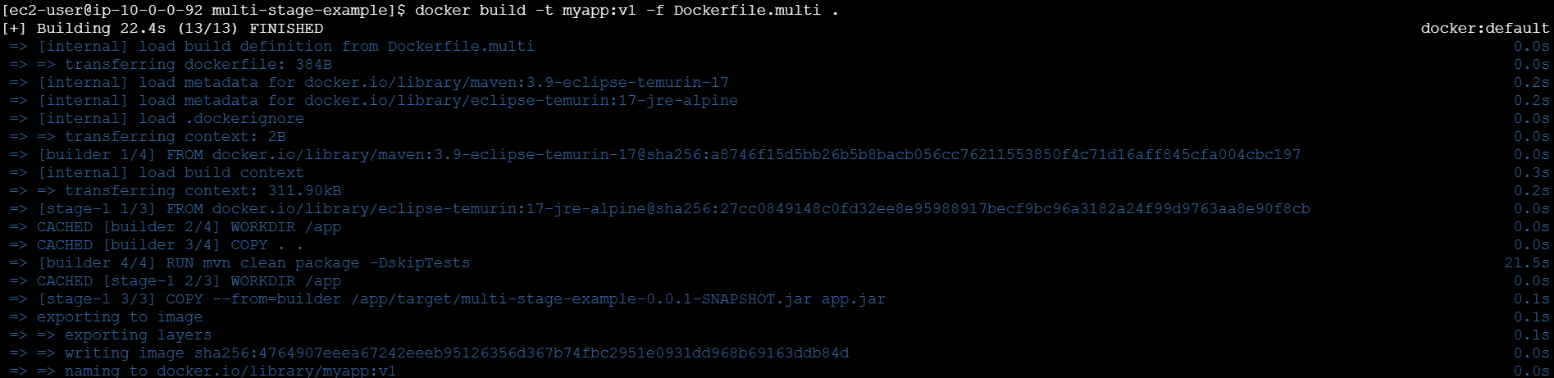
4. Install/verify Trivy
trivy --version
sudo dnf install -y wget
wget https://github.com/aquasecurity/trivy/releases/download/v0.74.0/trivy_0.74.0_Linux-64bit.tar.gz
tar -xzf trivy_0.65.0_Linux-64bit.tar.gz
sudo mv trivy /usr/local/bin/
trivy --version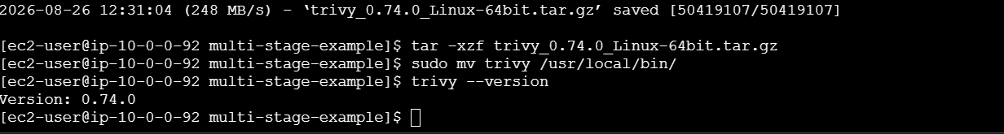
Purpose: Verify that the image-scanning tool is installed.

5. Scan image
trivy image myapp:v1
Purpose: Find vulnerabilities in the Docker image.
6. Scan HIGH and CRITICAL
trivy image --severity HIGH,CRITICAL myapp:v1
Purpose: Check for serious vulnerabilities.
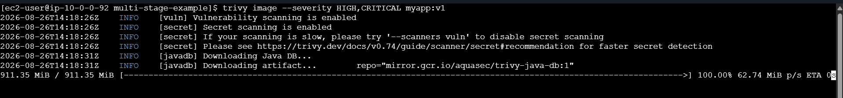
7. Fail if vulnerabilities exist
trivy image --severity HIGH,CRITICAL --exit-code 1 myapp:v1
Purpose: Stop the process if HIGH/CRITICAL vulnerabilities are found.
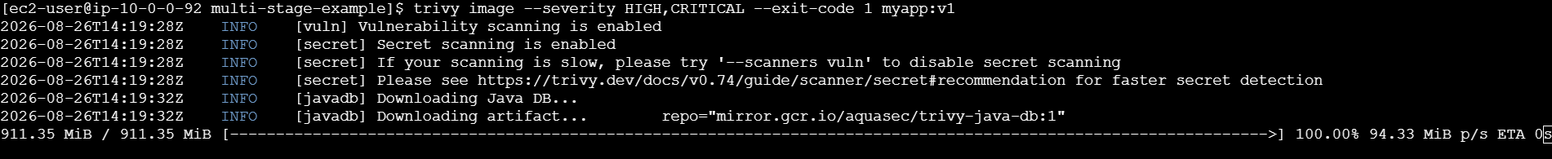
8. Tag image
docker tag myapp:v1 satishvasre/myapp:v1
Purpose: Prepare the image for Docker Hub.
9. Login
docker login
Purpose: Authenticate with Docker Hub.
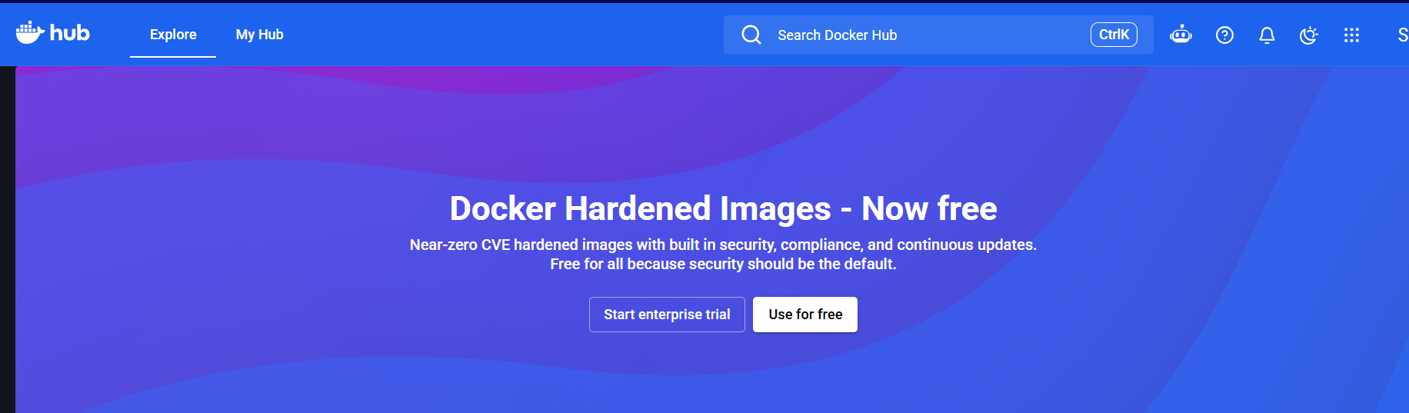

10. Push image
docker push satishvasre/myapp:v1
Purpose: Upload the verified image to Docker Hub.
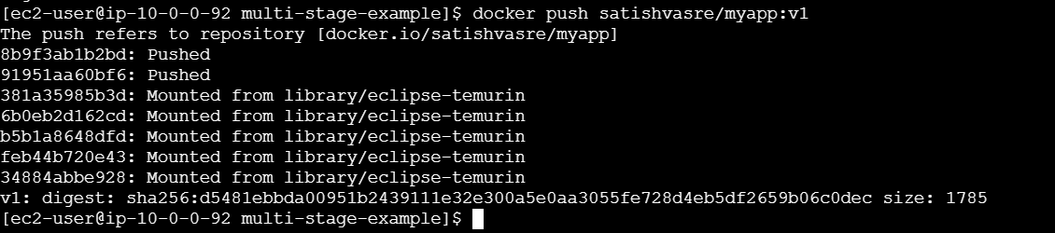
Flow
Build → Scan → Pass → Tag → Login → Push
↓
Fail
↓
Stop
Overall Purpose: Ensure vulnerable images are not pushed to the Docker registry.
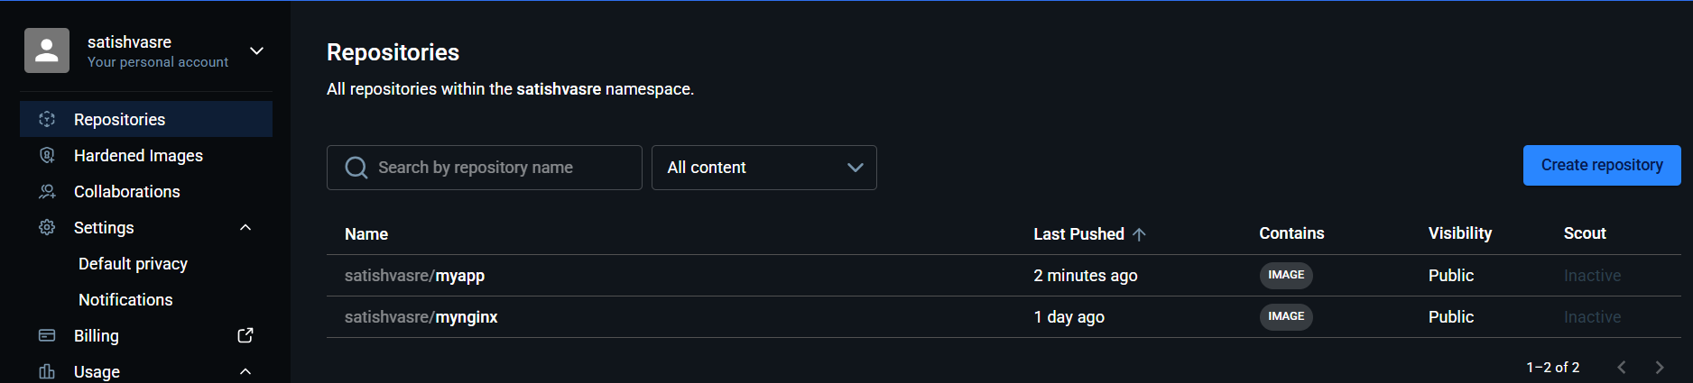

Implement solution to scan images when pushed to AWS ECR.
1. Create an ECR repository
aws ecr create-repository \ --repository-name myapp \ --region us-east-1
Verify:
aws ecr describe-repositories \ --repository-names myapp \ --region us-east-1
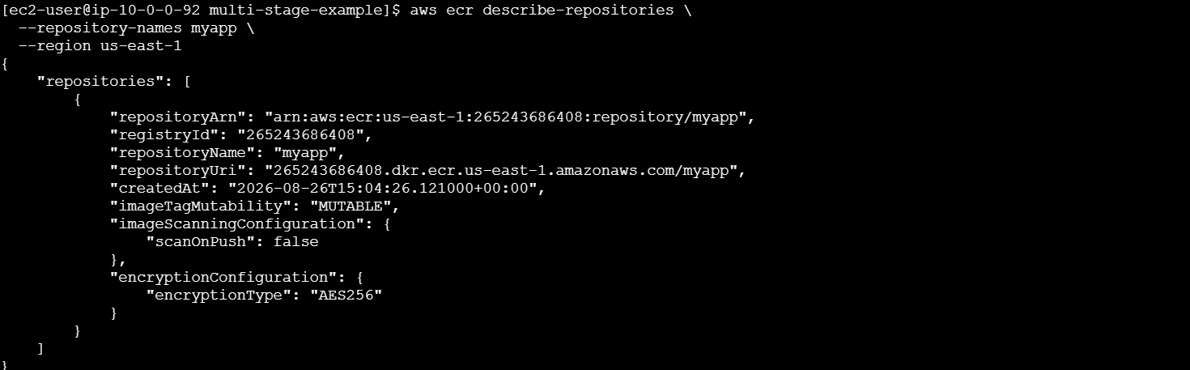

2. Login Docker to ECR
aws ecr get-login-password --region us-east-1 | \
docker login --username AWS --password-stdin 265243686408.dkr.ecr.us-east-1.amazonaws.com
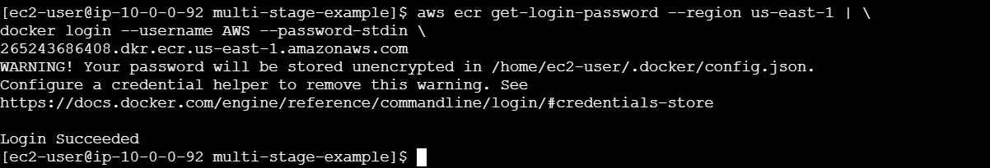

3. Tag your existing image
You already have:
myapp:v1
Tag it for ECR:
docker tag myapp:v1 \

Check:
docker images
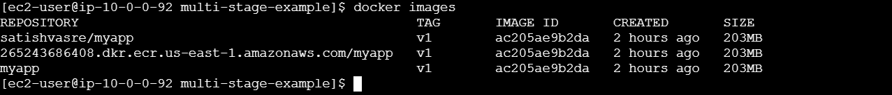

4. Push image to ECR
docker push \
265243686408.dkr.ecr.us-east-1.amazonaws.com/myapp:v1 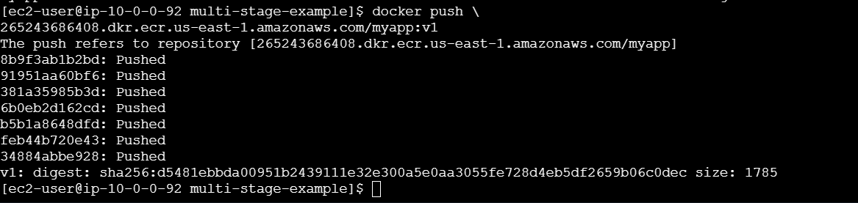

5. Enable ECR vulnerability scanning
For a new repository, enable scan on push:
aws ecr put-image-scanning-configuration \
--repository-name myapp \
--image-scanning-configuration scanOnPush=true \
--region us-east-1
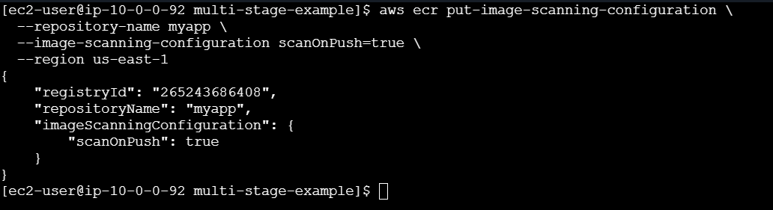
Verify:
aws ecr get-image-scanning-configuration \
--repository-name myapp \
--region us-east-1
You should see:
"scanOnPush": true

6. Push a new image
Whenever you push an image:
docker push 265243686408.dkr.ecr.us-east-1.amazonaws.com/myapp:v1
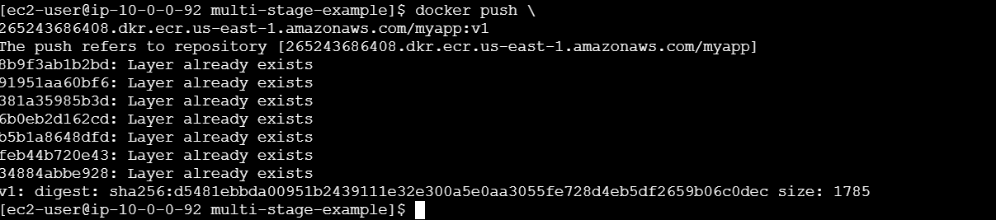
ECR automatically starts a vulnerability scan.
Flow:
Docker Image
↓
docker push
↓
AWS ECR
↓
Scan on Push
↓
Vulnerability Scan
↓
View findings

7. Check scan results
aws ecr describe-image-scan-findings \
--repository-name myapp \
--image-id imageTag=v1 \
--region us-east-1
You can also check:
AWS Console → ECR → Repositories → myapp → Images → v1 → Scan findings
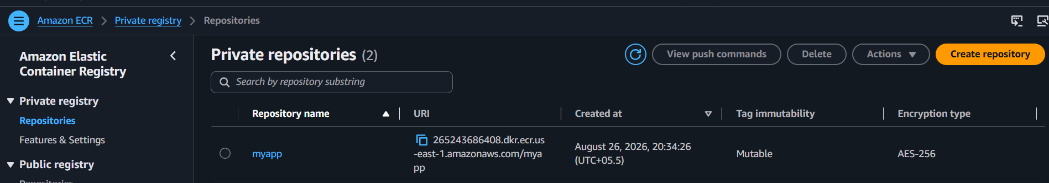

Create a Jenkins pipeline to create a docker image and push the image to Docker hub.
1. Prerequisites
Make sure the Jenkins server has:
- Jenkins
- Git
- Docker
- Docker Pipeline plugin
- A GitHub repository containing your application and Dockerfile
- Docker Hub account
Check on the Jenkins server:
git --version
docker --version
sudo yum install docker -y
sudo systemctl start docker
sudo systemctl enable docker
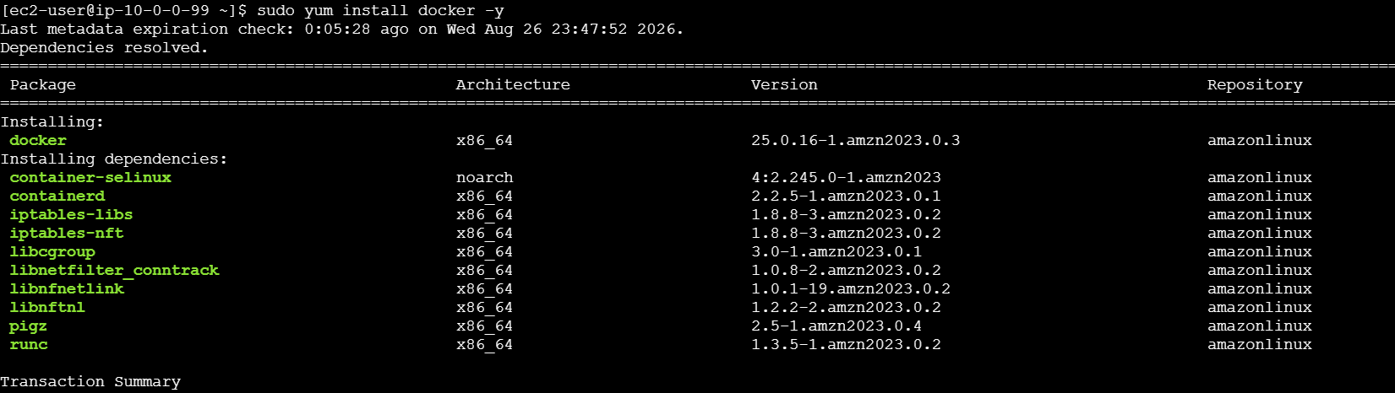

2. Give Jenkins permission to use Docker
Check Docker socket:
ls -l /var/run/docker.sock 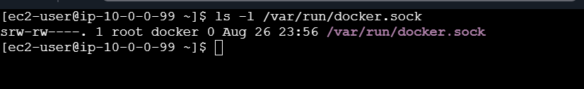
Add Jenkins user to Docker group:
sudo usermod -aG docker jenkins
Restart Jenkins:
sudo systemctl restart jenkins
Verify:
sudo -u jenkins docker ps
If it works without a permission error, Jenkins can use Docker.
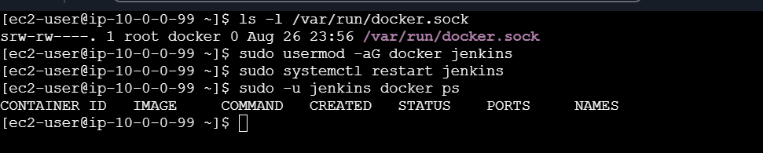
3. Prepare your project
Your GitHub repository should contain something like:
1. Create project
mkdir myapp
cd myapp
2. Create HTML file
echo "<h1>Hello from Jenkins</h1>" > index.html
3. Create Dockerfile
vi Dockerfile
Add:
FROM nginx:latest
COPY index.html /usr/share/nginx/html/
Now:
myapp/
├── Dockerfile
└── index.html

4. Test Docker
docker build -t myapp:v1 .
docker run -d -p 8080:80 myapp:v1
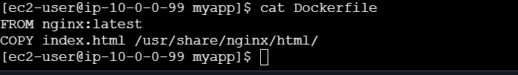
Step 4: Test Docker build locally
From inside myapp:
docker build -t myapp:v1 .
Check:
docker images
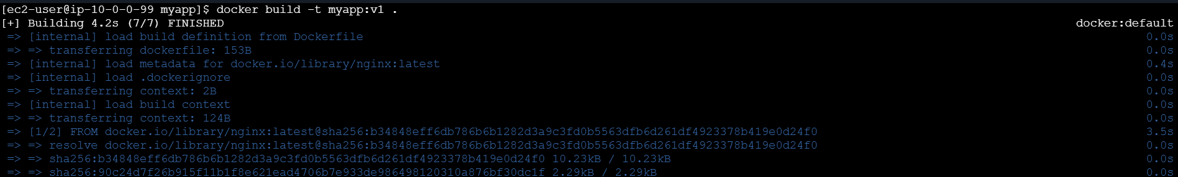
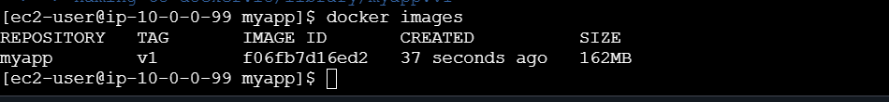

Step 5: Test the container
Run:
docker run -d --name myapp-test -p 8080:80 myapp:v1
Check:
docker ps
Then open:
http://<EC2-PUBLIC-IP>:8083


Step 6: Create GitHub repository
Go to GitHub.
Create a new repository:
Repository name: myapp
For now, make it Public to keep the Jenkins setup simple.

Step 8: Add your files
git add .
Check:
git status
Commit: git commit -m "Add Docker application" 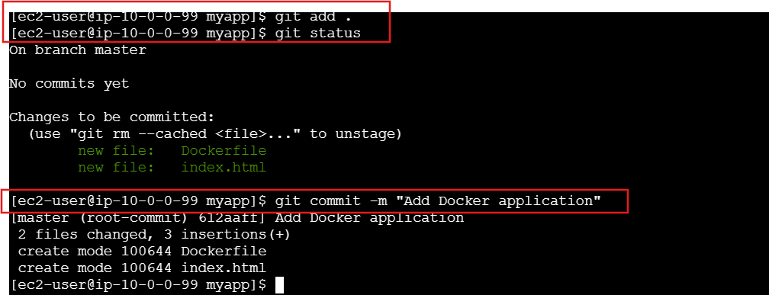
Step 9: Connect to GitHub
Copy your GitHub repository URL.
It will look like:
https://github.com/YOUR_USERNAME/myapp.git
Then:
git remote add origin https://github.com/YOUR_USERNAME/myapp.git
Check:
git remote -v 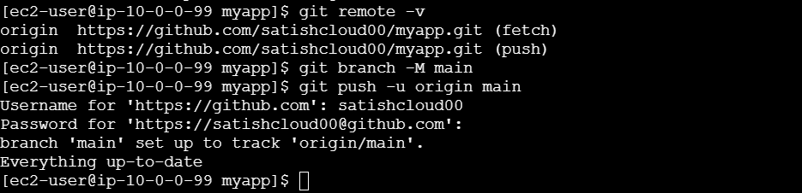

Step 10: Push to GitHub
Rename your branch:
git branch -M main
Push:
git push -u origin main
GitHub may ask for authentication.
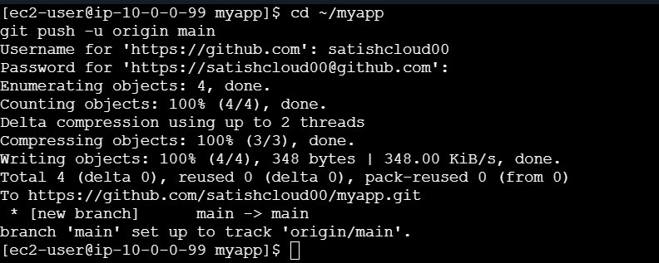
Step 11: Verify GitHub
Your repository should look like:
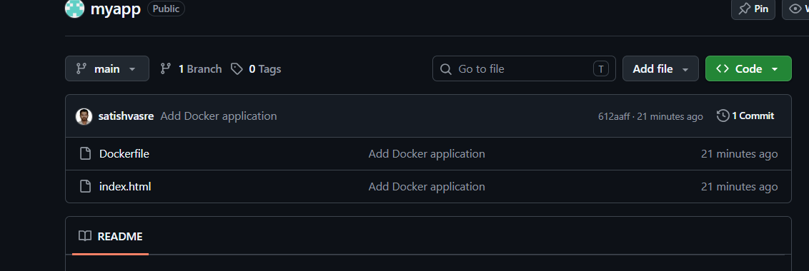
Step 12: Add Jenkinsfile
Now create the Jenkins pipeline file in the same directory:
vi Jenkinsfile
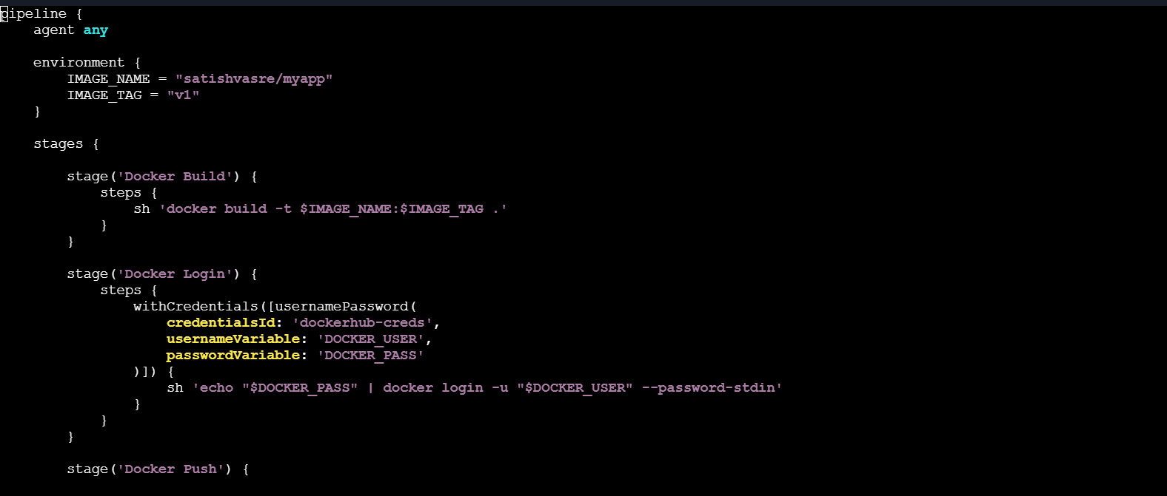

Then:
git add Jenkinsfile
git commit -m "Add Jenkins pipeline"
git push
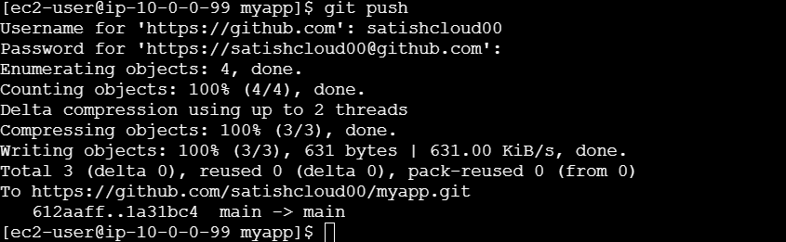
Now your GitHub repository will be:
myapp/
├── Dockerfile
├── Jenkinsfile
└── index.html

1. Run Jenkins
Go to:
Jenkins → docker-build-push → Build Now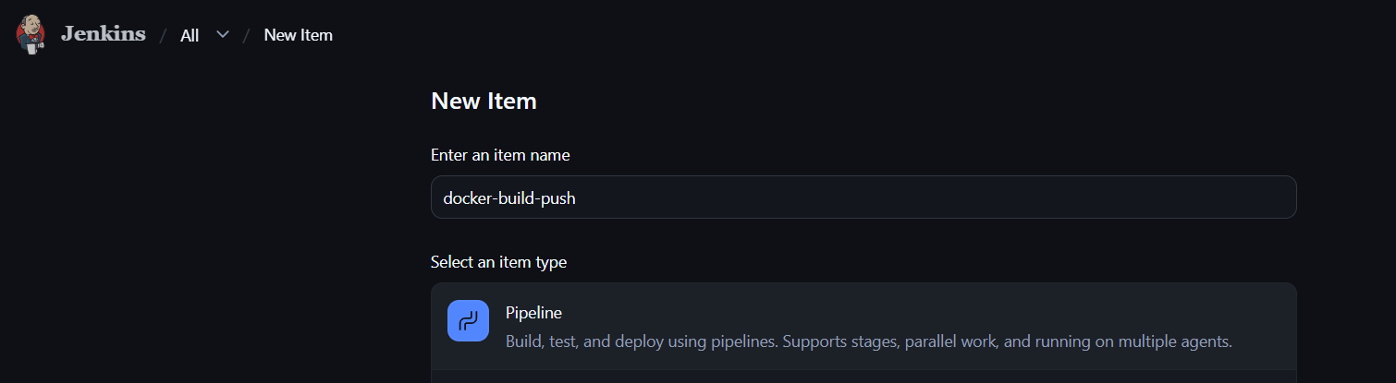
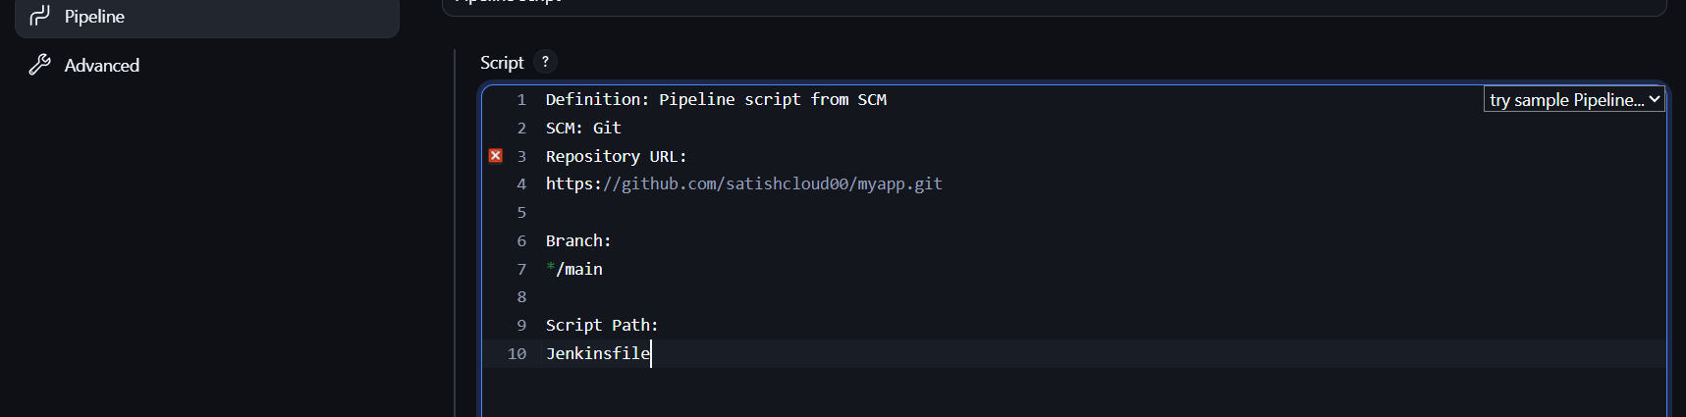
2. Check Console Output
You should see:
Docker Build
↓
Docker Login
↓
Docker Push
At the end:
Finished: SUCCESS
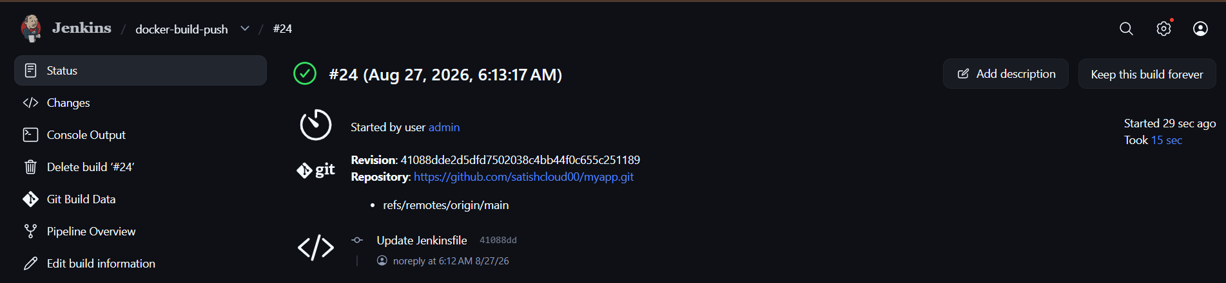
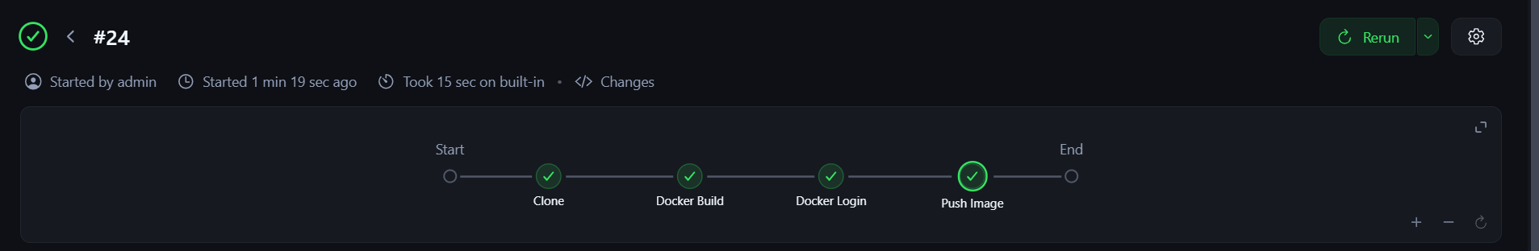
3. Verify Docker Hub
Open your Docker Hub repository and check that this image exists:
satishvasre/myapp:v1
4. Optional final verification
On your EC2:
docker pull satishvasre/myapp:v1
Then:
docker images
You should see:
satishvasre/myapp v1 