Jenkins-02

- Configure 2 slave machines in the Jenkins master.
Configure 2 Jenkins Slave/Agents

- Prepare Agent 1 & Agent 2

Create 2 EC2 Instances
- Jenkins Master → Existing EC2
- Jenkins slave-01 → New EC2
- Jenkins slave-02 → New EC2

Install Java 21:
sudo dnf install java-21-amazon-corretto -y
java -version
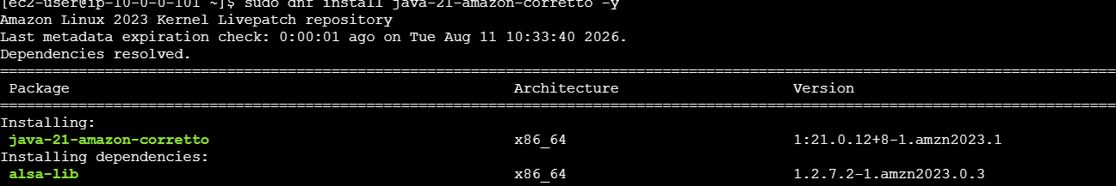

2. Create Jenkins User
sudo useradd -m jenkins
sudo mkdir -p /home/jenkins
sudo chown -R jenkins:jenkins /home/Jenkins
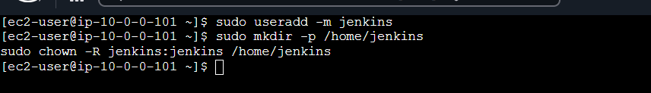

3. Configure SSH from Master
ssh-keygen -t ed25519
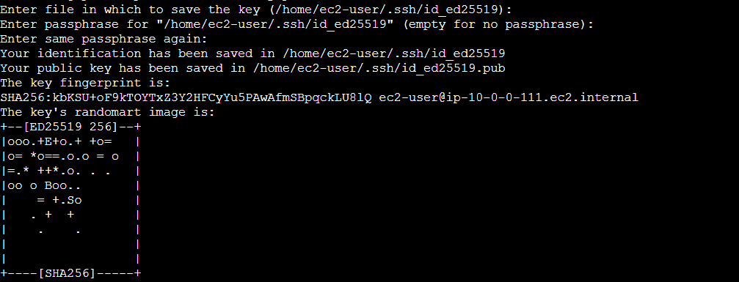
ssh-copy-id jenkins@<Agent1-IP>
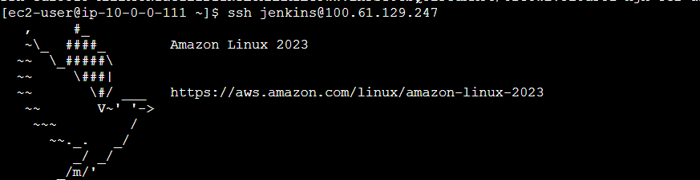

4. Add SSH Credential-Master Jenkins
Jenkins → Manage Jenkins → Credentials → Add Credentials
- Kind: SSH Username with private key
- Username: jenkins
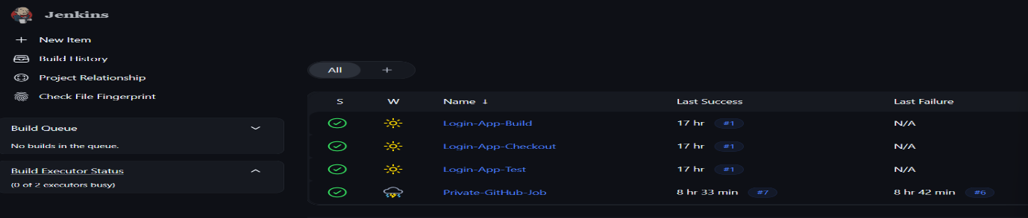
- Private Key: Master id_ed25519

5. Create Agent 1
Manage Jenkins → Nodes → New Node
Name: slave-01
Type: Permanent Agent
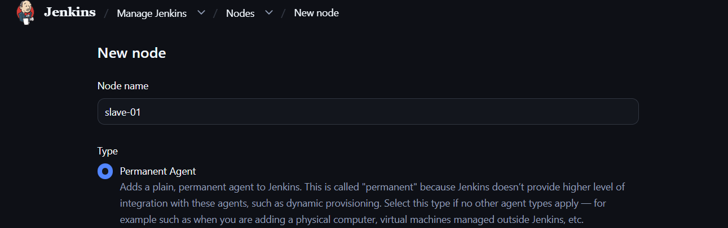
Remote directory: /root/slave-workspace
Label: java
Launch: SSH
Host: Agent1 IP
Save → Online 🟢
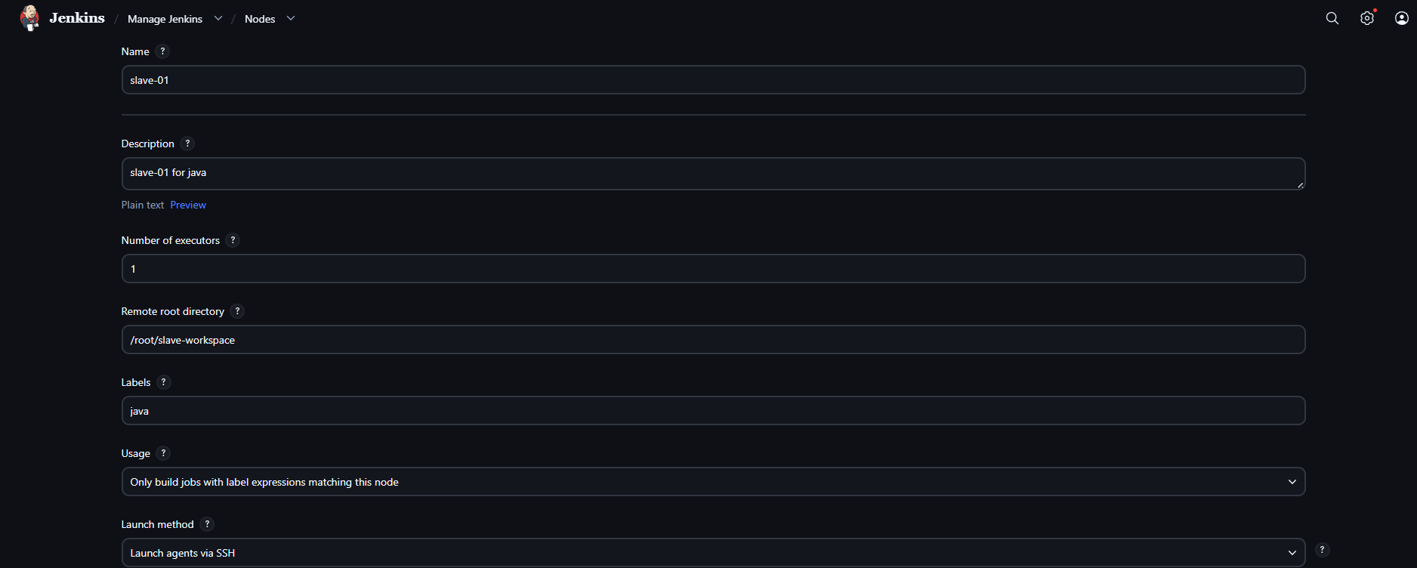

6. Create Agent 2
Configuration of slave-02
1. Create EC2 instance
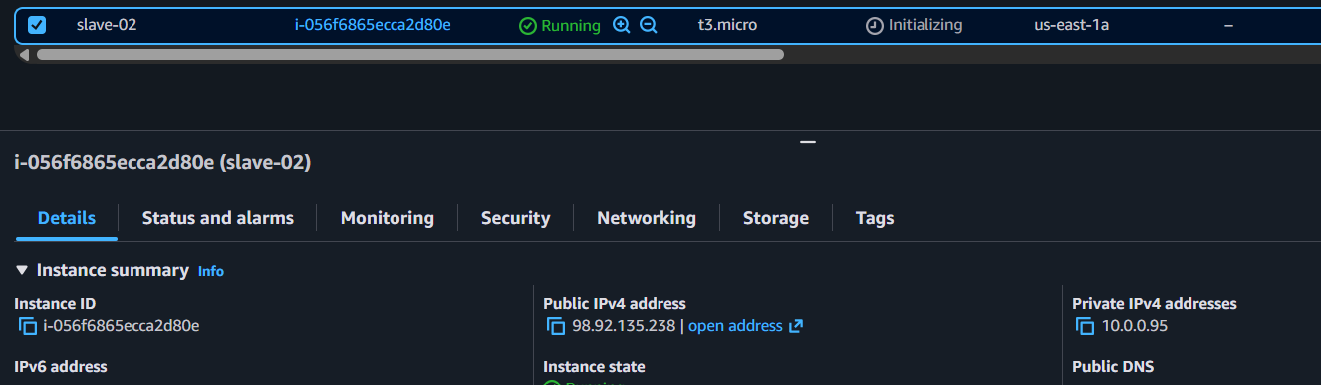
Connect

2. Switch to root
sudo su -

3. Install JDK
yum install java-17-amazon-corretto -y
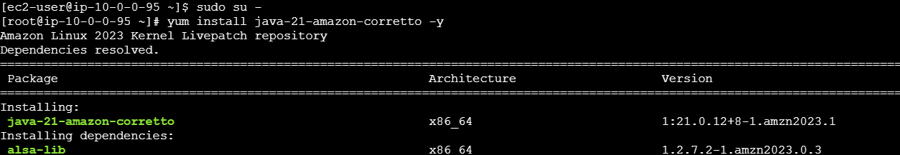

4. Generate SSH key
ssh-keygen -t rsa

5. View public key
cat ~/.ssh/id_rsa.pub
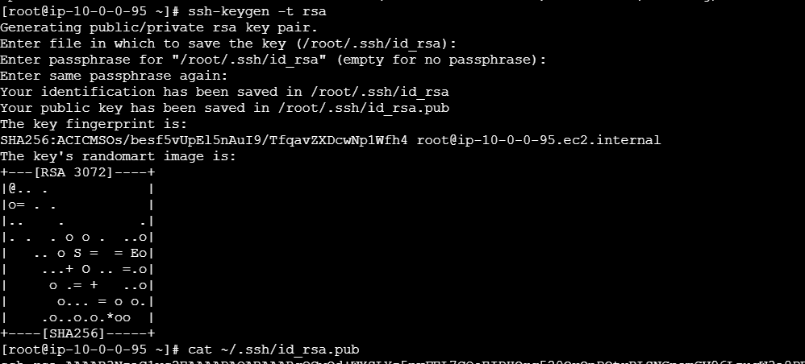

6. Set permissions
chmod 700 ~/.ssh
chmod 600 ~/.ssh/id_rsa
chmod 644 ~/.ssh/id_rsa.pub
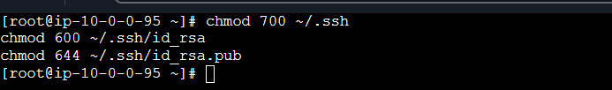

Go to Master-Jenkins
Manage Jenkins → Nodes → New Node
Name: slave-02
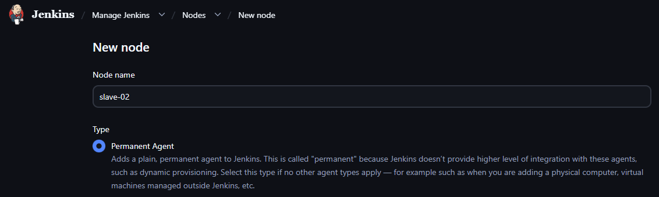
Remote directory: /home/jenkins
Label: agent2
Launch: SSH
Host: Agent2 IP(ip addres of the slave-02 : 98.92.135.238)
Credentials :ec2-user(slave-02-python)
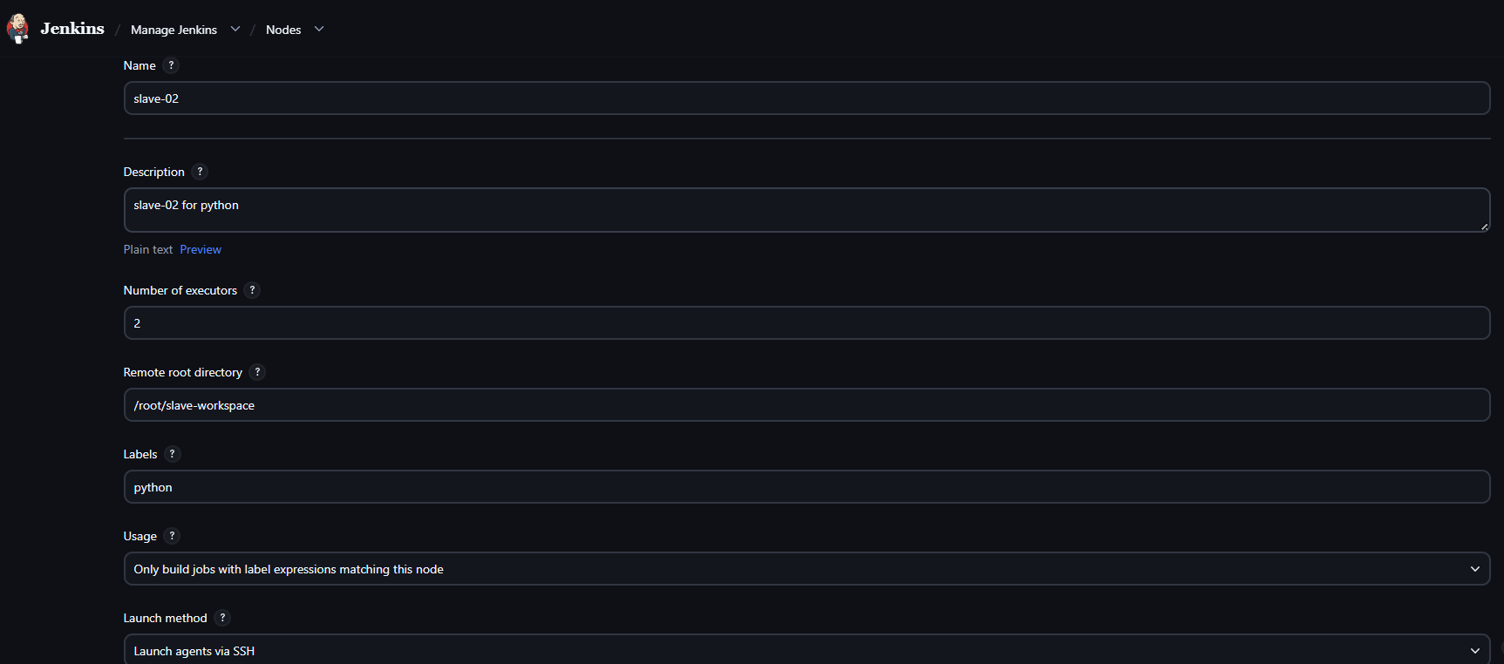
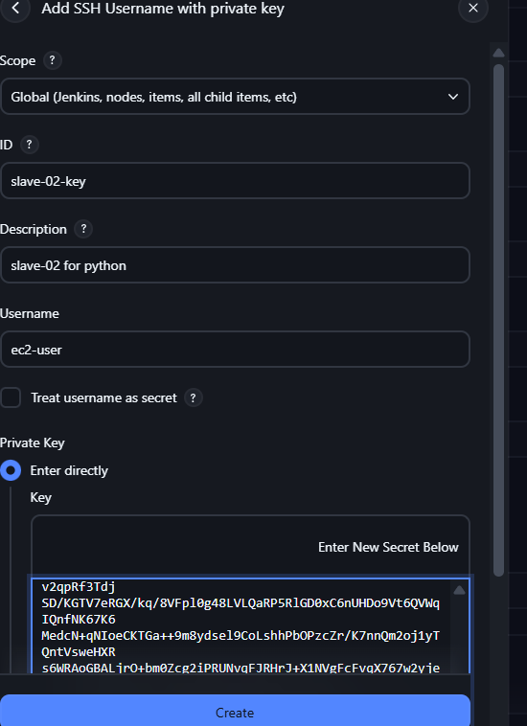
Save → Online 🟢

7. Test
Create a Jenkins job → Restrict where this project can be run → enter:
agent1
Build and verify the job runs on Agent 1. Repeat with agent2.

- Configure webhooks to the Jenkins job.
GitHub → Jenkins Webhook — Detailed Steps
1. GitHub Webhook
- Open your GitHub Repository
- Go to Settings → Webhooks
- Click Add webhook
- Enter:
Payload URL: http://<JENKINS-IP>:8081/github-webhook/
Content type: application/json
- Select Just the push event
- Keep Active checked
- Click Add webhook
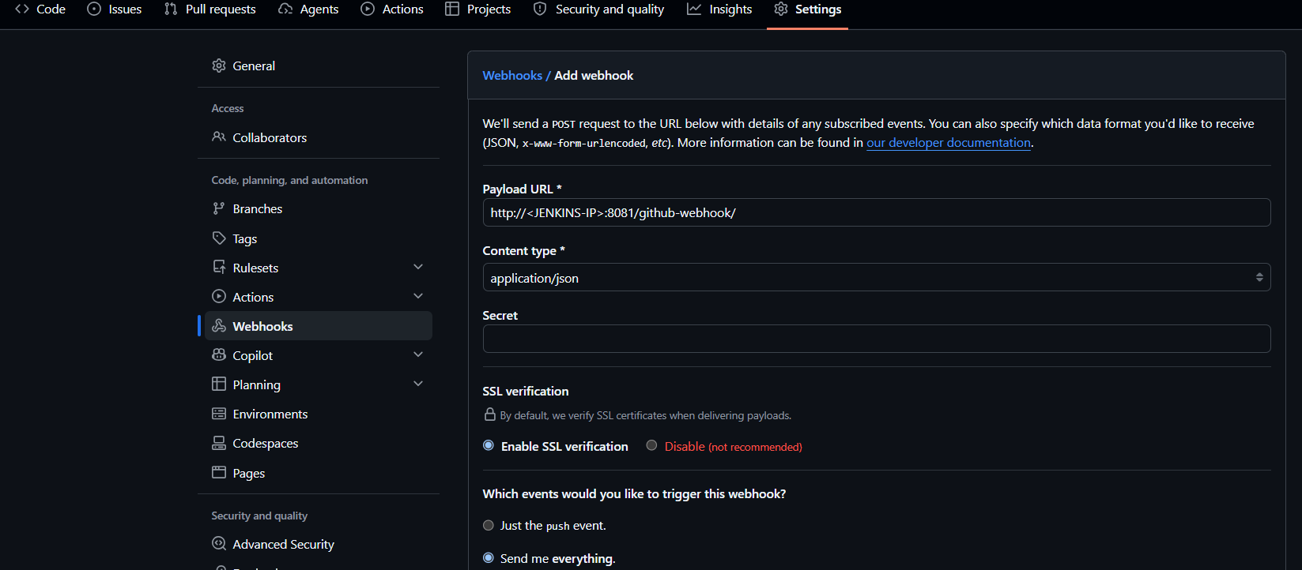
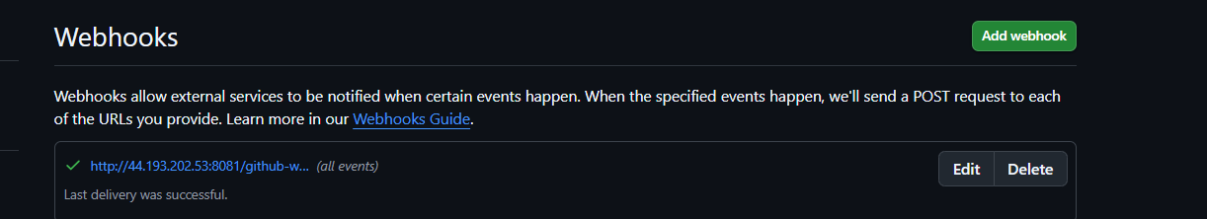

2. Create Jenkins Job
- Jenkins → New Item
- Enter Job Name
- Select Freestyle project
- Click OK
3. Configure GitHub Repository
- Go to Source Code Management
- Select Git
- Enter the GitHub repository URL
- Add credentials if the repository is private
- Branch:
*/main
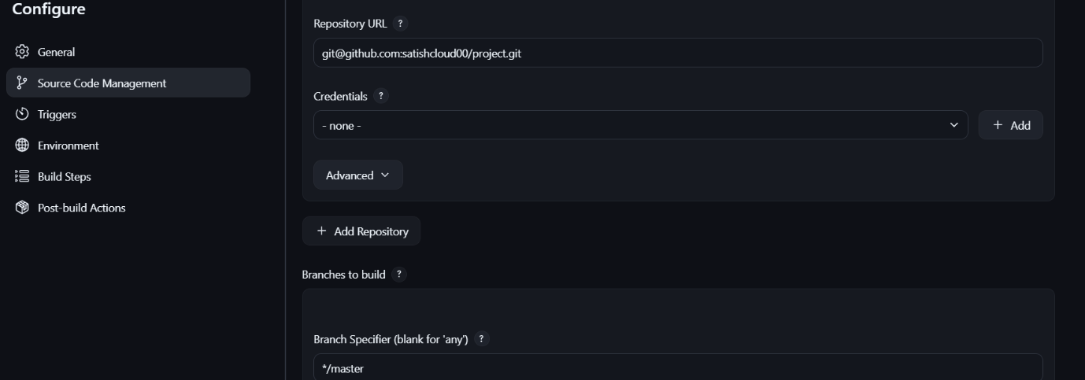
Save
- Click Apply → Save
- Click on Build Now

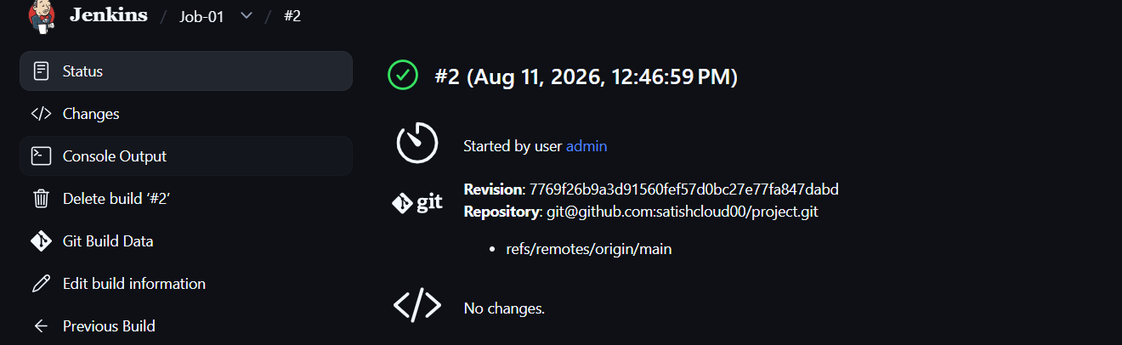

- Configure Poll SCM and Build Periodically options in the Jenkins job.
Job-02 — Poll SCM & Build Periodically
- Jenkins → New Item → Job-02 → Freestyle → OK
- Source Code Management → Git
git@github.com:satishcloud00/project.git
- Select SSH credentials
Jenkins → Manage Jenkins → Credentials
Select Global → Add Credentials
Kind: SSH Username with private key
Username: git
Private Key: paste the contents of:
cat /var/lib/jenkins/.ssh/id_ed25519
ID: github-ssh
Click Create
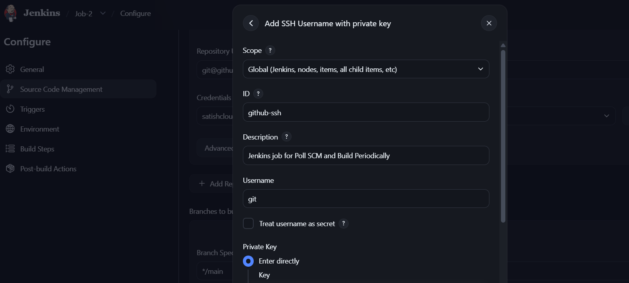
- Branch:
*/main
- Build Triggers → Poll SCM
H/5 * * * *
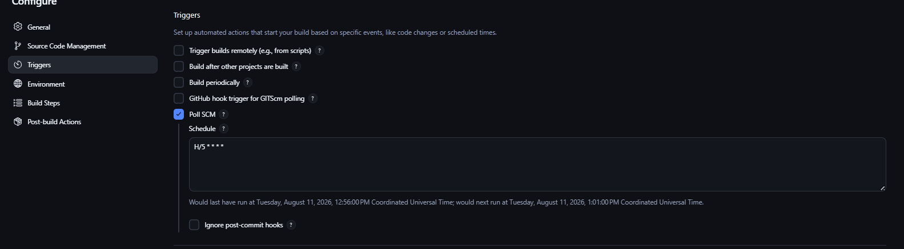
- Click on Build Now
- Go to GitHub - repo and make some changes
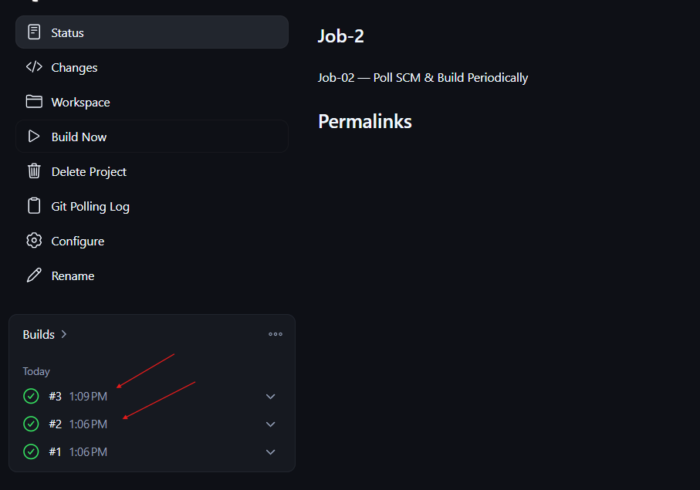

- Build periodically
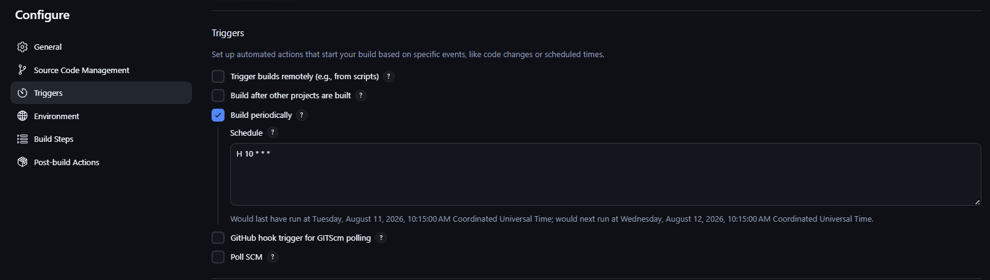
H 10 * * *

- Apply → Save → Build Now ✅
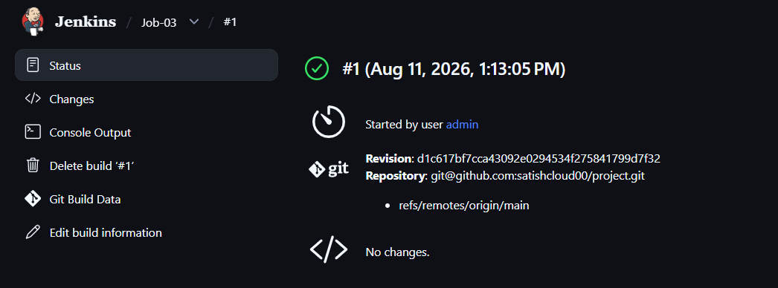

4.Take a backup of the Jenkins server using abash-script.
Jenkins Server Backup Using Bash Script
1. Create script
sudo vi /root/jenkins-backup.sh
2. Add script
#!/bin/bash

BACKUP_DIR="/backup"
DATE=$(date +%Y-%m-%d_%H-%M-%S)
mkdir -p "$BACKUP_DIR"
tar -czf "$BACKUP_DIR/jenkins-backup-$DATE.tar.gz" /var/lib/jenkins
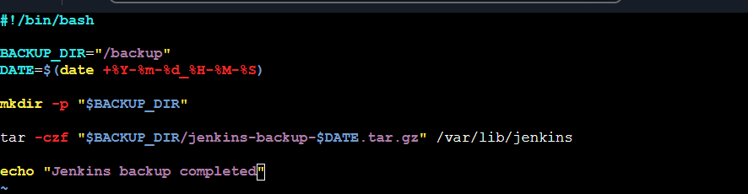
echo "Jenkins backup completed"

3. Give permission
sudo chmod +x /root/jenkins-backup.sh

4. Run backup
sudo /root/jenkins-backup.sh
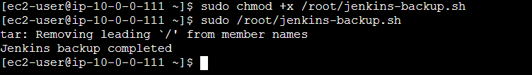

5. Verify
ls -lh /backup/
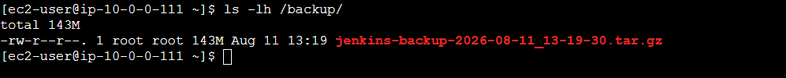

5.Take a backup of Jenkins using the ThinBackup plugin.
1. Install Plugin
Manage Jenkins → Plugins → Available plugins
Search:
ThinBackup
Install → Restart Jenkins if required.
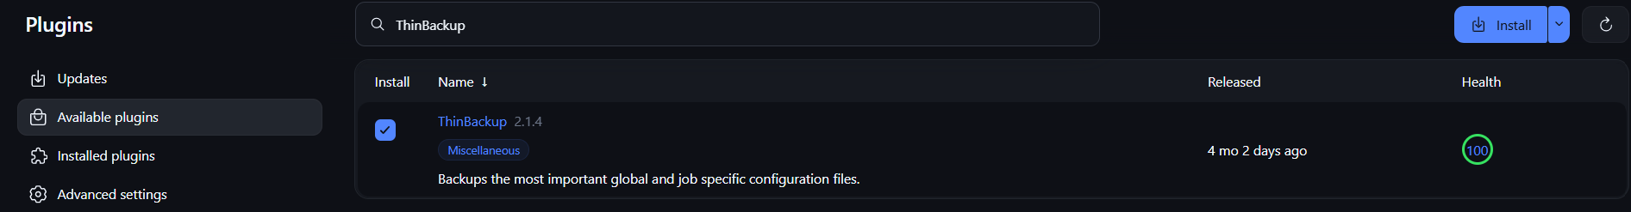

2. Configure ThinBackup
Manage Jenkins → ThinBackup
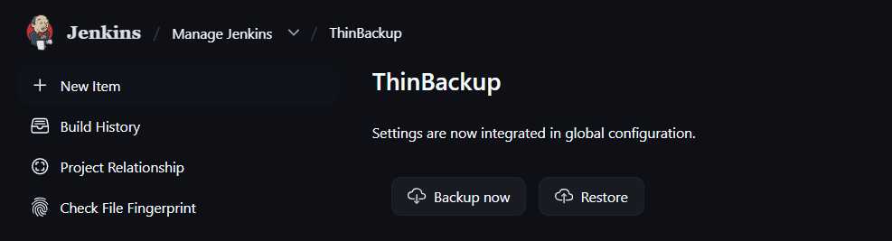
Set backup directory: /backup/jenkins-thinbackup
Click Save.

3. Take Backup
Go to:
Manage Jenkins → ThinBackup → Backup Now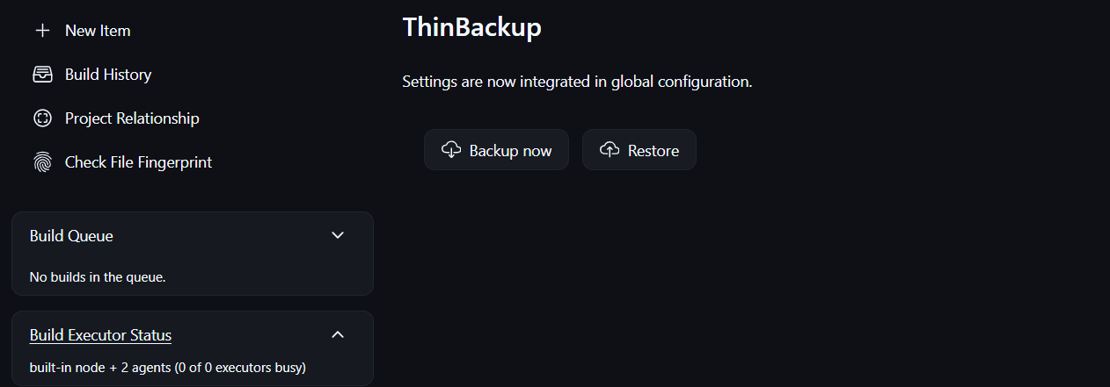

4. Verify
ls -lh /backup/jenkins-thinbackup/
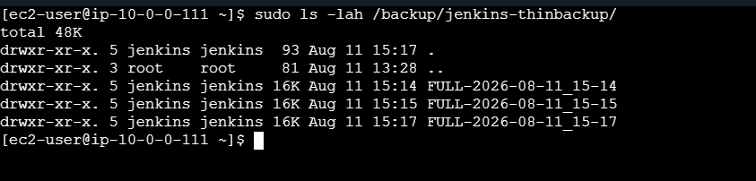
✅ Backup completed.

6.Set up a new Jenkins server and restore the backup taken in task 4.
Set up the new Jenkins server
Install Jenkins on the new EC2 server and start it once:
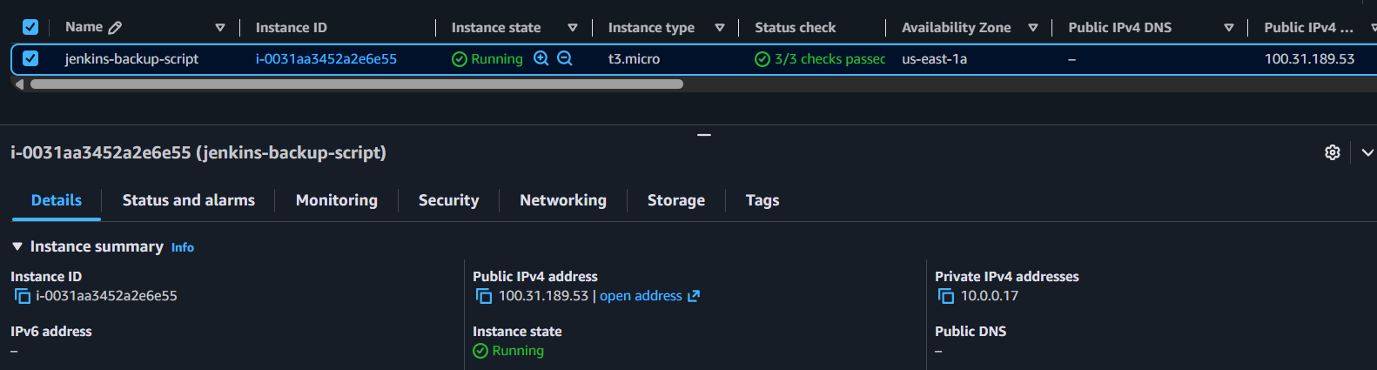

1. Install Java
sudo dnf install java-21-amazon-corretto -y
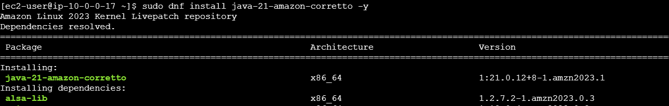
2. Add Jenkins repository
sudo wget -O /etc/yum.repos.d/jenkins.repo https://pkg.jenkins.io/redhat-stable/jenkins.repo
sudo rpm --import https://pkg.jenkins.io/redhat-stable/jenkins.io-2026.key
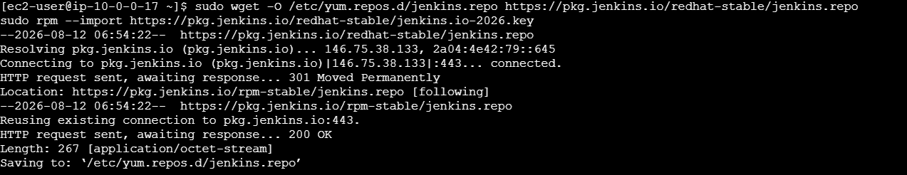
3. Install Jenkins
sudo dnf install jenkins -y
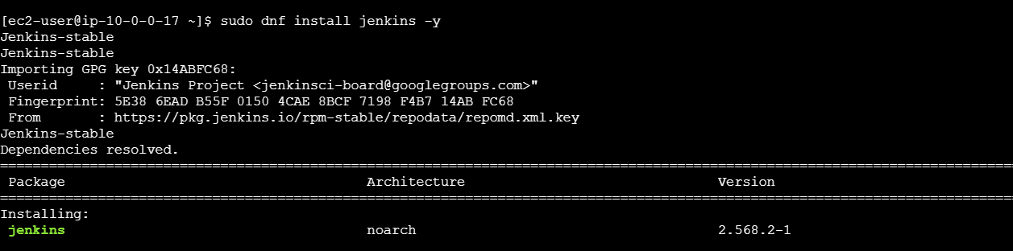
4. Stop Jenkins
sudo systemctl stop jenkins
5. Copy Task 4 backup to new server
Example:
scp -i key.pem jenkins-backup-2026-08-12_10-30-00.tar.gz ec2-user@NEW_SERVER_IP:/tmp/
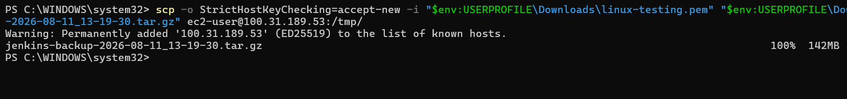
6. Verify backup on backup server
ls -lh /tmp/jenkins-backup*.tar.gz
7. Move the new Jenkins directory
sudo mv /var/lib/jenkins /var/lib/jenkins-old
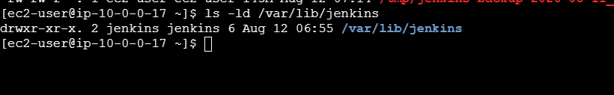
8. Restore backup
sudo tar -xzf /tmp/jenkins-backup-*.tar.gz -C /
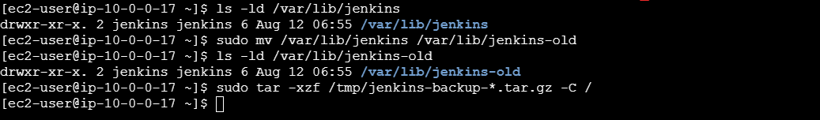
9. Fix permissions
sudo chown -R jenkins:jenkins /var/lib/Jenkins
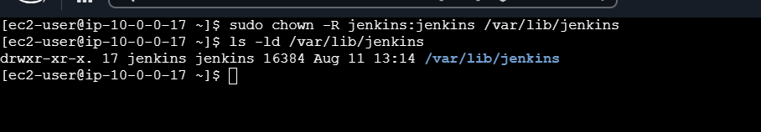
10. Enable and start Jenkins
sudo systemctl enable jenkins
sudo systemctl start Jenkins
11. Check Jenkins
sudo systemctl status Jenkins
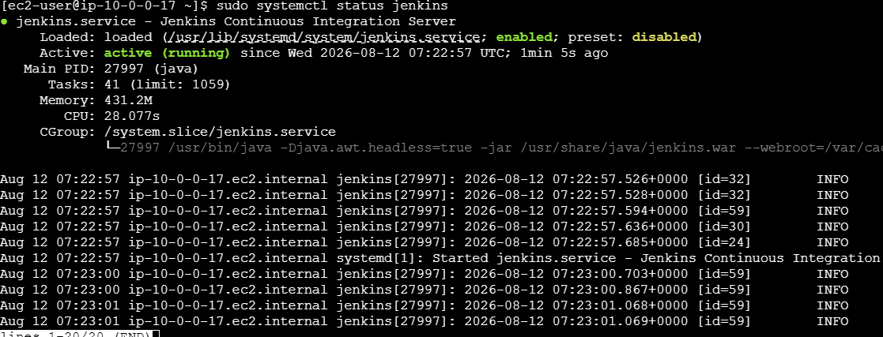
12. Open Jenkins
default port: http://NEW-SERVER-IP:8080
13. Verify restoration
Check that your old Jobs, configurations, users, build history, credentials, and plugins are available.
