1) Launch one AWS EC2 and install Jenkins.
- Log in to the ⁠AWS Management Console. [1]
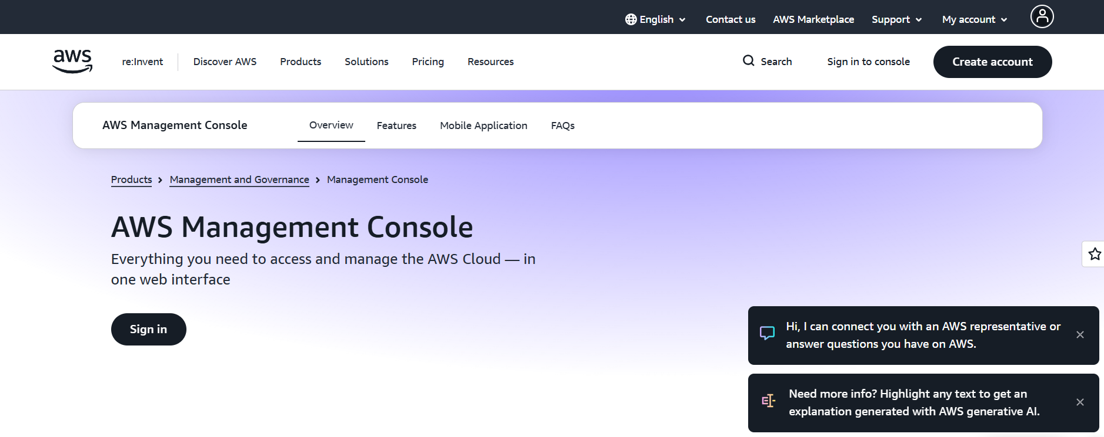

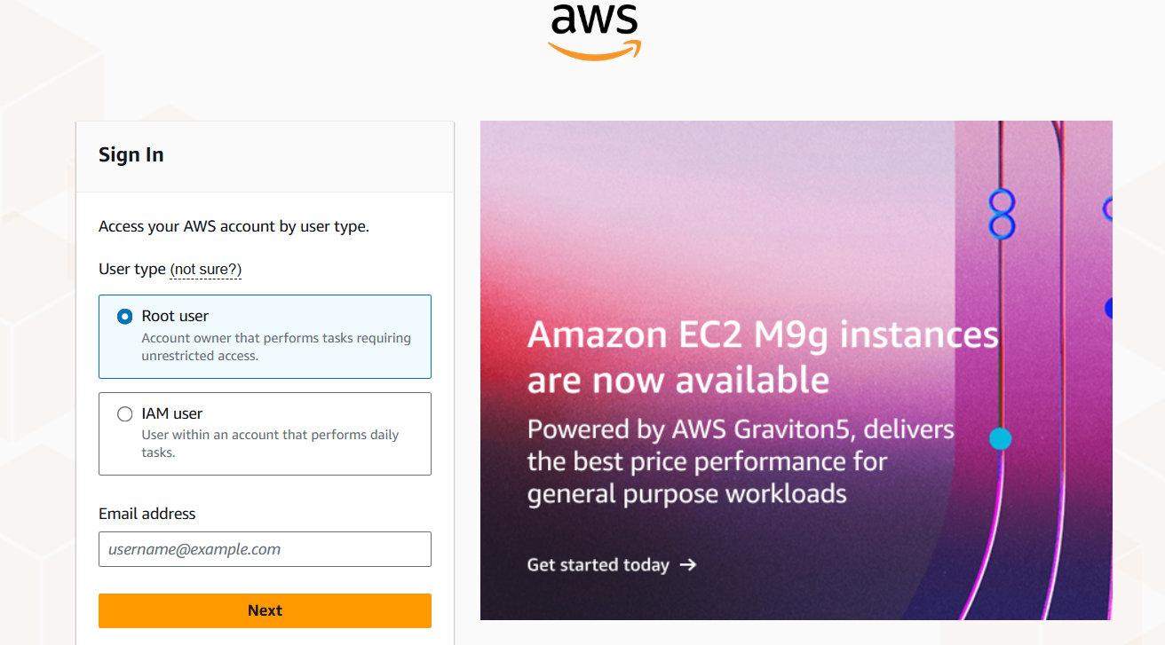

- Navigate to the EC2 Dashboard and click "Launch Instance." [1, 2]
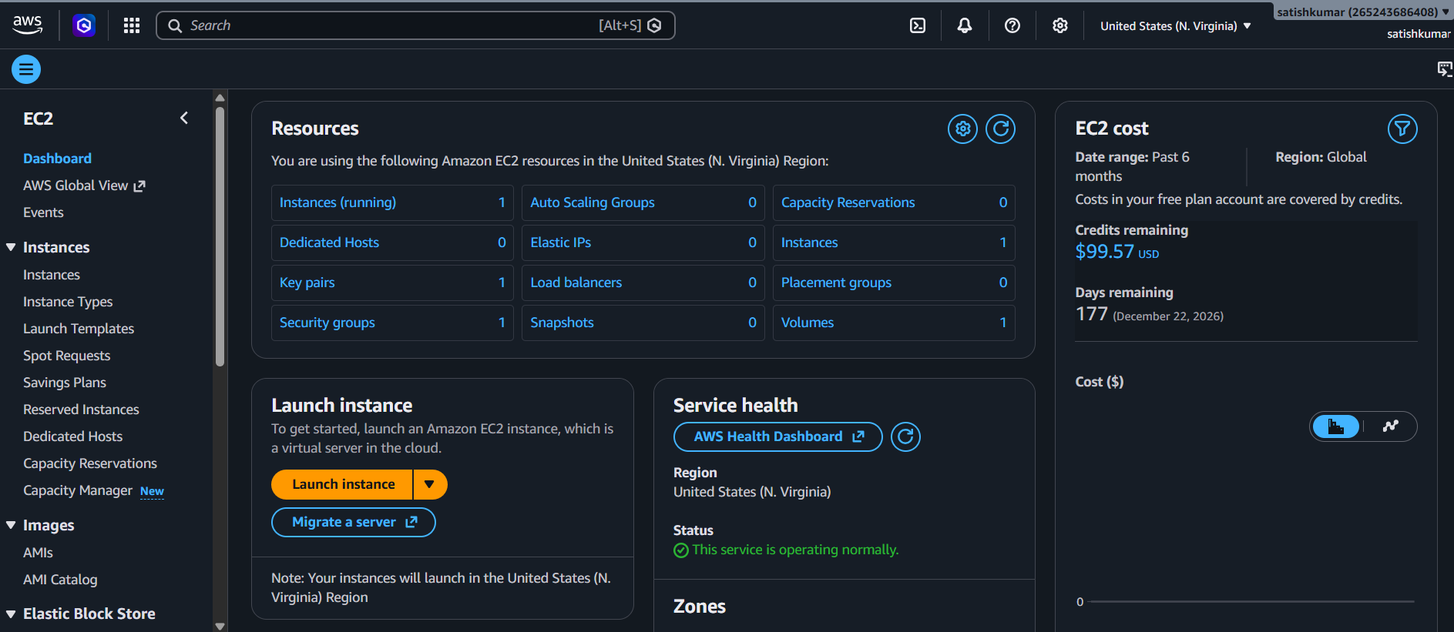

- Configure the following parameters:
Launch instance
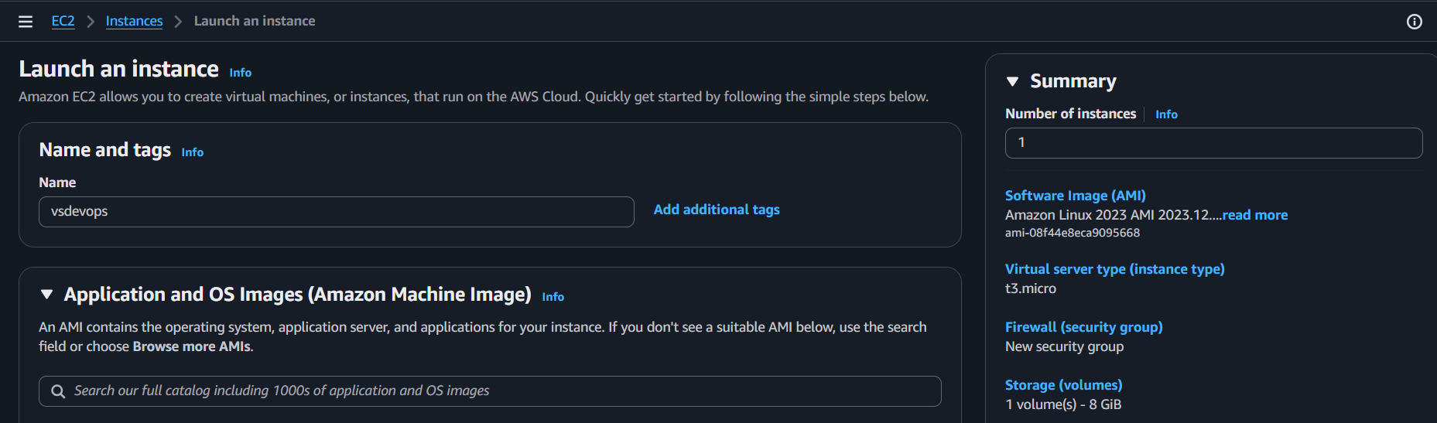
Amazon Machine Image (AMI)
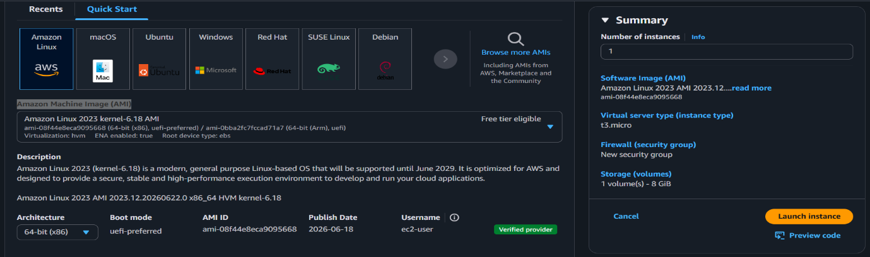

Create key pair
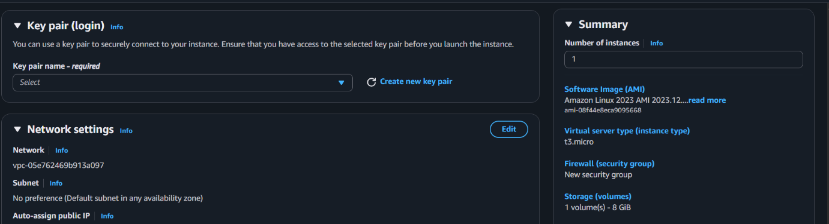

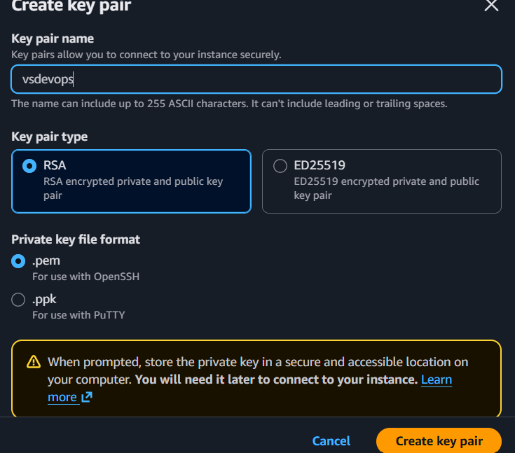

Click on create.
PER file download automatically in downloads.

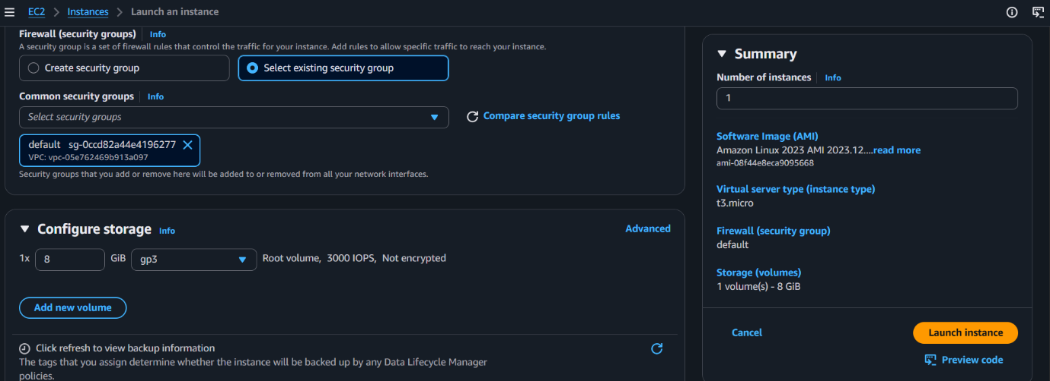
Firewall (security groups)
Firewall security group: Select existing security group
Common security groups : defult
Click on Lunch instance.
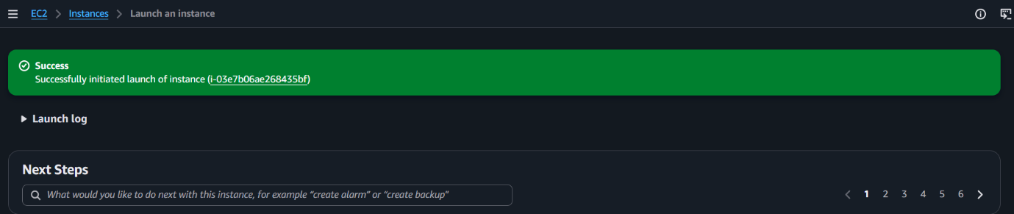

Click on instance (i-03e7b06ae268435bf)

