Setup a virtual machine using Ubuntu image.
- Go to AWS Console → EC2 → Launch Instance.
- Select Ubuntu Server 24.04 LTS AMI.
- Select instance type: t2.micro.
- Select/create a Key Pair.
- Allow SSH (22) and HTTP (80).
- Click Launch Instance.
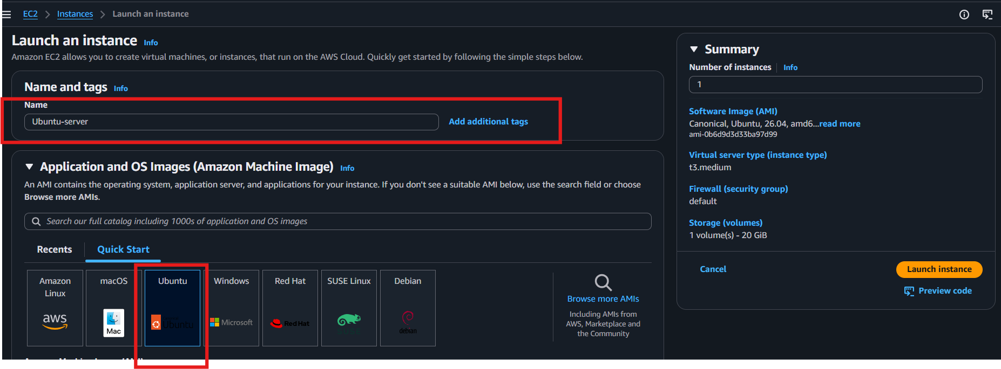
- Connect to the instance:
ssh -i key.pem ubuntu@<Public-IP>
8. Verify:
cat /etc/os-release
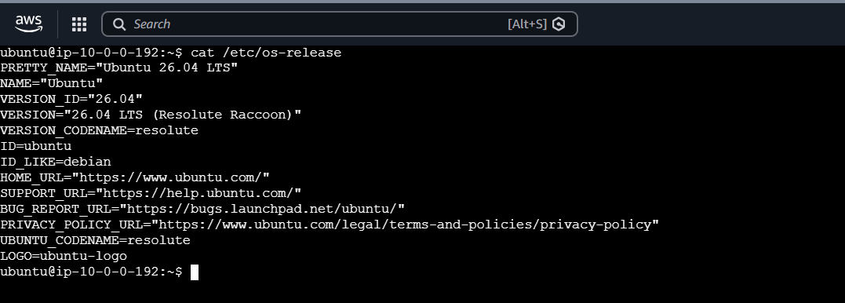
Done — Ubuntu EC2 instance is ready.

Install docker on ec2.
Step 1 — Update packages
sudo apt update
sudo apt upgrade -y
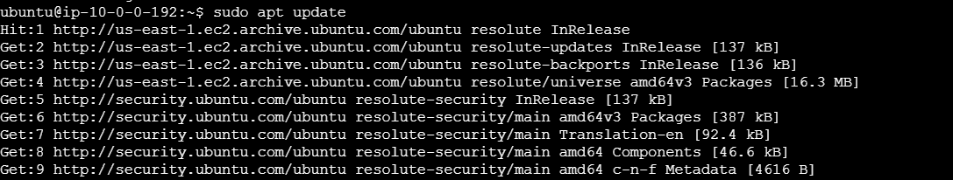
Step 2 — Install Docker
sudo apt install docker.io -y
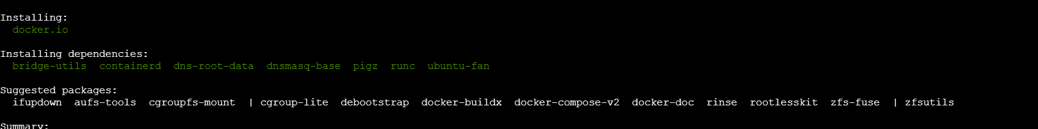
Step 3 — Start Docker
sudo systemctl start docker
sudo systemctl enable docker
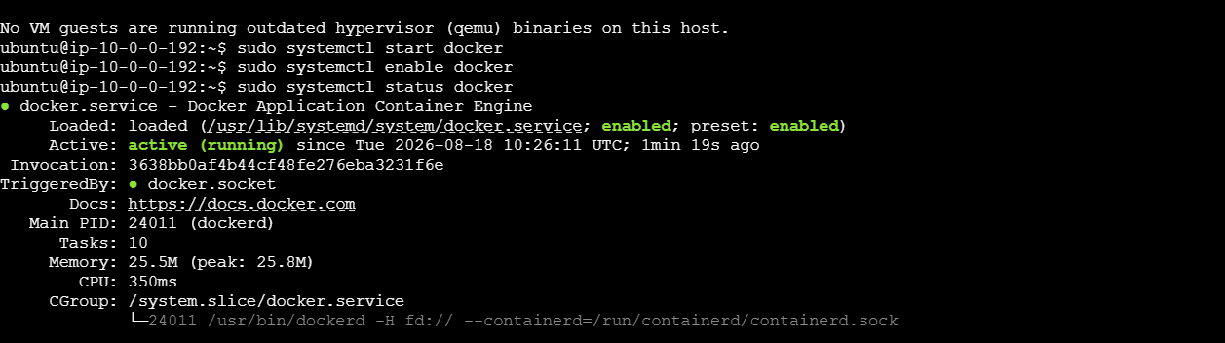
Step 4 — Verify Docker
docker --version
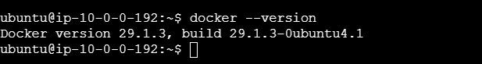

Step 5 — Allow your user to run Docker without sudo
sudo usermod -aG docker $USER
Apply the group change:
newgrp docker
Step 6 — Test Docker
docker run hello-world 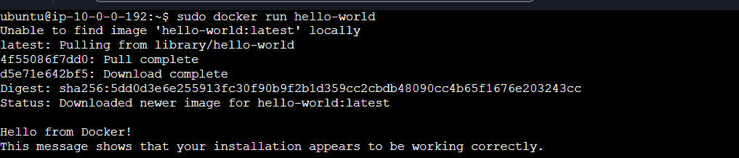

Pull 5 docker images. (nginx, Apache tomcat, ubuntu, Jenkins, SonarQube)
Definition: Pulling a Docker image means downloading the image from Docker Hub to your EC2 machine.
sudo docker pull nginx
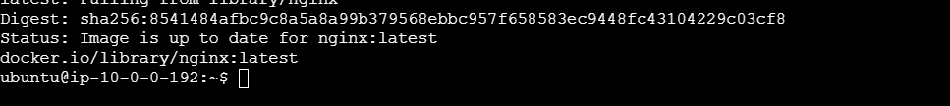
sudo docker pull tomcat
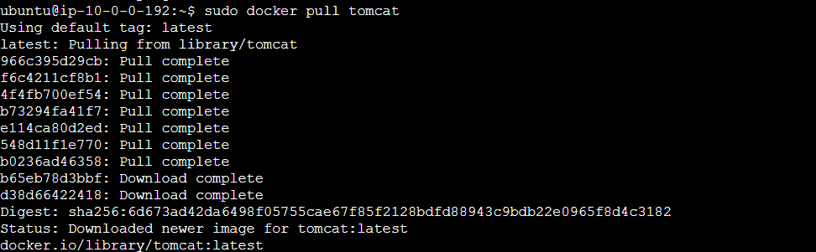

sudo docker pull ubuntu
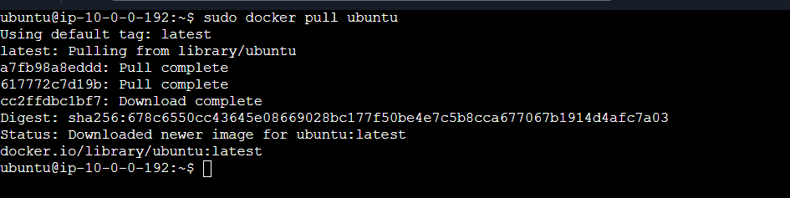
sudo docker pull jenkins/jenkins
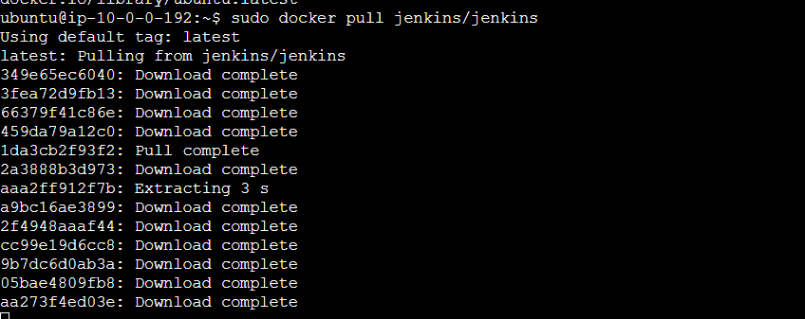
sudo docker pull sonarqube
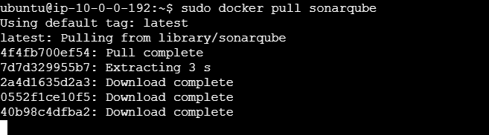
Check images:
sudo docker images
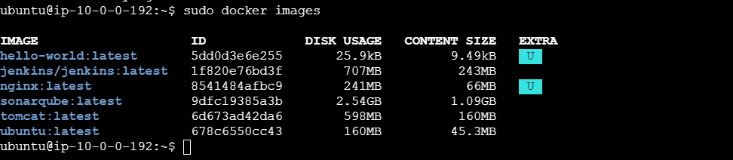

Run nginx container and expose on port 81.
4. Run Nginx Container and Expose on Port 81
Definition: Running a container means creating and starting a container from a Docker image. Port mapping connects EC2 port 81 to Nginx's container port 80.
sudo docker run -d --name nginx81 -p 81:80 nginx
Check:
sudo docker ps
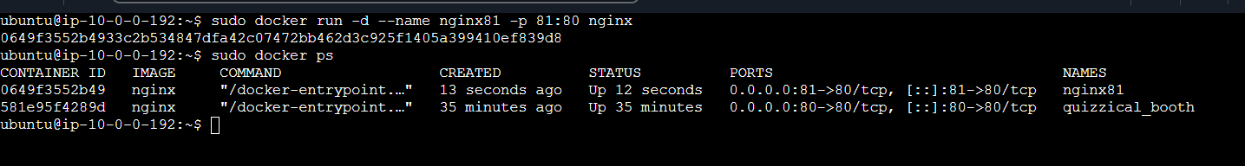
Open in browser:
http://<EC2-Public-IP>:81
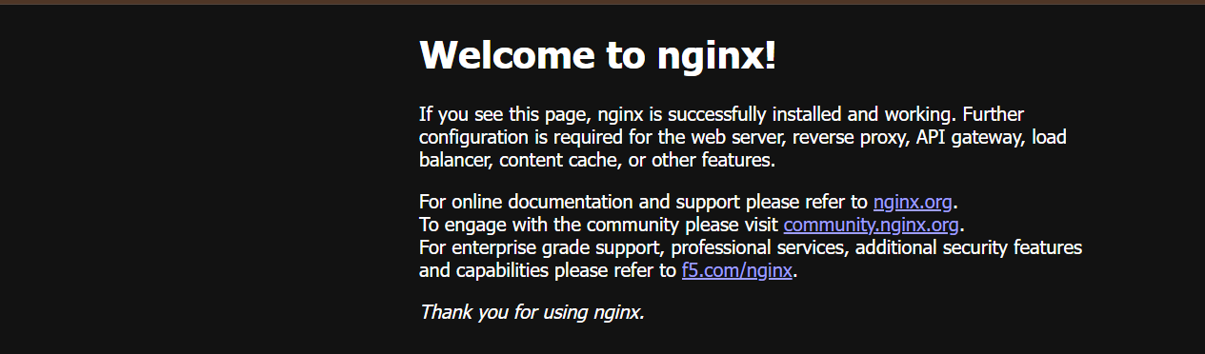

Delete the Apache tomcat image from local.
Check the Tomcat image:
sudo docker images
- Delete Tomcat:
sudo docker rmi tomcat
- Verify:
sudo docker images
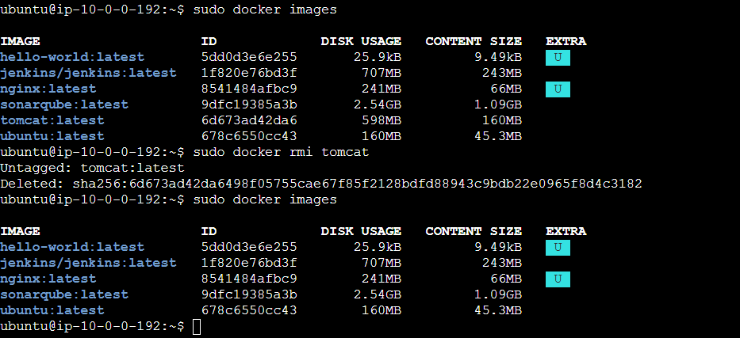
Done — Apache Tomcat image is removed from local EC2.

Inspect the Jenkins image, SonarQube image.
Definition: Inspecting a Docker image means viewing its detailed configuration and metadata.

Run:

sudo docker inspect jenkins/Jenkins
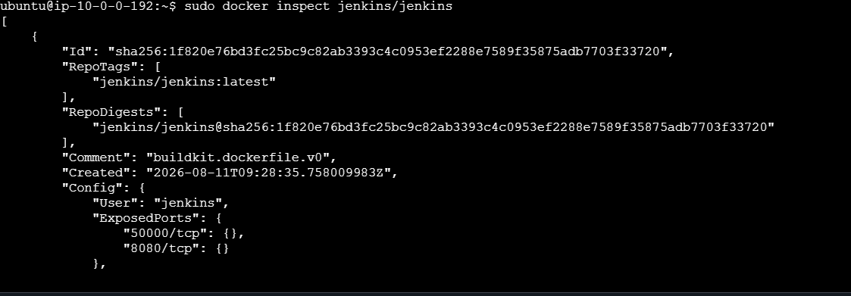
sudo docker inspect sonarqube
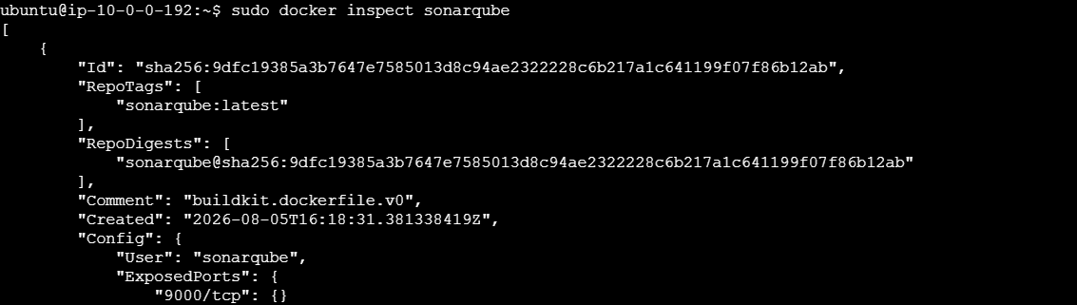

To see basic details:

sudo docker images jenkins/jenkins
sudo docker images sonarqube
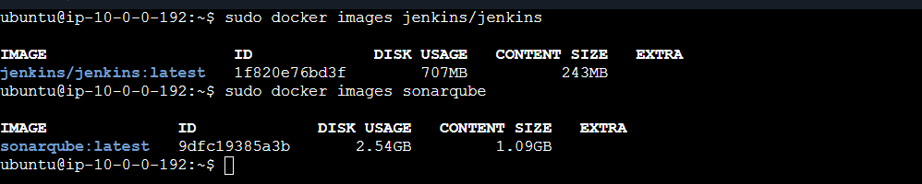
Done — Jenkins and SonarQube image details are displayed.

Run Jenkins container and run one sample job.

Definition: Run Jenkins as a Docker container and execute a simple Jenkins job.
1. Run Jenkins:
sudo docker run -d --name jenkins -p 8080:8080 -p 50000:50000 jenkins/jenkins:latest
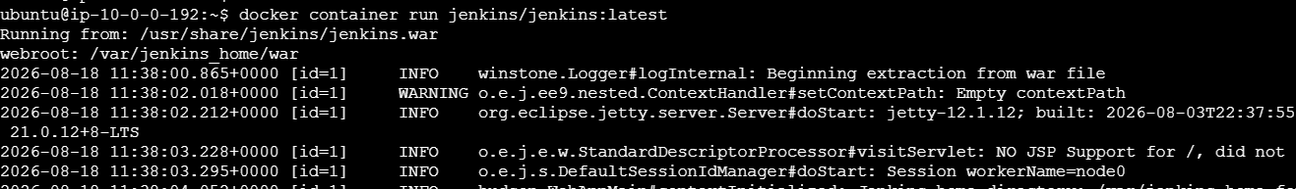
2. Check container:
sudo docker ps
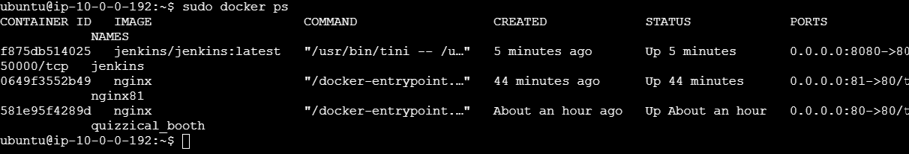
3. Open Jenkins:
http://<EC2-Public-IP>:8080
4. Get initial password:
sudo docker exec jenkins cat /var/jenkins_home/secrets/initialAdminPassword
5. Jenkins → New Item → sample-job → Freestyle project → OK
6. Build Steps → Execute shell:

echo "Hello from Jenkins"
7. Click: Save → Build Now
8. Check: Build #1 → Console Output
Expected:
Hello from Jenkins
Finished: SUCCESS
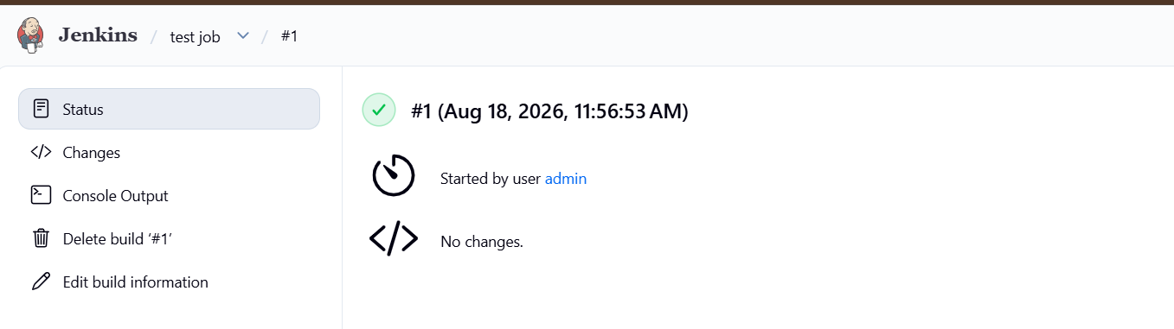
Done — Jenkins container is running and a sample job has been executed.

