Challenge.
Use Case: Setting up Transit Gateway and VPC Endpoints for a Multi-VPC Architecture
Scenario:
A large organization is migrating its on-premises infrastructure to the AWS cloud.
The organization's architecture involves multiple VPCs for different departments and applications, each requiring secure communication with centralized services and external resources.
The IT team needs to design and implement a scalable and efficient network architecture to accommodate the organization's growth and ensure robust connectivity between VPCs and external services.
Objectives:
- Design and deploy a scalable network architecture using AWS Transit Gateway to simplify network connectivity between multiple VPCs.
- Configure VPC endpoints to securely access AWS services without internet gateways or NAT gateways, ensuring data privacy and minimizing exposure to external threats.

Step 1: Create VPCs
Create three VPCs.
- VPC-A (10.0.0.0/16)
- VPC-B (10.1.0.0/16)
- VPC-C (10.2.0.0/16)
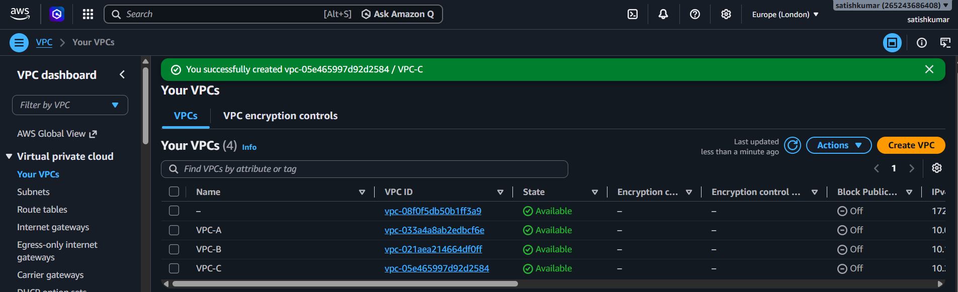
Create:
- 1 Public Subnet
- 1 Private Subnet
- Updated route table and Internet gateway
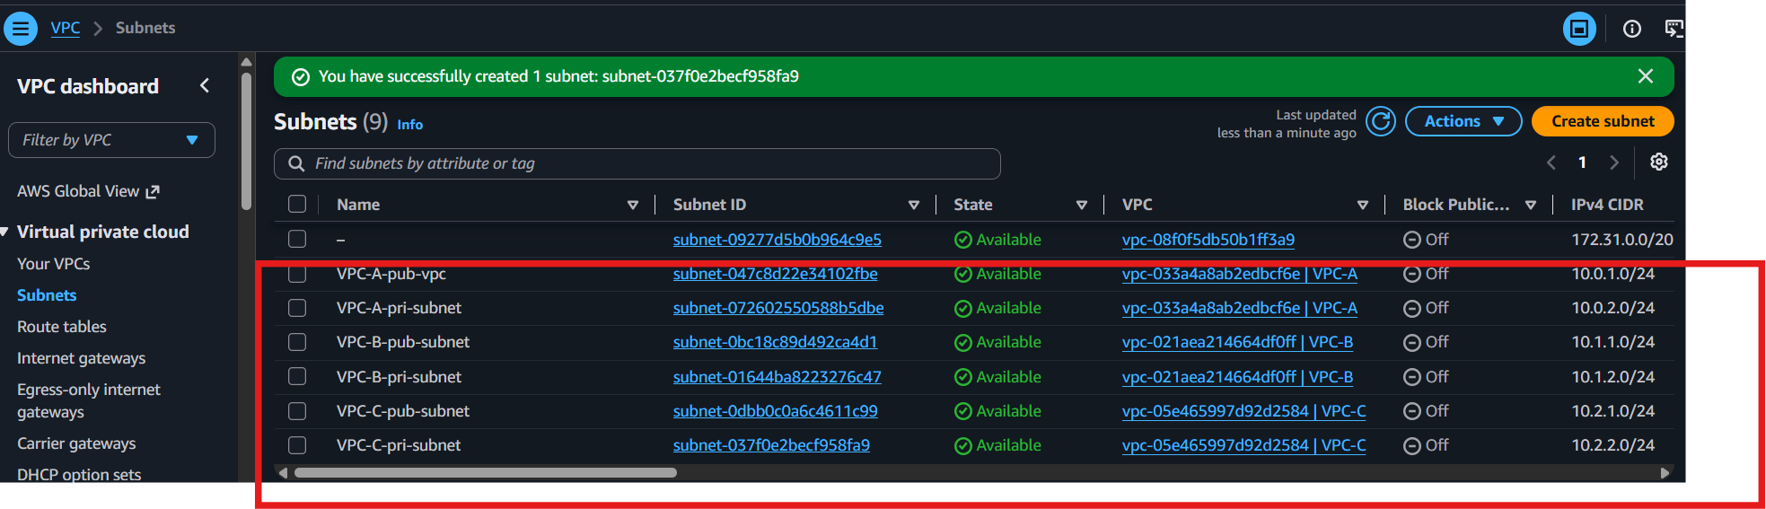

Step 2: Launch EC2 Instances
Launch one EC2 instance in each VPC.
Example:
- EC2-A
- EC2-B
- EC2-C
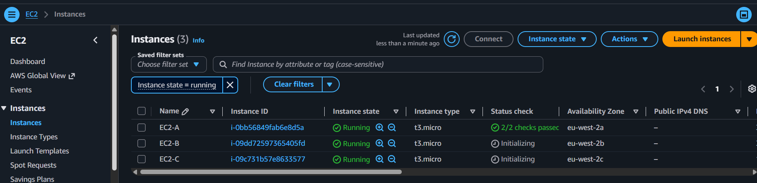

Step 3: Create Transit Gateway
Go to
VPC → Transit Gateways → Create Transit Gateway
Provide
- Name
- Amazon ASN (Default)
- Enable DNS Support
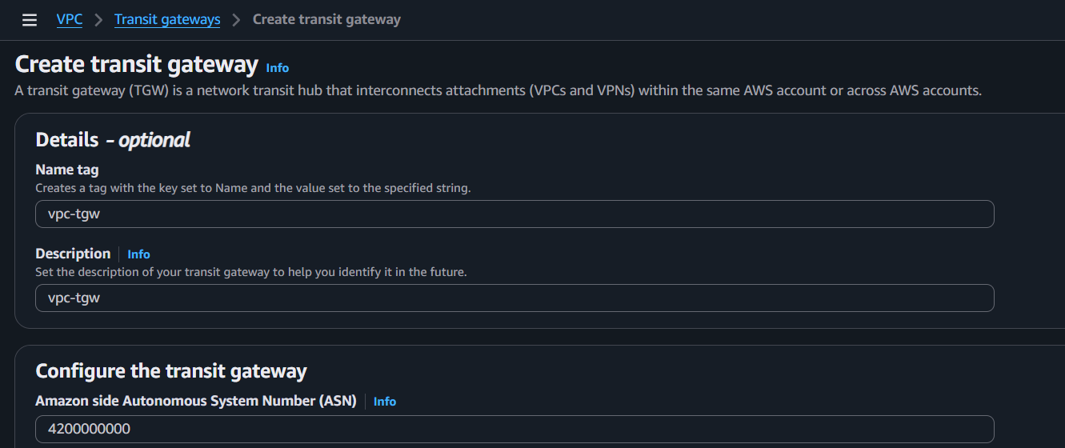
Click Create.
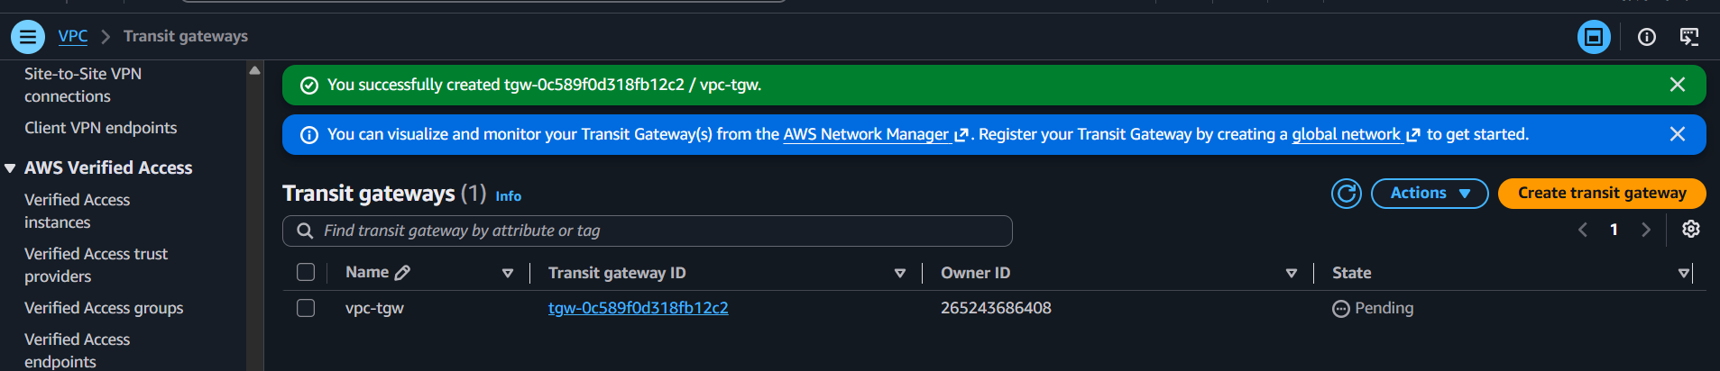

Step 4: Attach VPCs to Transit Gateway
Go to
Transit Gateway → Attachments → Create Attachment
Attach:
- VPC-A
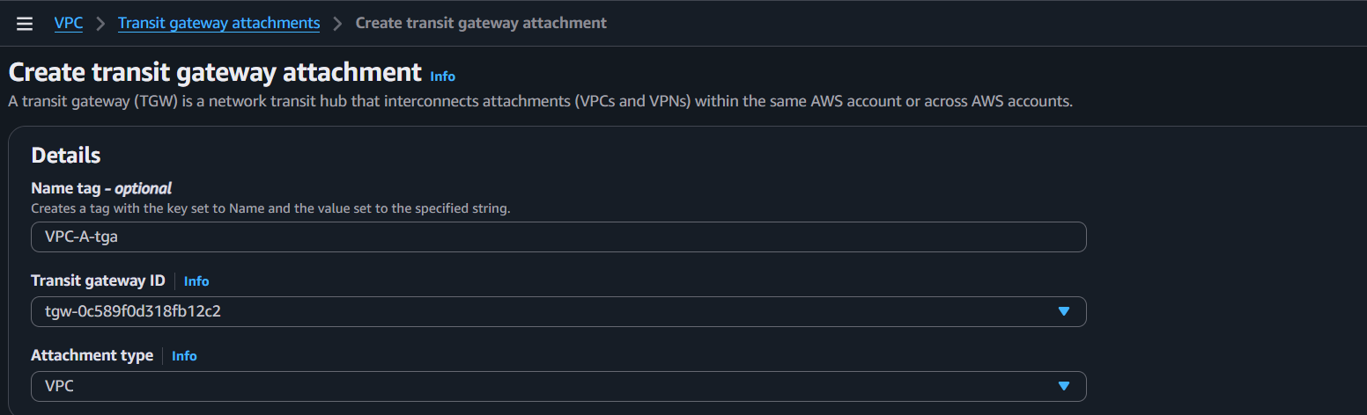
- VPC-B
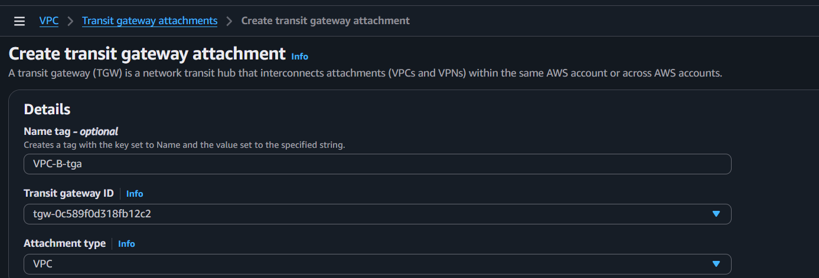
- VPC-C
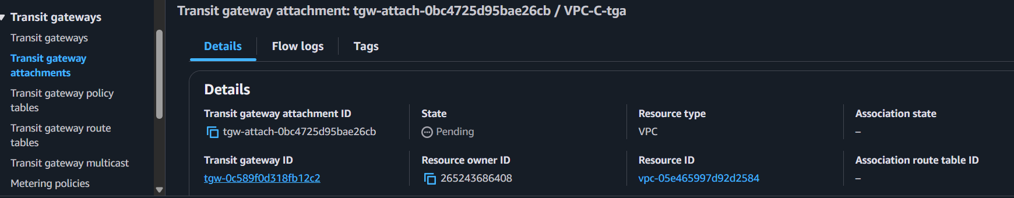
Select the subnet in each VPC.
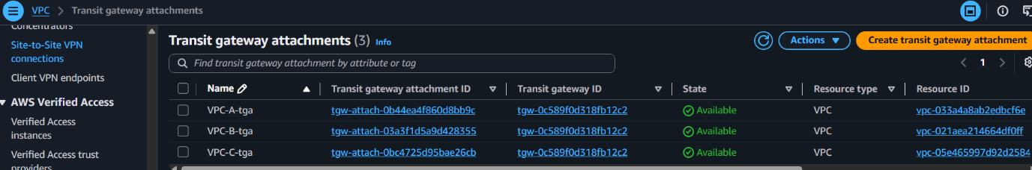
Wait until the attachment status becomes Available.

Step 5: Update Route Tables
In every VPC Route Table, add routes:
For VPC-A
Destination Target
10.1.0.0/16 Transit Gateway
10.2.0.0/16 Transit Gateway
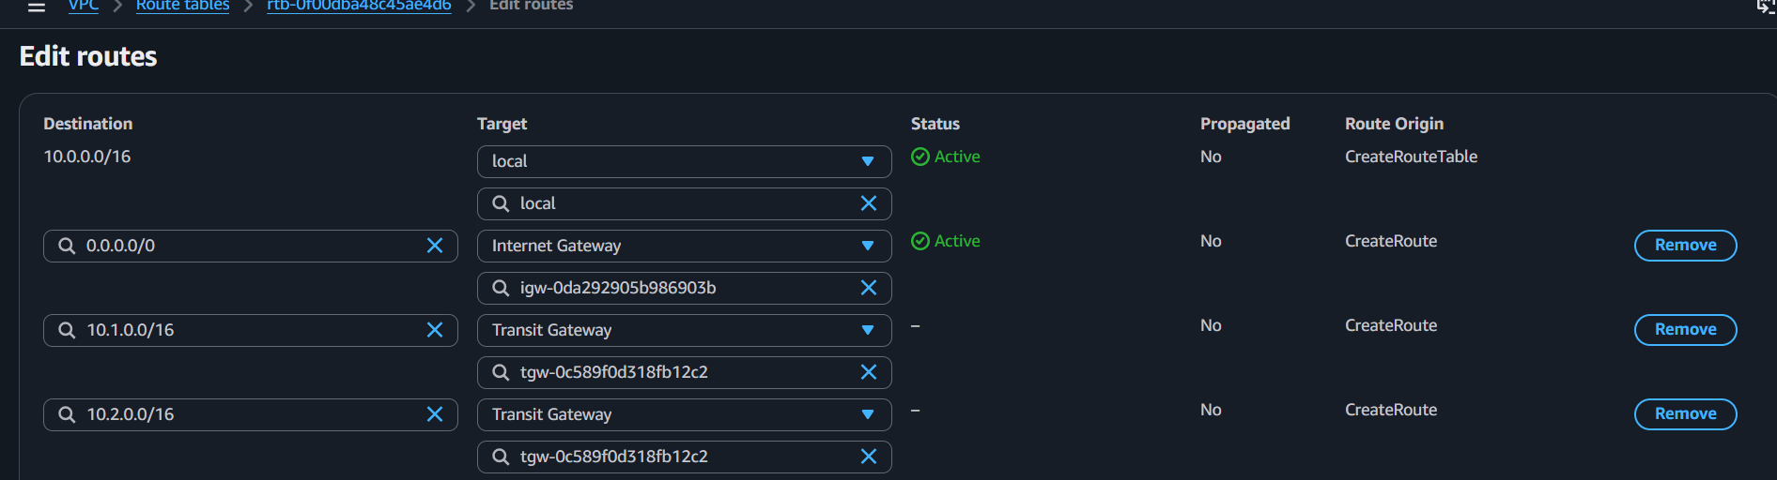
For VPC-B
10.0.0.0/16 Transit Gateway
10.2.0.0/16 Transit Gateway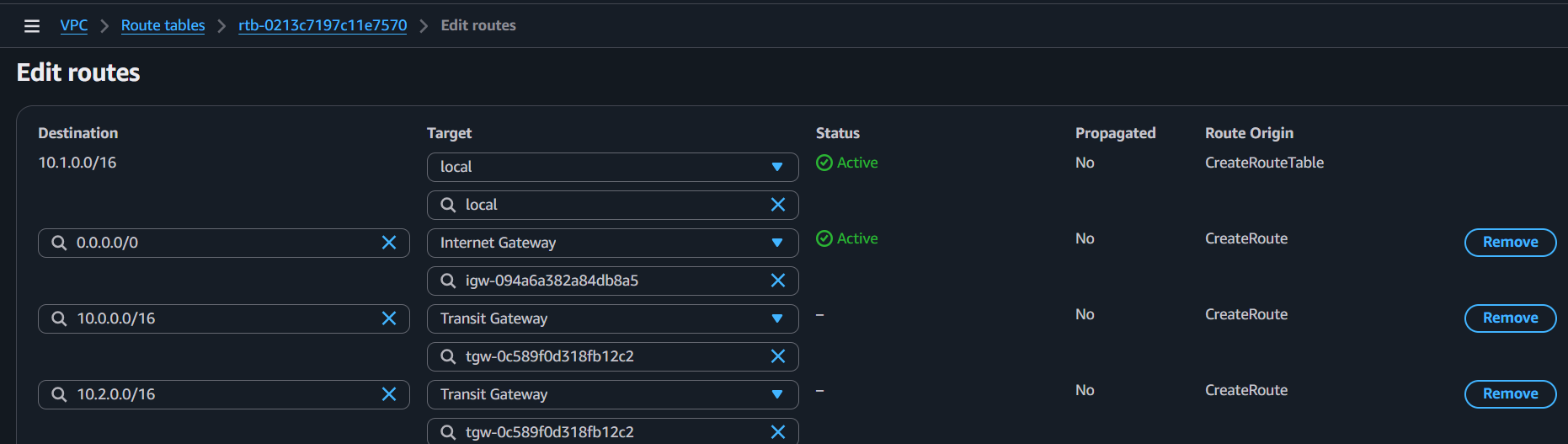
For VPC-C
10.0.0.0/16 Transit Gateway
10.1.0.0/16 Transit Gateway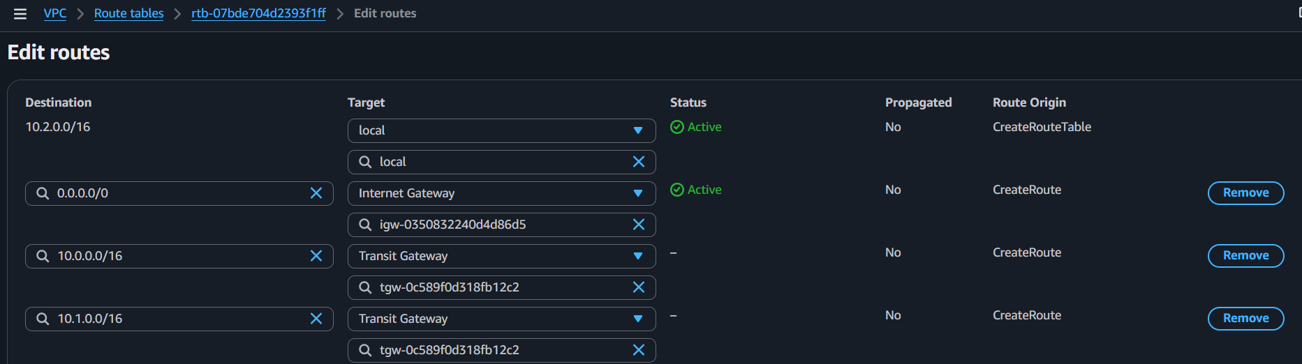

Step 6: Configure Security Groups
Allow ICMP (Ping)
or
Allow required ports like:
- SSH (22)
- HTTP (80)
- HTTPS (443)
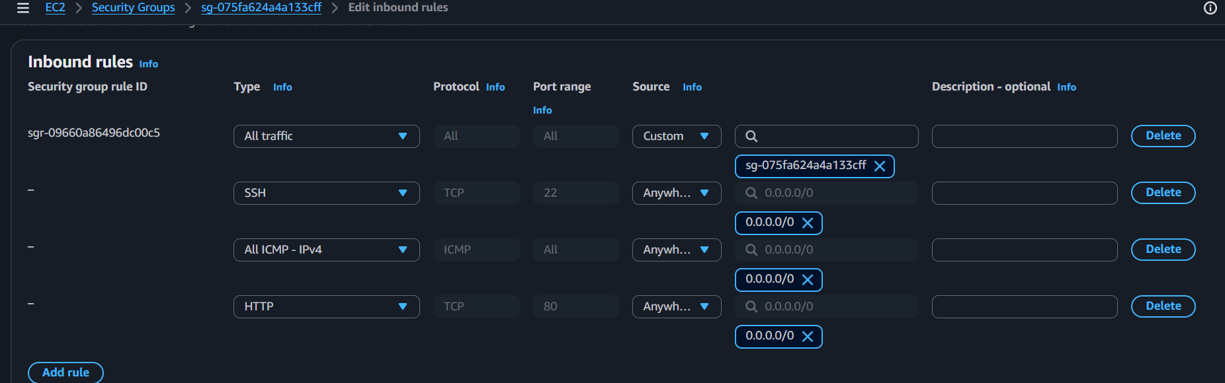

Step 7: Test Connectivity
From EC2-A
ping <Private-IP-of-EC2-B>
ping <Private-IP-of-EC2-C>
Connectivity should succeed through the Transit Gateway. 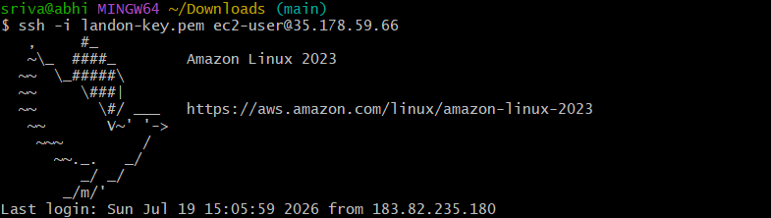
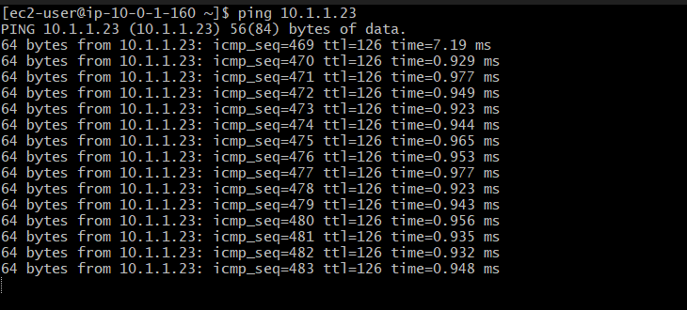

Step 8: Create VPC Endpoint
Go to
VPC → Endpoints → Create Endpoint
Choose the AWS service.
Example:
- S3 (Gateway Endpoint)
- DynamoDB (Gateway Endpoint)
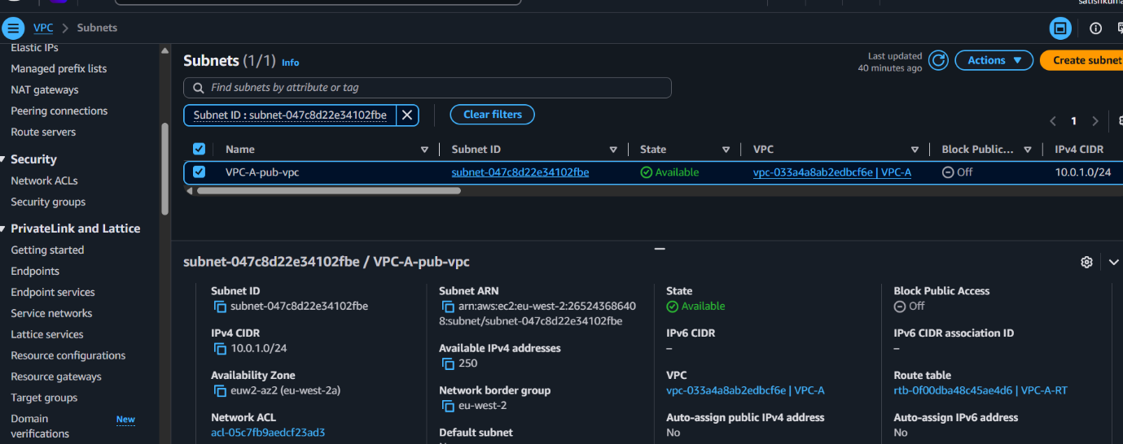
- SSM (Interface Endpoint)
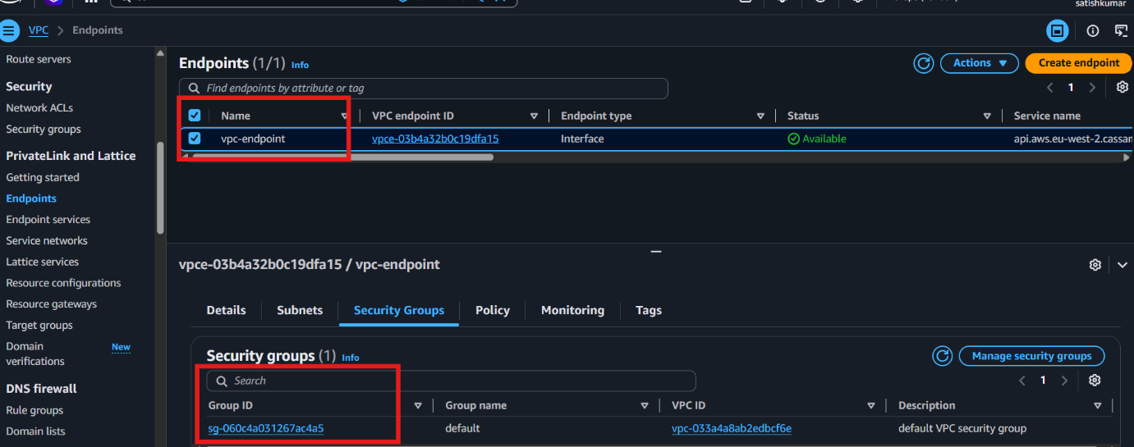

Configure VPC endpoints to securely access AWS services without internet gateways or NAT gateways.
An S3 Gateway Endpoint is specifically designed so EC2 instances can access Amazon S3 without using an Internet Gateway or NAT Gateway.

