Create a tomcat container on 8080 and deploy sample application in tomcat.
Prerequisites
- EC2 instance should be running.
- Docker should be installed and running.
- Docker permission should be configured for ec2-user.
- Port 8080 should be allowed in the EC2 Security Group.
- Internet access should be available to download the Tomcat image and sample application.
Check Docker:
docker --version
docker ps

Check Docker
docker --version
docker images
docker container ps
ps -a
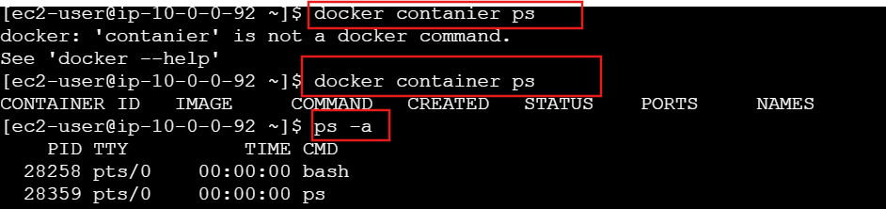
Steps
1. Pull Tomcat Image
docker pull tomcat:latest
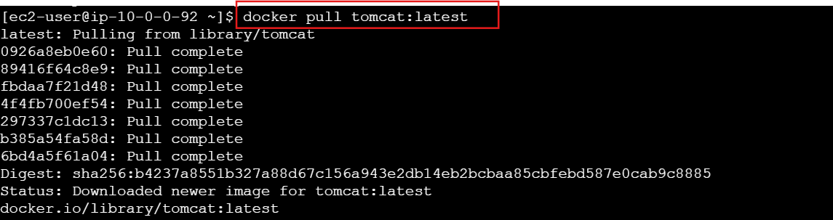
docker images
docker container ps
ps -a
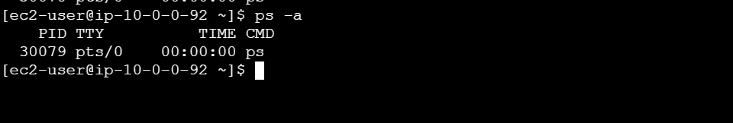
Downloads the Tomcat image from Docker Hub.
2. Create Tomcat Container
docker container run -itd -p 8080:8080 --name tomcat_test tomcat:latest
Creates and starts the Tomcat container.
3. Check Container
docker container ps
Verifies that the container is running.
4. Check Tomcat Logs
docker logs tomcat_test or
docker container log aa11d572ccac
Checks whether Tomcat started successfully.
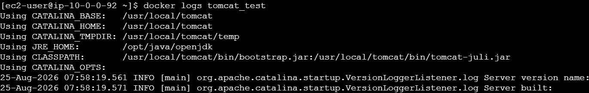
5. Enter the Container
docker exec -it tomcat_test /bin/bash
Enters the Tomcat container—login to docker container we use docker exec

6. Go to Webapps Directory
cd /usr/local/tomcat/webapps
This is where Tomcat applications are deployed.
7. Check Existing Applications
ll
8. Download Sample Application
Install wget
Inside the container, run:
apt update
apt install wget -y
Copy link address from tomcat sample
wget https://tomcat.apache.org/tomcat-7.0-doc/appdev/sample/sample.war
Downloads the sample .war application.
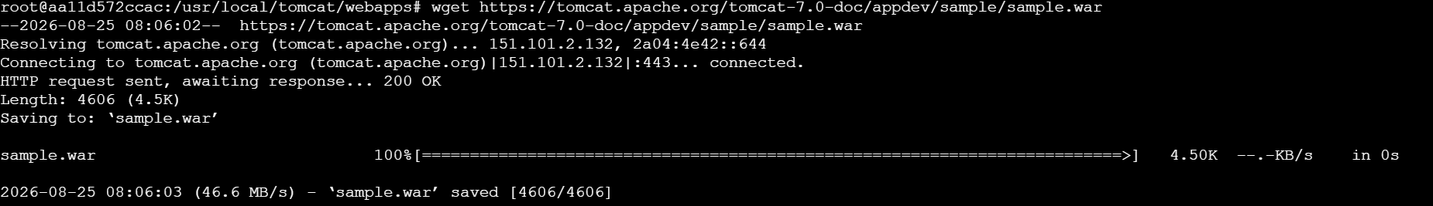
9. Verify Application
ll
You should see the .war file.
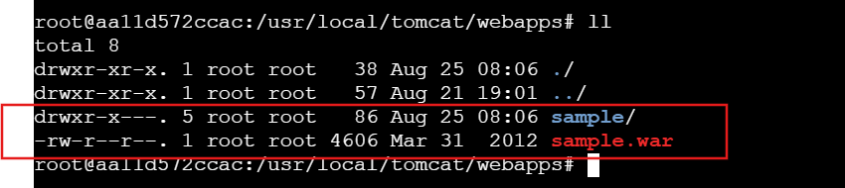
Tomcat automatically deploys the WAR file.

10. Access Application
Open in browser:
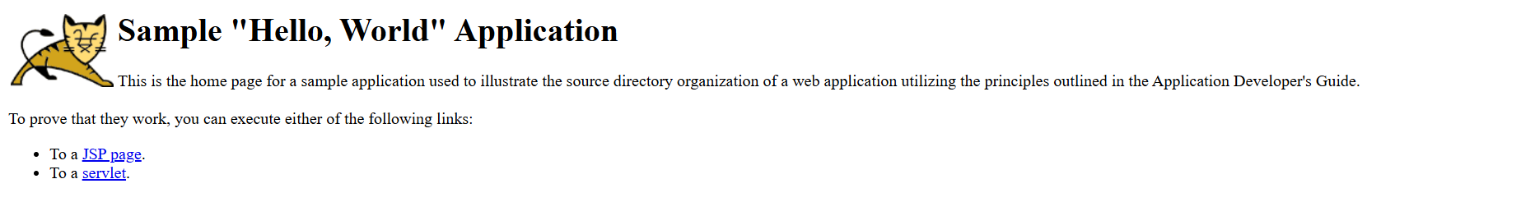
11.Check Tomcat Logs
docker container logs aa11d572ccac
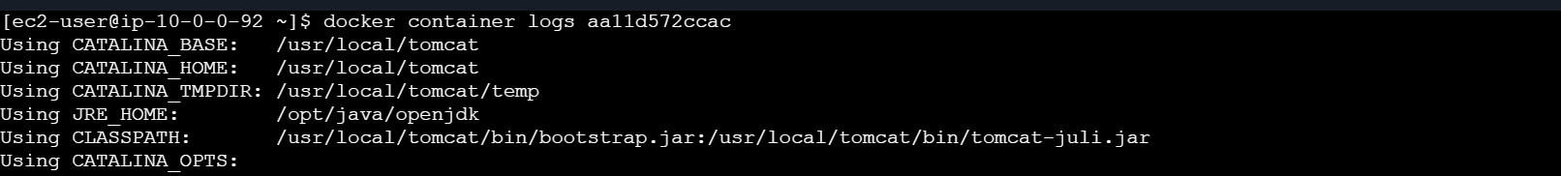

Create volume and deploy tomcat container on port 8081.
1. Create Volume
docker volume create deployment
2. Check Volume
docker volume ls
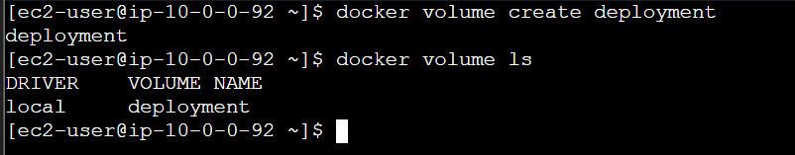
3. Go to Docker Volume Directory
cd /var/lib/docker/volumes/
ll
cd deployment/
ll
cd _data/
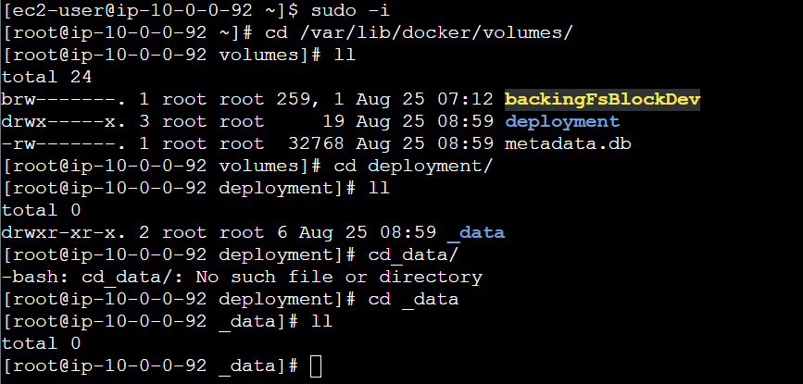
4. Check Volume Path
pwd
Output:
/var/lib/docker/volumes/deployment/_data
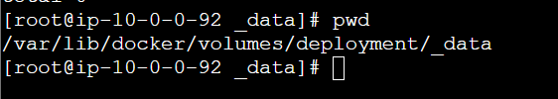
5. Download Sample Application
wget https://tomcat.apache.org/tomcat-7.0-doc/appdev/sample/sample.war
Check: ll
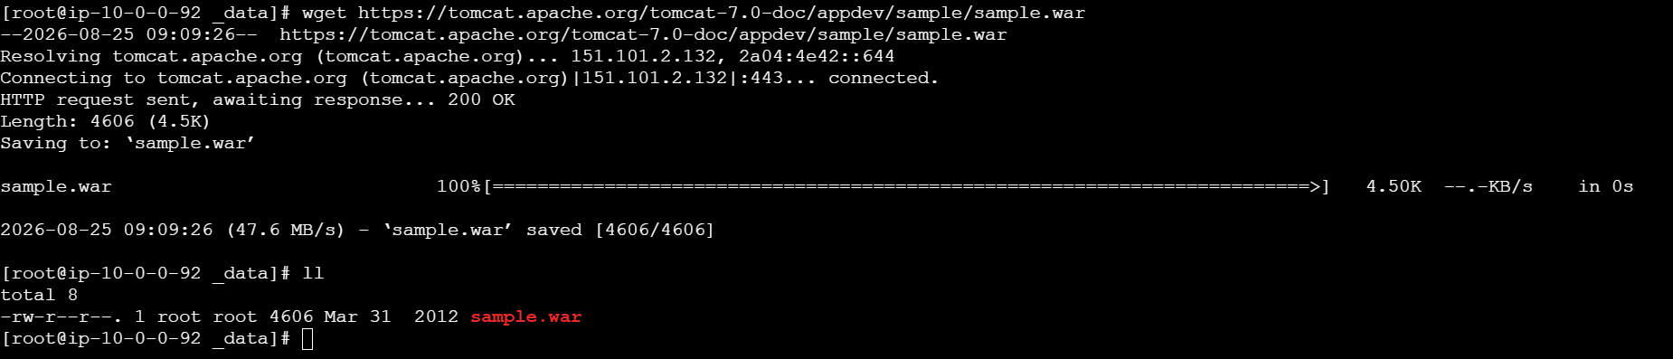
6. Create Tomcat Container
docker container run -itd -p 8082:8080 -v /var/lib/docker/volumes/deployment/_data:/usr/local/tomcat/webapps tomcat:latest

7. Check Container
docker container ps
8. Enter Tomcat Container
docker exec -it <container-id> /bin/bash
9. Go to Webapps
cd webapps
ll
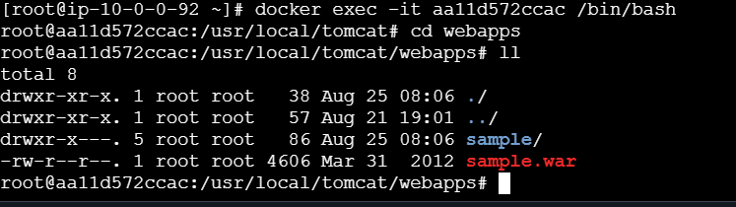
10. Test Volume
touch inside_container
ll
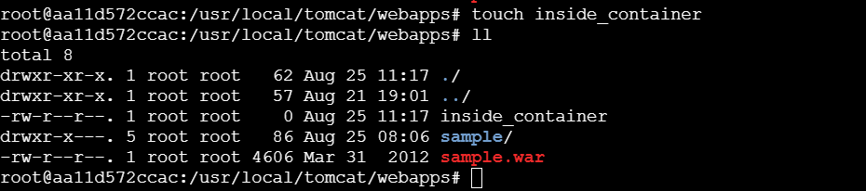
11. Exit Container
exit
12. Check File from Host
cd /var/lib/docker/volumes/deployment/_data
ll
You should see:
inside_container
sample.war
sample/
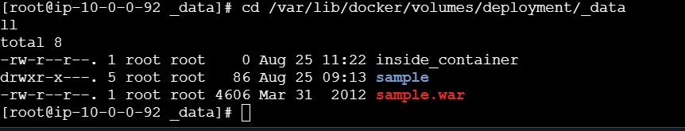
13. Access Application
http://<EC2-PUBLIC-IP>:8082/sample/
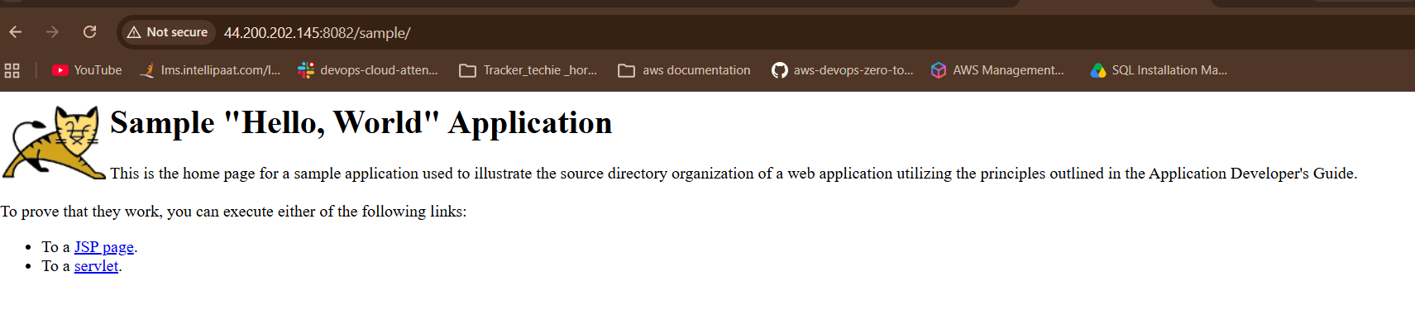

Limit the nginx container to 500 MB.
1. Pull Nginx image
docker pull nginx:latest
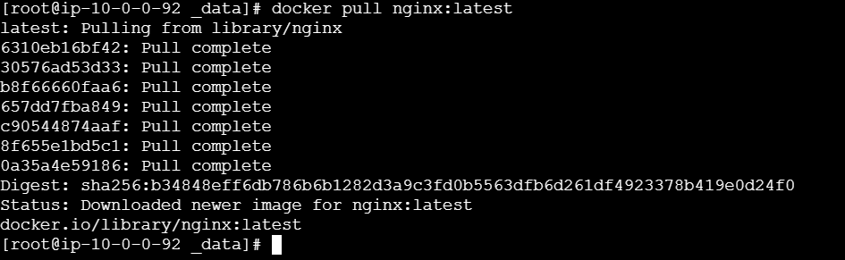
2. Create Nginx container with 500 MB memory
docker run -d --name nginx_test --memory=500m -p 8083:80 nginx:latest
- --memory=500m → Limits container RAM to 500 MB
- -p 8083:80 → EC2 port 8083 → Nginx port 80

3. Check container
docker ps
4. Verify memory limit
docker stats nginx_test
You should see the memory limit around:
MEM USAGE / LIMIT... / 500MiB
5. Access Nginx
http://<EC2-PUBLIC-IP>:8083
Make sure port 8083 is allowed in the EC2 Security Group.


Create a sample docker file using below instructions.

Base module as amazon Linux: latest

Maintainer you name

Install nginx

COPY one index.html file to image

Expose on port 80

Command to start the nginx container

1. Create a directory
mkdir nginx
cd nginx
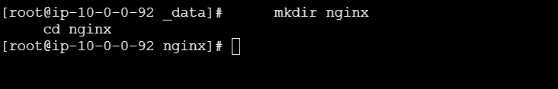
2. Create Dockerfile
vi Dockerfile
Add:
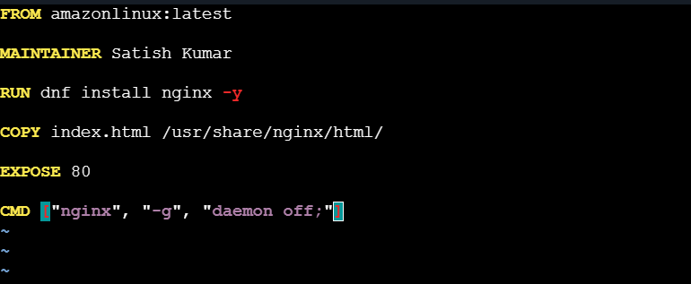

3. Create index.html
vi index.html
Add:
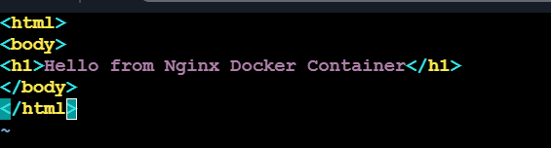
4. Build Docker Image
docker build -t mynginx .
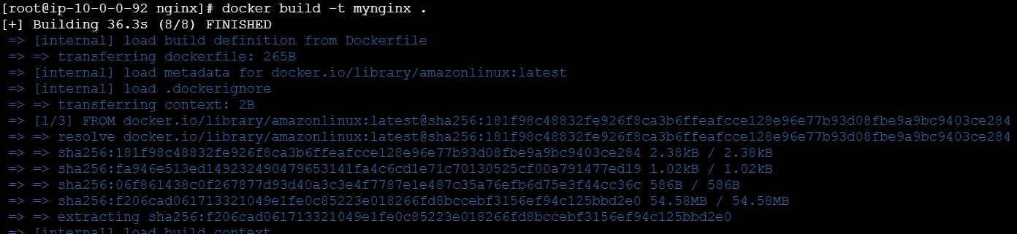
5. Run Container
docker run -d --name nginx_test -p 8083:80 mynginx
6. Check Container
docker ps
7. Test
curl http://localhost:8083
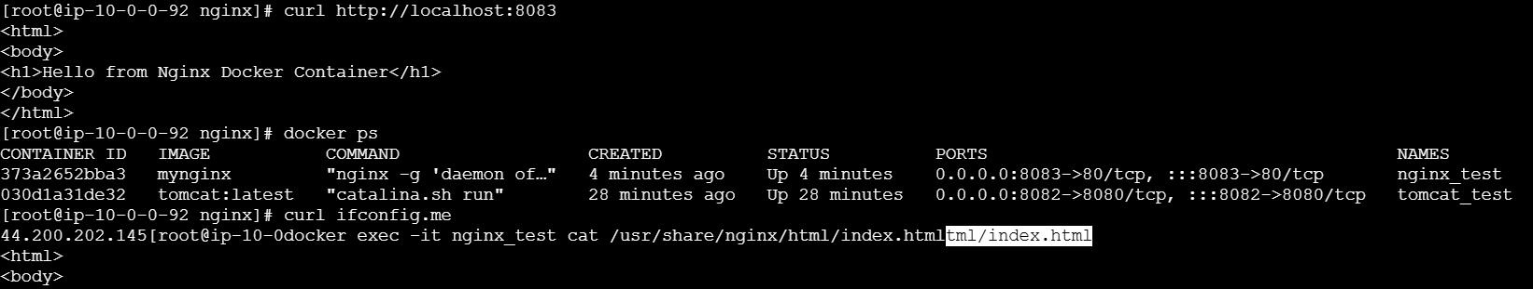
Or browser:
http://<EC2-PUBLIC-IP>:8083


Push image to Docker hub
1. Login to Docker Hub
docker login
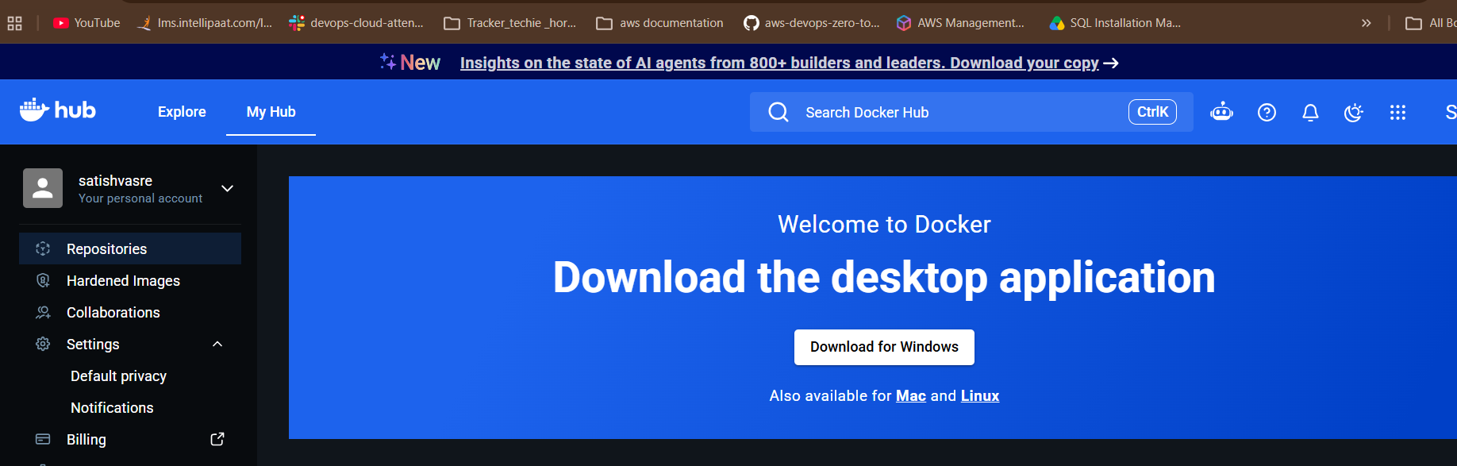
2. Check your image
docker images
You should see:
Mynginx
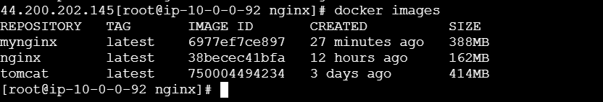
3. Tag the image
Replace yourusername with your Docker Hub username:
docker tag mynginx yourusername/mynginx:latest
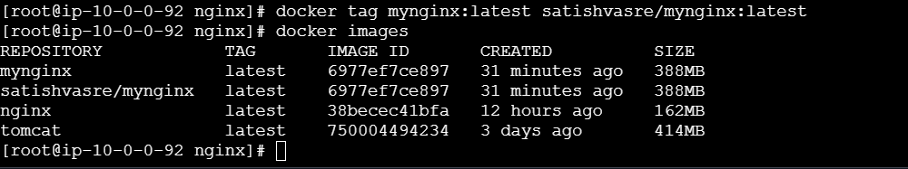
4. Check the tag
docker images
5. Push to Docker Hub
docker push yourusername/mynginx:latest
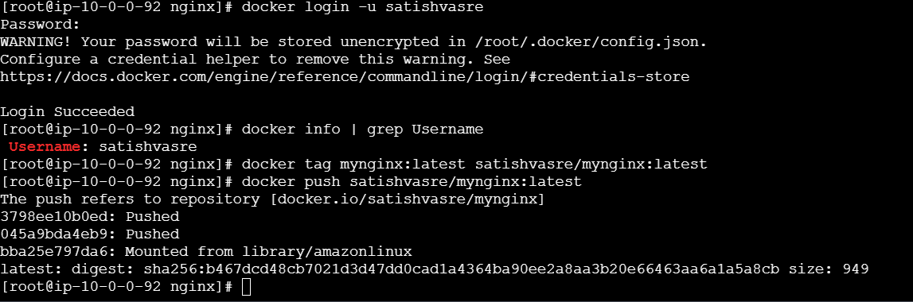
6. Verify
Go to your Docker Hub account and check the Repositories section.
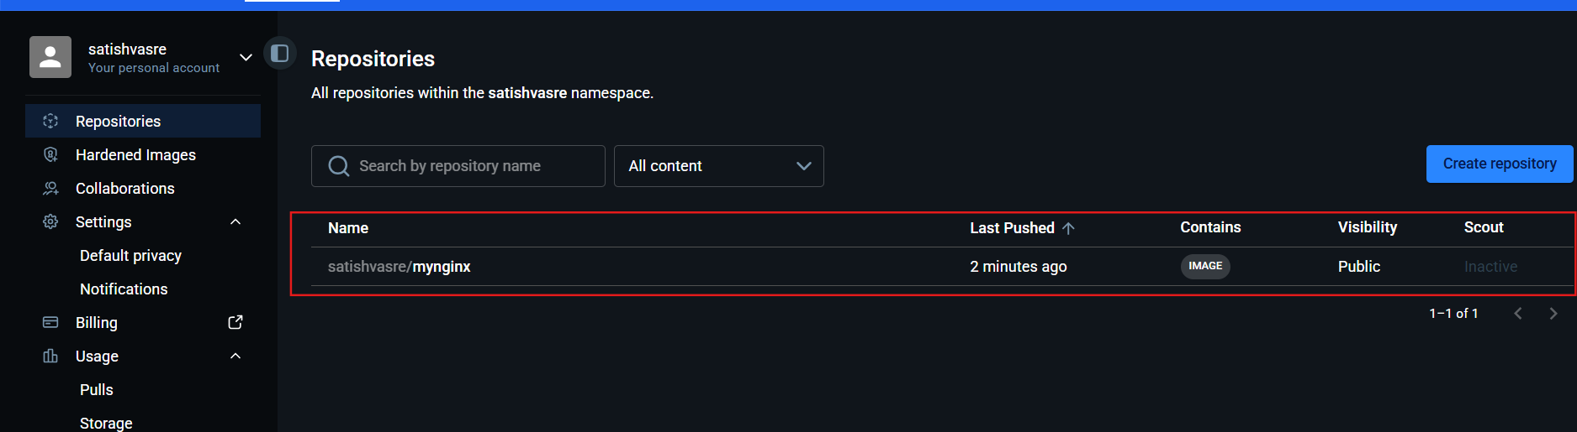
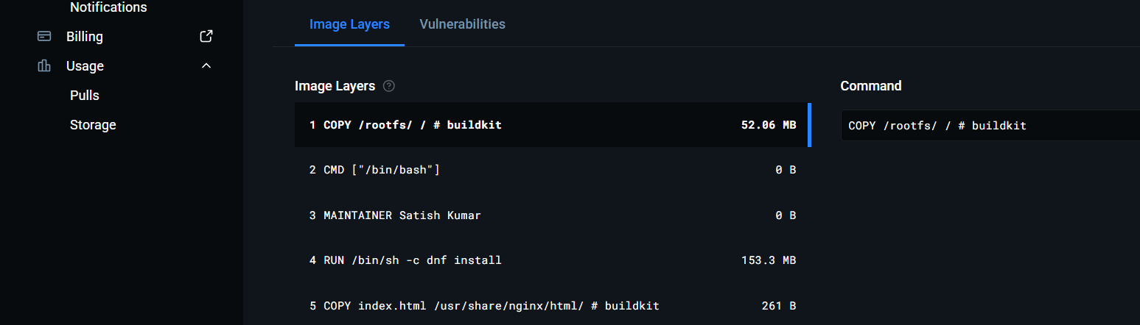

push image to AWS ECR
Push Docker Image to AWS ECR
mynginx:latest
Create ECR repository
aws ecr create-repository --repository-name mynginx
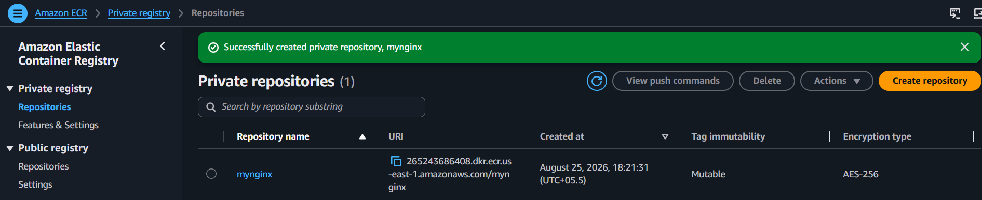
Prerequisites
- AWS CLI configured / EC2 IAM role attached
- ECR repository created: mynginx
- Docker image available: mynginx:latest
Steps
1. Login to ECR
aws ecr get-login-password --region us-east-1 | docker login --username AWS --password-stdin 265243686408.dkr.ecr.us-east-1.amazonaws.com
2. Tag the image
docker tag mynginx:latest 265243686408.dkr.ecr.us-east-1.amazonaws.com/mynginx:latest
3. Push the image
docker push 265243686408.dkr.ecr.us-east-1.amazonaws.com/mynginx:latest
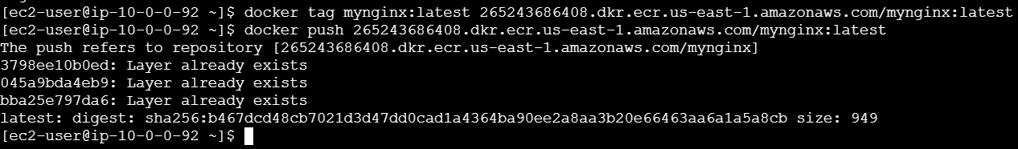
4. Verify
aws ecr list-images --repository-name mynginx --region us-east-1
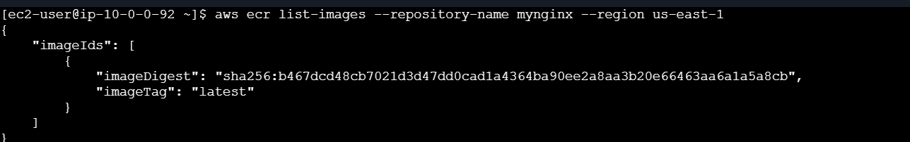
You can verify in:
AWS Console → ECR → Private repositories → mynginx

