k8s-06 tasks.
- Create a ConfigMap from a directory containing multiple files and inject the variables into a pod as environment variables.
Task: Create a ConfigMap from a directory containing multiple files and inject the values into a Pod as environment variables.
Purpose: ConfigMaps store non-sensitive configuration data separately from the application. The values can be injected into containers as environment variables.
1. Create a directory
On the Kubernetes master:
mkdir config-files
2. Create a ConfigMap from the Directory
echo "Satish" > config-files/username
echo "Hyderabad" > config-files/city
echo "DevOps" > config-files/role
Verify:
ls config-files 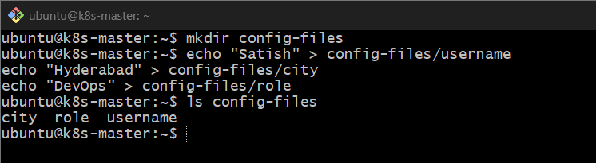
Expected:
city
role
username
Check the contents:
cat config-files/username
cat config-files/city
cat config-files/role 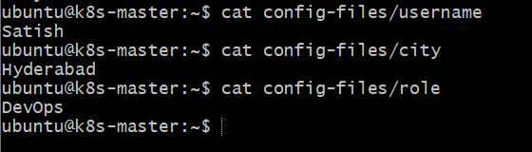
3. Create ConfigMap from the directory
kubectl create configmap app-config --from-file=config-files/ 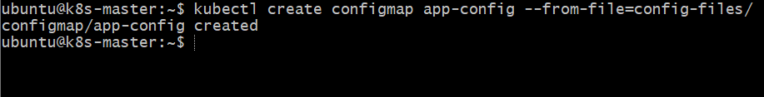
Verify:
kubectl get configmap app-config 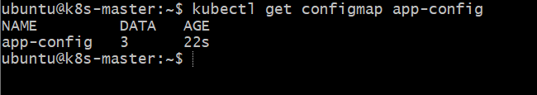
Check the data:
kubectl describe configmap app-config
You should see:
username: Satish
city: Hyderabad
role: DevOps 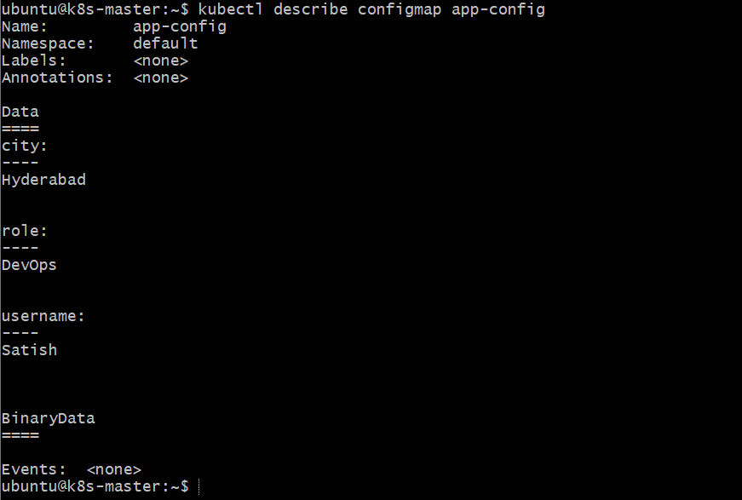
4. Inject ConfigMap Values as Environment Variables
Create YAML:
nano configmap-pod.yaml
Add:
apiVersion: v1
kind: Pod
metadata:
name: configmap-pod
spec:
containers:
- name: nginx
image: nginx
env:
- name: USERNAME
valueFrom:
configMapKeyRef:
name: app-config
key: username

- name: CITY
valueFrom:
configMapKeyRef:
name: app-config
key: city

- name: ROLE
valueFrom:
configMapKeyRef:
name: app-config
key: role
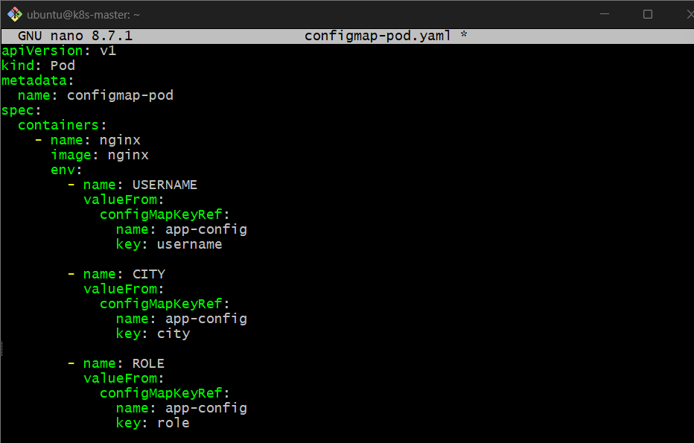
5. Apply the Pod Configuration
kubectl apply -f configmap-pod.yaml
Verify:
kubectl get pod configmap-pod 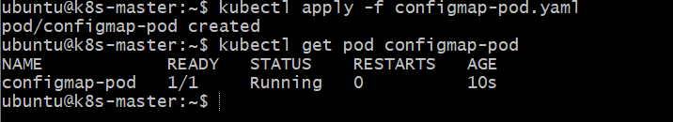
6. Verify the Injected Environment Variables
Run:
kubectl exec configmap-pod -- env | grep -E 'USERNAME|CITY|ROLE'
Expected:
USERNAME=Satish
CITY=Hyderabad
ROLE=DevOps 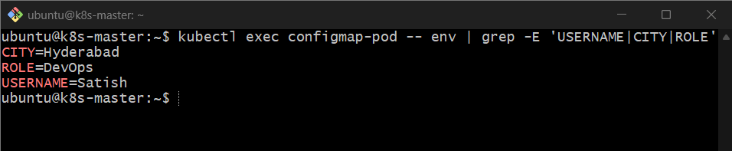
How it works
config-files/
├── username
├── city
└── role
↓
ConfigMap
app-config
↓
configMapKeyRef
↓
Pod
↓
USERNAME=Satish
CITY=Hyderabad
ROLE=DevOps

- Create a ConfigMap from a file and mount it as a volume inside a pod, ensuring the configuration data is available as files.
Task: Create a ConfigMap from a file and mount it as a volume inside a Pod, so the configuration data is available as files.
Purpose: To provide application configuration as files inside a container without rebuilding the Docker image.
1. Create a configuration file
Run on the Kubernetes master:
mkdir config-volume
cd config-volume
Create a file:
vi app.properties
Add:
APP_NAME=MyApplication
ENVIRONMENT=Development
CITY=Hyderabad
PORT=8080 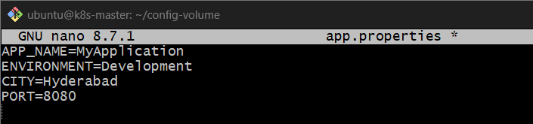
2. Create ConfigMap from the file
kubectl create configmap app-config-volume --from-file=app.properties
Verify:
kubectl get configmap app-config-volume
kubectl describe configmap app-config-volume 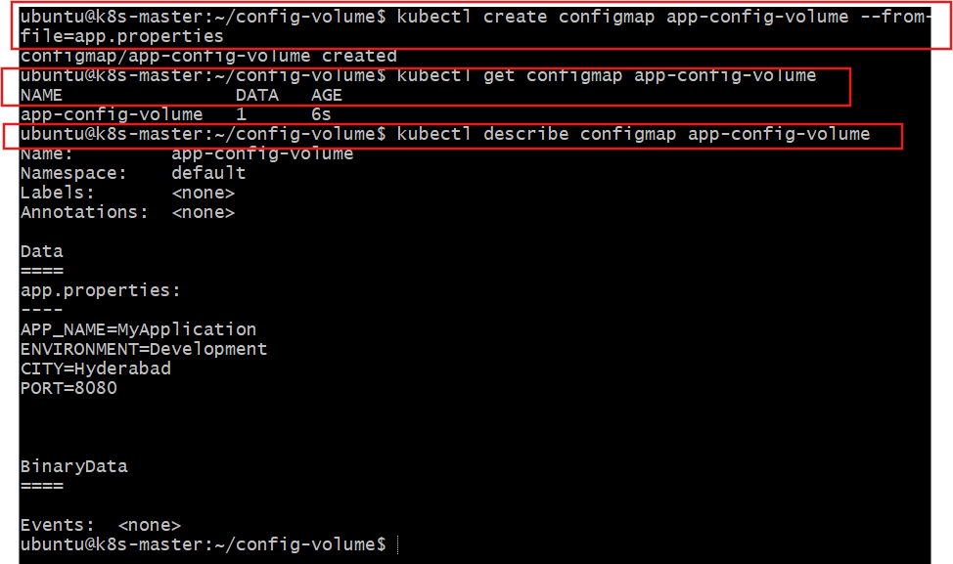
3. Create a Pod YAML
nano config-volume-pod.yaml
Add:
apiVersion: v1
kind: Pod
metadata:
name: config-volume-pod
spec:
containers:
- name: nginx
image: nginx
volumeMounts:
- name: config-volume
mountPath: /etc/app-config
readOnly: true
volumes:
- name: config-volume
configMap:
name: app-config-volume 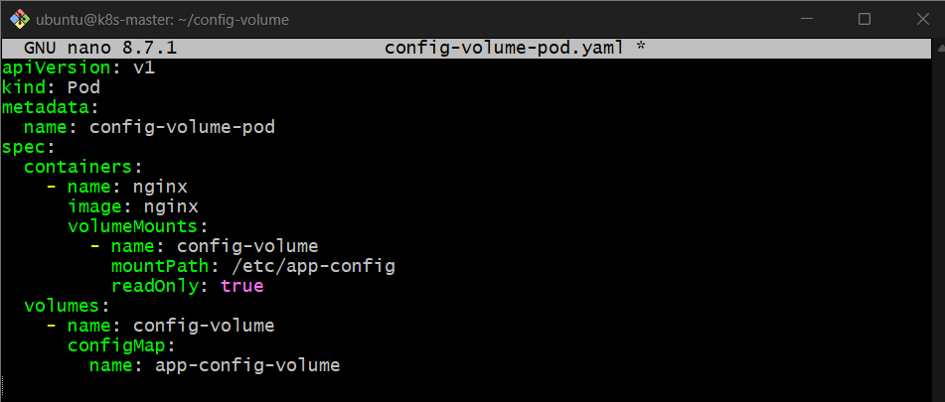
4. Create the Pod
kubectl apply -f config-volume-pod.yaml
Verify:
kubectl get pods
Wait until the Pod status is Running. 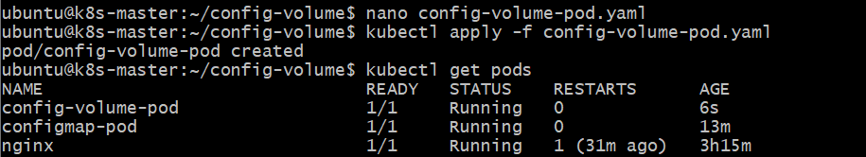
5. Verify the mounted configuration file
List the files inside the mounted directory:
kubectl exec config-volume-pod -- ls /etc/app-config
Expected output:
app.properties 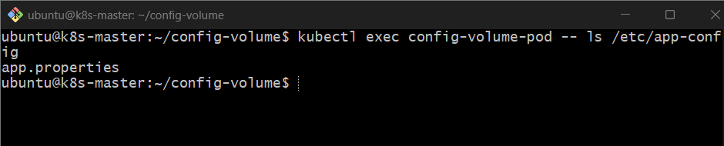
Read the configuration:
kubectl exec config-volume-pod -- cat /etc/app-config/app.properties 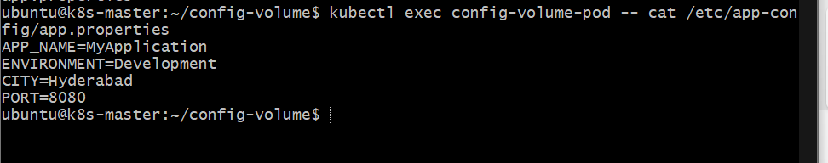
Expected output:
APP_NAME=MyApplication
ENVIRONMENT=Development
CITY=Hyderabad
PORT=8080
How it works
app.properties
Configuration file on the master
ConfigMap: app-config-volume
Stores the file's contents under the key app.properties
Pod: config-volume-pod
ConfigMap mounted at /etc/app-config
/etc/app-config/app.properties
Important concepts
- ConfigMap: Stores non-sensitive configuration data.
- Volume: Makes ConfigMap data accessible as files inside the container.
- mountPath: Specifies where the files appear inside the container.
- readOnly: true: Prevents the container from modifying the mounted configuration files.
Expected result
The Pod runs successfully, and the configuration file app.properties is accessible inside /etc/app-config/.

- Create a Secret with sensitive information (username and password) and inject it into a pod as environment variables.
Task: Create a Secret containing a username and password, then inject the Secret values into a Pod as environment variables.
Purpose: Kubernetes Secrets are used to store sensitive information such as usernames, passwords, tokens, and keys.
1. Create the Secret
Create the Secret directly using kubectl:
kubectl create secret generic app-secret \
--from-literal=username=admin \
--from-literal=password=MyPassword123 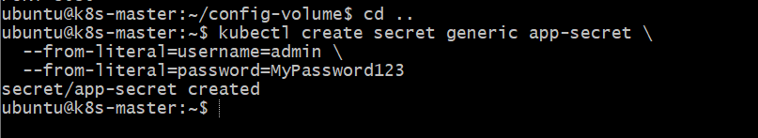
Verify:
kubectl get secret app-secret 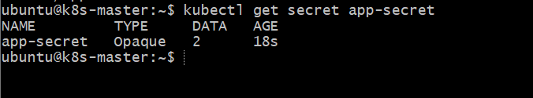
You can check the keys without displaying the actual values:
kubectl describe secret app-secret
Expected:
Name: app-secret
Type: Opaque
Data
====
password: 13 bytes
username: 5 bytes 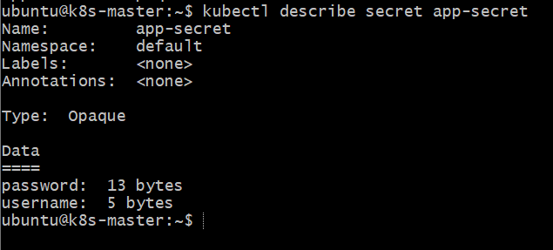

2. Create a Pod YAML
nano secret-pod.yaml
Add:
apiVersion: v1
kind: Pod
metadata:
name: secret-pod
spec:
containers:
- name: nginx
image: nginx
env:
- name: DB_USERNAME
valueFrom:
secretKeyRef:
name: app-secret
key: username

- name: DB_PASSWORD
valueFrom:
secretKeyRef:
name: app-secret
key: password 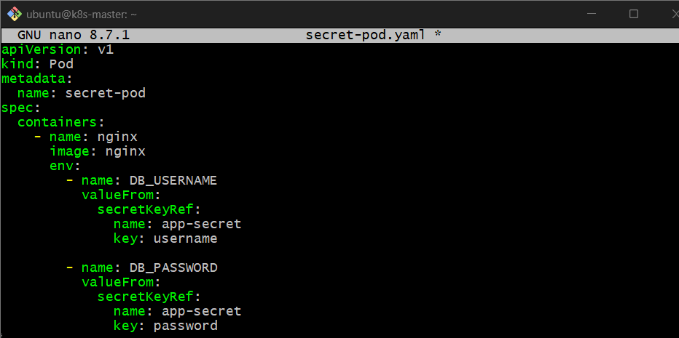
3. Inject Secret Values as Environment Variables
The injection happens here:
env:
- name: DB_USERNAME
valueFrom:
secretKeyRef:
name: app-secret
key: username

- name: DB_PASSWORD
valueFrom:
secretKeyRef:
name: app-secret
key: password
- secretKeyRef → gets a value from the Secret.
- name: app-secret → identifies the Secret.
- key: username → gets the username.
- key: password → gets the password.
4. Apply the Pod Configuration
kubectl apply -f secret-pod.yaml 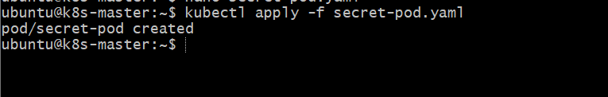
Check:
kubectl get pod secret-pod 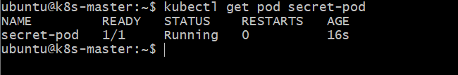
5. Verify the Injected Environment Variables
kubectl exec secret-pod -- env | grep -E 'DB_USERNAME|DB_PASSWORD'
Expected:
DB_USERNAME=admin
DB_PASSWORD=MyPassword123 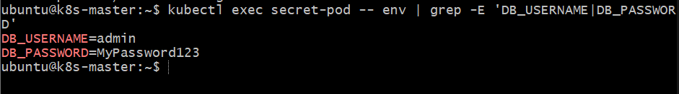
⚠️ For a real environment, avoid displaying passwords on the terminal. The command above is useful for this lab only.
Flow
Secret
│
├── username
└── password
│
▼
secretKeyRef
│
▼
Pod
│
├── DB_USERNAME
└── DB_PASSWORD
Key difference: ConfigMap is generally used for non-sensitive configuration, while Secret is intended for sensitive information.

- Create a Secret using a YAML file, mount it as a volume in a pod, and verify the specific Secret values are available as files.
Task: Create a Secret using a YAML file, mount it as a volume inside a Pod, and verify that the Secret values are available as files.
Purpose: To securely provide sensitive information to an application as files inside a container.

1. Create a Secret YAML File
nano secret-volume.yaml
Add:
apiVersion: v1
kind: Secret
metadata:
name: app-secret-volume
type: Opaque
stringData:
username: admin
password: MyPassword123 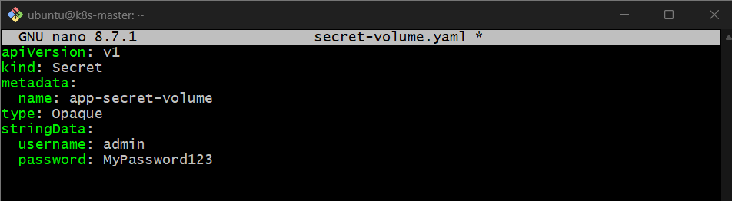
stringData allows us to write the values normally. Kubernetes stores them in the Secret's data field in encoded form.

2. Create the Secret
kubectl apply -f secret-volume.yaml
Verify:
kubectl get secret app-secret-volume
Check the Secret keys:
kubectl describe secret app-secret-volume
You should see:
Data
====
password: 13 bytes
username: 5 bytes 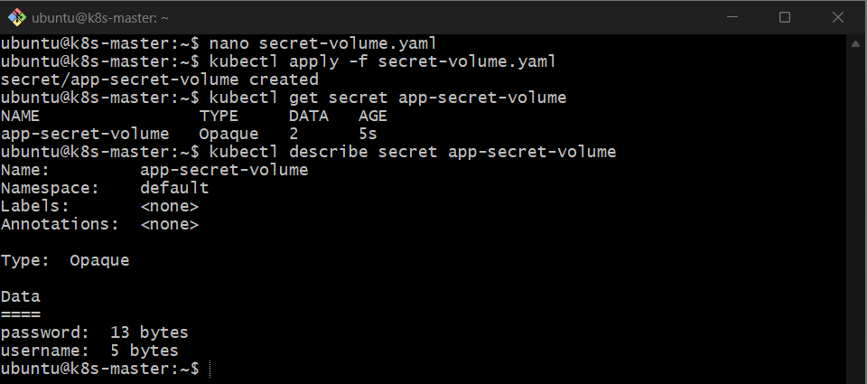

3. Create a Pod YAML with Secret Volume
vi secret-volume-pod.yaml
Add:
apiVersion: v1
kind: Pod
metadata:
name: secret-volume-pod
spec:
containers:
- name: nginx
image: nginx
volumeMounts:
- name: secret-volume
mountPath: /etc/app-secret
readOnly: true

volumes:
- name: secret-volume
secret:
secretName: app-secret-volume 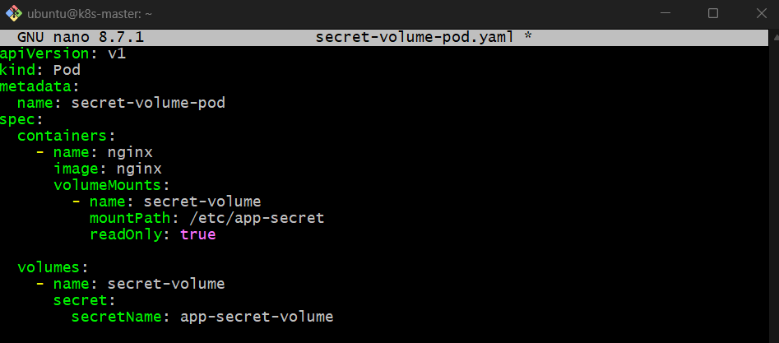

4. Mount the Secret as a Volume
The important configuration is:
volumeMounts:
- name: secret-volume
mountPath: /etc/app-secret
readOnly: true
and:
volumes:
- name: secret-volume
secret:
secretName: app-secret-volume
Kubernetes creates files using the Secret keys:
/etc/app-secret/username
/etc/app-secret/password

5. Apply the Pod Configuration
kubectl apply -f secret-volume-pod.yaml 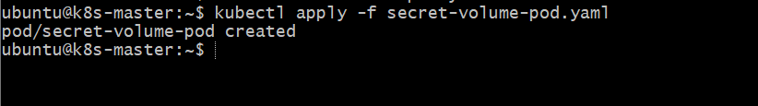
Verify:
kubectl get pod secret-volume-pod
Wait until it shows Running. 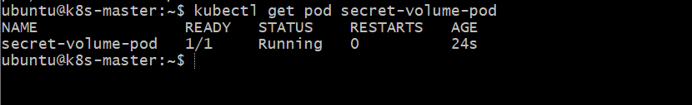

6. Verify the Secret Files
List the mounted files:
kubectl exec secret-volume-pod -- ls /etc/app-secret
Expected:
password
username
Verify the username:
kubectl exec secret-volume-pod -- cat /etc/app-secret/username
Output:
admin
Verify the password:
kubectl exec secret-volume-pod -- cat /etc/app-secret/password 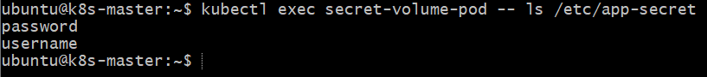
Output:
MyPassword123
How it works
Secret YAML
│
▼
app-secret-volume
│
▼
Secret Volume
│
▼
/etc/app-secret/
├── username
└── password
│
▼
Pod
Expected result: The username and password from the Secret are available as separate files inside /etc/app-secret/.

- Inject a ConfigMap as environment variables and a Secret as files into the same pod, ensuring both are accessible within the pod.
Task: Inject a ConfigMap as environment variables and mount a Secret as files in the same Pod.
Purpose: To demonstrate how a Pod can use both non-sensitive configuration from a ConfigMap and sensitive information from a Secret.

1. Create a ConfigMap
kubectl create configmap app-config-task5 \
--from-literal=APP_NAME=MyApplication \
--from-literal=ENVIRONMENT=Production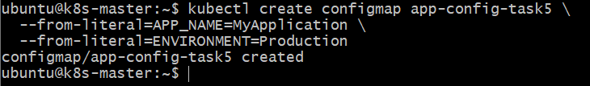
Verify:
kubectl get configmap app-config-task5 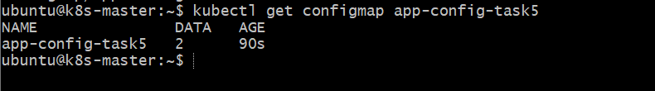

2. Create a Secret
Your app-secret already exists, so do not create it again.
Verify:
kubectl get secret app-secret 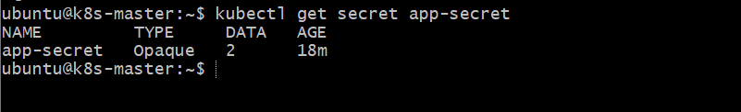
Check the keys:
kubectl describe secret app-secret
You should have:
username
password 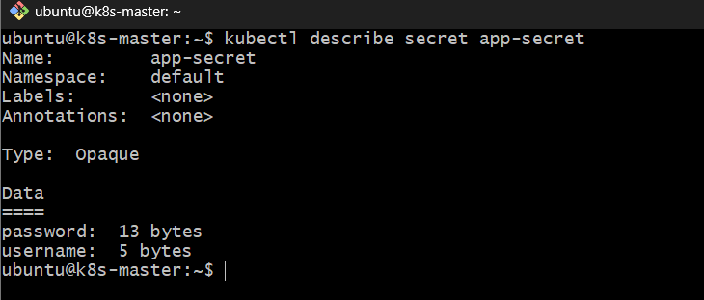

3. Create Pod YAML with ConfigMap and Secret
nano config-secret-pod.yaml
Add:
apiVersion: v1
kind: Pod
metadata:
name: config-secret-pod
spec:
containers:
- name: nginx
image: nginx

# ConfigMap as environment variables
env:
- name: APP_NAME
valueFrom:
configMapKeyRef:
name: app-config-task5
key: APP_NAME

- name: ENVIRONMENT
valueFrom:
configMapKeyRef:
name: app-config-task5
key: ENVIRONMENT

# Secret as files
volumeMounts:
- name: secret-volume
mountPath: /etc/app-secret
readOnly: true

volumes:
- name: secret-volume
secret:
secretName: app-secret 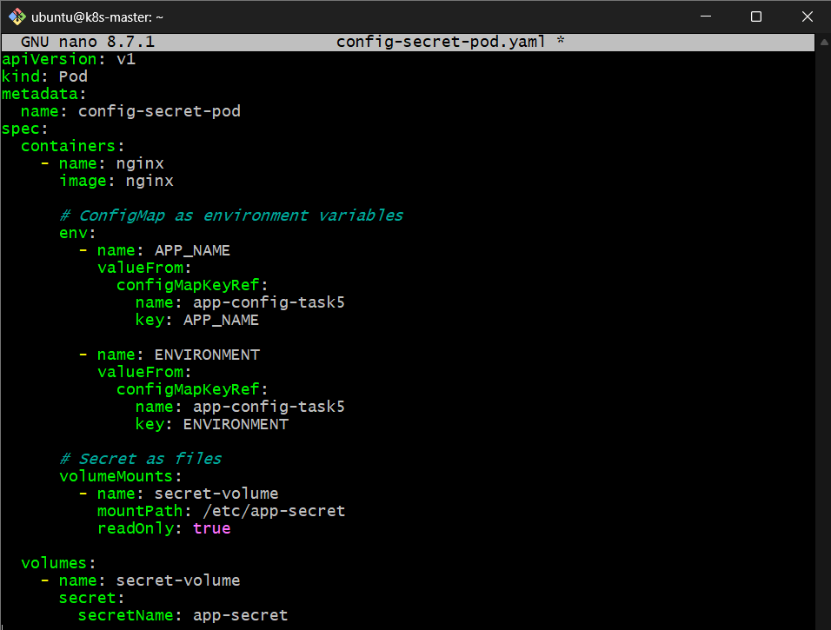
Important: Notice:
name: app-config-task5
not app-config.

4. Apply the Pod Configuration
kubectl apply -f config-secret-pod.yaml 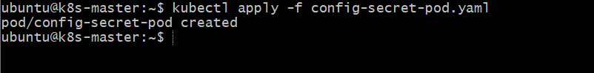
Verify:
kubectl get pod config-secret-pod
Expected:
NAME READY STATUS
config-secret-pod 1/1 Running 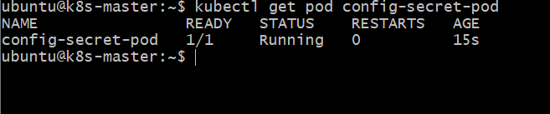

5. Verify ConfigMap Environment Variables
kubectl exec config-secret-pod -- env | grep -E 'APP_NAME|ENVIRONMENT'
Expected:
APP_NAME=MyApplication
ENVIRONMENT=Production
This confirms the ConfigMap was injected as environment variables. 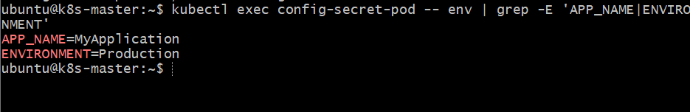

6. Verify Secret Files
List the mounted files:
kubectl exec config-secret-pod -- ls /etc/app-secret
Expected:
password
username 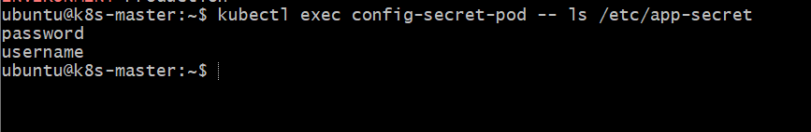
Check username:
kubectl exec config-secret-pod -- cat /etc/app-secret/username
Expected:
admin
Check password:
kubectl exec config-secret-pod -- cat /etc/app-secret/password
Expected:
MyPassword123
For a real environment, avoid displaying passwords in the terminal. This is only for lab verification.
Final Architecture
