k8s-05 tasks.
- Create a namespace dev-environment and apply a resource-based quota that restricts the number of pods to 3 and services to 2.
Purpose: To isolate development resources and control the number of Pods and Services created within a namespace.
Steps
1. Create a namespace
Run on the Kubernetes master node:
kubectl create namespace dev-environment
Verify:
kubectl get namespaces 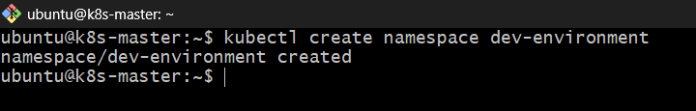
2. Create a ResourceQuota YAML file
vi dev-quota.yaml
Add the following configuration:
apiVersion: v1
kind: ResourceQuota
metadata:
name: dev-quota
namespace: dev-environment
spec:
hard:
pods: "3"
services: "2"
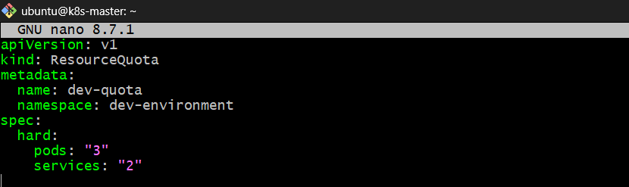
Purpose:
- pods: "3" – Allows a maximum of 3 Pods.
- services: "2" – Allows a maximum of 2 Services.
- namespace – Applies the quota only to dev-environment.

3. Apply the ResourceQuota
kubectl apply -f dev-quota.yaml 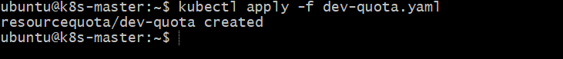
4. Verify the ResourceQuota
kubectl get resourcequota -n dev-environment 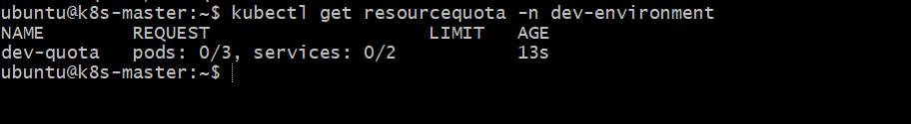
Check quota details:
kubectl describe resourcequota dev-quota -n dev-environment
Expected output:
Name: dev-quota
Namespace: dev-environment
Resource Used Hard
-------- ---- ----
pods 0 3
services 0 2 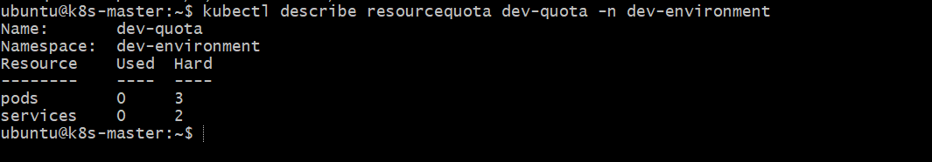
5. Test the quota
Create three Pods:
kubectl run nginx-1 --image=nginx -n dev-environment 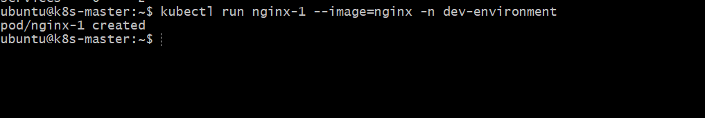
kubectl run nginx-2 --image=nginx -n dev-environment
kubectl run nginx-3 --image=nginx -n dev-environment
Try creating a fourth Pod:
kubectl run nginx-4 --image=nginx -n dev-environment 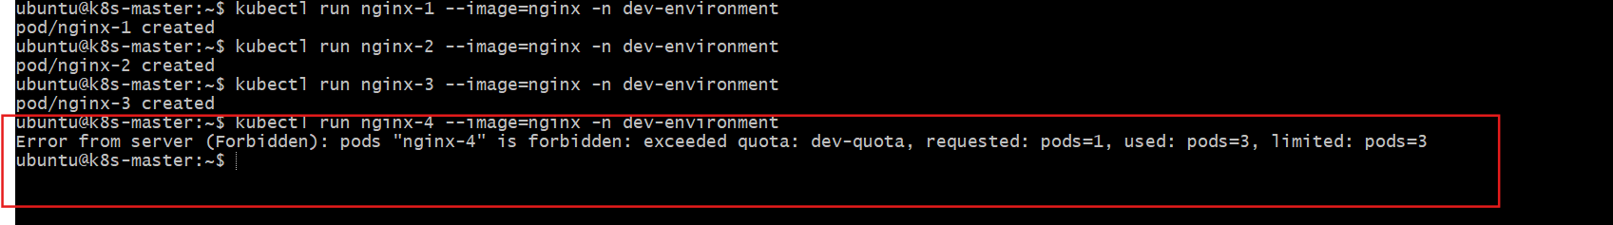
Expected result
The fourth Pod should be rejected because the namespace has reached its Pod quota.
Verify:
kubectl get pods -n dev-environment 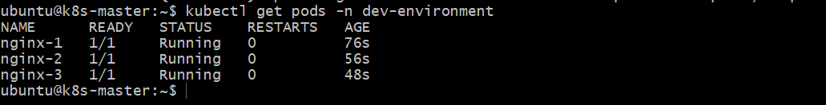
kubectl describe resourcequota dev-quota -n dev-environment 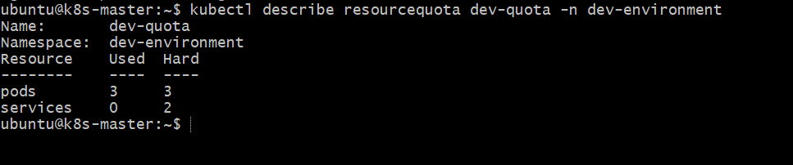
Final verification
kubectl get namespace dev-environment 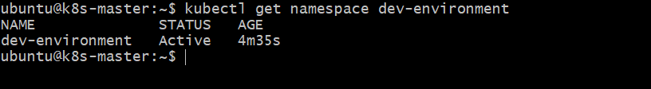
kubectl get resourcequota -n dev-environment 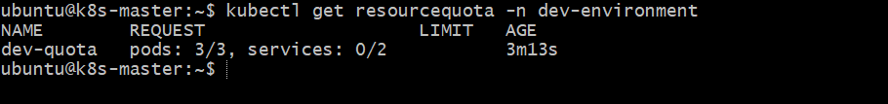
kubectl get pods -n dev-environment 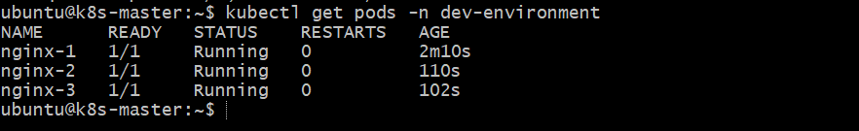
Expected outcome
- Namespace dev-environment created.
- ResourceQuota dev-quota applied.
- Maximum 3 Pods and 2 Services allowed.
- A fourth Pod creation is denied while all 3 quota slots are occupied.

- Create a pod in the prod-environment namespace with 0.2 CPU and 200Mi memory requests, and 0.5 CPU and 500Mi memory limits.
Resource | Requests | Limits
CPU | 0.2 (200m) | 0.5 (500m)
Memory | 200Mi | 500Mi
Task: Create a Pod in the prod-environment namespace with the following CPU and memory requests and limits.

Purpose: To reserve CPU and memory resources for a Pod and prevent it from exceeding its configured resource limits.
Steps
1. Create the namespace
kubectl create namespace prod-environment 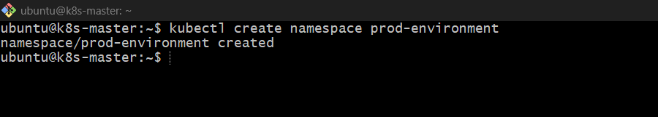
2. Create the Pod YAML file
vi prod-pod.yaml
Add the following configuration:
apiVersion: v1
kind: Pod
metadata:
name: nginx-prod
namespace: prod-environment
spec:
containers:
- name: nginx
image: nginx
resources:
requests:
cpu: "0.2"
memory: "200Mi"
limits:
cpu: "0.5"
memory: "500Mi" 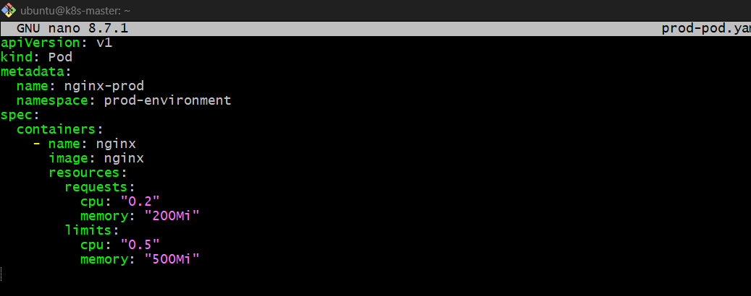

3. Apply the YAML file
kubectl apply -f prod-pod.yaml 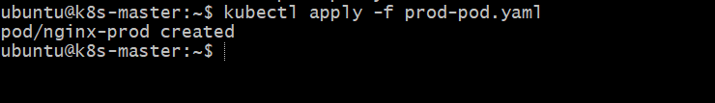
4. Verify the Pod
kubectl get pods -n prod-environment 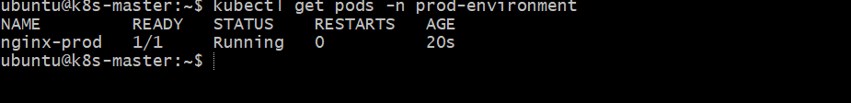
Check resource requests and limits:
kubectl describe pod nginx-prod -n prod-environment
Expected resource configuration:
Requests:
cpu: 200m
memory: 200Mi

Limits:
cpu: 500m
memory: 500Mi 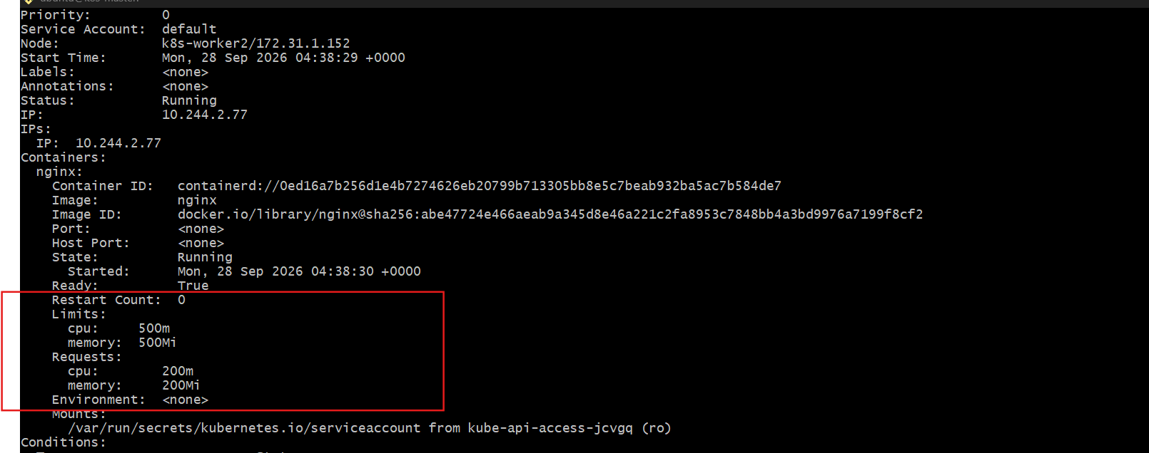
5. Verify the Pod YAML
kubectl get pod nginx-prod -n prod-environment -o yaml 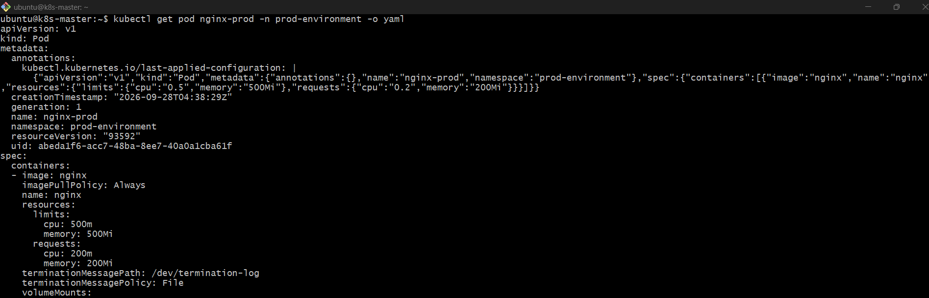
Expected outcome
Pod created
- Namespace: prod-environment
- Pod: nginx-prod
- Container: nginx
- CPU request: 200m
- Memory request: 200Mi
- CPU limit: 500m
- Memory limit: 500Mi
Important concepts:
- Requests: The minimum CPU and memory resources Kubernetes uses when scheduling the Pod.
- Limits: The maximum CPU and memory the container is allowed to use. CPU usage is throttled when it exceeds the limit; exceeding the memory limit can result in the container being terminated with an OOMKilled status.

- In the staging-environment namespace, set a LimitRange that assigns default CPU and memory limits (300m CPU, 600Mi memory) and applies a minimum and maximum CPU.
Task: In the staging-environment namespace, create a LimitRange that:
- Sets default CPU limit to 300m
- Sets default memory limit to 600Mi
- Applies a minimum and maximum CPU
Purpose: LimitRange controls the CPU and memory resources that individual containers can request or use inside a namespace.
1. Create the namespace
kubectl create namespace staging-environment 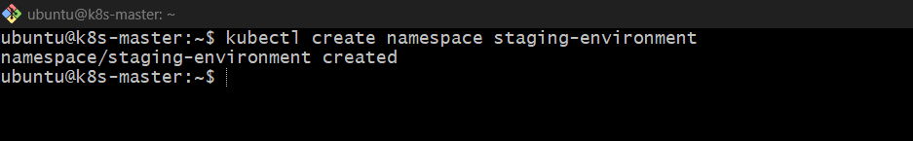
If it already exists, skip this step.
2. Create LimitRange YAML
vi staging-limitrange.yaml
Add:
apiVersion: v1
kind: LimitRange
metadata:
name: staging-limits
namespace: staging-environment
spec:
limits:
- type: Container
default:
cpu: "300m"
memory: "600Mi"
min:
cpu: "100m"
max:
cpu: "500m" 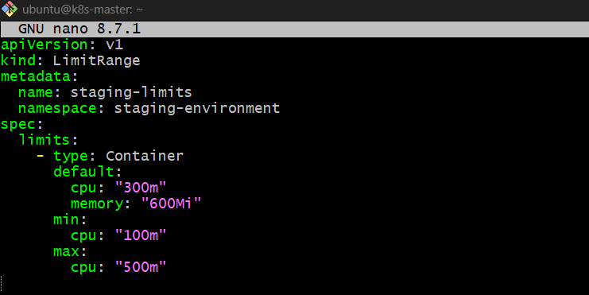

3. Apply the configuration
kubectl apply -f staging-limitrange.yaml 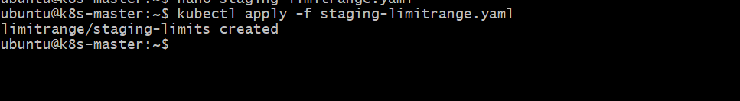
4. Verify
kubectl get limitrange -n staging-environment 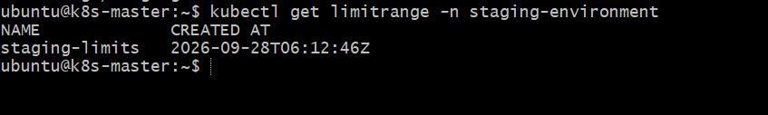
Detailed verification:
kubectl describe limitrange staging-limits -n staging-environment
You should see:
Default:
cpu: 300m
memory: 600Mi

Min:
cpu: 100m

Max:
cpu: 500m 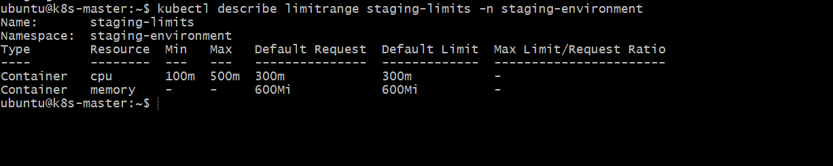
5. Test with a Pod
Create a Pod without specifying resources:
kubectl run nginx --image=nginx -n staging-environment 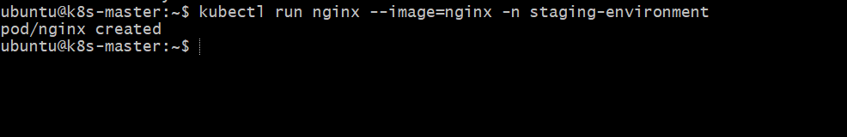
Check the Pod:
kubectl describe pod nginx -n staging-environment
Kubernetes automatically applies:
CPU limit: 300m
Memory limit: 600Mi 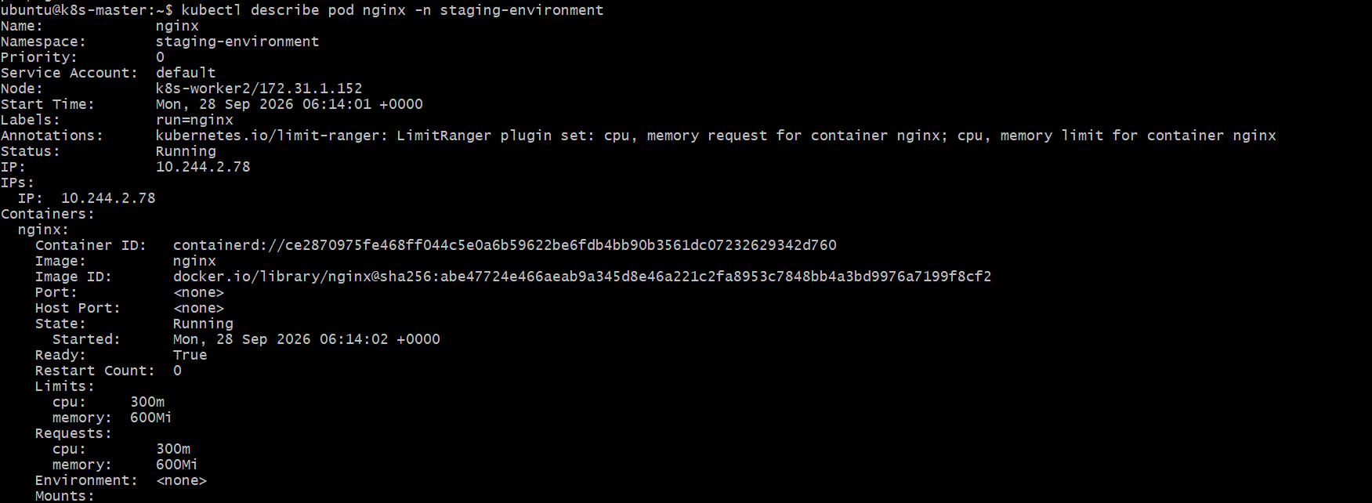
Important
- Default → Automatically assigned when the container does not specify a limit.
- Min CPU = 100m → Container cannot specify CPU below 100m.
- Max CPU = 500m → Container cannot specify CPU above 500m.
- 300m CPU = 0.3 CPU.
- 600Mi = 600 MiB memory.
Note: The task only specifies minimum and maximum CPU, so the YAML above does not set minimum/maximum memory.

- Create a pod and a NodePort service in the default namespace, then create another pod in the test namespace and communicate between them using Service DNS.
Task:
- Create a Pod and NodePort Service in the default namespace.
- Create another Pod in the test namespace.
- Communicate from the test namespace Pod to the Service in the default namespace using Service DNS.
Purpose: To understand how Kubernetes Services provide stable DNS names for communication between Pods in different namespaces.

1. Create the test namespace
Run on the Kubernetes master:
kubectl create namespace test 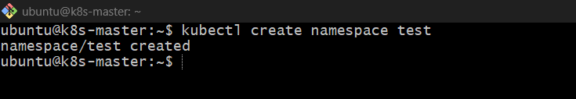

2. Create Pod in default namespace
kubectl run nginx --image=nginx
Verify:
kubectl get pods 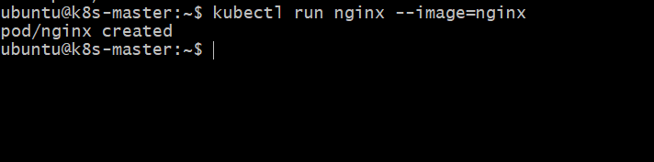

3. Create NodePort Service
kubectl expose pod nginx --name=nginx-service --port=80 --target-port=80 --type=NodePort
Verify:
kubectl get svc
Example:
NAME TYPE CLUSTER-IP PORT(S)
nginx-service NodePort 10.101.x.x 80:30xxx/TCP 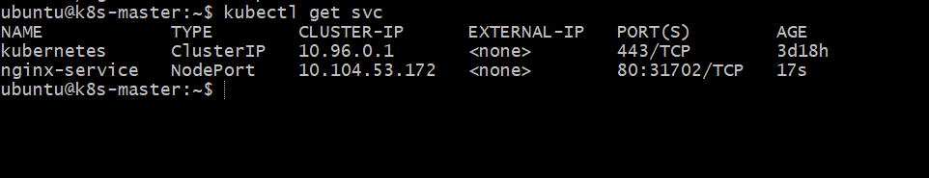
How it works
Pod nginx
↓
nginx-service
↓
Port 80
↓
NodePort 30xxx
The Service selects the nginx Pod using its labels and provides a stable IP/DNS name.

4. Create a Pod in test namespace
Create a temporary BusyBox Pod:
kubectl run test-pod --image=busybox:1.36 -n test --restart=Never -- sleep 3600
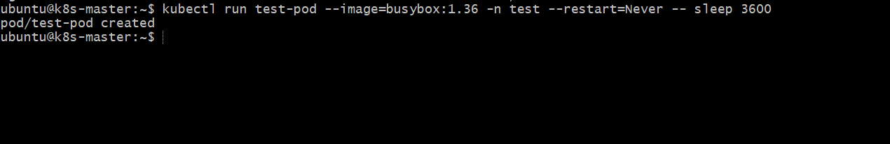
Verify:
kubectl get pods -n test 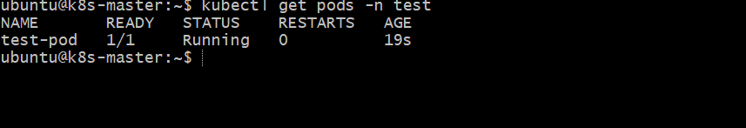

5. Test Service DNS
Enter the test-pod:
kubectl exec -it test-pod -n test -- sh 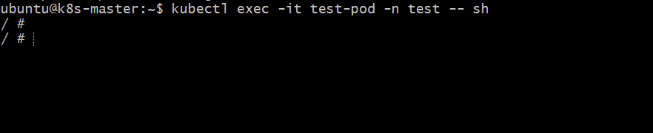
From inside the Pod, run:
wget -qO- http://nginx-service.default.svc.cluster.local
You should receive the nginx HTML response.
Exit:
exit

6. Understand the DNS name
The full Kubernetes Service DNS format is:
<service-name>.<namespace>.svc.cluster.local
For this task:
nginx-service.default.svc.cluster.local
Because the Service is in the default namespace and the client Pod is in the test namespace, specifying the namespace is important.
You can also try:
kubectl exec -it test-pod -n test -- wget -qO- http://nginx-service.default 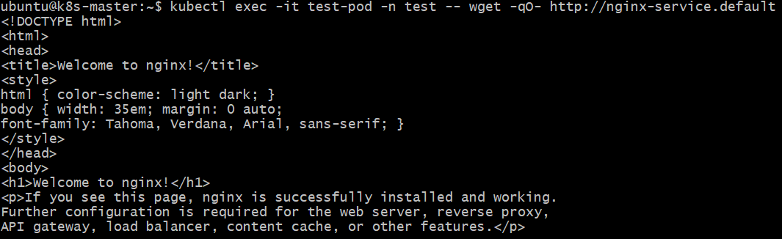

Final verification
kubectl get pods
kubectl get svc
kubectl get pods -n test 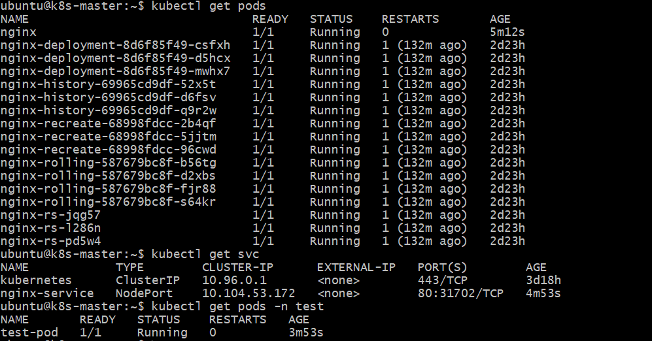
Expected architecture
test namespace
┌─────────────────────┐
│ test-pod │
│ │
│ wget nginx-service │
└──────────┬──────────┘
│
│ Service DNS
│
▼
default namespace
┌─────────────────────┐
│ nginx-service │
│ ClusterIP :80 │
│ NodePort :30xxx │
└──────────┬──────────┘
│
▼
┌──────────┐
│ nginx │
│ Pod │
└──────────┘
Key point: For Pod-to-Service communication inside the cluster, use the Service DNS name. The NodePort is mainly used to expose the Service through a Kubernetes node's IP and port; it is not required for this internal DNS communication.

- Apply a LimitRange with a max limit/request ratio of 2 for memory in the performance-environment namespace, and test by creating a pod with mismatched resource requests and limits.
Task: Apply a LimitRange in the performance-environment namespace with a maximum memory limit/request ratio of 2, then test it with a Pod whose memory limit is more than twice its request.
Purpose: To ensure that a container's memory limit cannot be excessively higher than its memory request.
1. Create the namespace
kubectl create namespace performance-environment 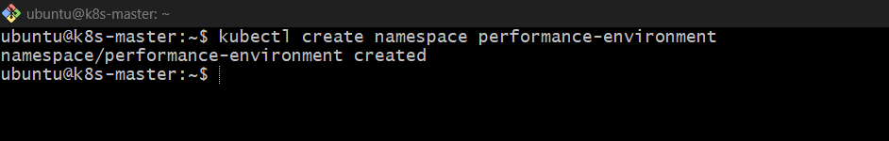
2. Create LimitRange YAML
vi performance-limitrange.yaml
Add:
apiVersion: v1
kind: LimitRange
metadata:
name: performance-limits
namespace: performance-environment
spec:
limits:
- type: Container
maxLimitRequestRatio:
memory: "2" 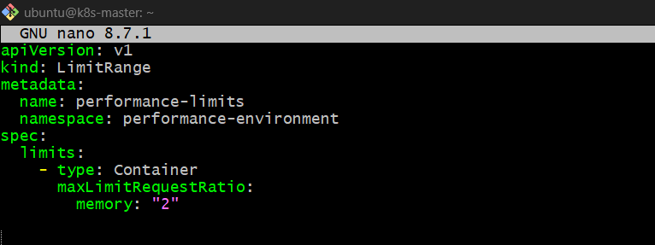
3. Apply the LimitRange
kubectl apply -f performance-limitrange.yaml 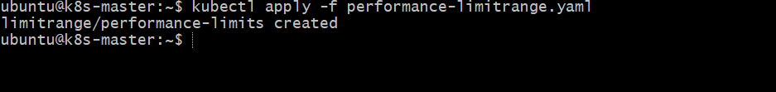
Verify:
kubectl get limitrange -n performance-environment 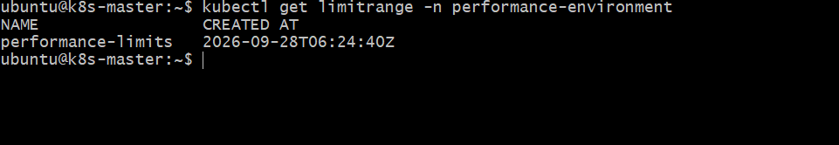
Detailed:
kubectl describe limitrange performance-limits -n performance-environment
You should see:
Max Limit Request Ratio:
memory: 2 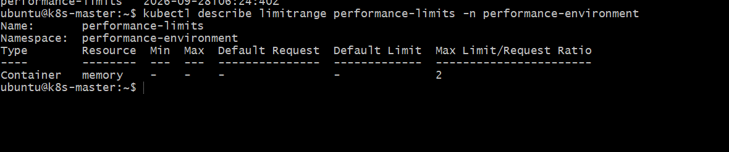

4. Create a Pod with mismatched resources
Create:
vi performance-pod.yaml
Add:
apiVersion: v1
kind: Pod
metadata:
name: memory-test
namespace: performance-environment
spec:
containers:
- name: nginx
image: nginx
resources:
requests:
memory: "200Mi"
limits:
memory: "500Mi"
Here:
Memory request = 200Mi
Memory limit = 500Mi

500 / 200 = 2.5
The allowed maximum ratio is 2, but this Pod has a ratio of 2.5. 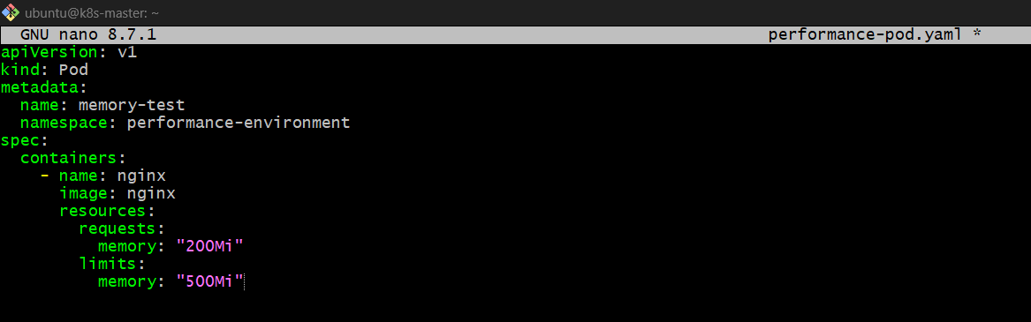
5. Apply the Pod
kubectl apply -f performance-pod.yaml
Expected result:
Error from server: admission webhook ...
or an error indicating that the limit/request ratio for memory exceeds the allowed maximum of 2.
6. Test with a valid Pod
Change the memory limit to 400Mi:
resources:
requests:
memory: "200Mi"
limits:
memory: "400Mi"
Now:
400 / 200 = 2 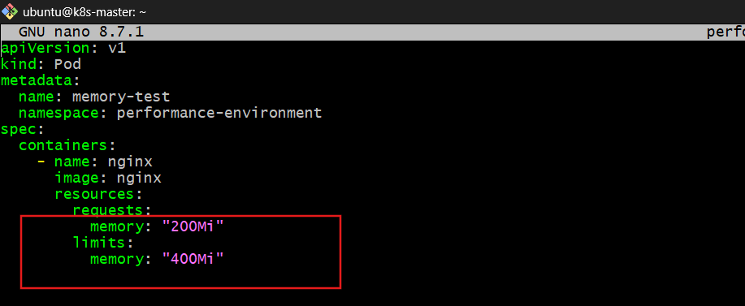
Apply again:
kubectl apply -f performance-pod.yaml 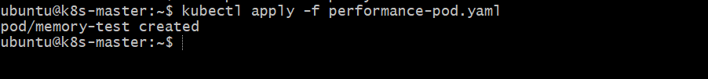
Verify:
kubectl get pods -n performance-environment 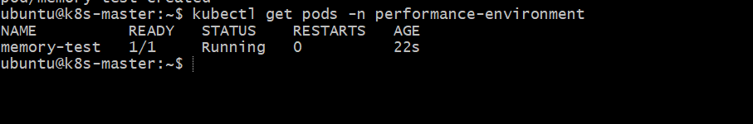
Key concept
maxLimitRequestRatio = limit / request
For this task:
Allowed ratio = 2

200Mi request → maximum 400Mi limit
300Mi request → maximum 600Mi limit
500Mi request → maximum 1000Mi limit
So 500Mi limit with 200Mi request is rejected because 2.5 > 2.

