k8s-10 tasks
- Setup eks cluster using eksctl
1. Connect to Amazon Linux EC2
ssh -i your-key.pem ec2-user@<EC2-PUBLIC-IP>
Check OS:
cat /etc/os-release
You should see Amazon Linux. 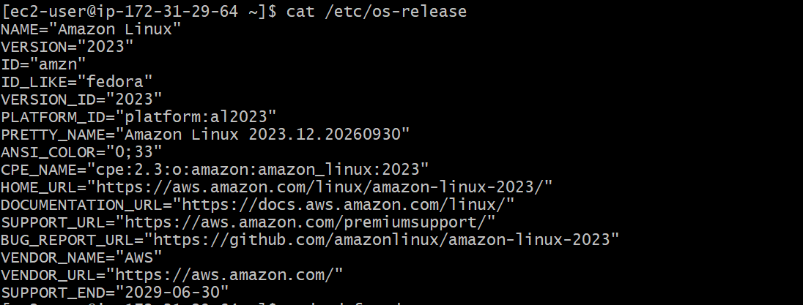

2. Update packages
sudo dnf update -y
If dnf doesn't work, try:
sudo yum update -y 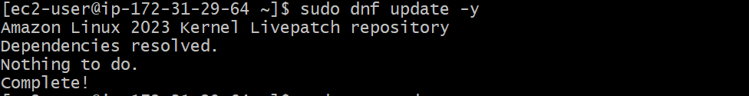

3. Check AWS CLI
Amazon Linux commonly already has AWS CLI.
aws --version
If it is missing:
sudo dnf install awscli -y 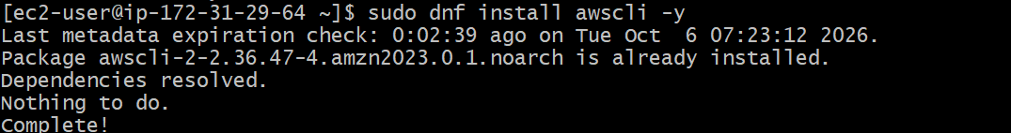
Then:
aws --version

4. Configure AWS
aws configure
Enter:
AWS Access Key ID: <your-access-key>
AWS Secret Access Key: <your-secret-key>
Default region: us-east-1
Output format: json 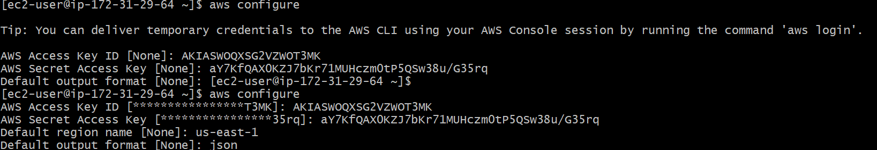
Verify:
aws sts get-caller-identity 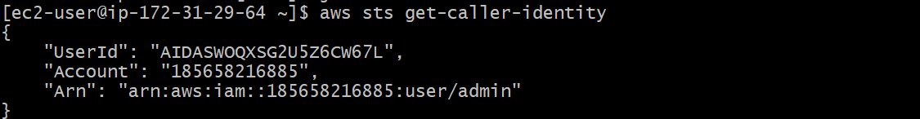
If you get your AWS account information → ✅ AWS CLI is working.

5. Install kubectl
Download the latest stable version:
curl -LO "https://dl.k8s.io/release/$(curl -L -s https://dl.k8s.io/release/stable.txt)/bin/linux/amd64/kubectl" 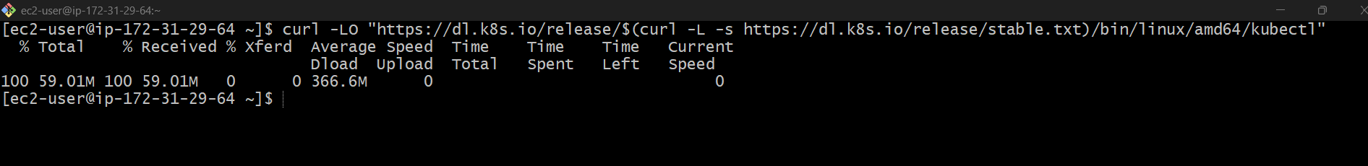
Install:
chmod +x kubectl
sudo mv kubectl /usr/local/bin/ 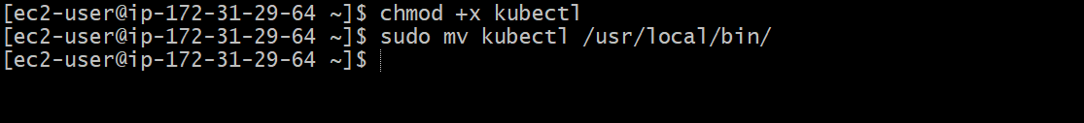
Check:
kubectl version --client 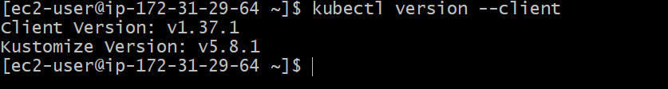

6. Install eksctl
For Amazon Linux x86_64:
curl --silent --location "https://github.com/eksctl-io/eksctl/releases/latest/download/eksctl_Linux_amd64.tar.gz" | tar xz -C /tmp
Move it:
sudo mv /tmp/eksctl /usr/local/bin/
Check:
eksctl version

7. Final verification
Run:
aws --version
kubectl version --client
eksctl version 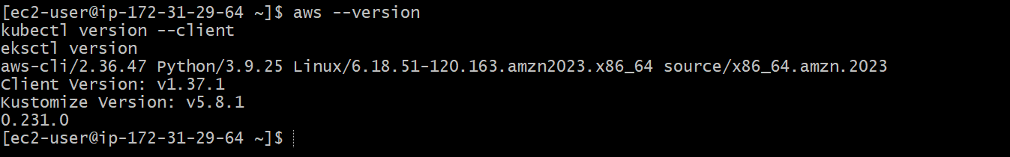
Then verify AWS access:
aws sts get-caller-identity 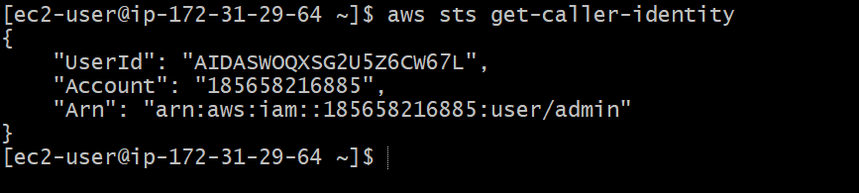

Steps to Add IAM Permission
- Open IAM
- Select Users
- Select admin
- Click Add permissions
- Choose Attach policies directly
- Search for:
AdministratorAccess
- Select it
- Click Next
- Click Add permissions 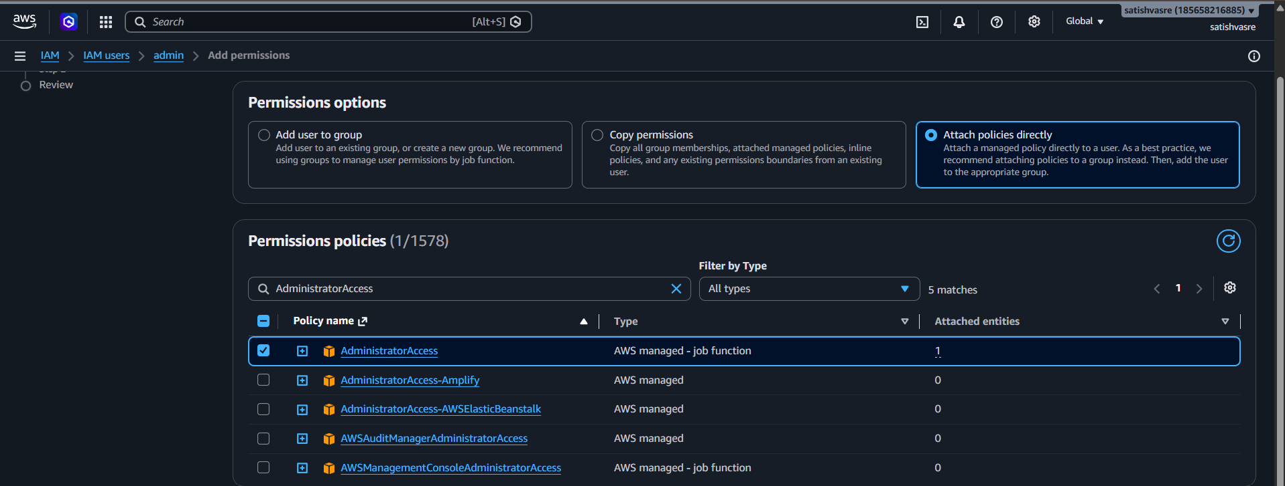
Then verify
Back on your Amazon Linux EC2:
aws sts get-caller-identity

8. Create the EKS Cluster
Once everything above works:
eksctl create cluster \
--name my-eks-cluster \
--region us-east-1 \
--nodegroup-name my-nodes \
--node-type t3.medium \
--nodes 2 \
--nodes-min 1 \
--nodes-max 3
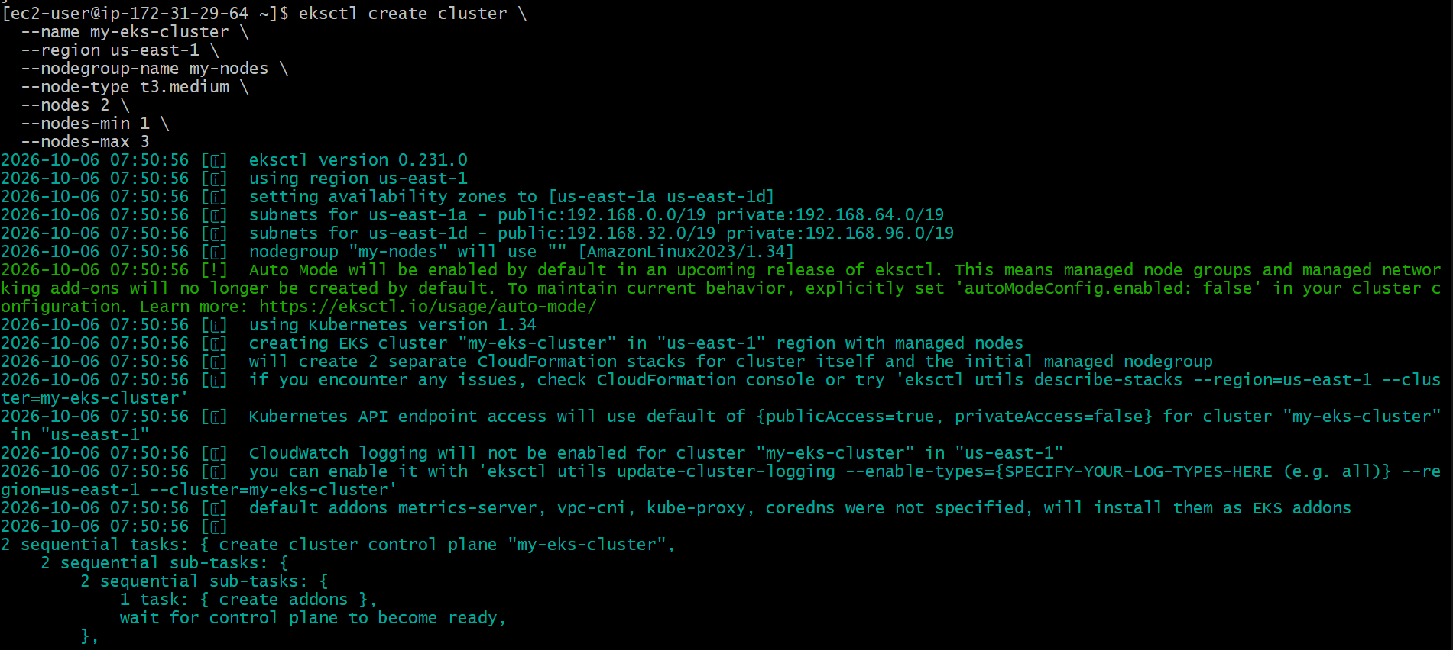
Your architecture
Amazon Linux EC2
│
├── aws
├── kubectl
└── eksctl
│
↓
AWS EKS
│
┌─┴─ ──┐
↓ ↓
Worker 1 Worker 2
One important recommendation: if this EC2 has an IAM role attached with sufficient EKS permissions, you don't need to put long-lived AWS access keys on the EC2. That's safer than aws configure.

- setup eks cluster using console
Step 1: Create Cluster
AWS Console → EKS → Clusters → Create cluster
Enter:
Name: my-eks-cluster
Kubernetes version: Select available version
Cluster IAM role: Select/Create EKS cluster role 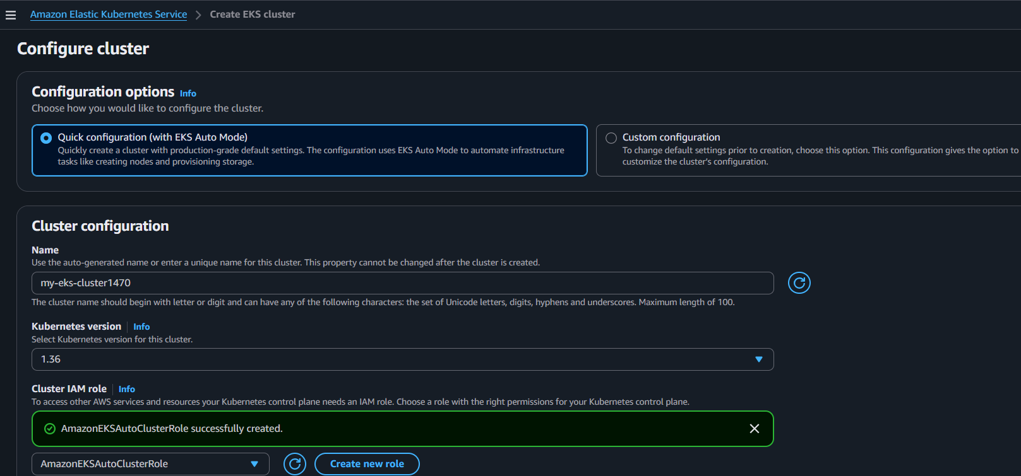
Step 2: Networking
Select:
VPC: Your VPC 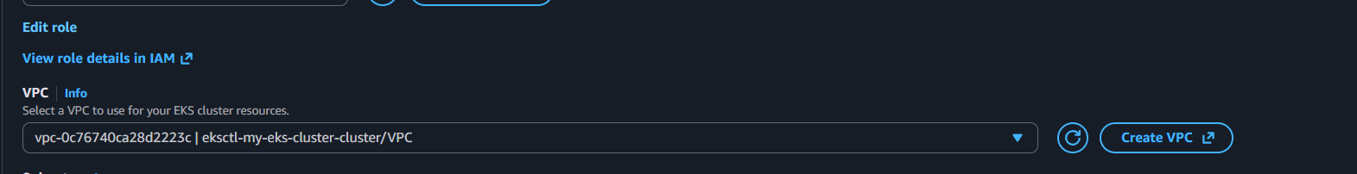
Subnets: Select required subnets 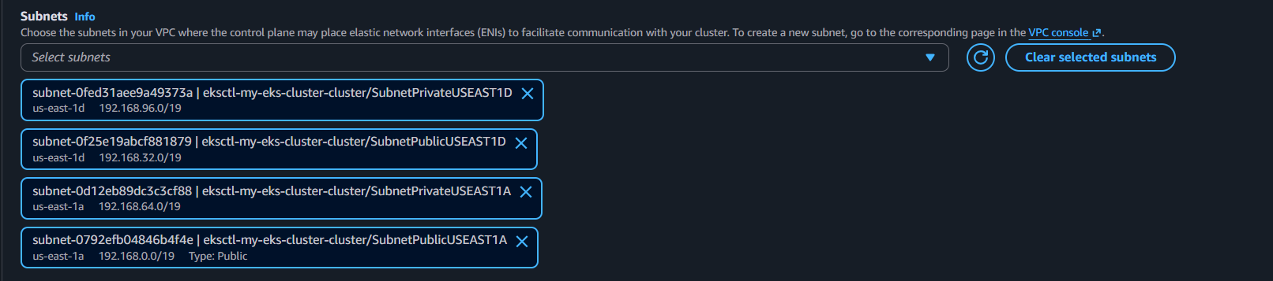
Click Create.
Step 3: Wait
Wait until:
my-eks-cluster → Status: ACTIVE 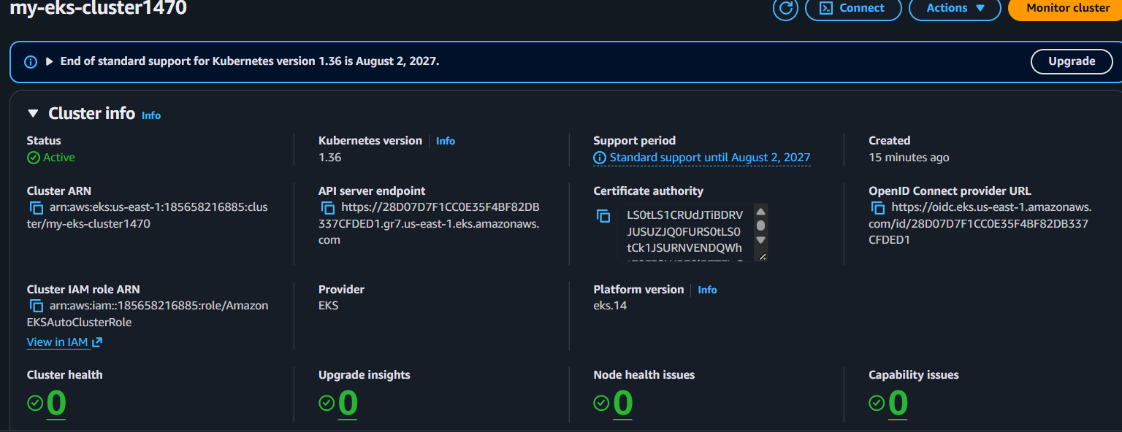
Step 4: Create Node Group
Go to:
my-eks-cluster → Compute → Add node group
Enter: 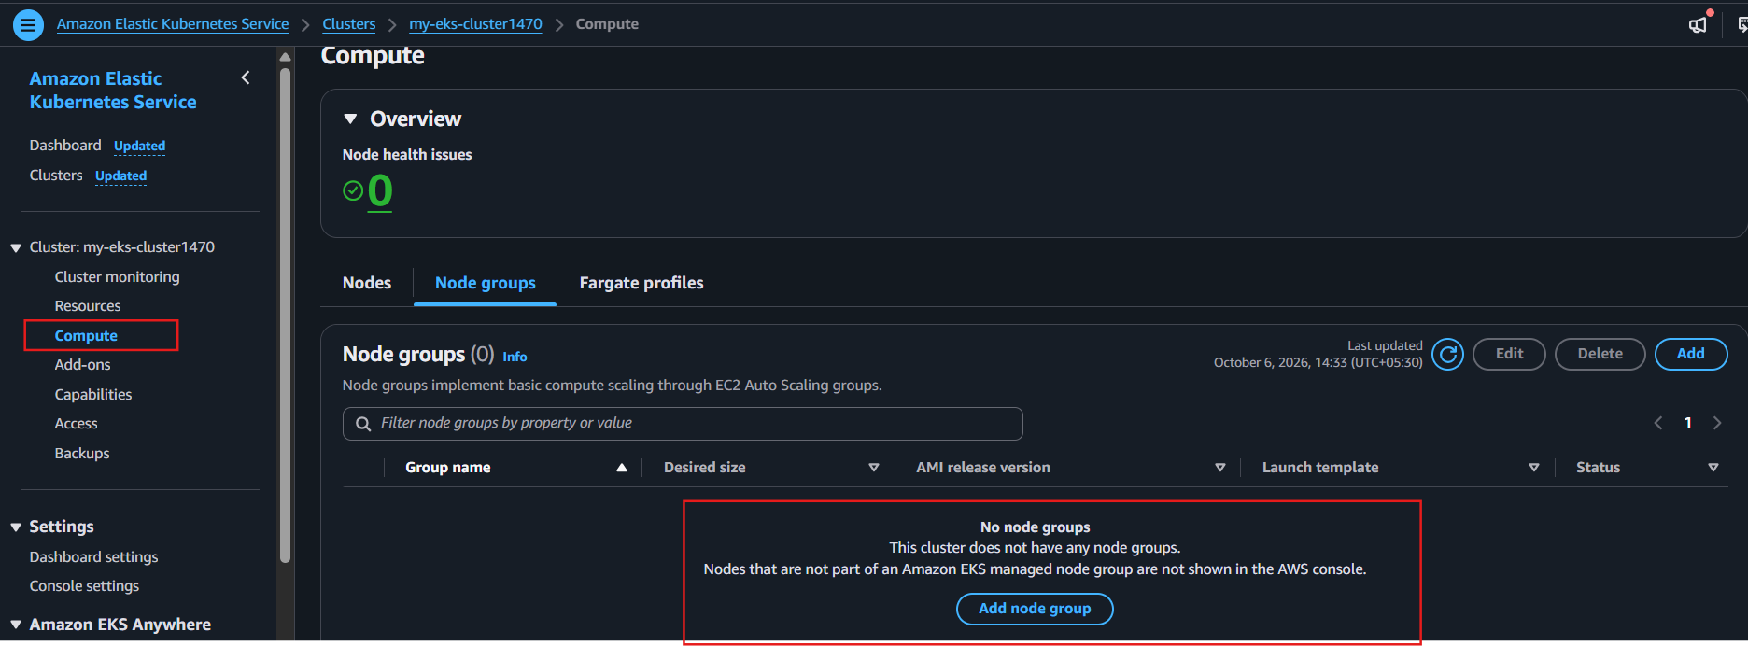
Name: my-nodes
Node IAM role: Select/Create node role
Instance type: t3.medium
Desired size: 2
Minimum size: 1
Maximum size: 3 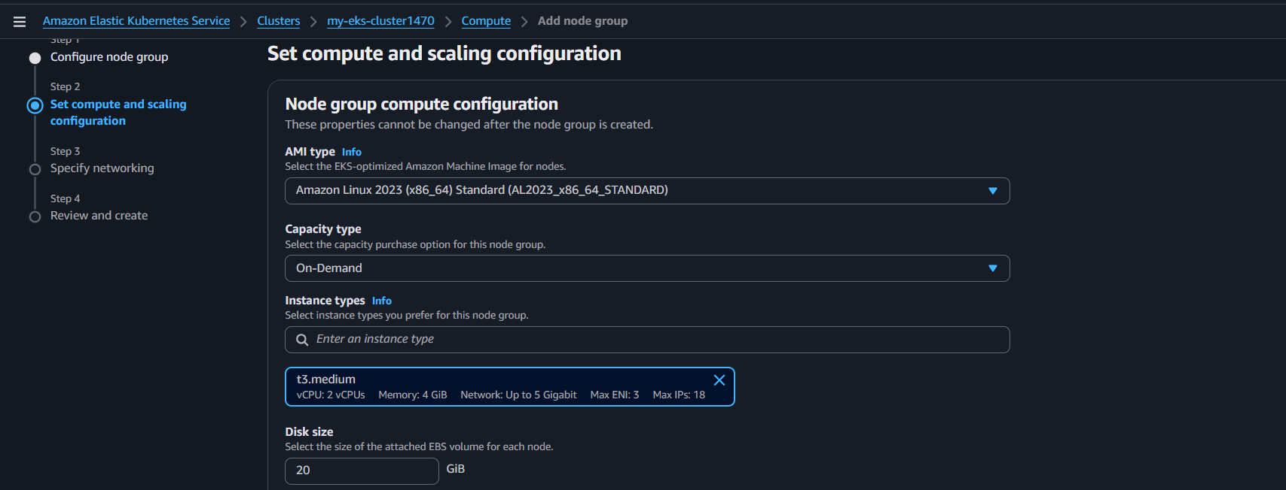 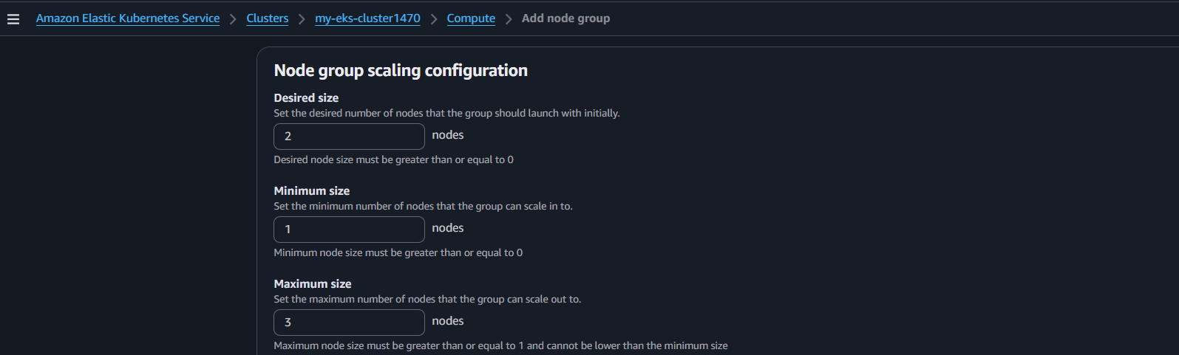 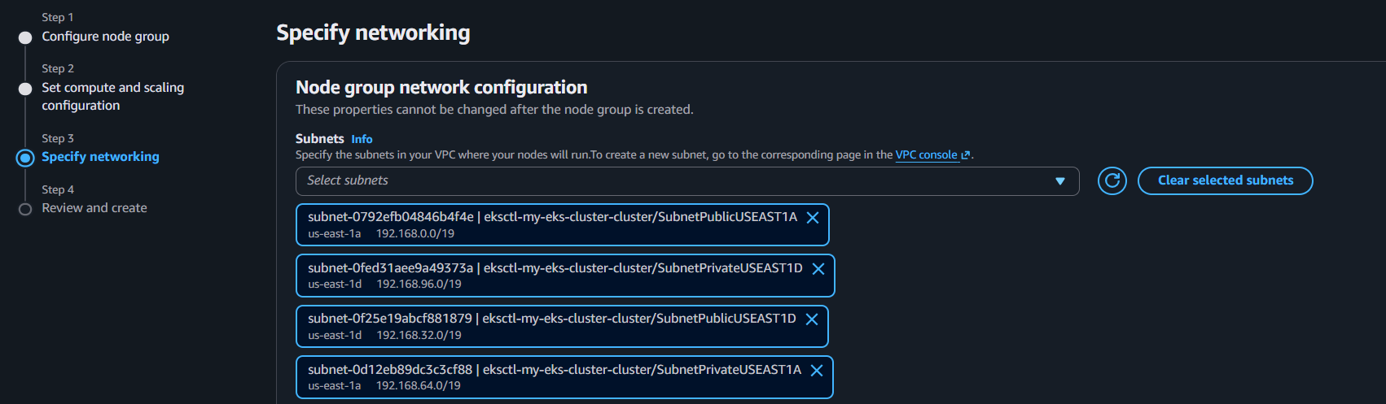
Select subnets → Create.
Step 5: Verify Node Group
Wait until:
my-nodes → ACTIVE
Step 6: Connect from Your Amazon Linux EC2
aws eks update-kubeconfig --region us-east-1 --name my-eks-cluster
kubectl get nodes
You should see 2 nodes with Ready status. 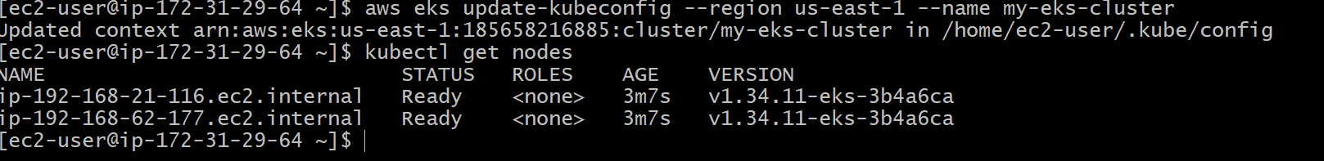
Step 1: Install Metrics Server
Run:
kubectl apply -f https://github.com/kubernetes-sigs/metrics-server/releases/latest/download/components.yaml 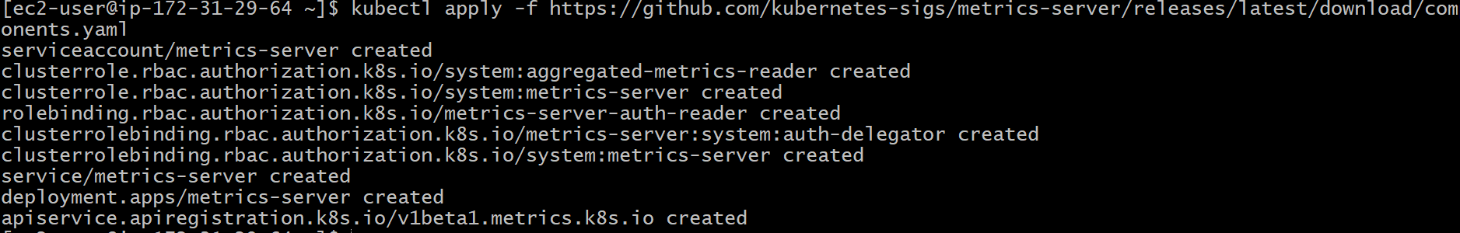
Step 2: Check Metrics Server
kubectl get deployment metrics-server -n kube-system
You should see:
NAME READY
metrics-server 1/1
Step 3: Verify Metrics
Wait a minute, then run:
kubectl top nodes 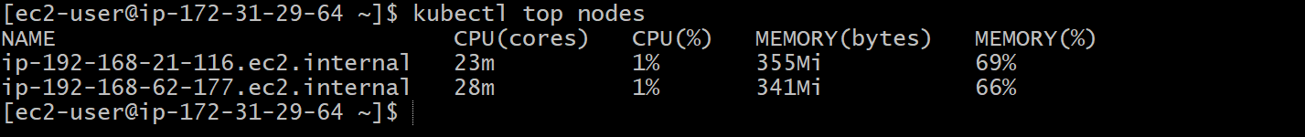

================================================================
- Setup HPA
Step 1: Check Metrics Server
kubectl get deployment metrics-server -n kube-system
If it exists, continue.
Step 2: Create Deployment
Nano Deployment.yaml
apiVersion: apps/v1
kind: Deployment
metadata:
name: web-app
spec:
replicas: 2
selector:
matchLabels:
app: web-app
template:
metadata:
labels:
app: web-app
spec:
containers:
- name: nginx
image: nginx
resources:
requests:
cpu: 100m
limits:
cpu: 200m 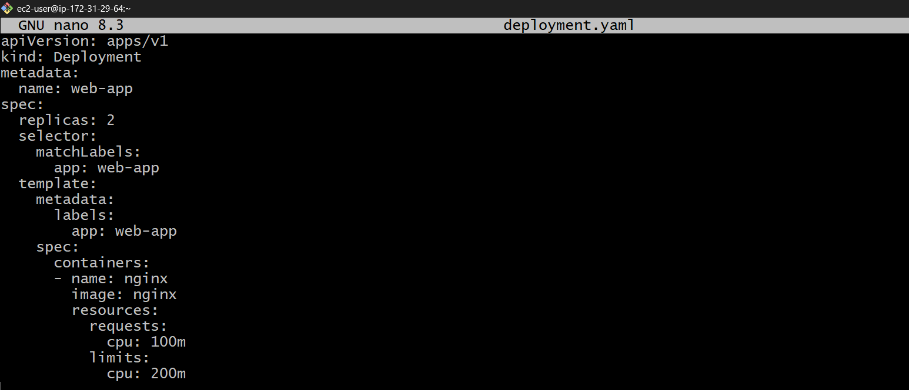
Apply:
kubectl apply -f deployment.yaml
Step 3: Create HPA
kubectl autoscale deployment web-app \
--cpu=50% \
--min=2 \
--max=5 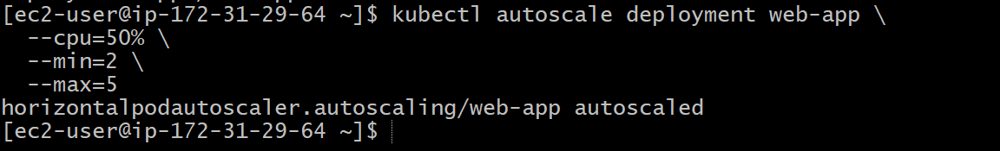
Step 4: Check HPA
kubectl get hpa
Example:
NAME TARGETS MINPODS MAXPODS REPLICAS
web-app 10%/50% 2 5 2
Step 5: Watch Scaling
kubectl get hpa -w 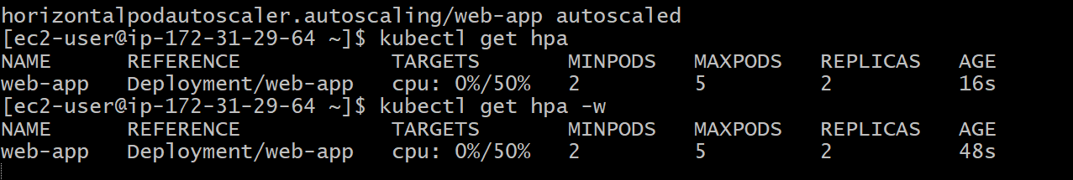
HPA will scale:
CPU increases
↓
HPA detects high CPU
↓
Pods increase
↓
CPU decreases
↓
Pods decrease

- Setup cluster autoscale
Purpose
Cluster Autoscaler (CA) automatically adds or removes EKS worker nodes based on pending Pods and node utilization.
Step 1: Check Node Group
eksctl get nodegroup \
--cluster my-eks-cluster \
--region us-east-1
Make sure my-nodes exists. 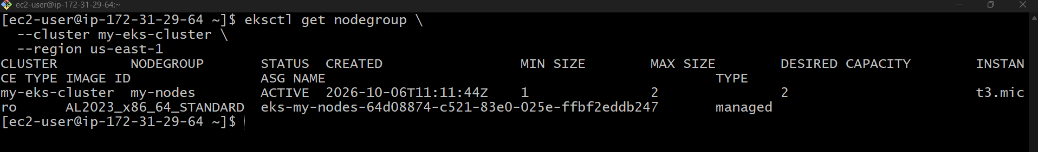
Step 2: Set Min/Max Nodes
eksctl scale nodegroup \
--cluster my-eks-cluster \
--region us-east-1 \
--name my-nodes \
--nodes-min 1 \
--nodes-max 3 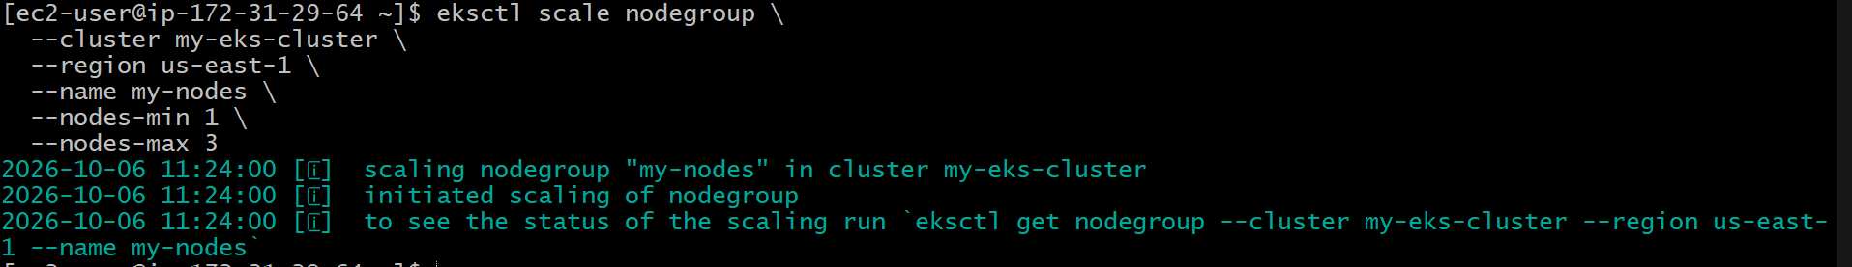
Step 3: Install Cluster Autoscaler
For EKS, use the AWS-supported Cluster Autoscaler deployment/configuration for your Kubernetes version and configure it to discover your node group using:
kubectl apply -f https://raw.githubusercontent.com/kubernetes/autoscaler/master/cluster-autoscaler/cloudprovider/aws/examples/cluster-autoscaler-autodiscover.yaml
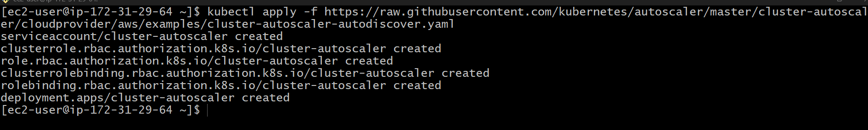
Step 4: Verify
kubectl get pods -n kube-system | grep autoscaler
Check logs:
kubectl logs -n kube-system deployment/cluster-autoscaler
Flow
Pending Pods
↓
Cluster Autoscaler
↓
Adds EC2 Worker Node
↓
Pod gets scheduled
HPA = scales Pods
Cluster Autoscaler = scales Worker Nodes

- Setup cronjob and job
1. Setup Job
Purpose: Run a task once until it completes.
Step 1: Create YAML
Nano cron.yaml
apiVersion: batch/v1
kind: Job
metadata:
name: my-job
spec:
template:
spec:
restartPolicy: Never
containers:
- name: job-container
image: busybox
command: ["sh", "-c", "echo Job completed"]
Save as: 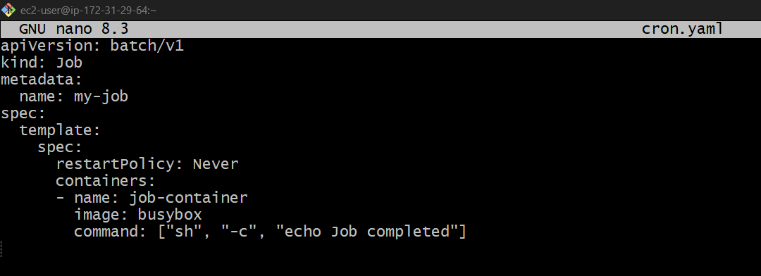
job.yaml
Step 2: Create Job
kubectl apply -f job.yaml 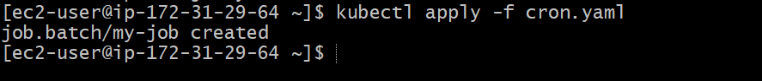
Step 3: Check
kubectl get jobs 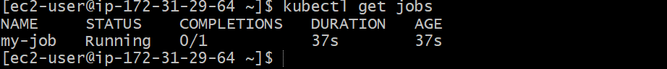
kubectl get pods

2. Setup CronJob
Purpose: Run a task automatically on a schedule.
Step 1: Create YAML
apiVersion: batch/v1
kind: CronJob
metadata:
name: my-cronjob
spec:
schedule: "*/2 * * * *"
jobTemplate:
spec:
template:
spec:
restartPolicy: Never
containers:
- name: cron-container
image: busybox
command: ["sh", "-c", "date; echo CronJob executed"]
Save as: 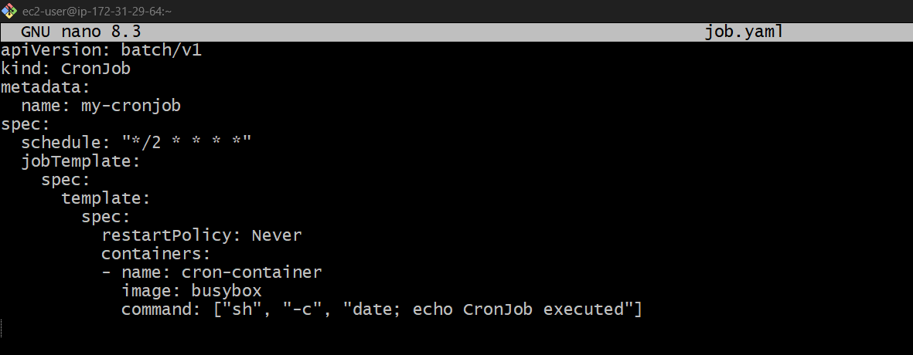
job.yaml
Step 2: Create CronJob
kubectl apply -f cronjob.yaml

Step 3: Check
kubectl get cronjobs 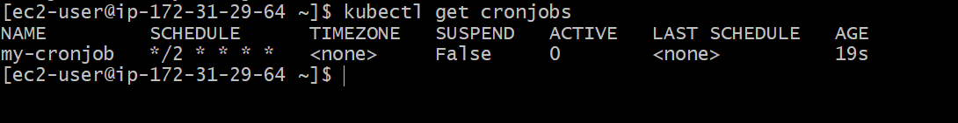
kubectl get jobs
kubectl get pods 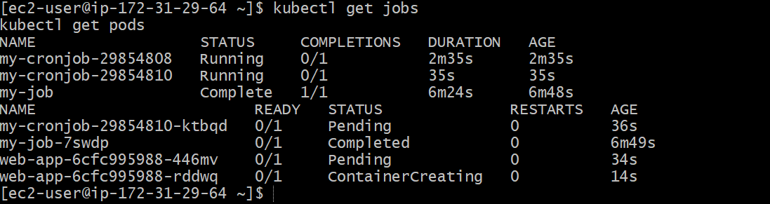
Schedule */2 * * * * = every 2 minutes.

- Create secret and inject inside pod
Purpose: Store sensitive data and use it inside a Pod.
Step 1: Create Secret
kubectl create secret generic my-secret \
--from-literal=username=admin \
--from-literal=password=12345 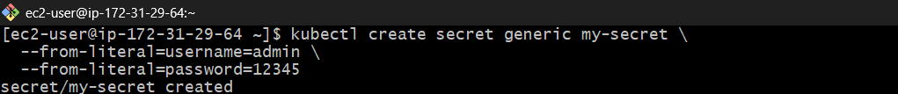
Step 2: Create Pod
apiVersion: v1
kind: Pod
metadata:
name: secret-pod
spec:
containers:
- name: app
image: nginx
env:
- name: USERNAME
valueFrom:
secretKeyRef:
name: my-secret
key: username
- name: PASSWORD
valueFrom:
secretKeyRef:
name: my-secret
key: password
Save as secret-pod.yaml. 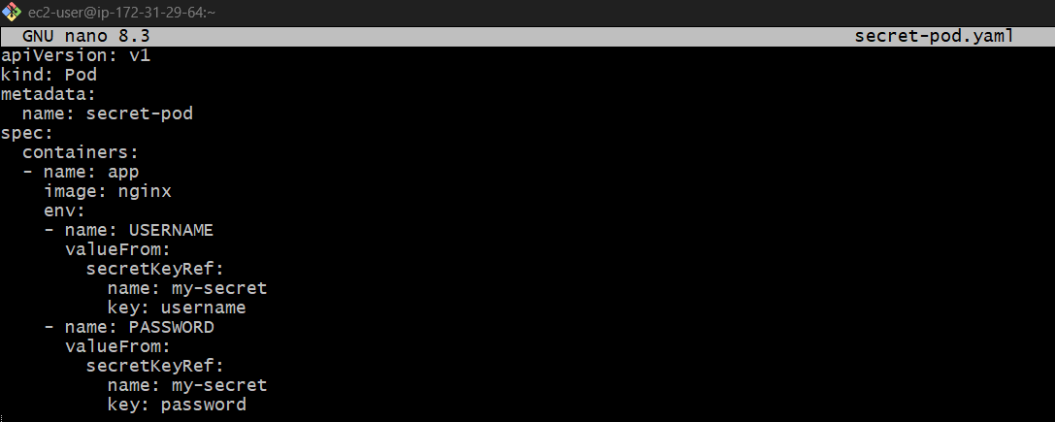
Step 3: Apply
kubectl apply -f secret-pod.yaml 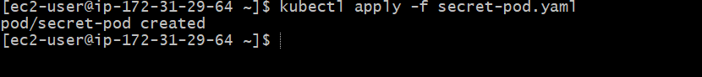
Step 4: Verify
kubectl exec secret-pod -- env | grep -E 'USERNAME|PASSWORD'

- Check differen add-ons available on eks.

Purpose: To see which AWS-managed add-ons are available and which ones are installed in your EKS cluster.
Step 1: Check available add-ons
aws eks describe-addon-versions \
--region us-east-1 \
--query "addons[].addonName" \
--output table
You will see add-ons such as:
vpc-cni
coredns
kube-proxy
aws-ebs-csi-driver
eks-pod-identity-agent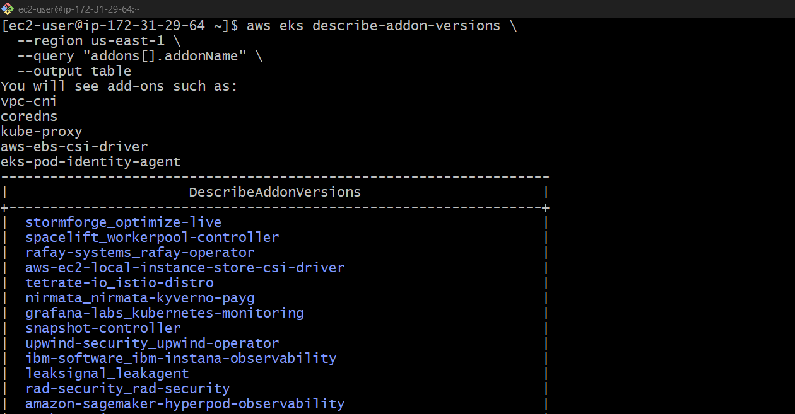
Step 2: Check installed add-ons
aws eks list-addons \
--cluster-name my-eks-cluster \
--region us-east-1 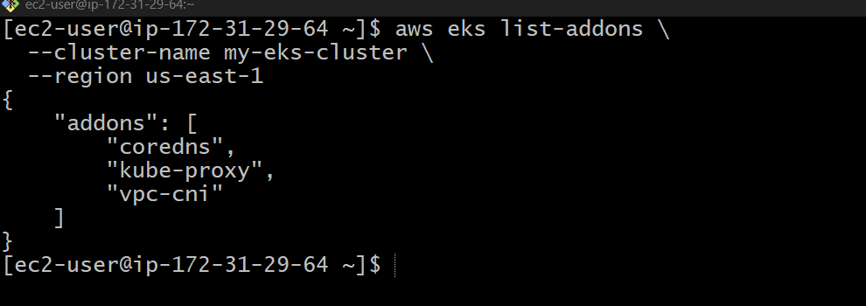
Step 3: Get details of an add-on
Example:
aws eks describe-addon-versions \
--addon-name aws-ebs-csi-driver \
--region us-east-1 \
--query "addons[].addonVersions[].addonVersion" \
--output table 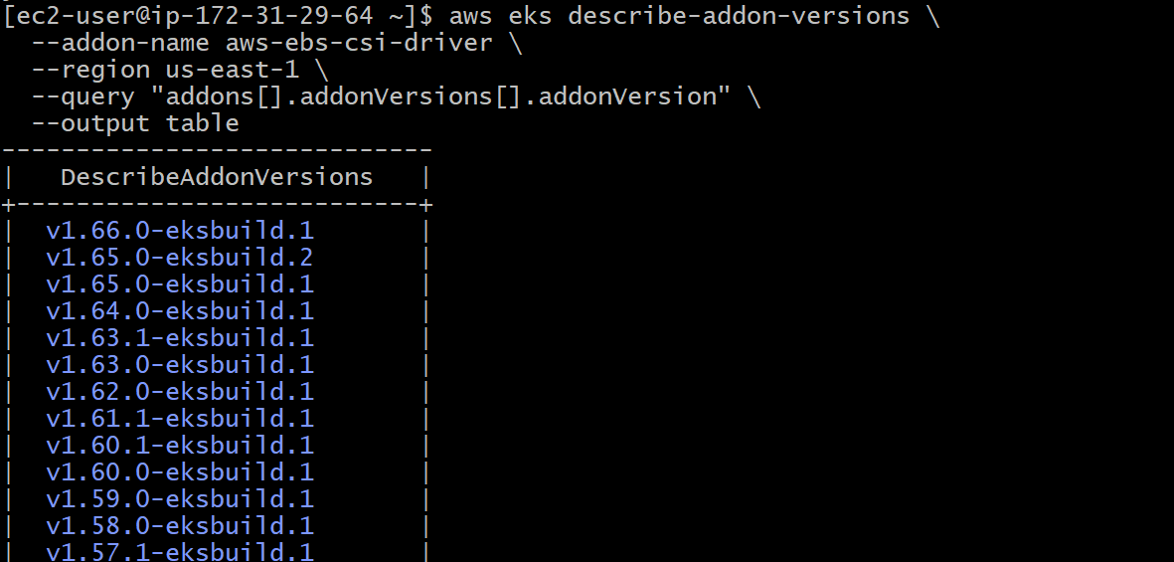
Step 4: Check add-ons using eksctl
eksctl get addon \
--cluster my-eks-cluster \
--region us-east-1
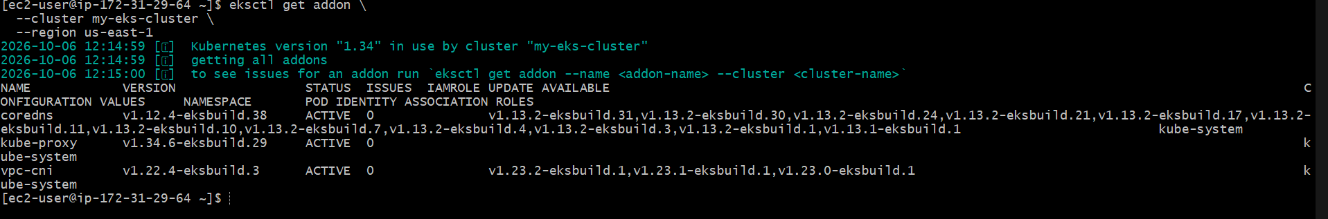

8.Upgrade eks cluster
1. Upgrade EKS Cluster
Purpose: Upgrade the EKS control plane to a newer Kubernetes version.
Step 1: Check current version
aws eks describe-cluster \
--name my-eks-cluster \
--region us-east-1 \
--query "cluster.version" 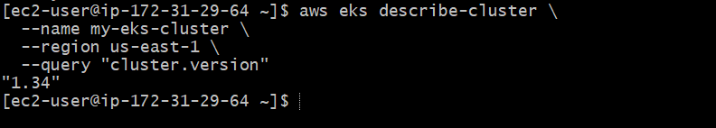
Step 2: Check available Kubernetes versions
aws eks describe-addon-versions \
--region us-east-1 \
--query "addons[0].addonVersions[].compatibilities[].clusterVersion" \
--output text
Step 3: Upgrade cluster
For example, if upgrading to 1.35:
aws eks update-cluster-version \
--name my-eks-cluster \
--kubernetes-version 1.35 \
--region us-east-1 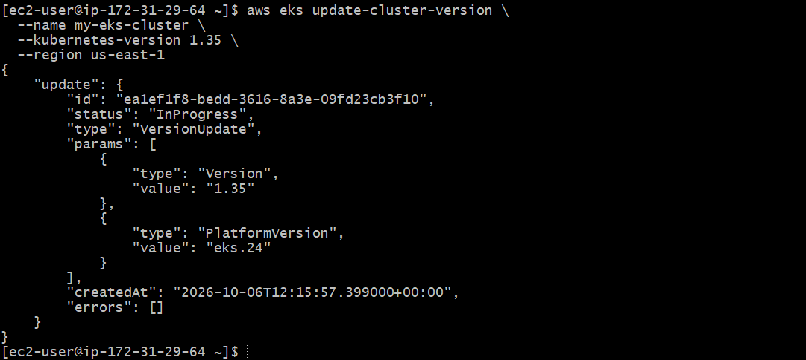

Step 4: Check upgrade status
aws eks describe-update \
--name my-eks-cluster \
--region us-east-1 \
--update-id <UPDATE-ID>
Or simply:
aws eks describe-cluster \
--name my-eks-cluster \
--region us-east-1 \
--query "cluster.version"
Step 5: Upgrade node group
After the control plane upgrade:
eksctl upgrade nodegroup \
--cluster my-eks-cluster \
--name my-nodes \
--region us-east-1 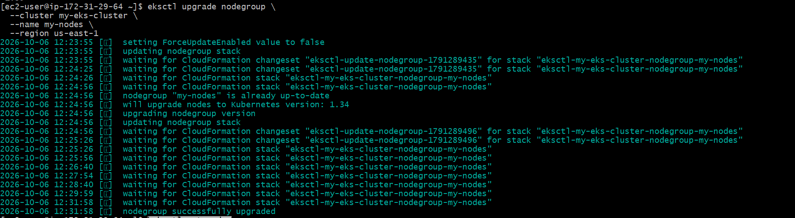
Step 6: Verify
kubectl get nodes 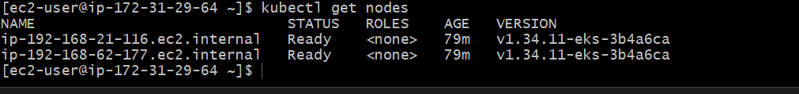
Remember:
EKS Upgrade
↓
Control Plane
↓
Node Group
↓
Add-ons

