K8s Task-01
- Setup Minikube in your local machine.
minikube Setup — Steps + Purpose
1) Install Docker on Windows
Install Docker Desktop:
After installation, verify:
docker --version 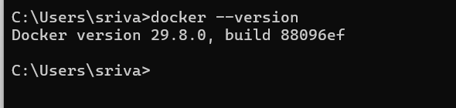
Purpose:
Docker provides the container environment that Minikube can use to create and run the Kubernetes cluster.

2) Install Oracle VirtualBox on Windows
Install VirtualBox:
https://www.virtualbox.org/wiki/Downloads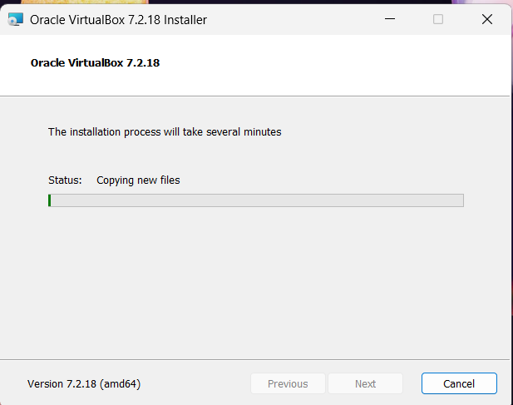
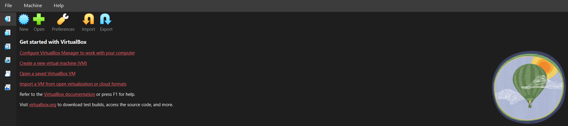

Verify:
VBoxManage --version 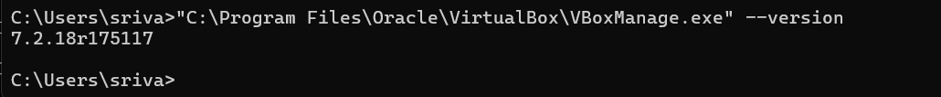
Purpose:
VirtualBox can be used by Minikube as a VM driver to create the Kubernetes node.
Since you're using Docker Desktop, you can use the Docker driver instead, so VirtualBox is optional for your setup.

3) Check System Information in CMD
Open Command Prompt (CMD):
systeminfo 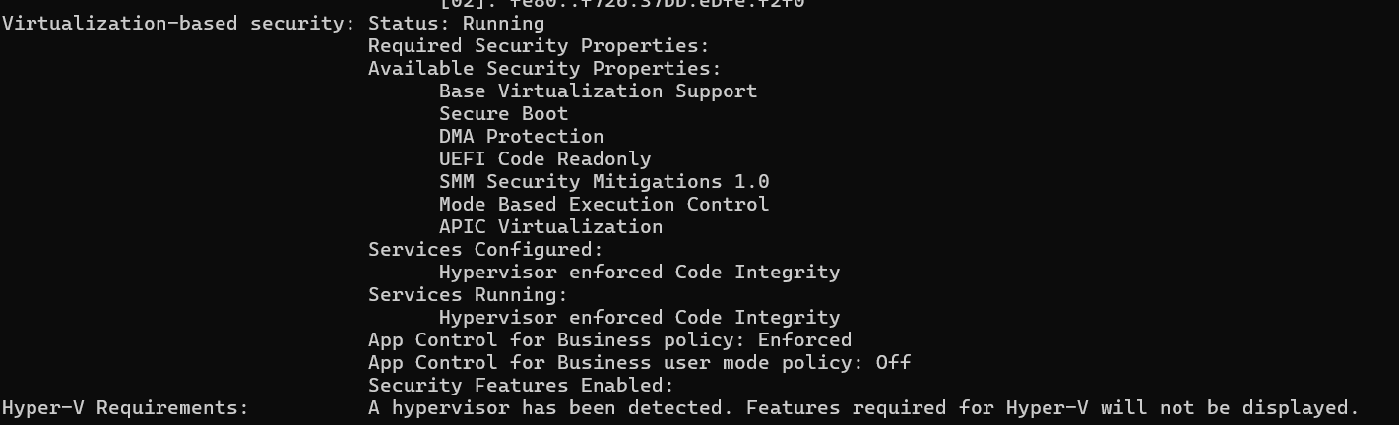
Check especially for virtualization-related information.
Purpose:
To verify that your Windows machine has the required hardware/OS capabilities for running Docker, VirtualBox, or a Minikube VM.

4) Install Minikube using PowerShell
Open link: https://minikube.sigs.k8s.io/docs/start/
Follow the official Minikube installation instructions:
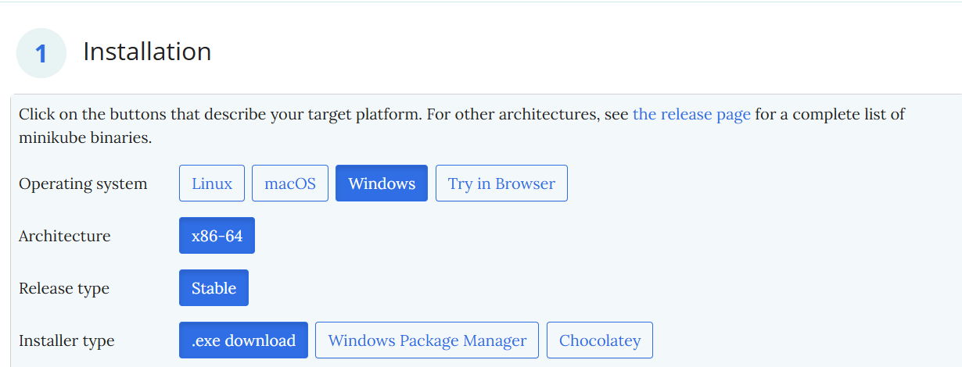
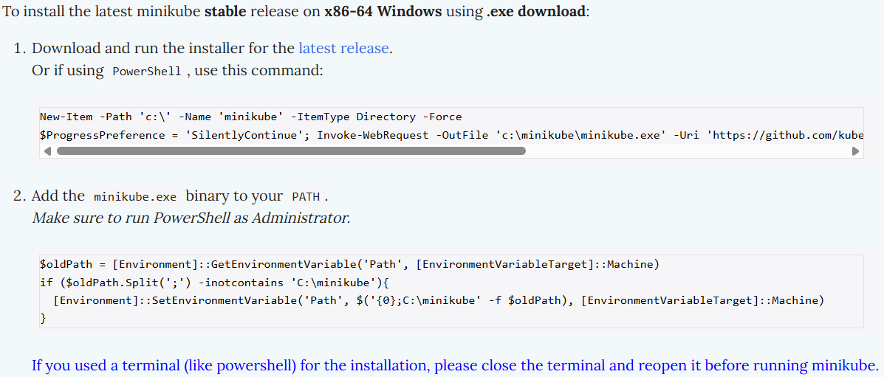
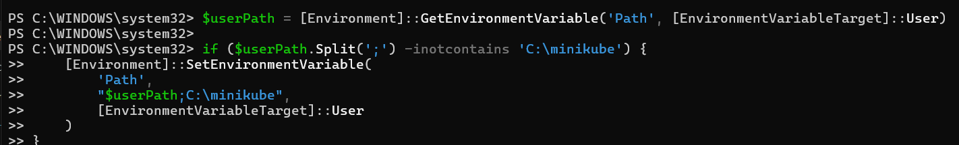
Using PowerShell, run above command:
After installation:
minikube version
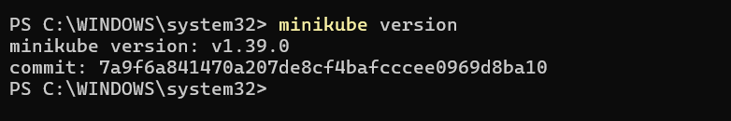
Purpose:
Minikube creates a local Kubernetes cluster on your Windows machine so you can practice Kubernetes without needing AWS or another cloud platform.

5) Add Minikube to the Environment PATH
Check: minikube version
For a permanent Windows PATH change, use:
Start → Environment Variables → Edit the system environment variables → Environment Variables → Path → New
Add:
C:\minikube 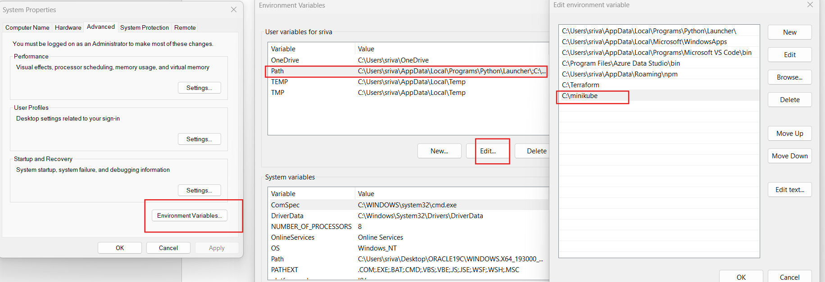
Purpose:
The PATH allows Windows to find and execute the minikube command from any PowerShell/CMD directory.

6) Restart PowerShell and Start Minikube
Close PowerShell and open a new PowerShell window.
Then:
minikube start
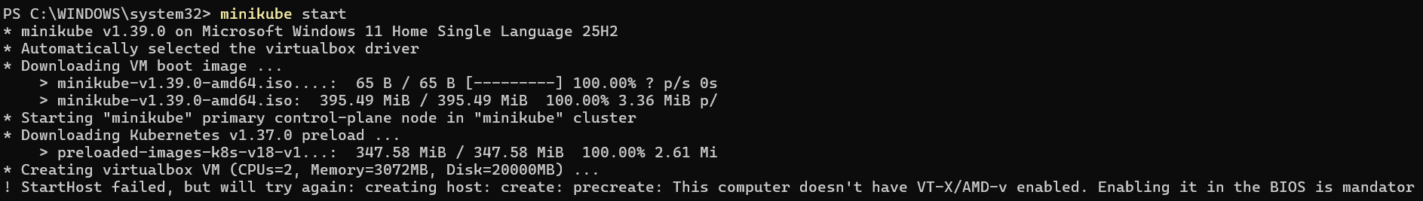
Purpose:
This actually creates and starts your local Kubernetes cluster.

Final Verification
After Minikube starts:
minikube status
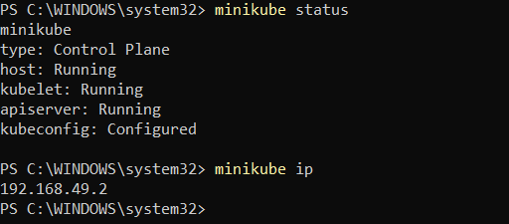

To check minikube ip use : minikube ip
To ssh to minikube: minikube ssh 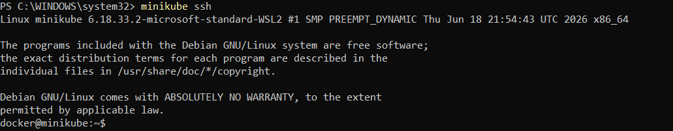
To connect or check the pods : kubectl get pods
To see minikube on dashboard: minikube dashboard

Your flow is:
Docker / VirtualBox
↓
Minikube
↓
Kubernetes Cluster
↓
Kubernetes Node
↓
Pods
Next task after this: run one Nginx Pod and verify it is running with kubectl.

- Setup k8s master and two worker nodes on ubuntu.
Setup 3-Node Kubernetes Cluster
1. Launch 3 EC2 Instances
- Launch 3 Ubuntu 24.04 LTS instances.
- Instance type: t3.medium
- Name:
  - k8s-master
  - k8s-worker1
  - k8s-worker2
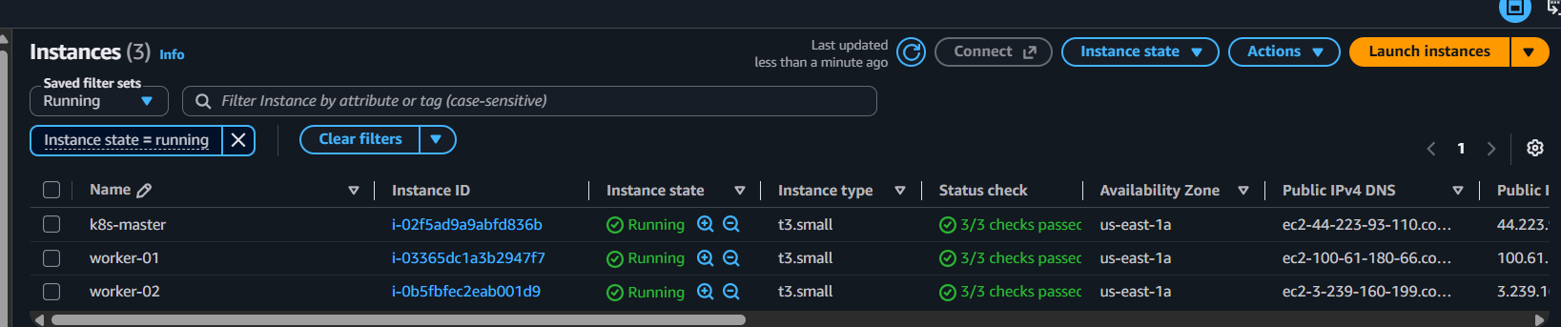
- Use the same VPC/subnet and security group.

Change Hostname
Master
sudo hostnamectl set-hostname k8s-master 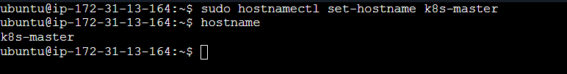
Worker 1
sudo hostnamectl set-hostname k8s-worker1 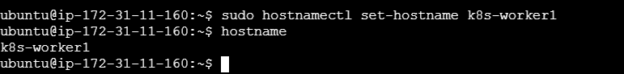
Worker 2
sudo hostnamectl set-hostname k8s-worker2 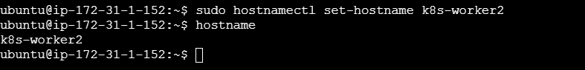
Verify on each node
hostname
Expected:
k8s-master
k8s-worker1
k8s-worker2 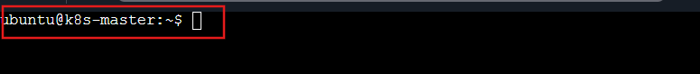
- Allow SSH and Kubernetes node-to-node communication.

- Disable Swap on All 3 Instances
By defult in aws swap memory will be zero ,ni need to run this step
We can use when we using other vm
Check swap:
free -h
Disable:
sudo swapoff -a
To disable permanently:
sudo nano /etc/fstab
Comment the swap entry:
#/swap.img
Check again:
free -h
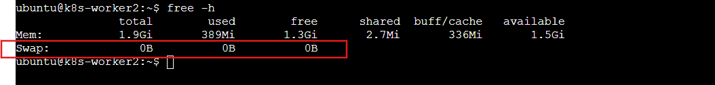

1. Install Container Runtime on All 3 Instances
Kubernetes needs a container runtime. For the current setup, use containerd.
sudo apt update 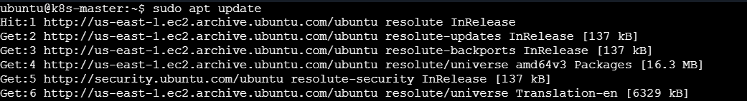
sudo apt install -y containerd 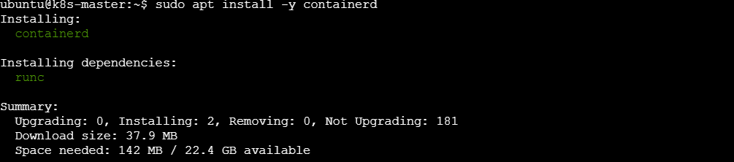

Configure it:
sudo mkdir -p /etc/containerd
containerd config default | sudo tee /etc/containerd/config.toml 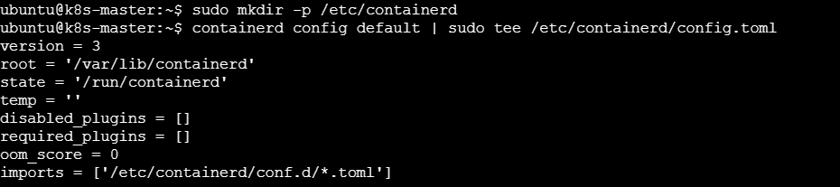
Enable systemd cgroup:
sudo sed -i 's/SystemdCgroup = false/SystemdCgroup = true/' /etc/containerd/config.toml
Restart:
sudo systemctl restart containerd
sudo systemctl enable containerd

4. Install Kubernetes Tools on All 3 Instances
Install:
kubeadm
kubelet
kubectl
Run these commands on the master, then repeat on both workers.
1. Update packages
sudo apt update 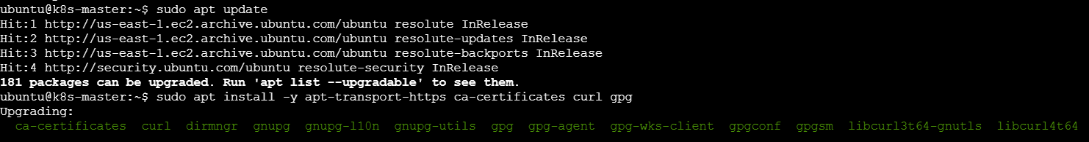
2. Install prerequisites
sudo apt install -y apt-transport-https ca-certificates curl gpg 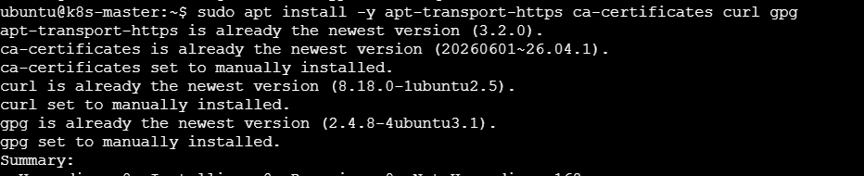
3. Add Kubernetes repository
sudo mkdir -p -m 755 /etc/apt/keyrings
curl -fsSL https://pkgs.k8s.io/core:/stable:/v1.34/deb/Release.key | sudo gpg --dearmor -o /etc/apt/keyrings/kubernetes-apt-keyring.gpg
echo 'deb [signed-by=/etc/apt/keyrings/kubernetes-apt-keyring.gpg] https://pkgs.k8s.io/core:/stable:/v1.34/deb/ /' | sudo tee /etc/apt/sources.list.d/kubernetes.list
4. Install Kubernetes
sudo apt update 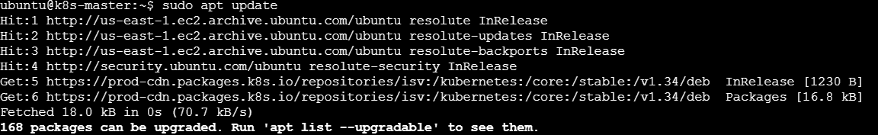
sudo apt install -y kubelet kubeadm kubectl 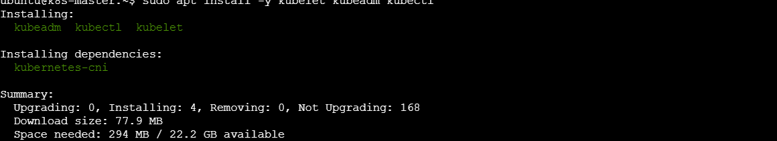
5. Enable kubelet
sudo systemctl enable --now kubelet
6. Verify
kubeadm version
kubectl version --client 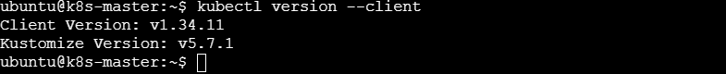
These tools are required to create and manage the Kubernetes cluster.

3. Initialize the Kubernetes Master
Login to k8s-master.
1. Login to master
ssh -i your-key.pem ubuntu@<master-ip>
2. Initialize cluster
sudo kubeadm init --pod-network-cidr=10.244.0.0/16
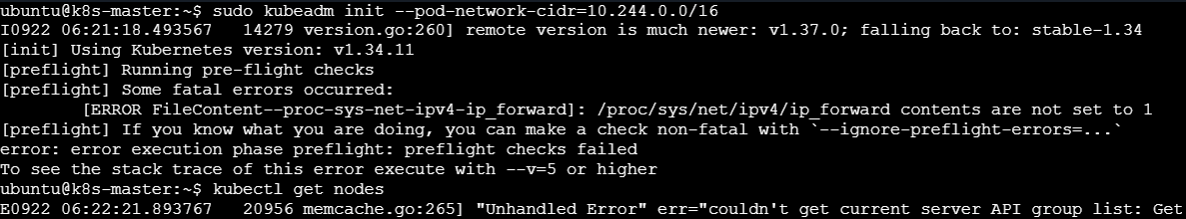

4. Configure kubectl on Master
Run on k8s-master:
mkdir -p $HOME/.kube
sudo cp -i /etc/kubernetes/admin.conf $HOME/.kube/config
sudo chown $(id -u):$(id -g) $HOME/.kube/config
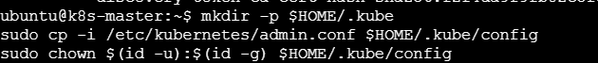
Check:
kubectl get nodes
Initially the master may show:
NotReady
This is expected because the Pod network is not installed yet.

5. Install Flannel Networking
Run these commands on k8s-master.
1. Install Flannel
kubectl apply -f https://github.com/flannel-io/flannel/releases/latest/download/kube-flannel.yml 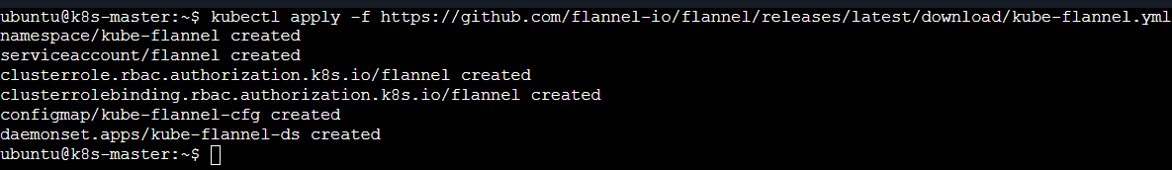
You should see resources being created.
2. Check Pods
kubectl get pods -A 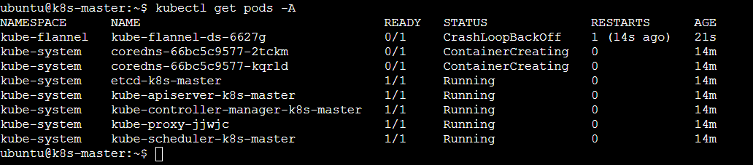
Wait until the Flannel and Kubernetes system Pods are Running.
3. Check nodes
kubectl get nodes 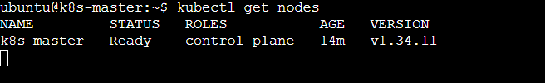
Expected:
NAME STATUS ROLES AGE
k8s-master Ready control-plane ...
✅ Master should become Ready.
If it still shows NotReady, wait 1–2 minutes and run:
kubectl get nodes

6. Join Worker Nodes to the Cluster
On Worker 1 & Worker 2
1. Enable IP forwarding
sudo sysctl -w net.ipv4.ip_forward=1
2. Install Kubernetes tools (if not already installed)
sudo apt update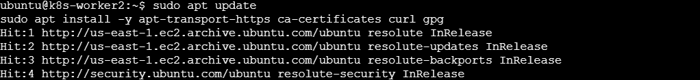
sudo apt install -y kubelet kubeadm kubectl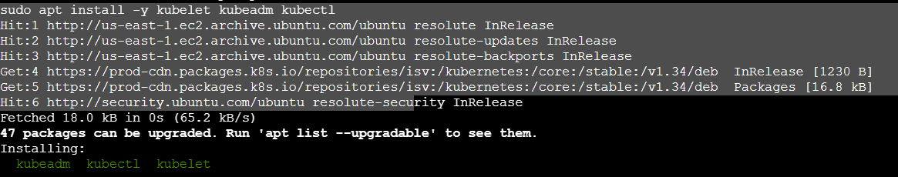
3. Run the join command
sudo kubeadm join <MASTER-PRIVATE-IP>:6443 --token <TOKEN> \
--discovery-token-ca-cert-hash sha256:<HASH>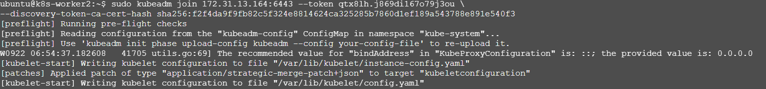

7. Verify the 3-Node Cluster
Go to k8s-master:
kubectl get nodes
Expected:
NAME STATUS ROLES
k8s-master Ready control-plane
k8s-worker1 Ready <none>
k8s-worker2 Ready <none> 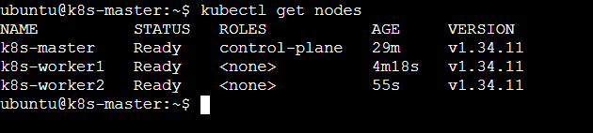
Check all Kubernetes components:
kubectl get pods -A

- Run one nginx pod.
Run on k8s-master.
Step 1 — Create Nginx Pod
kubectl run nginx --image=nginx 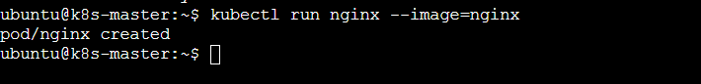
Step 2 — Check Pod
kubectl get pods 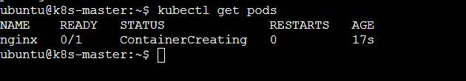
Expected:
NAME READY STATUS RESTARTS AGE
nginx 1/1 Running 0 ...
Step 3 — Get Pod details
kubectl get pod nginx -o wide
This shows which worker node is running the Nginx Pod.

- Mugup Master and slave components on k8s.
Kubernetes Master & Worker Components
Master = Control Plane
Slave = Worker Node (preferred terminology)
1. Master / Control Plane
Component | Purpose
API Server | Entry point; receives all Kubernetes requests
etcd | Stores Kubernetes cluster data
Scheduler | Decides which Worker Node runs a Pod
Controller Manager | Maintains desired state
Remember:
A-E-S-C
API → etcd → Scheduler → Controller

2. Worker Node
Component | Purpose
kubelet | Manages Pods on the Worker
kube-proxy | Handles Service networking
Container Runtime | Runs containers

Remember:
K-K-C
kubelet → kube-proxy → Container Runtime

3. Simple Flow
kubectl
↓
API Server
↓
Scheduler
↓
Worker Node
↓
kubelet
↓
Container Runtime
↓
Pod / Container

Control Plane manages and makes decisions; Worker Nodes run the applications.

