k8s-08 tasks
- Create and Test a Kubernetes Pod with an EmptyDir Volume
1. Objective
Create a Kubernetes Pod with an emptyDir volume, write data into the volume, and verify that the data is accessible inside the container.
2. What is EmptyDir?
emptyDir is a temporary Kubernetes volume that is created when a Pod is assigned to a node. It allows containers within the same Pod to share files and data.
- The volume is created when the Pod is assigned to a node.
- Containers in the same Pod can share the volume.
- Data remains available if a container restarts, as long as the Pod exists.
- Data is deleted when the Pod is removed from the node.
3. Create the YAML file
Run these commands on your Kubernetes master node.
Step 1: Create the Pod manifest
nano emptydir-pod.yaml
Step 2: Add the following YAML
apiVersion: v1
kind: Pod
metadata:
name: emptydir-pod
spec:
containers:
- name: writer
image: busybox
command: ["sh", "-c", "while true; do date >> /data/test.txt; sleep 10; done"]
volumeMounts:
- name: shared-storage
mountPath: /data

- name: reader
image: busybox
command: ["sh", "-c", "sleep 3600"]
volumeMounts:
- name: shared-storage
mountPath: /data

volumes:
- name: shared-storage
emptyDir: {}
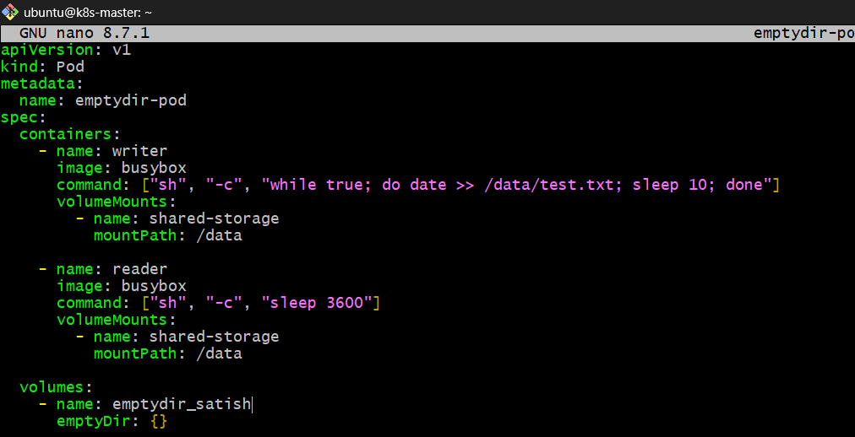
Save the file using Ctrl + O, Enter, then Ctrl + X.
4. Apply the YAML
kubectl apply -f emptydir-pod.yaml 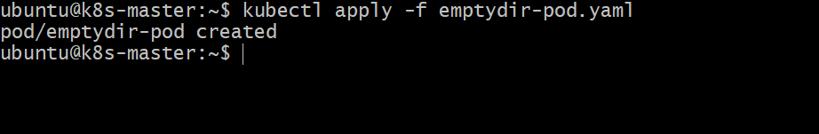
Purpose: Creates the Pod with two containers sharing the same emptyDir volume.
5. Verify the Pod
kubectl get pods -o wide
Expected output:
NAME READY STATUS RESTARTS
emptydir-pod 2/2 Running 0
Both containers should be running.
6. Verify the shared volume
Step 1: Check the file from the writer container.
kubectl exec emptydir-pod -c writer -- cat /data/test.txt
Step 2: Check the same file from the reader container.
kubectl exec emptydir-pod -c reader -- cat /data/test.txt
Expected output (timestamps will differ):
Wed Sep 30 12:00:00 UTC 2026
Wed Sep 30 12:00:10 UTC 2026
Wed Sep 30 12:00:20 UTC 2026
Both containers can read the same file because they mount the same emptyDir volume.
7. Inspect the volume
kubectl describe pod emptydir-pod
Look for:
Volumes:
shared-storage:
Type: EmptyDir
Medium:
SizeLimit: <unset>
This confirms that Kubernetes configured an EmptyDir volume for the Pod. 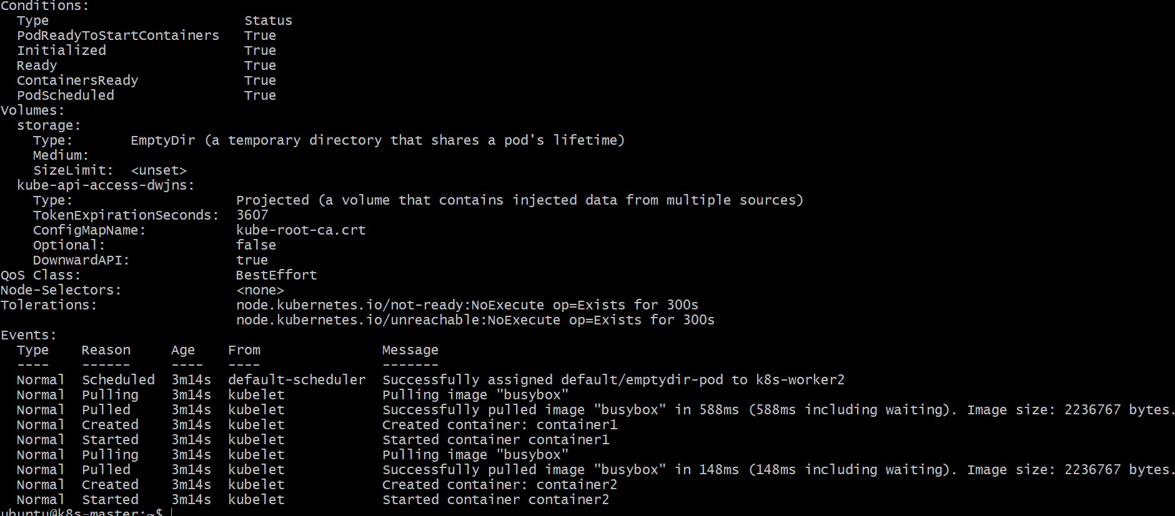
8. Test data persistence
Restart the writer container by deleting it is not directly possible independently through kubectl; instead, you can observe that the file remains accessible while the Pod exists. A container restart does not delete the emptyDir data.
To demonstrate the volume's temporary nature, delete the Pod:
kubectl delete pod emptydir-pod
Then recreate it:
kubectl apply -f emptydir-pod.yaml
Check the file again:
kubectl exec emptydir-pod -c reader -- cat /data/test.txt
The file will contain newly written timestamps, rather than the previous Pod's data, because the new Pod receives a fresh emptyDir volume.

9. Cleanup
kubectl delete -f emptydir-pod.yaml

- Configure a HostPath Volume in Kubernetes and Validate Data Persistence
1. Objective
Create a Kubernetes Pod with a hostPath volume, store data inside the container, and verify that the data persists on the Kubernetes worker node, even after the Pod is deleted and recreated on the same node.
2. What is HostPath?
A hostPath volume mounts a file or directory from the Kubernetes node's filesystem into a container.
- Data is stored on the host node, not inside the container.
- Data can persist after a Pod is deleted, provided the same node and host directory are used.
- Multiple Pods on the same node can access the same host directory.
- If a Pod is scheduled on a different node, it will access that node's corresponding directory, which may contain different data.
Architecture
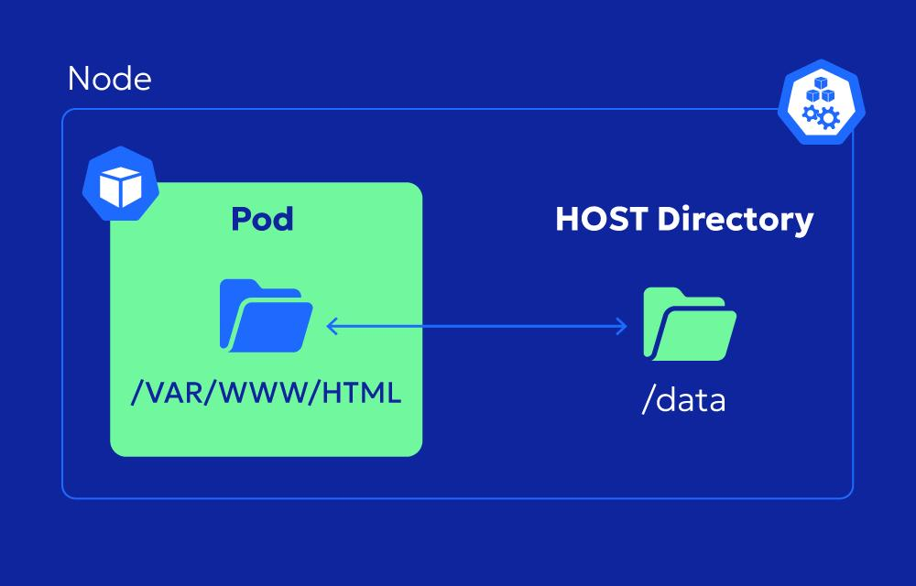

3. Create the HostPath directory on the worker node
For this practical, use k8s-worker1 (172.31.11.160).
SSH into the worker node:
ssh ubuntu@172.31.11.160
Create the directory:
sudo mkdir -p /mnt/k8s-hostpath
sudo chmod 777 /mnt/k8s-hostpath
Purpose:
- mkdir -p creates the directory if it does not exist.
- chmod 777 allows the lab container to write to it. Use appropriate ownership and restrictive permissions in production.
Verify:
ls -ld /mnt/k8s-hostpath
Exit the worker node:
exit 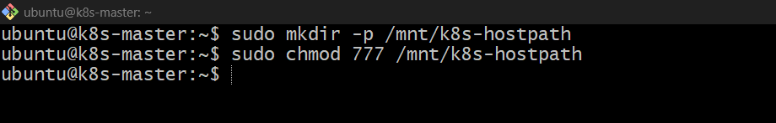
4. Create the Pod YAML file
On the Kubernetes master node:
nano hostpath-pod.yaml
Add the following configuration:
apiVersion: v1
kind: Pod
metadata:
name: hostpath-pod
spec:
nodeSelector:
kubernetes.io/hostname: k8s-worker1

containers:
- name: hostpath-container
image: busybox
command:
- sh
- -c
- "echo 'Hello from HostPath' > /data/test.txt; sleep 3600"
volumeMounts:
- name: host-storage
mountPath: /data

volumes:
- name: host-storage
hostPath:
path: /mnt/k8s-hostpath
type: Directory 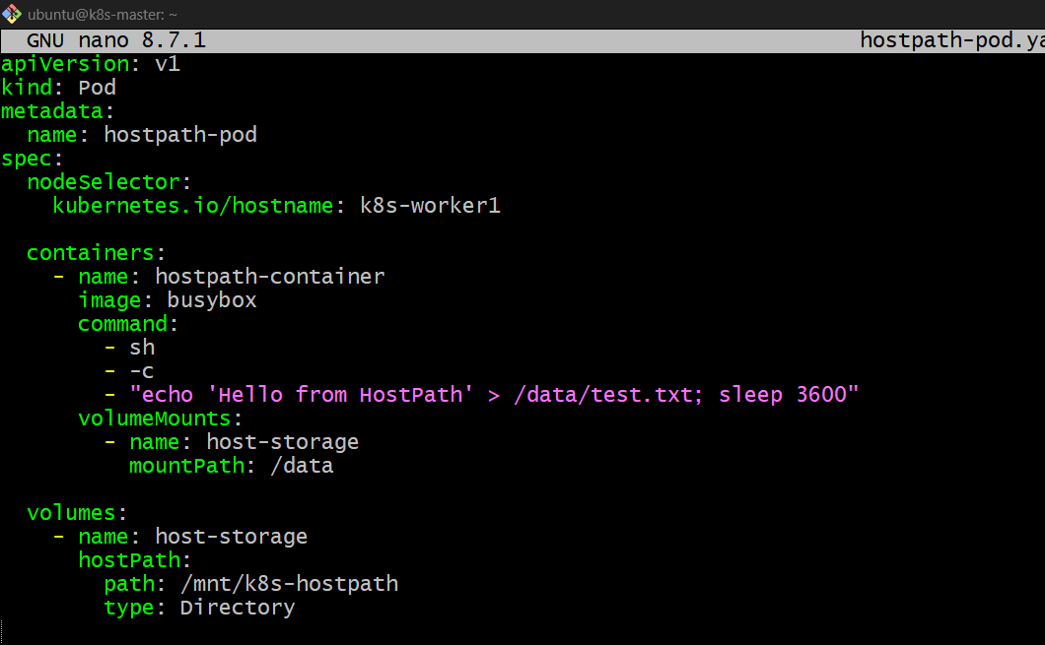
Save the file using Ctrl + O, Enter, then Ctrl + X.
Important configuration:
Configuration | Purpose
nodeSelector | Schedules the Pod on k8s-worker1
mountPath | Mounts host directory inside the container at /data
hostPath | Specifies the directory on the worker node
type: Directory | Requires the host directory to exist
sleep 3600 | Keeps the container running for testing

5. Deploy the Pod
kubectl apply -f hostpath-pod.yaml 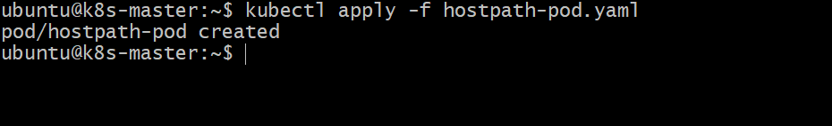
Check the Pod:
kubectl get pods -o wide
Expected output:
NAME READY STATUS RESTARTS NODE
hostpath-pod 1/1 Running 0 k8s-worker1
6. Verify data inside the container
Execute:
kubectl exec hostpath-pod -- cat /data/test.txt
Expected output:
Hello from HostPath
The container has written data to /data/test.txt, which is backed by the worker node's /mnt/k8s-hostpath directory.
7. Verify data on the worker node
SSH into k8s-worker1:
ssh ubuntu@172.31.11.160
Check the file on the host:
sudo cat /mnt/k8s-hostpath/test.txt
Expected output:
Hello from HostPath
Verified
The same file is accessible both inside the container and directly on the worker node. 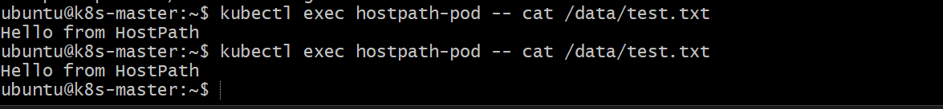
8. Test data persistence after Pod deletion
Return to the master node and delete the Pod:
kubectl delete pod hostpath-pod
Verify:
kubectl get pods
Recreate the Pod:
kubectl apply -f hostpath-pod.yaml
Wait for it to become ready:
kubectl get pods -o wide
Check the existing file:
kubectl exec hostpath-pod -- cat /data/test.txt
Expected output:
Hello from HostPath
Persistence verified
The data remains because the Pod was recreated on the same worker node and mounted the same host directory. 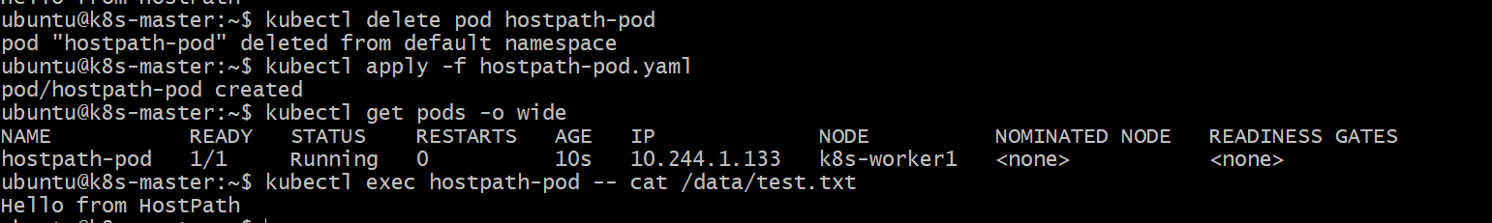
9. Verify the host directory again
On k8s-worker1, run:
sudo ls -l /mnt/k8s-hostpath
sudo cat /mnt/k8s-hostpath/test.txt
The file should still exist with its original contents.
10. Cleanup
On the master node:
kubectl delete -f hostpath-pod.yaml
If you want to remove the test data, SSH into the worker node and run:
sudo rm -rf /mnt/k8s-hostpath

- Deploy an Amazon EBS Volume Using Persistent Volume and Persistent Volume Claim (PVC)
AWS + Kubernetes
1. Objective
Create an Amazon EBS volume and use it in Kubernetes through a PersistentVolume (PV) and PersistentVolumeClaim (PVC). Deploy a Pod that writes data to the volume, delete and recreate the Pod, and verify that the data persists.
2. What are PV, PVC and EBS?
- Amazon EBS: AWS block storage that provides persistent disk storage for EC2 instances.
- PersistentVolume (PV): A Kubernetes resource representing storage available to the cluster.
- PersistentVolumeClaim (PVC): A request for storage made by a Kubernetes application.
- Pod: Uses the PVC to mount storage and read or write data.
Architecture
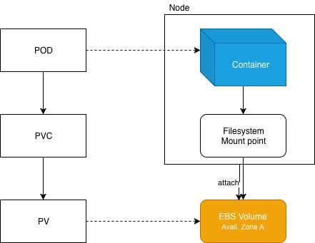

3. How it works
- Create an EBS volume in AWS in the same Availability Zone as the Kubernetes worker node.
- Create a PersistentVolume (PV) that references the EBS volume.
- Create a PersistentVolumeClaim (PVC) requesting storage.
- Bind the PVC to the PV so Kubernetes allocates the requested storage.
- Deploy a Pod that mounts the PVC and writes application data.
- Delete and recreate the Pod and verify that the stored data remains.

4. Prerequisites
For your existing self-managed Kubernetes cluster (1 master and 2 workers on AWS EC2), check the following:
- AWS EC2 worker nodes are running.
- The AWS EBS CSI driver is installed and has the required IAM permissions.
- The EBS volume is in the same Availability Zone as the worker node where the Pod runs.
- The worker node has permission and connectivity to attach and mount the volume.
The EBS CSI driver is required for Kubernetes to manage EBS volumes through CSI.
Important for your lab: Your cluster is self-managed, not Amazon EKS. Installing the EBS CSI driver alone does not automatically configure AWS permissions. The controller needs an IAM role or another supported AWS credential mechanism. Check this before creating the PV.
1. Install AWS CLI
sudo apt update 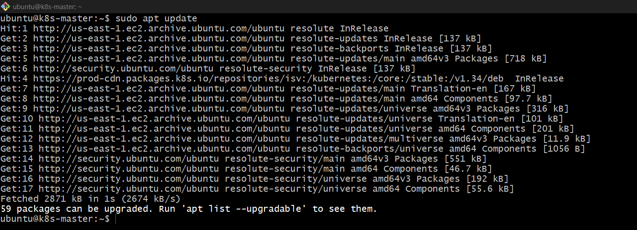
sudo apt install -y awscli
2. Verify AWS access
aws sts get-caller-identity
If this works, continue. 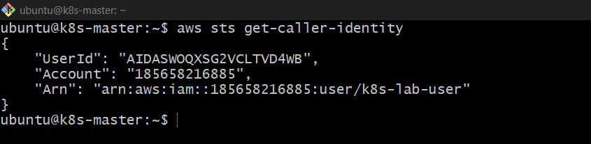
3. Get your Availability Zone
curl -s http://169.254.169.254/latest/meta-data/placement/availability-zone
You already got:
ap-south-1a
4. Create an EBS volume
aws ec2 create-volume \
--availability-zone ap-south-1a \
--size 5 \
--volume-type gp3 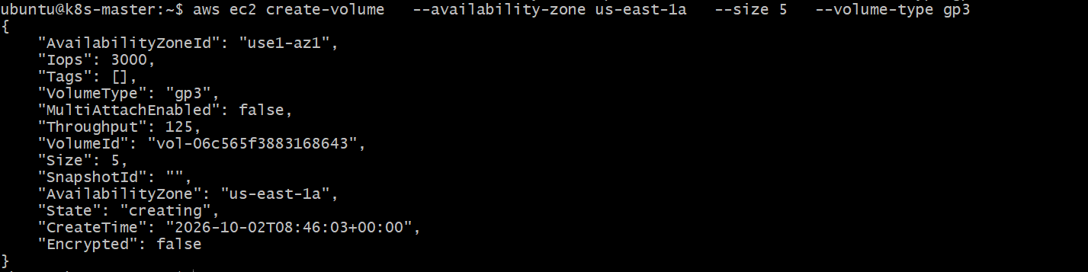
Copy the returned VolumeId, e.g.:
vol-06c565f3883168643
5. Create the Kubernetes PV
apiVersion: v1
kind: PersistentVolume
metadata:
name: ebs-pv
spec:
capacity:
storage: 5Gi
accessModes:
- ReadWriteOnce
persistentVolumeReclaimPolicy: Retain
awsElasticBlockStore:
volumeID: vol-XXXXXXXX
fsType: ext4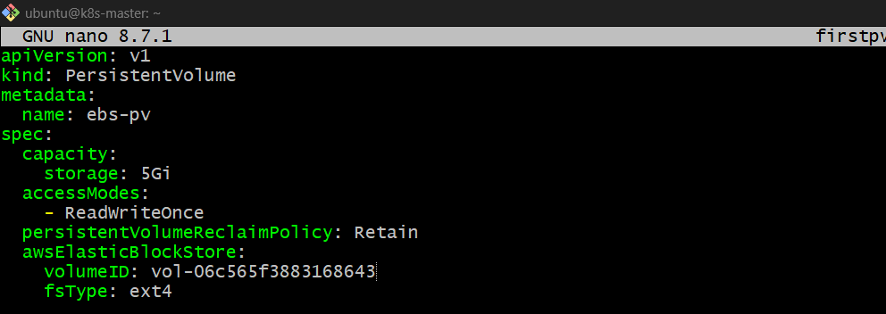
Apply:
kubectl apply -f ebs-pv.yaml 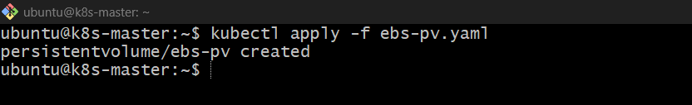
6. Create PVC
apiVersion: v1
kind: PersistentVolumeClaim
metadata:
name: ebs-pvc
spec:
accessModes:
- ReadWriteOnce
resources:
requests:
storage: 5Gi 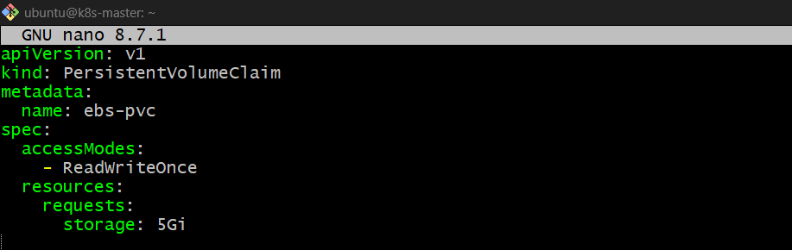
kubectl apply -f pvc.yaml 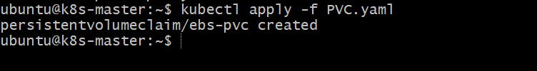
Check:
kubectl get pv,pvc 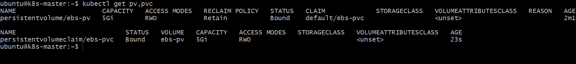
You want:
PV Bound
PVC Bound
7. Create Pod using PVC
apiVersion: v1
kind: Pod
metadata:
name: ebs-pod
spec:
containers:
- name: app
image: busybox
command: ["sh", "-c", "echo 'Hello EBS' > /data/test.txt; sleep 3600"]
volumeMounts:
- name: ebs
mountPath: /data
volumes:
- name: ebs
persistentVolumeClaim:
claimName: ebs-pvc 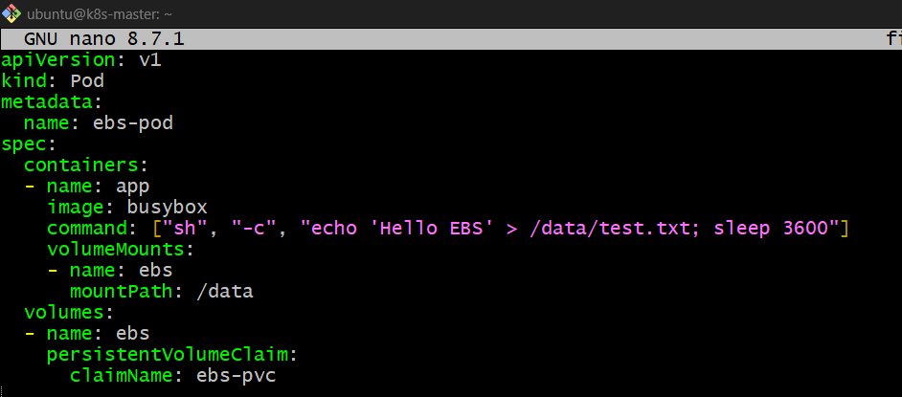
kubectl apply -f firstpod.yaml 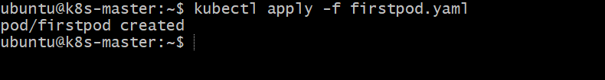
8. Verify
kubectl get pod,pv,pvc -o wide 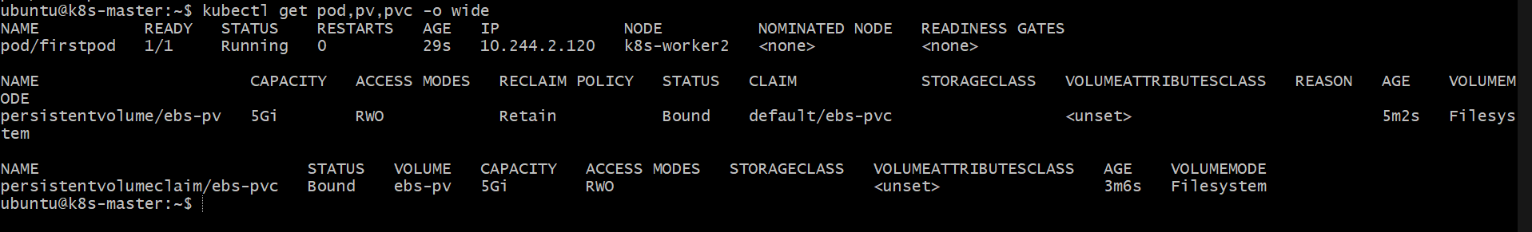
Then:
kubectl exec ebs-pod -- cat /data/test.txt
Expected:
Hello EBS
Important: This is the older/static awsElasticBlockStore approach. On modern Kubernetes, the recommended production approach is EBS CSI Driver + StorageClass + dynamically provisioned PVC. For a lab specifically teaching PV/PVC, static provisioning can be useful, but we should first check whether your Kubernetes version still permits the legacy EBS volume plugin.

- Set Up an Amazon EFS Volume and Attach it to Multiple Pods
1. Create an Amazon EFS file system

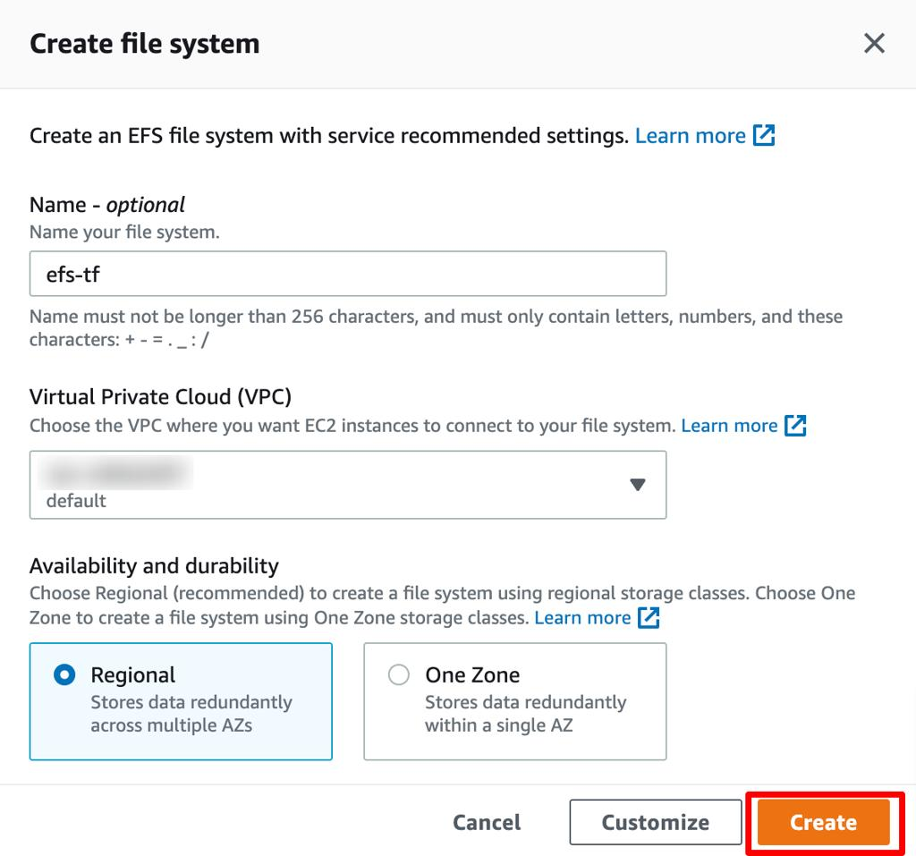
- Open the
Amazon EFS console
.
- Select Create file system.
- Enter the name k8s-shared-efs.
- Choose Regional availability for access across multiple Availability Zones.
- Select Create.
Record the EFS File System ID, for example fs-0123456789abcdef0.
2. Configure EFS mount targets and security
In the EFS console, select your file system and open Network.
- Create a mount target in each Availability Zone where your Kubernetes worker nodes run.
- Use the VPC containing your worker nodes.
- Associate a security group that allows inbound NFS traffic on TCP port 2049 from the worker nodes' security group.
Important: EFS uses NFS, so the worker nodes must be able to reach an EFS mount target over TCP port 2049. Ensure the VPC networking and security groups allow this traffic.
AWS Region: us-east-1
Kubernetes:
k8s-master
k8s-worker1
k8s-worker2
We will build:
AWS
│
EFS FS
│
EFS Mount Target
│
EFS CSI Driver
│
EFS PV
│
EFS PVC
/ \
/ \
Pod-1 Pod-2
│ │
└──── EFS ─────┘
shared data
Step 1 — Create EFS
Run on k8s-master:
aws efs create-file-system \
--region us-east-1 \
--creation-token k8s-efs-lab \
--tags Key=Name,Value=k8s-efs-lab
Look for:
"FileSystemId": "fs-xxxxxxxxxxxxxxxxx" 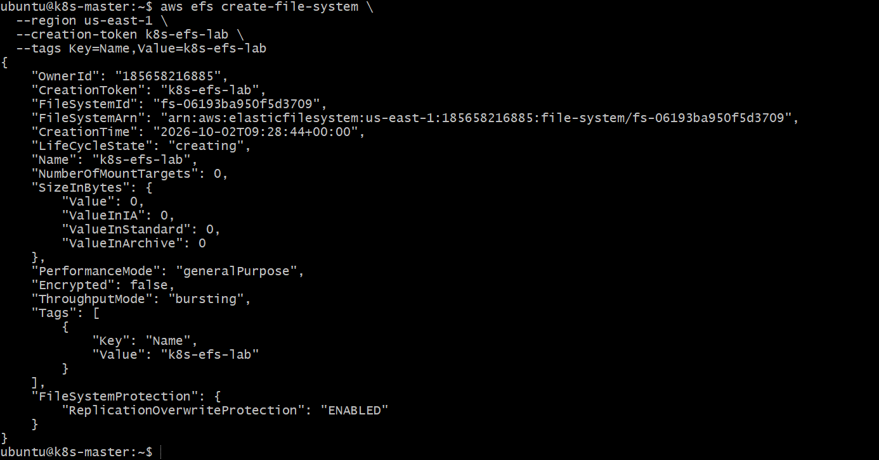
Save this ID. I'll call it FS_ID below.
fs-06193ba950f5d3709

Step 2 — Get the worker subnet and VPC
Run:
aws ec2 describe-instances \
--region us-east-1 \
--instance-ids i-03365dc1a3b2947f7 i-0b5fbfec2eab001d9 \
--query 'Reservations[].Instances[].{Instance:InstanceId,Subnet:SubnetId,VPC:VpcId,SG:SecurityGroups[0].GroupId,AZ:Placement.AvailabilityZone}' \
--output table
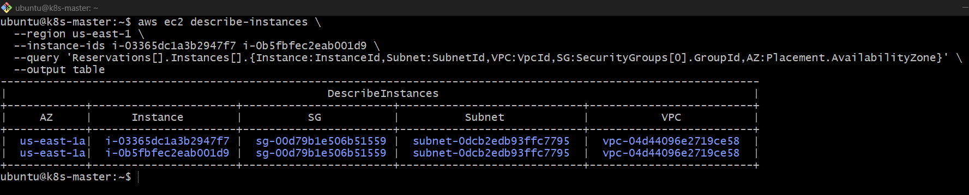
You'll get something like:
Instance Subnet VPC SG AZ
i-03365dc1a3b2947f7 subnet-xxxx vpc-xxxx sg-xxxx us-east-1a
i-0b5fbfec2eab001d subnet-yyyy vpc-xxxx sg-yyyy us-east-1a
We need:
VPC ID
Subnet ID
Security Group ID

Step 3 — Create EFS mount target
Use the worker subnet and security group.
Example:
aws efs create-mount-target \
--region us-east-1 \
--file-system-id fs-xxxxxxxxxxxxxxxxx \
--subnet-id subnet-xxxxxxxx \
--security-groups sg-xxxxxxxx
Replace:
fs-xxxxxxxx → your EFS FileSystemId
subnet-xxxx → worker subnet
sg-xxxx → worker security group
Verify:
aws efs describe-mount-targets \
--region us-east-1 \
--file-system-id fs-xxxxxxxxxxxxxxxxx \
--output table
You should see:
LifeCycleState available
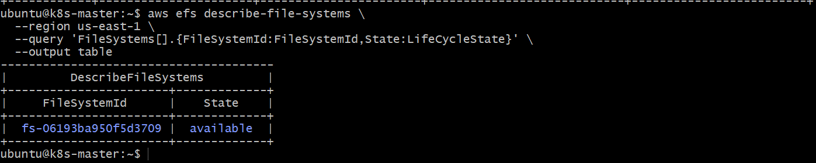

Step 4 — Install EFS CSI Driver
First check:
kubectl get csidrivers
If you don't see:
efs.csi.aws.com
we need to install the EFS CSI driver.
Because your cluster currently has no CSI drivers, we'll install it using Helm.
Add the repository:
helm repo add aws-efs-csi-driver \
https://kubernetes-sigs.github.io/aws-efs-csi-driver/
Update:
helm repo update
Install:
helm install aws-efs-csi-driver \
aws-efs-csi-driver/aws-efs-csi-driver \
--namespace kube-system
Check:
kubectl get pods -n kube-system | grep efs 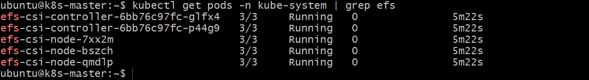
Then:
kubectl get csidrivers
You should see:
efs.csi.aws.com

Step 5 — Create EFS PersistentVolume
Create:
cat > efs-pv.yaml <<'EOF'
apiVersion: v1
kind: PersistentVolume
metadata:
name: efs-pv
spec:
capacity:
storage: 5Gi
volumeMode: Filesystem
accessModes:
- ReadWriteMany
persistentVolumeReclaimPolicy: Retain
csi:
driver: efs.csi.aws.com
volumeHandle: fs-xxxxxxxxxxxxxxxxx
EOF
Replace:
fs-xxxxxxxxxxxxxxxxx
with your actual EFS ID.
Apply:
kubectl apply -f efs-pv.yaml
Check:
kubectl get pv efs-pv 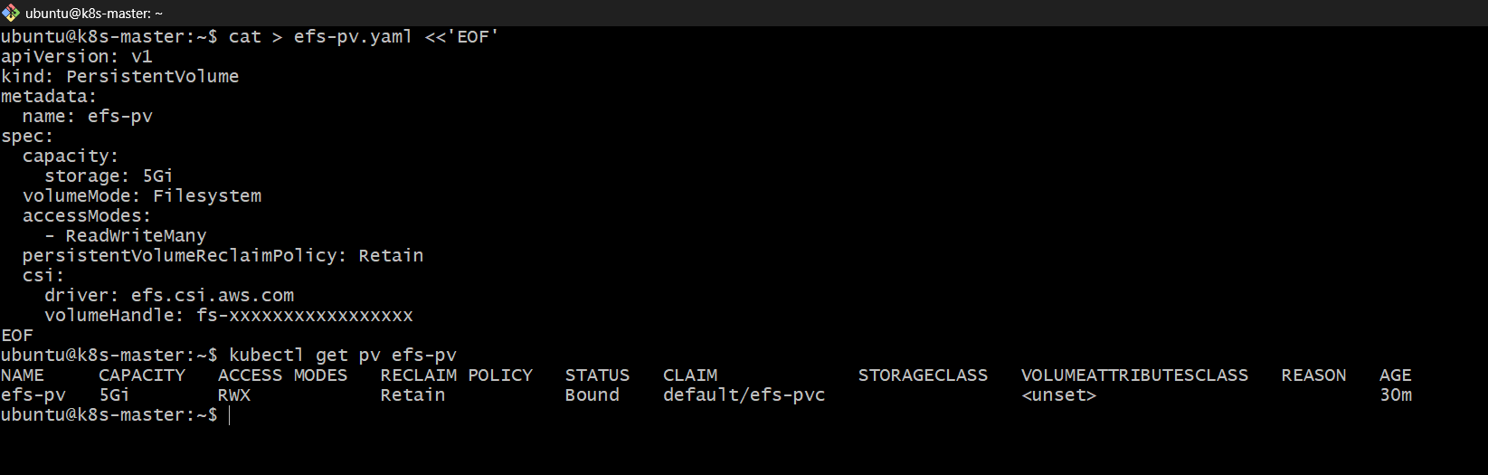

Step 6 — Create EFS PVC
cat > efs-pvc.yaml <<'EOF'
apiVersion: v1
kind: PersistentVolumeClaim
metadata:
name: efs-pvc
spec:
accessModes:
- ReadWriteMany
resources:
requests:
storage: 5Gi
EOF
Apply:
kubectl apply -f efs-pvc.yaml
Check:
kubectl get pv,pvc
You want:
efs-pv 5Gi RWX Bound
efs-pvc RWX Bound 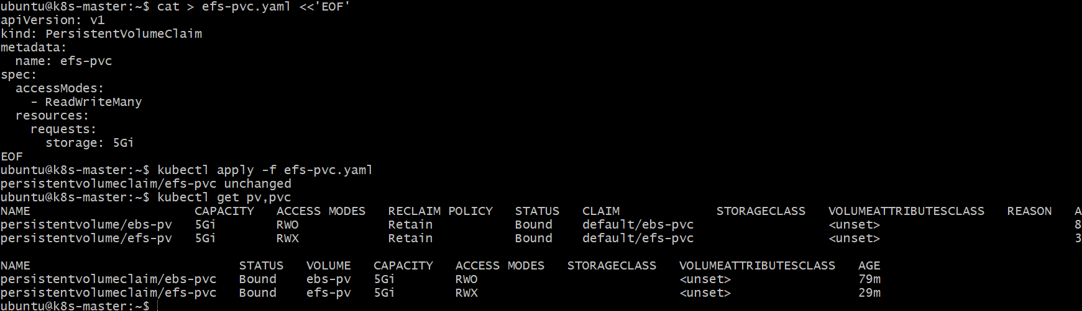

Step 7 — Create Pod 1
cat > efs-pod1.yaml <<'EOF'
apiVersion: v1
kind: Pod
metadata:
name: efs-pod1
spec:
containers:
- name: app
image: busybox
command: ["sh", "-c", "echo 'Hello from Pod 1' > /data/shared.txt; sleep 3600"]
volumeMounts:
- name: efs
mountPath: /data
volumes:
- name: efs
persistentVolumeClaim:
claimName: efs-pvc
EOF
Apply:
kubectl apply -f efs-pod1.yaml
Check:
kubectl get pod efs-pod1 -o wide
Wait until:
1/1 Running 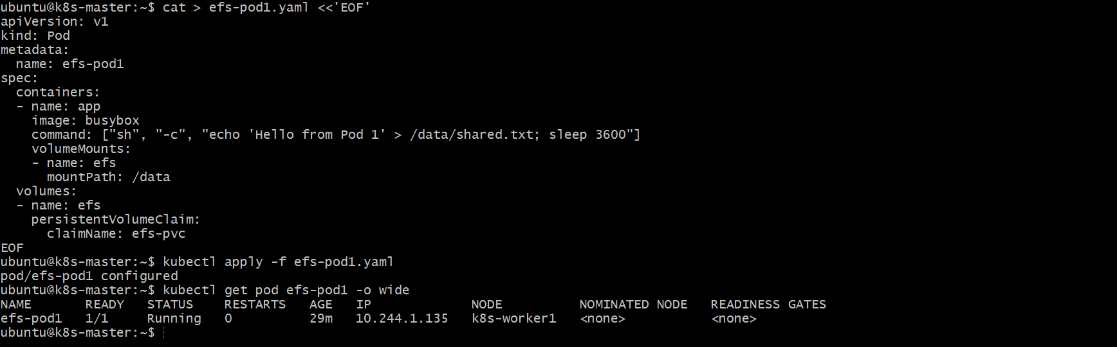

Step 8 — Create Pod 2
cat > efs-pod2.yaml <<'EOF'
apiVersion: v1
kind: Pod
metadata:
name: efs-pod2
spec:
containers:
- name: app
image: busybox
command: ["sh", "-c", "sleep 3600"]
volumeMounts:
- name: efs
mountPath: /data
volumes:
- name: efs
persistentVolumeClaim:
claimName: efs-pvc
EOF
Apply:
kubectl apply -f efs-pod2.yaml 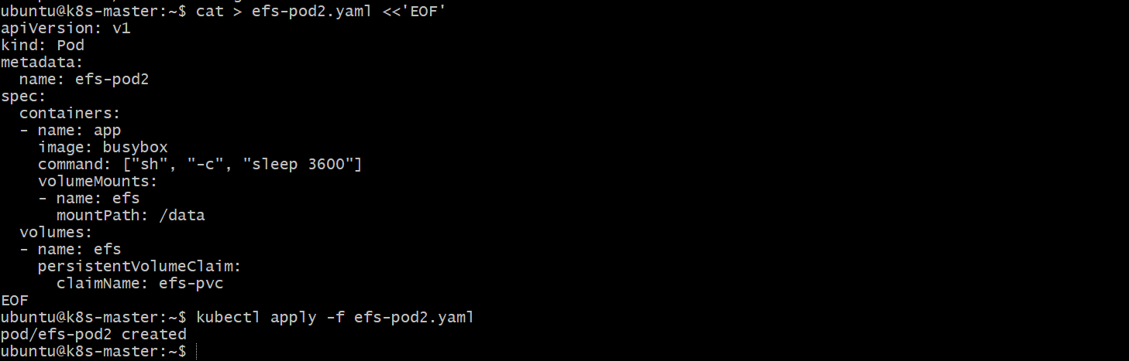
Check:
kubectl get pod efs-pod1 efs-pod2 -o wide
Both should be:
1/1 Running

Step 9 — Prove that both Pods share the same EFS
Pod 1 wrote:
Hello from Pod 1
Read it from Pod 2:
kubectl exec efs-pod2 -- cat /data/shared.txt
Expected:
Hello from Pod 1

- Implement and Test Liveness and Readiness Probes in a Kubernetes Pod
Step 1 — Purpose
- Liveness Probe: Checks whether the application is still alive. If it fails repeatedly, Kubernetes restarts the container.
- Readiness Probe: Checks whether the application is ready to receive traffic. If it fails, Kubernetes does not send traffic to the Pod.

Step 2 — Create the Pod
Purpose: Create an Nginx Pod with both probes.
cat > probe-pod.yaml <<'EOF'
apiVersion: v1
kind: Pod
metadata:
name: probe-pod
spec:
containers:
- name: app
image: nginx
ports:
- containerPort: 80

livenessProbe:
httpGet:
path: /
port: 80
initialDelaySeconds: 5
periodSeconds: 10

readinessProbe:
httpGet:
path: /
port: 80
initialDelaySeconds: 2
periodSeconds: 5
EOF 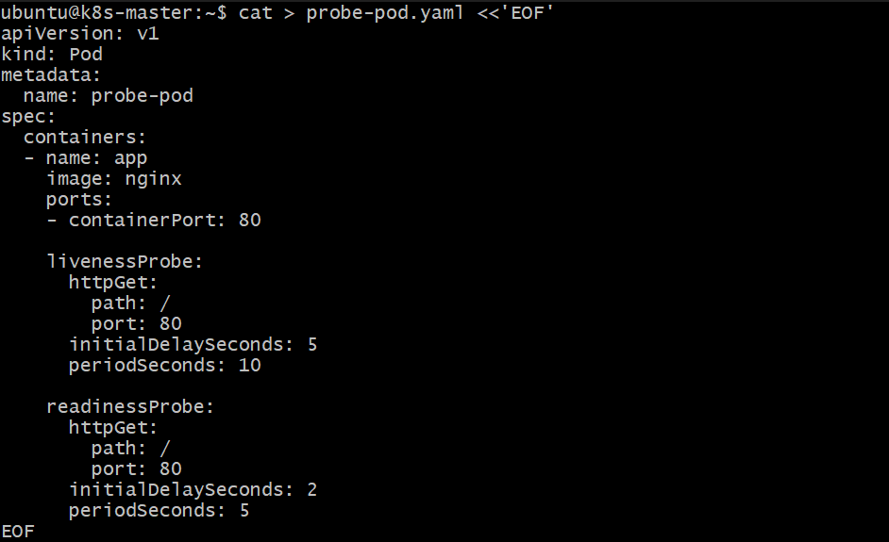

Step 3 — Deploy the Pod
Purpose: Create the Pod in Kubernetes.
kubectl apply -f probe-pod.yaml
Check:
kubectl get pod probe-pod
Expected:
NAME READY STATUS
probe-pod 1/1 Running 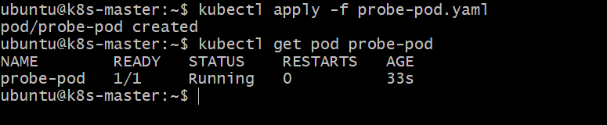

Step 4 — Verify the Probes
Purpose: Confirm Kubernetes has configured both probes.
kubectl describe pod probe-pod
Look for:
Liveness: http-get http://:80/
Readiness: http-get http://:80/ 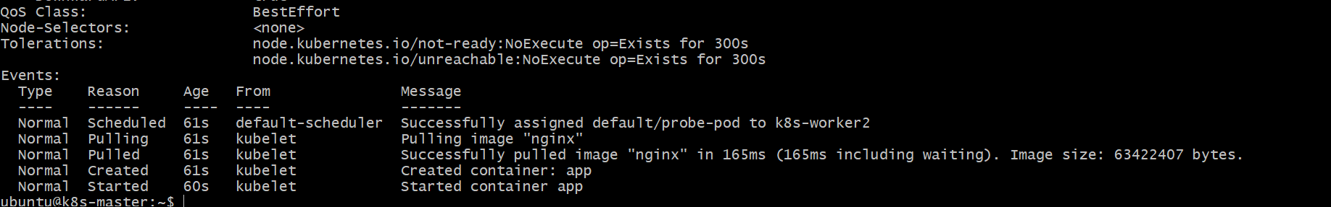 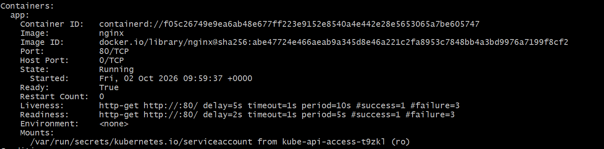

Step 5 — Test Readiness Probe
Purpose: Demonstrate that a failed readiness check makes the Pod not ready.
Edit the Pod:
kubectl edit pod probe-pod
Change the readiness path:
path: /
to:
path: /wrong
Then check:
kubectl get pod probe-pod
You should eventually see:
READY 0/1
The container is still running; it is simply not ready for traffic.

Step 6 — Test Liveness Probe
Purpose: Demonstrate that a failed liveness check causes Kubernetes to restart the container.
Change the liveness path to an invalid path:
livenessProbe:
httpGet:
path: /wrong
port: 80
Check:
kubectl get pod probe-pod 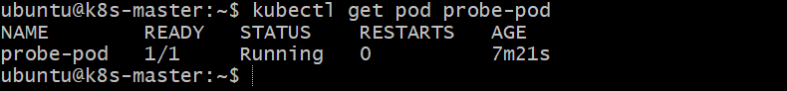
Then:
kubectl describe pod probe-pod
Look for events such as:
Liveness probe failed
Container restarted 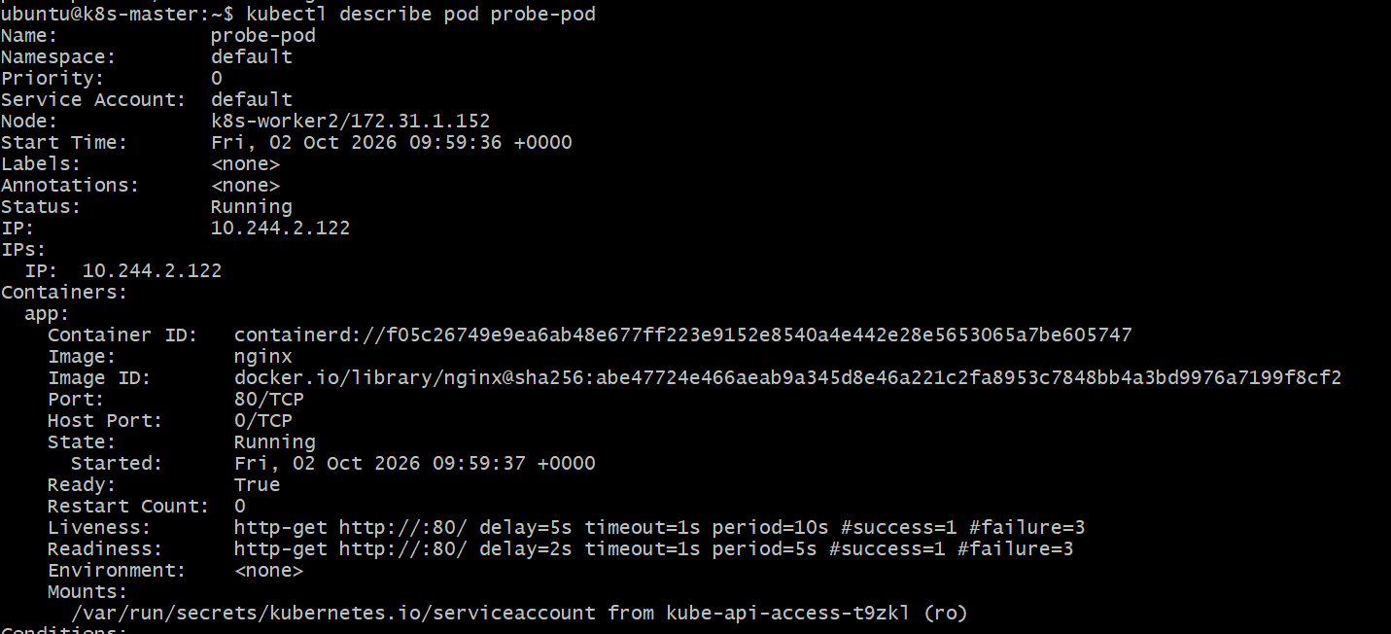

Step 7 — Clean Up
Purpose: Remove the test Pod.
kubectl delete pod probe-pod
Final Concept
Kubernetes
|
+---------+---------+
| |
Liveness Readiness
| |
"Is it alive?" "Can it receive traffic?"
| |
Restart Stop traffic
container to Pod

