Jenkins-01

What is Jenkins?
Jenkins is an open-source automation server used to automate build, test, and deployment processes.
Main uses
- Continuous Integration (CI)
- Continuous Delivery/Deployment (CD)
- Automate builds and tests
- Integrate Git/GitHub
- Run scripts and deployment jobs

1. Install Jenkins on EC2
Create EC2
- AMI: Amazon Linux 2023
- Instance type: t3.micro
- Allow inbound:
  - SSH 22
  - Custom TCP 8081
- Connect to EC2.
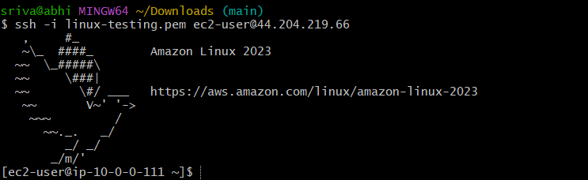
Install java
Command: sudo dnf update -y
Command: sudo dnf install java-17-amazon-corretto -y

Command: sudo wget -O /etc/yum.repos.d/jenkins.repo \
https://pkg.jenkins.io/redhat-stable/jenkins.repo

command: sudo rpm --import https://pkg.jenkins.io/redhat-stable/jenkins.io-2023.key
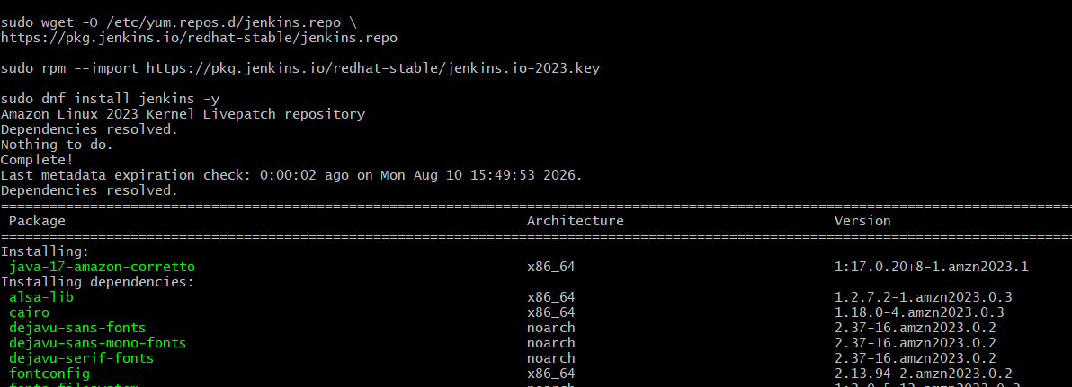

Install Jenkins

command: sudo dnf install jenkins -y
Start Jenkins:
sudo systemctl enable jenkins
sudo systemctl start jenkins
sudo systemctl status jenkins 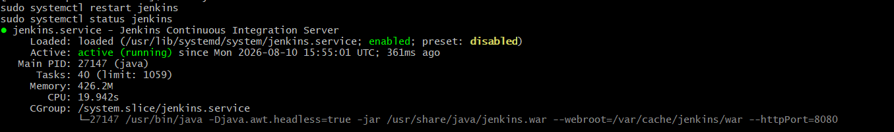

2. Run Jenkins on Port 8081
Jenkins Port 8081
1. Create directory
sudo mkdir -p /etc/systemd/system/jenkins.service.d
2. Create configuration file
sudo bash -c 'cat > /etc/systemd/system/jenkins.service.d/override.conf <<EOF
[Service]
ExecStart=
ExecStart=/usr/bin/java -Djava.awt.headless=true -jar /usr/share/java/jenkins.war --webroot=/var/cache/jenkins/war --httpPort=8081
EOF'
3. Reload and restart
sudo systemctl daemon-reload
sudo systemctl restart jenkins
4. Check
sudo systemctl status jenkins
You should see:
--httpPort=8081
5. Verify port
sudo ss -lntp | grep 8081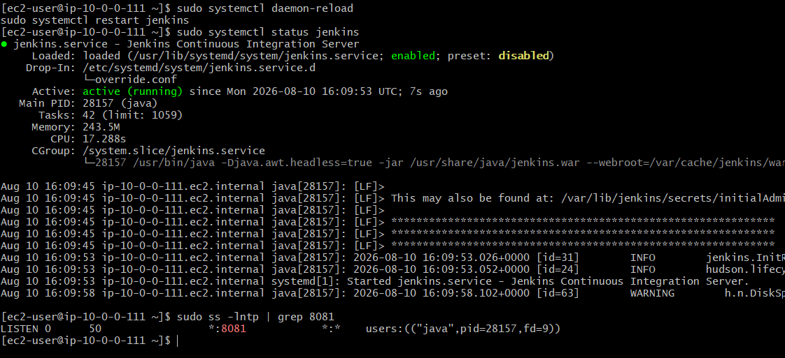
6. Open Jenkins
http://44.204.219.66:8081
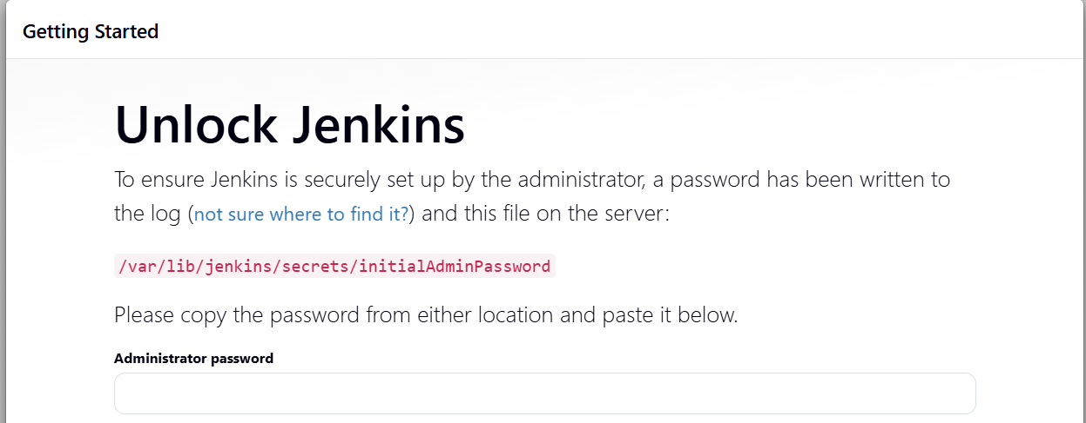
Get initial password:
sudo cat /var/lib/jenkins/secrets/initialAdminPassword

3. Secure Jenkins Server
- Go to Manage Jenkins → Security.
- Enable Jenkins' own user database.
- Disable Allow users to sign up.
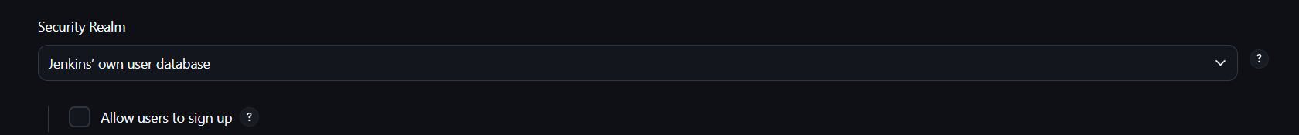
- Select Matrix-based security or Role-Based Authorization.
- Give only required permissions to users.
- Keep Administrator access only for the admin account.
- Save and apply.
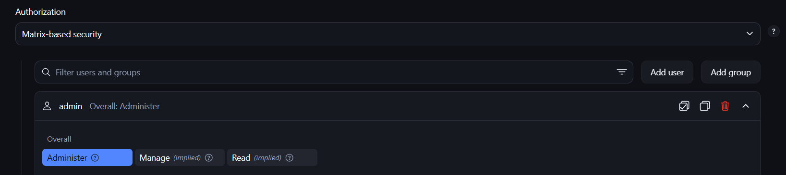

Create DevOps and Testing Users
Go to:
Manage Jenkins → Users → Create User
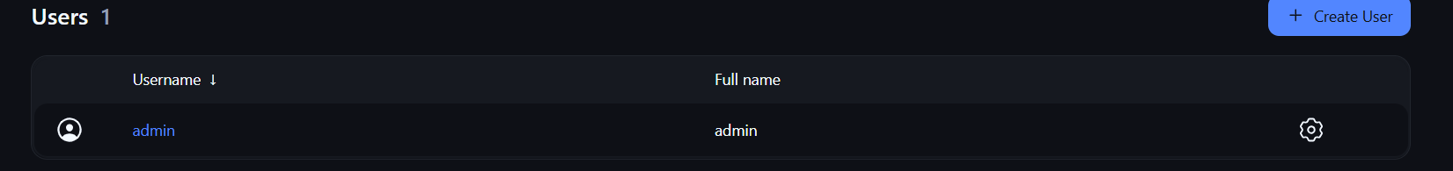
Create:
Username: DevOps
Username: Testing 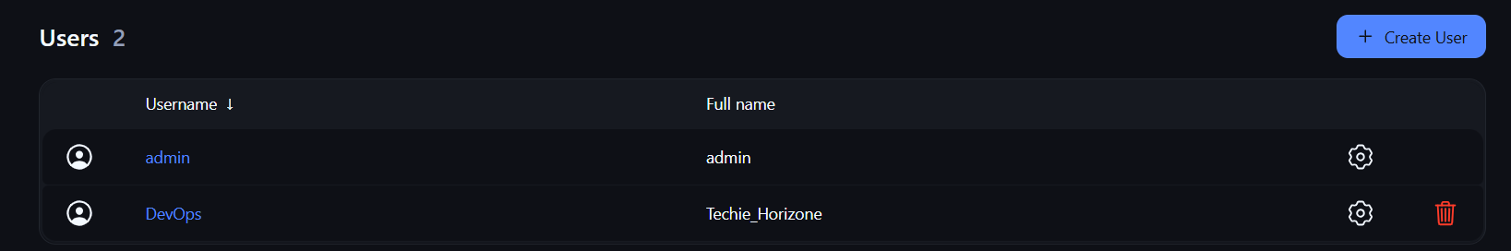
Give them limited permissions.
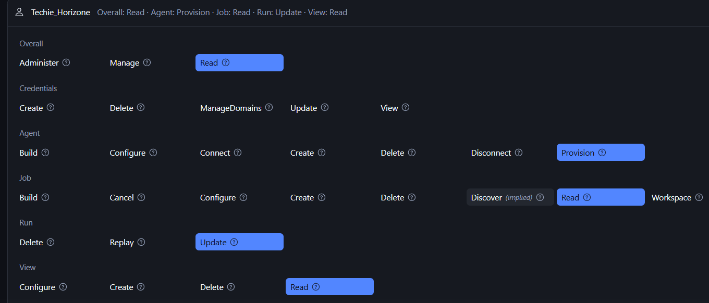

4. Configure labels and restrict the jobs to execute based on label only.
Configure Labels
Go to: Manage Jenkins → Nodes → Built-In Node → Configure
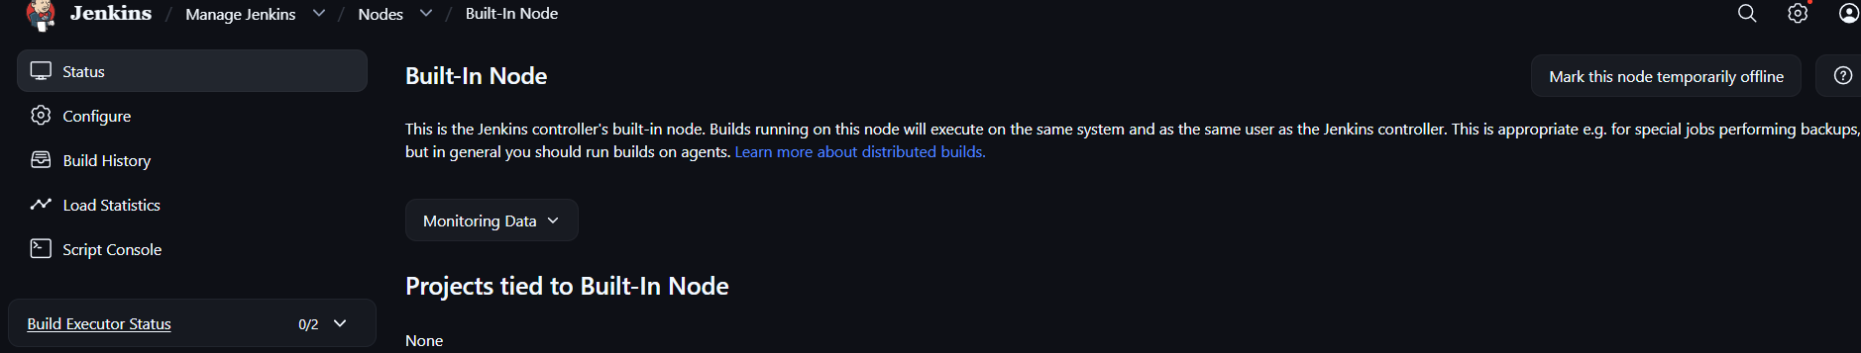
Set:
Labels: linux
Save.
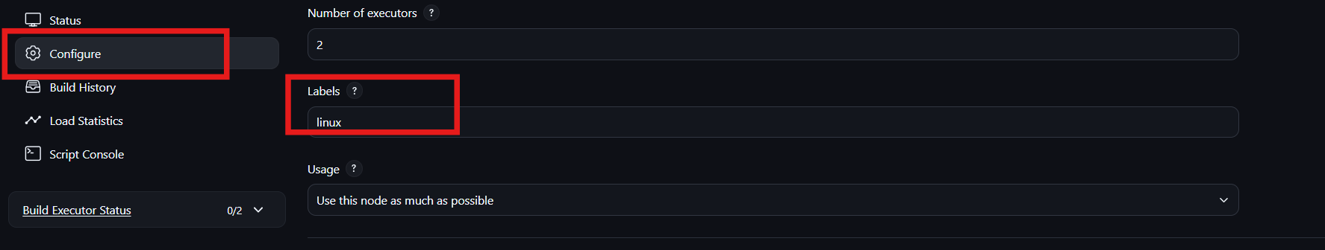
If you have another agent:
Labels: docker
Then jobs can be restricted to a specific node.

5.Create Three sample jobs using the below URL.
- Source Code:https://github.com/betawins/Techie_horizon_Login_app.git
Use the same GitHub source for all three jobs:
Techie_horizon_Login_app
Job 1: Login-App-Checkout
- New Item → Freestyle Project
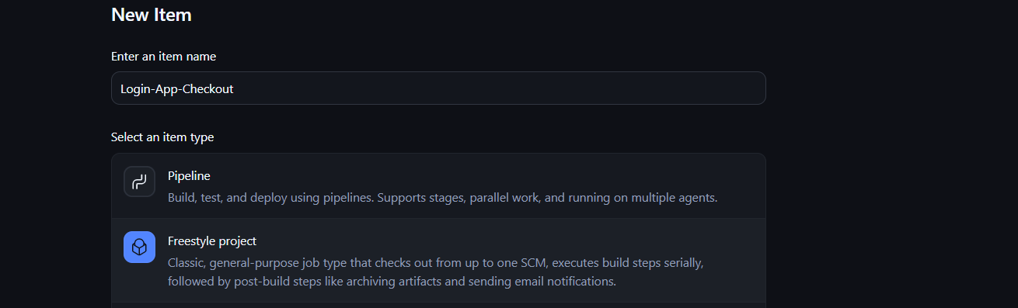
- Source Code Management → Git
- Repository URL → above URL
- Restrict where → linux
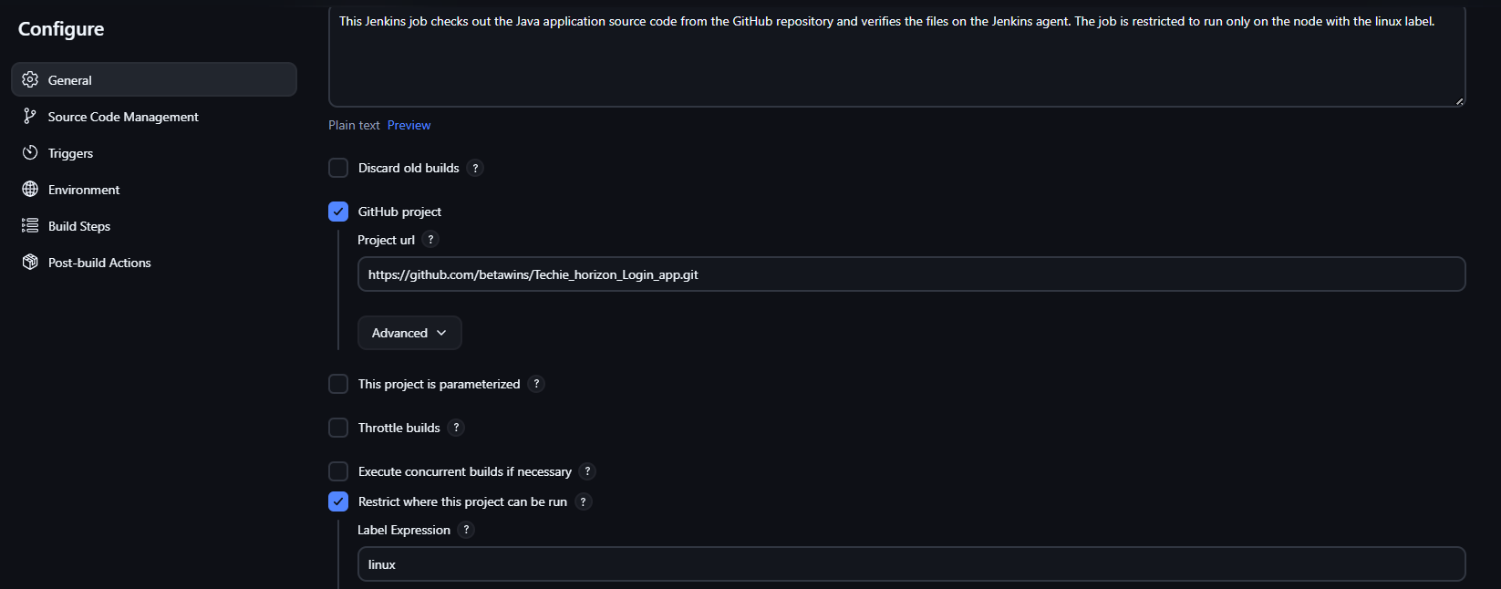
- Build → Execute Shell:
ls -la
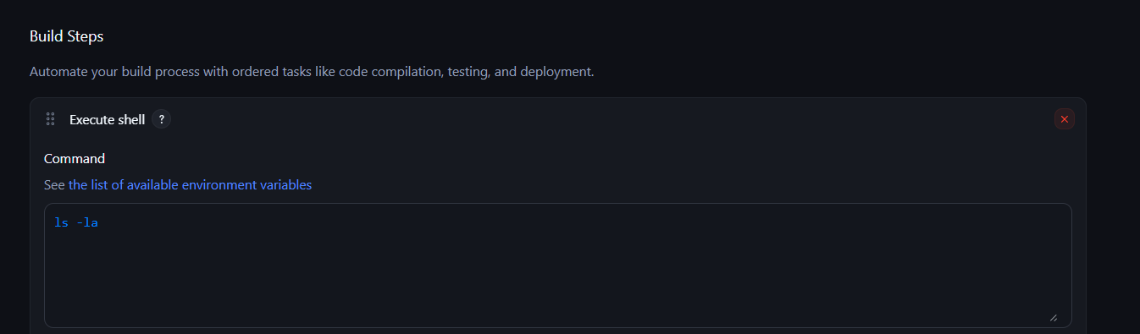
- Save → Build Now

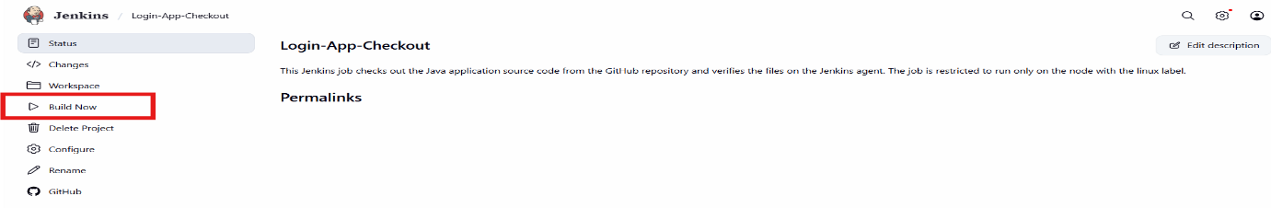
Job 2: Login-App-Build
- Create Freestyle Project
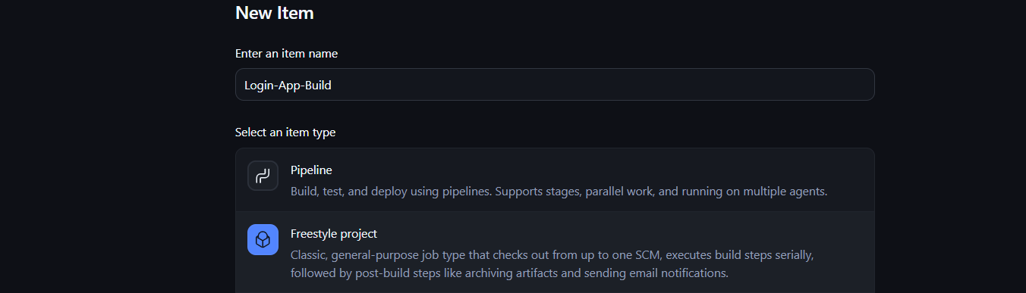
- Git → same repository URL
- Label → linux
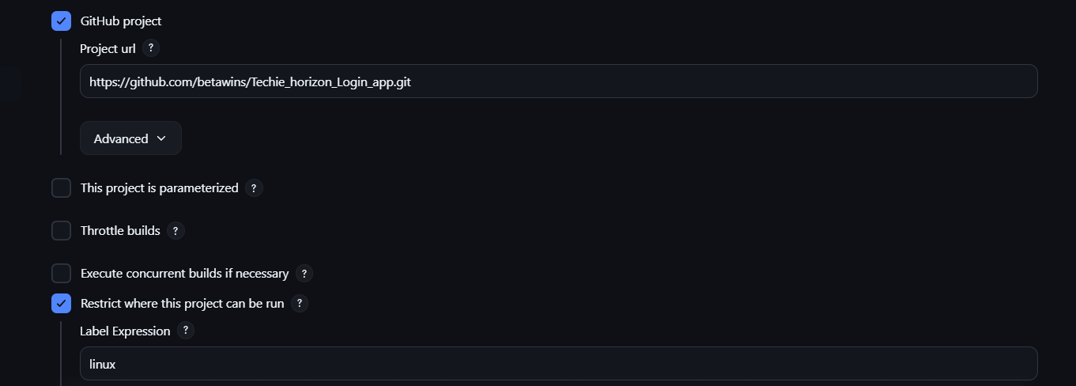
- Build command: echo "Building application"
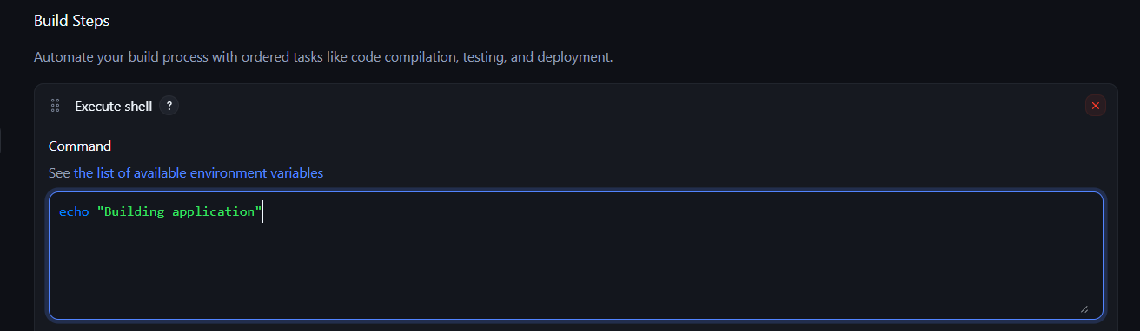
- Save → Build Now
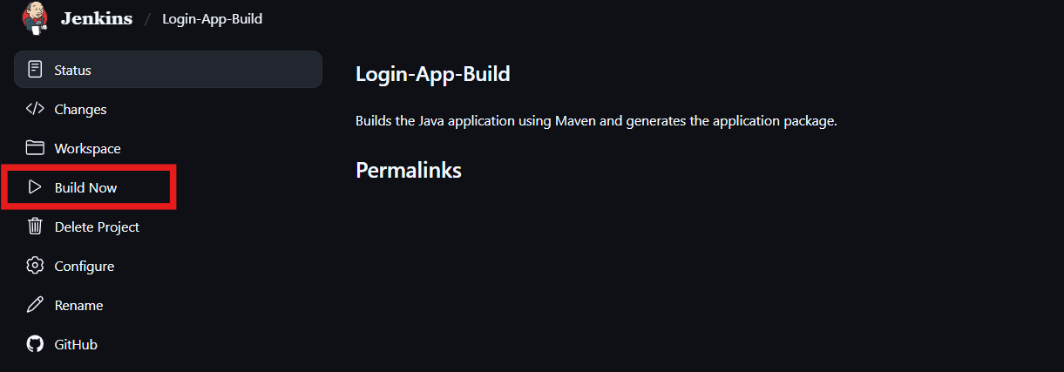
Job 3: Login-App-Test
- Create Freestyle Project
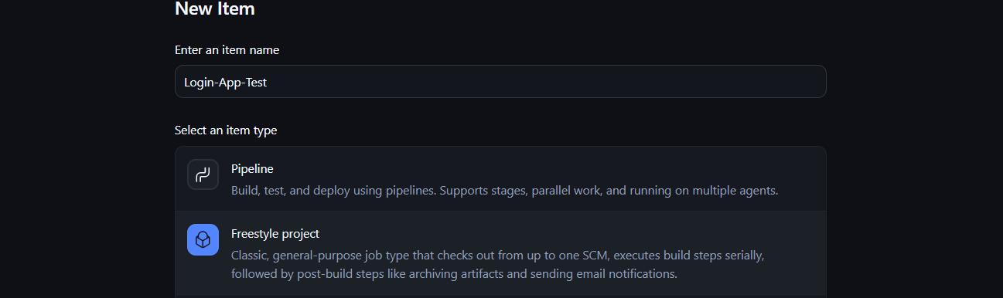
- Git → same repository URL
- Label → linux
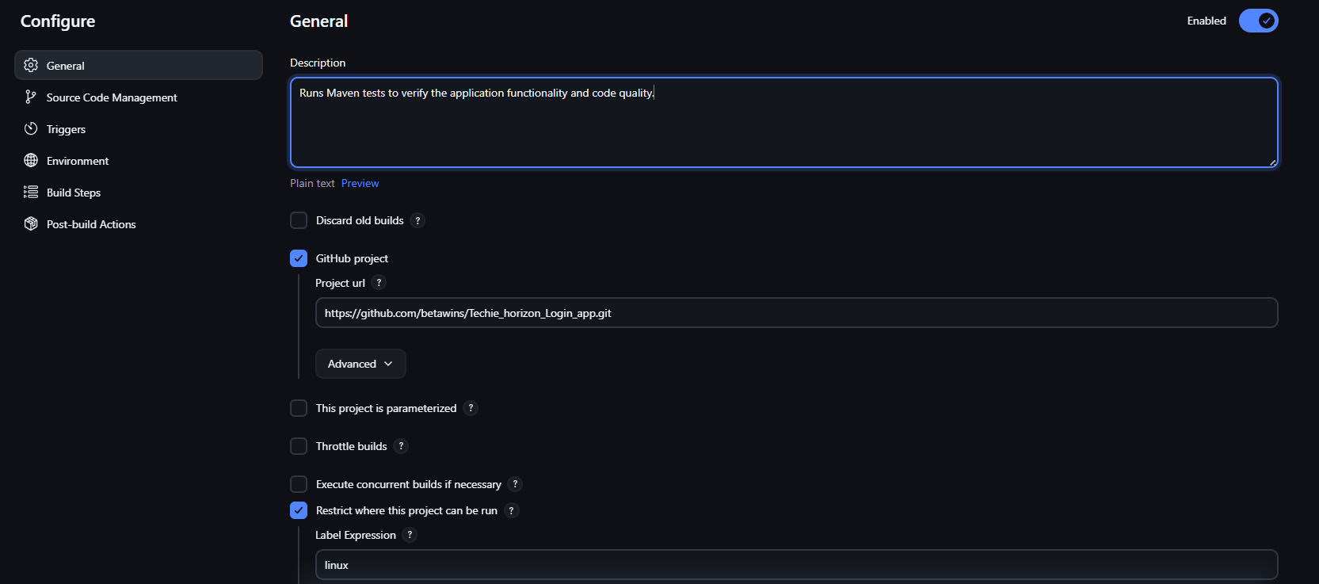
- Build command: echo "Testing application"
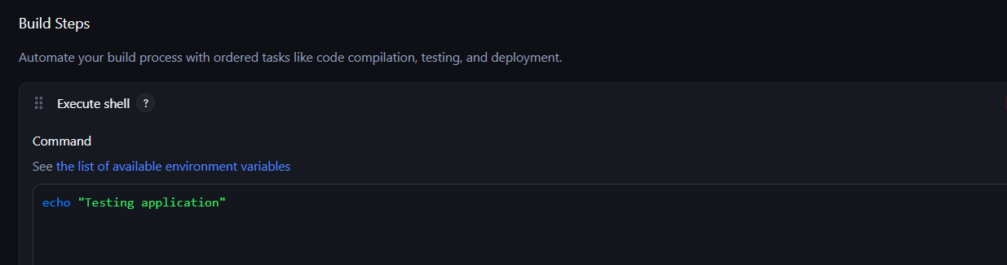
- Save → Build Now
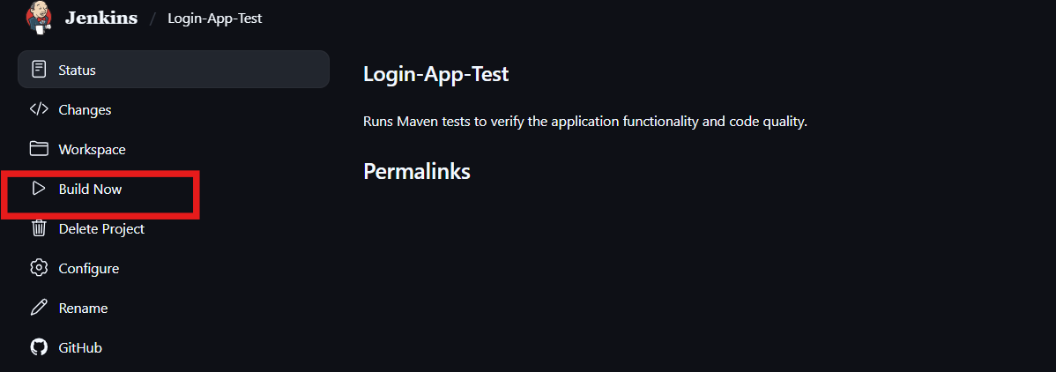
Result: 3 jobs will checkout the same source code and execute only on the linux labeled node.
6. Create one Jenkins job using GitHub Private repository.
Jenkins Job Using GitHub Private Repository
GitHub: Create a Private Repository and add your source code.
- Create GitHub PAT:
GitHub → Settings → Developer settings → Personal access tokens → Generate token.
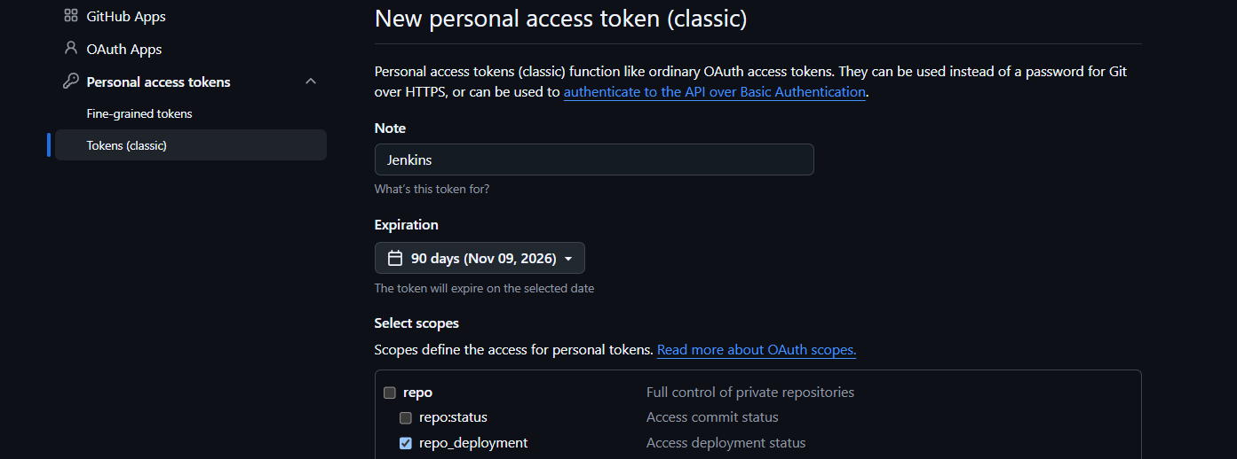
- Add credentials in Jenkins:
Manage Jenkins → Credentials → System → Global credentials → Add Credentials
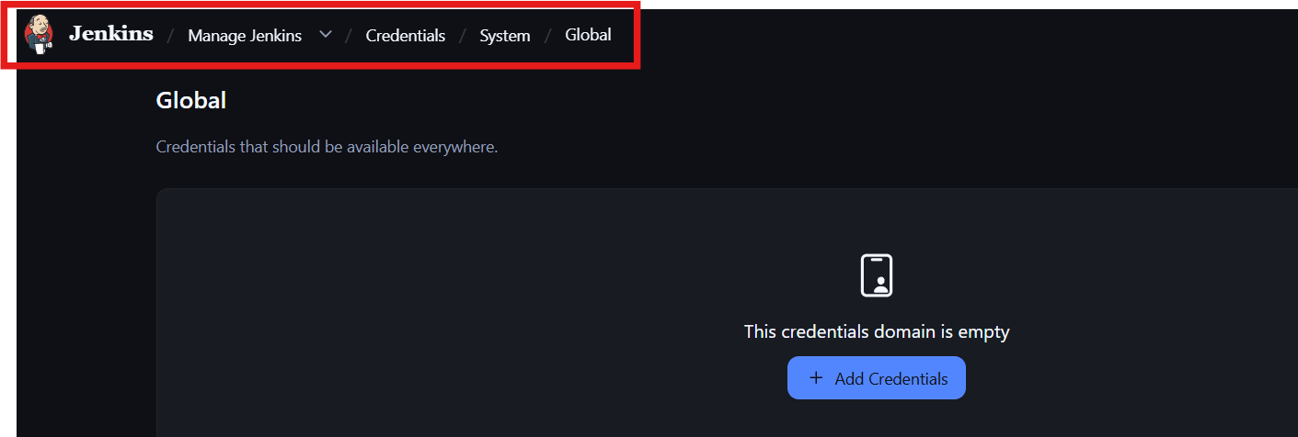
  - Kind: Username with password
  - Username: GitHub username
  - Password: GitHub PAT
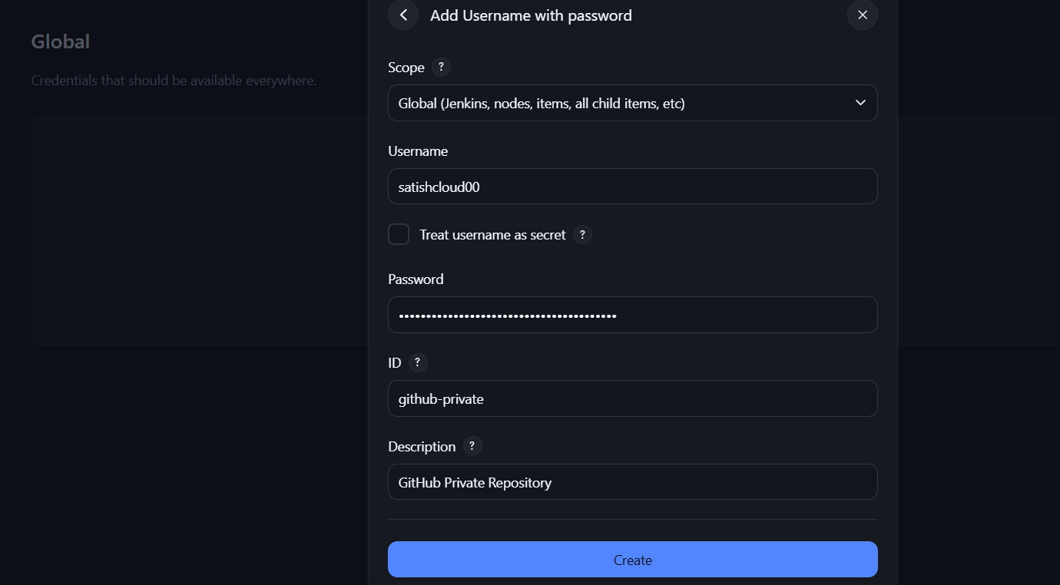
  - ID: github-private

- Create Job:
New Item → Private-GitHub-Job → Freestyle Project
- Configure Git:
  - Source Code Management → Git
  - Repository URL:
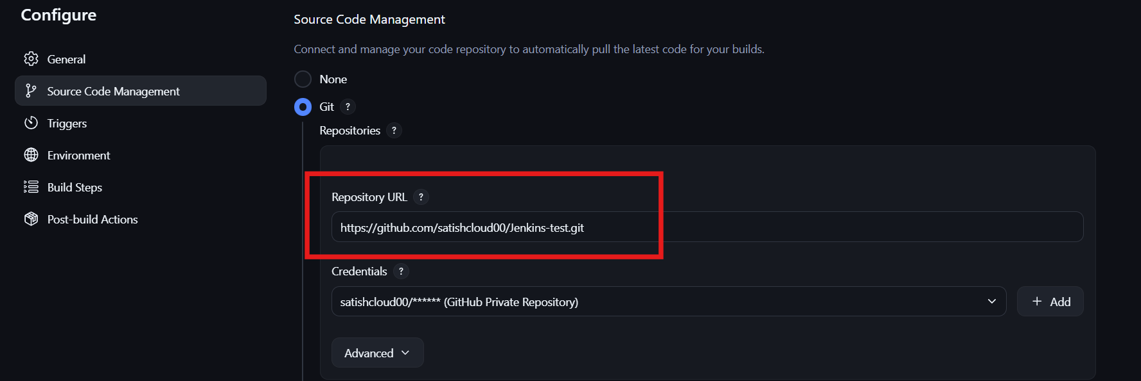
https://github.com/<username>/<private-repo>.git
Credentials: github-private
- Restrict to label: linux
- Build → Execute Shell: echo "Private repository checkout successful"
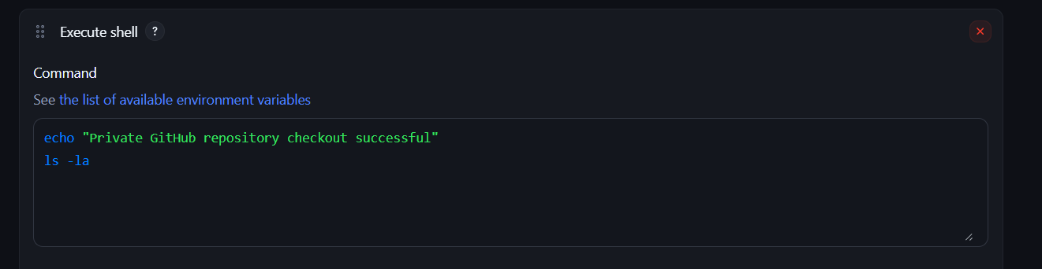
ls -la

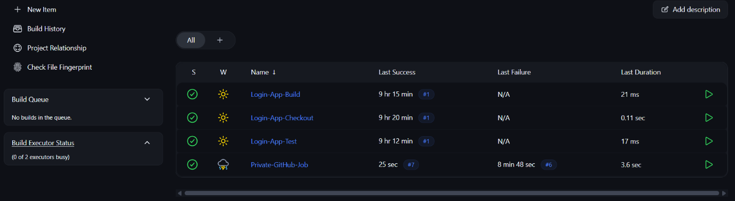
- Save → Build Now

✅ Successful, Jenkins has successfully accessed the private GitHub repository.

