1) Setup Jenkins CICD pipeline using freestyle job using Docker containers using below code.
Source Code: https://github.com/betawins/hiring-app.git
Stages:
- Git Clone
- SonarQube Integration
- Maven Compilation
- Nexus Artifactory
- Slack Notification
- Deploy On tomcat
Jenkins CI/CD Flow
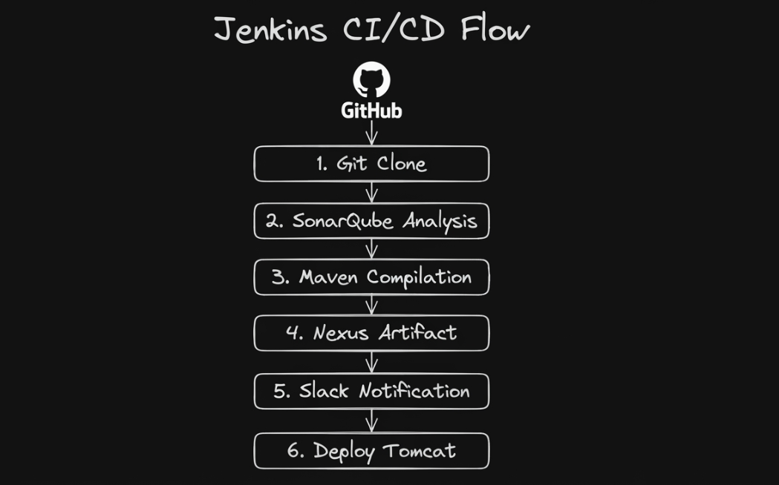

Prerequisites
- AWS Account
- Jenkins EC2
- SonarQube + Nexus EC2
- Tomcat EC2
- GitHub repository
- Slack workspace/channel
- Security Groups
- Java
- Git
- Docker

Jenkins CI/CD Pipeline Using Freestyle Job & Docker
Step 1 — Create Jenkins EC2
Purpose: Create the Jenkins server to manage the CI/CD pipeline.
AWS → EC2 → Launch Instance
Name: Jenkins-Server
AMI: Amazon Linux 2023
Instance: t3.small
Security Group: SSH 22 → Your IP
Jenkins 8080 → Your IP
Connect:
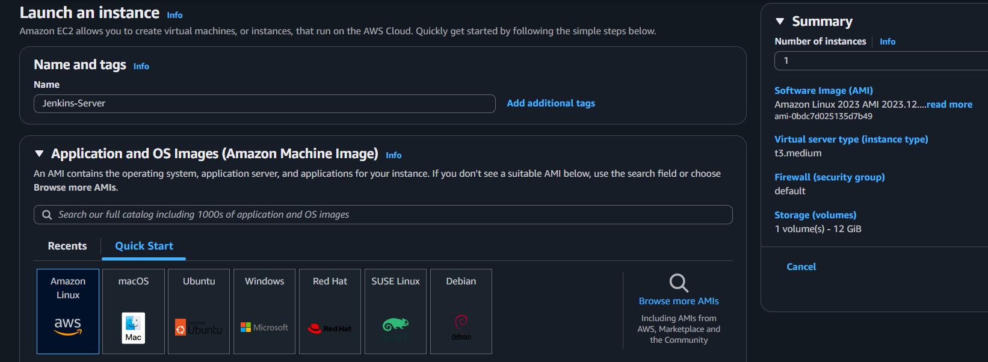
Step 2 — Install Java, Git & Docker
Purpose: Install the tools required to run Jenkins and Docker-based builds.
sudo dnf update -y
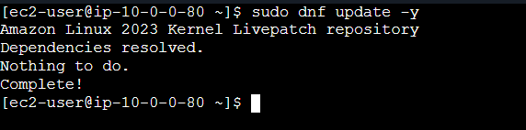
sudo dnf install -y git java-21-amazon-corretto docker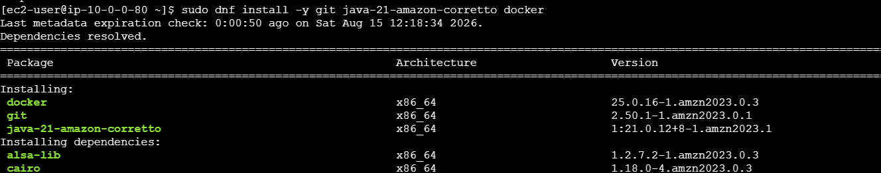
sudo systemctl enable --now docker
sudo usermod -aG docker Jenkins

  - Step 3 — Install Jenkins
Purpose: Install Jenkins to automate the CI/CD process.
sudo wget -O /etc/yum.repos.d/jenkins.repo \
https://pkg.jenkins.io/redhat-stable/jenkins.repo

sudo rpm --import \
https://pkg.jenkins.io/redhat-stable/jenkins.io-2026.key

sudo dnf install -y jenkins
sudo systemctl enable --now jenkins
Get password:
sudo cat /var/lib/jenkins/secrets/initialAdminPassword

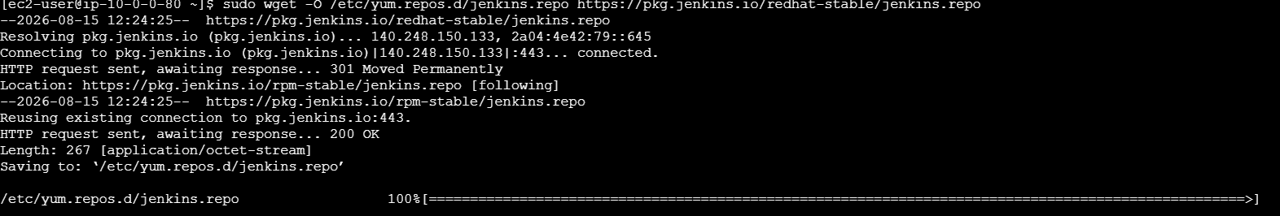
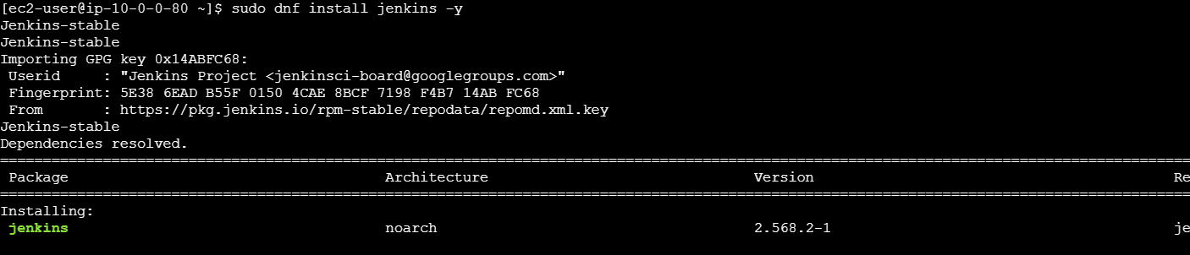

Open:
http://<JENKINS-IP>:8080
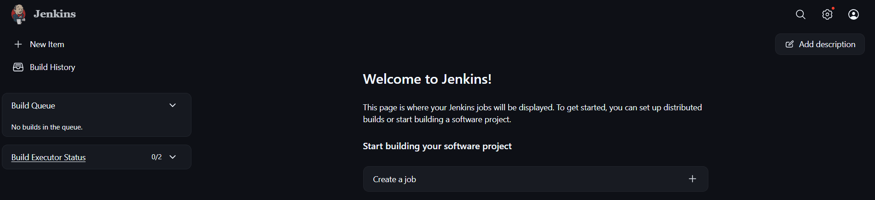

Step 4 — Verify Jenkins & Docker
Purpose: Confirm Jenkins and Docker are working correctly.
java -version
git --version
docker --version 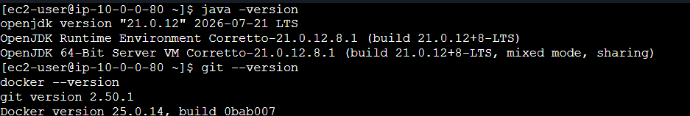
sudo systemctl status jenkins 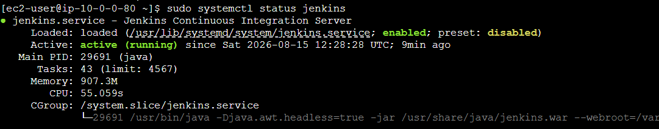
Verify Jenkins can use Docker:
sudo systemctl restart jenkins
sudo -u jenkins docker ps
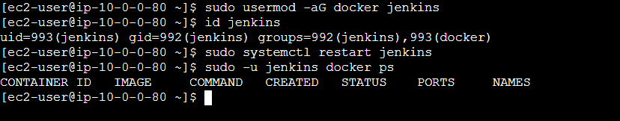

Step 5 — Create Freestyle Job

Purpose: Create the Jenkins job that contains the complete CI/CD flow.

Jenkins → New Item → Freestyle Project

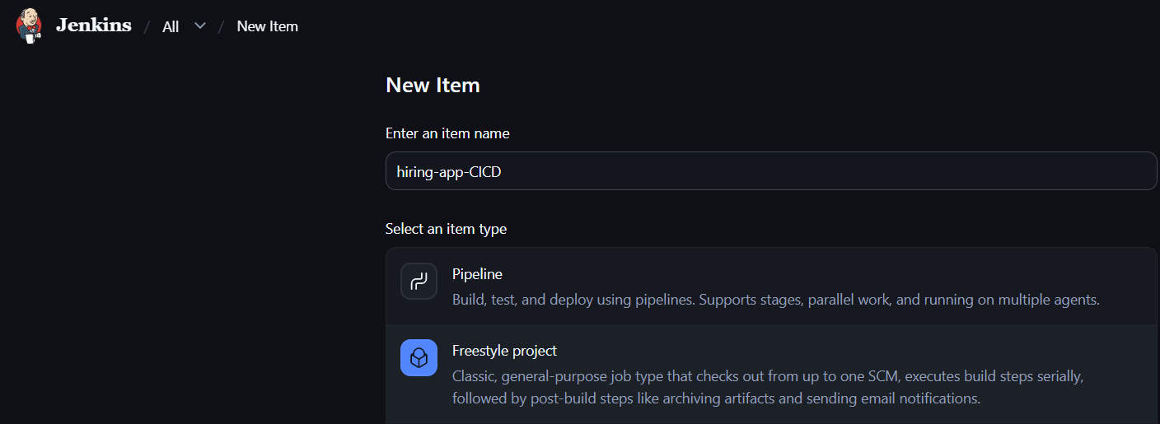
Name: hiring-app-CICD

Step 6 — Git Clone
Purpose: Pull the application source code from GitHub.
Job → Configure → Source Code Management → Git
Repository:
https://github.com/betawins/hiring-app.git
Branch: */main
Build Now → Console Output
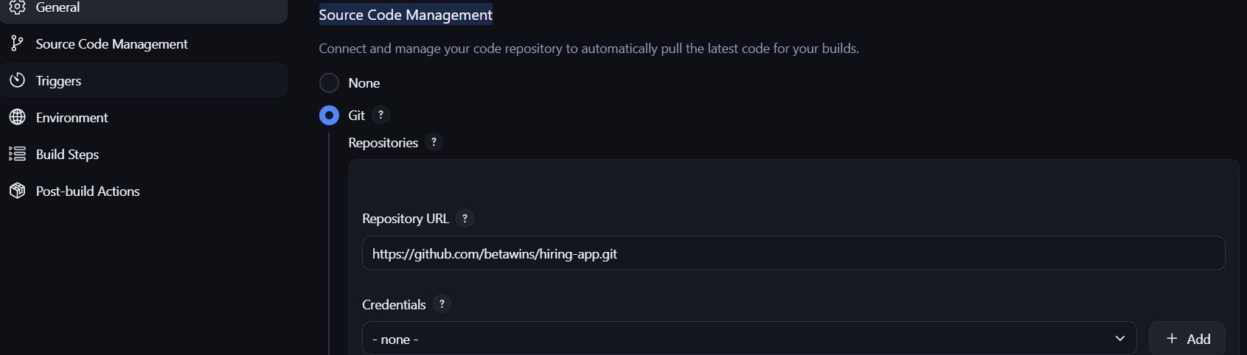

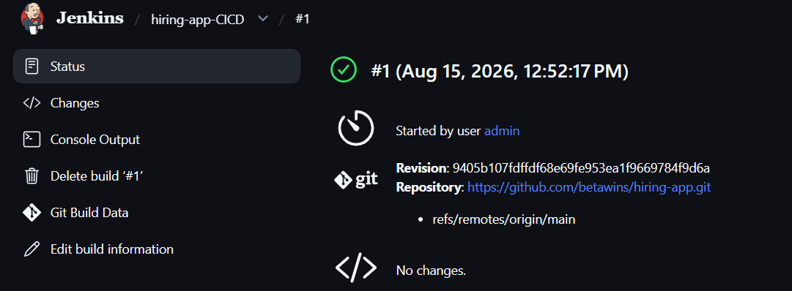

Install SonarQube
Purpose: Set up SonarQube for code-quality analysis.
On the SonarQube EC2:
sudo dnf install -y java-21-amazon-corretto wget unzip
sudo -u sonar /opt/sonarqube/bin/linux-x86-64/sonar.sh start
sudo -u sonar /opt/sonarqube/bin/linux-x86-64/sonar.sh status
Access: http://<SONARQUBE-PRIVATE-IP>:9000
Note: Use 20 GB+ storage and preferably 4 GB+ RAM for the SonarQube server.
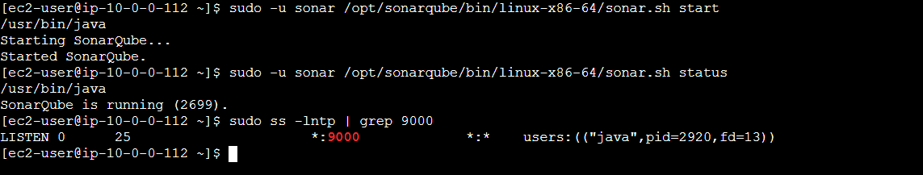
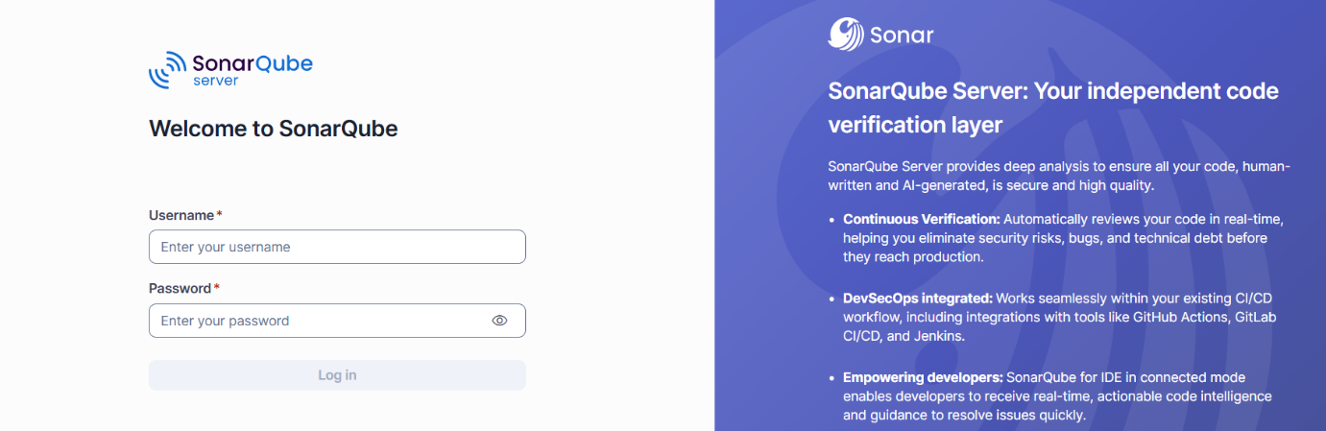

Step 7 — SonarQube Integration
Purpose: Perform code-quality and security analysis.
Manage Jenkins → Plugins → Install:
SonarQube Scanner
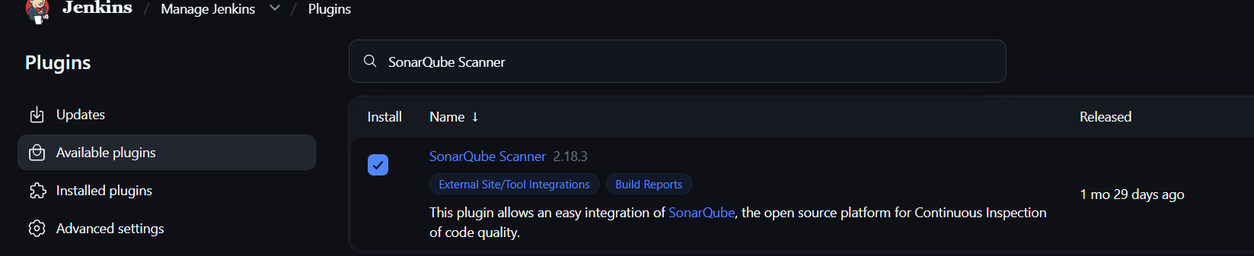

Manage Jenkins → System → SonarQube Servers
Name: SonarQube
URL: http://<SONARQUBE-IP>:9000
Add SonarQube token under:
Manage Jenkins → Credentials
Configure SonarQube analysis in the job. 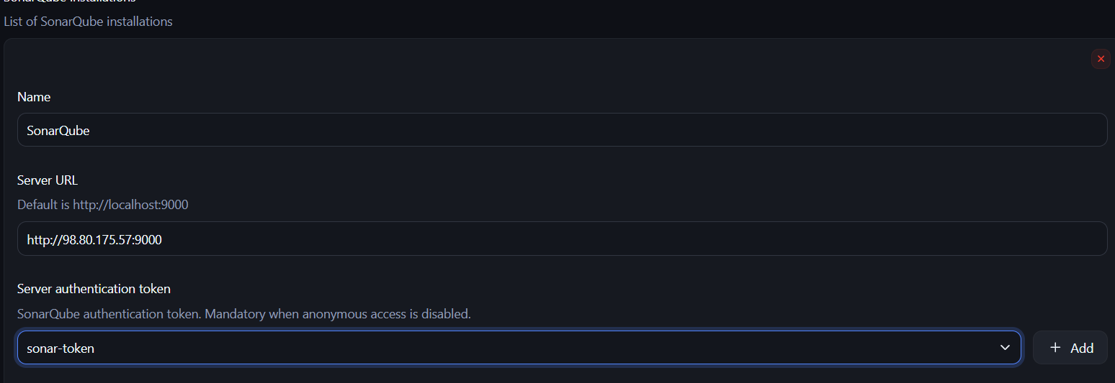
Step 8 — Maven Compilation Using Docker
Purpose: Build the Java application inside a Docker Maven container.
Job → Configure → Build Steps → Execute Shell
docker run --rm \
-v "$WORKSPACE:/workspace" \
-w /workspace \
maven:3.9-eclipse-temurin-8 \
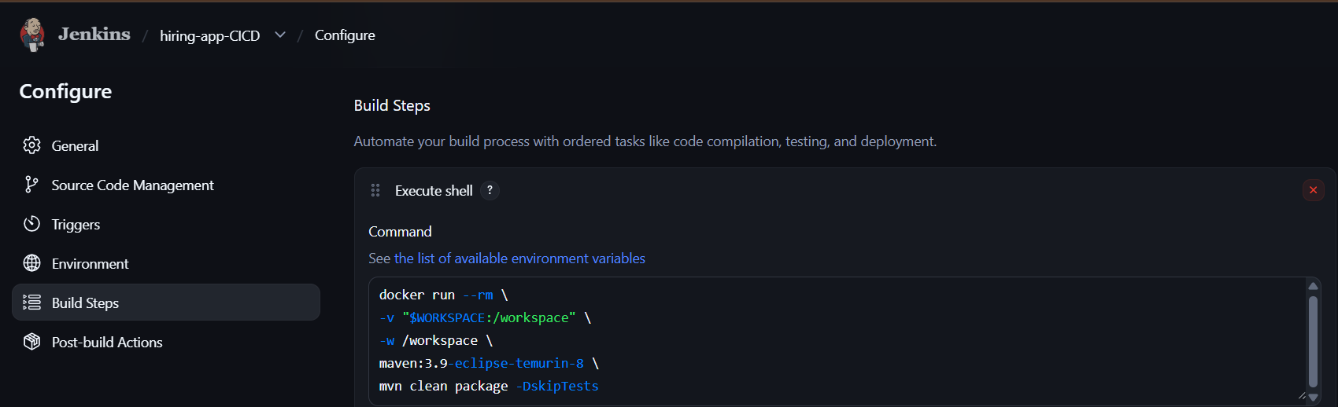
mvn clean package -DskipTests

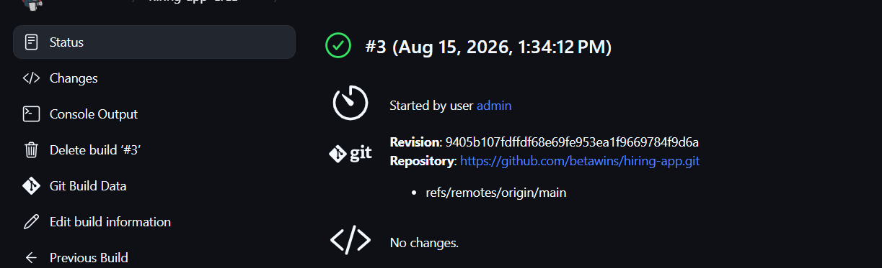
Verify: BUILD SUCCESS

Check: ls -lh target/*.war
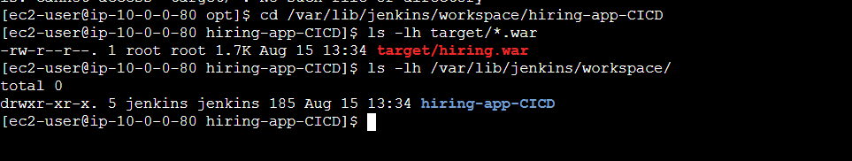

  - Step 9: Prerequisites for Nexus Artifactory
Create Nexus EC2
For a small lab:
Name: Nexus-Server
AMI: Amazon Linux 2023
Instance: t3. medium
Storage: 20 GB+
Security Group:
SSH 22 → Your IP
Nexus 8081 → Jenkins Security Group

Nexus server, let's install it.
Step 1 — Install Java
sudo dnf install -y java-21-amazon-corretto wget tar
Verify:
java -version
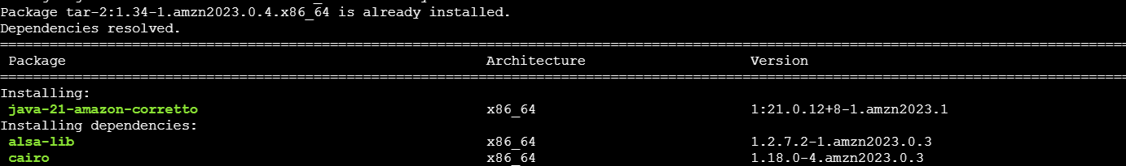

Step 2 — Download Nexus
cd /opt
sudo wget https://download.sonatype.com/nexus/3/nexus-3.78.1-01-linux-x86_64.tar.gz
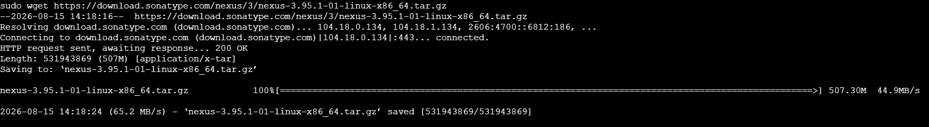
Extract:
sudo tar -xzf nexus-3.78.1-01-linux-x86_64.tar.gz
Rename:
sudo mv nexus-3.78.1-01 nexus
Step 3 — Create Nexus User
sudo useradd -r -m -d /opt/nexus -s /bin/bash nexus
Set ownership:
sudo chown -R nexus:nexus /opt/nexus
Step 4 — Start Nexus
sudo -u nexus /opt/nexus/bin/nexus start
Check:
sudo -u nexus /opt/nexus/bin/nexus status
Then:
sudo ss -lntp | grep 8081
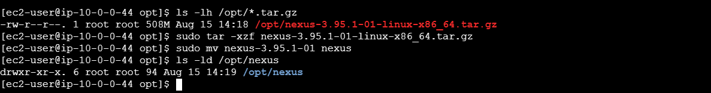
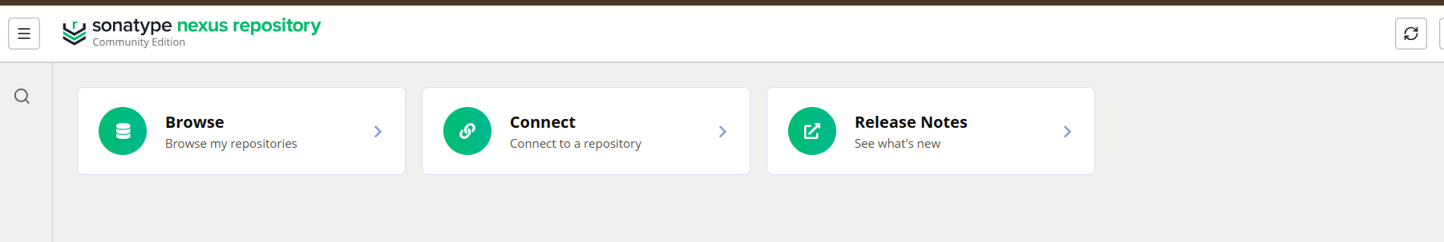

Nexus Artifactory
Create Nexus repository:
Repositories
→ Create Repository
→ maven2 (hosted)
→ maven-releases

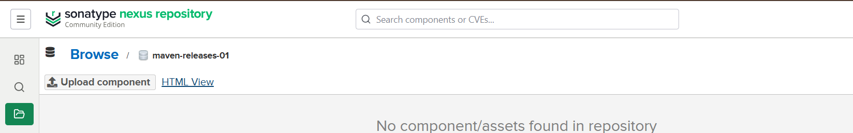

Add Nexus credentials to Jenkins.
Go to:
Jenkins → Manage Jenkins → Credentials → System → Global credentials → Add Credentials
Select:
Kind: Username with password
Username: admin
Password: <Nexus password>
ID: nexus-credentials
Description: Nexus Credentials
Click Create.
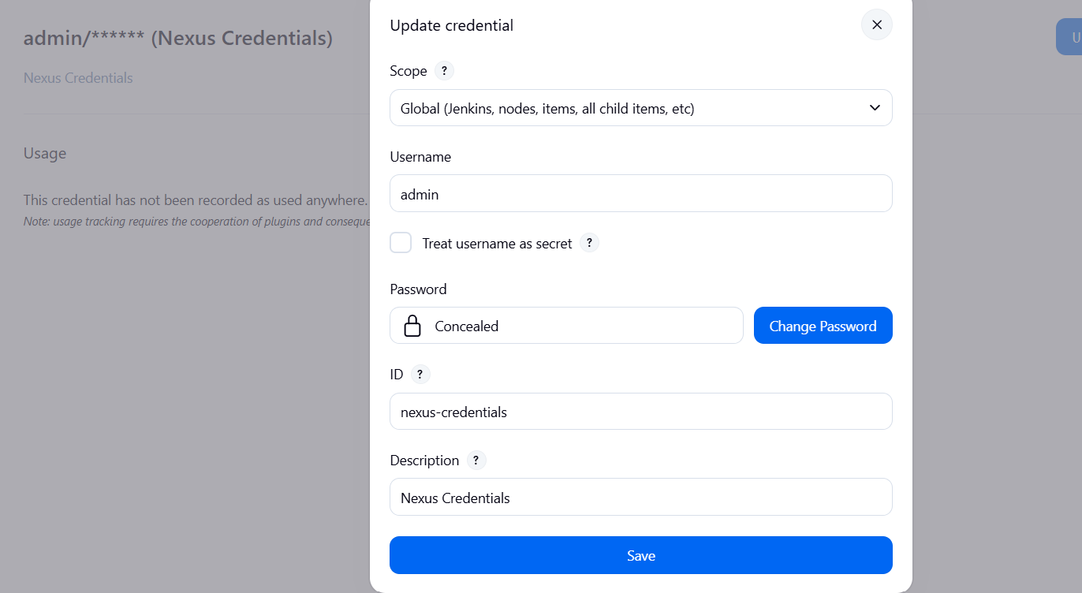

Configure Maven distributionManagement for Nexus.
Deploy:
docker run --rm \
-v "$WORKSPACE:/workspace" \
-w /workspace \
maven:3.9-eclipse-temurin-8 \
mvn deploy -DskipTests

Verify the .war appears in Nexus.
Step 1 — Create Maven credentials
mkdir -p ~/.m2
vi ~/.m2/settings.xml
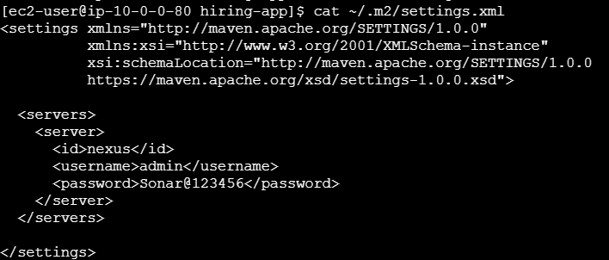
Save: Esc → :wq → Enter
Step 2 — Deploy
cd ~/hiring-app
mvn deploy -DskipTests
Expected:
BUILD SUCCESS
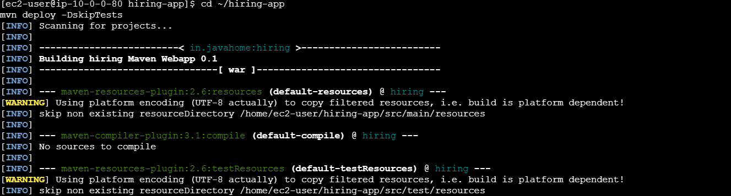

Step 3 — Verify Nexus
Nexus → maven-releases → hiring → 0.2 → hiring-0.2.war
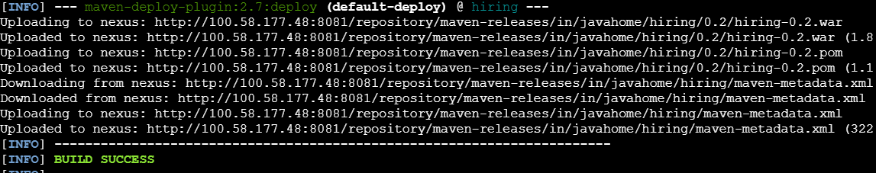
mvn deploy -DskipTests

Step 10 — Slack Notification
Manage Jenkins → Plugins
Install: Slack Notification
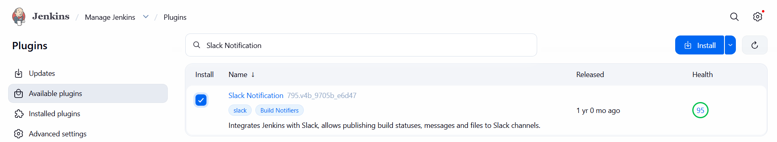
Configure:
Manage Jenkins → System → Slack
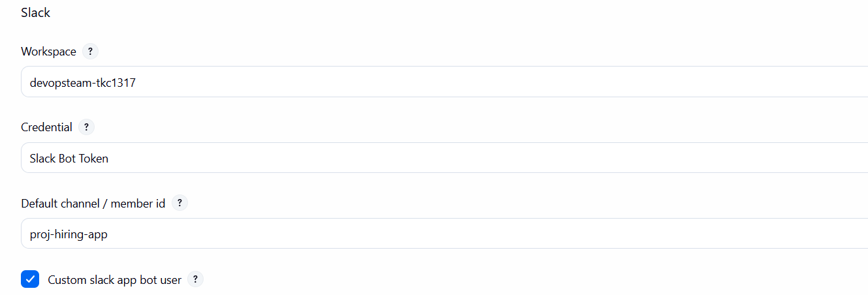
Then:
Job → Configure → Post-build Actions → Slack Notifications
Enable:
Success
Failure
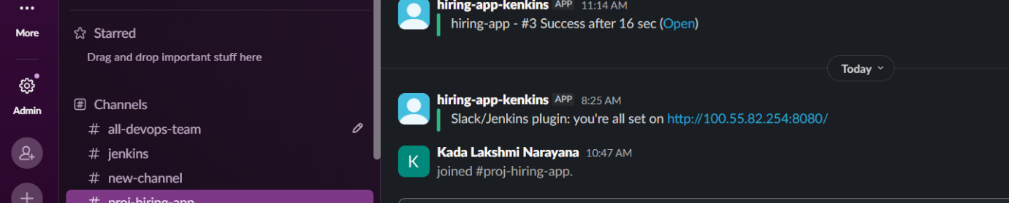
Verify: Jenkins notification appears in Slack.

Step 11 — Deploy on Tomcat
Prerequisites: Tomcat EC2
- Amazon Linux
- Java installed
- Tomcat installed
- Tomcat running on 8080
- SSH port 22 accessible from Jenkins
- Security Group allows 8080

1. Install Java
sudo dnf install java-17-amazon-corretto -y
2. Install Tomcat
sudo useradd -r -m -U tomcat
cd /tmp
wget https://dlcdn.apache.org/tomcat/tomcat-10/v10.1.46/bin/apache-tomcat-10.1.46.tar.gz
sudo tar -xzf apache-tomcat-10.1.46.tar.gz -C /opt
sudo mv /opt/apache-tomcat-10.1.46 /opt/tomcat
sudo chown -R tomcat:tomcat /opt/tomcat
3. Start Tomcat
sudo -u tomcat /opt/tomcat/bin/startup.sh
Verify:
http://TOMCAT-IP:8080
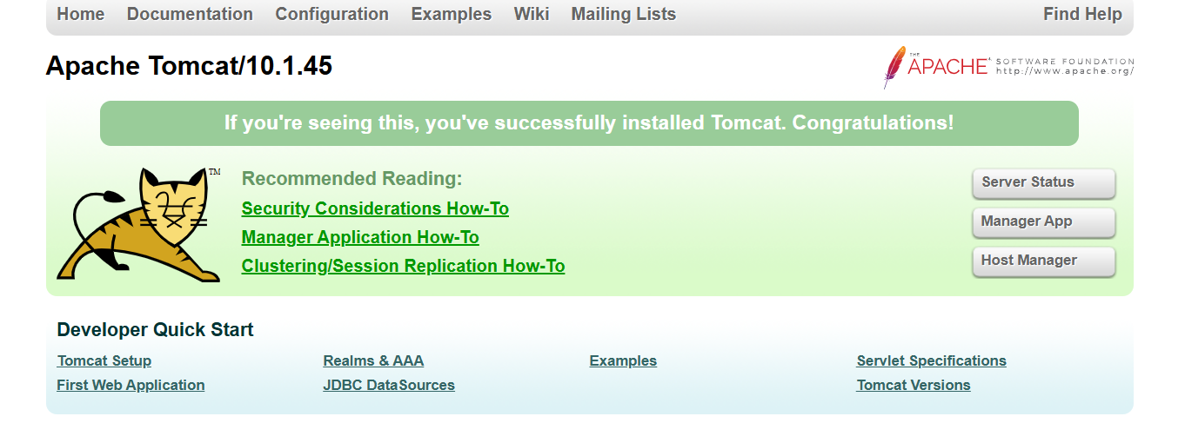

Configure Tomcat SSH credentials in Jenkins.
Tomcat deployment step
1. Configure Tomcat SSH credential in Jenkins
You already have this configured, so keep it.
Your Jenkins credential should contain:
- Kind: SSH Username with private key
- Username: ec2-user
- Private Key: Tomcat EC2 SSH private key

2. Deploy WAR to Tomcat
If you are deploying the Jenkins-built WAR directly:
scp target/*.war ec2-user@<TOMCAT-IP>:/tmp/
Then:
ssh ec2-user@<TOMCAT-IP> \
"sudo rm -rf /opt/tomcat/webapps/hiring /opt/tomcat/webapps/hiring.war && \
sudo cp /tmp/*.war /opt/tomcat/webapps/hiring.war && \
sudo chown tomcat:tomcat /opt/tomcat/webapps/hiring.war"
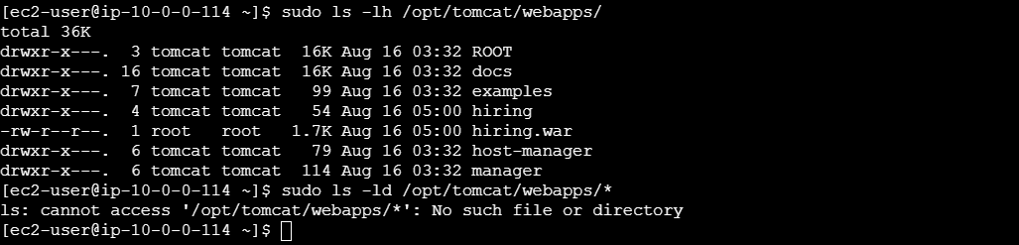
3. Restart Tomcat
ssh ec2-user@<TOMCAT-IP> \
"sudo systemctl restart tomcat"
4. Verify Tomcat
ssh ec2-user@<TOMCAT-IP> \
"sudo systemctl is-active tomcat"
You should get: active
Then: url http://<TOMCAT-IP>:8080/hiring/
You should see: Welcome to Techie Horizon
And from your browser:
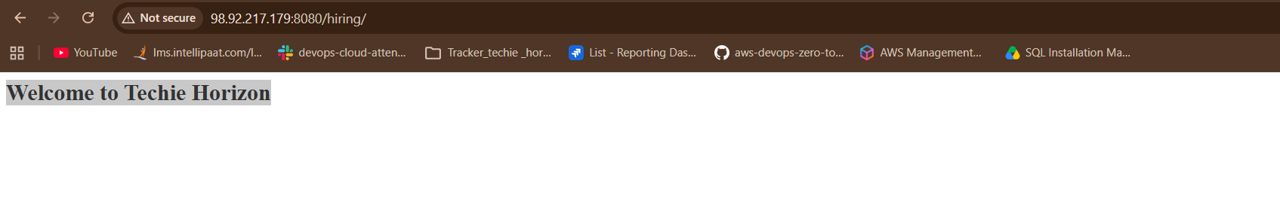
http://98.92.217.179:8080/hiring/

2) Setup a Jenkins CICD pipeline using Declarative pipeline using feature-1.1
branch.
Source Code: https://github.com/betawins/sabear_simplecutomerapp/tree/feature-1.1
stages:
- Git Clone
- SonarQube Integration
- Maven Compilation
- Nexus Artifactory
- Slack Notification
- Deploy On tomcat

Step 1 — Install Jenkins plugins
Go to:
Jenkins → Manage Jenkins → Plugins → Available plugins
Search and install:
1. Pipeline
2. Git
3. SonarQube Scanner for Jenkins
4. SSH Agent
5. Slack Notification
Click Install.
If a plugin is already installed, do not install it again.
The SSH Agent plugin requires the ssh-agent executable on the Jenkins agent that executes the pipeline.
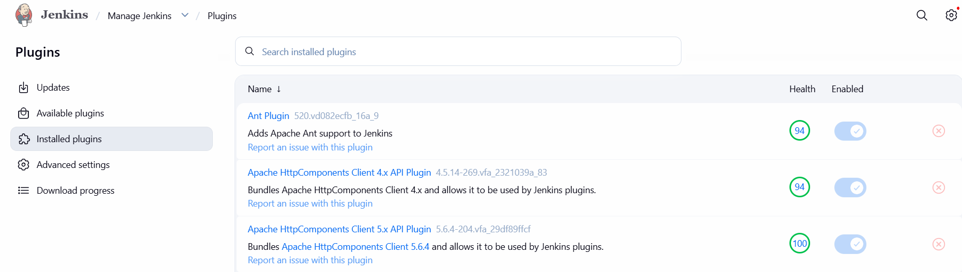

Step 2 — Configure Maven
Go to:
Manage Jenkins → Tools → Maven installations
Click:
Add Maven
Name: Maven-3.9
Install automatically: ✓
Click Save.
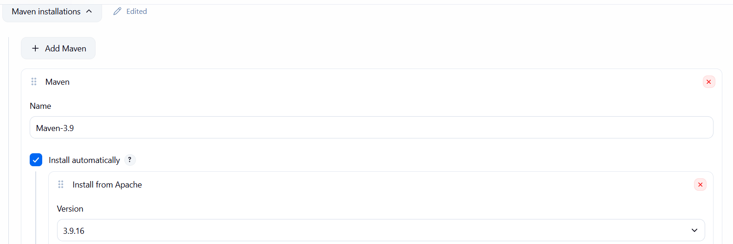

Step 3 — Configure SonarQube
Go to:
Manage Jenkins → System → SonarQube servers
Click:
Add SonarQube
Enter:
Name: SonarQube
Server URL: http://<SONARQUBE-IP>:9000
Select your existing SonarQube credential/token.
Click Save.
The name SonarQube must exactly match the name used in the Pipeline's withSonarQubeEnv('SonarQube').
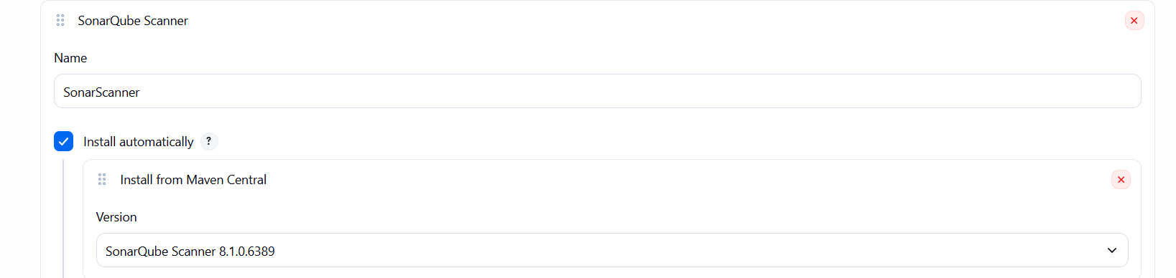

Step 4 — Verify Jenkins credentials
Go to:
Manage Jenkins → Credentials → Global
Make sure your existing credentials are present:
✓ Nexus credential
✓ Tomcat SSH credential
For Tomcat, note the Credential ID.
Example:
tomcat-ssh
The SSH Agent Pipeline step uses this credential ID.
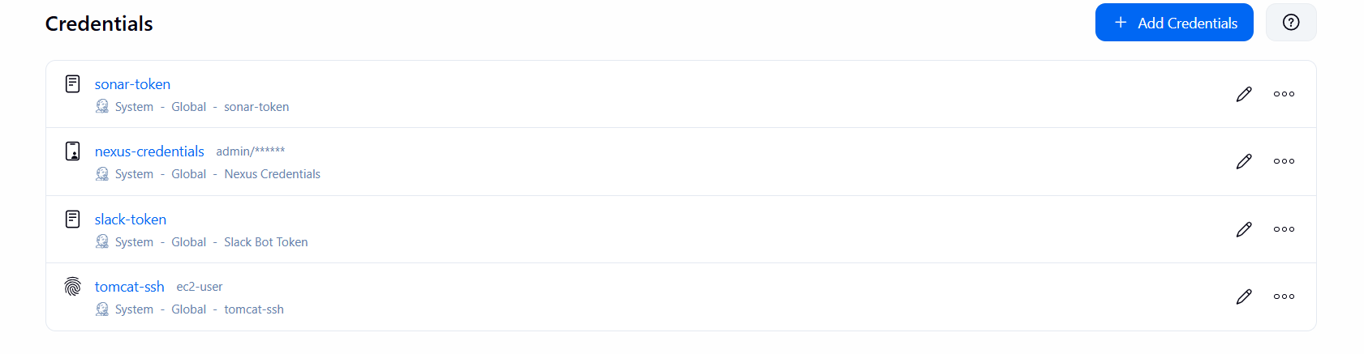

Step 5 — Verify Slack
Go to:
Manage Jenkins → System
Find:
Slack Notifications
Configure your existing Slack workspace/channel.
Example:
Channel: #jenkins
Save.
The Pipeline can then use slackSend. 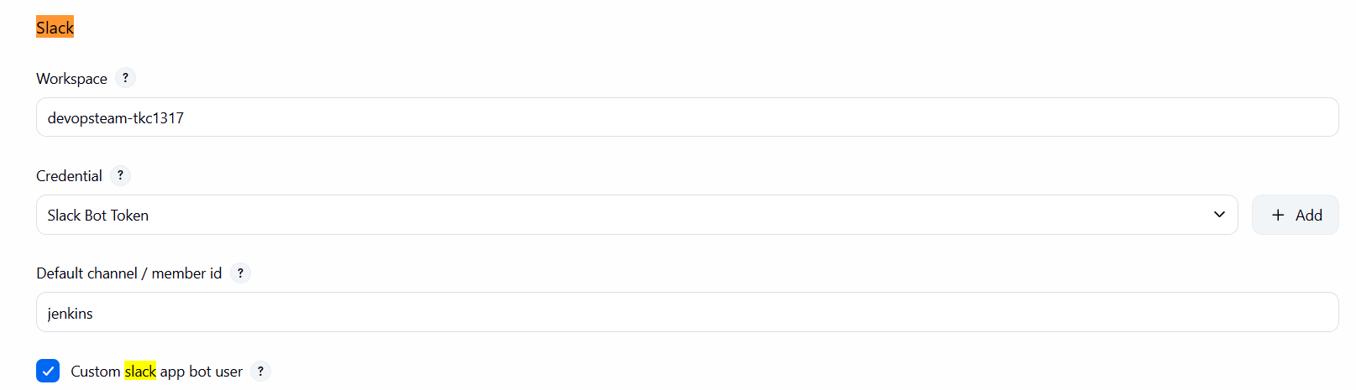

Step 6 — Create the new Jenkins job
Go to:
Jenkins Dashboard → New Item
Enter:
sabear-simplecustomerapp-CICD
Select:
Pipeline
Click OK.
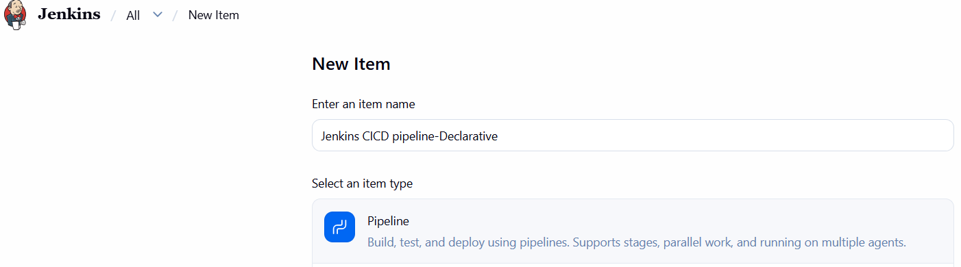
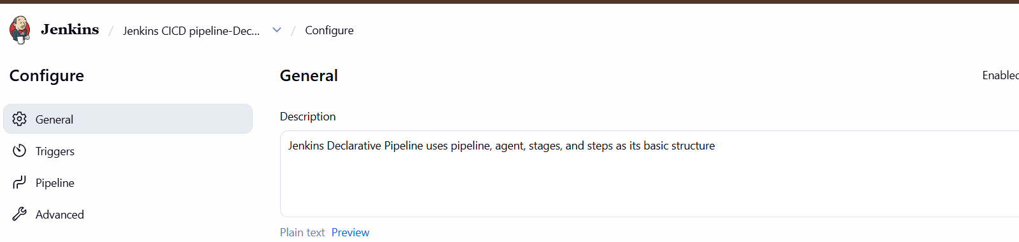

Step 7 — Pipeline configuration
Scroll to Pipeline.
Select:
Definition: Pipeline script
Paste the following Jenkinsfile.
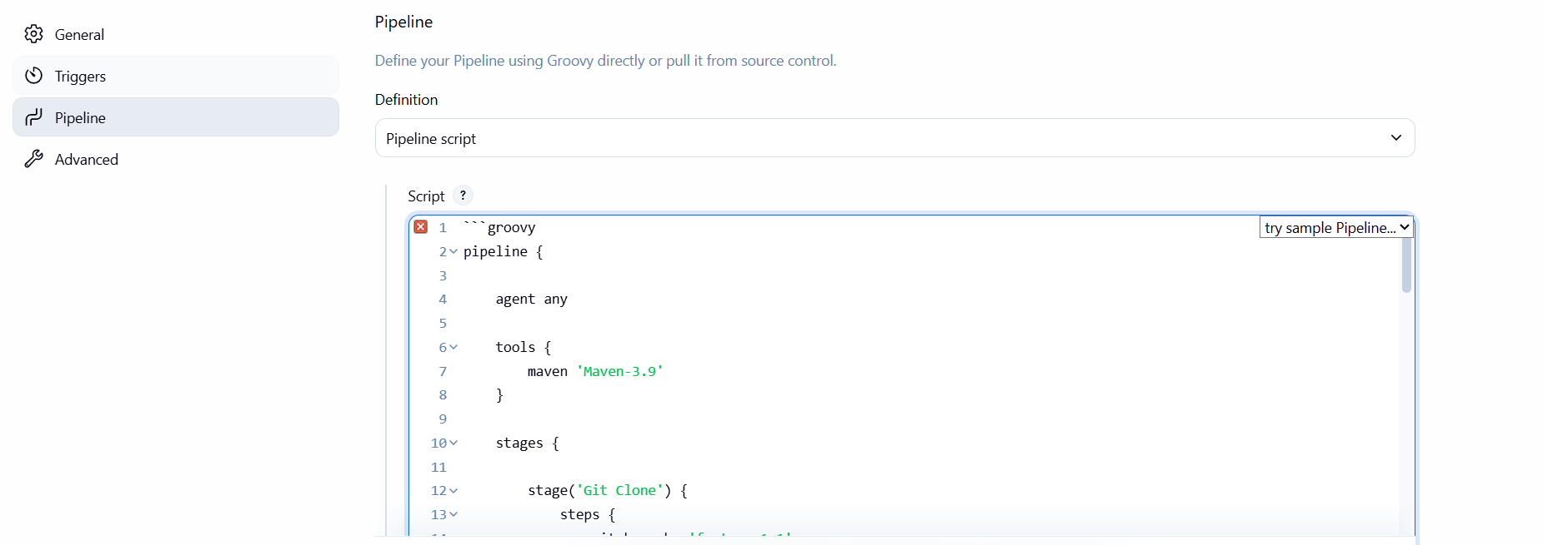
Step 4 — Configure SonarQube server
Go to:
Manage Jenkins → System
Find:
SonarQube servers
Click Add SonarQube.
Enter:
Name: SonarQube
Server URL: http://YOUR-SONARQUBE-IP:9000
Select your existing SonarQube credential.
Click Save.
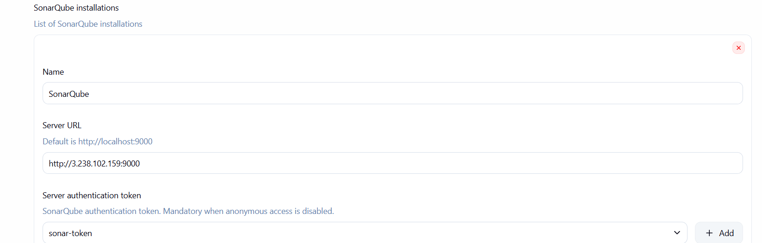
Step 5 — Check Tomcat credential
Go to:
Manage Jenkins → Credentials → Global
Find your existing Tomcat SSH credential.
Example:
ID: tomcat-ssh
Remember this ID.
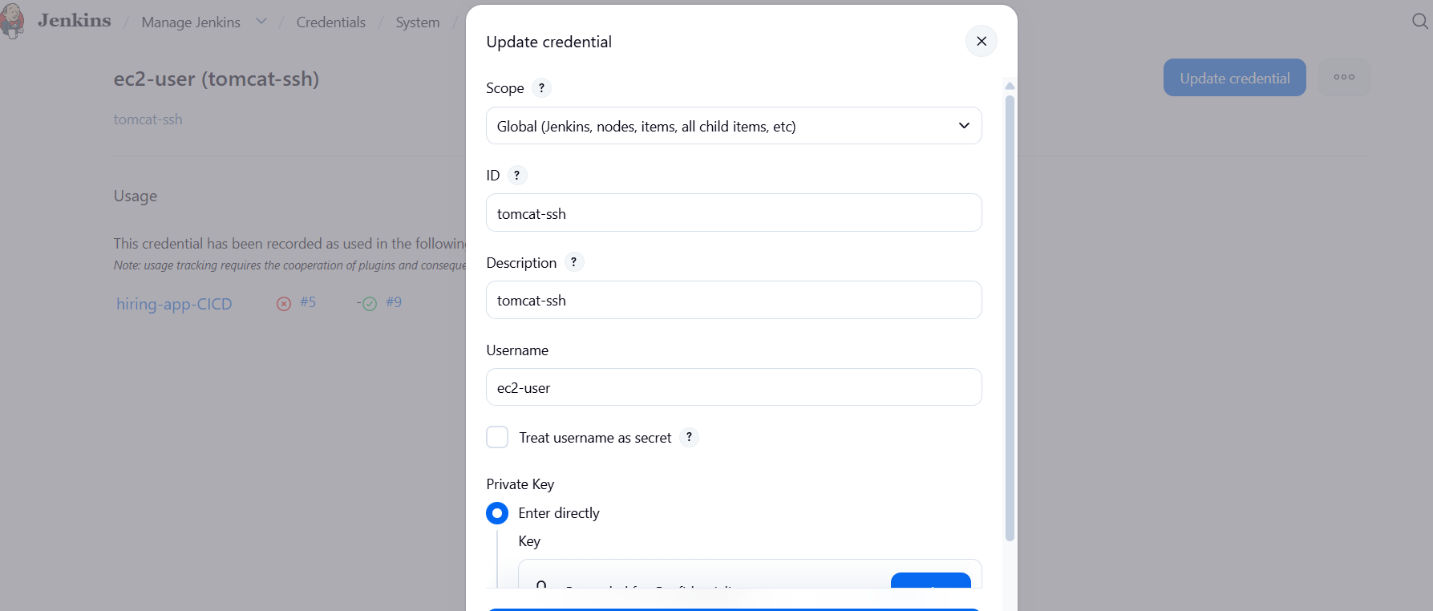

Step 6 — Find Tomcat private IP
AWS:
EC2 → Instances → Tomcat instance
Copy:
Private IPv4 address
Example: 10.0.0.112
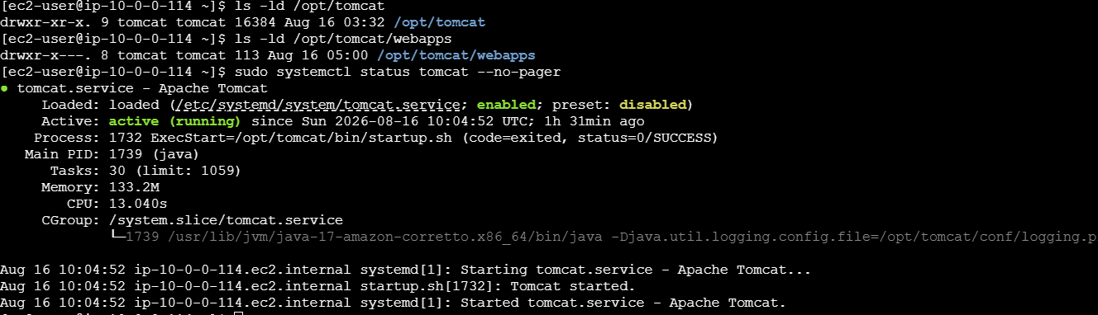
Step 8 — Create new Jenkins job
Go to:
Jenkins Dashboard → New Item
Enter: sabear-simplecustomerapp-CICD
Select:
Pipeline
Click OK.
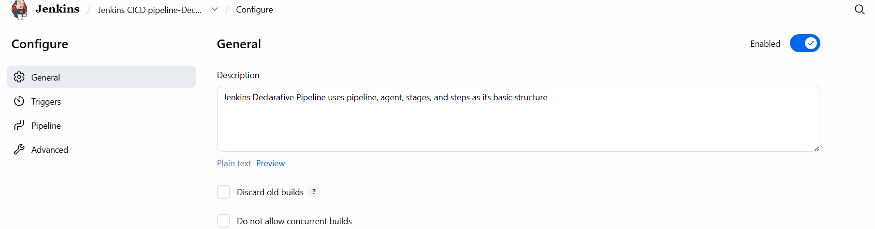
Step 9 — Configure Pipeline
Scroll down to:
Pipeline
Select:
Definition: Pipeline script
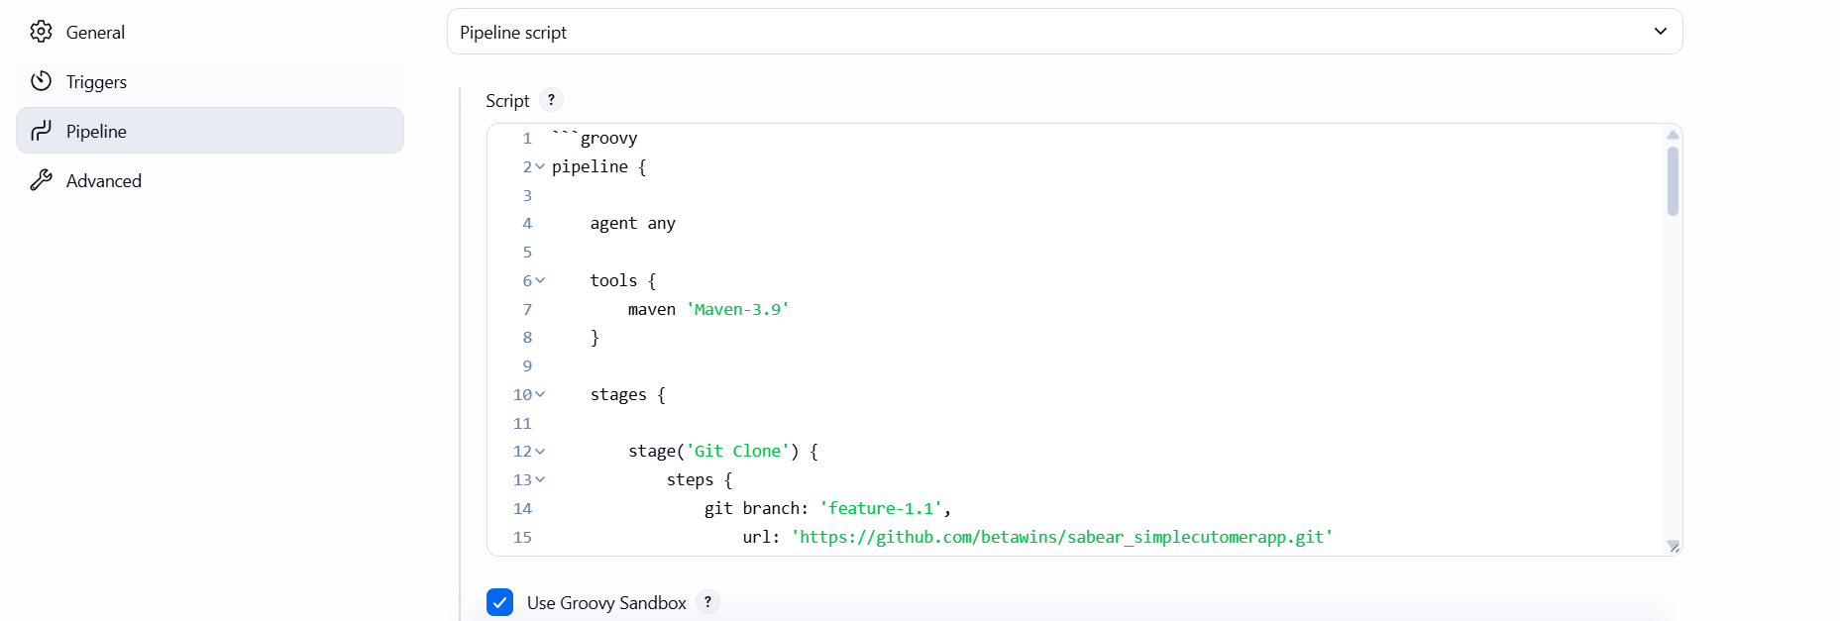
Step 11 — Run Pipeline
Click:
Build Now
Then:
Build #1 → Console Output
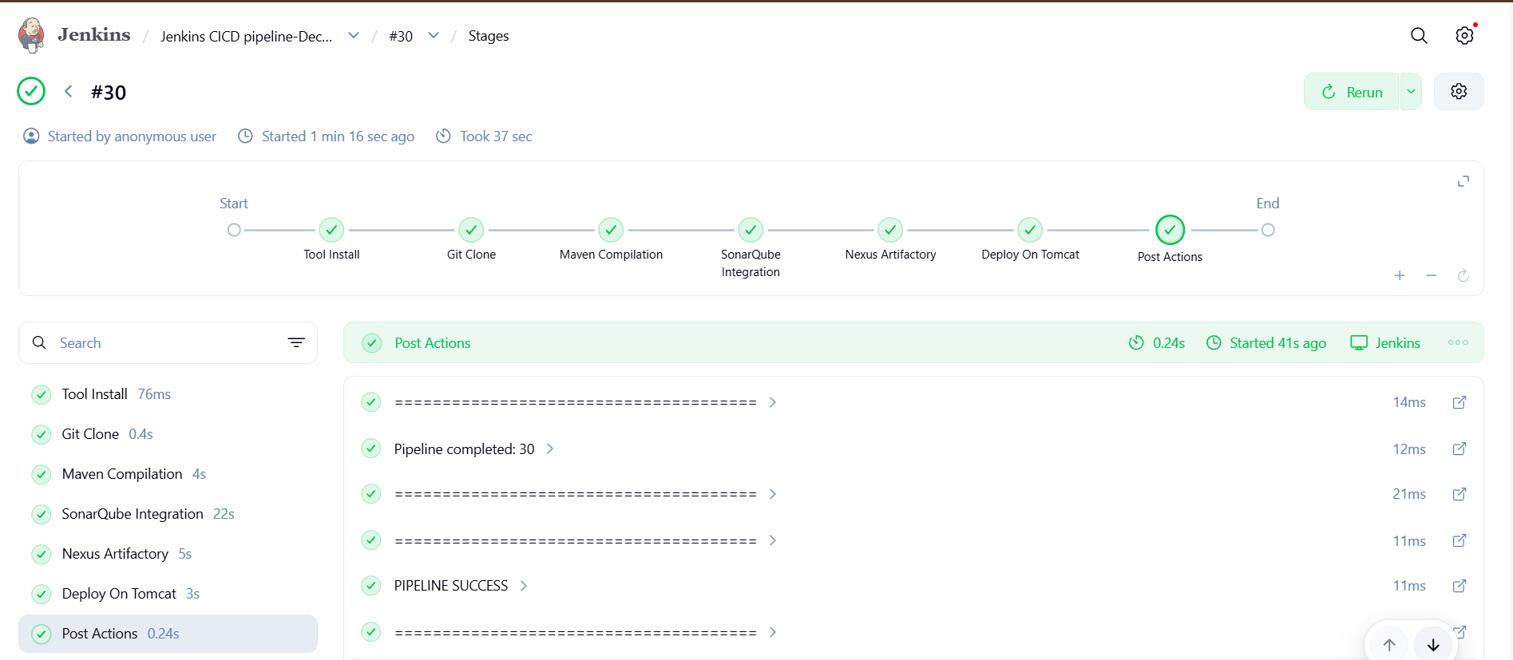

Check Slack now
Open your Slack workspace and go to:
#jenkins
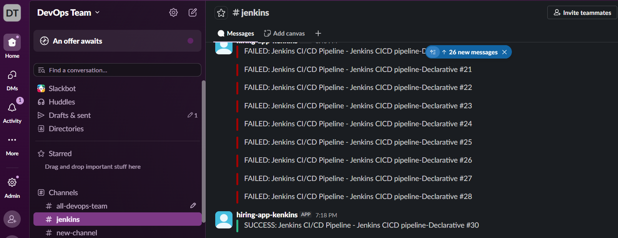

3) Setup a Jenkins CICD pipeline using Scripted pipeline using feature-1.1 branch.
Source Code: https://github.com/betawins/sabear_simplecutomerapp/tree/feature-1.1
stages:
- Git Clone
- SonarQube Integration
- Maven Compilation
- Nexus Artifactory
- Slack Notification
- Deploy On tomcat

1. Create a new Jenkins job
Jenkins → New Item
Name: SimpleCustomerApp-Scripted-CICD
Select:
Pipeline
Click OK.
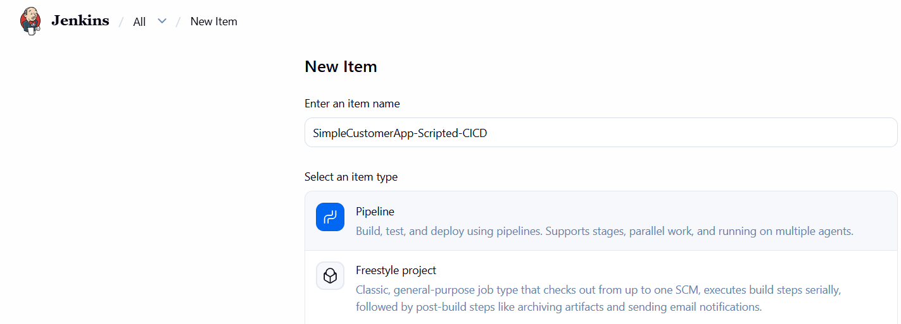

2. Pipeline configuration
Go to:
Pipeline → Definition
Select:
Pipeline script
Do not select Pipeline script from SCM for now.
Paste the complete script below.
This uses your existing:
GitHub: betawins/sabear_simplecutomerapp
Branch: feature-1.1

SonarQube: SonarQube
Sonar token: sonar-token

Nexus: 98.80.197.187:8081
Nexus repository: maven-snapshots01

Tomcat: 10.0.0.114
Tomcat user: ec2-user

Tomcat credential: tomcat-ssh-key

Slack credential: slack-token
Slack channel: #jenkins

3. Complete Scripted Pipeline
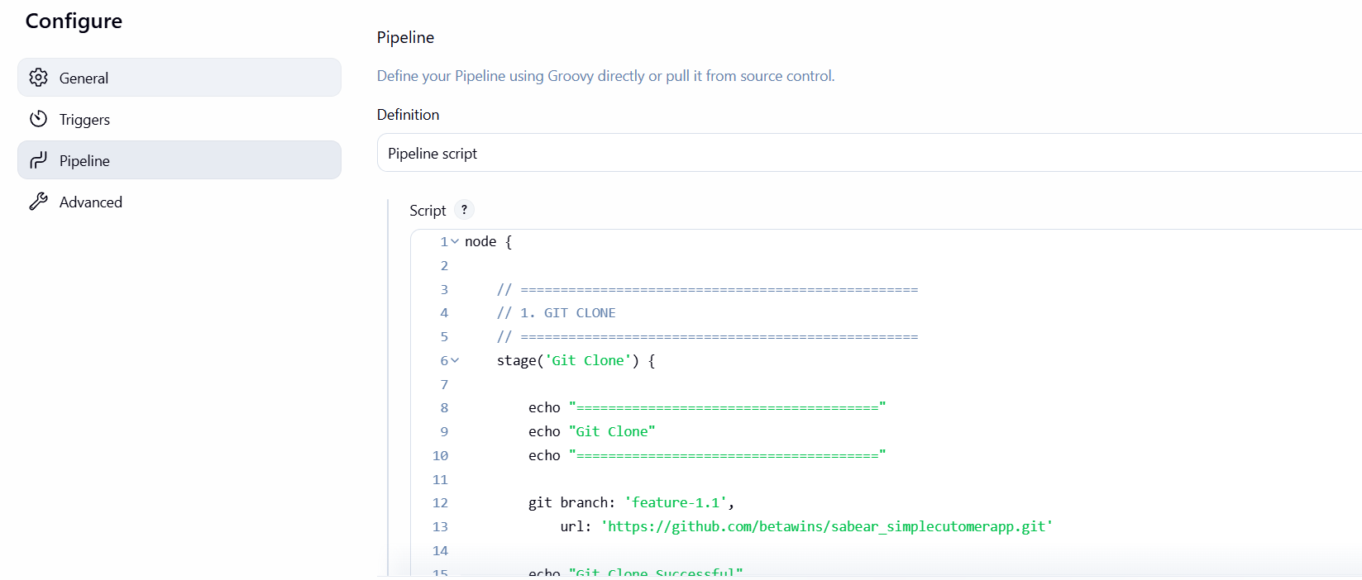

4. Save
Click:
Save
Then click:
Build Now
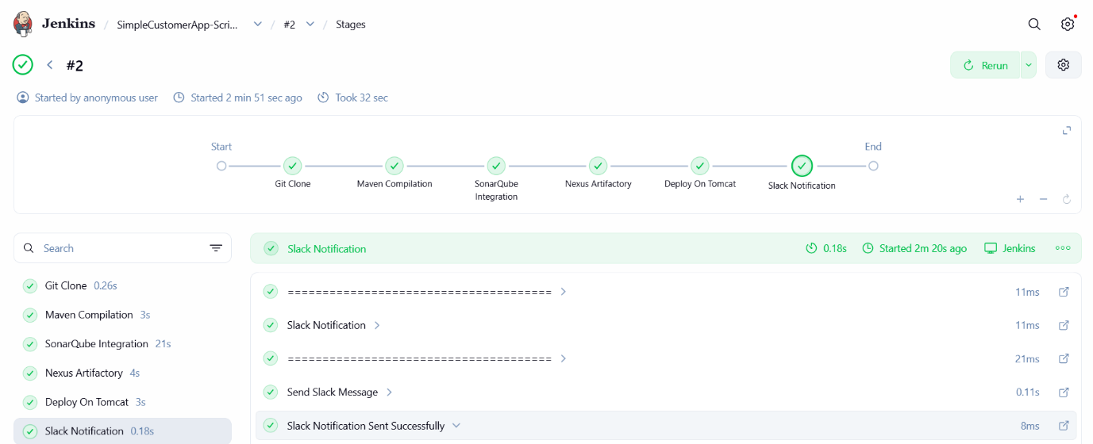
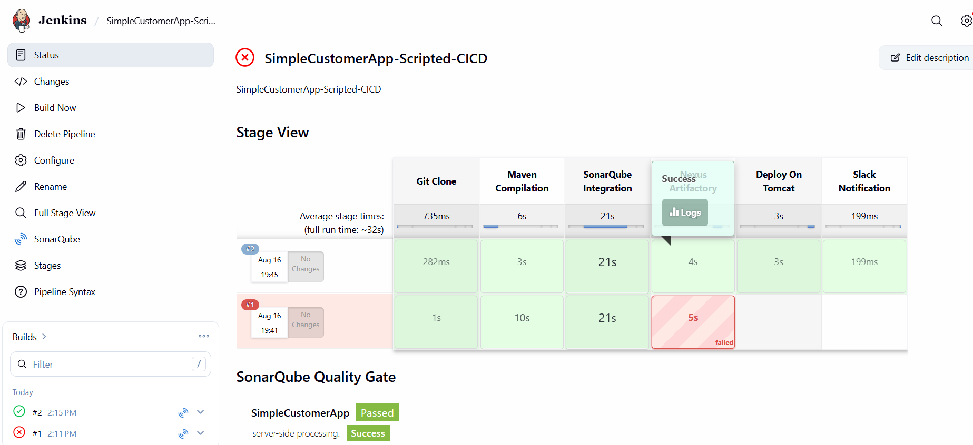

5.Check Slack
Open Slack → #jenkins
You should see:
SUCCESS: Scripted CI/CD Pipeline - <job-name> #<build-number>
Step 4 — Confirm
If the message appears in #jenkins, your Slack Notification is working successfully ✅.
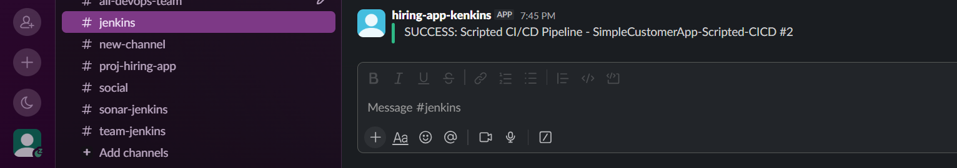

4) Sample Skeleton of Pipeline
Since the question asks for a sample skeleton and you need one script, use this simple Declarative Pipeline skeleton:

Step 1: Create a new Jenkins Pipeline Job
- Open Jenkins
- Click New Item
- Enter:
sample-skeleton-pipeline
- Select Pipeline
- Click OK
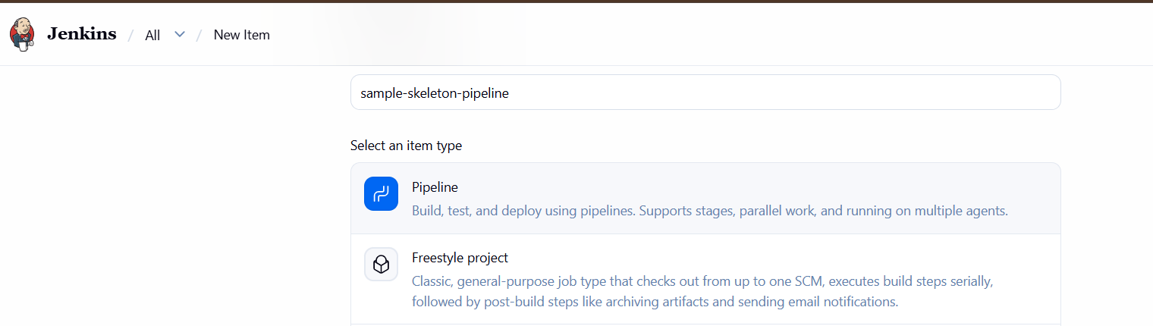
Step 2: Go to Pipeline section
Select:
Pipeline → Definition → Pipeline script
Step 3: Paste this skeleton
pipeline {
agent any

stages {

stage('Git Clone') {
steps {
echo 'Cloning source code...'
}
}

stage('SonarQube Integration') {
steps {
echo 'Running SonarQube analysis...'
}
}

stage('Maven Compilation') {
steps {
echo 'Building application with Maven...'
}
}

stage('Nexus Artifactory') {
steps {
echo 'Uploading artifact to Nexus...'
}
}

stage('Slack Notification') {
steps {
echo 'Sending Slack notification...'
}
}

stage('Deploy On Tomcat') {
steps {
echo 'Deploying application on Tomcat...'
}
}
}

post {
success {
echo 'Pipeline completed successfully'
}

failure {
echo 'Pipeline failed'
}
}
}
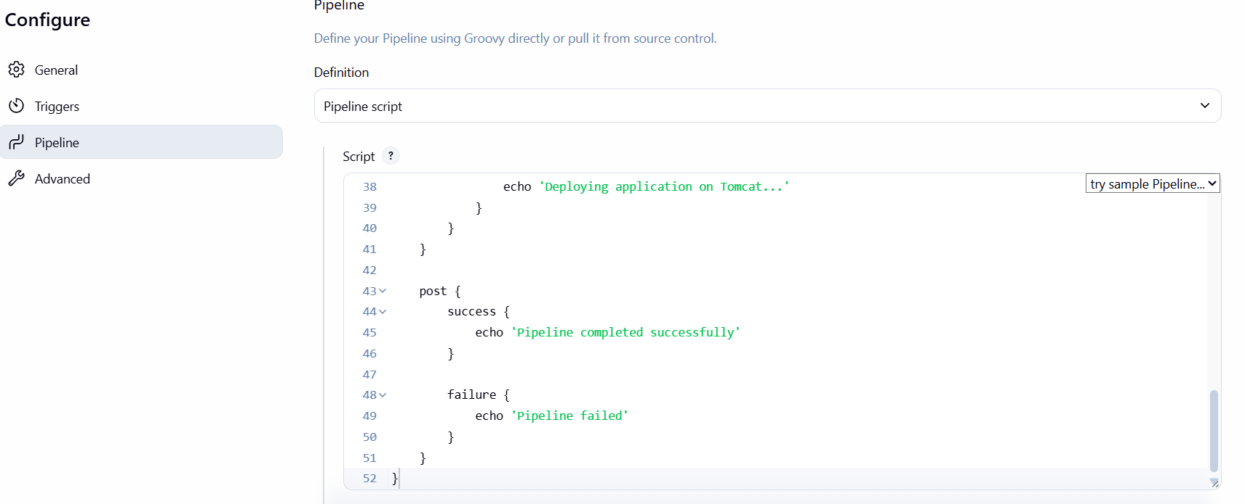
Step 4: Save and execute
- Click Apply
- Click Save
- Click Build Now
- Open Console Output

Step 5: Verify
You should see all stages:
Git Clone
↓
SonarQube Integration
↓
Maven Compilation
↓
Nexus Artifactory
↓
Slack Notification
↓
Deploy On Tomcat
Expected result:
Finished: SUCCESS
For your assignment, this is enough for Question 4. It is a sample skeleton, so the stages use echo instead of the actual deployment commands.
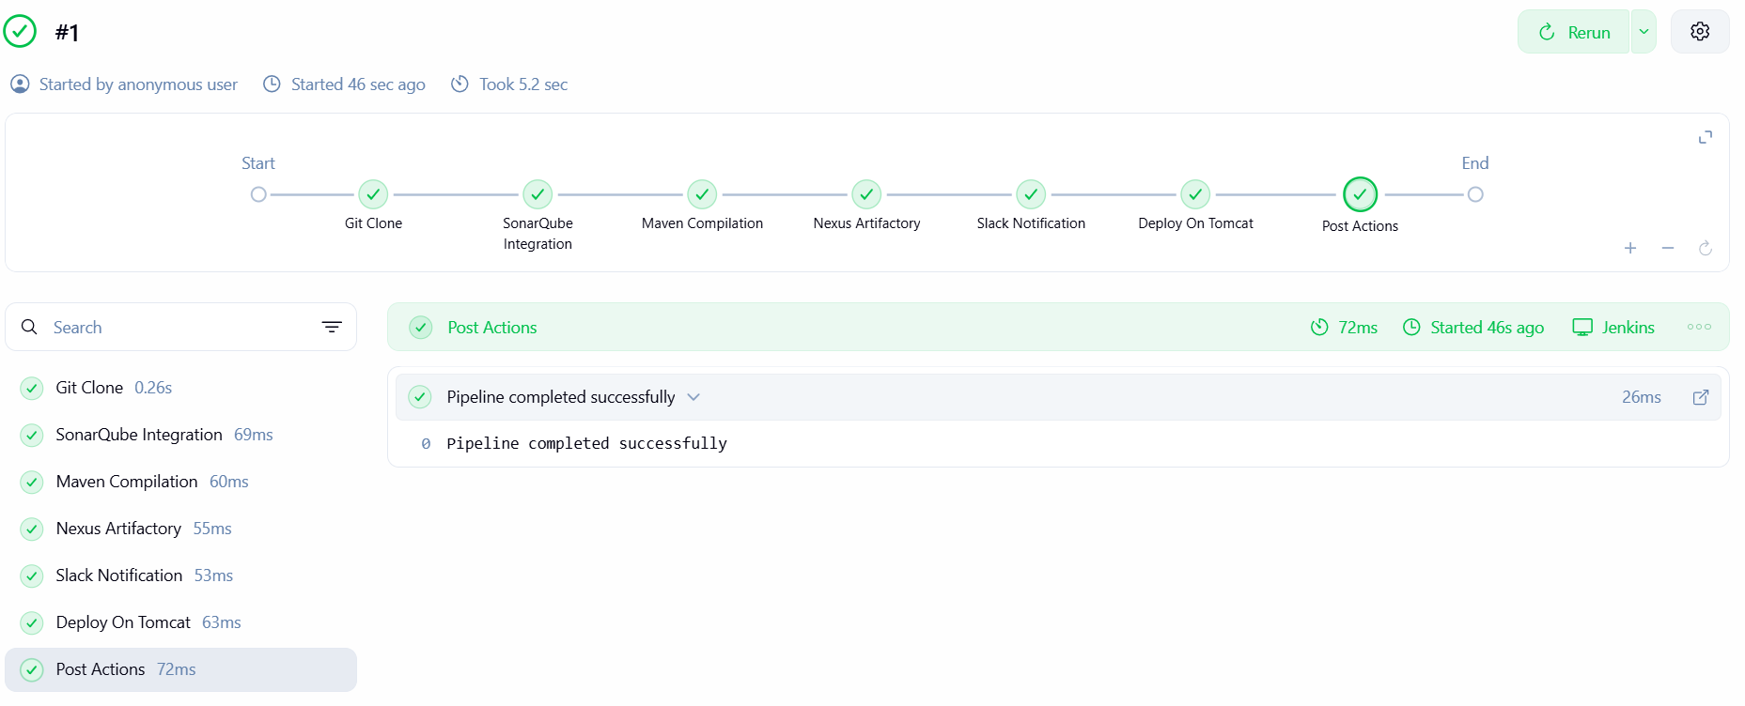

Task 5 — Create a Parameterized Job in Jenkins
Source Code: https://github.com/betawins/spring3-mvc-maven-xml-hello-world-1.git
Since you also want to see the application in Tomcat, we will create the parameterized job and deploy the WAR to your Tomcat server.

Step 1 — Create Jenkins Job
Go to:
Jenkins → New Item
Enter:
spring-parameterized-job
Select:
Pipeline
Click OK.
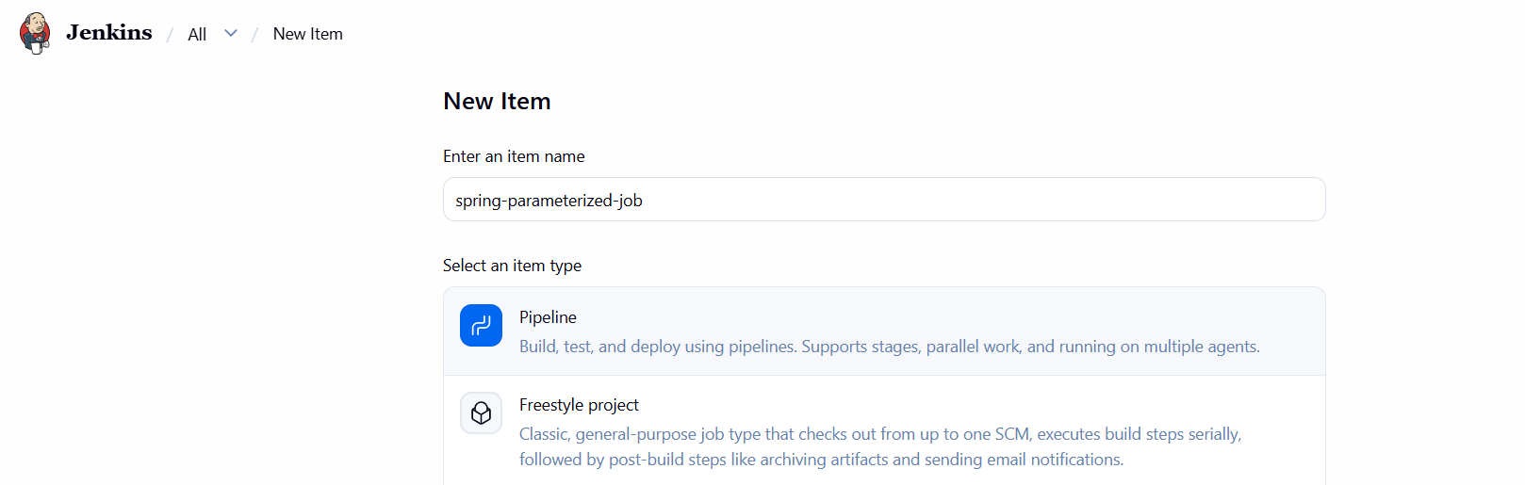

Step 2 — Configure Parameters
In the job configuration, you can use the parameters from the Pipeline itself, so you don't need to manually create them under "This project is parameterized."
Go to:
Pipeline → Definition → Pipeline script

Step 3 — Paste Complete Pipeline
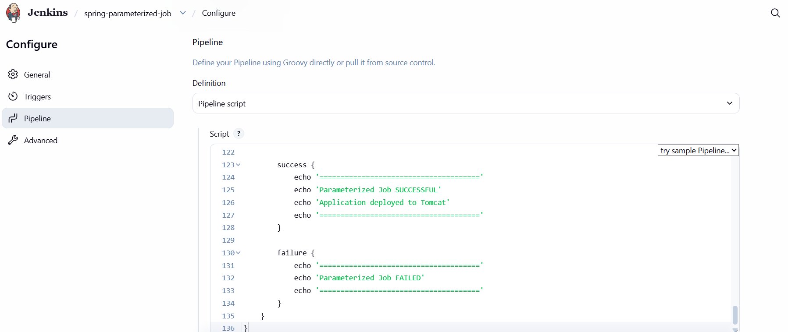
Step 4 — Save
Click:
Save

Step 5 — Build with Parameters
Go to the job: spring-parameterized-job
You should now see:
Build with Parameters
Click it.
You will see:
APP_NAME
HelloWorld

BUILD_TYPE
clean package

SKIP_TESTS
☑
Use these values for the first run.
Click:
Build
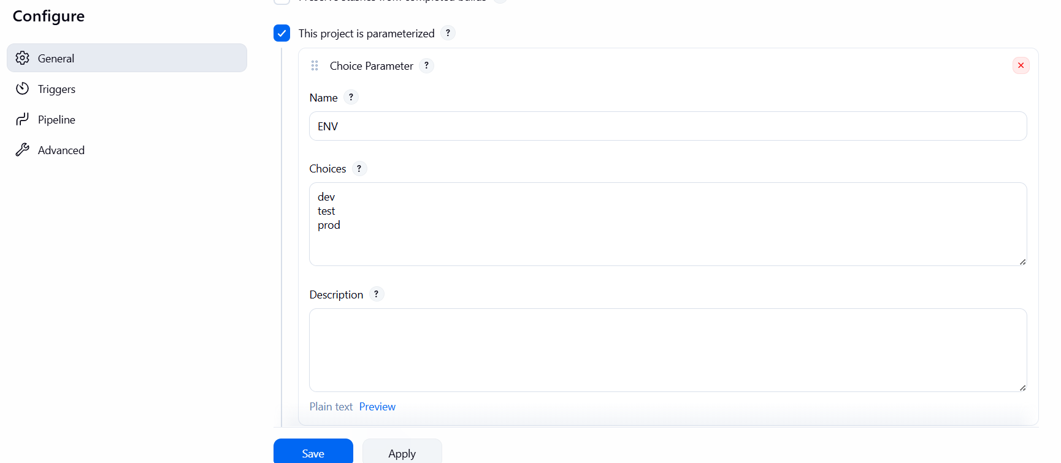

Step 6 — Check Jenkins Console
Open:
Build #1 → Console Output
You should see:
APP_NAME = HelloWorld
BUILD_TYPE = clean package
SKIP_TESTS = true
Then:
[INFO] BUILD SUCCESS
Then:
Deploying WAR to Tomcat...
Deployment completed.
Finally:
Parameterized Job SUCCESSFUL
Finished: SUCCESS
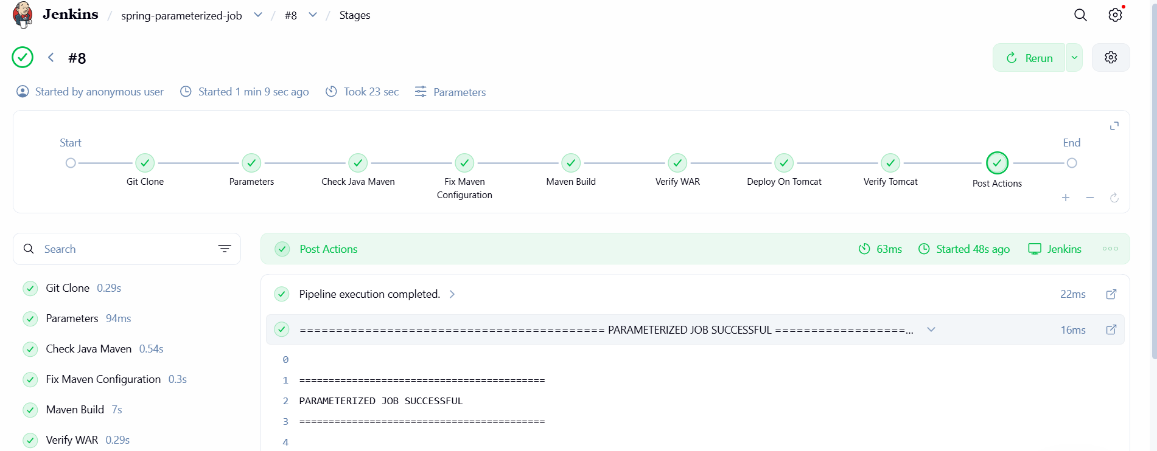

Step 7 — Check WAR on Tomcat
SSH to your Tomcat server:
ssh ec2-user@3.218.208.222
Then:
sudo ls -lh /opt/tomcat/webapps/
You should see:
HelloWorld.war
HelloWorld/
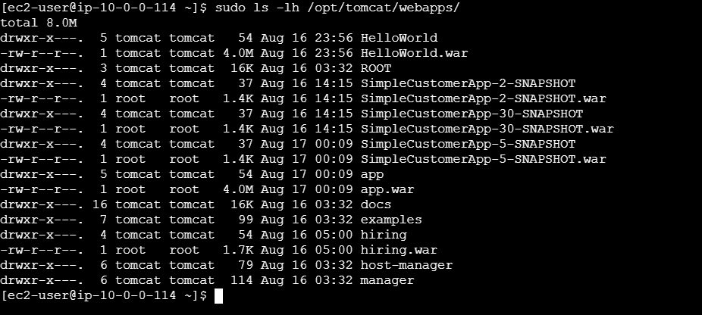

Step 8 — Check Tomcat Deployment
Run:
sudo find /opt/tomcat/webapps/HelloWorld -maxdepth 2 -type f
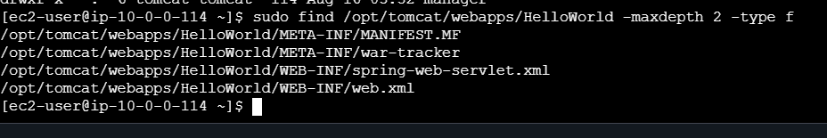
Also check Tomcat logs:
sudo tail -50 /opt/tomcat/logs/catalina.out
You should see something similar to:
Deploying web application archive [/opt/tomcat/webapps/HelloWorld.war]
Deployment of web application archive [/opt/tomcat/webapps/HelloWorld.war] has finished

Step 9 — Open Application
Open in your browser:
http://3.218.208.222:8080/HelloWorld/
If you get 404
Run:
sudo unzip -l /opt/tomcat/webapps/HelloWorld.war
Look for:
index.jsp
or the application's Spring configuration/controller.
Important: This particular repository is a Spring MVC sample, so its working URL may be a controller path rather than /HelloWorld/. If /HelloWorld/ returns 404, run:
sudo unzip -l /opt/tomcat/webapps/HelloWorld.war
and:
sudo find /opt/tomcat/webapps/HelloWorld -type f
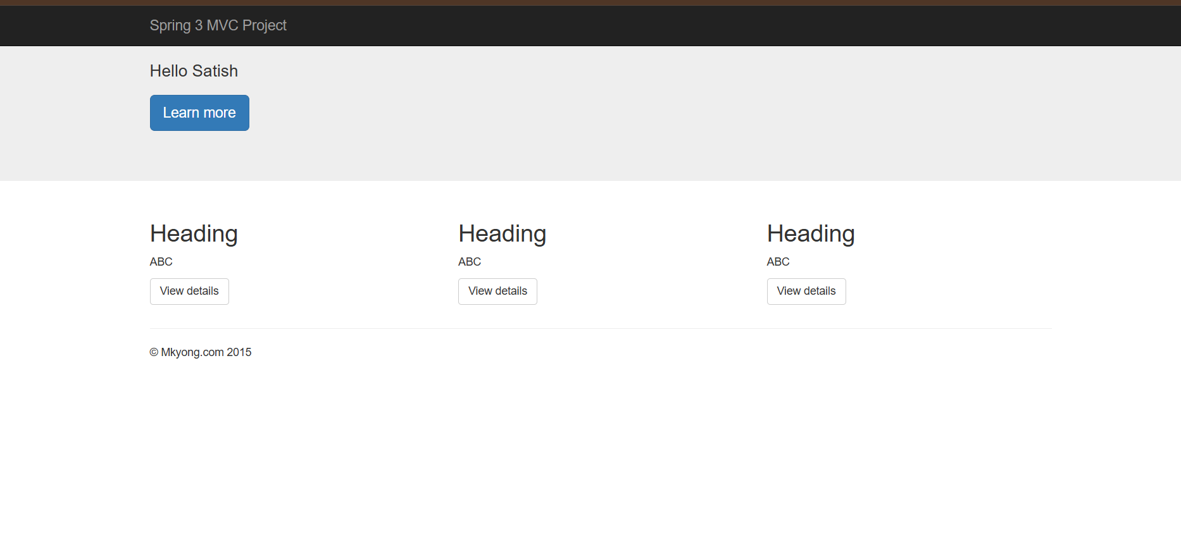

6) Setup One Slave Machine for Jenkins
A Jenkins slave (agent) is a separate machine where Jenkins executes jobs. The Jenkins controller manages the job, while the agent performs tasks such as Git checkout, Maven build, testing, Docker build, etc.
Step 1 — Prepare the Agent EC2
Create a second EC2 instance, preferably Amazon Linux.
On the agent machine:
sudo dnf update -y
sudo dnf install java-21-amazon-corretto git -y
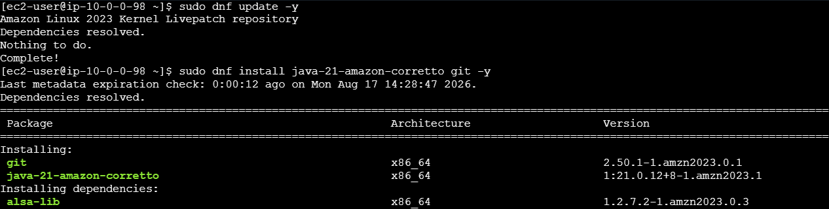
Verify:
java -version
git –version
Step 2 — Get Agent Private IP
On the agent:
hostname -I
Step 3 — Create Jenkins Agent User
On the agent:
sudo useradd -m jenkins
sudo passwd jenkins
Create the Jenkins working directory:
sudo mkdir -p /home/jenkins/agent
sudo chown -R jenkins:jenkins /home/Jenkins
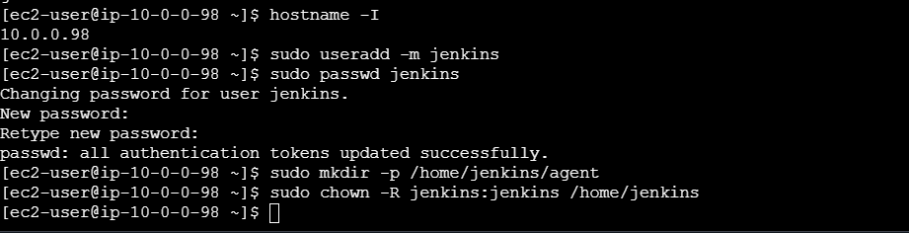

Step 4 — Configure SSH Access
On the Jenkins controller, generate an SSH key if you don't already have one:
ssh-keygen -t ed25519
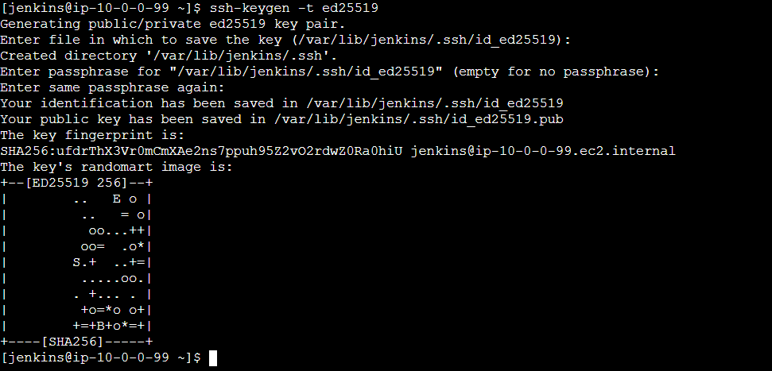
5.Create the SSH directory as ec2-user
Now run on the Agent:
sudo mkdir -p /home/jenkins/.ssh
Then:
sudo touch /home/jenkins/.ssh/authorized_keys
Set ownership:
sudo chown -R jenkins:jenkins /home/jenkins/.ssh
Set permissions:
sudo chmod 700 /home/jenkins/.ssh
sudo chmod 600 /home/jenkins/.ssh/authorized_keys

Step 3 — Add the Controller's public key
Still on the Agent, run:
sudo vi /home/jenkins/.ssh/authorized_keys

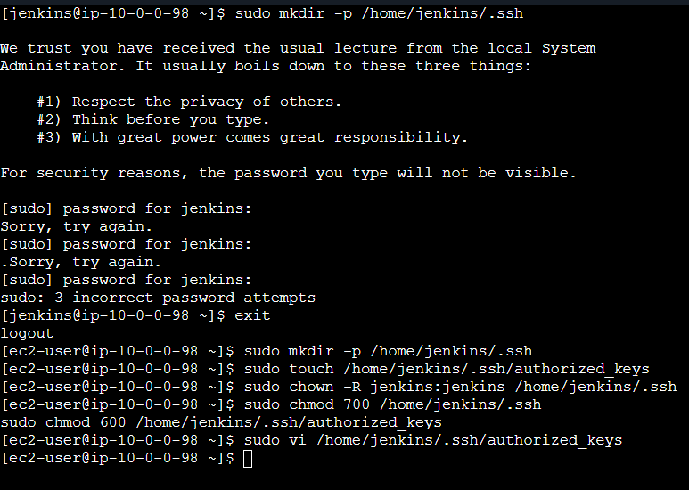
Paste the public key you got on the Controller from:
cat /var/lib/jenkins/.ssh/id_ed25519.pub

Step 5 — Add SSH Credential in Jenkins
Go to:
Jenkins → Manage Jenkins → Credentials → System → Global credentials → Add Credentials
Select:
Kind: SSH Username with private key
Username: jenkins
Private Key: Controller's ~/.ssh/id_ed25519
ID: jenkins-agent-key
Save. 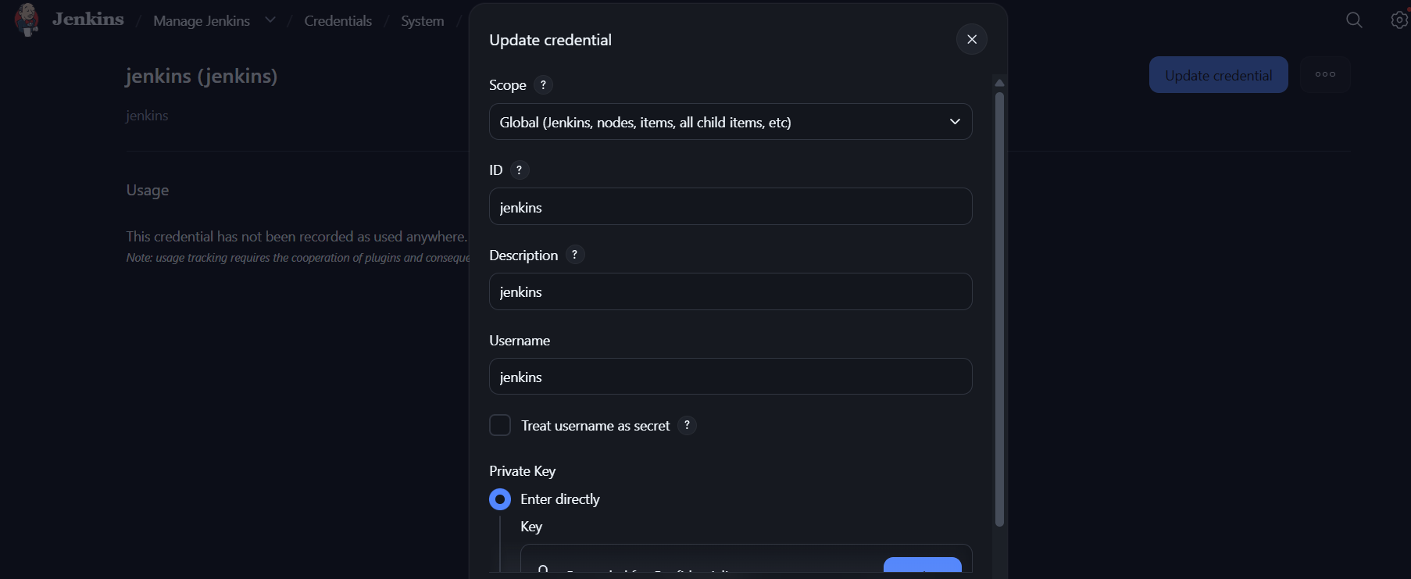
Step 6 — Create the Agent in Jenkins
Go to:
Manage Jenkins → Nodes → New Node
Enter:
Node name: linux-agent-1
Type: Permanent Agent
Click Create.
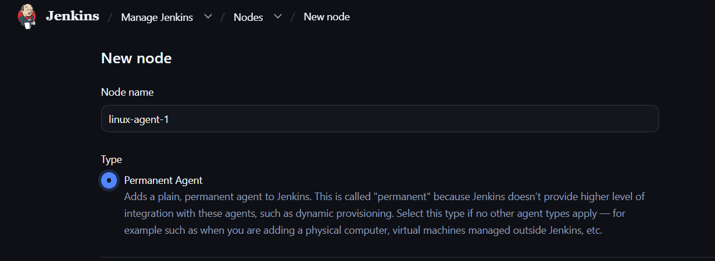
Configure:
Remote root directory: /home/jenkins/agent
Labels: linux-agent
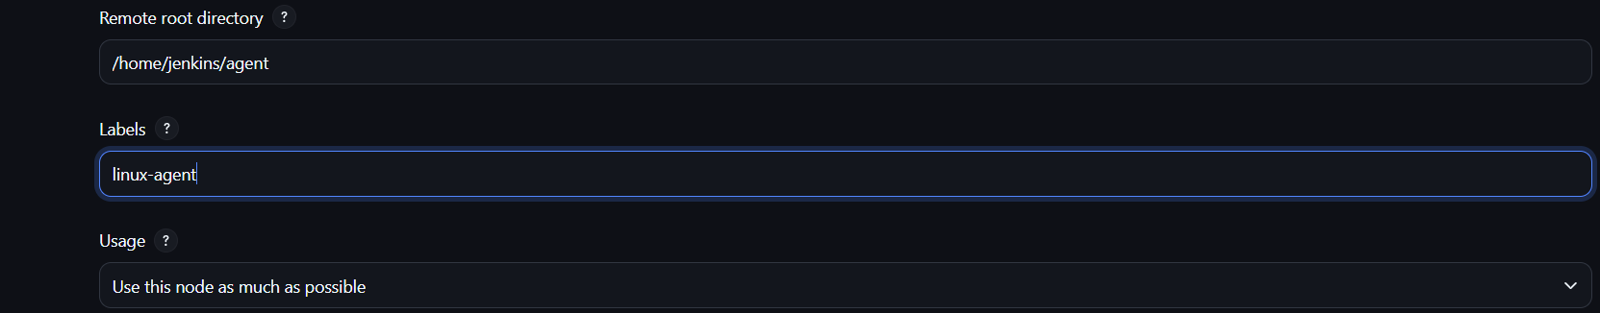

Launch method: Launch agents via SSH
Host: 10.0.0.115
Credentials: jenkins-agent-key
Host Key Verification Strategy:
Known hosts file
Click Save. 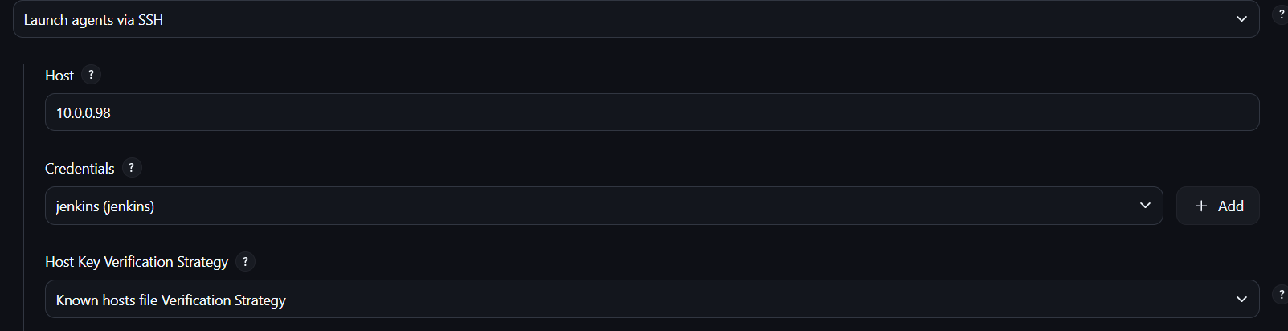
Step 7 — Verify Agent
Jenkins should connect to the agent and show:
linux-agent-1 Connected
You can also check:
Manage Jenkins → Nodes → linux-agent-1
Status: Online
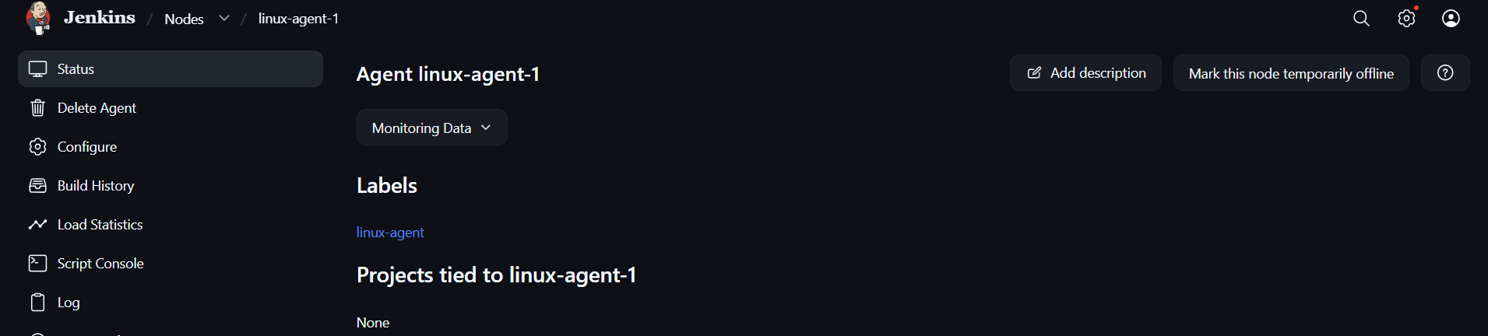

Step 8 — Test with Pipeline
Create a Pipeline job and use:
