Jenkins

1. Create EC2 Instance
Go to AWS Console → EC2 → Launch Instance
Select:
- Name: Jenkins-Server
- AMI: Amazon Linux 2023
- Instance type: t2.micro / t3.micro
- Key pair: Create/select your .pem key
- Network: Default VPC is fine for lab
- Public IP: Enable
- Security Group: Allow:
  - SSH — 22 — My IP
  - Custom TCP — 8080 — My IP
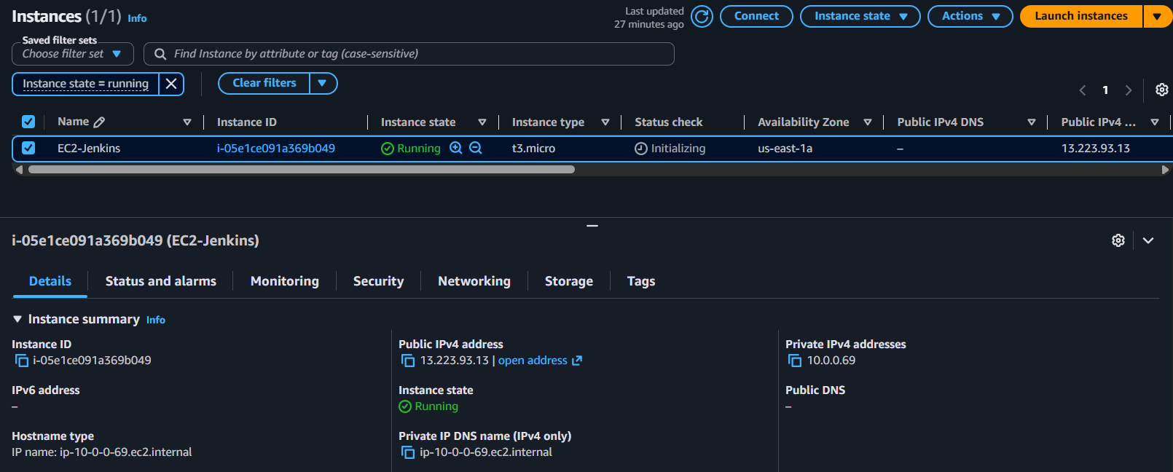
- Click Launch Instance

2. Connect to EC2
ssh -i jenkins-key.pem ec2-user@<PUBLIC-IP>

3. Install Java
sudo dnf update -y
sudo dnf install java-21-amazon-corretto -y
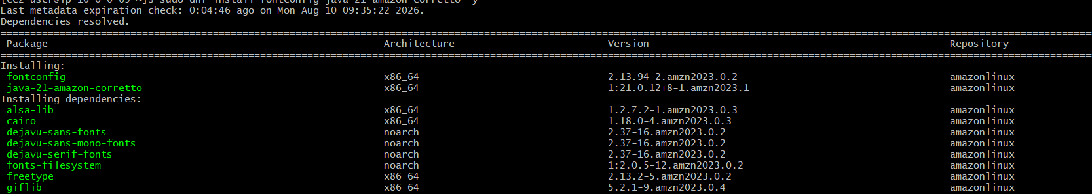
java -version
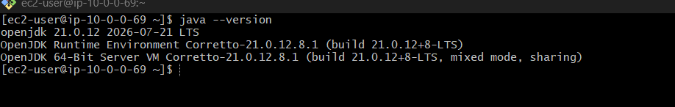
4. Install Jenkins
sudo wget -O /etc/yum.repos.d/jenkins.repo \
https://pkg.jenkins.io/rpm-stable/jenkins.repo
sudo rpm --import https://pkg.jenkins.io/rpm-stable/jenkins.io-2026.key
sudo dnf install jenkins -y
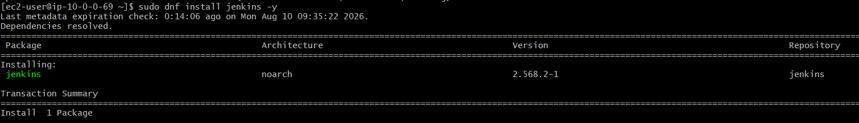
5. Start Jenkins
sudo systemctl enable jenkins
sudo systemctl start jenkins
sudo systemctl status Jenkins
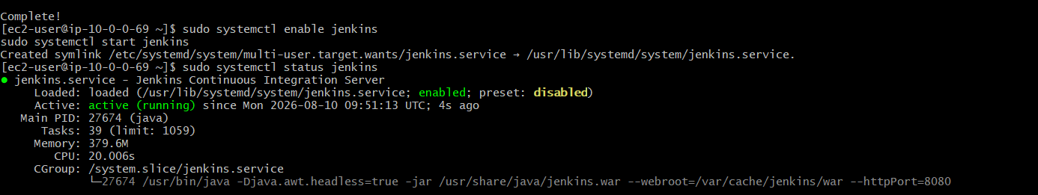

Create the Jenkins override file using vi
sudo mkdir -p /etc/systemd/system/jenkins.service.d
sudo vi /etc/systemd/system/jenkins.service.d/override.conf
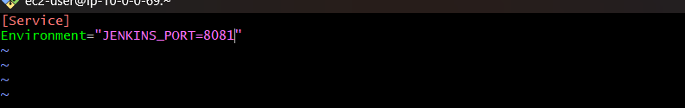

5. Change Jenkins port to 8081
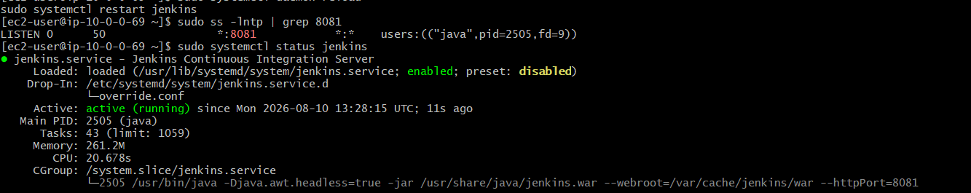

6. Get Jenkins Password
sudo cat /var/lib/jenkins/secrets/initialAdminPassword
7. Open Jenkins
Browser: http://<EC2-PUBLIC-IP>:8081
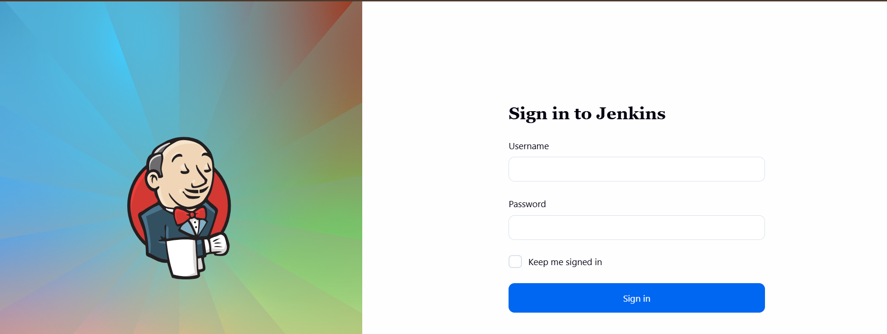
Paste the password → Install Suggested Plugins → Create Admin User.

Secure Jenkins
1. Restrict Jenkins port
- EC2 → Security Group → Inbound Rules
- Allow TCP 8081 → My IP
2. Enable authentication
- Jenkins → Manage Jenkins → Security
- Select Jenkins’ own user database
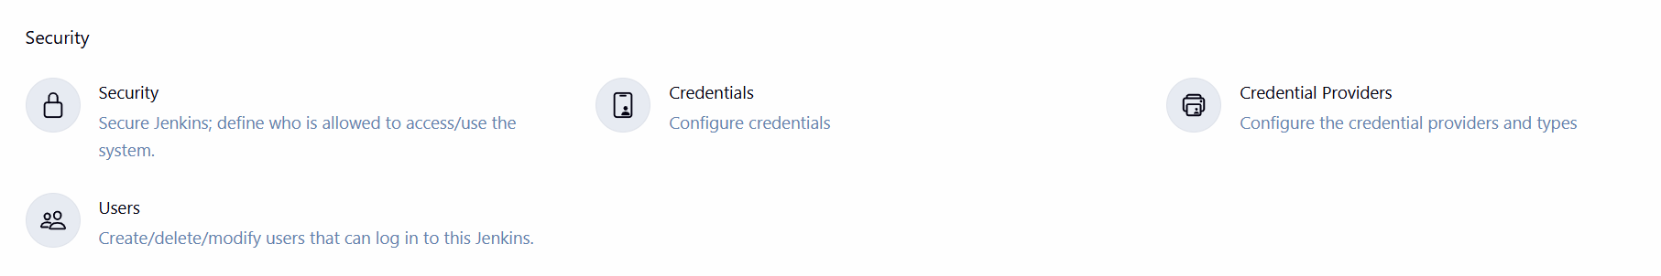
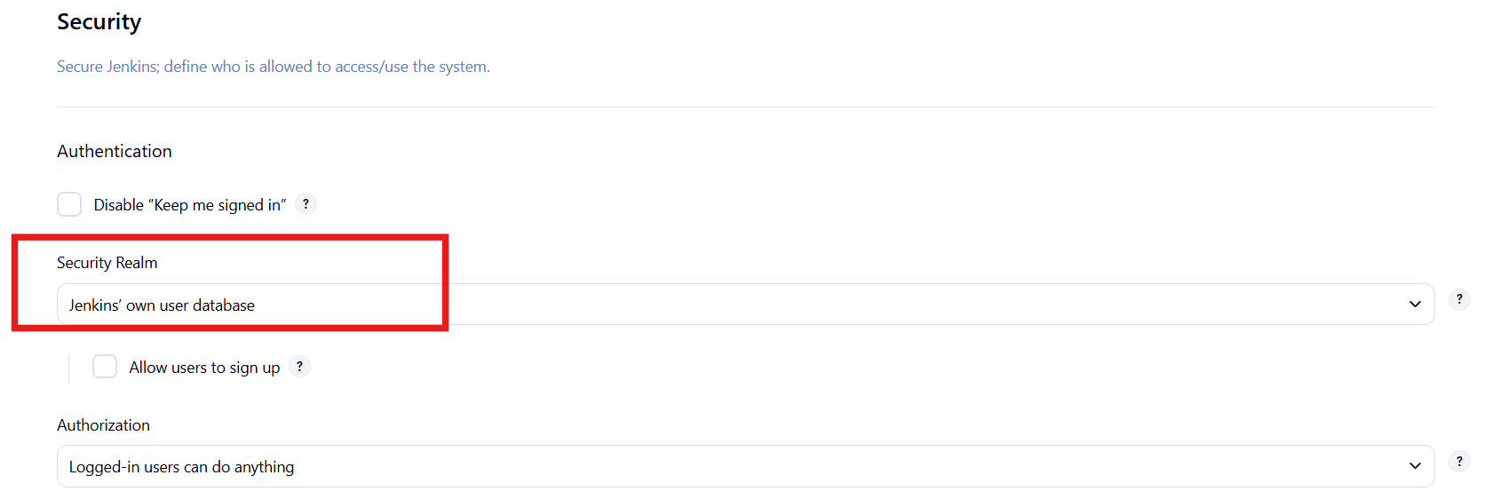
3. Disable anonymous access
- Do not allow anonymous users to access Jenkins.
4. Enable CSRF protection
- Manage Jenkins → Security → CSRF Protection → Enable
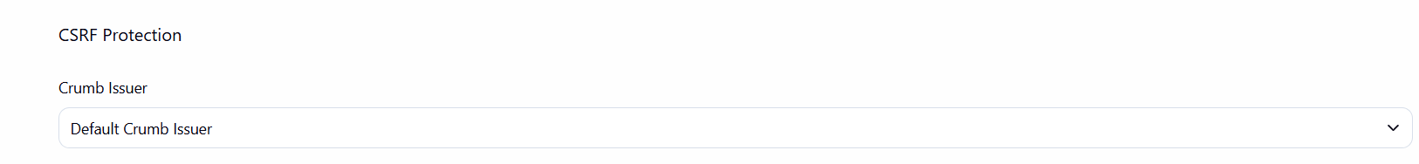

5. Create users
- Manage Jenkins → Users → Create User
- Use strong passwords.
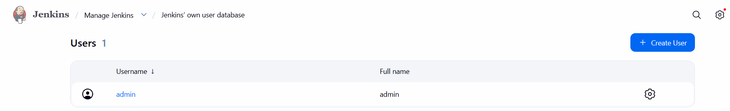
6. Apply permissions
Manage Jenkins → Security → Authorization
- Give users only the permissions they need.
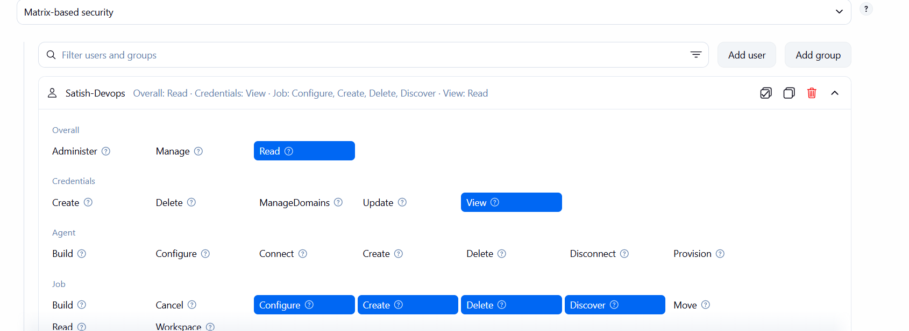
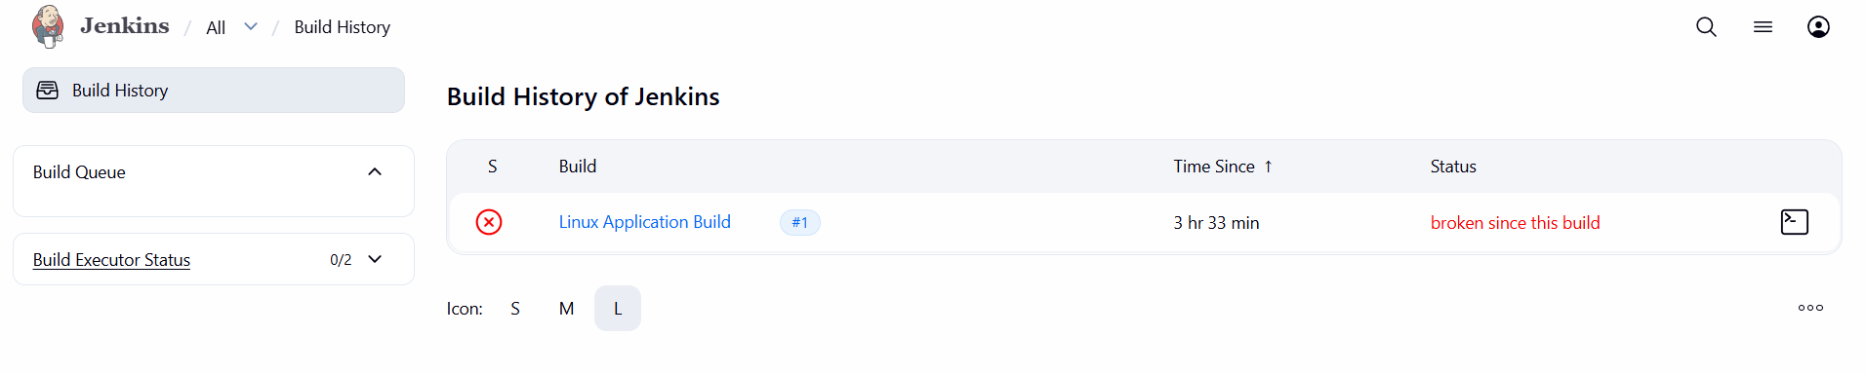
7. Update Jenkins/plugins
- Manage Jenkins → Plugins
- Install security updates.
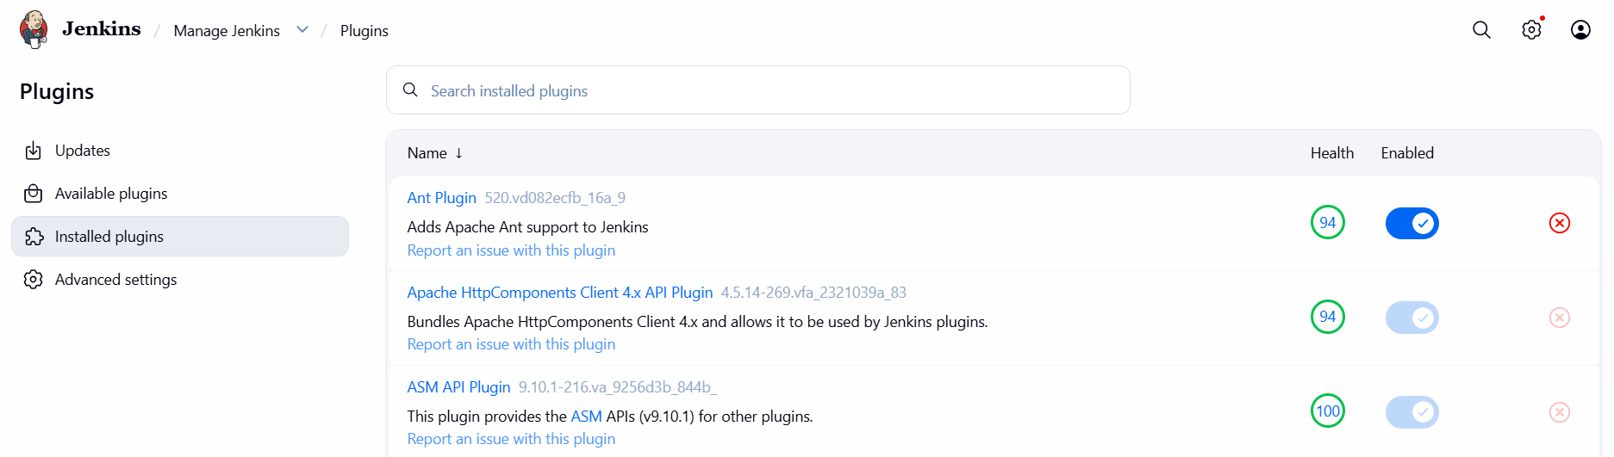
8. Monitor logs
sudo journalctl -u jenkins -f
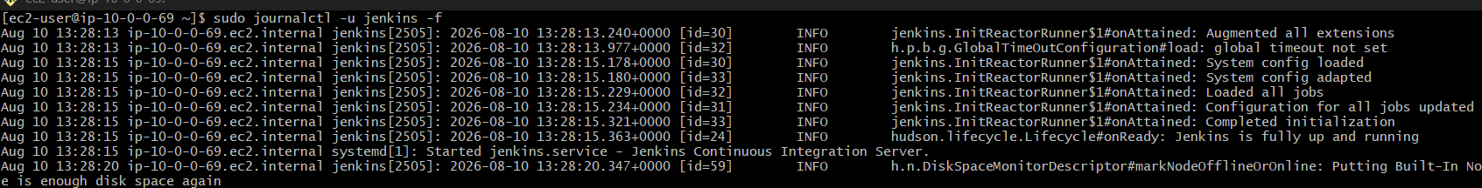
9. Use HTTPS
- For production, put Jenkins behind ALB/Nginx with HTTPS.

Configure labels and restrict the jobs to execute based on label only.

Configure Labels & Restrict Jobs
1. Add label
- Manage Jenkins → Nodes → Built-In Node → Configure
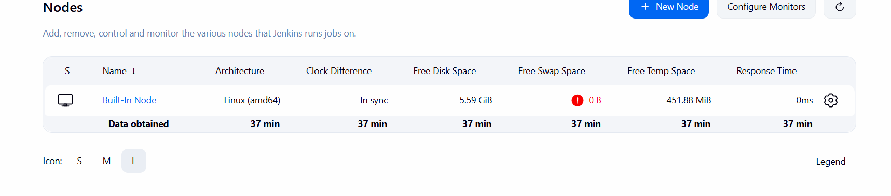
- Labels: devops
- Save
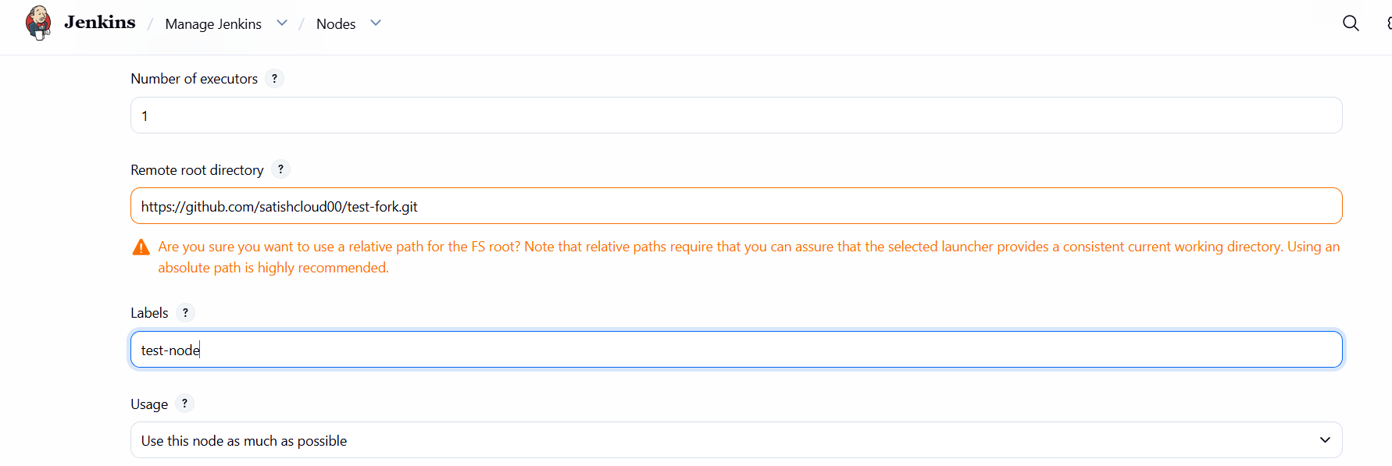
2. Restrict job
- Job → Configure → General
- Check Restrict where this project can be run
- Label Expression:
devops
- Save
3. Test
- Click Build Now
- Job runs only on the node with the devops label.

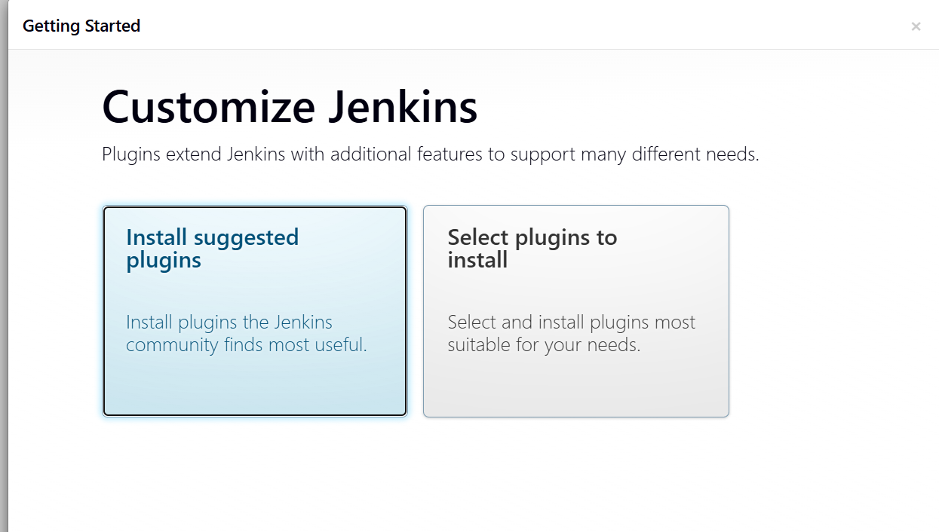
8.Create Admin User
After the plugins finish, Jenkins should show:
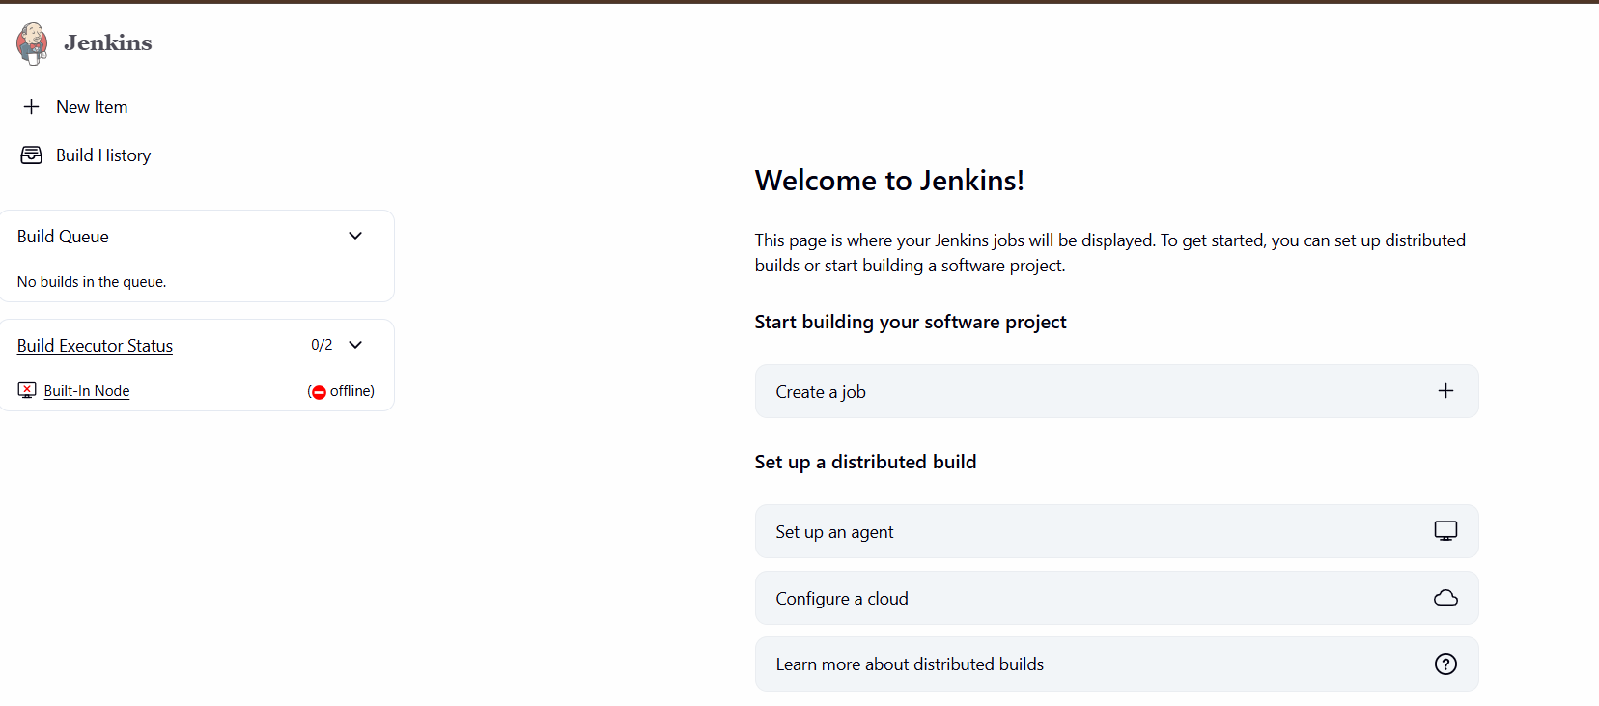

3 projects:
- Linux Application Build
- Application Deployment Pipeline
- Automated Build & Monitoring

Project 1 – Linux Application Build
Step 1: Open Jenkins
Open your Jenkins URL in the browser and log in.
You should see the Jenkins dashboard.
Step 2: Create the project
Click: New Item
Enter: Linux Application Build
Select: Freestyle project
Click: OK
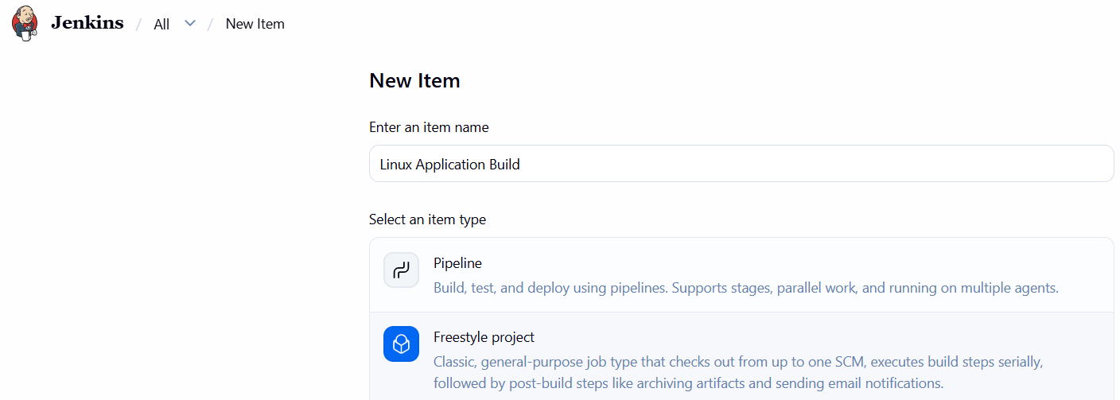

Step 3: Add description
In the Description field, enter:
Designed and configured a Jenkins-based automated build project for a Linux application. The project demonstrates Jenkins job configuration, build execution, and build validation through console output. It provides a foundation for implementing CI/CD practices by automating the application build process and monitoring the build status.
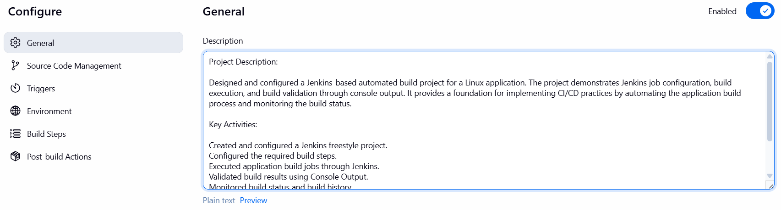

Step 4: Configure Build
Scroll down to:
Build Steps
Click: Add build step → Execute shell
Enter: echo "Welcome to Jenkins"
echo "This is my first Jenkins project"

Step 5: Save
Click:
Apply → Save

Step 6: Build the project
Click: Build Now
You will see:
Build #1
Click Build #1 → Console Output.
You should see:
Welcome to Jenkins
This is my first Jenkins project
If you see Finished: SUCCESS, the project is working.

